F1 Top 10 Prediction Report

Objective
The objective of this project is to predict whether a Formula 1 driver will
finish a race in the top 10. The task is framed as a binary classification
problem where the target variable is top10_finish.

Data
The project uses two public data sources:
- Jolpica F1 API, an Ergast-compatible API, for historical race results,
qualifying results, drivers, constructors, circuits, standings and pit stops.
- FastF1 for optional race-session enrichment, including weather and lap-based
historical form features for supported recent seasons.
The current model-ready dataset contains:
- 6521 driver-race rows
- seasons from 2011 to 2026
- 166 columns after optional FastF1 enrichment
- no missing values after preprocessing

Feature Engineering
The model uses only pre-race or historical features where possible. Important
feature families include:
- qualifying position and qualifying gaps
- driver and constructor standings before the race
- recent driver form over the previous 5 races
- reliability over previous races
- historical pit-stop performance
- circuit characteristics
- optional FastF1 rolling lap and strategy features
Post-race leakage columns such as final position, points, laps completed, race
status and fastest lap information are kept for analysis but excluded during
training.

Models
The project compares several machine learning algorithms:
- logistic regression
- random forest
- extra trees
- histogram gradient boosting
- neural network MLP
The neural network is included as a baseline, but the dataset is still tabular
and relatively small. In this context, tree-based methods remain strong and
more stable.

Validation Strategy
The project uses temporal validation instead of a random split. This better
matches the real use case because the model should learn from past seasons and
predict future races.
Two validation views are used:
- a holdout season test
- an expanding-window season-by-season backtest
The main race-level metric is race_precision_at_10, which checks how many of
the predicted top 10 drivers actually finished in the top 10 for each race.

Current Results
Current holdout season: 2025.
The current best holdout model by race precision@10 is histogram gradient
boosting:
- accuracy: 0.770
- precision: 0.778
- recall: 0.758
- F1: 0.768
- ROC-AUC: 0.836
- race precision@10: 0.775
Across the rolling backtest, random forest remains the most stable model:
- average accuracy: 0.782
- average F1: 0.781
- average ROC-AUC: 0.847
- average race precision@10: 0.775

How to Run
python scripts/run_pipeline.py
To run with optional FastF1 enrichment:
python scripts/run_pipeline.py --with-fastf1
To compare all algorithms:
python scripts/evaluate_models.py
To export readable race predictions:
python scripts/predict_top10.py

Limitations
Some important racing factors are still approximate:
- race-control events and safety cars are not fully modeled
- full telemetry is not used directly
- FastF1 enrichment currently covers recent seasons only
- actual weather is used as a proxy for race weather information
The next major improvement would be to expand FastF1 coverage and build
sequence-based features from lap-by-lap race evolution.

Figures
target_distribution.png
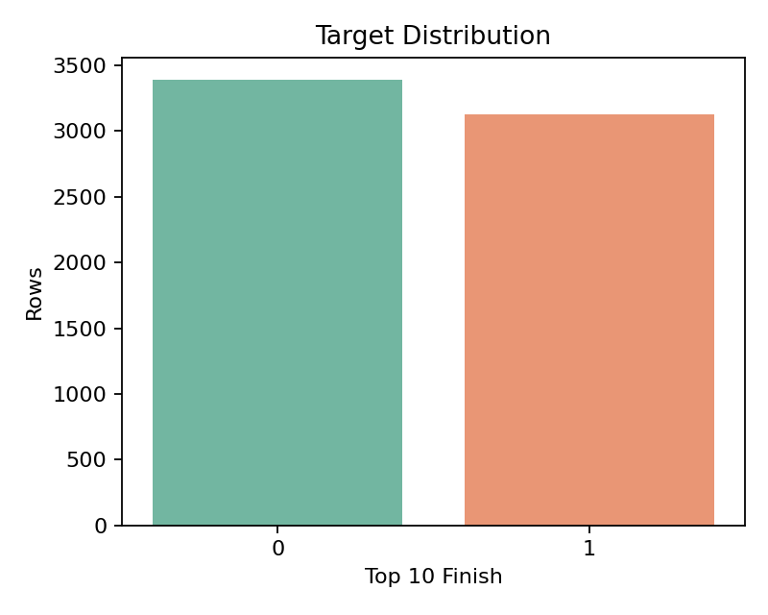
rows_by_season.png
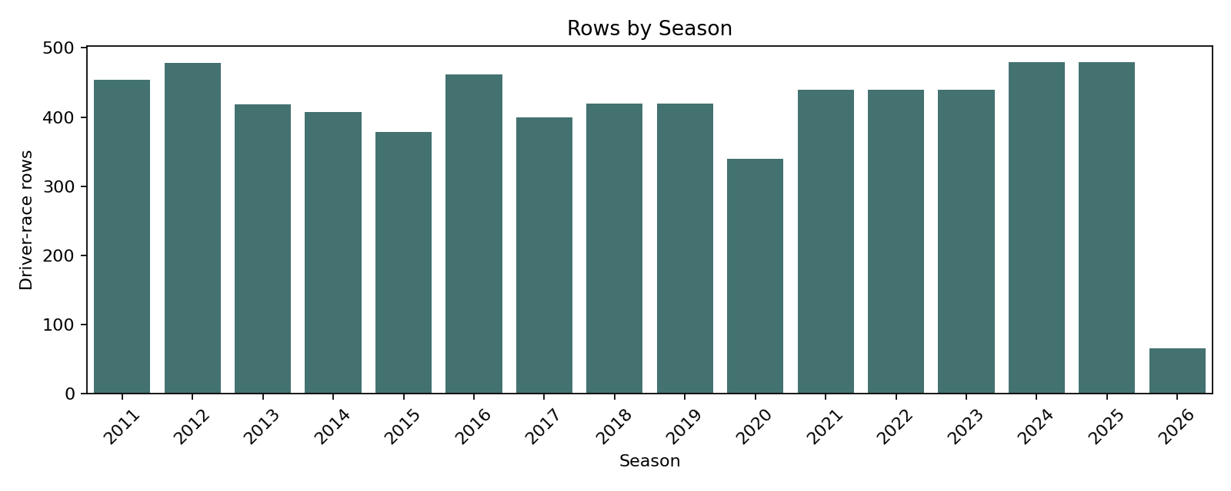
top10_rate_by_season.png
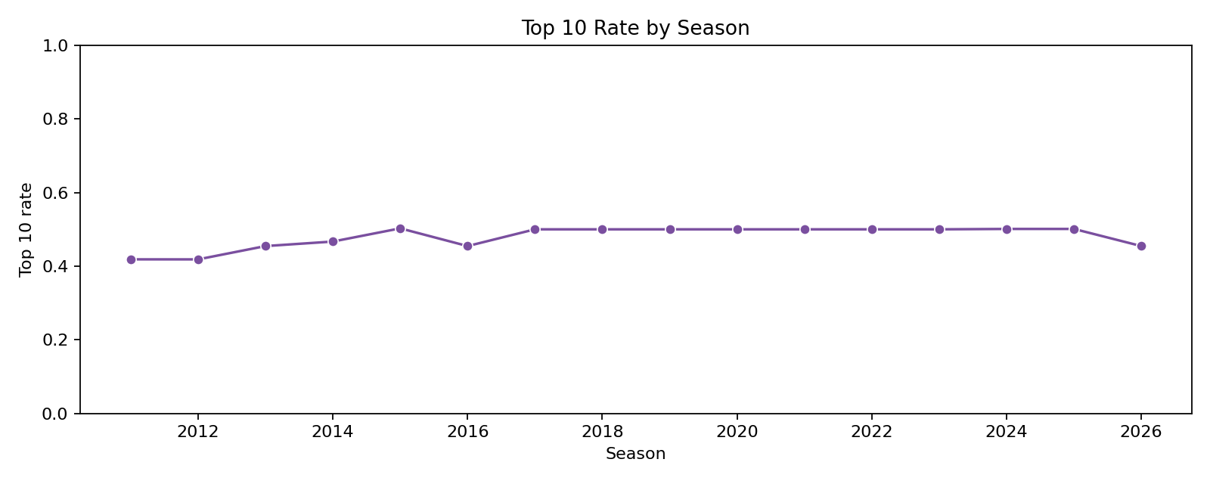
model_comparison.png
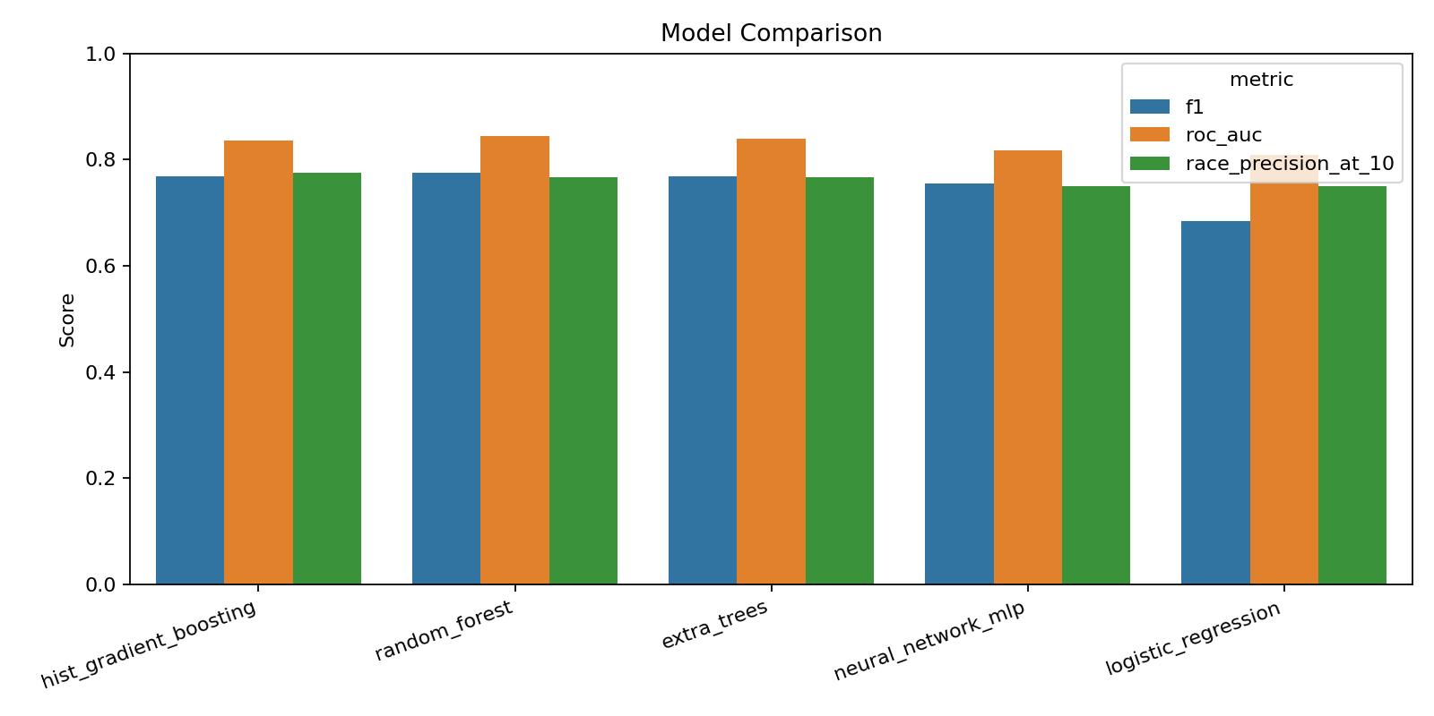
rolling_backtest.png
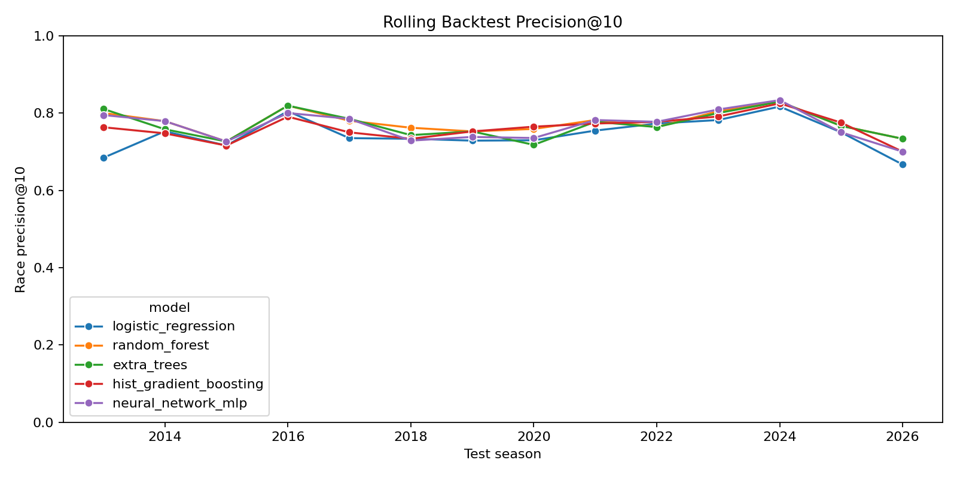
feature_importance.png
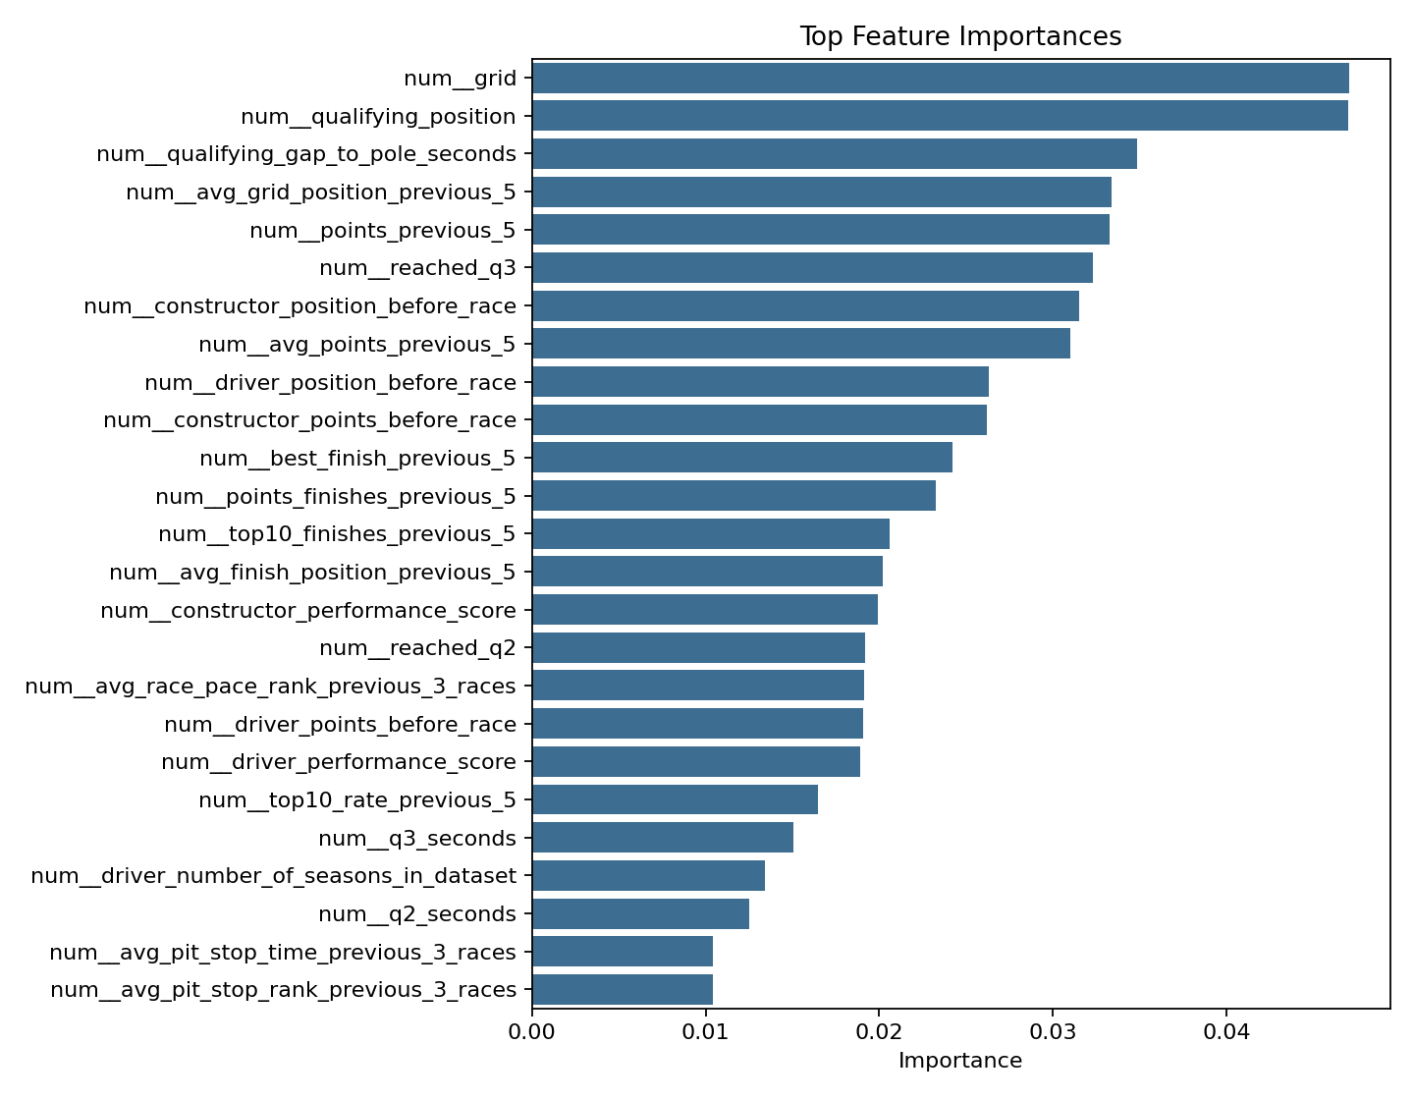
confusion_matrix.png
