Lab Report

OOP Lab

Lab 02

Student name: Nguyễn Vũ Thủy

Student ID: 20235562

1. Use case diagram

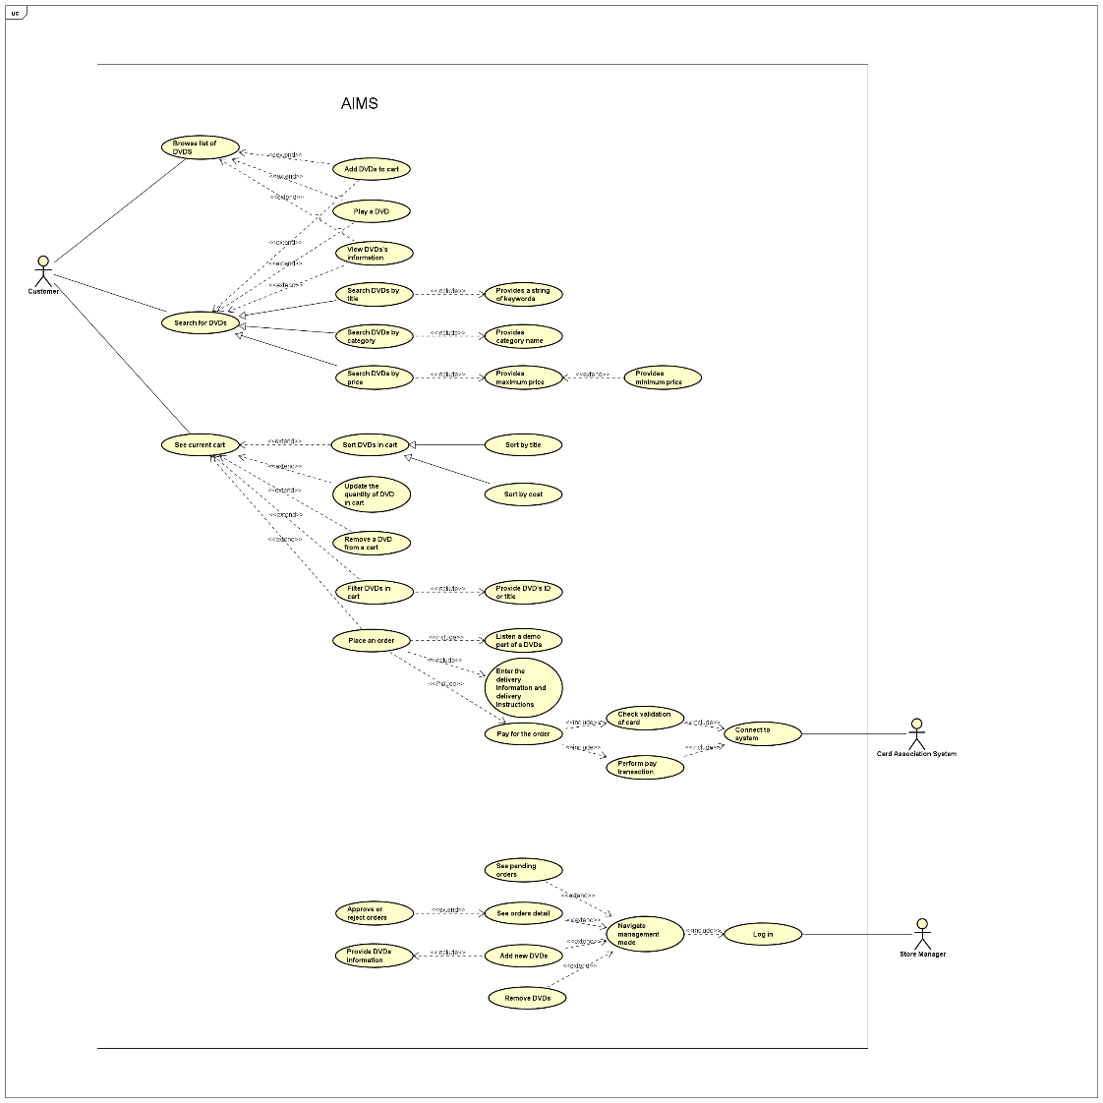

1. Class diagram

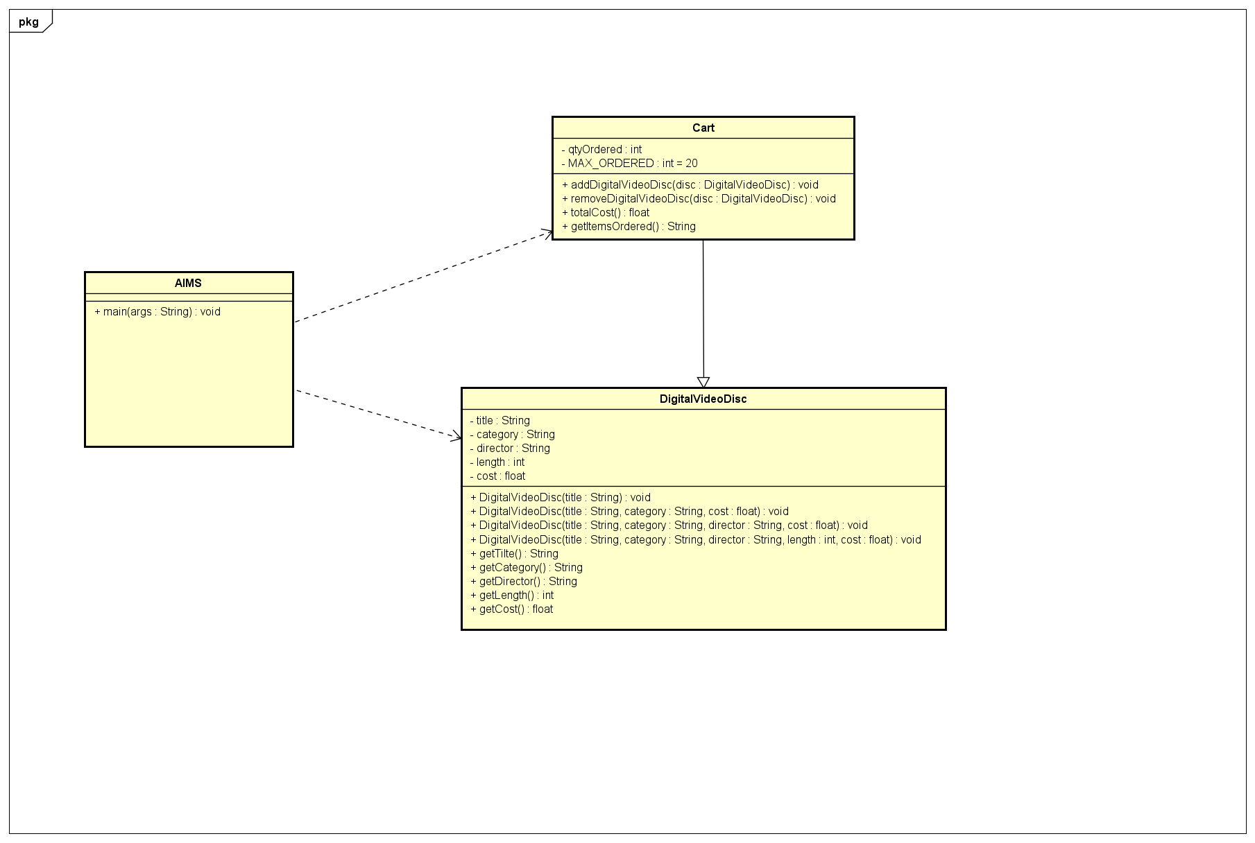

1. Reading assignment

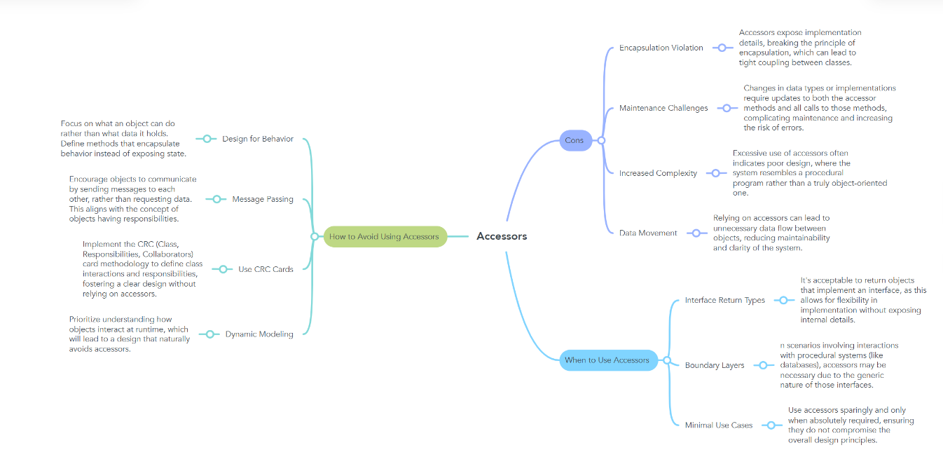

1. Answering question

* When should accessor methods be used?
* When you need a method to return an object without being concerned about changes to the underlying implementation.
* If you create a constructor method to build a DVD by title then create a constructor method to build a DVD by category. Does JAVA allow you to do this?
* No, it will result in an error because both methods have the same number of arguments (1) and the same argument type (String).