CS4303 – Practical 4

**God is Dead**

# Introduction

This practical involved the design and creation of our own game utilising the Processing library. The game I ultimately decided to implement was the same game idea which I had pitched, God is Dead. Even though we were tasked with implementing the game using Processing, I also had various other elements, namely p5.js, the Node framework Express and aspects from the cloud computing company DigitalOcean, to complete my game. In God is Dead, I managed to create a game that relies on players being deductive, deceptive, and attentive.

# Design

## Background and Genre

To prevent my game from being extremely like other games that would be created for this practical, and games which are currently incredibly popular, I initially decided that I would want to focus on a specific aspect of the game and implement it flawlessly. My choice, networking. Unlike Physics, AI, and Procedural Content Generation, Networking would allow me to explore a different aspect regarding video games, which was not as heavily covered in comparison to the former.

Upon deciding on a heavily networked game, I aimed at finding a core theme behind my game. I eventually chose philosophy. This was chosen as I wanted to make the players of my game heavily engaged with the game and requiring them to thoroughly contemplate their actions, as well as the events that would unfold before them. I had initially hoped to formulate an idea which would make the player question their own consciousness and existence, as well as that of objects within the game, as this branch of philosophy (phenomenology) had the potential to provide the exact user experience I desired. I managed to come up with a couple game ideas regarding this branch of philosophy, such as:

* A mystery free-for-all where you’re only certain of your own existence
* A puzzle/mystery game akin to “The Stanley Parable” where the player must explore and find clues to discover whether they are conscious or not

However, the ideas I came up with would have been either too complicated to accomplish within the timeline or have gameplay which could be synonymous as being “buggy”. For example, with the user finding themselves “teleported” to a bed at the start of a level after they believe they have moved around, but they had never woken up in the first place.

Instead, I turned to deduction. While not as heavily linked with phenomenology as I had hoped, this allowed me to define the genre of my game as a Social-Deduction Party Game (also referred to as a Social-Deduction Strategy RPG in my pitch). Despite lacking the ability to incite an existential crisis in the player, this game genre allows me to ensure that players are not passive participants. Players, in order to increase their chances of winning, must be fully invested.

## Title

As previously mentioned, the title for my game is “God is Dead”, as I had initially aimed to create a game highly inspired by philosophy, I felt it was necessary that the title also took influence from philosophy. Hence, my title references one of Friedrich Nietzsche’s most famous quotes – “God is Dead”. Initial plans for the game, hoped for God to be a playable character by a person, with Angel’s needing to protect God from their existence being revealed and prevent them from being killed. Thus, taking the phrase into a literal sense. However, given the lack of God as a playable entity in the game’s current form, I believe the title of the game is much more suited to being interpreted much figuratively. Notably, in the manner where scientific discoveries and rationalism make it viable to challenge existing doctrines, leading to the conclusion that humanity has no need for an omnipotent being to explain existence. Appropriate for my game as the players playing as humans aim to uncover more knowledge by investigating and executing suspected angels.

## Players and Opponents

As alluded to in previous sections, the players in God is Dead are either human beings or angels. Players are assigned to play as either an Angel or a Human, with the “opponent” being the other group of players. However, Humans are unaware of the role of other players, while Angels, are aware of all the other Angels, and are, transitively, aware of all of the humans in the game. Being a party game, all the players are within the same room, only differentiated by these roles that they’ve been assigned. As a result, players are not required to be represented by an avatar, instead, rather trivially, they represent themselves.

## Gameplay

Given that the gameplay is incredibly user driven, I decided against adding screenshots within this section. This decision was due to the fact that any added screenshots would not add any significant value to the explanation of rules or mechanics within the game. Admittedly, however, this decision further reinforces the theme regarding the lack of attention graphics received throughout the creation of this game in favour of ensuring core mechanics and networking would work in an ideal manner.

### Rules

The only rule per se within the game is to not cheat, i.e. not to look at another player’s device which may reveal their role. Violating this leads to a player being able to confirm, with complete accuracy, whether another player poses a threat to them or if they can be trusted, potentially leading to the unfair execution of a player, who may have played impeccably to deceive other players in the case that they were an Angel that gained the trust of other Humans.

### Mechanics

Gameplay in God is Dead is heavily user-driven. The players must decide among themselves about who to kill at night (where the player is an Angel), who to execute in relation to the murder that night and whether to pardon a player suspected of murder. God is Dead handles the murdering of a player at night, the accusation of a murder suspect and enforcing capital punishment of a convicted suspect. All of this is determined based on the votes and decisions supplied by the players regarding these various actions.

### Goals

For the Angels, they aim to conceal their existence and prevent the humans from investigating or killing off the entire group. The Angels are outnumbered by the humans, thus they must accomplish their task by eliminating any suspicion around themselves, consequently, by deceiving the humans into believing that, they too, are human. Defusing suspicion is critical for the Angels who, as a group, must remain alive for as long as possible to eliminate humans one by one by killing one human each night, thus completing their goal once every human has died.

Humans, on the other hand, need to utilise investigations and executions to either learn as much as possible about all the Angels or just simply kill all the Angels in existence.

The objectives of both groups of players are relatively similar. The difference comes from the primary method at which the Humans must achieve their goal, instead of being able to execute a player each night, as can the Angels, Humans may only eliminate an Angel from the game via an investigation or by coming together to execute an Angel.

# Context

## Mafia / Werewolf

Mafia (also commonly referred to as Werewolf) is a party game in which players are divided into two groups, the Mafia, and the “Innocents”. God is Dead in its current form was influenced by Mafia, evident by the similar gameplay, mechanics and genres.

Just like God is Dead and its Angels, members of the Mafia, once assigned, know the other members of the Mafia, while the Innocents are left completely oblivious. The similarities to the Angels in God is Dead also extends to their win conditions and how they go about achieving these conditions. Members of the Mafia can kill one Innocent each night, as are Angels. The Mafia also win the game when the number of mafia members alive outnumbers the number of remaining Innocents. However, this deviates slightly for Angels in God is Dead who only win once all of the Humans have been killed.

Differences in the game appear when regarding roles and some of the phases of the gameplay. Mafia can be played with extra roles in the game, such as an Innocent who learns the role of one player each night, an Innocent who protects one player from being killed each night, and a Mafia member who can recruit an Innocent to join the Mafia. God is Dead aimed on keeping the gameplay as simple and easy to understand as possible and opted not to include such roles.

Additionally, players interact God is Dead via their phone for specific phases of play, whilst simultaneously interacting in-person and communicating with fellow players. The inclusion of adding player interaction via their mobile phone for certain aspects of the game allows players the option of being discrete in their actions, as they utilise their mobile phone to vote against other players. This feature can lead to much more “ruthless” games where Angels are able to deem a player suspected of murder as being guilty, despite their innocence, much more often, without worry about an incredibly deductive player exposing them.

## Town of Salem

When conceiving the idea of God is Dead, I was unaware of the nature of this game, all I knew about Town of Salem was that the fact that it existed. Simply put, Town of Salem is an online version of Mafia, albeit much more advanced and reliant on player roles. Town of Salem is accessible via a web browser, costing £5 to “purchase” the game. Town of Salem is a multiplayer game played with strangers over the internet, instead of people in the same room as you, such is the case with God is Dead and Mafia. Thus, communication is entirely text-based, unless a player were to cheat by joining a game with their friend who they can speak with.

Being considered a variation of Mafia, the similarities between God is Dead and Mafia also carry over to this game. The only additional similarity between ToS and God is Dead, is the fact that they both utilise technology to complete the player experience.

As previously mentioned, ToS places a heavy influence on the roles and abilities of the players. In the base game, 33 roles are available, with 7 roles being exclusive to one player per game; the “Coven” expansion added an extra 16 roles, of which 11 are exclusive to a single player per game. This is incredibly daunting for a new player; anyone who is unaware of the abilities of different roles, may inadvertently come across as being evil (a player may assume a Vampire Hunter is not on the same team as a Sheriff, despite them working towards the same goal) and may call for the execution for a player who is actually on the same team.

The highly-saturated roles and abilities in the game make it incredibly difficult to understand deductions made about other players, however, it also lends itself to the position where one player could “carry” the game and ensure the Town (analogous to the Innocents and Humans) win the game. Alternatively, the reverse is also true, a new player who has been given a vital role (such as the Jailor or Mayor) could very quickly and easily lead to Town’s demise and effectively gifting the game to the Mafia. However, such a situation may also occur just as easily for less important roles like the Spy. Ultimately, the winner of the game could, rather effortlessly, be decided by a single player with keen deduction skills, or a player who is laughably naïve. This was a situation that I have avoided by ensuring that no player is seem as being vital to the success of their team by the omission of extra roles added to each team.

# Evaluation

## Initial Game Features

Initial ideas for the game intended for the inclusion of one player to play as God, who could not be killed until all the Angels had died previously. If someone attempted to kill God by executing him before all, his death would have instead been projected onto another Angel, thus revealing his identity in the process. I ultimately decided against this idea as I deemed it as adding no intrinsic value to the game apart from solidifying the game’s “story”. Additionally, it would be deemed highly unfair for the Angels who would have to sacrifice themselves to protect God out of their own volition, potentially leading to frustrating moments where a “good” Angel may die despite the player who is God being significantly inferior. Finally, there remains the balancing issue. God deflecting death onto an Angel, could have simply allowed all the humans to consistently attack God as they would, inadvertently, cause the death of an Angel if any were to remain.

## Testing

The point at which I had achieved a minimum viable product suitable for testing was at a point where I could not test the complete gameplay for the game. This is because several people are needed in order to play the game as intended, and as a result of various deadlines, arranging a group large enough was impractical. Ideally a group of 6 or more are needed to play a “proper” game; one which does not end quickly as a result of lucky guesses as to identify and execute all Angels. Subsequently, much more directed tests were conducted with individual people such that I can attest to the quality of the playing experience, as opposed to factors regarding inter-player interaction.

One main issue raised was the lack of graphics within the game. This is additionally an issue I had expected to encounter. Graphically, God is Dead is completely playable with just text displayed on a flat-coloured background, which is how I had tested for some players. As I was testing the playing experience with individual users at a time, thus with an embarrassingly little amount of role discussion (as the deduction element of the gameplay crumbles apart with few players), the main aspect of the game they evaluated was the technical aspect; disregarding the ever-important social aspect entirely. Therefore, I came to conclude that, as their focus was on the technical aspect, it would seem evident that any criticism or request would reflect this aspect. Once I had made changes to add a background and change the text colour as appropriate, testers were much keener on the design, the splash screen for which can be seen below.

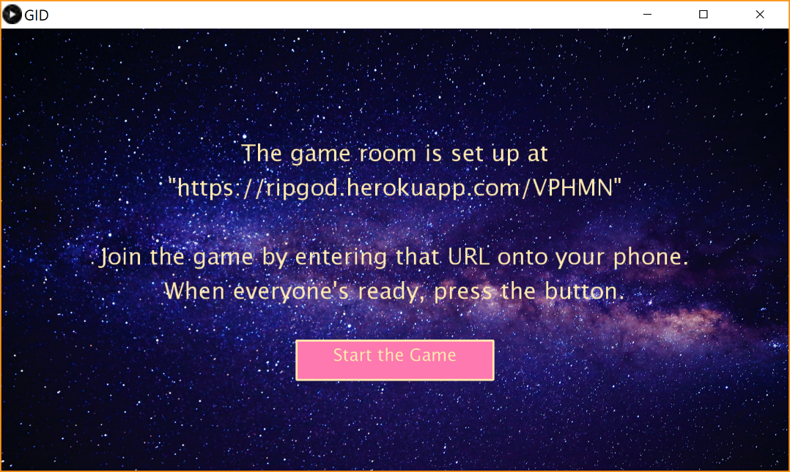

On the note of graphics, I had hoped that I would be able to allow players to select avatars within the game. Using the same reasoning as the limited textual output for players, given that the game is highly dependent on inter-player interaction, I had, effectively, treated the creation of an extravagant front-end as being akin to an extension. Avatars were also compounded into this assumption. As previously stated, players are expected to represent themselves in the game; from tests, testers unanimously agreed that avatars would have been a nice feature to add to the game, however, given the amount of time I had after conducting tests, implementing avatar selection would have been a difficult task to accomplish well.

Finally, the fact that the only thing required to play God is Dead is your phone received an overwhelmingly positive reception. Testers interacting with the technical aspect of the game with their phone found it to be incredibly intuitive, despite the fact that the game lacks information in certain areas. Testers were able to quickly realise the function of different buttons on the screen without any prior exposure to the game. Testers were also quick to agree that using their phone made the game much easier to set up and play as opposed to them needing to bring their laptop along (which some had expected beforehand).

A key issue with the game in its current state is the lack of the investigation phase. This phase would have allowed the players as a collective to nominate one player to “investigate” and thus have their role revealed to the entire group. However, due to the amount of time I had to work on this as a result of other practicals being rather demanding, this is a feature which I felt made the most sense to eliminate, despite my reluctance to accept this fact. Other features such as mobile communication and executing players were deemed critical to the game, and thus would have been unsuitable candidates for exclusion. That is without considering the amount of time that was already spent in their development process.

## Conclusion

Overall, a social-deduction party game was implemented, one which allows any player to join room/game in progress simply by visiting the corresponding URL.

Unfortunately, the networking aspects of the game were much more involved than I had anticipated, consequently leading them to account for longer than expected, nevertheless they did not present an astronomical hurdle in development. As repercussion, the quality of the front-end of the game was impacted, leading to the expectation that this would not appeal to testers. An expectation which was later realised during usability tests.

Ultimately, the core idea regarding God is Dead was successfully implemented, utilising players’ mobile phones as their principal method of interacting with the game itself; a key feature which I had hoped to implement from the beginning.