Report

**Title of the Game: Roll a ball by Víctor Iranzo**

Description:

The game consists on rolling the ball using the keyboard arrows to collect all the pick ups.

**First version:**

Mechanics of the game improved:

-The camera now follows the player from a better point of view.

-Changed the rotation of the pick up.

Artistic aspects improved:

-Added music. Obtained from: [the legend of Zelda skyward sword - zelda's lullaby - piano solo](https://www.youtube.com/watch?v=nJRYoq4CGp0)

-Added a skyview. Obtained from: <http://www.custommapmakers.org/skyboxes.php>

-Changed the texture of all the materials by images.

-Changed the pick up object. Obtained from: [Super Mario Bros - Coin](https://sketchfab.com/models/c49858b084e74f35b8631d9e2c2c2971)

**Second version:**

A new step has been added to the world. It is accessible using 2 ramps, that have been done using Paint3D.

Mechanics of the game improved:

-The camera now moves smoothly.

Photos of the production of the game:

**First version:**

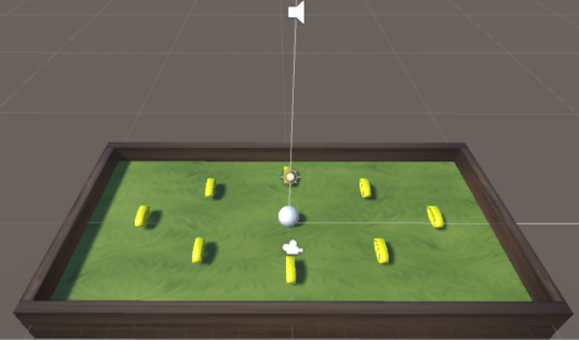

The world is little, like a mini-golf game.

**Second version:**

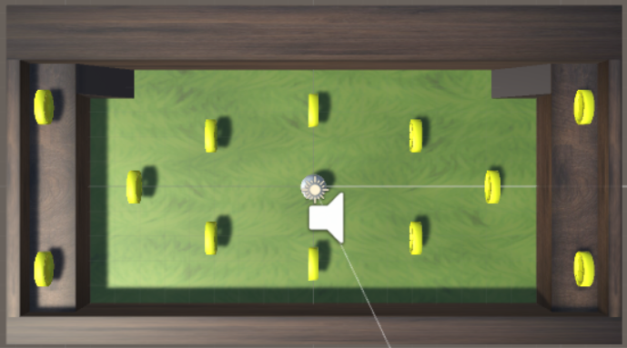

There have been added a second step with 4 coins reachable using a ramp.

Photos of the game in action:

**First version:**

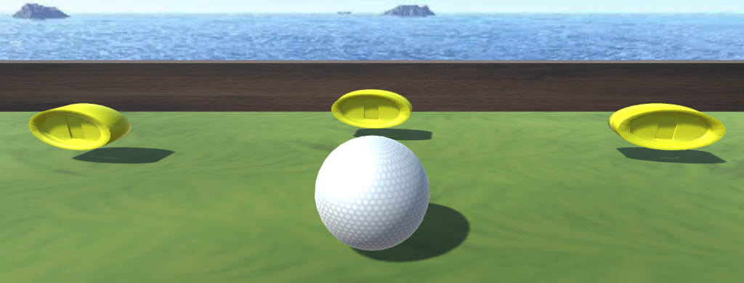

The game looks like a golf game where the player is the ball in a world of grass circled by wood walls.

**Second version:**

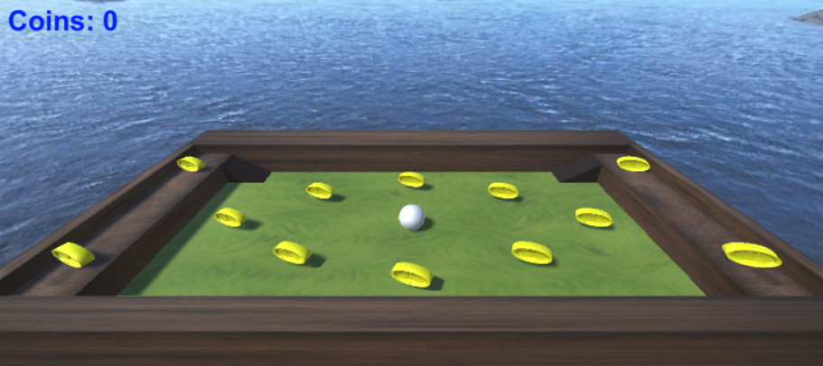

The camera has been changed by a far one, more or less  it has changed "from a first person to a god vision". As a new step has been added, it looks more as a 3D game.

**Technical aspects:**

-Using the ramp the player can fall down from the world. A plane has been added with a tag, and a trigger collider. So when the ball touches it, the game is restarted. In the player controller, I have added the following code:

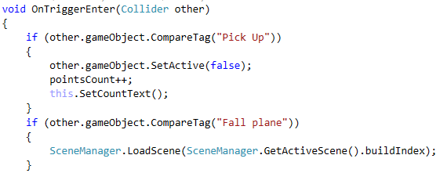

I have also changed some aspects about the lighting because when the scene was restarted the light became dark.

Report

**Title of the Game: Golf-Ball**

**Description:**

The game consists on rolling the ball using the keyboard arrows to collect all the pick ups.

**Mechanics of the game improved:**

-A new step has been added to the world. It is accessible using 2 ramps, that have been done using Paint3D.

-Countdown added.

-Points and coins now are different thing. The points depend on how fast you collect the coins.

-Added Scores, About and Resume menus. For the Scores view a XML file is persisted in the StreamingAssets folder and only the 3 top scores are shown.

-Using the ramp the player can fall down from the world. In this case, a Gameover message appears. This occurs also when the countdown arrives to 0 and not all the coins have been collected.

-The music can be muted from the game window.

**Artistic aspects improved:**

-From the previous version, a new Skybox is used for the game view. It looks like a toy workshop. I have built the skybox from an image, so it doesn't fit so well in the corners.

-All the buttons and panels look like a wood style.

-Added a golf player figure in the main scenario with a gold look.

-Created the title of the game for the menu using Gimp.

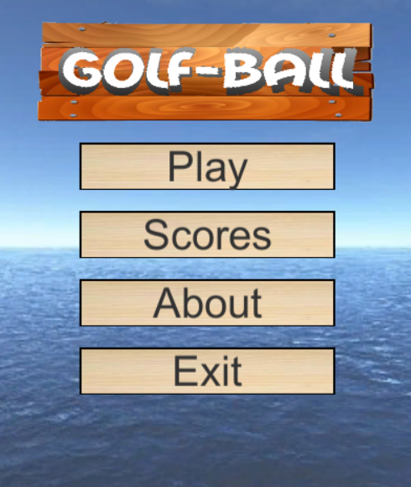

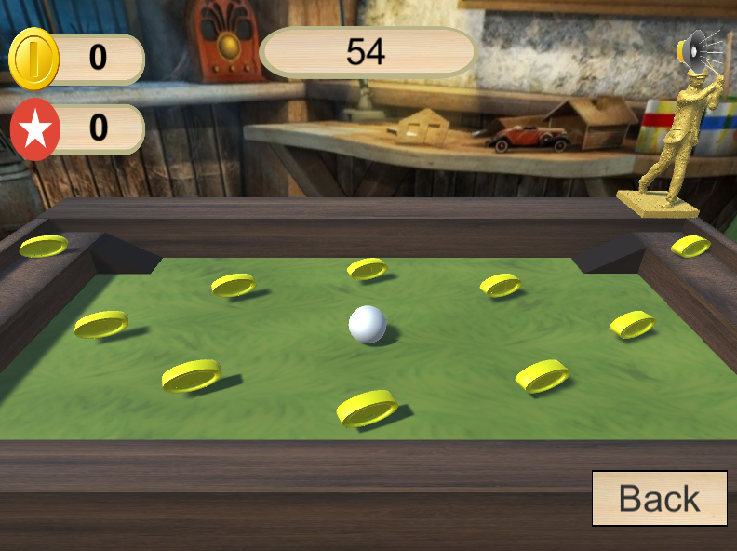

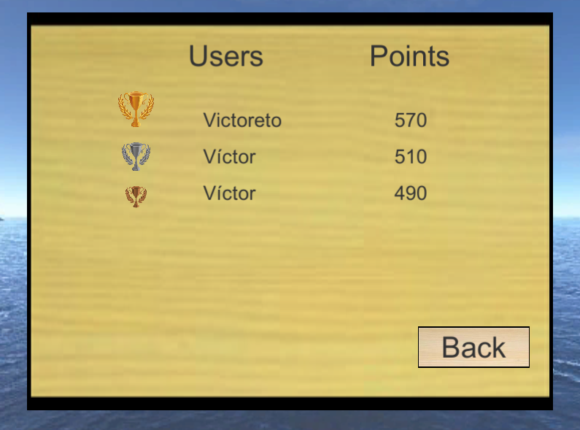

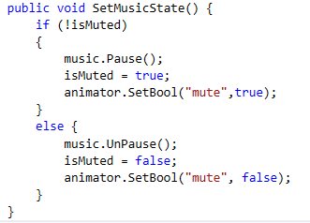

When a click to the sound icon is done, the boolean of the animator changes and a transition occurs to the contrary image while the music is paused.

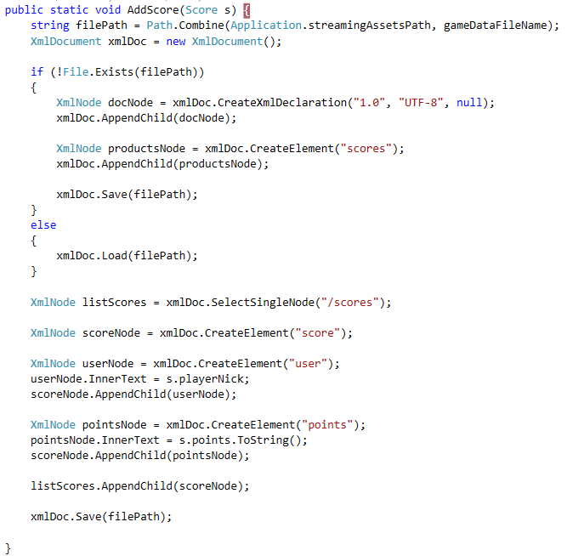

The StreamingAssets exists in every platform where the game is executed. If the XML file of the data doesn't exists, it's created. The XML structure is the attached. All values are wrapped in nodes. This is better that using a single node for each score with attributes for user nick and points.

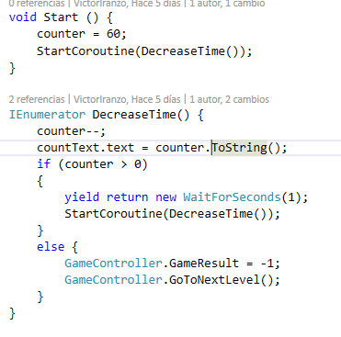

While the counter is positive, a call to the DecreaseTime routine is done recursively. After waiting one second and updating the Text UI element, the next call is done. If the counter arrives to 0, a Gameover is shown.

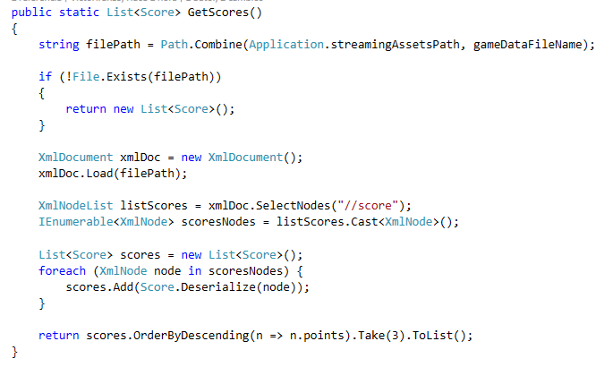

The data.xml file is read. From the XML we get all the childs of "scores" node. Each one is deserialized in a Score object. Then, the list of scores is ordered using LINQ and only the 3 highest in points are returned in a list.