|  |
| --- |
| **EASJ Notes** |
| Object-Oriented Programming With C# |
| A Gentle Introduction |

|  |
| --- |
| By Per Laursen  07-04-2018 |

Preface 6

Getting Started 7

The Programming Process 7

Software tools 9

Microsoft Visual Studio - overview 9

Tools, extensions and packages - overview 10

Tools (workloads) 10

Extensions 11

NuGet packages 11

What should I install? 12

ReSharper 13

GitHub 14

Code organisation and Visual Studio basics 15

Loading code into Visual Studio 15

Code organisation 16

Statements and Syntax 20

Programming I – fundamentals 24

Data Types 24

Variables 26

Arithmetic 28

Code Quality, part I 30

Screen output and type conversions 33

Logic 36

Functions 39

Pre-OO programming 41

Object-Oriented Programming I - fundamentals 42

The Object concept 42

State and Behavior 42

Public and private appearances 44

The Class concept 46

Using objects of an existing class 47

Code Quality, part II 51

Further on object creation 52

Value types and Reference types 54

Class definition elements 58

Instance fields 59

Properties 61

Methods 65

Constructors 69

Class collaboration, and a bit about Abstraction 71

Static – no object needed 74

Programming II – intermediate 76

Conditional statements 76

The if-statement 76

The if-else statement 79

The multi if-else statement 81

The switch statement 83

Repetition statements 85

The while-loop 85

The for-loop 89

Debugging 91

Data structures, part I 94

Arrays (and why you should not use them…) 94

Lists 99

Dictionary 102

Enumerations 106

Code Quality, Part III (Keeping your code DRY) 107

DRY and values 107

DRY and instance fields 109

DRY and methods 109

DRY and classes (and a brief introduction to Inheritance) 112

When does code become DRY? 115

Object-oriented Programming II – Intermediate 117

The has-a relationship (Composition/Aggregation) 117

The is-a relationship (Inheritance) 117

The inheritance mechanism 118

The protected access level 119

Constructors in derived classes 119

Overriding methods 121

Polymorphic behavior 122

Calling base class mehods 124

Abstract methods (and classes) 125

Interfaces 126

The Object class 128

Exceptions 129

Throwing and catching 130

Rethrowing an exception 132

Exceptions summary 133

GUI Development 134

GUI and Object-Orientation 134

Event-driven applications 134

The duality of a GUI components 135

What is XML (and XAML) 137

XAML and Visual Studio – getting started 140

Simple controls 145

Button 145

TextBlock 145

TextBox 146

Image 146

Slider 146

Layout controls 147

Grid 147

StackPanel 148

Control properties 149

Default properties 149

Complex properties 149

Attached properties 150

Layout properties 150

Using styles 151

Data Binding 151

Simple binding between GUI elements 152

Data binding between GUI elements and model objects 152

Collection Views and Data Binding 159

The ListView control – getting started 159

The ListView control – displaying items 161

Defining a data template 163

The ListView control – binding to SelectedItem 164

The GridView 166

Commands 167

Deleting a domain object 167

The ICommand interface 169

The MVVM application architecture 175

MVVM architecture – fundamental features 175

MVVM – single domain object 176

MVVM – collection of domain objects 181

A Data view model class 181

Creating a collection of data view model objects 184

A Page view model class 185

Adding a Delete command to an MVVM-based view 188

Generalising the classes 191

Further parameterisation 194

Generics – types as parameters 194

Shortcomings of inheritance 194

Using types as parameters 196

Type constraints 198

Type parameter variance 200

The IComparable<T> and IComparer<T> interfaces 203

Generic methods 207

Functions as parameters 208

A first attempt at parameterising code 208

Lambda expressions 211

Delegates 214

Events 216

Programming III – Advanced 219

Run-time complexity 219

Data structures, part II 223

The LinkedList class 223

The Queue and Stack class 225

The HashSet class 226

Recursion – iteration without loops 227

LINQ (Language In-Line Query) 232

Purpose and prerequisites 232

Sample Data 233

Selection – single property 234

Selection – several properties 235

Selection – collections containing collections 236

Filtering 237

Ordering 238

Aggregation functions 238

Joining 239

Deferred evaluation 240

Improving performance for resource-intensive applications 242

Managing CPU-bound operations 244

The Task class – creation and invocation 245

The Task class – synchronisation 246

The Task class – cancellation 248

The Task class – advanced topics 250

The Parallel class 250

Managing I/O-bound operations 252

Programming with async and await 253

Managing concurrent data access 258

Unit testing (in Visual Studio) 262

Benefits of automatic unit tests 262

Structure of a Unit Test case 264

Unit Testing in Visual Studio 264

Live Unit Testing 271

Code Coverage 272

Testing in more complex scenarios 273

Data Persistency 277

File-based persistency 277

Accessing data stored in a relational database 284

Creating a local database with Visual Studio 284

Accessing data from an application - overview 285

Accessing a database using the Entity Framework 287

Creating a Web Service for database access 296

Creating a basic RESTful web service 301

Using a RESTful web service 306

Towards a general client-side implementation 308

Deploying a database and web service to the Cloud (Azure) 311

Object-Oriented Programming III – Advanced 322

The Open/Closed principle 324

The Dependency Injection principle 329

Dependency Injection – parameter level 331

Dependency Injection – method level 334

Dependency Injection – class/interface level 335

Design Patterns – Creational Patterns 337

Factory Method 337

Abstract Factory 342

Design Patterns – Structural Patterns 344

Adapter 345

Proxy 348

Design Patterns – Behavioral Patterns 352

Template Method 353

Chain of Responsibility 356

# Preface

This text is intended to serve as an introduction to Object-Oriented programming, using the programming language C#. C# is part of the .NET Framework, developed by Microsoft.

The text has grown out a set of lectures notes on C# programming, and is in its cur­rent form primarily aimed at the course Software Construction, which is part of the Computer Science education at EASJ (Erhvervsakademi Sjælland). It should however be possible to use the text as a general introduction to Object-Oriented program­ming with C#.

The text is intended for students with no prior experience in programming, and is not a complete coverage of Object-Orientation or C#. The primary focus is program­ming, and the activities which surround programming such as requirement specifica­tion, design, deployment, etc. are only peripherally covered. Even though no prior experience with programming is required, we do assume that the reader is familiar with using a PC and the Windows operating system, and is able to download and install programs, etc..

A set of programming excercises has been developed to accompany the text. These excercises can be found on GitHub (<https://github.com/perl-easj>), along with C# source code (so-called projects) for each exercise. The text will occasionally refer to some of these projects. The most recent version of this text itself can also be found on GitHub.

The text has been prepared by me (Per Laursen), and has been an ongoing project since 2012. The text is as mentioned available on GitHub, and will be upda­ted con­tinu­ously. If you wish to use the text – partially or as a whole – for study purposes or as teaching material, feel free to do so. Any feedback will be greatly appreciated.

I would finally like to stress again, that this text is not intended to provide full cover­age of Object-Orientation or C#. I will usually prefer clarity over completeness, and the reader should be prepared to seek additional information from other sources.

# Getting Started

In this chapter, we take the first steps towards understanding what “computer pro­gramming” is all about. We introduce some of the software tools we will be using for developing C# programs, and take a first look at the structure of a so-called C# project.

## The Programming Process

If you have never tried something like computer programming before, it may seem like a mysterious activity – what is it really that we are doing? If we primarily focus on computer programming as a way of defining “business logic”, we are usually ***defining and mani­pulating a model of a small piece of the world***.

What does that mean more specifically? Suppose we wish to create a computer pro­gram – or **App[1]**, for short – for administration of a school. Then we probably need to store and process certain information about students (and other things) in the App. What information is relevant to know about a student? Date of birth? Shoe size? That will depend entirely on the **requirements** to the App, which somebody will have to define.

The outcome of such a requirement definition process will probably be that cer­­tain parts of the available information is need­ed, while other parts can be left out. So, the “model” of a student in the App may only contain certain informa­tion; the information which is relevant in relation to the requirements. Exactly which information we include will depend on the specific situation, i.e. the spe­ci­fic requirements.

Once we have figured out what information we need to include for each “concept” (student, teacher, classroom, course, …) in the model, we need to figure out how to repre­sent that information in our App. We get to that part very soon!

In almost all cases, the information will need to be processed in a certain way. A very simple pro­cess­ing could be just to show the information to a user of the App. A more complex processing could be to change the information. For a student, some information will probably never change (e.g. the date of birth), while some information will most likely change (e.g. the number of courses taken).

The way information changes can range from quite simple to very complex. The simplest change could simply be to change the current value to a new, given value. Say, when a student has taken one more course, the number of courses is increased by one. Other changes are more complex. If we e.g. store an average of the marks obtained for the exams passed by the student, then passing an additional exam will require a recalculation of the mark average. In any case, there will always be rulesfor how to process the information.

In programming, we then try to translatesuch rules (formulated in a human – or at least human-friendly – language) to instructions/logic written in a language the com­puter can understand; or more precisely: written in a language that

* We as humans can use to express such rules with relative ease, and
* The computer (using specialised software called a **compiler**) can translate into a language the computer hardware understands “directly”

A wide range of such **programming languages** exist. Some are quite obscure and only known to few, while others have gained widespread popularity. The program­ming language called **C#** (C-sharp) belongs to the latter category, and is used in these notes. C# is a so-called **Object-Oriented** language; other such languages are e.g. Java and C++.

So, translating our rules into the chosen programming language will result in writing a number of **statements**. A single statement usually performs a quite simple step of data processing, so most interesting programs will contain a large number of such statements (many thousands, even millions…).

When we have a large body of statements, we need to organise them into larger units. One such unit is a **method**, which is a fairly small collection of statements (usually less than twenty) performing a somewhat more complex kind of data processing. Collections of methods can then be organised into even larger units called **classes**, and so forth. We will discuss such units of organisation later in these notes.

## Software tools

In order to write Apps using the C# language, we need some software tools to help us with this. These software tools should enable us to:

* Write C# code as easily as possible
* Write C# code of high quality
* Write C# code in collaboration with other developers
* Help us to obtain – and maintain – an overview of the entire body of code, including all the various units of code organisation
* Translate our C# code into code that the computer can run directly
* Help us find and fix errors in our code, both when the code is written (syntax errors) and executed (logic errors)

Some of these features are somewhat fluffy (what does e.g. “high quality” mean in relation to C# code…?), but we will try to be more specific later in the notes.

### Microsoft Visual Studio - overview

C# is invented by Microsoft, and their tool **Visual Studio** can on its own help us with much of the above. You can obtain a free copy of Visual Studio from the school[2].

Visual Studio is a professional and commercial tool, with a lot of “bells and whistles”. It can therefore appear somewhat overwhelming at first glance. Fortunately, we only need to under­stand and use a fraction of the functionality:

* Understand the structure of a so-called solution or **project**
* Be able to navigate through the files in a project
* Understand the role of the files included in a project
* Add code to a project
* Compile, build and run a project
* Understand error messages from Visual Studio

Before we dig into the details about how to perform the above actions in Visual Studio, we need to take a brief look at the overall structure of Visual Studio as such.

### Tools, extensions and packages - overview

In the earlier days of Visual Studio, Microsoft seemed to approach the development of Visual Studio in a “monolithic” fashion, where the intention was to build a single, stand-alone tool, which (ideally) would contain everyting you need in order to deve­lop software. As the world of software development has become more and more complex and fragmented, Microsoft has now adopted a much more open strategy, where Visual Studio has the role of a sort of “functionality hub”, which on its own only contains limited functionality, but instead allows you to add additional func­tionality to Visual Studio by different means. The three major ways to add function­ality is through **tools**, **extensions** and **packages**.

### Tools (workloads)

The term **tool** may be a bit misleading in this context, since it actually refers to a num­ber of so-called **components**, which adds some capability to Visual Studio. Since a very large number of these components exist, Microsoft have bundled them into so-called **workloads**. A workload is thus a collection of a (large) number of compo­nents, which adds a capability to Visual Studio, for instance the ability to develop applications for mobile devices. Below is an example of some of the workloads that can be added to Visual Studio (also see[3])

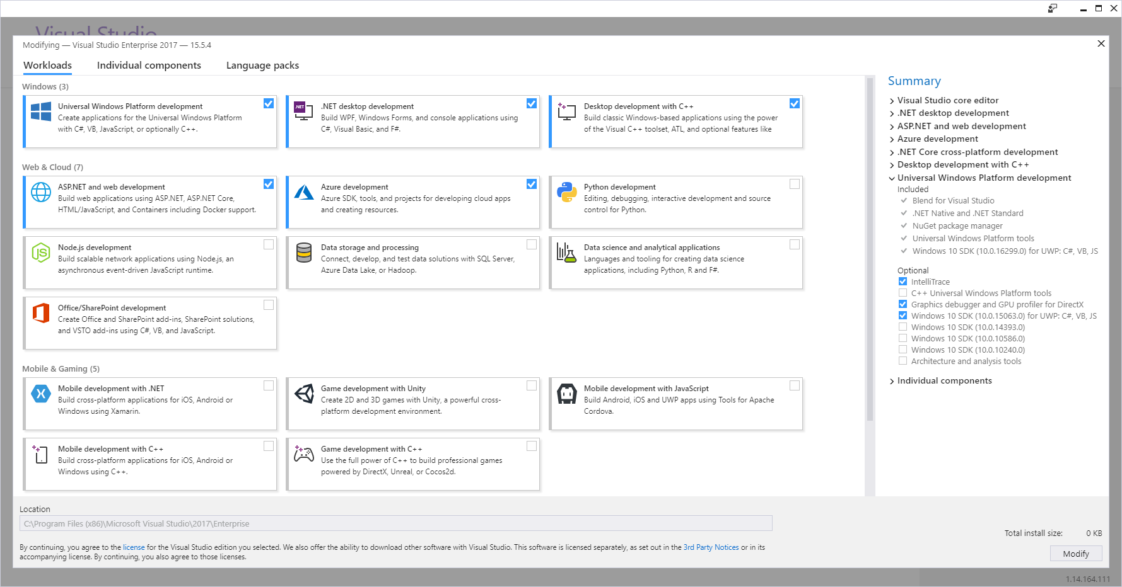

### Extensions

The workloads described above are thus optional to include in your own customised setup of Visual Studio. Still, they mainly consist of tools developed by Microsoft. It is however also possible for a third-party developer to develop software that integrates into Visual Studio. By “integrates into” is meant that once the third-party software in question has been installed, it will not appear as an extra application, but rather ma­ni­fest itself as extra functionality added to Visual Studio itself. The functionality may be very “discreet”; it could e.g. just add some keyboard shortcuts to the already ex­ist­ing shortcuts.

That fact that Microsoft has opened the door for third-party developers has resulted in a flurry of such extensions. You can (try to) get an overview of these extension at the Visual Studio Extension Marketplace[4].

### NuGet packages

The extensions described above will usually add some permanent features to Visual Studio, for instance an enhancement to the development user interface. An exten­sion is thus not something that relates to a specific development project, but rather to Visual Studio seen as a tool. Suppose now that a third-party developer has come up with a nice piece of software – maybe some very efficient algorithms for data encryption – and wish to make this software available to other developers. This can be done in the form of a **NuGet package**. Such a package is simply a way of distribu­ting code from third-party developers. The ability to use NuGet packages directly from Visual Studio has been a part of Visual Studio for some years now, and seems to have evolved into the *de facto* standard for package distribution.

A very important difference between extensions and packages is that packages are added to individual projects! If you are developing an application which needs to use encryption, the project for that application may need to refer to a NuGet package containing that functionality. If you are developing another application which does not use encryption, it doesn’t need to refer to that package. In general, you try to limit references to packages to those packages you actually use, to keep the size of your applications as small as possible.

### What should I install?

The concept of piecing together your setup of Visual Studio may appear confusing at first. Don’t worry too much; if you miss something along the way, you can always add it to your installation later. Also, we only need to install a fairly small set of tools and extensions to begin with.

With regards to **workloads**, we need to have three workloads installed initially. Once you have successfully installed Visual Studio and started it, choose **Tools | Get Tools and Features** from the menu. This should bring up the overview of workloads we saw a couple of pages back:

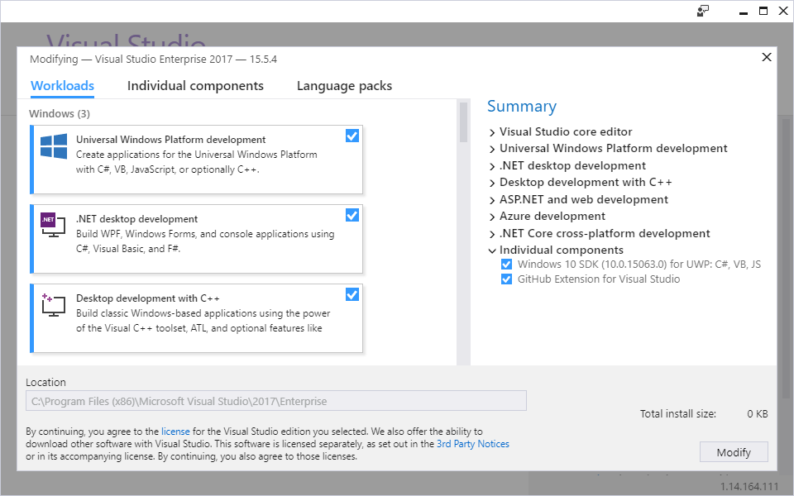

Initially, we only need to have these three workloads installed:

* Universal Windows Platform development
* .NET Desktop development
* Desktop development with C++

If there is already a checkmark in each of these three boxes, you don’t need to do anything – just close the window. If not, then check the missing boxes and press **Modify**. Note that these workloads are quite large – some of them several Gigabyte of data – so installation may take a while. Be patient ☺.

With regards to **extensions**, we need to install two extensions initially:

* Resharper Ultimate (by Jetbrains)
* GitHub Extension for Visual Studio (by GitHub)

We will provide brief descriptions of these extensions in a moment. The easiest way to install extension is to choose **Tools | Extensions and Updates** from the menu. This should bring up the below dialog:

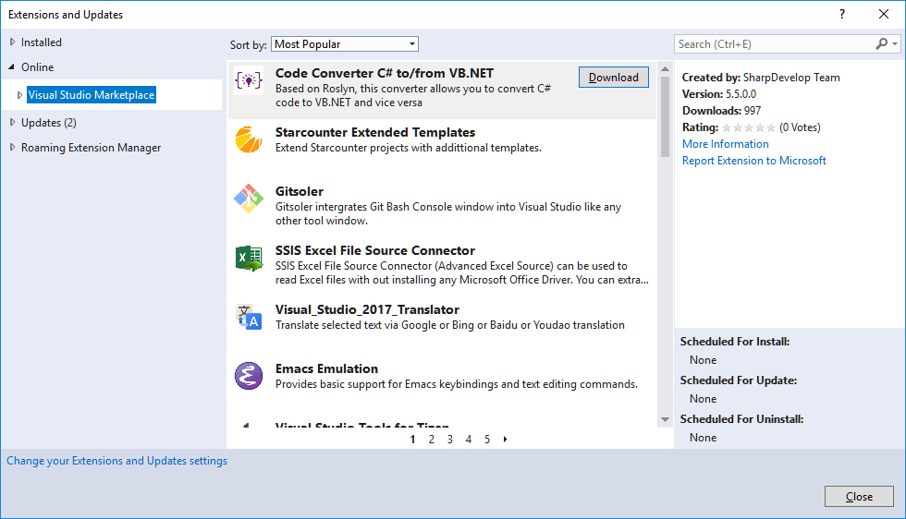

If you expand the **Online** node, and highlight **Visual Studio Marketplace**, you can then use the search box in the upper-right corner to find each extension. Once found, click on the **Download** button for the extension. This will download the extension and pre­pare it for installation. The installation will however not be completed before you close Visual Studio. Once you open Visual Studio again, the extension should be installed.

### ReSharper

The ReSharper extension provides a lot of extra/improved functionality to Visual Studio, but it will not as such be visible; it will just seem like Visual Studio has been updated with extra functionality. In fact, it can be hard to distinguish between native Visual Studio functionality and Resharper functionality, but that is more or less the point. For a newcomer to Visual Studio and/or programming in general, the most note­worthy feature of Resharper is probably its ability to provide suggestions for how to fix problems in your code. This is to be understood in a quite broad sense; Reshar­per can provide suggestions for fixing errors that makes your program unable to compile (so-called **syntax errors**), but can also provide suggestions for changing code that is actually compilable, but may contain an unsafe construction, be ineffi­cient, etc.. It can initially be a bit difficult to navigate through all these suggestions, but there are (fornunately) also ways to configure how “intrusive” Resharper should be with regards to presenting suggestions. We will revisit this feature – and some other features – of Resharper later in these notes.

### GitHub

In the beginning of the chapter, we mentioned that our development tool should also enable us to collaborate with others when writing code. This is probably not a feature you will need until you embark on creating a larger App as part of a group project, but it is still useful to set up from the beginning, since you can also use it to safely experiment with code changes, without risking to lose previous work.

A general challenge in multi-developer projects is to ensure that the deve­lopers can work independently – and simultaneously – on the project. As long as the deve­lop­ers work on non-overlapping parts of the project, the process is fairly easy to manage. In reality, you may however often need to work on parts that do overlap, and you then need to be very careful about how to manage changes to the project.

This is obviously not a new problem, so the concept known as **version control sys­tems (VCS)** is well-established in software development. These systems will typically maintain a “master” version of the project at some central location (i.e. a location which all developers can access – this is often referred to as a **repository**), and pro­vide the developers with various tools to be able to manage changes to the project in a safe and systematic way. The exact strategy for how to manage changes may vary from system to system, and may also depend on the policies for change manage­ment agreed upon by the developers. Almost all modern VCSs also offer a lot of useful features like maintaining a complete history the project – making it possible to “roll back” a project to a certain point in time – statistics, integration with tools like Visual Studio, etc..

A lot of VCSs exist today, and it may be hard to choose one over another. The VCS called **Git** has gained widespread popularity, and we have chosen to use Git as the VCS of choice as well. The GitHub extension integrates VCS functionality based on Git into Visual Studio. But why is the extension then called **GitHub**? The term GitHub is strictly speaking a reference to the website [www.github.com](http://www.github.com), which offers web-based hosting of repositories, including – but not limited to – source code reposi­to­ries. The service uses Git technology under-the-covers, but also adds functionality on top of the native Git functionality. GitHub has also gained substantial popularity in recent years, and offers free repositories without significant limitations, as long as the repositories are public.

The GitHub extension simply adds GitHub-based VCS functionality to Visual Studio. This means that project files can be managed (w.r.t. version control) directly in Visual Studio. Several other features also become available, which we will discuss later in these notes.

## Code organisation and Visual Studio basics

We should now be up-and-running with Visual Studio, including the workloads and extensions covered in the previous section. We will now try to open a (very small) piece of code in Visual Studio, for two purposes:

* Investigating how code is organised
* Trying to load, navigate, edit and run the code

### Loading code into Visual Studio

For demonstration purposes, a small piece of code called **Sandbox** has been created. This piece of code should be available to you – exactly where will depend on the course, but your teacher can inform you about this ☺. With this information, you should be able to follow the below steps:

1. Start Visual Studio
2. From the menu, choose **File | Open | Project/Solution…**
3. Navigate to the folder called **Sandbox**, and go into the folder
4. Double-click on the file called **Sandbox.sln**
5. The code should now load – you will see some files in the window with the title ***Solution Explorer***

If you have completed the above steps successfully, you should see something similar to this in the ***Solution Explorer*** window (if you for some reason don’t see a window with this title, choose **View | Solution Explorer** from the menu):

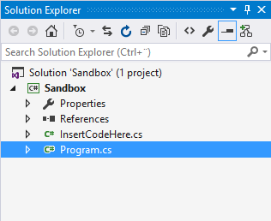

What are we seeing here? In order to understand that, we need a basic under­stand­ing of **code organisation** in Visual Studio.

### Code organisation

The highest unit of organisation in Visual Studio is a **solution**. Remember that Visual Studio is an advanced, industrial-strength tool, which can handle very complex soft­ware development tasks. This could imply that the entire “solution” to e.g. a school administration system would contain several applications (say, a smart­phone App for students, a desktop App for staff, another desktop App for admini­stra­tors, etc.). All these applications should be manageable as one integrated solution.

The next level is a **project**. A project will usually correspond to a single application. If you have several projects in a solution, you will still be able to modify, compile and run a single project, without involving the other projects.

With this information, we can already better understand what we just did, and what we see in the ***Solution*** (aha!) ***Explorer*** window.

First, we navigated to a folder called **Sandbox**. In Visual Studio, a solution is typically con­tained in a file folder with the same name as the solution it contains. So, this folder contains a solution called **Sandbox**.

Second, we entered the folder. The folder contained

* A file called **sandbox.sln**
* A folder called **Sandbox**

A file with the extension **.sln** is interpreted by Visual Studio as a **solution file** (.sln = solution) which holds information about a particular solution. The subfolders in the folder contains those projects that are part of the solution. So, the solution **Sandbox** thus contains a project called… **Sandbox**. It might seem confusing that we have a pro­ject with the same name as the solution it is part of, but this is actually a quite common naming convention for small solutions that only contain a single project. It will be quite a while before we deal with solutions containing more than one project.

Third, we double-clicked on the **sandbox.sln** file. This prompted Visual Studio to load in the **Sandbox** solution, which only contains the **Sandbox** project. This is what we see in the ***Solution Explorer*** window:

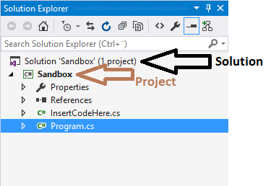

The project itself is where the really interesting stuff is. The stuff “hanging” under the **Sandbox** project in the ***Solution Explorer*** window is where the actual C# code is. Before dealing with actual code, we return again to the code structure discussion.

What is the next unit of organisation below **project**? The simple answer is **classes**. Classes is where the actual C# code resides, and we will deal with classes in great detail in these notes. A class is (usually) defined within a single file with the extension **.cs**. In the **Sandbox** project, there are thus two classes **Program** and **InsertCodeHere**, defined in the files **Program.cs** and **InsertCodeHere.cs**, respectively.

With this information, we should be able to understand almost everything we see in the ***Solution Explorer*** window. The two items called **Properties** and **References** are not interesting at this point, so they will remain a mystery…

For completeness, it should be mentioned that a unit of organisation between **pro­ject** and **class** actually exist, called **namespace**. A namespace is a way to organise classes that in some sense belong together, which can indeed be useful in projects with many classes. However, if you have very few classes in your project, the most common setup is to have just one namespace, with the same name as the project. We will not really utilise namespaces before our projects grow beyond these “few classes”.

Returning to classes – which we advertised as containing actual C# code – the next unit of organisation is **methods**. A method is a collection of C# **statements**, that per­forms some useful task. We will deal quite a lot with methods later on. It should also be mentioned that classes can contain more than just methods, but in terms of code organisation, they can for now be thought of as containers for methods.

With statements, we have reached the end of the line of terms of code organisation, since statements are the “atoms” of code. Let us then review the entire hierarchy of code organisation:

A **solution** contains a number of

**projects**, that contain a number of

**namespaces**, that contain a number of

**classes**, that contain a number of

**methods**, that contain a number of

**statements**

A six-tiered hierarchy, no less! This may seem overwhelming, but try to compare it with a publication of a large body of text, say, the collected works of Kierkegaard (a Danish philosopher of some fame). Such a publication would probably be organised like this:

A **publication** contains a number of

**volumes**, that contain a number of

**chapters**, that contain a number of

**sections**, that contain a number of

**paragraphs**, that contain a number of

**sentences**, that contain a number of

**words**

A seven-tier hierarchy… This hopefully illustrates that the code organisation is as such quite meaningful, and not overly complex. However, the solutions we will encounter in relation to these notes will usually have a rather simple structure:

A **solution** that contains one

**project**, that contains one

**namespace**, that contain a few

**classes**, that contain a few

**methods**, that contain a few

**statements**

This also holds for the **Sandbox** solution. Going forward, we will try to work in a bottom-up fashion, where we initially focus entirely on writing statements, without thinking too much in terms of methods and classes.

We conclude this first brief look at Visual Studio by trying to actually run the code we have loaded into Visual Studio, i.e. the **Sandbox** project. In general, C# code must be compiled and built, before it can be executed (running the code is often denoted as executing the code). Compiling and building C# code essentially consists of two activi­ties, both performed by Visual Studio

1. Checking that the code obeys the syntax for the C# language
2. Translating the code into a language the computer can execute directly

The process is a bit more sophisticated than this, but we need not worry about that now. One important thing to note is that even though the code passes successfully through these steps – and can therefore be executed – there is no guarantee whatso­ever that the code behaves as we intend it to, i.e. that it complies with our require­ments. We will return to this distinction later.

The **Sandbox** project does contain code that is ready-to-run, and we set the execution of the code in motion by either pressing ***F5*** on the keyboard, or clicking on the button containing a small green triangle in the toolbar:



If you are able to run the code successfully, you should see something like this appear on your screen:

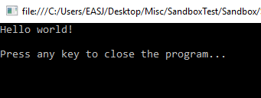

This somewhat primitively looking window is a so-called **console application**. This is what most Apps looked liked before Windows and Macs became mainstream. It does look rather dull, and only allows input/output in character form, but using this style first enables us to postpone having to learn about GUI (GUI: Graphical User Interface) development initially.

As advertised on the screen, the App does nothing more than print ***Hello world!***, and now awaits that you press a key on the keyboard to terminate it. Once you do that, you have successfully loaded, compiled, built and executed your first C# appli­cation using Visual Studio!

### Statements and Syntax

As promised earlier, we will investigate the organisation of code in a bottom-up manner, starting with the simplest entity: the **statement**.

A statement can be thought of as a “code atom”, i.e. it is a fundamental code building block, but it also has an internal structure, which must follow certain rules. We cannot just mash up any sequence of characters and claim it to be a C# statement, just as we cannot throw together a random mix of electrons, neutrons and protons, and expect to end up with a stable, useful atom. Only certain combinations qualify as being valid C# statements.

More specifically, a statement is an instruction to the application about what to do next. This could be to

* Perform an arithmetic or logical calculation
* Read or write data to a file, the screen, etc..
* Control the “flow” of execution, i.e. choose between several alternatives about what to do next
* Etc.

You may already here sense that statements tend to fall into two board categories: statements that actually do something, like a calculation, visualisation or data trans­fer, and state­ments that control what to do next, depending on certain conditions. We shall see several examples from both categories in these notes.

Returning to Visual Studio; if you – assuming the **Sandbox** project is still loaded – double-click on the file **InsertCodeHere.cs** in the ***Solution Explorer*** window, a new window will open, showing the content of that file (there may be some small differences between the code below, and what you actually see in the window):

**using System;**

**namespace Sandbox**

**{**

**public class InsertCodeHere**

**{**

**public void MyCode()**

**{**

**// The FIRST line of code should be BELOW this line**

**Console.WriteLine("Hello world!");**

**// The LAST line of code should be ABOVE this line**

**}**

**}**

**}**

This may look a bit overwhelming, with a lot of colors and odd characters posi­tioned strangely on the screen; for now, try to apply “tunnel vision”, and focus on a single of these lines:

**Console.WriteLine("Hello world!");**

This line is indeed a C# statement. It instructs the computer to print out the words ***Hello world!*** on the screen. However, if you are new to programming in general, that may be hard to figure out just by reading the line of code… The sentence ***Hello world!*** is indeed part of the line, but it is wrapped up in a lot of other stuff. What that “stuff” precisely means is not that important – we will learn to under­stand it later on.

To put it in more general terms: there will usually be a “gap” between what we intend the computer to do, and how we express that intention in a programming language. In human language, our intention could be written as:

Please display the words ***Hello world!*** on the screen.

In C#, that intention is expressed as:

**Console.WriteLine("Hello world!");**

If somebody could make a compiler that could directly translate the human-language intention into executable code, the world wouldn’t need programmers… However, human language is inherently vague and ambiguous, while a computer needs very precise instructions! If you think about it, the human-language intention leaves many questions unanswered, like e.g.

* How should the words be displayed (where on the screen, color, size, etc.)?
* What “words” exactly. Only **Hello world!** or maybe **Hello world! on** or…?
* What should be done after displaying the words? Stop the application, wait for the user to do something, or…?

And this is just for an extremely simple intention! For more complex intentions, we need intermediate “stops” on the road from intention to code, like requirement specifications, designs, etc..

Another distinction between human-language intentions and C# code is the tole­rance for errors. Suppose we made some small spelling mistake in our intention description:

Please displlay the words ***Hello world!*** on the screen.

This small mistake would probably not hinder another human being in under­standing the intention. However, a similar mistake in the C# statement, like

**Console.WriteLline("Hello world!");**

will have catastrophic consequences (Try it! Open the file **InsertCodeHere.cs**, make the change, and try to run the application…). The compiler is absolutely unforgiving about errors! A C# statement has to strictly follow a predefined **syntax** for that parti­cular type of statement. Imagine that your mail application had a similar Draconian[5] attitude towards errors, absolutely refusing to send a mail unless there are ZERO spelling and grammatical errors in the content…

The fact that C# programming (and most programming, actually) is a discipline that requires strict adherence to a given syntax, is something you need to come to terms with as an aspiring programmer. Fortunately, the software tools available now do a very good job in assisting you with getting the syntax right. If you try to modify or add code to the **Sandbox** project, you will quickly notice that Visual Studio will provide suggestions to – and even point out errors – while you type! Visual Studio’s eagerness to help you can feel a bit intrusive and confusing at first, but once you get used to it, you will find it quite helpful.

If you tried to do the small change suggested above, you probably noticed that a squiggly red line appeared below the incorrect piece of code. Such lines imply that something is wrong with the code! If you hover the mouse cursor over the line, an error mes­sage tooltip will pop up. Some error mes­sages may be hard to understand for a novice programmer, and the best advice is often simply to try to read the code again, and use your common sense to spot the problem.

In general, you should try to fix errors as soon as you see them! If you have more than one error in your code, some errors may actually not be true errors, but rather errors that occur because the previous code is incorrect. In that case, you should try to fix the errors from the top and downwards.

If we zoom out just a little bit in the code in the **InsertCodeHere.cs** file, you will notice some more lines of text:

**// The FIRST line of code should be BELOW this line**

**Console.WriteLine("Hello, world");**

**// The LAST line of code should be ABOVE this line**

Are these new lines also C# code? No, they are so-called **comments**. A comment is just a piece of text that Visual Studio does not consider to be code, and it will there­fore ignore it when compiling the code. Comments are thus only present in order to help the human beings working with the code. A single-line comment like the two above must always start with the symbol **//**. A multi-line comment must start with the symbol **/\***, and end with **\*/**.

The ability to add comments to code is very common in programming languages, and it is consider good practice to add comments to code that has a certain complexity[6], to help those that might work with the code at a later time.

In this specific situation, the two comment lines have been added to outline the “sandbox” (hence the project name) within which we will play around for a while, to learn about the fundamentals of programming.

# Programming I – fundamentals

We have already discussed what the programming process as such is all about – instructing the computer to do our bidding! Being a bit more specific, we can say that programming essentially deals with **representation** and **processing** of data.

Concerning processing of data, we can detail this activity further:

* Obtain the data needed for a particular type of processing
* Store the data in the computer memory, in suitable data structures
* Perform the processing, according to certain business logic (algorithms)
* Store the resulting data in suitable data structures
* Enable the user to access the resulting data

The two main topics we need to delve into are thus:

* Data representation, using suitable data structures
* Data processing, using suitable algorithms (sequences of statements)

The first question to consider is then: What types of data do we wish to be able to represent and process? Possible types could be:

* Numeric data (numbers)
* Text data
* Logical data
* Special-purpose data (pictures, music, etc..)

We will here focus on the first three types of data, since the last category typi­cally requires more advanced handling, which is beyond the scope of this text.

## Data Types

From the computer’s perspective, the discussion about “types” of data is somewhat meaningless, since all data is represented as sequences of **bits**, where the value of a bit is either 0 or 1. However, working directly at the bit level is somewhat obscure for human beings, so we like to group bits together in larger units, and interpret such a group in different ways.

The first common level of bit-grouping is to define a group of 8 bits as being a **byte**. We very rarely work at a finer level than the byte-level. As you may know, a modern PC will usually have between 4 and 16 Gigabytes of working memory (RAM). Each byte in the computer memory can be specified by its **address**. The address is just a counter starting from zero, up to the number of bytes in memory. When we place some data in the working memory of the computer, we are essentially just writing a sequence of bytes into a specific area of the memory, starting at some given address.

Suppose we want to store something more human-friendly than “raw” bit sequences in the computer memory, for instance an integer number (i.e. a number without any decimal part, like 12 or 704). How do we translate an integer number into bits? First, we note that with 8 bits in a byte, we can create 28 (2 to the power of 8) different bytes, like

00000000

00000001

00000010

00000011

00000100

00000101

…and so on, until

11111111

Hopefully, you can see a system here. If we choose to interpret the first bit sequence as the number 0, the next one as the number 1, the next one as the number 2 and so forth, we get:

00000000 = 0

00000001 = 1

00000010 = 2

00000011 = 3

00000100 = 4

00000101 = 5

…and so on, until

11111111 = 255

So, we can use a single byte to represent numbers from 0 to 255. Actually, since it is us that interpret the sequence of bits, we are free to choose a different starting num­ber than zero, if we also want to be able to store negative integers. Suppose we start from -128. We can then follow the same pattern as above, giving us a range from -128 to 127 (both included).

This is very nice, but what if we need to store larger numbers? We could then choose to use four bytes instead of just one byte to represent a number. That would give us a more impressive range, from –2147483648 to 2147483647. You could even use 8 bytes, giving you an even large range. A natural thought could then be *“well, lets be absolutely sure we have a large enough range! Lets use 64 bytes for each integer number!”*. For most applications, this would probably also work fine in this day and age, where even tiny devices have multi-gigabyte memories. Still, there was a time where memory was a more scarce resource, and there are indeed still many appli­cations today where you have to be quite careful w.r.t. memory consumption. A Machine Learning algorithm may need to represent billions of numbers, making it a highly relevant matter if each number takes up 4 or 8 bytes.

The general point, however, is this: Even though the computer stores everything as sequences of bits, we can fortunately make use of more human-friendly data types, that are available in C#. The compiler – and underlying code – will handle the details of the translation to bits for us.

A lot of these so-called **primitive data types** are available; we only present a few here, but feel free to look for additional information about other such types else­where. The names of the types are sometimes a bit obscure, which is often for historical reasons.

|  |  |  |
| --- | --- | --- |
| **Type name** | **Memory use** | **Description** |
| **int** | 4 bytes | A number without decimal part, like -98 or 6501.  Range: from –2147483648 to 2147483647 |
| **double** | 8 bytes | A number with decimal part, like 3.8716243456  Range: from about 10-308 to 10308  NB: Not completely precise! |
| **bool** | 4 bytes | A boolean value, either **true** or **false** |
| **string** | One byte per character | A sequence of characters, like ***“Hello!”***  NB: Strictly speaking not a primitive type! |

Notice how these four types match the three types of data (numeric, text and logical) we initially stated we want to be able to process. With that in place, we can begin to define so-called **variables** in C#.

## Variables

A variable in C# - and programming languages in general – is just a piece of memory that we define as containing data of a certain type. We can then store and change the actual data as we wish, hence the term “variable”. The data in a variable will thus be located at a specific address in memory. However, instead of having to refer to that address directly, we assign a name to the variable as well. Creating such a variable in C# can look like this:

**// Reserve space in memory for an int,**

**// refer to the address by the name “age”**

**int age;**

**// Store the value 24 in the address**

**// referred to by “age”**

**age = 24;**

The first line of code is called a variable declaration, where we reserve some memory in the computer, with the intention of storing data of the type **int** in it. At this point, there is strictly speaking not any data in the variable yet (in practice, C# will set the value to zero initially). The next line – which is known as an assignment statement – puts the value 24 into the memory referred to by **age**.

If you are new to programming, but have some knowledge of mathematics, the second statement may seem confusing. You may think that this statement tries to compare **age** with 24 – which may be true or false, depending on the value of **age** – which is how to understand that statement in a mathematical context. However, in C# that statement is an action; we change the value contained in **age** to 24. We will soon see how to express a comparison of two values.

Suppose we added a third line of code after the first two lines:

**age = 28;**

This will change the value of (the data in) **age** to 28. What happens to the previous value of 24? That value is now irretrievably lost! A variable of this type can contain only one value of the specified type, so assigning a new value to the variable will overwrite the existing value.

Finally, it is considered good practice to initialise – i.e. assign an initial value – to a variable as part of the declaration statement, like this:

**// Reserve space in memory for an int,**

**// refer to the address by the name “age”,**

**// and initialise the value to 24.**

**int age = 24;**

If the initial value of an **int** variable should be 0, you should still write this explicitly, even though an **int** is initialised to 0 by default. By writing it explicitly, you remove any doubt about whether or not you simply forgot to initialise the variable…

## Arithmetic

A very important part of most programming tasks is **arithmetic**. Almost all program­ming languages support arithmetic, since much data processing has an arithmetic nature – we perform calculations. The specific syntax may vary somewhat between the different languages.

C# supports most common arithmetic operations, but there are certain operations that differ from “classic” arithmetic. We have already seen an assignment statement

**int age;**

**age = 24;**

Again, be aware that the second line means *“change the value of* ***age*** *to 24”*, and NOT *“compare the value of* ***age*** *to 24”*.

Below is an example of very simple arithmetic

**age = 24 + 32; // Now age is 56**

Perhaps not the most mind-bending example, since we could just have written 56 directly on the right-hand-side of the **=** symbol. A bit more interesting is this:

**age = age + 10;**

Can we really assign a new value to a variable, and use the variable itself as part of the assignment? Yes, because the expression on the right-hand-side will be evaluated first – using the value currently assigned to **age** – and the resulting value is subsequently assigned to **age**. Suppose the value of **age** is 24 when the statement is reached. The first step is then to evaluate the right-hand-side, which is 24 + 10, i.e. 34. Next, the value 34 is assigned to **age**, thus replacing the previous value of 24.

We can have complex expressions on the right-hand-side of an assignment, involving several variables, say

**double tax = incomeTax + housingTax + 0.5*zoneTax;**

assuming that the variables on the right-hand-side have been declared previously.

Doing addition, subtraction and multiplication with integer numbers is fairly straight­forward (even though integer overflow[7] is a pitfall). Division can be slightly more tricky. Consider the below code:

**int a = 7;**

**int b = 4;**

**int c = a / b; // a divided by b**

The result is NOT 1.75 as you might expect, but 1. When doing arithmetic with inte­gers, the result will also be an integer. Also, there is no rounding of the result. It might seem more natural that **c** should become 2, but it doesn’t!

There are some non-standard operators in C#, for instance the “remainder” operator % (or “modulo”)

**int a = 7 % 4;**

The result of the above is 3 – the remainder when dividing 7 with 4 (integer division). The modulo operator is not something you will use very often, but it can come in handy when e.g. checking if, say, a number is even. We will see such examples later.

The usual rules for so-called operator precedence also apply in C#, so e.g.

**int a = 2 * 3 + 4; // This is 10, NOT 14**

Use of parentheses is also allowed, and follows standard rules from mathematics. It is often a good idea to use parentheses to increase readability, even if they are not strictly necessary.

## Code Quality, part I

We are now at the brink of being able to write small pieces of C# code ourselves. Before that, it is now an appropriate time for an initial discussion of code quality, and setting up a few good habits to follow.

We have already seen that a first hurdle to pass for any C# application – even the size of just a few lines of code – is to be syntactically correct. If we cannot achieve that, we cannot even compile our code, let alone run it. This forms a (trivial) first criterion for high-quality code: it must be able to compile!

The next hurdle is usually much harder: the C# application should behave according to specification. For any real-life application, this is almost impossible to achieve! We might achieve a state where “almost everything” behaves as expected, but reaching an absolute 100 % is usually unrealistic. At some point, the effort to get closer to 100 % may not be worthwhile, since the remaining errors may be quite insignificant. Exactly when this break-even point is reached will be highly dependent on the type of application. A software control system for a nuclear weapon should (hopefully) be much closer to 100 % than a harmless mobile game needs to be… Regardless of this, the degree of compliance to requirements is also a relevant measure of quality.

Suppose now that the application can compile, run and seems to behave as specified (to a reasonable degree). Are we then done? Can we not increase the quality further? In some situations, we could actually say that “we are done”. We might just need the software to demonstrate that something is possible (a proof-of-concept), and discard the software after the demonstration. In a lot of other real-life situations, however, the code will need to be updated at a later time, perhaps very significantly. Software tends to have a long lifecycle, and will in many organisations outlast those employees that originally wrote it. A piece of software may thus “change hands” many times during its lifecycle. Such a change of hands will often come at a significant cost, since new developers will need to get acquainted with the software, before being able to safely and easily modify it. Therefore, we should strive to create code that is as easy as possible to maintain and extend, in order to reduce this cost.

Writing code that is “as easy as possible to maintain and extend” is somewhat sub­jective. What does this mean in practice? This is quite hard to pin down, and there are diverging opinions about it. Historically, it has to some extent been assumed that as long as you were careful about specifying and designing your application, the resulting code would automatically be of high quality. This has proven to be an illusion; in the real world, requirements may change rapidly, and we cannot up-front anticipate how the optimal end design will be. We must therefore do the best we can on the basis of the available information, but also be prepared to spend time on making quality improvements to our code, that do not add extra functionality. Over the years, some agreement has been reached concerning what such improvements might specifically be; the famous (in the software development community) book **Refactoring[8]** by Martin Fowler gave a first comprehensive presentation of a large number of so-called “refactorings” that can be applied to code, with the sole purpose of improving code structure, while keeping the functionality intact. These refactorings range from the very simple – as we shall see in a moment – to the quite sophisticated.

Just as we can probably never reach the “100 % compliance to requirements” level, we can probably never reach the “100 % perfectly structured code” level either. How­ever, improvements will still have value until some breakeven point. One of the simp­lest refactorings is simply called **Rename**.

Consider the code below:

**double x = 25.00;**

**double y = 6.00;**

**double z = 0.08;**

**double t = x * (1.00 + z) + y;**

What does it do? You can probably see that some arithmetic calculation is going on, but it is hard to figure out what those variables actually mean.

Now compare it to this code:

**double netPrice = 25.00;**

**double shipping = 6.00;**

**double tax = 0.08;**

**double totalPrice = netPrice * (1.00 + tax) + shipping;**

Now it should be clearer what this is all about; calculating the total price for a bought item, including tax and shipping. The logic of the two examples is identical, however. This may be too small an example to be convincing, but imagine that the calculation of the total price had been coded wrong (we assume the logic should be as above). Which of these two lines makes it easier to spot the error?

**double t = x * (1.00 + y) + z;**

or

**double totalPrice = netPrice * (1.00 + shipping) + tax;**

The simple practice of using descriptive names for variables (and other elements in your code) is a first good habit to get into!

You may also notice that besides using descriptive names, a distinctive style has also been used with regards to the choice of small and capital letters. For variables like the above (which we will later know as being so-called **local variables**), we will use a style known as **camelCase**. A word written in camelCase will

* Start with a lower-case letter
* Not contain underscores
* If the word is concatenated by several words, each word after the first word will start with a capital letter

All the four variables in the example above are examples of camelCase. We choose this style simply because it is recommended by Microsoft. Trying to use descriptive variable names written consistently in camelCase is a good starting point for an aspiring software developer!

At this point, you may start to sense what all these tools, functionalities and whatnot we have crammed onto the computer are actually good for. They all play a role in helping us get past the three hurdles of software development:

* Make the code compilable
* Make the code conform to requirements
* Make the code of high quality

We have only looked briefly at some of the tools, and not at all at others, so the full picture is probably far from clear yet. It may also be hard to distinguish if a certain feature comes from Visual Studio itself or e.g. ReSharper, but it doesn’t really matter. The entire suite of tools are designed to collaborate within the framework of Visual Studio.

## Screen output and type conversions

We should now be capable of writing small pieces of code…but we cannot really present the results of e.g. an arithmetic calculation anywhere. It would be nice to

be able to print it on the screen, in a fashion similar to the ***“Hello world!”*** example.

Fortunately, that is not too hard to achieve, but requires some understanding of how data becomes “printable”. We have already seen that the code line

**Console.WriteLine("Hello world!");**

will write ***Hello world!*** on the screen. We could change the line to

**Console.WriteLine("How are you today?");**

and see ***How are you today?*** printed on the screen. So, it seems like everything we stuff into the highlighted area gets printed:

**Console.WriteLine("Whatever you want printed…");**

So, maybe we can print the value of a variable like this:

**int age = 24;**

**Console.WriteLine("age");**

Try it! It doesn’t work as we hoped… It prints ***age*** rather than ***24***. The problem seems to be that whatever we put into the highlighted area literally gets printed. Well, that is partly true. The “ and “ symbol on either side of the highlighted area are used to delimit a **string**, while not being part of the string themselves. If we put something between the delimiters, it will always be interpreted as a string.

Can we then just get rid of the string delimiters, like this:

**int age = 24;**

**Console.WriteLine(age);**

Indeed we can! We can now print the value of the **age** variable, and thus print the value of any variable we wish. The **Console.WriteLine** method (we will talk much more about methods pretty soon) is quite flexible with regards to what it can print on the screen. It will print almost everything you put inside the parentheses, or rather; it will try to print the best possible string representation of it. When the value of **age** was printed, it was in fact the string “24” that got printed. For us, that distinction is a bit academic, since the conversion from the number 24 to the string “24” is trivial. We will see later that such conversions can be more complicated.

So far, so good. But what if we want to print something more descriptive, maybe like ***The value of age is …*** followed by the value of **age**. Somewhat surprisingly, you can do this in the following way:

**string message = "The value of age is " + age;**

**Console.WriteLine(message);**

What is happening on the right-hand-side here? It looks like we are adding a **string** to an **integer** variable!? Well, the compiler will happily compile and run the code, indeed printing the intended message… What we see here is an example of type conversion.

We saw earlier that you need to be careful when doing integer division, since the result will also be considered an integer. What happens if you try to divide an integer value with a decimal value (i.e. a value of type **double**)? Try to run this code:

**int age = 24;**

**double someNumber = 1.3;**

**Console.WriteLine("Dividing age by 1.3 is " + age/someNumber);**

If an arithmetic operation involves variables of different types, the compiler will cho­ose one of these types and convert all elements to this type. In the example, we use the types **int** and **double**. Which type should be chosen? If **int** was chosen, we would have to convert 1.3 to an integer, and thereby lose the decimal part. If **double** is cho­sen, the **int** value 24 can simply be converted to 24.0, which is a perfectly valid deci­mal number. The type **double** is therefore chosen, and the result will thus also be of type **double**. That value can in turn be converted to a **string** type, which is done inside the parentheses of **Console.WriteLine** (note that addition of strings simply means to attach the second string to the end of the first string; this is also known as string conca­tenation).

In general, the compiler allows automatic conversion between types if no information is lost during conversion. We saw above that **double**-to-**int** conversion is problematic, becau­se we lose the decimal part (and thereby some information), but **int**-to-**double** conversion is safe, because any integer value **x** can be converted to **x**.0.

Using string concatenation is one way of printing a longer message – consisting of a mix of strings and variable values – on the screen, using **Console.WriteLine**. However, there is another way to do this which might be more convenient, by using so-called string interpolation. Suppose we have two variables like:

**string name = "James";**

**int age = 23;**

and want to print a message like ***James is 23 years old***. Using string interpolation, this will look like:

**Console.WriteLine($"{name} is {age} years old");**

The first thing to notice is the $ (dollar) sign in front of the string. This signals to the compiler that this string is used for string interpolation. If omitted, the actual content of the string – including the brackets – would just be printed as-is.

Also notice the use of the curly brackets. This should be understood as: For each set of brackets, calculate the value of the expression within the brackets (in this case simply the value of a variable) , and replace **{…}** with that value. In this example, **{name}** is replaced with “James”, and **{age}** is replaced with “23”, producing the string above. Note that you can use this principle for as many expressions as you wish.

## Logic

The ability to process so-called **logical expressions** is also a key element in almost all programming languages, and indeed also for C#. A logical expression is an expression that evaluates to either **true** or **false**. This type of logic is also known as **Boolean logic**, since it was invented by British mathematician George Boole.

Boolean logic fits very well into the realm of computers, where the **bit** – which can also only have one of two values – is a fundamental concept. Boolean logic is also useful for controlling the **flow of execution** of the code in an application. We will soon see examples of code where certain conditions will decide which part of the code to execute next. Such conditions will be of the kind that are either **true** or **false**.

The most common form of Boolean logic encountered in programming is to evaluate a **relationship** between two items. A very simple – but quite common – example is to evaluate if two items are equal to each other. If the items are e.g. integer numbers, this evaluation is pretty trivial. Other situations are less trivial; consider for instance the strings “Hello” and “hello”. Are they equal? Time will tell…

Starting out with integer numbers, the below code is a simple example of such an evaluation:

**int firstNumber = 12;**

**int secondNumber = 14;**

**bool areTheyEqual = (firstNumber == secondNumber);**

**Console.WriteLine($"The numbers are equal : {areTheyEqual}");**

Notice in particular the highlighted area; here we compare the value of **firstNumber** to the value of **secondNumber** (more precisely: we evaluate if **firstNumber** is equal to **secondNumber**). The **==** symbol is a **logical operator**, used to evaluate if two values are equal to each other. Notice that we do not use the single-equal symbol (**=**) for this purpose, even though it might seem natural. Remember that the single-equal symbol is used when we assign a new value to a variable! This distinction is very important, but also a bit confusing for those new to programing. As a challenge, try to remove one of the = symbols in the expression, and see what the compiler thinks of that…

Several additional logical operators are available; below is a table of those most com­monly used:

|  |  |
| --- | --- |
| **Operator** | **Meaning** |
| a == b | a is **equal to** b |
| a != b | a is **not** **equal to** b |
| a > b | a is **strictly greater than** b |
| a >= b | a is **greater than or equal to** b |
| a < b | a is **strictly smaller than** b |
| a <= b | a is **smaller than or equal to** b |

The meaning for all of these operators should be pretty clear, as long as we are dea­ling with numerical values. It is less clear what it means that a string is “smaller than” another string. Shorter? Starts earlier in the alphabet? Depending on the type of the items you try to compare, it might only be certain of these operators that make sense. The compiler will tell you if you try to perform a meaningless compari­son.

A well-known pitfall in relation to the equal operator occurs when working with deci­mal numbers (of e.g. the type **double**). A decimal number cannot be guaranteed to be represented precisely in memory (how would you represent 1/3 = 0.3333…. ?), so you may experience small so-called **rounding errors** when doing arithmetic with decimal numbers. If you perform a complicated calculation and expect the result to be pre­cise­ly 4, the result might actually be 4.000000001. If you then compare this value to precisely 4, the comparison will evaluate to **false**. A typical workaround is to define a small value (often called **epsilon**) and define that two decimal values are indeed con­sidered equal, if the difference between them is smaller than **epsilon**.

Returning to integer values again, we observe that the operators listed above make it possible to e.g. check if a number is smaller than a certain value (say, 10), like so

**int age = 8;**

**bool isSmaller = (age < 10);**

What if we want to check if a value falls within a certain interval? Say we wish to check if somebody is a teenager. The value of **age** should then be:

* Smaller than 20, and
* Larger than 12

So, both of these conditions must be fulfilled. In order to express this in code, we need to introduce the **AND** operator. The AND operator allows us to combine two logical expression into one (more complex) expression.

**int age = 14;**

**bool isTeenager = (age < 20) && (age > 12);**

The highlighted symbol **&&** means AND. The right-hand-side should thus be read as “**age** smaller than 20 AND **age** larger than 12”. The somewhat obscure **&&** notation for AND is mostly a matter of tradition.

A close sibling to the AND operator is the OR operator. Suppose we wish to check that somebody is not a teenager. The value of **age** should then be:

* Larger than 19, or
* Smaller than 13

So, just one of these conditions must be fulfilled. In code, this becomes

**int age = 14;**

**bool isNotTeenager = (age > 19) || (age < 13);**

The highlighted (and also slightly obscure) symbol **||** means OR. You could say that OR is the more forgiving brother to AND; where AND requires both expressions to be true, OR only requires one of them.

A third member of this small family is the NOT operator. If a NOT operator is used in front of a logical expression, it simply reverses the value of that expression. We could have used that in the previous code example:

**int age = 14;**

**bool isTeenager = (age < 20) && (age > 12);**

**bool isNotTeenager = !isTeenager;**

The highlighted symbol ! means NOT. With these three operators available, we can build up very complex logical expressions, in the same way as we can build up very complex arithmetic expressions. Again, use of parentheses may improve the read­ability of complex logical expressions.

Finally, it can be useful to see how these operators work by means of a **truth table**. Here we list all four possible combinations of two logical expressions A and B, and the result of applying the operators described above:

|  |  |  |  |  |
| --- | --- | --- | --- | --- |
| **A** | **B** | **A && B** | **A || B** | **!A** |
| true | true | true | true | false |
| true | false | false | true | false |
| false | true | false | true | true |
| false | false | false | false | true |

## Functions

We now have some basic tools available that allow us to write non-trivial pieces of code. For instance, we can calculate the average of three integers:

**int average = (value1 + value2 + value3)/3;**

This is still rather simple, but if we must do this several places in our code, it becomes tedious to write again and again. This is even more problematic if the logic is more complex. Instead of this, we would like to define the logic in one place, and then refer to that logic instead of writing it again over and over. We can do this by defining a so-called **function**.

A function is a fundamental concept in programming. The syntax may vary a bit from language to language, but you always need to

1. Name the piece of logic, so you can refer to it
2. Define what input the function needs
3. Define the logic of the function
4. Define what the output of the function is

A function written in C# for calculating the average of three numbers – as we just did above – could look something like this:

**int CalculateAverage(int val1, int val2, int val3)**

**{**

**int average = (val1 + val2 + val3) / 3;**

**return average;**

**}**

We do not know enough about C# to fully understand this code yet, but the code actually conforms to the four points written above:

1. The name of the function is **CalculateAverage**
2. The function takes the three integers **val1**, **val2** and **val3** as input
3. The logic is to calculate the average of the three values given as input
4. The output is the average value just calculated

We will later on use other words to describe input, output and logic, but the principles are just as described here.

We can now use the function **CalculateAverage** elsewhere in the code, whenever we need to calculate the average of three integers. We can **invoke** or **call** (we will usually use the term **call**) the function by writing code like this:

**// Assume that ageJohn, ageJim, ageJack are integer variables**

**int ageAverage = CalculateAverage(ageJohn, ageJim, ageJack);**

Note that we are using an assignment statement here; if we want to use the output value returned by the function for something useful, we need to e.g. assign that value to a variable. Also note that it is possible to use a function as part of an expres­sion, as illustrated in the somewhat silly code below:

**int ageAveragePlus10 = CalculateAverage(ageJohn, ageJim, ageJack) + 10;**

This is perfectly valid C# code; the compiler will look at the function and think *“Well, the output of calling that function will produce an integer value, so I can just add 10 to that value, no problem!”*. As long as the type of the value produced by the function can be used in the expression the function is part of, everything is fine.

At this point, you may think that we haven’t gained that much by defining a function, since it would be just as easy to simply write the statement that calculates the ave­rage directly. That is true for a simple example like this, but imagine when the logic becomes more complicated. It may then require several lines of code to express the logic in C# code, and it would both be tedious and error-prone to have to write out that collection of statements over and over in the code. Also imagine if you suddenly found an error in your logic! If you had repeated the code over and over in your appli­cation, you would have to correct the error in a lot of places. If you defined a function instead, you only have to fix the error in one place; inside the function.

Another extremely useful property of functions is that you can call a function inside another function. This allows you to define functions at various levels of abstraction in your code. At the lowest level, you may have functions like **CalculateAverage**, which only use simple C# statements. At the next level, you may have functions which call func­tions like **CalculateAverage**, and they may in turn be called by other functions at even higher levels, and so on. This allows you to break down very complex logic – maybe requiring thousands of statements – into manageable parts.

## Pre-OO programming

We have now been introduced to types and variables, basic arithmetic and logic state­ments, and the general concept of functions. In the “old days” of computer program­ming (before ca. 1990) – before so-called **Object-Oriented programming** – this was more or less the level of abstraction applications were written at. Once you master Object-Oriented programming, you may wonder how it was ever possible to create complex software with just these facilities. Still, people did write software to put men on the moon back then…

What we have learned so far, does indeed relieve us of many considerations that earlier software developers had to handle themselves:

* We can use variables and types, and do not have to worry about details of actual data representation and memory management.
* We can define and use functions, which allow us to divide complex logic into manageable parts.

As indicated above, this alone enables creation of very sophisticated software. How­ever, there was a growing sense in the programming community, that such languages still made it difficult to model real-life concepts, like a “student” or “employee” in a system for school management. It was realised that such “concepts” were in a sense **self-contained units of both data and functions**, and it would be beneficial to be able to express and use such concepts more directly in programming languages. These con­­siderations led to the emergence of **Object-Oriented programming**.

# Object-Oriented Programming I - fundamentals

Before the emergence of Object-Oriented programming, is was hard to establish a con­nec­tion between the data and the functions belonging to a specific real-life con­cept, like a “student” or “employee”. You could e.g. use a naming conven­tion that would imply that certain data and functions were related, but it was still difficult to create a “unit” of some sort in your code, that would correspond to a specific concept in the domain you were trying to model. Object-Oriented pro­gram­ming (or just **OO-programming**) introduces concepts to allow just that!

## The Object concept

The central concept in **OO-programming** is the **object**. An object is something that is created (in the memory of the computer) when your application runs. Objects are created, used for certain purposes, and may also disappear again when they have ser­ved their purpose. If your application is a school management system, the appli­cation may start by reading data from an external source, and use that data to create several objects. Each object will be of a certain type; in a school management system, you might have objects of type **Student**, other objects of type **Teacher**, and so on. The ob­jects may be used for many purposes, like being shown on the screen, used for certain calculations, etc.. All that will (of course) be defined by the C# code somebody wrote for creating the application.

This probably sounds radically different than the simple types and variables we have seen so far – and it is! However, there is nothing magical about it. From the compu­ter’s point of view, things are represented the same way as before. Object-orientation is thus only a tool for making it easier for humans to express (human) logic in terms of code. If there is anything close to magic going on, it is perhaps inside the compiler itself, which has the rather formidable task of translating human-friendly code into (radically different) machine-friendly code…

## State and Behavior

The fundamentally new idea in OO-programming is to join both data and logic into single units (objects). In the OO-world, some different terms are used:

* When talking about the **data** contained in an object, we usually refer to the **state** of an object.
* When talking about the **logic** contained in an object, we usually refer to the **behavior** of an object.

It requires a bit of practice to be comfortable with these terms. As a specific example, suppose we have an object called **john** in our code. For now, we don’t worry about how such an object is created – we’ll learn that very soon. We already know that an object has a type – the type for the object **john** is called **Human** (very soon, we will also learn where such a type as **Human** comes from). So, the object **john** is supposed to represent a human being. More precisely, we can say that the object **john** repre­sents a model of a human being, i.e. that model which is defined by the type **Human**. Exactly what this model contains will be very situation-specific. In some applications, we may only need a very crude model of a human being, which only contains a little bit of state-and-behavior. Other applications may require use of a much more detail­ed model.

Suppose that **john** is a fairly simple object (i.e. **Human** is a very simple model of a human being). What “state” is the object **john** in? We defined above that the term “state” is related to data, so a “state” is simply a set of values, which in total describe the state that this particular object is in, at a given moment in time. In this simple exam­ple, we could define that the only relevant data is the name, weight and height. So, if we can obtain these three values, we will know what state the object **john** is in. You can think of the object **john** as a little box containing the described data:

john

Name: John Smith

Weight: 85

Height: 185

During the entire lifetime of the object **john**, we expect that it will always contain these three values, and that each value will always be meaningful. A natural way to use the object would then simply be to get information from the object, if we need it for some purpose. Imagine that there are a lot of objects of the type **Human** present, and we want to calculate the average height for all of them. We would then “ask” each object for that particular information, and expect the object to “respond”.

More generally, we will usually want to be able to “ask” an object for information about its “state”. We may even want to be able to change the state of an object, by providing the new value for a particular piece of the state. Maybe the real-life John has gained a bit of weight, so we would like to update Weight to 90.

## Public and private appearances

When you look at Name, Weight and Height in the blue box above, you may – very naturally – think *“Ah, that’s just three variables! One of type string, and two of type integer”*. The truth is slightly more complicated, however. As a first version of our object, it would indeed be very natural to define it to contain three “variables” (we will soon see that a different term is used), and also that we should be able to – for each variable – get its current value and update its value. Suppose now that we also want to know if an object – or rather; the person represented by the object – is over­weight. One definition of overweight is that if your so-called **BMI** (Body Mass Index) is higher than 25, you are considered to be overweight. The BMI is defined as:

BMI = (weight in kilograms) / (height in meters)2

Calculating the BMI with the numbers for **john** given above gives 24,8. Good for John! But the pending question is: should we add a fourth variable to **john**, to hold the value of the BMI? It’s tempting to do this, but consider the definition of BMI. It only uses in­formation that is already present inside the object! Adding a fourth variable would therefore be a bad idea for three reasons:

* The object would use a bit more memory
* If you update either the weight or the height, you must also update the BMI
* You may risk that the information inside the object becomes inconsistent!

The last two points are closely related; you should definitely avoid having redundant data in an object! Not only simple, duplicated data, but also data that can be calcula­ted from other data. So, no fourth variable inside **john**!

Deciding not to keep the BMI explicitly represented inside the object does however not solve the original problem: we wish to be able to ask the object what its BMI is, and we don’t want to calculate it ourselves. The last point is important; even if we would be able to calculate the BMI ourselves, by extracting the relevant information from the object, we should not have to be burdened with this. We should not need to know the details of BMI calculations, since we are only interested in the result!

This discussion brings us to another powerful feature of objects: the way an object “presents itself” to the outside world (i.e. the state-and-behavior the outside world can obtain from the object) may differ from how state-and-behavior is represented inside the object itself! In our case, the outside world is interested in knowing about four different properties of the object **john**: the Name, Weight, Height and BMI. However, the clever creator of **john** – or more precisely, the type **Human** of which **john** is one instance – has figured out that we only need to store the three first values inside the object:

John (public)

Name: John Smith

Weight: 85

Height: 185

BMI: 24,8

John (private)

name: John Smith

weight: 85

height: 185

The outside world

You can think of an object as having a “public” and a “private” side. The public side is how the object presents itself to the outside world, i.e. what state-and-behavior the object makes available to the outside world. The private side is how the state-and-behavior is actually represented inside the object. In some cases, the relation betwe­en public and private is straightforward: the (public) property **Height** is simply the value of the (private) variable **height** inside **john**. In other cases, the relation may be more com­plex, as we just saw for BMI. However, the outside world doesn’t need to know about this complexity. The BMI is “just another property” and can be treated as such.

This ability seems to solve our problem. We can present a simple set of public proper­ties to the outside world, and hide away the details of implementation inside the object. There is a slight complication, though. We have argued that an external user should be able to obtain – and change – the value of a property. In the example, this makes perfect sense for Name, Weight and Height. But what about BMI? It does not make sense to set the value of BMI directly, since there is no correspon­ding variable inside the object…. Now what? Fortunately, the C# language makes it possible to set restrictions on what an external user can do with a property. For most properties, you can both **get** (i.e. retrieve the current value) and **set** (update the value) the property, but you can also specify that only the get-part is available. That would be a natural restriction to put on the BMI property.

The above concerns the “state” of an object, and how an external user interacts with it. The “behavior” part is similar, and it may sometimes be hard to see exactly where to draw the line between interaction relating to state or to behavior. As a somewhat vague definition, we can say that behavior is something we invoke to make an object “do something”. A behavior will be implemented in terms of a **method** (which is essen­tially the same as a function) that an external user can call, in a manner very similar to calling a function. A simple example could be a method called **PrintInfo**, that prints some information about the object, in our example something like this:

*“Hi, my name is John Smith. My height is 185 cm, and my weight is 85 kg”.*

This is a “behavior” – when we invoke this particular behavior on the object **john**, this line is printed on the screen. It does not change the state of the object, however. We will of course see examples of more interesting behaviors later. Just as for state, it may also sometimes make sense to define certain behaviors (i.e. functions) to be “private”, for instance if their only purpose is to help in the implementation of more complex, publicly available behaviors.

## The Class concept

We have several times claimed that all objects must have a type, and that the object **john** has the type **Human** in the example above. Where do these types come from, and how do you define such a type?

In C# - and in OO-programming in general – types are defined by a **class definition**. A class definition is where you define all the features that every object of this class will have. This includes:

* Publicly available properties
* Publicly available behaviors (called methods)
* Private data structures, properties and methods needed to implement the public properties and methods.

Once a class definition has been completed, it will be possible to create objects of this particular class (i.e. type – we will also use term “class” from now). In our previous exam­ple, somebody must have written the **Human** class definition, in order to make it possible to create objects – like **john** – of the class **Human**.

It makes sense to distinguish between the creator of a class definition and a client of a class (by “client” we here mean a part of the code which needs to use objects of a parti­cular class). The creator will of course know about all details – both public and private – of the class, while the client only needs to know about the public parts. From the client’s perspective, the class is a kind of “black box”; the client can cre­ate objects of a particular class, and can interact with the objects through the public parts (often cal­led the interface) defined in the class definition. However, the client cannot – and sho­uld not – obtain information about the internal structure of the class.

This separation of the public and private side of a class also enables a certain degree of freedom, with respect to changes in code. If a developer uses objects of a certain class, she only uses the public part. So, as long as the public part remains unchanged, it is possible for the creator of the class to update the code inside the class definition, e.g. to fix errors or improve performance.

## Using objects of an existing class

Before we dive into the details of how to define a class, we take a look at how to use an already existing class. The first question would naturally be: what classes are avail­able for use? Class definitions can come from several sources, including:

* **The .NET class library:** The C# language is actually just one part of a larger soft­ware ecosystem called **.NET**, created by Microsoft. A part of this system is a very large collection of ready-to-use classes, called the .NET Framework Class Library. It is well beyond the scope of these notes to detail the content of the library, but once you get to a level where you need to create fairly sophisticated software, you may often find a class in the library that suits your needs.
* **Third-party suppliers:** The classes in the .NET class library are usually quite gene­ral, and are not focused on a particular real-world domain (say, finance). Some companies develop smaller, more specialised class libraries, that you (or your company) can license for use in your own projects.
* **Open source:** Just as for other kinds of software, there is also a fair amount of open-source C# code available from various sources.
* **Your company:** Most companies dealing with software development will deve­lop a code base over time, which might also contain useful classes
* **Yourself**: If all of the above fails, you may have to write a class definition your­self. This should be your last resort ☺.

There are various ways to try to navigate your way through a class library, and the easi­est solution is often to use Google (or whatever search engine you prefer) for the job. Microsoft has recently made some effort to create a “portal” for .NET documen­ta­tion[9], which is also a good starting point. The mechanics for making a class available for use in your project can vary a bit, and we take a closer look at that later. For now, we will just assume that class defini­tions can be made available.

Let us assume that a class definition for a class called **Student** is available. We should then be able to create an object of class **Student**. In C# code, this is done like:

**Student firstStudent = new Student();**

This line contains some new elements, but also elements we have seen before. Compare it with a line of code we should be familiar with now:

**int age = 18;**

The overall structure of these two lines is actually the same:

* A type name (a class is also just a type)
* A variable name
* The assignment operator (=)
* A right-hand-side

For the second line, the right-hand-side is very simple; just a numerical value. The right-hand-side in the first line is more spectacular:

**new Student();**

This line reads: “please create an object of the type **Student**”. The keyword **new** is crucial here; this instructs the application to create a brand new object of the class **Student**. The creation process is then set in motion, which essentially involves:

* Allocating a piece of memory, to hold the data that is part of the object.
* Running a piece of initialisation code defined in the **Student** class definition, which ensures that the object is in a meaningful state once it has been created.

Note that we as clients of the class do not need to know exactly what happens during this initialisation; we just need to know that the object is ready for use, once it has been created.

Once the line has completed, a brand new object of type **Student** has been created, and the variable **firstStudent** refers to that object. Note the term “refers to”, as op­posed “is equal to”. When we deal with objects, the assignment process is a bit more complex than assignment of primitive types like integers. When object creation is set in motion by the **new** keyword, we are in a sense making a method call. The return value of that call is a reference to an object. This also implies that the type of the vari­able **firstStudent** is not **Student**, but rather “reference to a **Student** object”. We dis­cuss this distinction and its implications in a moment; for now, we will just see what we can do with this variable.

Given the variable **firstStudent** that now refers to a **Student** object, we can now inter­act with the object through this variable. Suppose that the class creator has decided that the **Student** class should contain a (public) property called **Name**. How do we then retrieve that property from the object? Like so:

**string name = firstStudent.Name;**

The most important thing to notice is the use of the “.” (dot) just after the variable **firstStudent**. This is how you specify that you want to interact with the object that **firstStudent** refers to. This is an extremely important point to understand! When you wish to interact with an object, you must specify what object you wish to interact with. Suppose we created not just one, but a couple of **Student** objects:

**Student firstStudent = new Student();**

**Student secondStudent = new Student();**

**firstStudent.Name = "Allan";**

**secondStudent.Name = "Jane";**

**Console.WriteLine(firstStudent.Name);**

**Console.WriteLine(secondStudent.Name);**

What will this code print on the screen? First ***Allan***, then ***Jane***. Even though both ob­jects have the same type, they can easily be in different states. Just as most humans have different names, weight, height, etc., but are all of the class **Human**. A common beginner’s mistake is to write code like:

**Student.Name = "Carl";**

That does not make sense, because **Student** is not an object; it is the name of a class definition (it does, however, turn out that code like the above can make sense some­times, but we will cross that bridge a bit further down the road…).

Just as you might wonder how we get to know what classes we have available, you may also wonder what properties and methods we have available for (objects of) a particular class. Again, there might be various sources of information available, but the Visual Studio environment can also help you. As soon as you type the (.) dot after a variable that refers to an object, Visual Studio will pop up a list box with all those properties and methods you can make use of. Scrolling to a specific entry will often pop up some additional information about this specific entry. If you add comments formatted in a specific way to your own class definitions, those comments will actually also pop up when using objects of that class.

The example above illustrated how to retrieve a property from an object, i.e. a part of the state of the object. How about behaviors? Behaviors – in the form of methods – are invoked (or **called**, as we will usually say), in a very similar manner. Suppose we have defined a method **PrintInformation**, that does just that; prints out information about the object in a human-friendly way. Calling this method will look like:

**firstStudent.PrintInformation();**

This is very similar to what we just saw for properties, except for a subtle difference: the parentheses following **PrintInformation**. When a method is defined, the author can choose to define that method requires a number of **parameters**. You can think of a method parameter as a special kind of variable, which can be used to pass data to the method when the method is called. Some methods do not require parameters – the **PrintInformation** method finds the information it needs inside the object on which it is called, so the caller of the method need not provide any extra information. A method that does not need extra information – i.e. it takes zero parameters – will be called as above, using the method name followed by an empty set of parentheses.

Imagine now that we have a class that provides very simple mathematical methods like **Add**, **Multiply**, and so on. Would it make sense to have an **Add** method taking zero parameters? Not really – we need to tell the method what values to add. An **Add** method with two parameters would make more sense, so we could make calls like **Add(3,7)**. The value returned by **Add** can be picked up in a variable, like:

**int result = myCalculator.Add(3, 7);**

Are the values 3 and 7 then “parameters” to the **Add** method? Actually not. We usu­ally distinguish between method **parameters** and method **arguments**.

* The term **para­meter** is used in relation to the definition of a method; we can e.g. say that the defini­tion of the **Add** method states that **Add** takes two para­meters.
* The term **argument** is used in relation to calling a method; we can e.g. say that we called the method **Add** with two arguments: 3 and 7.

An argument to a method will thus be a specific value (or an expression which is eva­luated before the method is called), which is then passed to the method through the method parameters. If multiple arguments need to be specified, they are simply writ­ten one after another (separated by comma) within the parentheses.

We used two specific values in the example, but we can actually put any sort of ex­pres­sion into an argument list, as long as the type of the result matches the expected type of the argument! This is also a very important point. We have here assumed that the **Add** method takes two integer values as arguments. A call like the below would therefore be illegal:

**int result = myCalculator.Add("3", "7");**

However, the below is indeed legal, but maybe a bit mind-bending:

**int result = myCalculator.Add(myCalculator.Add(1,2), 3*4);**

Again; we can put any expression we can dream up into an argument list, as long as it evaluates to a value of the expected type!

## Code Quality, part II

The attentive reader has probably noticed that we use a slightly different standard for naming classes, properties and methods, than we have used for variables so far. For classes, properties and methods, we also use the camelCase standard, but now with a capitalised first letter! The argument is – again – that this is a widespread standard, and we see no reason not to adopt it as well. This standard is often referred to as **PascalCase**.

We also – again – note that we should strive to give all our classes, properties and methods descriptive names, to increase the clarity of the code. However, the naming of properties and methods should take the class within which they are defined into account. What does that mean? If you are creating a class named **Student**, and this class contains a property that can retrieve the name of the student, it might be temp­ting to name this property **StudentName**. Such a naming is too verbose. If you are dealing with a **Student** object, it should be pretty obvious what a property named **Name** will return.

## Further on object creation

Previously in this chapter, we claimed that you could create a **Student** object in the following way:

**Student firstStudent = new Student();**

That is probably also correct, but it will depend a bit on what options the creator of the **Student** class has made available for object creation. Recall that we claimed that using the **new** keyword would cause certain actions to happen:

* A piece of memory is allocated, to hold the data that is part of the new object
* A piece of initialisation code defined in the **Student** class definition is executed, to ensure that the new object is in a meaningful state once it has been created.

The second part doesn’t really hold up, if you think about it. We have not given any details about the definition of the **Student** class, but it would be reasonable to expect it to provide several properties, for instance **Name**, **Address**, **DateOfBirth**, and so on. If you create a **Student** object as defined above, what state will it then be in? What would the **Name** property return? Probably nothing (e.g. an empty string), because we have not provided any information as part of the creation process! That is hardly a realistic modeling of the real world. In a school administration system, you would pro­bably not be able to create a new student in the system, unless some minimal amount of information is available (maybe name, address and social security number).

Likewise, it seems reasonable to enforce a similar restriction on creation of **Student** objects. We should not be able to create a **Student** object with no informa­tion in it, since such an object is meaningless. Fortunately, the class creator can enforce such restrictions. With the knowledge we now have, we can see that the code for object creation looks similar to a method call:

**Student firstStudent = new Student();**

Note the (empty) parentheses. The object creation does in fact involve a method call, to this “initialisation code” we have mentioned before. Just as for any other method, the class creator can define that the method for object creation includes a number of parameters. A more realistic version of the above code could then be:

**Student firstStudent = new Student("Allan Smith", 1988);**

In this case, we must provide two arguments (i.e. actual values for name and year-of-birth) in order to create a **Student** object. Now it seems more plausible that a just-created **Student** object will be in a meaningful state from the moment it is created.

Deciding exactly what information to consider mandatory for object creation will of course be highly situational, and it turns out that the class creator can provide several “versions” of the object initialisation code, each taking different sets of information as parameters. Ultimately, the requirement specification for the application will decide what versions that should be made available. In the terminology of class definitions, such a piece of initialisation code is known as a **constructor** (a method called when an object is “constructed”).

## Value types and Reference types

Before we dive into how to create class definitions ourselves, we need to understand a fundamental difference between objects and so-called **simple types** (sometimes also called primitive types).

Simple types are some of those types we saw early on in these notes, like **int** and **double**. We saw that we can e.g. create variables of a simple type, like:

**int age;**

We can also assign a value to such a variable, like:

**age = 18;**

We can even do both in one line, like:

**int age = 18;**

For objects, things looked a bit different. Object creation involved the use of the keyword **new**, like:

**Student firstStudent = new Student("Allan Smith", 1988);**

The syntax on the right-hand-side is thus a bit more complicated, when we are dealing with objects. The left side – i.e. where the variable is defined – looks pretty much the same. However, there is a subtle – but quite important – difference.

When you define a variable of a simple type like **int** or **double**, and subsequently assign a value to it, the content (when looking directly into the computer’s memory) of the variable will be that actual value, which is probably what you would expect. Such a variable is therefore known as a **value-type** variable.

However, if the type of the variable is a class (like above, where **firstStudent** is of type **Student**), the content of the variable is not the object itself, but instead a reference to the object. You may recall that we earlier on stressed that a variable like **firstStudent** has the type “reference to an object of type **Student**” rather than just **Student**. The re­ference is as such just an address specification into the memory of the computer; the important point to grasp is that the variable does not contain the object itself, only a reference or “handle” to it. Such a variable is thus called a **reference-type** vari­able. These considerations give rise to (at least) two questions:

* Why does this difference exist?
* Should I care?

The first question is hard to answer precisely without getting into rather tech­nical details about computer memory management, but it is to some extent a consequence of the fact that simple types have been around longer than classes and objects. When the concept of classes and objects entered programming languages, it was realised that a more advanced form of memory management was needed, but the existing, simpler memory management was retained for the simple types. The fact that this difference exists is simply something we as programmers must embrace.

Should you care about it? Yes, because this difference has some consequences that will seem quite surprising, if you don’t know a bit about what happens “under the hood”. Buckle up…

Consider first two variables of a simple type, like **int**. We can create them like this:

**int age1 = 18;**

**int age2 = 21;**

These two variables will occupy two separate parts of the computer memory, as illustrated below:

Age2

21

Age1

18

We can change the values of the two variables as we wish, even using the value of one variable to set the value of the other:

**age1 = age2;**

**age2 = 23;**

Age2

23

Age1

21

For objects, things work in a different way. The statement

**Student s1 = new Student();**

will create a new **Student** object somewhere in memory, and set **s1** to be a reference to that object (we have momentarily suspended our intention to give descriptive names to all variables…):

s1

(Student object)

This is by itself not really something we need to think much about, since we know how to interact with an object through the reference ( e.g. **s1.Name**). Let’s bring one more variable into play, and update the code to:

**Student s1 = new Student();**

**Student s2 = s1;**

How many variables have we created? Two. How many **Student** objects have we created? Only one! But both variables (of reference type) now refer to the same **Student** object, like so:

s2

s1

(Student object)

Is that a problem? Not as such, but try to guess what the code below will print on the screen:

**s1.Name = "John";**

**s2.Name = "Allan";**

**Console.WriteLine(s1.Name);**

If this didn’t surprise you… well, good for you! Some might guess that ***John*** would be printed, since we set the **Name** property for **s1** to “John”. However, the next state­ment will overwrite that value, since **s1** and **s2** both refer to the same object! Saying that we “set the **Name** property for **s1** to John” is too simplified. What we actually do is to “set the **Name** property for the object referred to by **s1** to John”. As it happens, **s2** also refers to that object, thus overwriting the value we previously assigned to the **Name** property. The assignment statement we saw previously:

**Student s2 = s1;**

will not create a new **Student** object, by only set the references equal to each other!

An additional difference between value-type and reference-type variables is the fact that reference-type variables can be set to refer to… nothing. The special keyword **null** is available for this particular purpose:

**Student s1 = null;**

This is often used in practice; you may have some sort of complicated object in your code, that is only created if certain circumstances apply. The fact that a reference-type variable can be equal to **null** does however make it more complicated to use such a variable for e.g. calling a method. Suppose that **s1** is indeed equal to **null**. What should happen if you try this?:

**Console.WriteLine(s1.Name);**

**s1** does not refer to any object, so there is no way to retrieve a name… If you try this, Visual Studio will respond with an error message reporting a “null pointer exception”. Trying to use a null reference is a very common error in program­ming, and is some­thing you will need to anticipate and handle. We do not really have any tools to pro­perly handle such a situation yet, but a slight modification of the line above will actu­ally make it more robust w.r.t. handling **null**:

**Console.WriteLine(s1?.Name);**

Note the addition of the question mark just before the “dot”. The question mark and the dot combined (i.e. “**?.**”) is known as the **null-conditional operator**. That sounds very fancy; what it does is however fairly simple:

* If the variable just before the operator (in our example: **s1**) is **null**: do nothing.
* Otherwise, do the part after the operator (in our example: get the value of the **Name** property)

This operator makes it very simple to prevent null pointer exceptions, but it is not a silver bullet; you still need to consider what should happen if a variable is indeed **null** at some point. In some cases it might be as intended, but it may in other cases be a symptom of an underlying problem in your logic, which you should then find and solve by other means.

This chapter should have provided you with enough knowledge to use existing classes, by creating objects and using the available properties and methods. Next, we shall see how to create our own class definitions.

## Class definition elements

Being able to define your own classes provides you with the ultimate ability to create “packages” of functionality, that fit exactly to your needs. It is, however, still worth the effort to explore various sources for existing classes first. The amount of available classes is ever-growing, and one of those classes may be a close-enough fit.

With that in mind, we will embark on the – somewhat large – topic of creating classes from scratch. Visual Studio will help you get started: Highlight a project in the **Solu­tion Explorer** window – this could be the **Sandbox** project we have used previ­ously –right-click to bring up the context menu, and choose **Add | Class**. Choosing this entry brings up a dialog window, where you simply enter the name of the class you wish to create, in the text box at the bottom:

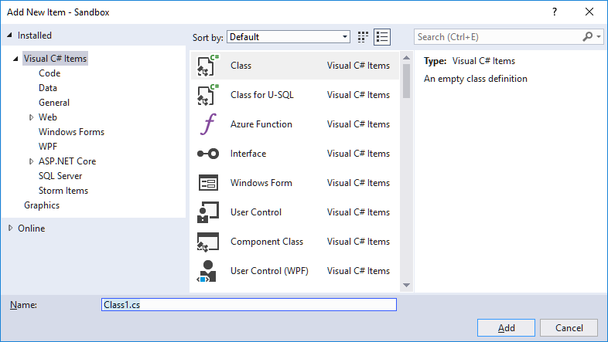

To create a class called **Human**, simply type “Human” (without the “”) into the box, and hit the **Add** button.

This sets a couple of things in motion in Visual Studio. A new file called **Human.cs** is added to the project, and the file is also opened by Visual Studio in the editor area. The initial content of the file should look like this (there will also be some lines at the top of the file starting with **using**; ignore those lines for now):

**namespace Sandbox**

**{**

**public class Human**

**{**

**}**

**}**

We need not worry about the first and last line; this is related to a unit of organisation called namespaces (see the chapter on Code Organisation), which is not important now. We will thus zoom in on the below bit (note: depending a bit on the precise way you create a new class, the keyword **public** may or may not have been included in the generated code. If it is not included in your code, then please add it, just before the **class** keyword):

**public class Human**

**{**

**}**

This is an absolutely minimal definition for the class **Human**. With this, we can actually start to create objects of type **Human**, but they will not be very interesting, since they have neither state nor behavior.

What do the parts of this definition mean? Let’s break it down:

* First is the keyword **public**. This is an **access specifier**, which tells us that this class can be used by everyone else. You might wonder if you would ever choose otherwise, but once you create larger projects, it may make perfect sense to keep some classes “private”, i.e. only to be used internally in the application code. In these notes, we will almost always create public classes.
* Next is the keyword **class**. This simply tells us that a class definition will now follow.
* Then follows a **{**, often referred to as a **curly bracket**. This symbol – along with the counterpart symbol **}** – are the delimiters of the class specification. Every­thing related to the class definition must be placed within these brackets.

Since all class definitions must contain this bare minimum, Visual Studio is kind enough to generate this code automatically.

The specific content of a class definition will vary from class to class. However, the content falls in a few well-defined categories, which we will detail in the following.

### Instance fields

We have seen examples of variables several times, and variables will usually also be part of a class definition. However, variables in a class definition can have different purposes. Some variables will be used inside methods (we get to method definitions very soon), but other variables are used for representing the state of an object of the class. These variables are called **instance fields**. The word “instance” signifies that whenever a new object is created, this object will contain its own set of instance fields, that are independent of the instance fields in other objects. If you change the value of an instance field in one object, it will not effect the corresponding instance field in any other object.

If we wish to add an instance field to the **Human** class, to hold the name of an indi­vidual, it will look like this:

**public class Human**

**{**

**private string _name;**

**}**

This sort of looks like what we have seen before, with a few additions. The keyword **private** indicates that this instance field can not be accessed from the outside. That is, if you create a **Human** object, and try to get hold of the value of the instance field (or try to change it), the compiler will consider that code to be in error, and therefore uncompilable. Again, you may wonder why you would create an instance field and then hide it away; the main reason is that we want access to such an instance field to go through a so-called **property**. We have mentioned these properties in the previous chapter, and we shall see in a moment how to create a property.

Also, we have prefixed the name of the instance field with an underscore (_). This has emerged as a standard for “branding” instance fields in a way that distinguishes them from plain variables. We adopt that standard as well, and encourage you to do so.

If we wish to add more instance fields to our class, we simply add them one after another (it is considered good form to define instance fields on separate lines):

**public class Human**

**{**

**private string _name;**

**private int _height;**

**private int _weight;**

**}**

Note that we always specify instance fields to be “private”, since we wish to restrict access to instance fields to only be possible through **properties**.

### Properties

In the chapter about usage of existing classes, we stated that it is usually possible to retrieve certain “properties” from a given object. One example was an object of the type **Student**, where we assumed that a property called **Name** was available:

**string name = firstStudent.Name;**

Such a property only becomes available, if the creator of the **Student** class has deci­ded to include such a property in the definition of the class. Including a **Name** proper­ty in the **Human** class also seems like a very natural thing. The initial code for creating such a property looks like this (the rest of the class definition is omitted):

**public string Name**

**{**

**get { }**

**set { }**

**}**

If you type this code into the **Human** class definition in Visual Studio, you will be in­form­ed that the code is invalid… Don’t be alarmed by this; we will insert the relevant code in a moment. First, we take a step back and see how a property can be used by someone who has created a **Human** object.

Imagine that somebody has created a **Human** object, like so:

**Human firstHuman = new Human();**

We also assume that the **Name** property is available for use, meaning that the below lines of code should be perfectly valid:

**firstHuman.Name = "Adam";**

**Console.WriteLine(firstHuman.Name);**

What happens in these two lines of code? It seems like the **Name** property is part of the state of any **Human** object. The type of that part of the state is **string**, and we can perform certain operations with the value of that part of the state. We can

* Set the value to something we specify
* Get the value out again, and e.g. print it.

These are two separate operations, but they involve the same part of the state. If we wish to enable these two operations, we must specify it in the definition of the **Name** property. This bring us back to the code from before:

**public string Name**

**{**

**get { }**

**set { }**

**}**

What we now need to figure out is what statements we need to write, in order to en­able the two operations. The statements needed to “get” the value should be written between the **{}** in the line with the **get** keyword, and likewise for **set**.

Let us consider the **set** operation. The result of that operation should be to update the state of the object to the given value, such that when somebody tries to **get** that pro­perty, that value is returned. So, the provided value must be stored inside the object somehow… That is exactly why we have instance fields! Previously, we defined an instance field of type **string**, with the name **_name**. That seems like a proper place to store that value ☺.

How do we then “store” the provided value in **_name**? This is how:

**public string Name**

**{**

**get { }**

**set { _name = value;}**

**}**

One single statement does the trick. Note, however, that a keyword **value** is also used here (you have probably noticed by now that keywords are **blue**). The **set** operation is always called when an assignment statement involving a property is performed, like:

**firstHuman.Name = "Adam";**

In general, **value** is simply set to the value of the right-hand-side (be it a simple value or an expression). In this case, **value** will be set to “Adam”, meaning that the **set** ope­ration will update the value of **_name** to “Adam”, and thereby changing the state of the object.

Having all this in place, the **get** operation is relatively simple. We wish to retrieve the current value of the property **Name**, and since we have defined this value to be stored in **_name**, we should simply return the current value of **_name**:

**public string Name**

**{**

**get { return _name; }**

**set { _name = value; }**

**}**

Note the keyword **return**. This is also a quite important part of the C# syntax, meaning *“return the value of the expression following the keyword* ***return****, to the caller of this method/property”*. In this simple case, the value of **_name** is returned, as we wished.

If you have never dealt with properties before, it can be difficult to figure out exactly when these **get** and **set** operations are invoked. The general rules are:

* If a property appears on the left-hand-side of an assignment statement (i.e. we are assigning a new value to the property), the **set** operation is invoked.
* In all other scenarios where a property is being used, the **get** operation is invoked.

If you have paid close attention so far, you might see a way to short-circuit all this fuss for retrieving and setting a single value. Recall that the keyword **public** is used to indi­cate if a certain part of an object is accessible for everyone, which is why all pro­per­ties are marked as **public**, as opposed to all the instance fields marked as **private**. So, why not simply mark the instance fields as **public**? We can then just write code like:

**firstHuman._name = "Adam";**

**Console.WriteLine(firstHuman._name);**

No more messing around with properties, that just do the same thing anyway! In this very simple case, there would not be any practical difference. However, it is one of the pivotal principles in Object-Oriented programming to keep the details of internal implemen­tation private, the motivation being that we can then change this imple­men­tation without affecting the external user. If we make the **Human** class slightly more complicated, we can see this idea in action.

In the chapter about public and private appearance of an object, we used a property called BMI (Body Mass Index) as an example. The BMI for a person can be calculated from the weight and height:

BMI = (weight in kilograms) / (height in meters)2

How would we implement a **BMI** property in the **Human** class? First the skeleton code for a **BMI** property:

**public int BMI**

**{**

**get { }**

**set { }**

**}**

First consider the **get** operation. Since the BMI is calculated as above, we can calcu­late the value to return by using the current values of **_weight** and **_height**, as below:

**public int BMI**

**{**

**get { return (_weight * 10000)/(_height * _height); }**

**set { }**

**}**

The factor 10000 is just to get the units right. The important point is that the value is now calculated; it is not just pulled out of some instance field. We could have chosen to create a **_bmi** instance field and store the value there (think about why this would be a bad idea), but we didn’t…but the user of the object doesn’t need to know this! All the user knows is that a BMI value can be retrieved from a **Human** object, but he does not know anything about how the value is produced. It could be stored in an instance field, it could be calculated…it doesn’t matter.

What about the **set** operation? Does it even make sense to have a **set** operation for the BMI? Not really… Since the BMI is calculated, it should not be allowed to set it “manually”, since that value may contradict the calculated value. Can we then prevent statements like the below?

**firstHuman.BMI = 12;**

Yes, we can! We simply remove the **set** operation from the **BMI** property definition:

**public int BMI**

**{**

**get { return (_weight * 10000)/(_height * _height); }**

**}**

This turns the property into a “read-only” property; you can retrieve the value, but not change it yourself. This is a fairly common situation, and this is indeed the correct way to handle it – this is not a “hack” in any way.

The property concept can be a bit hard to appreciate at first, since it can seem overly complex in many cases. If all properties in a class are simple one-to-one mappings to single instance fields, there is indeed not that much gained. However, as soon as you are in a situation where

* A property is something that needs to be calculated, or
* It is relevant to be able to execute some code before assigning a new value to an instance field

you will benefit from using properties. We have seen an example of the first situation already; the second situation could be if you wish to perform some sort of data valida­tion, before you update the value of an instance field. Consider a **set** operation for a **Height** property:

**set { _height = value; }**

What if somebody by mistake tries to set **Height** to -10…? That is hardly a meaningful value for a height property, so we should somehow detect and handle that error. That can be done by adding some code to the **set** operation before the actual assignment. Precisely what kind of code we should add is a topic for one of the later chapter.

### Methods

By now, you have hopefully recognised that **properties** and **object state** are closely related; if we wish to know – or change – part of the state of an object, we do so by using pro­perties. But objects usually also have **behavior**. We can make the objects perform certain actions, that go beyond a simple state change. If we have an object represen­ting a collection of students (this could be part of a school administration system), a useful action could be to ask the object to add an additional student to the collec­tion (maybe in the form of a **Student** object). In code, it could look like:

**Student aStudent = new Student();**

**SchoolAdministrationSystem admSystem = new SchoolAdministrationSystem();**

**// aStudent is updated with relevant data**

**admSystem.AddStudent(aStudent);**

The last line contains a call of a method named **AddStudent**, which hopefully does what we expect: add a new **Student** object to the collection of existing objects. In this way, we are invoking a **behavior** for the object, by calling a method.

How do we then define such methods? A method is essentially a collection of state­ments, that can be invoked by calling the method on a specific object. A method defi­nition will always contain these elements:

* **An access specifier**: We have seen before that certain parts of a class definition can be declared as being **public** or **private**. This goes for methods as well. Some methods should be available for users of the class, and should then be marked as **public**. Other methods may be “helper methods”, that only exist for making the implementation of public methods easier; these methods should be marked as **private**.
* **A return type**: We saw that the **get** operation in a property definition needs to specify the value it returns. Methods may also return values to the caller, and we need to specify what type (e.g. **string**, **int** or maybe a class type) this value will have.
* **A method name**: Just as for e.g. variables, we need to give our method defi­ni­tion a name, so we can refer to it when we wish to call it. As mentioned before, the name should be as descriptive as possible, and be written in CamelCase with a capital first letter.
* **A list of parameters**: We have already seen that some methods may require the caller to specify a list of arguments, used to pass actual values to the method being called. In the method definition, a corresponding parameter list must be specified, including the type for each parameter.
* **A method body**: The term “body” here means the set of statements inside the method definition. When the method is called, the statements will be executed.

Let us see an example of a method definition. At this point, we only know a few rather simple C# statements, so we can only create very simple methods. A - somewhat con­trived – method on a **Human** class could be a method that returns whether or not this individual is higher than a given average:

**public bool HigherThanAverage(int averageHeight)**

**{**

**bool isHigher = _height > averageHeight;**

**return isHigher;**

**}**

If we dissect the definition according to the elements mentioned above, we get:

* **Access specifier**: Is **public**, so an external user can call this method.
* **Return type**: Is **bool** – we can also see that the expression (in this case just a variable) after the **return** keyword indeed has the type **bool**.
* **Method name**: Is **HigherThanAverage**
* **List of parameters**: One parameter named **averageHeight**, of type **int**.
* **Method body**: The single line of code between the { and the }.

An additional element is worth mentioning here: The first line of the method body contains a variable declaration, as we have seen many times before. When a variable is declared inside a method body, it is a so-called **local variable**. You may recall that a class definition can contain instance fields, that look almost like local variables; they have a type and a name (instance fields also have an access specifier).

Why do we distinguish between local variables and instance fields? An instance field is created when the object that encapsulates it is created, and only then. Likewise, it is destroyed when the object is destroyed. The lifespan of an instance field is therefore exactly the same as the lifespan of the encapsulating object. If a method call changes the value of an instance field, another method call will be able to access that instance field and retrieve the value. The value thus “endures” between method calls. This is not the case for local variables. A local variable is created when the method it is de­fined inside is called. Also – and that is the most important point – the local variable is destroyed again when the method call is finished. Local variables thus have a much shorter lifespan that instance fields, since they only exist during a method call; not before, and not after.

The obvious consequence is that if you need to save a value inside an object across method calls, you will need to save it in an instance field… and saving something in an instance field is exactly to change the state of an object! Creating and changing the value of a local variable is not considered a state change, since these actions will not cause any “permanent” change in the state of the object.

For further illustration, consider the below method for adding two given numbers and printing the result on the screen:

**public void AddAndPrintResult(int a, int b)**

**{**

**int result = a + b;**

**System.Console.WriteLine(result);**

**}**

Two points are of interest here: First, note that this method takes two parameters, which are specified in the parentheses just after the method name. Each parameter is specified by a type and a name, and parameters are separated by comma. Also, note the keyword **void**, that appears where we would expect a type specification. The type specification should be for the return type…but this method does not return anything! The keyword **return** is not present in the method body either. This is fine, but the C# syntax specifies that you must specify a type at this position in a method definition. Therefore, the keyword **void** simply means “no type”. The **void** type is used quite often, so it is important to know its meaning.

With these final points, we are now capable of defining methods as part of a class definition. Once we learn about more advanced C# language constructions, we can create more complex methods with richer functionality. A couple of more general remarks about methods are in place, though:

* When you create methods, you should also strive for clarity. If you are creating a public method with complex functionality, you may quickly end up with a method containing many lines of code. Even though the method might work as speci­fied, it will then be a good idea to see if the method can be broken down into additional (probably private) methods, that can then be called from the public method. This should not change the functionality, but make the method easier to understand and maintain.
* When you add methods to a class, the methods should be relevant for that class. There is nothing that prevents you from adding a **Multiply** method to a **Human** class, but that doesn’t seem like a functionality that naturally belongs to that class. Figuring out what methods that should be present in a class is strictly speaking a software design matter.

Finally, you might wonder if properties are not just a special kind of methods. Indeed they are. The syntax is a bit different, and you do not have the same degrees of free­dom with regards to naming, parameters and return type, but you do have the ability to specify a “method body”, that will be executed when the **get** or **set** operation is invoked.

### Constructors

During the discussion about how to use an existing class, we saw an example of how to create an object of a specific class:

**Human firstHuman = new Human();**

We claimed that the statement on the right-hand-side will cause a new **Human** object to be created, and that a piece of “initialisation code” will be executed as well. The purpose of that code should be to ensure that the object is in a meaningful state from the moment it is created.

This “initialisation code” is also written as part of the class definition, in the form of a **constructor**. A constructor is also just a method, but with a special syntax and some limitations compared to ordinary methods. For our **Human** class example, the simp­lest possible constructor looks like this:

**public Human()**

**{**

**}**

This is as simple as it gets. Compared to ordinary method, we again see an access spe­cifier as the first part. However, there does not seem to be a return type… That is the first important difference; you do not specify a return type for a constructor. Next, we see the word “Human”, i.e. exactly the same name as the class. This is also a defining characteristic for a con­structor; it always has the exact same name as the class it is defined in. Next follows the parameter list. The list is empty in this example, but we are allowed to specify parameters to a constructor, in the same way as for ordinary methods. Finally follows the method body, on which there are no restrictions either.

The most important point is to understand that once the statement containing the **new Human()** part is executed, the code inside the constructor will be executed. In that sense, you can say that **new Human()** is a method call, that:

1. Creates a new **Human** object
2. Executes the code within the constructor’s body, on the newly created object
3. Returns a reference to the **Human** object to the caller

As said above, the caller would then expect the object to be ready to use, and thus be in a meaningful state from the start. If we assume that the **Human** class contains the instance fields we defined earlier on:

**public class Human**

**{**

**private string _name;**

**private int _height;**

**private int _weight;**

**}**

then it would seem that the simple constructor – which does nothing – is not good enough. What would the initial values of the three instance fields be? C# does set the initial value for e.g. an **int** to a well-defined value (zero), and for a **string** to the empty string, but that is hardly meaningful either. What then? Should we set the values to some sort of “default” values, like:

**public Human()**

**{**

**_name = "Adam";**

**_height = 180;**

**_weight = 80;**

**}**

That’s not really what we want either. The essence of the problem is that we should not be able to create a **Human** object, until we have enough meaningful information about it. We discussed a similar problem for the **Student** class; you should not be able to create an “empty” **Student** object, since it does not make sense in the real world.

We can impose such a restriction by adding parameters to the constructor definition. If we define – and that should probably be a design decision – that you cannot create a new **Human** object without knowing the name, height and weight, you should then define the constructor as below:

**public Human(string name, int height, int weight)**

**{**

**_name = name;**

**_height = height;**

**_weight = weight;**

**}**

In this way, the previous simple statement **new Human()** becomes invalid and uncom­pilable. It now becomes mandatory for the caller to provide the information needed to create a meaningful **Human** object:

**Human firstHuman = new Human("Adam", 180, 80);**

This is a very sound principle: Define your constructor in a way that makes it impos­si­ble to create an object in a meaningless state.

For completeness, it should be noted that you can actually define more than one con­structor for a class. This could e.g. reflect a situation where you would prefer that cer­tain information is available when an object is to be created, but you will also allow creation with less information. For a **Student** class, you could make one constructor that takes all relevant information (name, address, country, phone, CPR number, and so on), but maybe also allow a version that only requires name and CPR number. Again, such requirements should be resolved during design.

You might get the impression from the above that a caller should provide initial values for all instance fields in a class. That is definitely not the case! Consider if a **Student** class also contained a field called **_numberOfExamsPassed**. What would be a reason­able initial value for this field? Zero, of course! And that would be the case for all new **Student** objects. In general, the caller should only need to provide initial values for those properties that are individual for an object.

## Class collaboration, and a bit about Abstraction

Once we know how to create our own classes, we can start building more complex models, involving more than one class. We recommended earlier that you should break a complex method into a set of simpler methods, that can “collaborate” to implement complex functionality. Likewise, you should strive to create simple classes, that are closely related to specific aspects of your model. Suppose we wish to create an application for simulating a car – this could perhaps be part of a racing game. We would probably create a **Car** class, and fill in functionality relating to various aspects of a real-life car. A real-life car is a very complex system, and you can perceive it as a set of sub-systems, that collaborate in a well-defined way. You could see the engine, the lighting system, the navigation system, etc.. as exam­ples of such sub-systems. If we cram all the functionality into a single **Car** class, it will end up being very complex. It would be a better approach to create classes corre­sponding to the sub-systems, like an **Engine** class, a **NavigationSystem** class, and so on. The role of the **Car** class would then be to hold the sub-systems together, and coordinate various actions between the subsystems. In C# code, we could imagine that part of the **Car** class could look like this:

**public class Car**

**{**

**private string _modelName;**

**private Engine _theEngine;**

**private NavigationSystem _theNavigationSystem;**

**// many other fields would probably follow...**

**public Car(string modelName)**

**{**

**_modelName = modelName;**

**_theEngine = new Engine();**

**_theNavigationSystem = new NavigationSystem();**

**// (rest of constructor)**

**}**

**public void Start()**

**{**

**_theEngine.Start();**

**_theNavigationSystem.Start();**

**// (rest of Start method)**

**}**

**// many other methods would probably follow...**

**}**

First, note that we now have instance fields that are of a reference type. For instance, the field **_theEngine** is a reference to an **Engine** object. This is perfectly valid, and is a consequence of the notion of seeing a car being “composed” by sub-systems. When a **Car** object is created, we expect it to be in a meaningful state after creation, so it is quite natural that the **Car** constructor should ensure that a new **Engine** object and a new **NavigationSystem** is created. Likewise, the **Start** method “relays” the starting command to the subsystems, and the **Car** object thus acts as the coordinating entity. You can take this idea further, and imagine that **Engine** and **NavigationSystem** are themselves composed of sub-systems, until a point where the sub-systems become so simple that further decomposition is unnecessary.

What we see here is also a first example of a very important idea in Object-Orien­ta­tion: **abstraction**. We did intentionally not write *“important idea in Object-Oriented programming”*, since it is strictly speaking a design concept. However, modern soft­ware development does not distinguish software design and software development as sharply as it was traditionally done, so we can discuss the concept here as well.

**Abstraction** is the idea that you should be able to work with software development at various levels of “abstraction” or “complexity”. What does that mean? If you investi­gate how various car industry professionals work with the development of a real-life car, you will probably quickly realise that nobody knows all the details about the car… and that is a good thing!

A systems engineer may have “sub-system communication and coordination” as his area of responsibility. He will need to figure out how the various sub-system need to work together, but he will not know – and will not need to know – the details about how e.g. the navigation system works internally. All he is interested in knowing is how that sub-system interacts with the outside world. Of course, that needs to be speci­fied in sufficient detail. Once he knows that, he can use the sub-system as he sees fit, without knowing what goes on inside it. So, the systems engineer works at that parti­cular **level of abstraction**. A navigation system engineer probably works at a lower level of abstraction – he needs to work with all the internal details of the navigation system, but that system may itself rely on other, smaller sub-systems, and so on. As long as you know how to interact with a subsystem at your particular level of abstrac­tion, you don’t need to know about internal details.

You can hopefully see that this way of thinking fits very well to the main features of object-oriented programming; you can specify how an object presents itself to the outside world – i.e. how the outside world should interact with it – and then hide away the details of implementation inside the private sections of the object.

## Static – no object needed

Over the last pages, we have again and again insisted that you define methods in classes, and call methods on objects. This is a very clean distinction, but there are in fact situations where you don’t need objects in order to call methods.

Suppose you have a class called **SimpleMath**, which contains simple methods for addi­tion, subtraction and so on. The “header” of an **Add** method will probably look like:

**public int Add(int a, int b)**

So, the **Add** method takes two arguments **a** and **b**, and returns the sum. Very simple. So simple, that it is hard to see why we even need an object to call the method on… We said earlier that some methods may need arguments, in order to provide it with the infor­mation it needs to do its job. In this case, all the information needed is pro­vided as arguments. If called on an object, the method would not change anything in the state of the object. In total, there are not any good arguments for having to create a **Simple­­Math** object, just to be able to call **Add**. Instead, the method can be declared as a **static** method:

**public static int Add(int a, int b)**

**{**

**return (a + b);**

**}**

We can now call the method like this:

**SimpleMath.Add(2, 6);**

We do not create a **SimpleMath** object, but simply call the method “on the class”. This may seem confusing, now that we have been accustomed to calling methods on objects, but it is an important feature to know. In fact, we have been using a static method almost from the beginning:

**Console.WriteLine("WriteLine is a static method!");**

**Console** is the name of a class, not an object! If you investigate the .NET Framework class library further, you will find that static methods are quite common. The very useful **Math** class is filled with static methods.

You can apply the **static** keyword to all the elements of a class definition: instance fields, proper­ties, and even on the class itself. If you define a class as being static, it becomes impos­sible to create an object of that class. Also, a static class can only contain static elements (how would you access a non-static element, if you cannot create an object…?).

Having static elements in a non-static class is however possible, and quite common. A very common static element is a so-called **constant**. A constant is a variable that can­not change its value. That sounds a bit contradictory, since you would expect a “vari­able” to be able to change its value… However, you will often need to use some fixed value in your code, the classic example being the value of **π** (pi). That value is actually found in the **Math** class, called **Math.PI**. You can create a constant inside a class defi­nition like this:

**public class CardDeck**

**{**

**public const int CardsInDeck = 52;**

**}**

Notice the keyword **const** – this defines the instance field to be a constant. We also need to specify the value of the constant as well. You might expect that you should also add the keyword **static**, in order to make the constant static. However, since constants are always considered to be static – since there will never be a reason to create more than one instance of a constant – you don’t need to specify it explicitly.

For someone new to programming, it might be difficult to figure out when to declare a class element as being static. The question you should ask yourself is: *“does this ele­ment depend on the state of individual objects?”*. If the answer to that question is no, you can declare that element as being a static element. It is in fact recommended that you do this! Declaring something as static is not “cheating” or a “hack”; it is a way to inform the user of the element that he can use it without having to create an object first. This saves both time and code.

# Programming II – intermediate

So far, we have only learned about a few types of individual C# statements, which we can combine to sequences of statements. This sequence of statements will always be executed in the same order. That is obviously a severe limitation – it is very easy to imagine some business logic that involves **choices**: If a certain condition is fulfilled, we will perform certain actions; if the condition is not fulfilled, we may perform different actions, or maybe no actions at all. We therefore need additional C# statements that enable us to implement such choices in C# code. Such statements are of course avail­able, and are in general known as **control statements**. These state­ments control the “flow of execution” of the other statements, and allow us to create much more sophisticated code.

The two main categories of control statements are

* Conditional statements
* Repetition statements

## Conditional statements

In the category of conditional statements, we find

* The **if**-statement
* The **if-else** statement
* The multi-**if-else** statement
* The **switch** statement

As you can probably tell from the naming, the first three statement types are essen­tially variations over the same format, while the **switch** statement is fundamentally different.

### The if-statement

As stated above, we will need to be able to implement logical conditions, if we want to imple­ment non-trivial logic in C#. The **if**-statement is the first tool for this. The syn­tax for an **if**-statement is quite simple:

**if (*condition*)**

**{**

**}**

An **if**-statement always contains three defining elements:

* The keyword **if**, followed by
* A pair of parentheses, containing a **logical condition** (for completeness, note that the word ***condition*** is not a C# keyword; it just indicates where the con­dition should be written)
* A **code block**, inside the curly brackets **{** and **}**. A code block is essentially the same thing as a **method body**, i.e. a sequence of C# statements.

The most interesting feature is the **condition**. A condition is in this context a **logical** condition, which in plain terms is “something that is either true or false”. We have seen such a thing before: a **logical expression**. That’s what a condition is: it is a logical expression, that will evaluate to either **true** or **false**. The expression itself can be very simple or very complex, but whenever the “flow of execution” reaches the condition, the logical expression will be evaluated.

If the logical expression evaluates to **true**, the statements inside the code block will be executed. We should also note that the statements are executed once (we will later see why this is important to remember). If the logical expression evaluates to **false**, the entire code block is skipped! The condition is thus a sort of “gatekeeper”; it will only allow the “flow of execution” to enter the code block, if the condition is **true**.

What happens after an **if**-statement? When the **if**-statement is done – which may or may not include execution of the statements in the code block – the first statement following the **if**-statement is executed. In that sense, nothing is changed. We still execute statements in the order they are written, but the statements themselves can now be more complex.

A very simple example of how to use an **if**-statement is given below:

**int age = 17;**

**Console.WriteLine("Starting to check age...");**

**if (age < 18)**

**{**

**Console.WriteLine("You are still a child...");**

**}**

**Console.WriteLine("Finished checking age");**

In a more realistic situation, we could imagine that **age** is read from an external source. If we run the above code, the output will be:

Starting to check age...

You are still a child...

Finished checking age

Why is the code block executed? When the **if**-statement is reached, the value of **age** is 17, so the condition becomes: 17 < 18. That is indeed true, so we enter the code block and execute the statements inside it (in this case only a single statement).

If we run the same code again, but change the value of **age** to 19, the output is:

Starting to check age...

Finished checking age

In this case, the condition evaluated to false, so the code block was skipped.

If the above code was part of a real system, we would probably like the system to tell us the result of the check, no matter what the result is. We could do this by using two **if**-statements:

**int age = 17;**

**Console.WriteLine("Starting to check age...");**

**if (age < 18)**

**{**

**Console.WriteLine("You are still a child...");**

**}**

**if (age > 18)**

**{**

**Console.WriteLine("You are an adult!");**

**}**

**Console.WriteLine("Finished checking age");**

That seems to solve the problem, since the application now provides an answer in all cases…or does it? It is probably easy to see that we can never have a situation where both possible answers are given, since both conditions cannot be true at the same time. Is there a situation where no answer is given? Yes, if the value of **age** is exactly 18. In that case, both conditions will be false, so no answer is given.

Even for such a simple situation, it can be a bit difficult to spot the error. What we really want is to be absolutely sure that exactly one answer is given, no matter the value of **age**. Sure, we could modify the second condition to (**age** >= 18), but a better (less error-prone) solution is to use a slightly extended version of the **if**-statement, called the **if-else** statement.

### The if-else statement

The syntax for the **if-else** statement is:

**if (*condition*)**

**{**

**}**

**else**

**{**

**}**

Compared to the **if**-statement, we have added two elements:

* The **else** keyword
* An additional code block

The functionality is probably not too hard to guess: If the condition evaluates to true, we execute the first code block only. If the condition evaluates to false, we execute the second code block only. We are thus guaranteed that exactly one of the two code blocks is executed; never both, never none! This construction is less error-prone than the construction using two **if**-statements, and it is strongly recommended to use the **if-else** statement, if you wish to execute exactly one of two code blocks, depending on the value of a logical expression.

For completeness, it should be mentioned that if – as in the example above – you have code blocks containing just a single statement, you can omit the curly brackets, and write the code like:

**if (age < 18)**

**Console.WriteLine("You are still a child...");**

**else**

**Console.WriteLine("You are an adult!");**

Even though this is syntactically valid code, it is recommended to always use the **{}** delimiters, since it makes the code easier to read. Also, be aware that the below code is also syntactically valid:

**if (age < 18);**

**Console.WriteLine("You are still a child...");**

If you run this code, the code will always print the ***you are still a child…*** message, no matter the value of **age**. Note the highlighted semi-colon (;) after the condition… This is allowed, but fairly meaningless. The code now checks the condition…and then does nothing. How­ever, the semi-colon indicates that the **if**-statement is now completed, so the next statement is not considered part of the **if**-statement any more… An error like that can be hard to spot, but Visual Studio is clever enough to identify it, and puts up a *do-you-really-mean-that* warning.

Concerning use of semi-colon, it might also seem strange that **if**-statements and **if-else** statements are not completed with a semi-colon. Whenever you use a code block with the **{}** delimiters, it is not required to use semi-colon to end the statement.

Finally, you may wonder if there are any restrictions on the type of C# statements, we can place inside a code block being part of a conditional statement. There isn’t any. Inside the code block of an **if**-statement, you could for instance put…another **if**-state­ment! Imagine you want to check if somebody is a teenager:

**if (age > 12)**

**{**

**if (age < 20)**

**{**

**Console.WriteLine("You are a teenager");**

**}**

**}**

In order to enter the outermost code block, **age** must be larger than 12. Once inside that block, **age** must also be smaller than 20 to enter the innermost code block. Only then will the message be printed.

By adding **if**-statements to our repertoire of C# statements, we can suddenly create quite complex methods, by combining statements to whatever “depth” we need. In the above case, it would however be a better solution simply to use a single **if**-state­ment, with a somewhat more complex condition:

**if ((age < 20) && (age > 12))**

**{**

**Console.WriteLine("You are a teenager");**

**}**

The logic is, of course, the same. Exactly how to “balance” a complex conditional statement between complex conditions and nested statements is mostly a matter of taste and readability.

You often encounter situations where you need to perform a very simple action, depending on whether or not a condition is true or false. This could be assigning a value to a variable, where the value will depend on the condition, like:

**int age = 15;**

**string message = "You are ";**

**if (age < 18)**

**{**

**message = message + "a child.";**

**}**

**else**

**{**

**message = message + "an adult.";**

**}**

In such cases, it can be convenient to use the so-called **ternary operator**:

***condition* ? *expression1* : *expression2***

This reads: if the condition is true, return the value of **expression1**, else return the value of **expression2**. If we rewrite the above **if**-statement using the ternary operator, we get:

**message = message + ((age < 18) ? "a child." : "an adult.");**

This is definitely more compact. The logic is exactly the same, so using the ternary operator is mostly a matter of taste.

### The multi if-else statement

The third variant of **if**-statements is useful in situations where you wish to choose between several (i.e. more than two) alternative actions. Suppose we need to find the appropriate mark for a test, where the score for the test is given as a percentage, i.e. a number between 0 and 100. The logic for finding the mark could be like:

|  |  |  |
| --- | --- | --- |
| **Lower limit** | **Upper limit** | **Mark** |
| 0 | 39 | D |
| 40 | 69 | C |
| 70 | 89 | B |
| 90 | 100 | A |

This logic can be written as a somewhat complex nested **if-else**-statement:

**if (score >= 90)**

**{**

**Console.WriteLine("Mark is: A");**

**}**

**else**

**{**

**if (score >= 70)**

**{**

**Console.WriteLine("Mark is: B");**

**}**

**else**

**{**

**if (score >= 40)**

**{**

**Console.WriteLine("Mark is: C");**

**}**

**else**

**{**

**Console.WriteLine("Mark is: D");**

**}**

**}**

**}**

Feel free to check the logic yourself… This code is perfectly fine, but can be a bit hard to understand due to the deep nesting of statements. The multi-**if-else** statement allows you to formulate the code slightly different:

**if (score >= 90)**

**{**

**Console.WriteLine("Mark is: A");**

**}**

**else if (score >= 70)**

**{**

**Console.WriteLine("Mark is: B");**

**}**

**else if (score >= 40)**

**{**

**Console.WriteLine("Mark is: C");**

**}**

**else**

**{**

**Console.WriteLine("Mark is: D");**

**}**

The code does exactly the same as the previous example, but is easier to read. It also makes it clearer that the four alternatives are equally “worthy”, which may be harder to see when using nested statements. If you compare this statement with the simple **if-else** state­ment, we have actually just added a number of **else-if** blocks between the **if**-part and the **else**-part. An important detail to remember is that a multi-**if-else** statement must end with an **else**-part.

Finally, we note that even though it is possible to formulate “overlapping” conditions (such that more than one condition can be true at the same time) in a multi **if-else** statement, it is still only one code block that will be executed; the first code block where the corresponding condition is true, or alternatively the **else** code block.

### The switch statement

In some situation, the business logic has a nature where there is a distinct outcome for certain specific value of a variable. Maybe the logic for calculating child support could be like this:

|  |  |
| --- | --- |
| **Number of children** | **Child support (kr. per month)** |
| 0 | 0 |
| 1 | 1200 |
| 2 | 2000 |
| 3 | 2600 |
| >3 | 3000 |

There is no simple formula for this dependency, so we would probably implement this logic by using a multi-**if-else**-statement, in a manner similar to the previous example. However, the **switch**-statement allows us to “directly” choose an alternative based on a specific value:

**switch (noOfChildren)**

**{**

**case 0:**

**childSupport = 0;**

**break;**

**case 1:**

**childSupport = 1200;**

**break;**

**case 2:**

**childSupport = 2000;**

**break;**

**case 3:**

**childSupport = 2600;**

**break;**

**default:**

**childSupport = 3000;**

**break;**

**}**

The important features of a **switch**-statement are:

* At the outermost level, we use the keyword **switch**, followed by the expression (typically just a variable) that we “switch on” in parentheses.
* We write a **case**-statement for each of the cases that we wish to handle indivi­dually, using the keyword **case** followed by the actual value, followed by “:” (colon, not semicolon!)
* Each case contains a sequence of statements, concluded by a **break**-statement. The **break**-statement indicates that no more of the code within the **switch**-statement should be executed. It is perfectly legal to include **if**-statements, etc. in the code before the **break** statement, but often you will just put a single line of code. If you need many lines of code for each case, a **switch**-statement may not be the best choice.
* If the value is not handled explicitly by a matching **case**-statement, it is caught in the **default**-statement, and the lines of code specified here are executed.

Again, there is nothing you can do in a **switch**-statement that you cannot do in a **if**- statement; they are logically equivalent.

In general, when dealing with conditional statements, you should choose the type of state­ment that you feel is a best fit for the problem at hand, and makes the code as easy as possible to understand.

## Repetition statements

The various conditional statements allow us some control of the flow of execution, but mostly in the sense that we may or may not execute certain sections of code. A very useful ability would be the ability to repeat execution of a code block, as long as some condition is true. The so-called **repetition statements** enable us to do just that.

Just as for conditional statements, there are a few variants of repetition statements to choose from, but they are essentially all variations over the same theme: repeat exe­cution of a block of code, as long as a certain condition is true.

The two most common types of repetition statements are:

* The **while**-statement (or **while**-loop)
* The **for**-statement (or **for**-loop)

A third type called **foreach**-loop is also quite useful, but only in relation with so-called **collections**, which we will discuss later.

### The while-loop

The syntax for the **while**-loop is quite simple, and is almost identical to that of the **if**-statement:

**while (*condition*)**

**{**

**}**

Syntactically, the only difference is the keyword **while** (instead of **if**). Apart from that, the **while**-loop consists of the same three elements:

* The keyword **while**
* A logical condition
* A code block

The functionality is different, though. The **if**-statement will – depending on the value of the logical expression in the condition – execute the code block one or zero times. The **while**-statement will execute the code block several times, more specifically as long as the condition is true. The word “several” is a bit misleading; the code block might only be executed once, or not at all! The exact number of **iterations** – meaning the number of times the code block is executed – depends on the condition.

The exact way a **while**-loop works is probably best described by a number of steps:

1. The “flow of execution” reaches the **while**-loop.
2. The condition is evaluated, giving either **true** or **false**.
3. In case of **true**:
   1. the code block is executed, and
   2. the flow of execution returns to step 2.
4. In case of **false**: the **while**-loop is considered completed, and the flow of execution will continue with the first statement after the **while**-loop.

The entire difference between a **while**-loop and an **if**-statement lies in step 3b. If you remove step 3b from the above, you have a precise description of an **if**-statement! The ability to send the flow of execution back to a point it has already passed, makes all the difference.

A valid concern here is how you ever get out of such a loop again! Won’t the condi­tion keep on being true, if it was true the first time around? That is indeed possible, and you (well, the “flow of execution”) would then be stuck in an **infinite loop**. The only way to break out of such an infinite loop is to terminate the application! To avoid this situation, something must happen in the code block that can affect the value of the condition. This is a very important point about any type of loop statement.

Let’s see an example of a fairly simple **while**-loop:

**int number = 1;**

**while (number < 5)**

**{**

**Console.WriteLine($"The value of the number is {number}");**

**number = number + 2;**

**}**

If you follow the steps above, you should be able to work out how many times the code block is executed: two times. The first time the condition is evaluated, the con­dition is 1 < 5, which is **true**. The message is printed, and the value of **number** is then increased by 2. Next time around, the condition is 3 < 5, which is also **true**. We do the same steps again. Third time around, the condition is 5 < 5, which is **false**. So, we do not do a third iteration through the loop. The loop has now finished.

This is of course a simple, not very useful example, but we can also use it to illustrate how easy it is to get into trouble. Consider the code below:

**int number = 1;**

**while (number < 5)**

**{**

**Console.WriteLine($"The value of the number is {number}");**

**}**

It looks fairly innocent, but if we try to run it, we will be stuck in the dreaded infinite loop. We took out the statement that increased the value of **number**, so the condi­tion will now remain true forever… Visual Studio is also clever enough to see this and warn us about it, so you might run into fewer infinite loops than the developers before you have ☺.

Just as for the conditional statements, there are no restrictions on the code you can put into a **while**-loop code block. You can put a **while**-loop inside a **while**-loop, if that is what your logic dictates. Nested loops are quite common in programming.

The example above is a so-called **counter-controlled** **while**-loop; we use the numeric value of some variable to check if we should do another iteration through the loop. This is typically used when the **while**-loop should be repeated a fixed number of times, or at least a numeric value known when the start of the loop is reached.

A different situation arises if you want a **while**-loop to continue until a certain “event” occurs. What does that mean? Suppose we have defined a class **Reader**, which can read a single character from the keyboard (i.e. the key the user presses). We could then imagine code like the below:

**Reader myReader = new Reader();**

**string keyPressed = "";**

**while (*condition*)**

**{**

**keyPressed = myReader.ReadFromKeyboard();**

**Console.WriteLine($"You pressed {keyPressed}");**

**}**

The idea is that **ReadFromKeyboard()** will wait until the user has pressed a key; when that happens, the key is read and stored in **keyPressed**. We then keep doing this, until…what? We could perhaps do it, say, ten times, but what we really want is for the user to tell us when he wants to stop. Of course, the user could just terminate the application, but if we want the user to be able to stop the loop, we could do this by defining that a certain value of **keyPressed** means “stop”. We could e.g. choose the character ‘q’ (meaning “quit”). The code would then become:

**Reader myReader = new Reader();**

**string keyPressed = "";**

**while (keyPressed != "q")**

**{**

**keyPressed = myReader.ReadFromKeyboard();**

**Console.WriteLine($"You pressed {keyPressed}");**

**}**

This means: as long as **keyPressed** is not equal to ‘q’, we keep on iterating (and there­by obtaining a new value from the user). Of course, we have no way of knowing if this will happen after one, four or 427 iterations, so we cannot use a counter-controller **while**-loop here. The above construction is called a **sentinel-controlled** **while**-loop. You can think of the condition as a “sentinel” that will only allow further iteration if a variable has (or does not have) a specific value. Also, the loop itself does not have control over the variable, but retrieves it from some outside source.

When you are new to loop statements, it can be easy to forget something. All loops do however have the below elements in common:

* **Initialisation**: Before the loop itself is entered, we usually – but not always – initialise some variable that is also used as part of the condition.
* **Condition**: The logical condition itself, which is evaluated before performing another iteration of the loop.
* **Change**: Since the condition itself is fixed, at least one of the values of the vari­ables in the condition must have the chance to change during an iteration. Otherwise, we have an infinite loop. Formally put, the probability that some-thing changes must be larger than 0 (zero).
* **Action**: The set of statements that is executed during an iteration, i.e. those statements that perform the actual “action” we want to happen during each iteration. This could e.g. be to print a line on the screen.

You can use this as a “checklist” when creating a loop statement, to be sure that you have considered all the relevant elements.

### The for-loop

Let’s take a look at a very common, counter-controlled **while**-loop. Some comments have been added to the code, to identify the four elements we listed above:

**int number = 1; // Initialisation**

**while (number < 5) // Condition**

**{**

**Console.WriteLine(number); // Action**

**number = number + 1; // Change**

**}**

This type of **while**-loop is very generic: do something a certain number of times, using an integer variable to track how many iterations we have performed. The loop state­ment known as the **for**-loop is tailored to this scenario. A **for**-loop implementing the same logic as the above **while**-loop looks like:

**for (int number = 1; number < 5; number = number + 1)**

**{**

**Console.WriteLine(number);**

**}**

If you compare this code to the previous code, you can hopefully see that we have just rearranged the four elements; the elements themselves are the same. In general, a **for**-loop has this structure:

**for (*initialisation* ; *condition* ; *change*)**

**{**

***Action***

**}**

A **for**-loop and a **while**-loop are logically equivalent; there is nothing you can do with a **for**-loop that you can’t do with a **while**-loop. So why choose a **for**-loop over a **while**-loop? It is mostly a matter of taste. The structure of the **for**-loop does per­haps make it harder to forget one of the elements, since the **for**-loop looks a bit “odd” if you remo­ve one of the elements. Still, this is a subjective criterion.

A slight drawback of the **for**-loop could be, that it is less obvious what order the operations are done in, and how often. Both are the same as for the **while**-loop: the initialisation is done once, as the first operation when the **for**-loop is reached. The condition is then checked, and – if the condition is true – the code block containing the action is then executed. After that, the change operation is done. The condition is then checked again, and so forth.

At this point, it is also relevant to introduce an alternative way to change the value of an integer variable. A very common format for the **for**-loop is this:

**for (int number = 1; number < 5; number = number + 1)**

**{**

**// Action**

**}**

Having a “counter variable” that simply counts the number of iterations performed – and a corresponding condition that remains true as long as the desired number of iterations has not been performed yet – is very common, and you will often see the above written as:

**for (int number = 1; number < 5; number++)**

**{**

**// Action**

**}**

This is exactly the same logic as before, except that the new notation **number++** is used. This notation simply means: increase **number** by one. It may look confusing at first, but since we very often need to increase an integer variable by one (also called to **increment** the variable), you will soon appreciate it. Similarly, you can decrease the value by one using the notation **number--**.

Finally, you should know that none of the elements in the **for**-loop are mandatory. You could in principle write a **for**-loop like:

**for (;;)**

**{**

**// Action**

**}**

This is a legal **for**-loop, that will iterate forever…

Are there any general guidelines for choosing between a **while**-loop and a **for**-loop? Not really – as said before, it is mostly a matter of taste. Many prefer to use a **for**-loop when the iteration is controlled by a simple counter variable, and to use a **while**-loop when you have a sentinel-controlled scenario. Choose the loop type you are most com­fortable with, but try to choose in a consistent manner.

## Debugging

As soon as we start to use conditional and repetition statements, we can start to create much more interesting – and complex – code. This makes it much more fun to code, but it also makes it harder to get the code right the first time. You will now start to find yourself in that somewhat frustrating situation where:

* Your code is syntactically correct (and can compile)
* The code seems correct when you read it
* The code does not produce the results you expect!

No matter how much effort you put into the design, and no matter how brilliant a pro­grammer you become, you will inevitably spend a large part of your program­ming life in this situation. We therefore need to know about tools and techniques to help us find errors (or **bugs**, as they are often called) in our code. This process of finding and fixing bugs is called **debugging**.

A first – and quite obvious – technique is simply to read the code closely once again. In many cases, the bug is quite simple (like e.g. using a minus instead of a plus some­where), and surprisingly many bugs can be caught this way. Even better is to try to explain the code to someone else; the process of stating the intention of the code aloud will often reveal bugs. In lack of somebody to explain it to, just explain it to your dog or teddy-bear – it’s the act of explaining aloud that matters ☺.

If such manual techniques are not successful, you can add some statements to the code, that print out useful information to the screen, e.g. inside a loop. It could be the value of a variable that seems to cause the problem, like:

**for (int divideBy = 10; divideBy >= 0; divideBy--)**

**{**

**Console.WriteLine($"Trying to divide by {divideBy}");**

**Console.WriteLine(100 / divideBy);**

**}**

This technique can be helpful if the logic is not too complex, but it quickly becomes a bit of a mess to add all these extra lines of code, and it is tedious to remove them again. A slightly better technique is to use the built-in statement **Debug.WriteLine** instead; this prints to the **Output Window** in Visual Studio instead, and only prints when running the application in *Debug* mode. Still, adding and managing such printing statements is a somewhat old-fashioned approach to debugging, and we will gene­rally try to avoid it.

A more powerful and elegant technique is to use the so-called **integrated debugger**, which is part of Visual Studio. Almost all modern programming tools contain an inte­grated debugger.

The integrated debugger can help with debugging in a lot of ways, and getting familiar with the debugger is definitely a worthwhile investment if you are serious about pro­gramming. Still, you can get quite far with knowing just a few things.

A very useful concept is a **breakpoint**. A breakpoint is a position in the code (a specific statement) that you choose. When you then run the program, the program will pause (not terminate!) at the breakpoint. You can think of it a pausing the “flow of execu­tion” at this specific point in the code. You choose the location of a break­point simply by clicking in the leftmost part of the code editing window. A red dot will appear (you can remove the breakpoint simply by clicking on it again):

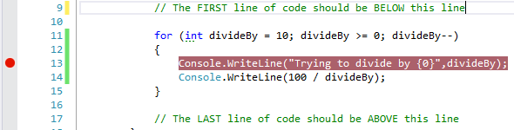

If you run the application now, the flow of execution will pause at the breakpoint, more specifically just before that line of code gets executed.

What now? Now you can inspect the current values of all variables simply by hovering the mouse cursor over the variable in the code editor window. This is in itself quite useful, since you may often find that the values are different from what you expected. If you then want the application to continue the execution from the breakpoint, you simply click the green triangle button, just as when starting the application (note that the text at the button now says **Continue**). Note that you can place multiple break­points in the code; hitting **Continue** will then resume execution until the next break­point is reached.

The above features – being able to pause the flow of execution at a break­point, and inspect variable values by hovering over them – are by themselves extremely useful for debugging. Getting used to using this feature will save you a lot of time. The next useful feature to know is the ability to “step” through the execution of the applica­tion. When you reach a break­point, a small set of buttons appear (they can also be found under the **Debug** menu):



There are a few more options available, but these three are the most important for now. These three options (and corresponding buttons) are called:

* *Step Into*
* *Step Over*
* *Step Out*

These “step” buttons enable you to advance the flow of execution by a single state­ment at a time, just as if all lines of code contained breakpoints. The interes­ting question is then: what is the next statement to be executed?

The obvious answer would be the next line of code in the method where we placed the breakpoint. If you click the *Step Over* button, the arrow marking the current posi­tion in the code will indeed advance to that statement (note that this need not be the line that “physically” follows in the code, since we might have conditional state­ments, loops etc. in play here).

But what if the statement we are currently at is a method call? If we want to investi­gate what happens inside that method call, we can use the *Step Into* option. This will take us into the code for the called method. In this way, you can step infinitely deep into methods being called by other methods (cue music from ***Inception***...).

If you step through all the statements in the called method, you will eventually be returned to the calling method – if you want to be taken immediately back to the calling method, you can use the *Step Out* option, which then finishes the method call. Using these three ways of stepping through the code is also extremely useful, since you can follow the flow of execution in every detail. In this way, you will often find that the code doesn’t behave as you expected.

In total: as soon as your code grows beyond trivial, it is a really good investment to familiarise yourself with the most fundamental features of the integrated debugger. The best way to learn this is – as always – to practice! There are more advanced features in the debugger than mentioned here, but get some practice in using the features described here, before diving deeper into the capabilities of the debugger.

## Data structures, part I

Learning about control statements enable us to go far beyond simple, sequential bits of code. Likewise, we now need to go beyond simple variables, that can only contain a single value. In many situations, we need to handle multiple values that have some­thing in common. Examples could be:

* Names of students in a class
* Temperature measurements over a long period
* Information about cars that can be rented at a Car Rental Service

…and so on, and so on. We could in principle just declare a lot of individual variables for e.g. holding the names of students, but a such an approach quickly becomes very clumsy to implement. Therefore, we need ways to handle such **collections** of data more elegantly. Fortunately, all modern programming languages – C# included – contain a number of ways to handle collections of data, by using so-called **data structures**.

### Arrays (and why you should not use them…)

One such data structure is the **array**. The array is a classic data structure, and it has been around for much longer than Object-Oriented programming. Therefore, it doesn’t quite “fit” into such a language as C#, since the syntax for using it has a non-Object-Oriented flavor to it. So why learn about it at all? Even if better alternatives do exist, you may still encounter use of arrays in existing code, and certain parts of the array syntax has leaked into more modern data structures. So, knowing about arrays is still useful background knowledge to have as a programmer.

Before diving into the syntax for arrays, we describe them on a conceptual level first. In essence, they are just a construction for handling a set of values of the same type (e.g. **int** or **string**). We can think of an array as a line of boxes, into which we can put a single value. Below is an array of integers:

|  |  |  |  |  |  |  |  |
| --- | --- | --- | --- | --- | --- | --- | --- |
| **index** | 0 | 1 | 2 | 3 | 4 | 5 | 6 |
| **value** | 34 | -233 | 9801 | 67 | 2 | -9582 | 770 |

Note that the “line of boxes” mentioned above is only the shaded part of the drawing, in the row labeled *value*. So, we have a total of 7 integer values in this particular array. What is the **index** then? The **index** is the “address” of a specific element in the array. When we put something into the array, we have to specify which “address” it should have. The **index** is exactly that. We can then use the index again, when we wish to retrieve an element from the array. The index itself is just an integer number; the only peculiarity is the fact that an array index always starts from 0 (zero). This also means that in this particular array, the last element has index 6 (not 7)!

Let us now see how to use arrays in C#. More specifically, we need to be able to:

* Create an array
* Enter a value into an array
* Retrieve a value from an array

The syntax for array creation is the first place where the pre-OO nature of arrays start showing. First, we need to declare a variable that can refer to an array:

**int[] myFirstArray;**

We deliberately used the phrase “refer to”, since an array is indeed an object, and a variable of an array type is thus by-reference. This particular variable refers to an array of **int** values. The important thing to notice here is the use of **[]**, called **square brackets**. A proper declaration of an array variable is thus the type for the values it should contain, followed by [].

Just declaring the variable does not create the array itself. Creating the array looks like:

**myFirstArray = new int[7];**

This will create an array with 7 elements, that can contain values of type **int**. Again, notice the somewhat odd syntax. We are indeed creating a new object here, by using the **new** keyword. However, there is not as such a class corresponding to the array…

With this, we can start to use the array. If we wish to put a value into the array, we must specify the index of the element into which we put the value:

**myFirstArray[3] = 23;**

This puts the integer value 23 into the element with index 3 (i.e. the fourth element in the array). There is not more to it than that. If you wish to retrieve an element from the array, you must again use the index:

**int singleValue = myFirstArray[5];**

The important thing to realise is this: once you specify an element in an array by its index, that element can be used in exactly the same manner as a simple variable of that type. You can use it in expressions, you can assign a value to it, and so on. If you want to increase the value of an element by one, you can just write:

**myFirstArray[4]++;**

This is no different than writing e.g. **age++**.

In the above example, we just created an array of **int** values, with 7 elements. We did not really specify the content of the array. Is the array then empty initially? No, since the concept “empty” doesn’t quite make sense for an array. Once the array is created, it immediately has the specified size, and the content of each element is then inter­preted as an **int** value. In C#, the elements in a array of numerical values are set to 0 (zero) by default, so that will be the initial content of this array. If we already know the initial values when we want to create the array, we can use a handy syntax to put those elements into the array:

**int[] myFirstArray = new int[] { 34, -233, 9801, 67, 2, -9582, 770 };**

This will create an array with 7 elements and put the specified values into the array. Neat!

So far, we have not gained that much as compared to using variables of simple types. Arrays do however go hand-in-hand with repetition statements. Suppose we want to print all the elements in an array. That is quite easy to do with a **for**-loop:

**for (int index = 0; index < 7; index++)**

**{**

**Console.WriteLine(myFirstArray[index]);**

**}**

That’s it! The variable **index** starts at 0, and keeps increasing until it reaches 7, where the condition becomes false. Also, this code (almost) doesn’t change if we have an array with 10000 elements instead of 7. The only small problem with this code is the explicit use of the size of the array. If we do change the size of the array, we must also change the condition in the loop. Can we avoid that? Yes, since you can retrieve the length of the array from the array itself:

**for (int index = 0; index < myFirstArray.Length; index++)**

**{**

**Console.WriteLine(myFirstArray[index]);**

**}**

This is a more robust style, since it is no longer necessary to change the condition, no matter the size of the array.

The above is a simple – but still quite typical – example of how arrays are used: Do some operation for each of the elements in the array (in this case: print them on the screen). Since this usage pattern occurs so often, a variant of repetition loops have been created just for this purpose, called a **foreach**-loop:

**foreach (var item in myFirstArray)**

**{**

**Console.WriteLine(item);**

**}**

Here you don’t even need to worry about array sizes, loop variables and so on: just specify the name of the array, and what you want to do with each element. The gene­ric version of the **foreach**-loop looks like this:

**foreach (var *variableName* in *arrayName*)**

**{**

**// Whatever you want to do with the value**

**}**

You can choose whatever variable name you prefer; it is just a “placeholder”, that will hold the actual values from the array during the iterations. You may also have noticed the use of the keyword **var**. Strictly speaking, you should also specify the type of the placeholder variable. However, the compiler can figure out what the type should be (it must be the same as the type of the elements in the array), so it “allows” you to be a bit lazy. By using **var**, you are saying “you figure it out!”. The compiler will protest if this is not possible ☺.

With arrays and loop statements (including the **foreach** loop), we can start to handle collections of values instead of just single values. However, in a modern language like C#, arrays will rarely be the best choice for such a task. Even though arrays are rather easy to work with, they have several drawbacks:

**The size of an array is fixed**: When you create an array, you must specify its size. This means that already at creation time, you must anticipate how many elements you may need to store in the array. That is often impossible, or at least very uncertain.

What if the array is used in a school administration system? How many students must it be possible to handle? 100? 10000? Who knows… You could then argue that you sho­uld just create a “sufficiently large” array, maybe with one million elements. Is that a problem? It could be, since you will then use a fixed-size chunk of memory for this array, even though it may often be next-to-empty. Even though RAM is cheap these days, we should still be wary of excessive memory consumption.

**You can use array indices that are invalid:** These is nothing stopping you (even though Visual Studio will raise an eyebrow…) from writing a statement like:

**myFirstArray[-2]++;**

If you try to run this code, you will get an error (more specifically an **exception**, that we will learn about later).

**There is no clear definition of an “empty” element:** We mentioned above that an array of a numerical type will – unless told otherwise – be initialised with the value 0 (zero) in each element. Can we then assume that if an element contains the value 0, it is considered empty? You could, but it’s a fragile strategy. What if 0 is also a valid value? Maybe the array contains temperature measurements, and 0 may then be a perfectly valid temperature. We could then choose another value as indicating empty, but that just shifts the problem. The core of the problem is that as soon as the array is created, any content in an element is interpreted as being of the specified type.

**There is no help with common tasks:** Since the array is not really a class, there are no methods available for various common tasks, like e.g. sorting the elements. It should be mentioned that C# does contain an **Array** class, but this is more a collec­tion of vari­ous static methods that can be used on arrays, not part of the array as such.

In total, there is a variety of more modern classes available in C#, that are better choi­ces for handling collections of values. Certain very specific situations – e.g. where the size of the collection will never change, and no sophisticated processing of the items is needed – may still justify the use of arrays, but they are mostly a leftover from the earlier days of programming. Still, some syntactical elements from arrays are also found in more modern collection classes.

### Lists

The .NET Framework Class Library contains several classes for handling collections of values. The **List** class is probably the class that has most in common with the classic array structure.

The **List** class does not suffer from the drawbacks described above. The pur­pose is similar to arrays: insert and retrieve values (or object references) of a specific type. The syntax for creating a **List** object is:

**List<int> myFirstList = new List<int>();**

There are a couple of things to notice here:

* The statement creates a **List** object, that can hold a collection of **int** values. The type specification goes between the **pointy brackets** **<>**, that follow right after the **List** class name. The **List** class is a **generic** class; we will discuss gene­ric classes later, but for now we just note that this is the syntax we must use for specifying the type of the items in the list.
* If you type in the statement in Visual Studio, you will notice that an additional line is generated by Visual Studio, at the top of the file:

using System.Collections.Generic;

The **List** class is part of the .NET Framework class library, and the above line instructs Visual Studio that we would like to use the part of the class library containing this class. This part also contains other useful collection classes.

* We do not need to specify an initial size of the list! Upon creation, the list is indeed empty. Once we start adding items to the list, the size is increased accordingly, and also decreased if items are deleted.

Having created the (initially empty) list, we can add items to it:

**myFirstList.Add(982);**

This is also quite different from the array style; here we use a method call in order to insert a value. Note that there is no specification of the index. The **Add** method will simply add the new item to the end of the list. If you at some point wish to insert an item at a specific position, you can use the **Insert** method:

**myFirstList.Insert(2,980);**

This will insert the value 980 into the item at index 2. A very important point here is that this may cause other items to be moved! Suppose the list looks like this before the insertion:

|  |  |  |  |  |
| --- | --- | --- | --- | --- |
| **index** | 0 | 1 | 2 | 3 |
| **value** | 34 | -233 | 9801 | 67 |

After the insertion, the list will look like:

|  |  |  |  |  |  |
| --- | --- | --- | --- | --- | --- |
| **index** | 0 | 1 | 2 | 3 | 4 |
| **value** | 34 | -233 | 980 | 9801 | 67 |

This is intentional, but is a feature that might surprise you if you are used to wor­king with arrays. Likewise, you can remove an item specified by index with the **RemoveAt** method:

**myFirstList.RemoveAt(1);**

This will shrink the list, again with the consequence that items will be moved. The list will change from:

|  |  |  |  |  |  |
| --- | --- | --- | --- | --- | --- |
| **index** | 0 | 1 | 2 | 3 | 4 |
| **value** | 34 | -233 | 980 | 9801 | 67 |

to

|  |  |  |  |  |
| --- | --- | --- | --- | --- |
| **index** | 0 | 1 | 2 | 3 |
| **value** | 34 | 980 | 9801 | 67 |

The list is thus much more “dynamic” than an array, and you cannot expect an item to retain its original position. With regards to removing an item, you might wonder why the method isn’t just named **Remove**. The **List** class does indeed contain a **Remove** method – also taking a single argument – but this method will remove the first occur­rence of the specified value. In this case, the method argu­ment is thus inter­preted as a value, not an index! This can be somewhat confusing, and you should be sure to understand the meaning of the method arguments before using the methods.

The **List** class contains a lot of additional methods, and we will only present a few of them here:

|  |  |
| --- | --- |
| **Clear** | Removes all items from the list |
| **Contains** | Returns **true** or **false**, depending on whether the specified value was found in the list |
| **IndexOf** | Returns the index of the first occurrence of the specified value (or -1 if no occurrence is found). |
| **Sort** | Sorts the items in the list |

Feel free to dig deeper into the C# documentation yourself, if you want to know more about the available methods. Some of them are quite sophisticated.

All these methods enter items into the list, and process them in various ways. How do you retrieve a single item by index? This is done by using the old-school array syntax:

**int aValue = myFirstList[3];**

This is convenient, but the responsibility for specifying a valid index rests with the caller. Nothing prevents you from specifying an invalid index, which will provoke an error (just as for arrays). You can actually also use the array-style syntax to change the value of an element, like:

**myFirstList[3] = 111;**

This statement does not add a new item to the list, it only changes the value of an existing item (assuming the index is valid…).

Lists are thus used through a mix of explicit, named methods like **Add** and **Insert**, and array-style indexing. This may seem a bit confusing. You could argue that all inter­action with a list ought to be through methods, to keep things consistent. Still, the array-like indexing using [] is a very well-established standard in programming (you will find it in a lot of programming languages), and if you look a bit further under the hood, you will find that using [] is actually also a method call (called an **indexer**). Indexers are similar to properties; in code, they do not really look like method calls, but they are in fact method calls with a special syntax. We will not discuss indexers further in this note, but if you define your own class to handle collections of values, you can add indexers to your class definition, just as you can add properties.

Processing the items in a list is just as easy as for an array, if we use the **foreach**-statement:

**foreach (var item in myFirstList)**

**{**

**Console.WriteLine(item);**

**}**

This loop is almost identical to the loop we used for printing the items in an array, and that is in fact an important point. This loop doesn’t really care if we give it an array or a list, since these structures are “similar enough” to be processed in this way.

What do we mean by “similar enough”? If you think about it, all that seems to be necessary is:

* The structure must have a well-defined starting point (i.e. first item).
* The structure must have a well-defined ending point (i.e. last item).
* It must be well-defined how we proceed from one item to the next item.

If these requirements are fulfilled, we can find the first item, proceed from the first item to the second item, to the third, and so on. We can also detect when we have reached the end. Arrays and lists both have these features, along with many other collection classes. The exact details of how to achieve this are not so interesting, and they will be hidden inside the classes themselves. Later on in these notes, we will learn the proper terminology to express such “similarities” in a more precise way.

### Dictionary

The **List** class is a significant improvement over the array structure, and make many tasks much easier. There are however a number of scenarios that lists cannot handle very well. One such scenario – that often occurs in practice – is when we need to handle data that has a **key-value relationship**.

Suppose we have a system for school management, and we need to create and mana­ge a lot of **Student** objects (we assume the system contains a **Student** class). We may thus need to use a collection class that can contain (references to) **Student** objects. A **List** could be a possible choice, like:

**List<Student> allStudents = new List<Student>();**

We can then go ahead and create **Student** objects, and insert them into the list. So far, no problems. A useful feature of such a system is probably the ability to look up a specific student. What information would we need in order to do that? Something that uniquely identifies a student. The name is not really enough, since it may not be unique. The Social Security Number (SSN, in Denmark known as CPR) is however gua­ranteed to be unique. So, given an SSN, we must find the student with that SNN. If we were to do this with a list, it would probably look like:

**bool found = false;**

**int index = 0;**

**Student theStudent = null;**

**while (!found && index < allStudents.Count)**

**{**

**if (allStudents[index].SSN == givenSSN)**

**{**

**found = true;**

**theStudent = allStudents[index];**

**}**

**}**

In plain language: Examine the items one by one, until the correct student is found, or all items have been examined.

There are several problems with this code. First, it is somewhat complex, so there is definitely a risk of not getting it right the first time. Second, it is also very inefficient. By “inefficient” we mean that it will use much more computing power than needed. Suppose we have a school with 1,000 students. How many **Student** objects will we on average have to examine before finding the right one? Probably about 500. Consider how nice it would be if we could just use the SSN as an index! All of the code above would boil down to:

**Student theStudent = allStudents[givenSSN];**

If a student with the specified SSN exists, **theStudent** will then refer to that object; if not, **theStudent** will be **null**. The collection class called **Dictionary** enables you to do just that!

When declaring a **Dictionary** object, you must specify a type for the key, and a type for the value. In our example, the SSN is the key, and a **string** could be a proper type for this. The value is then (a reference to) a **Student** object:

**Dictionary<string, Student> allStudents = new Dictionary<string, Student>();**

The syntax is a bit intimidating, but it is just the same style as for the **List**, with an extra type parameter. We can now start adding items to the dictionary:

**allStudents.Add(aStudent.SSN, aStudent);**

For the **Dictionary**, the **Add** method takes two arguments: the key (here the SNN), and the value (the **Student** object). You can also use the array-like syntax:

**allStudents[aStudent.SSN] = aStudent;**

The two statements do the same thing, but with a subtle difference. If you try to add an item with a key that doesn’t already exist, the item is just inserted, no matter which style you use. However, if the key already exist, then:

* The **Add** method will provoke an error (more specifically an exception)
* The index method will just overwrite the existing value with the new value.

You should thus choose the alternative that matches the behavior you want.

In order to remove an element, you only need to specify the key:

**allStudents.Remove(givenSSN);**

The method will return a **bool** value: **true** if an item was found and removed, **false** otherwise.

To retrieve an item, you use the array-style index syntax:

**aStudent = allStudents[givenSSN];**

If an item with the specified key exist, the method will return that item. If no such item exist, an error will occur! If this is not the desired behavior, you can use the method **ContainsKey** to check if a given key exist in the dictionary, like

**if (allStudents.ContainsKey(givenSSN))**

**{**

**aStudent = allStudents[givenSSN];**

**}**

This is in fact a perfect opportunity to use the ternary operator:

**aStudent = allStudents.ContainsKey(givenSSN) ? allStudents[givenSSN] : null;**

The code needed for retrieving values associated with keys is thus much simpler for a dictionary, compared to a list. As an extra bonus, the dictionary can retrieve such a value much more efficiently (i.e. faster) than a list. We saw in the above, that using a list would require sequential search through the entire list. This implies that if the size of the list doubles, the average time needed to find a specific item also doubles. For a dictionary, the time needed to find a value is (almost) constant, no matter how many values we store in the dictionary! This makes the dictionary a very attractive choice, if you have an obvious key-value relationship in your data. Just as for the **List**, there are a lot of additional methods available for the **Dictionary**, and you should take some time to get an overview of the methods.

Finally, the **Dictionary** contains two very useful properties: **Keys** and **Values**. The **Keys** property returns the entire set of keys for the items in the dictionary, while **Values** return the entire set of values. If you e.g. wish to iterate through all of the values in a dictionary, it can be done like this:

**foreach (Student s in students.Values)**

**{**

**Console.WriteLine(s);**

**}**

There are several other collection classes available in the .NET Framework class library (we will discuss some of these a bit later in the notes), but knowing about the **List** and **Dictionary** will take you a long way. When should you then choose one class over the other? Some general guidelines follow below:

Choose a **List** if:

* There is no obvious key-value relationship in your data
* You don’t need to retrieve data very often
* The typical operations will involve doing the same operation to all items

Choose a **Dictionary** if:

* There is a clear key-value relationship in your data
* You often need to retrieve a specific value, given a key.

As always, using your common sense is also a good starting point ☺.

### Enumerations

A final, somewhat small, topic in relation to data structures are **enumerations**. Enumerations are not related to collection classes; they solve a different problem.

The primitive types available in C# are often not exactly what we want. Suppose we wish to make an application that deals with fruit, say these five kinds of fruit: *Apple*, *Pear*, *Cherry*, *Banana* and *Kiwi*. How should we then represent a fruit? Let’s examine some possible strategies:

* As a **bool**: That is obviously not a good strategy, since we only have two pos­sible values for a **bool**
* As an **int**: Possible (say, use the values 1 to 5, where 1 = *Apple*, and so on), but not very convenient.
  + Since an **int** can obviously have a value smaller than 1 or larger than 5, we may assign a value that does not correspond to a fruit
  + Code can be hard to understand
* As a **string**: Possible, but with problems similar to **int**

What we would really like is a custom-made type that can only hold exactly the five values given above, making it impossible to specify a wrong value. This can be done by defining an **enumerated type**. In code, it could look like:

**public enum FruitType {** **Apple, Pear, Cherry, Banana, Kiwi }**

An enumerated type will typically be part of a class definition, so we can imagine a **Fruit** class in which **FruitType** is declared. If we now want to declare a variable else­where in the program, and assign a value to it, it will look like:

**Fruit.FruitType aFruit = Fruit.FruitType.Apple;**

The point is: We can never assign a value to the variable that does not represent a valid fruit, since the type itself specifies the legal values. Errors are caught at compile-time, not at run-time. Also, the intention of the code is probably easier to understand, even though the syntax for using the enumerated type is a bit verbose.

A typical rule-of-thumb is to use enumerations for types where there are from 3 to around 10 legal values. This doesn’t mean that it is forbidden to have an enumeration with 12 valid values, but your code will inevitably become more complex when the number of valid values increases.

## Code Quality, Part III (Keeping your code DRY)

A long way back in these notes, we discussed a scenario where a **Human** class con­tained three properties: **Weight**, **Height** and **BMI**. It turned out that we could imple­ment these three properties using only two instance fields: one for weight, and one for height. The **BMI** property could then be calculated from the weight and the height. Compared to having an extra instance field for BMI, this gave us two advantages:

* We use less memory, if **Human** only has two instance fields instead of three
* We eliminate the risk of data inconsistency, since the value of the BMI is not stored explicitly

This is a simple example of a very important principle in programming (and computer science in general): the **DRY** principle:

**D**on’t

**R**epeat

**Y**ourself

There are other ways to phrase this principle (for instance **SSoT**: Single Source of Truth), but the essence is the same. Applied to programming, the principle dictates that we should avoid duplicating any kind of information in our code. This goes both for data and algorithms! More specifically, we will try to avoid duplication at four levels in our code:

* Values
* Instance fields
* Methods
* Classes

### DRY and values

Imagine that you create an application for some sort of “world simulation”. To keep things simple, you define your world to be a 2-dimensional grid, where something can happen in each cell of the grid. To see if your model works properly, you start out with a small world, say 10x10 cells. You will probably write several loops like:

**for (int x = 0; x < 10; x++)**

**{**

**for (int y = 0; y < 10; y++)**

**{**

**// Do something for each cell**

**}**

**}**

Once everything seems to work, you might want to crank up the world size to a larger grid, say 100x100. In order to do this, you must find all occurrences of such loops, and replace 10 with 100. Visual Studio can in fact do this for you, by doing a project-wide search-and-replace operation. That is, however, a risky operation. What if the value 10 is used for other purposes in the code? Replacing those values with 100 is probably asking for trouble…

The way forward here is to remove these explicitly stated values from the code (such values are often called **magic numbers**), and replace them with something else. An obvious suggestion is **constants**. In the example, we could simply introduce two con­stants **DimensionX** and **DimensionY**, and use them in the relevant loops instead. If a value is only used within a single class, you can just declare the constant as part of that class definition. If the value is used in multiple classes, things get a bit more com­pli­cated. One strategy could be to define a public constant, as part of a “setup” class. In the world simulation example, we could imagine a **WorldSettings** class, from which the dimension constants can then be retrieved, like:

**public static class WorldSettings**

**{**

**public const int DimensionX = 100;**

**public const int DimensionY = 100;**

**}**

Using the constants will then look like:

**for (int x = 0; x < WorldSettings.DimensionX; x++)**

**{**

**for (int y = 0; y < WorldSettings.DimensionY; y++)**

**{**

**// Do something for each cell**

**}**

**}**

This has two advantages: First, the specific values of the constants are now defined once, and only need to be updated there. Second, it improves the readability of your code. If you need to understand what the code is actually doing, it is probably easier to understand **WorldSettings.DimensionX** than just the value 10.

### DRY and instance fields

We have already seen the DRY principle in action in the BMI example, so there is not that much to add here. The general rule-of-thumb is to look out for data that:

* An external user is interested in (and we therefore wish to expose as a proper­ty of a class)
* Can be calculated from other data

A valid concern here is the effort (i.e. computing power) needed to do the calculation. Returning a value directly from an instance field is a very fast operation, while a calcu­la­tion will require more effort. Still, this should be seen in the correct perspective. Suppose the primary purpose of the BMI in the example is to show the value in a user dialog. In that case, it doesn’t really matter if it takes one micro-second or 50 micro-seconds to retrieve the value, since it is negligible compared to the time it takes to open the dialog, and for the user to read the content. If there is a vast diffe­rence (say, the calculation takes several seconds), you may need to con­­sider other strategies. Still, you should not break the principle just for efficiency reasons, if efficiency is not the primary concern.

### DRY and methods

Once we apply the DRY principle to source code, things can get a bit more complex. Consider the below addition to the **Human** class (don’t worry if you don’t understand exactly what happens in the code – it’s just about printing information on the screen with a bit of visual decoration):

**public void PrintNameNicely()**

**{**

**string nameLine = "Name is : " +_name;**

**nameLine = nameLine.PadLeft(20);**

**nameLine = nameLine.PadRight(40);**

**nameLine = "|" + nameLine + "|";**

**Console.WriteLine("------------------------------------------");**

**Console.WriteLine(nameLine);**

**Console.WriteLine("------------------------------------------");**

**}**

So, our customer sees this, and says *“Hey, that looks nice! Can’t you also make it possible to print the height like that?”*. Well, of course we can! Here we go:

**public void PrintHeightNicely()**

**{**

**string nameLine = "Height is : " + _height;**

**nameLine = nameLine.PadLeft(20);**

**nameLine = nameLine.PadRight(40);**

**nameLine = "|" + nameLine + "|";**

**Console.WriteLine("------------------------------------------");**

**Console.WriteLine(nameLine);**

**Console.WriteLine("------------------------------------------");**

**}**

That didn’t take long – we just copy-pasted the code from **PrintNameNicely**, and made a few changes. Maybe we would even make a **PrintWeightNicely** method in the same manner. Later on, the customer comes back and says *“Well... I would rather have stars (*) printed instead of hyphens (-)…can you do that?”*. Yes, you can… but how many places will you have to make that change? Three places, since you just copy-pasted code from the original method. More work, and also the risk of missing an update! The “fixed” code might now print name and height with stars, but weight with hyphens… Now the customer is not happy!

How should we then approach this problem? If you apply the DRY principle here, you should look at the code above and think *“what do these two methods have in com­mon?”*. Quite a lot, since the only difference is the specific data printed in the middle line, plus the leading text (***Height is :*** vs ***Name is :***). Everything else is the same. So, if we create a new method, where these two pieces of information are converted into parameters, we have a single method that can handle both situations! Let’s create such a method:

**private void PrintNicely(string data, string leadText)**

**{**

**string dataLine = leadText + data;**

**dataLine = dataLine.PadLeft(20);**

**dataLine = dataLine.PadRight(40);**

**dataLine = "|" + dataLine + "|";**

**Console.WriteLine("------------------------------------------");**

**Console.WriteLine(dataLine);**

**Console.WriteLine("------------------------------------------");**

**}**

This method does not contain references to specific fields, but relies on two para­meters instead. This method can now be called from the original methods:

**public void PrintNameNicely()**

**{**

**PrintNicely(_name, "Name is :");**

**}**

**public void PrintHeightNicely()**

**{**

**PrintNicely(_height.ToString(), "Height is :");**

**}**

We do introduce a very small complication, since the caller must now convert the data to a string. Converting an **int** to a **string** is however a very simple operation. The gain is absolutely worth the price, since we now only have to do the hyphen-to-star update in one single place! Our code is now much DRYer ☺.

The attentive reader will perhaps wonder why the new method is private – why not make it public, and simply discard the old methods? Remember that public methods are used by the outside world, so deleting them may cause problems for others. Even changing them by e.g. changing the name and/or the required parameters can cause problems. However, we are free to change the implementation, which we have done.

Are we done? Well, take a closer look at the **PrintNicely** method. Does it contain any repetition? The statements that print the top and bottom line are indeed identical. We could create yet another method:

**private void PrintSeparator()**

**{**

**Console.WriteLine("------------------------------------------");**

**}**

and update the **PrintNicely** method accordingly:

**private void PrintNicely(string data, string leadText)**

**{**

**string dataLine = leadText + data;**

**dataLine = dataLine.PadLeft(20);**

**dataLine = dataLine.PadRight(40);**

**dataLine = "|" + dataLine + "|";**

**PrintSeparator();**

**Console.WriteLine(dataLine);**

**PrintSeparator();**

**}**

Here the gain seems a bit more marginal, but we have in fact isolated the use of hyphens even further.

Could we go even further? There are still some spots of repetition left, for instance the use of the vertical separator line (**|**). Instead of writing it explicitly twice in the code, we could perhaps add a constant **verticalSeparator** to the class:

**private const string verticalSeparator = "|";**

So once again, we have isolated the specification of the vertical separator to one single place in the code. If you feel up to the challenge, you can probably find even more ways to improve the method.

A natural question here is of course: Is it worth the effort? Giving a definitive answer to that question is impossible. It will always be a matter of risk versus reward, and depend on specific circumstances. If you don’t care about (or don’t want to pay for) such improvements to your code, you can in principle use that saved effort for some­thing else. However, if you anticipate that the code will indeed need to be modified later on, that modification may require more effort, due to the less-than-optimal state of the code.

Code modifications of this kind are another example of code **refactoring**. We saw a simpler refactoring much earlier in these notes (simple renaming of variables), and we are now stepping up to some not-so-trivial refactorings here. Remember that any refactoring is supposed to:

* Improve the structure of the code, making it easier to maintain and extend
* Keep the functionality of the code unchanged.

With regards to when it is “worth it” to do such a refactoring, Martin Fowler suggests a “rule of three” in his **Refactoring** book: When you write the same code the third time, you should definitely refactor. This could be a useful rule-of-thumb to start with.

### DRY and classes (and a brief introduction to Inheritance)

We have now seen examples of how to eliminate code duplication inside a class, both with respect to instance fields and methods. Code duplication may however also oc­cur across several classes. Suppose we are creating a banking system, where we need to model different types of bank accounts. We might have a standard bank account, with the below features:

1. You can deposit money into the account
2. You can withdraw money freely from the account, as long as the resulting balance is positive
3. You get an interest rate assigned once a year

We might also have a savings bank account, with the below features:

1. You can deposit money into the account
2. You can withdraw money from the account three times per month, as long as the resulting balance is positive
3. You get an improved interest rate assigned once a year

If we just go straight ahead and create code for these two types of accounts, we will probably create two classes **StandardAccount** and **SavingsAccount**. What will these classes look like, i.e. what instance fields and methods might they have? A reasonable suggestion could be that:

* Both classes have an instance field **_balance**, and a read-only property **Balance**
* Both classes have a **Deposit** method, and the implementation will be identical
* Both classes have a **Withdraw** method, but the implementation will be different, since different business rules apply
* Both classes have an **AssignInterest** method, but the implementation will be different, since different business rules apply

So, even though the individual classes might not contain any duplicate code, we will still have code duplication, in the sense that e.g. the **Deposit** method is implemented identically in two classes. Can we eliminate such cross-class code duplication as well? Indeed we can, by using a mechanism called **inheritance**. The concept of inheritance is one of the pillars of Object-Oriented programming. The ability to “share” common features between classes is extremely useful, and is a very powerful tool for solving the cross-class code duplication problem.

Consider again the two classes **StandardAccount** and **SavingsAccount**. We saw above that they have certain features in common, and certain features that are individual. We could illustrate this relationship like so:



Each ellipsis represent the code for one class: the yellow and blue areas will thus be code specific for one particular class, while the green area will be the code common to both classes. We would like to lift the green area out of the individual classes, and make the individual classes “refer” to the green area:

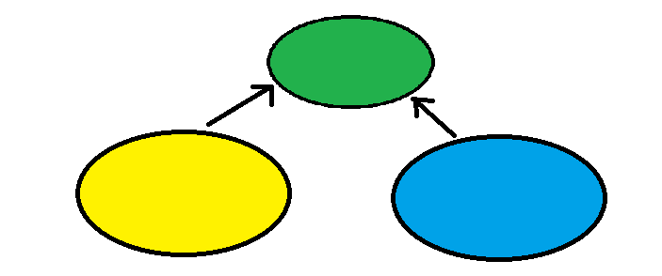

The way to express this in terms of object-orientation is as follows:

* We create a **base class** called **Account**. This class is supposed to contain those elements (instance fields, properties, methods, etc.) that are common to all bank accounts. This is the green area.
* We create two **derived classes** called **StandardAccount** and **SavingsAccount**, that only contains those elements that are specific for that particular bank account type. This is the yellow and blue area, respectively.
* We let **StandardAccount** and **SavingsAccount** inherit from **Account**. The inheritance mechanism has the effect that e.g. a **SavingsAccount** object will now contain both the common elements defined in **Account** and the specific elements defined in **SavingsAccount**.

We chose the phrase “a **SavingsAccount** object will now contain…” deliberately. Inheritance does not mean that the source code from the base class is somehow sucked into the derived class before compilation. The source code for **Account** will only exist in the **Account** class definition, which was the whole point. The effect – in terms of functionality – is however just as if we had duplicated the code. So once again, we improved the structure of the code, without changing the functionality.

How do you then specify inheritance in C#? In the example above, we would not be able to see any signs of inheritance, if we just looked at the **Account** class. That class would look like any other class, with some instance fields, methods, etc.. For the deri­ved classes, we explicitly specify inheritance like this:

**public class StandardAccount : Account**

**{**

**// Rest of class definition follows here...**

A colon, followed by the name of the base class. That’s it. We have now specified that **StandardAccount** inherits from **Account**.

There is quite a lot more to know about inheritance than what we described here, but we will return to this shortly. For now, we just note that inheritance enables us to eliminate cross-class code duplication, and is yet another tool to DRY up our code ☺.

### When does code become DRY?

As you are hopefully aware, these notes are about **Object-Oriented programming**. Another discipline in Object-Oriented Software Development is **Object-Oriented Design**. These two disciplines are obviously related, but exactly how they are related and what activities they involve – and how these activities may overlap – is a matter of debate. The traditional standpoint can – very simplified – be stated like:

*If we put a lot of effort into developing a sound and detailed Object-Oriented Design, the subsequent programming is almost trivial.*

In other words: If you think hard and long about the domain you want to model with your software, you can probably figure out what classes you need, how they will be related in terms of base classes and derived classes, what instance fields and methods you will need, and so on and so forth…without writing a single line of code! Once you are done with this activity – which is traditionally called Object-Oriented design – you will get the code right the first time!

Is that how it works in the real world? Rarely… In real life, you will typically create a design that looks “reasonable”, start to create some code, discover some flaws in the design, rethink the design, rework and extend the code, and so on; a much more iterative approach, where the line between design an code is blurred. This state-of-affairs has been embraced by the so-called Agile movement. Their standpoint – again very simplified – is:

*It does not make sense to separate design and programming – design happens and evolves hand-in-hand with code. We need to focus on structured ways to change the design of existing code.*

Hopefully, you can see that an activity like refactoring is exactly such a way to change the design of existing code. Refactoring is indeed considered one of the pillars of agile software development.

So, why all this high-level talk at this point? Think about the previous example, where we used inheritance to eliminate code duplication. If you subscribe to the traditional standpoint on design-vs-code, you would argue that code duplication should never have happened in the first place! You shouldn’t market inheritance as a remedy for code duplication, since it is a tool for design purposes! We don’t really want to take sides in this discussion, but either way, you may indeed find yourself in a situation one day, where you can eliminate code duplication by introducing inheritance. Also, the specific “mechanics” of inheritance are definitely in the realm of programming, and should be mastered by any object-oriented programmer, no matter if inheritance emerges as a result of up-front design or of code reorganisation. As promised, we will now investigate these mechanics in more detail.

# Object-oriented Programming II – Intermediate

Once we get to the point where our models consist of several classes, there will inevi­tably be some kind of relationship between the classes. We have already seen exam­ples of classes that themselves refer to other classes: A **Car** class could have a relation to a **Wheel** class, an **Employee** class could have a relation to a **Teacher** class, and so forth. We usually make a distinction between two fundamental kinds of class relation­ships: the ***has-a*** relationship, and the ***is-a*** relationship.

## The has-a relationship (Composition/Aggregation)

The **Car**-**Wheel** example above is a classic example of a ***has-a*** relationship. A **Car** is probably a (model of a) quite complex system, so it will make perfect sense to divide the system into a number of smaller sub-systems, each represented by a **class**. The **Car** class will thus be “composed” by several sub-classes; this sort of relationship is therefore denoted **composition** (or **aggregation**, depending on how strong the rela­tion between the classes is). In a **Car** class definition, the relation to the other classes will be implemented by a number of instance fields, which will have the type of the classes representing the smaller systems, like

**public class Car**

**{**

**private Wheel[] wheels;**

**public Car()**

**{**

**wheels = new Wheel[4];**

**// (rest of Car constructor)**

**}**

**}**

We have seen similar examples before, and there is as such not that much more to explain about this relationship. The higher-level classes will use the lower level-classes to implement their own functionality, by using properties, calling methods, etc.. Still, the fact that classes can make use of other classes enables us to construct com­plex systems of collaborating classes.

## The is-a relationship (Inheritance)

A different kind of relationship can emerge as a result of discovering similarities be­twe­en classes. Imagine we are working with a system for school administration. At some point, we see that we have a class **Teacher**, and another class **Secretary**. Upon further examination, we also see that the two classes have a lot in common. They probably both have properties like **Name**, **Address**, **Salary**, etc.. In accordance with the DRY principle, this is a situation we should do something about. But what? Should we try to merge the two classes into one larger class, that can accommodate both teachers and secretaries? That is not a good solution, since classes should be focused on a single responsibility. A different approach is to try to move the common parts of the two classes into a new class, and only retain the truly teacher-specific and secre­tary-specific parts in the original classes. The common class could be called **Employee,** and should only contain those parts common for all types of employees.

This “decomposition” of the original classes has at least brought us in line with the DRY principle, since no code is present twice anymore. Still, we need to have classes that can fully represent a teacher and a secretary, respectively. Could we then make these classes refer to the new **Employee** class through composition? That is indeed a possible solution, but it would be a somewhat convoluted version of a ***has-a*** rela­tion­ship: A **Teacher** has-a **Employee**… This sounds much more like an ***is-a*** relationship: A **Teacher** is-a **Employee**. An ***is-a*** relationship is implemented by using **inheritance**.

## The inheritance mechanism

The two classes that are part of an **is-a** relationship each play a different role. One class is more general, while the other is more specific. In the example, the **Employee** class is general, while the **Teacher** class is more specific. By “more specific”, we mean that the **Teacher** class should be everything that the **Employee** class is, plus a bit extra (the parts that are specific for a teacher). We achieve this by using **inheritance**. In C#, inheritance is syntactically quite simple to express. If we want the **Teacher** class to “inherit” from the **Employee** class, it will look like:

**public class Teacher : Employee**

**{**

**// Teacher-specific parts**

**}**

This reads “class **Teacher** inherits from class **Employee**”. In this way, a **Teacher** object will expose all the public properties and methods that are defined in the **Employee** class, plus its own public properties and methods. To the outside world, a **Teacher** object thus appears exactly like before the “decomposition”, while we have achieved our goal of not repeating code in classes.

In more general terms, we refer to the class from which someone inherits as the **base class**, while the class that inherits (from the base class) is called the **derived class**. Another terminology is **superclass** (the base class) and **subclass** (the derived class).

### The protected access level

We mentioned above that the derived class will expose all public parts of the base class, which implies that the derived class can also make use of these properties and methods inside its own properties and methods. But what about elements marked **private** in the base class? A derived class can not access these elements, so private really means private! This may seem very strict, since we could imagine that a derived class would need access to certain parts in the base class, that are not available to the outside world. For this reason, there is a third access specifier named **protected**. An element in the base class marked as **protected** can indeed be accessed by a derived class, but not by an outside user.

Should we then preferably mark all elements in a class as **protected** rather than **pri­vate**, to accommodate any class that wants to inherit from the class? No. We should still be careful about what we expose, even to a derived class. If we allow a derived class direct access to all elements in the base class, it may short-circuit all sorts of validations, etc. that have been put in place in the base class. Also, the derived class might become too dependent on the internal structure in the base class, meaning that it can become difficult to change this structure if needed. We are not saying that you should never use the **protected** access level, just that you should consider the poten­tial con­sequences very carefully first.

### Constructors in derived classes

Even though inheritance in itself is very simple with regards to syntax, there are a number of non-trivial aspects you need to be able to handle. The first arises with regards to constructors. Imagine that we found that our **Employee** class will need a constructor with two parameters:

**public class Employee**

**{**

**public Employee(string name, string address)**

**{**

**// (rest of Employee constructor)**

**}**

**}**

Also, we found that the derived class **Teacher** (derived from **Employee**) only needs one parameter in its own constructor:

**public class Teacher : Employee**

**{**

**public Teacher(string mainSubject)**

**{**

**// (rest of Teacher constructor)**

**}**

**}**

This all looks nice here in print, but in Visual Studio, the code above will produce an error. Visual Studio will complain that *“Base class* ***Employee*** *does not contain a para­meter­less constructor..”*. The problem is: If you derive from a class with a para­meter­ised constructor, you need to explicitly call this constructor when calling the construc­tor for the derived class, providing it with the arguments it needs. Syntac­ti­cally, it will look like this:

**public class Teacher : Employee**

**{**

**public Teacher(string mainSubject)**

**: base(name, address)**

**{**

**// (rest of Teacher constructor)**

**}**

**}**

Note the keyword **base** (preceeded by a colon); this is the call to the base class con­structor. In the code above, we are still not done. The parameters **name** and **address** are in red, because they are not defined anywhere… Where should they come from? The most obvious solution is that they must also be provided as part of the parameter list for the constructor of the derived class:

**public class Teacher : Employee**

**{**

**public string MainSubject { get; set; }**

**public Teacher(string name, string address, string mainSubject)**

**: base(name, address)**

**{**

**MainSubject = mainSubject;**

**}**

**}**

We have here assumed that **Teacher** contains a property **MainSubject**. This is a very common derived class constructor: the parts belonging to the base class are used for calling the base class constructor, while the parts belonging to the derived class are saved in the properties (instance fields) of the derived class itself.

### Overriding methods

The inheritance mechanism described so far is actually sufficient in many scenarios. The parts defined in the base class and derived class will co-exist peacefully in objects of the derived class type, and an external user of the class will not really notice that in­heritance is in play. It is however possible to use inheritance for more refined pur­po­ses, in parti­cular to achieve so-called **polymorphic behavior**, which we describe in some detail later. A prerequisite for polymorphic behavior is the ability to “override” methods defined in the base class.

Suppose that the **Employee** class from before has a **CalculateSalary** method, which has a generic implementation sufficient for most employees. However, it turns out that salary calculation for a teacher is more complex. We must therefore implement a different way of calculating salary in the **Teacher** class. The straightforward way to do this would be to define a new method in **Teacher** called **CalculateTeacherSalary**, since we cannot call it **CalculateSalary** (it would “collide” with the name for the method in the base class). This could be a feasible solution in many scenarios, but it is in con­flict with the polymorphic behavior mentioned before.

For this reason – which will become clearer soon – we need to be able to implement a method called **CalculateSalary** in the **Teacher** class, containing the teacher-specific logic for calculating salary. This method should “override” the implementation of **CalculateSalary** in the base class, such that if you call **CalculateSalary** on an object of type **Teacher**, the teacher-specific salary calculation is executed. Is this different from before? Again, if you know you are dealing with a **Teacher** object, you might as well call a method called **CalculateTeacherSalary**? One of the main points of polymorhic behavior is however that you can call **CalculateSalary** on an object that seems like an **Employee** object, but really is a **Teacher** object, and still have the teacher-specific version of **CalculateSalary** executed! That is essentially what polymorphic behavior is.

In order to achieve this, we must however state our intention very explicitly in C#. We need to state two things:

1. In the base class, we must explicitly mark any method that may be overrided in a derived class.
2. In the derived class, we must explicitly mark any method that is overriding a corre­sponding method in the base class.

By “corresponding” we mean a method with exactly the same signature, i.e. same name, return type and parameter list. If just one of these don’t match, we are not overriding a base class method.

How does this look with regards to C# syntax? In the base class, we can state that a method may be overrided by adding the **virtual** keyword:

**public class Employee**

**{**

**// // (rest of Employee class definition)**

**public virtual int CalculateSalary()**

**{**

**// Generic salary calculation**

**}**

**}**

Note that we only state that the method may be overrided; the derived class has no obligation to do so. If the derived class chooses to do so, it states this intention by add­ing the **override** keyword in its own definition of the method:

**public class Teacher : Employee**

**{**

**// (rest of Teacher class definition)**

**public override int CalculateSalary()**

**{**

**// Teacher-specific salary calculation**

**}**

**}**

With this setup in place, we can now achieve this enigmatic “polymorphic behavior”. So, what is it?

### Polymorphic behavior

When we are using classes related by inheritance, we can suddenly loosen up one of our most fundamental assumptions: When you create a variable and assign a value to it, the variable and the value must have the same type. We have seen this almost from the beginning:

**int age = 23;**

**Teacher theTeacher = new Teacher("Per", "Home", "Programming");**

However, if **Teacher** inherits from **Employee**, the below code is also valid:

**Employee theEmployee = new Teacher("Ole", "Away", "Design");**

The variable has type **Employee**, but the value has type **Teacher**... but since **Teacher** is-a **Employee** (that’s what inheritance expresses), the above is also valid. But is it also useful? On its own, not so much. We have in fact restricted ourselves a bit in this way. Suppose the **Teacher** class has a property **MainSubject**. Consider then the two lines of code below:

**Console.WriteLine(theTeacher.MainSubject); // OK**

**Console.WriteLine(theEmployee.MainSubject); // ERROR!**

We can only use the **MainSubject** property on the variable of type **Teacher**, not on the variable of type **Employee**. This makes good sense, since that property is indeed teacher-specific. Now consider the below code:

**Console.WriteLine(theTeacher.CalculateSalary()); // OK**

**Console.WriteLine(theEmployee.CalculateSalary()); // OK**

This also makes sense, since both classes now have an implementation of **Calculate­Salary**. The big question is now:

What implementation of **CalculateSalary** will be called in each case?

The first case is probably most obvious; the variable has type **Teacher**, so the imple­men­­tation in **Teacher** should be called. That is indeed true. In the second case, it is still the implementation in **Teacher** that gets called! This seems surprising, since we make the call on a variable of type **Employee**, and **Employee** has its own implemen­tation of **CalculateSalary**. However, the C# compiler has noticed our intention of over­riding the method in the derived class, and will therefore call the implementation in the derived class on any object of that type, even if the object is referred to by a vari­able of the base type! That is **polymorphic behavior**.

It is understandable if you still cannot appreciate why this is such a useful construct. Suppose we have a more complex system with many types of employees – all inherit­ing from **Employee** – where some choose to override **CalculateSalary**, while other just go with the generic implementa­tion in the base class. Suppose also that part of the system deals with processing salaries for all employees. We could then imagine func­tionality like “for all employees, calculate the salary and print a salary specifica­tion”. In other words, we need to iterate through all employee objects, and make calls to **CalculateSalary** on each object. If we had to do this without using inhe­ritance and polymorphic behavior, we would have to maintain a list for each type of employee, in order to call the correct implementation of **CalculateSalary**, like

**List<Teacher> allTeachers= new List<Teacher>();**

**allTeachers.Add(new Teacher("Hans", "Home", "English"));**

**List<Secretary> allSecretaries = new List<Secretary>();**

**allSecretaries.Add(new Secretary("Leon", "Office", "Law"));**

**// ..and so on**

**foreach (Teacher t in allTeachers)**

**{**

**t.CalculateSalary(); // Teacher-specific salary calculation**

**}**

**foreach (Secretary s in allSecretaries)**

**{**

**s.CalculateSalary(); // Secretary-specific salary calculation**

**}**

**// ..and so on**

This is definitely an implementation and maintenance nightmare. With inheritance and polymorphic behavior, we can however achieve our goal with just one list:

**List<Employee> allEmployees = new List<Employee>();**

**allEmployees.Add(new Teacher("Per", "Home", "Programming"));**

**allEmployees.Add(new Secretary("James", "Office", "Marketing"));**

**foreach (Employee e in allEmployees)**

**{**

**e.CalculateSalary(); // Calls the correct implementation!**

**}**

Through polymorphic behavior, we will always call the correct implementation of **Cal­cu­lateSalary**, be it the generic or specific version. The above loop will not even need to be updated, if we later on add additional employee types, as long as they inherit from **Employee**. This enables much more clean and generic programming, and is defi­nite­ly yet another tool for adhering to the DRY principle.

### Calling base class mehods

When we override methods, we often wish to replace the base class method imple­men­tation completely. However, there are also scenarios where we wish to extend the base class implementation. That is, we still want the code in the base class me­thod to be executed, but we want to do something additional in the derived class. This could very well be the case for salary calculation: some generic parts of the cal­culation are done in the base class, while some more specific parts are done in the derived class. The two parts are then added up in the derived method. In the derived class, we can achieve this using the following syntax:

**public override int CalculateSalary()**

**{**

**return base.CalculateSalary() + payGrade*500;**

**}**

Again, the keyword **base** is used to refer to a base class implementation.

### Abstract methods (and classes)

One of our assumptions in the above example was that some sort of gene­ric salary calculation logic exists, that can be used if no extra salary calculation logic applies for a specific kind of employee. What if the salary calculation logic is so diverse that no generic logic exists? What will the implementation of **CalculateSalary** in **Employee** then look like? Maybe this:

**public virtual int CalculateSalary()**

**{**

**return 0;**

**}**

This could be the case, maybe with the argument *“Well, we have to put something, right?”*. That is however not a valid argument. In general, we often face this situation:

* All classes inheriting from a base class **B** should implement a method **M**
* The is no meaningful implementation of **M** in **B** itself

First of all, what is the problem with the not-so-meaningful implementation of **Calcu­late­Salary** above? We will override the method in all derived classes anyway, yes? True, if we remember to do it! There will be nothing alerting us that we have forgot­ten to over­ride it for a new derived class, except that some employee might see a zero on his salary specification… It would be much better if we could make it mandatory for all classes inheriting from **Employee** to implement **CalculateSalary**, but without having a meaningless default implementation in **Employee**. We can achieve this by making the **CalculateSalary** method **abstract**.

An abstract method is a method without a body… that is, we only specifiy the method signature in the class definition:

**public abstract class Employee**

**{**

**public abstract int CalculateSalary();**

**// (rest of Employee class)**

**}**

Notice the semi-colon at the end. We are really done with what we have to say about this method in the **Employee** class. We only specify its signature, nothing more. If a class inherits from **Employee**, it will now be required to implement **CalculateSalary**.

Declaring an abstract method in a class has an additional consequence. Consider the below (invalid) code

**Employee e = new Employee("Vivian","Home"); // ERROR!**

**e.CalculateSalary(); // What should happen here?**

What should indeed happen in the second line? It’s meaningless, since there is no im­plementation of **CalculateSalary** to call. In general, any class that contains an abstract method will itself need to be marked as **abstract** (as **Employee** is above), implying that you can not create an object of that type! However, you can still have a variable of that type, so the ability for polymorphic behavior is preserved.

With this in place, we can sum up the difference between a **virtual** method and an **abstract** method:

* **Virtual** method: Has an implementation in the base class, can be overriden in a derived class. Use when a meaningful implementation of the method can be pro­vided in the base class
* **Abstract** method: Does not have an implementation in the base class, must be overriden in a derived class. Use when no meaningful implementation of the method can be provided in the base class

### Interfaces

The concept of defining abstract methods in a class can be taken to the extreme; a class that only contains abstract methods. This is actually a very useful idea, and has even been given its own name in Object-Oriented programming: an **interface**.

An interface can be seen as the absolutely minimal specification of a class. Imagine somebody interested in some particular functionality, for instance a class capable of drawing geometric shapes. How can he state his requirements in a very precise way, but without any assumption about specific implementation details? In terms of an interface definition! An interface definition for a (very simple) geometry drawing system could be specified in C# as:

**public interface IGeometryDraw**

**{**

**void DrawCircle(double x, double y, double radius);**

**void DrawLine(double x1, double y1, double x2, double y2);**

**void DrawRectangle(double x1, double y1, double x2, double y2);**

**}**

There are several things to take note of here:

* The keyword **interface** is used instead of **class**
* The interface name starts with an I – this is a naming convention
* There is no access specifier – all methods are per definition **public**
* There is no constructor
* All methods are **abstract**

Somebody interested in obtaining this functionality could simply state it in terms of this interface definition, alongside a specification of what an implementation of the interface is supposed to do, from an external perspective. It will of course not make sense to implement the **DrawCircle** method in a way that draws a square, so some sort of requirement specification or “contract” is needed. But apart from that, there is no need for additional information. A programmer could then go back and create a class that implements the interface:

**class GeometryDrawV10 : IGeometryDraw**

**{**

**public void DrawCircle(double x, double y, double radius)**

**{**

**// (rest of DrawCircle)**

**}**

**// (rest of GeometryDrawV10)**

**}**

The syntax for implementing an interface is identical to the syntax for inheritance in general. One important difference is however that a class can “inherit” from (i.e. imple­­ment) multiple interface, but can only inherit from a single non-interface class. The reasons for this limitation are a bit technical, and beyond the scope of this text.

If you take a tour through parts of the .NET Framework class library, you will see that interfaces are used quite heavily. Use of interfaces is a very strong mechanism for ma­king couplings between classes as weak as possible, since they are a specification of the absolute minimum you need to know about a class in order to use it. We will use interfaces quite often in the rest of these notes.

## The Object class

We conclude this section on inheritance by a small revelation – we have been using inheritance all along. All C# classes tacitly inherit from a “universal” base class named **Object**. This base class has seven methods:

**GetType**

**Equals**

**GetHashCode**

**ToString**

Finalize

MemberwiseClone

ReferenceEquals

Some of these methods (**Equals**, **GetHashCode** and **ToString**) can be overrided in a class definition, if you want your class to have certain abilities. A particularly interest­ing method is the **ToString** method. As we have seen many times before, we can put anything into a **Console.WriteLine** method call; the method will then try to print out the argument. This works well for simple types like e.g. **int**, where the value is printed as expected. However, if we try to do something like this:

**Console.WriteLine(theTeacher);**

we will get something like **MyNamespace.Teacher** printed on the screen. What hap­pens is that the method tries to print the string representation of the argument, more specifically by calling the **ToString** method – which all classes implement due to the inheritance from **Object** – and print the return value. What we see is the base class implementation of **ToString**. If we want a more useful result, we can override the **ToString** method in the **Teacher** class:

**public override string ToString()**

**{**

**return Name + " teaches " + MainSubject;**

**}**

Now we will see a printout like e.g. “John teaches Design”, whenever the program tries to print a **Teacher** object.

Some of the remaining **Object** methods can also be overrided for more or less exotic purposes; seek up additional information online about this, if you find that you need to do so.

## Exceptions

So far, we have given very little consideration to how to handle error situations. Hand­ling error situations is usually a pretty significant issue in software development, so we cannot ignore it; we need to know about tools and strategies for managing it.

So, what can go wrong? Below are just a few of the error situations we can imagine for a simple value:

* Value is correct type-wise, but is outside the range of meaningful values (example: A test score is supposed to be between 0 and 100, but an **int** can represent many other values, like e.g. -27, 22987).
* Value is used for indexing an array – only values from 0 (zero) up to (**Length** - 1) are meaningful. Other values will produce an error.
* A string does not follow a given syntax (e.g. for a license plate).
* A variable that is supposed to refer to an object has the value **null** instead.

The proper action of the application in the above cases will be situation-dependent. The application may halt, show an error message, silently handle the error, fall back to a default value, etc. In any case, we should be prepared for handling all possible error situations in a graceful manner. Simply shutting down the application is usually not an acceptable option.

Management of error situations can in general be divided into four phases:

1. **Detection** – realising that an error situation has occurred
2. **Signaling** – making the surrounding code aware that an error has been detected
3. **Capturing** – taking responsibility for handling the error
4. **Handling** – actually performing the error handling actions

The actions corresponding to these phases can be distributed in the code. This may imply that the part of the code detecting the error does not know how to handle the error! Information about the error must then somehow be propagated to the error handling code. One way of doing this could be to use return values. A method could return some sort of error object as its return value, which the caller could then act upon. This strategy does however quickly turn out to become very complicated, so we usually resort to a different mechanism: **exceptions**.

### Throwing and catching

Exceptions are by themselves just a set of classes, that all inherit from the .NET library class **Exception**. If you need to use an exception object, you create it using **new**, just as for any other object. The distinctive feature for exceptions is that you can “throw” and “catch” excep­tion objects.

If an error situation – or “exceptional” situation, to use a broader term which includes errors – occurs, the code which **detects** the situation can “throw” an exception. In C# code, this will look like:

**public void Deposit(int amount)**

**{**

**if (amount < 0) // Error detected**

**{**

**NegativeAmountException ex = new NegativeAmountException("Deposit");**

**throw ex;**

**}**

**_balance = _balance + amount;**

**}**

Here **NegativeAmountException** is a class we have defined ourselves. It inherits from **Exception**, which makes a **NegativeAmountException** object “throwable”. Note the keyword **throw** – this is where the object gets thrown. This is the **signaling** phase of the error handling process. When an exception object is thrown, no more code in the method is executed, just as if we had used the **return** keyword.

What does it mean more specifically to “throw” an object? Throwing an object is dif­fe­­rent from returning an object. An object which is thrown is passed up through the method calling chain just as return values are, but – and this is a significant difference – a method that has no interest in exceptions does not need to do anything at all in terms of handling it. A thrown object will silently pass up through the method calling chain, until someone decides to “catch” the exception object.

Catching an exception object is something a caller deliberately chooses to do. If you are calling a method that might throw an exception, and you are intent on handling the exception if it occurs, you should encapsulate the call in a **try-catch** statement:

**BankAccount theAccount = new BankAccount();**

**try**

**{**

**theAccount.Deposit(-1000);**

**}**

**catch (NegativeAmountException ex)**

**{**

**Console.WriteLine($"{ex.Message}: Negative amount not allowed");**

**}**

This may look a bit tedious with regards to syntax, but remember that it is only if you have the intent of actually handling the error, that you need to use this con­struction.

How do we read the above code? The caller is aware that **Deposit** might throw an exception, so he places the call in the **try**-part of the statement. If the call goes well, nothing else happens – the **catch**-part does not come into play. However, if an excep­tion is thrown, the exception is caught by the **catch**-part (this is the **capturing** phase). Now the code in the **catch**-part is executed. In this simplified case, the code does a very simplistic error handling (this is the **handling** phase), by printing out a message. In a more realistic setting, the code might make a call to some code dedicated to error handling, error recovery and error presentation. Once the error handling code finish­es, the state­ments following the entire **try-catch** statement will be executed.

We said above that the **catch**-part was executed if the **Deposit**-statement threw an exception. That is not entirely accurate. The code will only be executed if an excep­tion object of the type **NegativeAmountException** is thrown. A **catch**-statement will only catch exceptions of that type we have specified in the parentheses following the **catch** keyword. If a different exception had been thrown, it would not have been catched here, but possibly futher up the method calling chain. If we want to catch more than one type of exceptions, we can simply write additional **catch**-blocks after the first one, like:

**BankAccount theAccount = new BankAccount();**

**try**

**{**

**theAccount.Deposit(-1000);**

**}**

**catch (NegativeAmountException ex)**

**{**

**Console.WriteLine($"{ex.Message}: Negative amount not allowed");**

**}**

**catch (LargeAmountException ex)**

**{**

**Console.WriteLine($"{ex.Message}: Amount must not exceed …");**

**}**

In the above example, it seems reasonable to assume that **NegativeAmountException** and **LargeAmount­Exception** are two exception classes defined on the same level in an exception class inheritance hierarchy. They might both inherit from the .Net library class **ArgumentException** (which itself inherits from **Exception**). Suppose now that your exception handling logic is as follows:

* **LargeAmountException** (which inherits from **ArgumentException**) is handled according to strategy A
* **ArgumentException** (other than **LargeAmountException**) is handled according to strategy B
* **Exception** (other than **ArgumentException**)is handled according to strategy C

Can we express this in C# in a simple way? Indeed we can, again by including multiple **catch**-blocks in our **try**-**catch** statement:

**try**

**{**

**// Some action which may generate an exception**

**}**

**catch (LargeAmountException ex)**

**{**

**// Strategy A**

**}**

**catch (ArgumentException ex)**

**{**

**// Strategy B**

**}**

**catch (Exception ex)**

**{**

**// Strategy C**

**}**

In this way, you specify the most “specialised” error handling first, followed by more and more general error handling. When an actual exception is generated, the appli­cation will execute the first **catch**-clause (and only that clause) which matches the type of the exception.

### Rethrowing an exception

What if you want to do something if an exception occurs, but also want others to have a chance of handling the exception? You can then “re-throw” the exception. A com­mon scenario could be that you wish to do some sort of logging of the exception, but also want to do more specific exception handling further up the call chain. You can then do a re-throw in the style illustrated below:

**try**

**{**

**// Code that may throw exceptions**

**}**

**catch (Exception ex)**

**{**

**Logger.Log(ex.Message); // Log exception**

**throw; // Rethrow exception**

**}**

This is a quite useful construction, where someone having a stake in error handling can perform a specific kind of handling, but also pass on the exception to others.

### Exceptions summary

We now know the esssentials of dealing with exceptional situations using exception objects. The most important points are:

* The .NET Framework class library contains a lot of exception classes, including the class **Exception**, which is the base class for all exception classes. If you need a specialised exception class, explore the library first. There might be a class that fits your needs.
* You can define your own exception classes, but they must inherit from **Excep­tion**, or one of the other existing exception classes (including exception classes you have defined yourself).
* You should **throw early**: as soon as you have discovered an error situation that you don’t want to handle yourself, throw an appropriate exception.
* You should **catch late**: do not catch an exception unless you are sure what to do with it. Do not catch an exception and then ignore it by doing nothing.
* Consider **rethrowing** the exception, when you have dealt with it. Others might want a chance to handle the exception as well.

Exceptions is a construction that is a bit contrary to the ordinary flow-of-execution, but once you get a grasp of it, it is a quite elegant and powerful way of dealing with errors in a non-intrusive way. Remember, you only need to deal explicitly with (i.e. write code for) exceptions, if you have an interest in handling them.

# GUI Development

So far, we have only used some very primitive facilities for interacting with the users of our small applications. For more sophisticated applications with richer user inter­action, this is clearly not enough. We will therefore now embark on the – quite large – topic of GUI (Graphical User Interface) development.

Modern GUI development is a rather complicated activity. There is a large number of GUI “components” or **controls** (like buttons, drop-down menus, list boxes, etc.) to choose from, and the layout of the GUI can be specified in many different ways. In this chapter, we only discuss the more general challenges related to GUI develop­ment, and subse­quently focus on so-called **data binding**, which relates to the problem of keeping the GUI and the underlying data model consistent at all times.

## GUI and Object-Orientation

We have so far mostly used Object-Orientation as a way of modeling aspects of a cer­tain **domain**, like a bank, a role-playing game, etc.. Object-Orientation is however also a useful tool in the realm of GUI development. We can imagine classes that represent specific GUI elements – like a **Button** class, a **Window** class, etc. – and we can also imagine relations between such classes, in terms of inheritance and composition. Not surprisingly, such a system of classes has already been created, and is part of the .NET Framework class library. In fact, this part of the class library is quite large, and it is easy to get lost in the vast jungle of controls, available properties, and so on. We will only scratch the surface here.

## Event-driven applications

Applications equipped with a “real” GUI usually have a different model of execution than we have seen so far. Until now, most applications have had a very well-defined flow-of-execution, beginning execution of the logic immediately when the application is launched, and usually executing the entire logic without user interaction. A GUI-rich application can be characterised as an **event-driven** application, meaning that the application will usually wait for the user to initiate some specific action, perform that action on the users initiative, and then wait for the user to initiate the next action. The user may initiate an action by e.g. clicking on a button or making a selection in a list box; such an **event** will in turn launch a specific part of the business logic defined in the application. As we will see later on in this chapter, this model of execution makes it a bit more complicated to activate specific parts of the code, in response to the users actions.

## The duality of a GUI components

All GUI components share a few characteristics, that influence how we in general define and use GUI components. Most importantly, the full specification of a GUI compo­nent falls into two fundamentally different categories:

* The **visual appearance** of the GUI component: How does the component mani­fest itself on the device on which the user interacts with the application?
* The **behavior** of the GUI component: What happens inside the application when the user interacts with the GUI component?

Why is this distinction important? Primarily due to the role of time. The visual appear­ance of a GUI component does not depend on the “flow of execution”, but has a more timeless nature (this is a bit simplified, but we will elaborate a bit on this shortly). Con­versely, behavior is per definition something that starts (with respect to time) and ends. This difference is important in relation to how we should specify appearance and behavior, respectively.

Considering behavior first, it should not be surprising that C# itself is a very suitable language for specifying behavior – that’s what we have been doing over and over in the previous chapters. However, C# may not be the best choice for specifying appear­ance. We have characterised C# as an Object-Oriented language; it can also be charac­terised as a language with a **procedural** nature. In less academic terms, this means a language where we describe how things are done. We use sequences of state­ments to describe this, with the underlying assumption that statements are executed in a certain order with respect to time. Other languages can be characterised as being **declarative**. These languages only describe relations between certain elements, and time is not as such a factor. One example of such a language is HTML (HyperText Markup Language). HTML has traditionally been used for specifying the layout of a website, i.e. its visual appearance. The point we’re trying to make is: since the visual appearance is not as such dependent of time or the “flow of execution” of the appli­cation, it can be advantageous to use a declarative language to describe the visual appearance, rather than try to describe it in e.g. C#. Or even shorter: Use the right tools for the right job!

So, the conclusion of the above discussion is:

* Use C# for defining behavior for a GUI component
* Use a declarative langauge for defining the visual appearance of a GUI component.

This conclusion leads to two new problems:

* What language should we then use for defining appearance?
* How can we define a single C# class that contains definitions of both the behavior and the appearance?

Microsoft has resolved this by introducing the language **XAML** (eXtensible Application Markup Language), which is a specialised version of **XML** (eXtensible Markup Langu­age). We will talk a bit more about XAML/XML in a moment; for now, just note that XAML is indeed a declarative language.

If XAML is used for defining appearance for a GUI component, while C# is still used for defining behavior, how is it then possible to “merge” this into a single C# class? C# does – very conveniently – allow a class definition to be split across more than one file! The keyword **partial** can be added to a class definition, which indicates to the compiler that the class definition is spread across a number of files.

With this in place, only one more piece of the puzzle remains: transformation of a XAML-based definition to a (partial) C# class. This is indeed possible to do, and is an integral part of Visual Studio. We don’t need to know how this is done, only that it is possible to do it ☺.

The diagram below should illustrate how the pieces are put together. The behavior part is written in C# “by hand”, and is stored in a file with the extension **.xaml.cs**. The appearance part is written (or imported, see later) in XAML, and is stored in a file with the extension **.xaml**. This file is then processed by Visual Studio, generating a C# file with the extension **.xaml.g.cs**. This file – which now contains a partial class definition – is then combined with the hand-written C# file, which also contain a partial class definition. The end result is thus a complete C# class, containing definitions for both behavior and appearance.

MyControl

C# - generated

MyControl (behavior)

C# - written

MyControl.xaml.cs

MyControl (appearance)

C# - generated

MyControl.xaml.g.cs

MyControl (appearance)

XAML - written/imported

MyControl.xaml

This may look like a lot of trouble for creating a C# class, and it is indeed possible to write a GUI component class directly in C# without all this fuss. However, the division of definition of behavior and appearance does make it possible to define a GUI using an external tool. If the external tool is capable of exporting a GUI definition to XAML, we can simply import that definition into Visual Studio! Microsoft has made such a tool, called **Microsoft Blend**. The point is that GUI (appearance) definition is an acti­vity that doesn’t require programming skills as such, so it should be possible for a de­sign professional to work with GUI design using a tool specialised for this purpose.

## What is XML (and XAML)

We claimed above that XAML is a specialisation of XML, which in turn is a declarative language. So, what is XML?

XML (eXtensible Markup Langu­age) is a language for specifying structural relations between data. What does that mean? Suppose I have some data about a small book collection, like:

“War and Peace”, Tolstoy, 539 pages

“Huckleberry Finn”, Twain, 341 pages

As human beings, we can fairly easily understand this data. If a computer appli­cation had to process this data, it would need some extra data to make sense of the data. Suppose now we write the data as:

**<BookCollection>**

**<Book>**

**<Title>War and Peace</Title>**

**<Author>Tolstoy</Author>**

**<Pages>539</Pages>**

**</Book>**

**<Book>**

**<Title> Huckleberry Finn</Title>**

**<Author>Twain</Author>**

**<Pages>341</Pages>**

**</Book>**

**</BookCollection>**

Here we have added “data about the data”, so-called **meta-data**. This meta-data can be used by an application to e.g. search for specific types of data, or to display the data in a certain manner, depending on the type of data. Also, the meta-data defines the relation between the actual data. More specifically, we express the meta-data in terms of **tags**. A tag is a sort of keyword, that we have decided has a certain meaning. In the example, the word **Book** has a certain – hopefully obvious – meaning. We can then insert a tag into our description like this:

**<Book>**

**</Book>**

The **<Book>** tag means *“now will follow data about a Book”*, and the **</Book>** tag means *“now ends the data about a Book”*. Between these so-called **opening** and **closing** tags, we can then add data about a specific book:

**<Book>**

**<Title>Huckleberry Finn</Title>**

**<Author>Twain</Author>**

**<Pages>341</Pages>**

**</Book>**

So, it seems that there are three pieces of data about a book: title, author and (the number of) pages. All of the above (the opening tag, the details and the closing tag) defines an **element**, here of type **Book**. Note that the details themselves follow the same structure: opening tag, details, closing tag. We can thus have elements within elements, and this is precisely what enables us to express relations between ele­ments. In the XML above, the **Title** element is a “child” of the **Book** element, and **Book** elements are themselves children of the **BookCollection** element.

This is essentially what XML is; data, and meta-data specifying the structure of the data itself. You can hopefully see that such a language has a very different nature than C#, since there is no concept of “flow of execution” here. We only declare certain relations between data. A file containing XML code – plus a little bit of information about the XML version being used – is formally called an **XML document**.

Even though we have just stated that XML is very different from C# (which is true), it doesn’t mean that it operates in a realm that is completely different from that of C#. If you think a bit about it, you can interpret the XML data as describing the structure between specific objects: A **BookCollection** object is just a collection-type object, that contains two **Book** objects. A **Book** object in turn has some properties **Title**, **Author** and **Pages**, that have some specific values. If we had defined similar classes in C#, we could easily create a similar structure by creating C# objects, and use composition to relate them to each other. Some describe XML as an “object instantiation language”, which is fairly accurate. In that light, it may be easier to understand why a transfor­mation from XML to C# isn’t that complicated to perform.

We said earlier that by adding this meta-data, a computer application could make better sense of the data. This is a bit too simplified. No computer applications know as such what a “book” is… When you wish to use data on XML format, the “producer” (which could be a human being or another application) and the “consumer” (the appli­cation receiving the XML data) of the XML data must agree on the XML “lang­u­age” used for communication. That “language” is essentially just a specification of

* Names that are considered valid tag names (i.e. data types)
* What relation elements must have to each other

Such a specification is called a **schema**. We don’t need to know much more about schemas at this point, but it is the schema that defines the type names we may use and how the types are related. For the above example, the schema may define that:

* **BookCollection**, **Book**, **Title**, **Author** and **Pages** are legal types
* A **BookCollection** element may contain any number of **Book** elements
* A **Book** element must contain exactly one **Title** element
* …and so on

In this way, it is the schema that defines a “specialisation” of XML. Our example is rela­­ted to books, so we could name this specialisation XBML (eXtensible Book Markup Langu­age). Likewise, Microsoft has defined a schema related to specifi­cation of gra­phi­cal elements in an application, and named it XAML (eXtensible Application Markup Langu­age). Describing the structure of a GUI fits pretty well with this way of structu­ring information. A GUI usually starts with a window, inside which is a number of pa­ges, within which there are a number of controls, and so on.

XAML makes heavy use of another XML feature called **attributes**. An attribute is just another way of representing data. In the example above, we could have chosen to use attri­butes instead:

**<Book Title="War and Peace" Author="Tolstoy" Pages="539">**

**</Book>**

The meaning is exactly the same, but expressed in terms of attributes. Attributes are written inside the **<** and **>** of the opening tag. Each attribute should be understood as a key-value pair; the value of **Title** is *“War and Peace”*. Note that all attribute values must be specified as strings, even if they are numeric (such as the page number). It should also be mentioned that you can use a shorthand for tags, if the element only contains attributes:

**<Book Title="War and Peace" Author="Tolstoy" Pages="539" />**

The **/** symbol from the closing tag has thus been moved to the end of the opening tag. As before, the meaning is exactly the same.

When should you use attributes in favor of child elements? There is no clear-cut rule for this, and it is strictly speaking not a relevant question here, since we will have to follow the style that XAML “imposes” on us. The important point here is to under-stand what an attribute is.

There are of course many tutorials about XML on the web, if you want to learn more. The W3Schools tutorial <http://www.w3schools.com/xml/> is a good starting point.

## XAML and Visual Studio – getting started

Let’s recap the story so far:

* There is a fundamental difference between the visual appearance and the beha­vior of a GUI component
* The behavior is defined by using C#
* The visual appearance is defined by using XAML (eXtensible Application Markup Language)
* You can create the (visual appearance of a) GUI directly in Visual Studio (using XAML), or by using a third-party tool

The next step is to investigate in more detail how we go about creating an application with a real GUI. In Visual Studio, we have usually created and worked with so-called “console applications”, where we use **Console.WriteLine** to print simple texts on the screen. However, we can also choose to create an application of the type **Universal Windows Platform** (UWP). In Visual Studio, we can choose this application type in the **New Project** dialog:

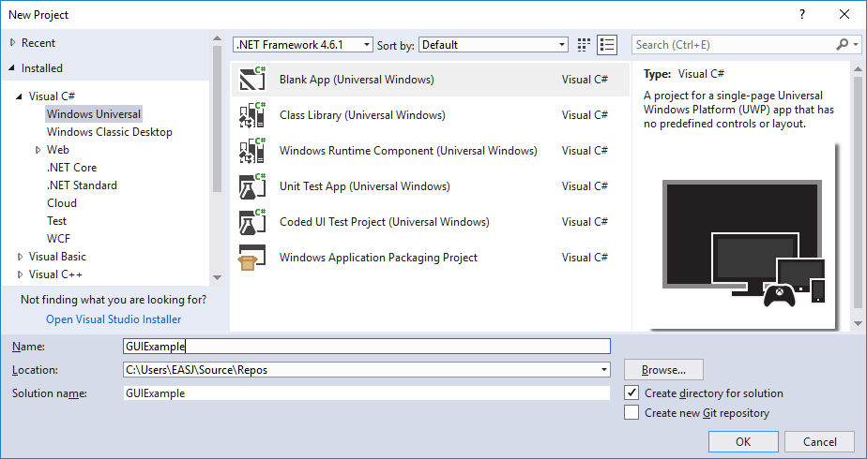

Here, we choose to create a “Blank App (Universal Windows)”, and have chosen the name **GUIExample**. Once Visual Studio has created the project (which may take a little while, if this is the first project of this kind you are creating), we are met with some­thing which looks radically different from the projects we have worked with so far. The **Solution Explorer** window will look something like this:

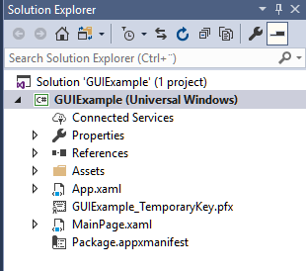

There is no **Program.cs** file, and a couple of files with the extension .xaml. The file called **MainPage.xaml** is the most interesting one right now. If you double-click this file, an view looking similar to the below will appear:

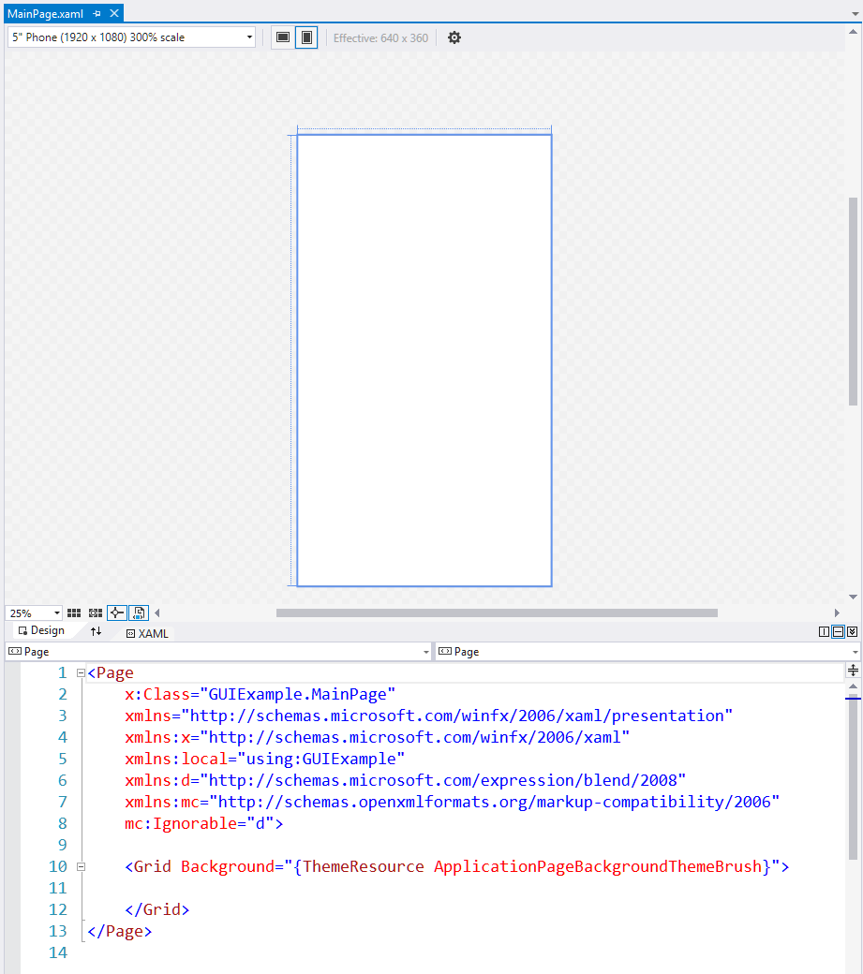

This is the **main view** of the application right now. Or more specifically; if we run the application as it is right now, this is what it will look like, if we run it on a Windows phone with a 5” screen with resolution 1920x1080. One of the fundamental ideas behind UWP is that a UWP application should be able to run on any hardware device that runs Windows 10, be it an ordinary computer, a smartphone, an Xbox, a Smart-TV or whatever. Therefore, it is possible to preview what an application will look like on a certain device. If you look closely in the upper-left corner of the previous image, you will see a list-box where **“ 5” phone (1920 x 1080) ”** has been chosen. We can choose other devices, for instance a 23” desktop with 1920x1080 resolution. We will in general work with this choice, and will not in this text dive into the details related to how to ensure that a UWP application looks reasonable on all possible devices. Assuring this involves setting up the GUI elements in a certain manner, which is not a feature we will focus on here.

Below the top part (usually called the **Design View**) is a window containing XML code; more specifically XAML code, as described earlier. This may initially look quite com­plex, but the good news is that the XAML code present from the beginning is usually not something we need to think much about, let alone change. This is actually the definitions of the “schemas” we also mentioned earlier, so this just ensures the we “speak XAML” in this file.

The only part that is directly related to the GUI is the **<Grid>** element. Visual Studio inserts this per default. To keep things simple, we will simply delete it, so we start completely from scratch. Be sure, however, that you only delete the **<Grid>** tag (from **<Grid>** to **</Grid>**, both included).

With this out of the way, we have a blank area to work with. Right now, the GUI does not contain any elements at all. How do we then add a GUI element? You can do this in a couple of ways.

The first way is the graphical way. Just next to the **Solution Explorer** window, there should be a **Toolbox** pane to click on (alternatively, choose **View | Toolbox** in the menu). If you then expand the **Common XAML Controls** element, you will see a long list of GUI elements. One of those elements is called **Button**. If you click on the entry in the list, you can then simply drag an element onto the view. If you do so, you will probably end up with an enormous button, filling up the entire view! Don’t worry, we will fix that later on. For now, just note that some text (probably one long line of text) has been added to the XAML part of the window. The text (with a bit of formatting) will probably look like:

**<Button Content="Button" HorizontalAlignment="Left"**

**Height="1080" VerticalAlignment="Top" Width="1920"/>**

How do we read this? The tag type specifies what kind of GUI control the tag defines, in this case a **Button**. Then follows the “content” of the button, which initially simp­ly is the text **Button**. The last four elements are related to the graphical layout of the button; if you try to change 1080 to 100, and change 1920 to 200, you will see that the button changes size accordingly (remember that the values must be enclosed in **“”**, even though they are numeric!).

You have probably by now figured out that the visual view and the XAML code are just two sides of the same thing; it is simply two ways of looking at the same data. This also means that you can work with the GUI in both ways, choosing the way that you are most comfortable with. You can thus add GUI elements simply by writing proper XAML in the XAML window. There is even a third way to work with the GUI: If you select the button in the view and then press F4, a **Properties** window will open:

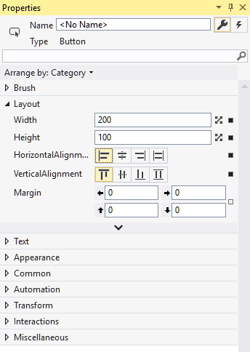

Here the **Layout** part has been expanded, and you can again see the values that we have already seen in the XAML code and in the Design view. So, the **Properties** view is just a third view into the same data. If you close the **Properties** view, you can always open it again by pressing F4.

All these ways to view data, the number of GUI controls and the myriad of properties you can set for a control can feel overwhelming, and there are indeed many little knobs you can turn. However, you only need to know about a few control and a few properties for controls in order to get started.

Before diving into the specifics of certain controls, a couple of things about working with these types of applications should be mentioned. First, it is as mentioned before possible to get a “preview” of how the application will look on various devices, by choosing such a device in the Design view. It is even possible to try to run the appli­cation in a device simulator, where it is not only the visual appearance that is simula­ted, but also things like memory limitations, etc.. You choose between such simula­tors by expanding the lis box attached to the well-known **Start** button. However, note that you will need to download device-specific simulators to Visual Studio, before they can be used. In or­der to keep things simple, we will in general just go with the “Local Machine” option, that just launches the application directly on your computer.

Another – somewhat more obscure – issue is related to setting access rights to the file system. If you create a UWP application – or e.g. download an exercise project – build it, and try to launch it, you may very well experience an “Access denied” error. Access to the file system is a non-trivial issue for UWP applications[10], but the easiest way to fix theis problem is as follows:

1. Using the **File Explorer**, go to the folder where you intend to store your UWP applications.
2. Right-click the folder, and go to **Properties** in the menu.
3. Go to the **Security** tab.
4. Click on the **Edit** button.
5. Click on the **Add** button.
6. Add **SYSTEM** as a user name.
7. Give the **SYSTEM** user full access rights to the folder.

This should get rid of any problems with denied access.

## Simple controls

The term “simple controls” is not a formal one – we just use it to describe a handful of very fundamental controls, that will almost always be part of a typical GUI. You may of course encounter more specialised situations, where you will need to rely on other types of controls. If so, seek information about such controls online[11].

### Button

We have already seen an example on a **Button** control, where the content of the but­ton was a simple text. The content of a button can be more complex – for instance an image combined with text – but the overall purpose of a button is of course to enable a user to invoke a certain action. We will later see how you associate such an action with the button, such that the action is invoked when the user clicks on the button.

### TextBlock

A **TextBlock** is just a section of text to be displayed somewhere in the GUI, without being part of another control (e.g. a **Button**). The user cannot as such interact with a **TextBlock**, but it is possible to change the text in a **TextBlock** dynamically, as we will see examples of later. A very simple **TextBlock** will in XAML look like:

**<TextBlock Text="Hello there" />**

The **Text** property is thus the holder of the content itself. In addition to this, there are of course a multitude of attributes related to the visual appearance of the text. These attributes are probably easiest to explore in the **Properties** window.

### TextBox

A **TextBox** is to some extent similar to a **TextBlock**, the major difference being that a user can usually enter text into a **TextBox** control (if the control is enabled for recei­ving user input). A simple **TextBox** in XAML could be:

**<TextBox Text="Hello there" Width="100" Height="50" />**

Just as for the **TextBlock**, the text itself can be formatted in various ways. It is quite common to use a **TextBox** together with a **TextBlock**, where the **TextBlock** can con­tain a “lead text”, describing the data you should enter into the following **TextBox**.

### Image

An **Image** control will – not surprisingly – contain an image, and it will usually be a passive element in the GUI. The most important property of an **Image** control is the **Source** property, where you specify the source for the image to display. The source is a URL; it can point to a local file, but also to a destination on the web:

**<****Image Source="http://shortly.be/content/auto_site_logo.png" />**

Note that an **Image** control can be used as part of the content of other controls, for instance a **Button**. It is also possible to make an **Image** control responsive, i.e. make it react to being clicked on by the user.

### Slider

The **Slider** control is maybe on the borderline of being a “simple” control, and does not occur that often in GUIs compared to the previous controls. A slider control can be used to set a value between a specified minimum and maximum value. This can be utilised to allow the user to choose a numeric value inside a certain interval, without requiring the user to enter the number into e.g. a **TextBox**, which would require that the application does some validation of the entered data. This can be avoided using a **Slider** control. A simple **Slider** control can look like.

**<Slider Maximum="800" Minimum="100" Value="400"/>**

Whenever the user slides the marker in the **Slider** control, the **Value** property will change accordingly. We will later see how that value can then be used to control the value of properties in other controls.

## Layout controls

The small examples above have not been placed in some sort of context. When a GUI becomes just a bit more complex, we need ways to organise the GUI elements into larger groups, in order to manage the visual layout. A number of **layout controls** are available for this purpose. You may recall that Visual Studio put a **Grid** element into the XAML code per default; the **Grid** control is an example of such a layout control.

### Grid

The **Grid** layout control is used if the overall layout of a window follows a regular row/ column structure, i.e. where all columns have the same number of rows, and vice versa. Placing a **Grid** tag inside the XAML code will create a 1-by-1 grid; if you wish to create a grid with several rows and columns, you will need to add a number of so-called row- and column-definitions to the **Grid**. The below XAML code defines a 3-by-2 grid:

**<Grid>**

**<Grid.RowDefinitions>**

**<RowDefinition/>**

**<RowDefinition/>**

**<RowDefinition/>**

**</Grid.RowDefinitions>**

**<Grid.ColumnDefinitions>**

**<ColumnDefinition/>**

**<ColumnDefinition/>**

**</Grid.ColumnDefinitions>**

**</Grid>**

In the Design view, you will see something like:

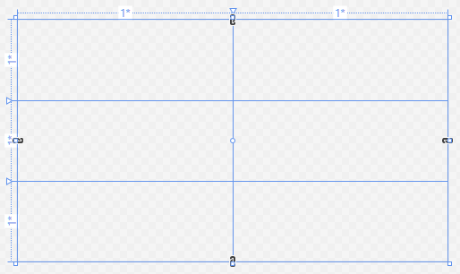

There are a number of ways to control how the columns and rows are sized with respect to each other; we will get back to this in the chapter on control properties. Once a suitable structure has been defined, you can add controls inside specific grid cells. You do this using the below syntax:

**<Grid>**

**<Grid.RowDefinitions>**

**<RowDefinition/>**

**<RowDefinition/>**

**<RowDefinition/>**

**</Grid.RowDefinitions>**

**<Grid.ColumnDefinitions>**

**<ColumnDefinition/>**

**<ColumnDefinition/>**

**</Grid.ColumnDefinitions>**

**<Image Grid.Row="0" Grid.Column="1"**

**Source="http://shortly.be/content/auto_site_logo.png"/>**

**<Slider Grid.Row="1" Grid.Column="1"**

**Maximum="800" Minimum="100" Value="400" Width="400" />**

**</Grid>**

Since the controls are defined within the **Grid** tag, they are per definition assumed to be positioned within that grid. All specifications of relative positioning of a control – like e.g. alignment – will now be done relative to the grid cell containing the control.

### StackPanel

The **StackPanel** control is in a sense more primitive than the **Grid** control, but also more flexible. Inside a **StackPanel**, you can specify a sequence (or “stack”) of controls, e.g. like this:

**<StackPanel>**

**<Image Source="http://shortly.be/content/auto_site_logo.png"/>**

**<Slider Maximum="800" Minimum="100" Value="400" Width="400" />**

**</StackPanel>**

This will “stack” the controls visually on top of each other. This is in itself rarely what you want. However, two additional features make the **StackPanel** really useful:

* You can orient the **StackPanel** to stack the controls either vertically (default) or horizontally
* You can put **StackPanels** inside **StackPanels**

The latter property is as such not something special for the **StackPanel**; if you wish, you can also put a **Grid** control within a **Grid** control. Still, these two features alone make it possible to create quite sophisticated layouts. Also, there is no need to specify the position of an embedded control explicitly (as was the case for the **Grid** control), since the order of the controls themselves specify the position within the **StackPanel**. Only drawback is perhaps that the nesting level of the **Stackpanel** controls tends to become quite deep.

## Control properties

We have already used some of the (many) properties that are available on controls, and we will not try to give a comprehensive description of all properties here. A good way to explore the available properties for various control types is to select a control in the Design view, and then open the **Properties** window (press F4). Also, remember that even though there might be dozens of properties to fiddle with, you will usually only need to use a few of them. In the below, we will give an overview of some impor­tant categories, and describe a few specific properties in more detail.

### Default properties

All controls have a so-called default property. The default property can be set simply by writing its value between the opening and closing tag of the control, like:

**<TextBlock>Hello all</TextBlock>**

The default property for a specific control is usually chosen such that it is a commonly used property. For a **Page** control, the default property is **Content**, which is the reason for the commonly seen error *“The property ‘Content’ is set more than once”*, if you just add a number of controls directly to a page. The error is usually fixed by wrapping the controls into a **StackPanel** tag.

### Complex properties

The term complex is not a formal one here; it is just a common denominator for properties that cannot be set by a single simple value. Consider for instance this definition of the background for a **Button** control:

**<Button.Background>**

**<LinearGradientBrush EndPoint="1,0.5" StartPoint="0,0.5">**

**<GradientStop Color="Black" Offset="0" />**

**<GradientStop Color="White" Offset="1" />**

**</LinearGradientBrush>**

**</Button.Background>**

Here we have a complex definition of the background, so we need to write out the entire hierarchy of “sub-properties” we need to set.

### Attached properties

We have already used attached properties, when we defined the positioning of a control inside a **Grid** control:

**<Image Grid.Row="0" Grid.Column="1"**

**Source="****http://shortly.be/content/auto_site_logo.png"/>**

**<Slider Grid.Row="1" Grid.Column="1" Maximum="800" Minimum="100"**

**Value="400" Width="400" />**

The **Grid.Row** property is an attached property for e.g. the **Image** control, since it refers back to enclosing **Grid** control.

### Layout properties

The layout of most controls can be controlled in quite detailed ways, and it can be somewhat confusing to figure out why a certain combination of layout property values result in a certain graphical layout. There are various ways to e.g. specify the size of a control; some specify the size in an absolute measure (e.g. pixels), while others specify a relative size. The commonly used properties **Height** and **Width** can be set in (at least) four ways:

|  |  |
| --- | --- |
| “Auto” | Adjusts according to the controls inside the control in question |
| “*” | A certain part of the controls total size |
| “60” | 60 physical pixels |
| “3*” | A certain part of the controls total size (three times larger than “*” |

On top of this comes the fact that sizes are sometimes relative to the size of the en­clo­sing control, which may again be relative, and so on… The best advice is probably to go for a fairly simple layout initially, which can then be adjusted later.

A first attempt at organising a set of controls often results in the controls being visu­ally mashed up against each other, which is not very visually pleasing. The **Margin** property comes in handy for this problem. If you wish to create a **Button** control with a 10-pixel margin to all sides, it will look like:

**<Button Content="OK" Margin="10,10,10,10"/>**

The margins are specified in the order left-top-right-bottom. Adding just a fex pixels of space between controls will usually make a significant difference.

### Using styles

Once your GUI grows beyond a few controls, you will often be in a situation where you want several controls of the same type – say, a set of **TextBox** controls – to follow the same layout. This can of course be achieved just by explicitly setting all relevant properties for each control, but this can quickly become cumbersome to maintain, if you decide to change the layout. One way around this is to define a **Style**.

A **Style** is a set of settings for certain properties, that you wish to apply to several con­trols of the same type. A **Style** is specified as a so-called **Resource**, typically apply­ing to an entire **Page**, like:

**<Page.Resources>**

**<Style x:Key="TextBoxStyle" TargetType="TextBox">**

**<Setter Property="FontSize" Value="24"/>**

**<Setter Property="Width" Value="300"/>**

**<Setter Property="Margin" Value="5,5,5,5"/>**

**</Style>**

**</Page.Resources>**

Apart from the slightly peculiar **Setter/Value**-syntax, it is pretty straightforward. You can then apply such a style to a control of the specified type, like:

**<TextBox Style="{StaticResource TextBoxStyle}" Text="(Name)"/>**

There are of course more in-depth descriptions of layout properties – and XAML layout considerations in general – available elsewhere, for instance here[12].

## Data Binding

As the previous chapter illustrates, it is by no means a simple task to accurately speci­fy the graphical layout of an application GUI…and we haven’t even begun to use the GUI for anything yet! The GUI is rarely an end-goal in itself; it is just a tool for helping the user to interact with the application. The ultimate goal for most applica­tions is to do some sort of data manipulation, and the GUI is the surface through which the user can manipulate the data. This in turn implies that the GUI elements must somehow be in contact with the data. So how is this achieved?

A central concept in achieving this goal is so-called **data binding**. Data binding covers the idea that data – both in simple and complex forms – can be “bound” to GUI con­trols, such that changes in the data are directly reflected in the GUI controls, and – very importantly – vice versa. If the actual data inside the application comes “out of sync” with the data presented to the user by the GUI, the results can be cata­stro­phic. Imagine a banking application, where the balance of a bank account suddenly is diffe­rent from what the user sees on the screen. Or perhaps a military control system… This problem is almost as old as computer programming itself, and has been handled in various ways. Most of these ways are variants of data binding.

### Simple binding between GUI elements

The simplest form of data binding can be between two GUI controls defined on the same page. In the previous example with an **Image** and a **Slider** control, we can add data binding in the following way (image source omitted for brevity):

**<Image x:Name="theImage" Source="…"**

**Height="{Binding ElementName=theSlider, Path=Value}"**

**Width="{Binding Height}" />**

**<Slider x:Name="theSlider" Maximum="800" Minimum="100" Value="400"**

**Width="400" Height="400"/>**

How should this be read? The two interesting entries are the **“{Binding …}”** entries. The first entry should be read as *“bind the* ***Height*** *of the* ***Image*** *control to the GUI element named* ***theSlider*** *(which is a* ***Slider****), specifically to the* ***Value*** *property”*. With this binding, the height of the image will actually change if we slide the marker in the **Slider** control back and forth. The second entry reads *“Bind the* ***Width*** *property of the* ***Image*** *to the* ***Height*** *property of the (same)* ***Image****”*. This just ensures than the width and height of the image are both changed according to the value of the slider.

Data bindings like these are fairly simple, since they only involve the GUI controls them­­­selves. Things get a bit more complex when GUI elements must be bound to data that is not part of the GUI itself, but rather part of the data “model” contained in the application; that is, the model of whatever domain the application concerns.

### Data binding between GUI elements and model objects

We mentioned in the start of this chapter, that one of the fundamental ideas in this approach to GUI development is the division of specification of appearance and beha­vior. That is, we specify the visual appearance of a GUI element in XAML, and the beha­­vior (including interaction with domain model objects) in C#. However, since the XAML code is transformed into C# and compiled along with the “native” C# code, the GUI controls will effectively be nothing more than C# objects, living in the context defined by the class definition they are part of.

A consequence of this fact is that it is fairly straightforward to bind a GUI control to a non-GUI property of the class in which it is defined. Still, this is not the recommended approach. We will in general aim to keep the code-behind files associated with XAML files as small as possible – preferably empty – since there are several advantages of keeping the binding specifi­cations in the XAML code. One such advantage is **portabili­ty**. XAML code can be used in other contexts than applications written in C#, but any logic placed in the code-behind files cannot be ported as easily.

The preferred approach is therefore to specifiy data bindings in the XAML code alone. Fortunately, this is also relatively easy to do. A key concept related to this is the **data context**. We said before that GUI controls are just C# objects living inside a class defi­nition. This also means that it is possible to refer to objects of other classes, e.g. do­main model classes. In XAML, this is done by specifying a **data context** for a GUI con­trol. Data contexts are “hierarchical”, in the sense that if you e.g. set a data con­text for a **Page** control, all GUI controls defined within that **Page** will also be set to use that data context (unless they themselves explicitly set a different data context). A com­mon approach is therefore to set the data context once, for the “outermost” control in a window, typically a **Page** control.

How does this look in practice? Suppose we define a simple domain class called **Car**, that for now only has one very simple property called **Brand**:

**class Car**

**{**

**public string Brand { get { return "Toyota"; } }**

**public Car() { }**

**}**

The class is just defined in the same C# project as the XAML code is defined in, and there is for now nothing special about it. In the XAML code, we add a simple **TextBox** control as well:

**<TextBox Text="(not set)"/>**

The **TextBox** control is defined inside a **StackPanel**, which again is defined inside a **Page**. We now set the data context property for the **Page** control (this must be done within the **Page** start- and end-tag):

**<Page.DataContext>**

**<local:Car/>**

**</Page.DataContext>**

The validity of this code rests on the fact that a namespace declaration for **local** was added to the XAML code at creation:

**xmlns:local="using:GUIExample"**

The **GUIExample** term is simply the name of the C# project we are working with here; in your own project, it will be substituted with the name of your own project. With this in place, we can now change the **TextBox** declaration to:

**<TextBox Text="{Binding Brand}"/>**

This should be read as “the value of the **Text** property of the **TextBox** control is now bound to the value of the **Brand** property of the **Car** object.” With the data con­text in place, this binding is not more complex w.r.t. syntax than binding to a value from another GUI control. Running the application now will indeed update the text in the **TextBox** control as desired:

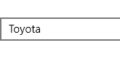

There are however a couple of issues to consider. First, it was stated above that the **Text** property is bound to the **Brand** property on the **Car** object…. But which **Car** object is that? With a data context specification like this, the application will create a new **Car** object whenever the **Page** object containing the data context specification is created, e.g. when the user navigates to that page in the application. In this simple example, the behavior is always the same, since the **Brand** property always returns the same value (**Toyota**). In a more realistic setup, it will require a more elaborate appro­ach to cause this behavior to create the desired binding. We return to this in the chapter on the MVVM Architecture.

Second, we have now seen that the text in the **TextBox** control is actually updated with the text returned by the **Brand** property on the **Car** object. So, the binding going from **Car/Brand** to **TextBox/Text** (we use this informal **Class/Property** notation as a short way of saying “the **Property** property on the object of type **Class**”) seems to work. But what about the other way around? It would be natural to expect that we could type something into the text box, and expect that **Car/Brand** is updated to this new value. Achieving that does however require a few additions to the code.

First of all, the **Car/Brand** property must be changed, since it doesn’t have a **set**-part yet. The **Car** class then becomes a bit more useful:

**public class Car**

**{**

**private string _brand;**

**public string Brand**

**{**

**get { return _brand; }**

**set { _brand = value; }**

**}**

**public Car()**

**{**

**_brand = "Toyota";**

**}**

**}**

Next issue is to have a way of seeing if the value is actually changed in the **Car** object itself, if we type something into the text box. In order to do this, we create a simple **TextBlock** control, and bind it to the same property:

**<TextBox Text="{Binding Brand}"/>**

**<TextBox Text=""/>**

**<TextBlock Text="{Binding Brand}"/>**

An empty text box has also been added here; this is just for being able to leave the first **TextBox** control when having completed the typing of the new value. The GUI will as such not react to the typed value until the **TextBox** control “loses focus”, i.e. the screen cursor has been moved to a different control. Since you cannot move the cur­sor to a **TextBlock** control, an extra **TextBox** has been added to enable this. It has no other function.

If we now run the application, and type a new value into the text box, we will not see the desired behavior. This is partly due to an incomplete data binding specification. Data binding can be specified as having a certain “mode”:

|  |  |
| --- | --- |
| **One-time** | Data is only retrieved from the source once. Subsequent changes are not reflected. |
| **One-way** | Data flows from the source to the target, so changes in the source value are reflected in the target, but not vice versa. |
| **Two-way** | Data flows from the source to the target, and vice versa. Changes in both source and target values are reflected in the counterpart as well. |

We obviously want a two-way binding for the **TextBox** control. That is, however, not the default value (default is one-way). We must therefore explicitly set the data bind­ing mode for the **TextBox** control:

**<TextBox Text="{Binding Brand****, Mode=TwoWay}"/>**

All seems to be in place now, but if we run the application, we still don’t see the desi­red behavior… If you place a breakpoint in the **set**-part of the **Brand** property, you will indeed find that the **set**-part is called, and the instance field is updated as it should. What is missing?

The last part of the puzzle is to enable the source object (here the **Car** object) to signal to the outside world that the value of a property has been changed. Even though the **TextBlock** con­­trol has set up a binding to the **Brand** property, it is not automatically notifed about changes in the property value! This does happen automatically when you bind to other GUI controls directly in XAML code, but not for “pure” C# classes.

The mechanism commonly used for enabling such notifications is the **INotifyProperty­Changed** interface, which is part of the .NET class library. If you want a class to be able to signal changes to its properties to those interested in knowing about such changes, the class should implement this inter­face. Doing this for the **Car** class adds some extra code to the class:

**public class Car** **: INotifyPropertyChanged**

**{**

**private string _brand;**

**public string Brand**

**{**

**get { return _brand; }**

**set { _brand = value; }**

**}**

**public Car()**

**{**

**_brand = "Toyota";**

**}**

**public event PropertyChangedEventHandler PropertyChanged;**

**protected virtual void OnPropertyChanged**

**([CallerMemberName] string propertyName = null)**

**{**

**PropertyChanged?.Invoke(this, new PropertyChangedEventArgs(propertyName));**

**}**

**}**

The added code deserves some explanation: The interface **INotifyPropertyChanged** actually only consists of a so-called **event** named **PropertyChanged**, as seen in the yellow part of the highlighted code. We will discuss events in more detail later in the notes; for now, you can think of events as a mechanism for letting other parts on an application know that a certain “event” (e.g. a change in the value of a property) has occurred. Once you let a class implement **INotifyPropertyChanged**, Visual Studio will display an option to auto-generate code which implements the interface, plus a bit of extra code (the green part of the highlighted code). This extra bit of code is a method called **OnPropertyChanged**. The effect of calling this method from the **set**-part of a property, will be that all those properties that are bound to the property will be noti­fied that the value of the property has changed. This is exactly what we need.

The only code we need to explicitly add is a single line of code to the **set**-part of the **Brand** property, like this:

**public string Brand**

**{**

**get { return _brand; }**

**set**

**{**

**_brand = value;**

**OnPropertyChanged();**

**}**

**}**

If we now run the application, we will indeed see that as soon as we leave the **Text­Box** control (by hitting Tab or clicking in the empty text box), the text block below is updated with the new value. The **Car/Brand** property now “broadcasts” changes to its value to those interested, i.e. those elements that have set up a binding to that speci­fic property.

We can now recap all the steps needed in order to achieve a working two-way binding between a GUI control and an ordinary C# class:

1. Make sure that an appropriate **namespace** definition is part of your XAML page. It will be part of the top lines in the XAML file, and typically look like:

**xmlns:local="using:YourProjectName"**

1. Set the **data context** at an appropriate level in the XAML page, for instance for the **Page** element itself. The code will typically look like:

**<Page.DataContext>**

**<local:YourDomainClass/>**

**</Page.DataContext>**

1. Create a **data binding** for the relevant control. The types of the control element and the source property should be compatible, i.e. a **Text** element will usually bind to a property of type **string**, and so on. A typical binding will look like:

**<TextBox Text="{Binding YourProperty}"/>**

1. Remember to set the **binding mode** as well. If a GUI element and an object property must be in sync at all times, the binding type should be two-way:

**<TextBox Text="{Binding YourProperty, Mode=TwoWay}"/>**

1. Your domain class must implement the **INotifyPropertyChanged** inteface in order to be able to notify others about changes in its property values:

**public class YourDomainClass : INotifyPropertyChanged**

**{**

**// Rest of class definition**

**}**

1. Finally, the **set**-part of each relevant property must call **OnPropertyChanged** when the value of the property has been updated:

**public string Brand**

**{**

**get { return _brand; }**

**set {**

**_brand = value;**

**OnPropertyChanged();**

**}**

**}**

## Collection Views and Data Binding

Creating bindings to simple properties like e.g. the **Text** property in a **TextBox** con­trol is thus fairly straightforward. These bindings are usually relevant in situations where the data context is suitably represented by a single domain object. If we need to ma­na­ge and interact with a **collection** of domain objects, we need to use other control types suitable for such collections. Such control types do of course exist, but require a bit more elaboration in order to specify appearance and data bindings properly.

### The ListView control – getting started

The **ListView** control is one of those controls that can handle a collection of items. In its simplest form, it can be used completely without data binding:

**<ListView>**

**<ListViewItem>Toyota</ListViewItem>**

**<ListViewItem>BMW</ListViewItem>**

**<ListViewItem>Opel</ListViewItem>**

**<ListViewItem>Volvo</ListViewItem>**

**</ListView>**

This form is of course only relevant when the items in the list are “constant”, i.e. will not change during the lifetime of the application. This is rarely the case in prac­tice, so we need to figure out how to create data bindings for a **ListView**.

Compared with the recap for single-element bindings above, the first and second steps regarding namespace and data context are still needed, in order to make the classes in the project visible to the control. The third step (data binding) will look a bit different. First, we update the **Car** class with a new property **BrandNames**:

**public List<string> BrandNames**

**{**

**get { return new List<string>() {"Toyota","BMW","Opel","Volvo"}; }**

**}**

This list is of course also “constant”, but could in principle have been populated by reading the values from a file or database; the data binding does not care about the origin of the values. The binding itself looks like this:

**<ListView ItemsSource="{Binding BrandNames}" />**

Not much more complicated than binding to a single element, except for the use of the **ListView** property **ItemsSource**. As the name indicates, we must bind this proper­ty to a collection of values, here more specifically a list of **string** values.

This is much more useful than the first example, since the population of the list can be done in any way we wish, as long as the list is ready-to-use when the **ListView** asks for it. A natural next step would be to enable the user to add new elements to the list. This will require some additions to the code. First, we add a **TextBox** control to the GUI, so the user can type in a new brand name (this is just the **TextBox** control from the previous example):

**<TextBox Text="{Binding Brand, Mode=TwoWay}"/>**

**<ListView ItemsSource="{Binding BrandNames}"/>**

Next, we make the **Car** class a bit more general, by adding an instance field to hold the list of brand names:

**private string _brand;**

**private List<string> _brandNames;**

**public string Brand**

**{**

**get { return _brand; }**

**set**

**{**

**_brand = value;**

**OnPropertyChanged();**

**}**

**}**

**public List<string> BrandNames**

**{**

**get { return _brandNames; }**

**}**

**public Car()**

**{**

**_brand = "Toyota";**

**_brandNames = new List<string>() {"Toyota", "BMW", "Opel", "Volvo"};**

**}**

Is that enough? No, since we do not at any point add any new elements into the list of brand names. However, a small addition to the **set**-part of the **Brand** property can fix this (please note that this is not a very pretty nor user-friendly solution; it only serves to explore what it takes to get the data binding up-and-running…) :

**public string Brand**

**{**

**get { return _brand; }**

**set**

**{**

**_brand = value;**

**_brandNames.Add(_brand);**

**OnPropertyChanged();**

**}**

**}**

If you run this code, you will find that the situation is similar to what we saw at some stage in the previous example: it seems like the list should be updated, and running the code through the debugger reveals that the list does indeed get updated, but this is not reflected in the GUI… The underlying problem is actually also very similar: the list does not notify the outside world when it gets updated. Here the solution is less straightforward, since it does not make much sense to implement a **set**-part of the **BrandNames** property. It seems that the **Add** method on the **List** class ought to some­how call the **OnPropertyChanged** method.

The solution is to substitute the use of the **List** class with another class from the .NET class library: the class **Observable­Collection**. This class does what we want; when an element is added or removed from the collection, a notification is broadcasted. Once the substitution is made in the code, the list in the GUI does get updated whenever we leave the text box.

The **Observable­Collection** class is quite convenient, but it does have one major draw­back. If you add or remove an element, notifications are indeed triggered. However, if you just update a value in an existing element, no notifications are triggered! If you need this sort of functionality, a more sophisticated solution must be used.

### The ListView control – displaying items

In the above example, we did not really worry about how each item in the collection (i.e. the **ObservableCollection** object) was displayed. Since each item has the type **string**, it is easy for the **ListView** control to display the items. What if we wish to dis­play a collec­tion of **Car** objects instead? First, we need to create a property in the code where such a collection can be bound to. In order to keep things simple rather than pretty, we just add an additional property to the **Car** class:

**public ObservableCollection<Car> Cars**

**{**

**get**

**{**

**return new ObservableCollection<Car>()**

**{**

**new Car() { _brand = "Volvo" },**

**new Car() { _brand = "BMW" },**

**new Car() { _brand = "Opel" },**

**new Car() { _brand = "Toyota" }**

**};**

**}**

**}**

The data binding for the **ListView** control also needs to be updated:

**<ListView ItemsSource="{Binding Cars}"/>**

Running the code with these updates does produce a **ListView** control containing four items, but they are not displayed in a particularly useful way:

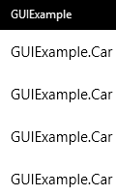

What has happened is that the **ListView** has called the **ToString** method on each ob­ject, and displays the result of that call. Since we have not overrided **ToString**, this is the result. If we override **ToString** in the **Car** class, we get a better result:

**public override string ToString()**

**{**

**return "This is a " + _brand;**

**}**

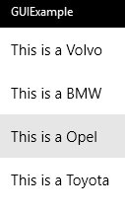

If the data you wish to display in a **ListView** control can be appropriately displayed by a simple string, you probably don’t need something much more advanced than this. It is however possible to specify more elaborate ways to display elements in a **ListView**, by defining a so-called **data template**.

### Defining a data template

The data template is a way of specifying the visual appearance of a single item in the **ListView**. Formally, the data template is set as the value of the **ItemTemplate** proper­ty of a **ListView** control, like this:

**<ListView ItemsSource="{Binding Cars}">**

**<ListView.ItemTemplate>**

**<DataTemplate>**

**(your item layout specification)**

**</DataTemplate>**

**</ListView.ItemTemplate>**

**</ListView>**

Inside the **DataTemplate** tag, you specify the layout of an item. You can use all of the available control types without restriction. If you e.g. want to display each **Car** item as a small picture followed by the brand name, it could look like this:

**<DataTemplate>**

**<StackPanel Orientation="Horizontal">**

**<Image Source="{Binding ImageSource}" Height="80" Width="80"/>**

**<TextBlock Text="{Binding Brand}"/>**

**</StackPanel>**

**</DataTemplate>**

Assuming that the **ImageSource** property has been added to the **Car** class, and that some suitable images have been made available, the **ListView** will now look like:

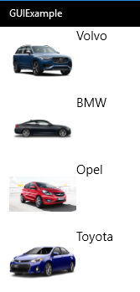

Since we have chosen to jam everything into the **Car** class, the data template does not need to be told explicitly that the bindings refer to properties on the **Car** class. If the class structure is more elaborate, it is possible to state explicitly what the type of the items in the **ListView** is:

**<DataTemplate** **x:DataType="local:Car">**

**<StackPanel Orientation="Horizontal">**

**<Image Source="{Binding ImageSource}" Height="80" Width="80"/>**

**<TextBlock Text="{Binding Brand}"/>**

**</StackPanel>**

**</DataTemplate>**

The **x:** syntax just implies that we are referring to a specific part of the namespaces included at the top of the XAML file.

### The ListView control – binding to SelectedItem

A final (in this text) useful feature of the **ListView** control is the ability to bind to the currently selected item in the control. The **SelectedItem** property on the control can be targeted in a data binding:

**<ListView ItemsSource="{Binding Cars}"**

**SelectedItem="{Binding SelectedCar}">**

**<ListView.ItemTemplate>**

**<DataTemplate>**

**(your item layout specification)**

**</DataTemplate>**

**</ListView.ItemTemplate>**

**</ListView>**

A **ListView** control is often used in a so-called **Master/Details view**. In this category of views, the user can select an item in the **ListView** control, and see further details of the selected item in a different part of the view. If we imagine that the **Car** class con­tains some additional properties, we could add some additional controls to the page that until now only contains the **ListView** control:

**<StackPanel Orientation="Horizontal">**

**<ListView ItemsSource="{Binding Cars}"**

**SelectedItem="{Binding SelectedCar, Mode=TwoWay}">**

**<ListView.ItemTemplate>**

**<DataTemplate x:DataType="local:Car">**

**<StackPanel Orientation="Horizontal">**

**<Image Source="{Binding ImageSource}"**

**Height="50" Width="50"/>**

**<TextBlock Text="{Binding Brand}"/>**

**</StackPanel>**

**</DataTemplate>**

**</ListView.ItemTemplate>**

**</ListView>**

**<StackPanel>**

**<StackPanel Orientation="Horizontal">**

**<TextBlock Text = "Brand"/>**

**<TextBlock Text = "{Binding SelectedCar.Brand}"/>**

**</StackPanel>**

**<StackPanel Orientation="Horizontal">**

**<TextBlock Text = "Color "/>**

**<TextBlock Text = "{Binding SelectedCar.Color}"/>**

**</StackPanel>**

**<StackPanel Orientation="Horizontal">**

**<TextBlock Text = "Seats "/>**

**<TextBlock Text = "{Binding SelectedCar.Seats}"/>**

**</StackPanel>**

**<StackPanel Orientation="Horizontal">**

**<TextBlock Text = "Price "/>**

**<TextBlock Text = "{Binding SelectedCar.Price}"/>**

**</StackPanel>**

**</StackPanel>**

**</StackPanel>**

With this setup, we get something that is at least a rough draft of a Master/Details view for a **Car** domain object:

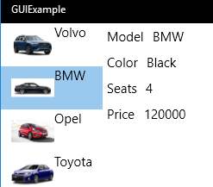

There is obviously some work to do with regards to the visual presentation of the data, but the essential wiring with respect to data binding is largely in place now.

### The GridView

Once we know how to deal with a **ListView** control, there is actually not that much more to say about a **GridView** control. The considerations that applied to **ListView** are also valid here, so it is mostly a matter of the visual presentation. With a little bit of adjustment, a **GridView**-version of the previous example could look like:

**<GridView ItemsSource="{Binding Cars}">**

**<GridView.ItemTemplate>**

**<DataTemplate>**

**<StackPanel HorizontalAlignment="Center">**

**<Image Source="{Binding ImageSource}"**

**Height="200" Width="200"/>**

**<TextBlock FontSize="48" Text="{Binding Brand}"/>**

**</StackPanel>**

**</DataTemplate>**

**</GridView.ItemTemplate>**

**</GridView>**

The visual result is:

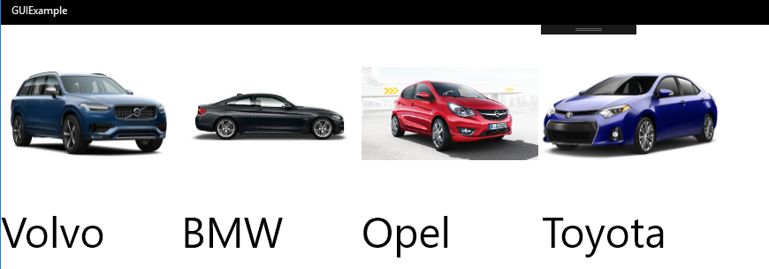

Again, some visual polishing would probably be in order, but the fundamental setup is almost identical to the setup we developed for the **ListView** control example.

## Commands

So far, we have mostly concentrated on how to bind GUI controls to existing data, in the form of domain model objects. We did have a single example of how to add an element to a list, but it was done in a haphazard way inside the **set**-part of a property. That is definitely not a recommendable approach for a real system. We will therefore now look closer at how to perform modifications to a domain data model, e.g. how to delete a domain object through a GUI.

### Deleting a domain object

As such, the actions we wish to perform are not particularly complicated. Suppose we now have a fuller **Car** domain class, like:

**public class Car**

**{**

**private string _licensePlate;**

**private string _brand;**

**private string _model;**

**private string _imageSource;**

**private string _color;**

**private int _seats;**

**private int _price;**

**// ...and so on (Properties, etc.)**

**}**

In this class, we assume that the **LicensePlate** property (associated with the **_license­Plate** instance field) defines a unique key for **Car** objects, i.e. no two **Car** objects will have the same value for **LicensePlate**. Also, we have created a class **CarCatalog**, which holds a collection of **Car** objects (in an **ObservableCollection**), like:

**public class CarCatalog : INotifyPropertyChanged**

**{**

**private ObservableCollection<Car> _cars;**

**private Car _selectedCar;**

**public ObservableCollection<Car> Cars**

**{**

**get { return _cars; }**

**}**

**// ...and so on**

**}**

How would we go about implementing functionality for deleting a **Car** object from our model? Since we assume that the collection of car objects is indeed that entity which represents the cars we have in our model, deletion of a specific car will amount to de­le­ting the corresponding **Car** object from the **CarCatalog** object. We thus assume that there will always be exactly one **CarCatalog** object present, and we only need to dele­te the **Car** object from that object. Since we have defined that the **LicensePlate** field uniquely maps to a **Car** object, we can add a **Delete** method to our **CarCatalog** class:

**public void Delete(string licensePlate)**

**{**

**// Implementation of deletion functionality**

**}**

The implementation details of the deletion are as such not interesting, so we will not detail them further.

With this functionality available on the **CarCatalog** class, the remaining issues are:

* How do we select the value for **LicensePlate** to be used in a call of **Delete**?
* How is the deletion functionality activated from the GUI?

If we assume that we still have some sort of Master/Details view set up for cars, a natural way of selecting the car targeted for deletion could be to select a car in the Master view (i.e. a list view), and then have a button labeled **Delete** available for the user to click on. That is, when the **Delete** button is clicked, the **Car** object correspond­ing to the selected item in the list view should be deleted:

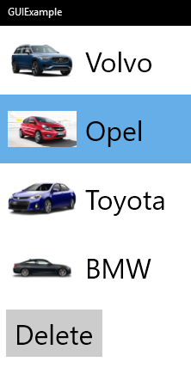

We have already seen that it is fairly easy to bind the selection in the list view to e.g. a **SelectedCar** property on the **CarCatalog**, so once we click on the **Delete** button, we can easily retrieve a value for **LicensePlate** to use in the call to **Delete**:

**Delete(SelectedCar.LicensePlate);**

There is a small problem lurking here; what if no **Car** object is currently selected? We’ll get back to that in a moment. Right now, the main issue is how to invoke this call of **Delete**, i.e. how do we bind the action of clicking on the **Delete** button to the invocation of the method? The prefer­red way to achieve this is to encapsulate the deletion code into a so-called **Command** object.

### The ICommand interface

A **Command** object is in this context an object that implements the **ICommand** inter­face. This interface is part of the .NET class library, and contains two methods and an event, similar to the event we saw in the code generated for **INotifyPropertyChan­ged**. A simple class **Command** that inherits from **ICommand** could look like:

**public class Command : ICommand**

**{**

**public bool CanExecute(object parameter)**

**{**

**// Should return whether or not the command**

**// can currently be executed.**

**}**

**public void Execute(object parameter)**

**{**

**// The code to execute**

**}**

**public event EventHandler CanExecuteChanged;**

**}**

This is in itself not very useful, but illustrates the elements contained in the interface. The more important point is that we can create properties on a domain class like **Car­Catalog**, that have the type **ICommand** and return a **Command** object:

**public ICommand DeletionCommand**

**{**

**get { return new Command(); }**

**}**

We will implement a more proper deletion command class in a moment, but the point is that we can now bind the **DeletionCommand** property to a **Delete** button, like this:

**<Button Content="Delete" Command="{Binding DeletionCommand}"/>**

A **Button** control has a **Command** property, which can be bound to a corresponding property on a non-GUI object, if the property is of type **ICommand**. The consequence of this binding is that whenever the user clicks the **Delete** button, the application will retrieve the object returned by the bound-to property, and call its **Execute** method! This is the essence of the command concept; we “encapsulate” a piece of function­ality – often some business logic – inside a command object, such that the function­ality will be activated when the **Execute** method in the command object is called. Creating a command object will thus not in itself execute the functionality, but rather make it available for execution later, when a certain “event” happens (e.g. the user clicking on a **Button** control).

The **CanExecute** method supplements this idea; it is intended to return **true** if the application is in a state where execution of the functionality is allowed, otherwise **false**. If a GUI control binds to a command object, the GUI control will be disabled if **CanExecute** returns **false**. This is quite user-friendly, since the user will never experi­ence being able to click on e.g. a **Button**, and then being told that the functionality cannot be executed anyway. With this knowledge, we can now get much closer to a proper implemention of a deletion command class:

**public class DeleteCommand : ICommand**

**{**

**private CarCatalog _carCatalog;**

**public DeleteCommand(CarCatalog carCatalog)**

**{**

**_carCatalog = carCatalog;**

**}**

**public bool CanExecute(object parameter)**

**{**

**return _carCatalog.SelectedCar != null;**

**}**

**public void Execute(object parameter)**

**{**

**_carCatalog.Delete(_carCatalog.SelectedCar.LicensePlate);**

**}**

**public event EventHandler CanExecuteChanged;**

**}**

Several elements have now been added to the original outline of the class:

* An instance field **_carCatalog** of type **CarCatalog**
* A constructor, taking a parameter of type **CarCatalog**
* An implementation of **Execute**
* An implementation of **CanExecute**

Since the deletion operation is performed on a **CarCatalog** object, the command object needs a reference to such an object. Once the reference has been set – this is done in the **DeleteCommand** constructor – it is fairly straightforward to implement the functionality for **Execute** and **CanExecute**, respectively:

* **Execute** simply calls the **Delete** method defined in the **CarCatalog** class, using the license plate from the cur­rently selected **Car** object as parameter.
* **CanExecute** – which decides if we can go ahead with the operation at all – only returns **true** if the **SelectedCar** property actually refers to a **Car** object (i.e. is not **null**)

It might seem a bit risky for **Execute** to try to obtain the **LicensePlate** property from the **SelectedCar** property, since that property might be set to **null**. However, that is exactly the condition that **CanExecute** tests for! **Execute** can thus only be executed if a **Car** object is actually selected.

The implementation of the **DeleteCommand** class is now finished. What remains is to create a **DeleteCommand** object in a proper place, and tie it to the view using data binding. Considering the first issue, there is not really any other place to create a **DeleteCommand** object than inside the **CarCatalog** class. But a **DeleteCommand** ob­ject also needs a reference to a **CarCatalog** object… So, can a **CarCatalog** object create a **DeleteCommand** object, and give it a reference to…itself? Yes, indeed it can! In the **CarCatalog** class, we add a new instance field:

**private DeleteCommand _deleteCommand;**

In the **CarCatalog** constructor, we then add:

**_deleteCommand = new DeleteCommand(this);**

The keyword **this** means “myself”, i.e. an object can provide a reference to itself in this manner. This is actually a fairly common strategy; an object creates another ob­ject, and hands it a reference to itself in the process. The question of whether this is the correct strategy for this situation is a question we will revisit later in this chapter.

All that remains is to make the **DeleteCommand** object available for a view to bind to. We defined a property **DeletionCommand** in the **CarCatalog** class earlier, and we only need to update the implementation of that property:

**public ICommand DeletionCommand**

**{**

**get { return _deleteCommand; }**

**}**

It looks like we are done now. However, if we run the application, the **Delete** button is now always disabled… The reason for this is somewhat subtle. When the application is launched, the page (i.e. view) containing the list view is created. Since the data con­text for the page is **CarCatalog**, a new **CarCatalog** object is created, which in turn will create a new **DeleteCommand** object. Since the **DeleteCommand** object is bound to the **Delete** button, the method **CanExecute** will be called once during this initialisation phase. At this point, the **SelectedCar** property will return **null**, since no select­ion has been made yet! This in turn causes **CanExecute** to return **false**, thereby disabling the **Delete** button.

This reaction is as such correct, since the **Delete** button should be disabled in this state. The problem is that changing the state – by selecting a **Car** object in the view – does not change the state of the **Delete** button. The reason is that noone has told the command object that things have now changed, in a way that might yield a different result if **CanDelete** is called again. This predicament is the reason for the **CanExecute­Changed** event property in the **ICommand** interface. When the state of the **CarCata­log** changes in a way that makes it relevant to refresh the state of the button – i.e. call **CanExecute** again – the event must be “raised”. This ought to happen exactly when the selection in the list view changes. Making it happen requires a couple of changes in the code.

First, we add a new method **RaiseCanExecuteChanged** to the **DeleteCommand** class:

**public void RaiseCanExecuteChanged()**

**{**

**CanExecuteChanged?.Invoke(this, EventArgs.Empty);**

**}**

We can then call this method when the selection in the list view changes. Since the **SelectedItem** property of the **ListView** control is bound to the **SelectedCar** property in the **CarCatalog** class, we need to update the **set**-part of that property with a call of the **RaiseCanExecuteChanged** method:

**public Car SelectedCar**

**{**

**get { return _selectedCar; }**

**set**

**{**

**_selectedCar = value;**

**OnPropertyChanged();**

**_deleteCommand.RaiseCanExecuteChanged();**

**}**

**}**

A test run of the application shows that the state of the **Delete** button now indeed reflects whe­ther or not a car is selected in the list view. When a car is seleted and deleted by clicking **Delete**, the car is now deleted from the list view and the **Delete** button becomes disabled, until a new car is selected.

The addition of **RaiseCanExecuteChanged** to **DeleteCommand** is very generic, and it is therefore quite common to create a command base class that implements the **ICom­mand** interface and contains the **RaiseCanExecuteChanged** method. You could e.g. create a command base class called **CommandBase**, like this:

**public abstract class CommandBase : ICommand**

**{**

**public abstract bool CanExecute(object parameter);**

**public abstract void Execute(object parameter);**

**public event EventHandler CanExecuteChanged;**

**public void RaiseCanExecuteChanged()**

**{**

**CanExecuteChanged?.Invoke(this, EventArgs.Empty);**

**}**

**}**

A derived class will then only need to implement **Execute** and **CanExecute**, and a pro-per constructor.

The concept of command objects may seem like an overly complex way of invoking func­tion­ality, that often only amounts to a couple of lines of code. There’s not really any way around it. Properties on GUI controls can bind to properties – not methods – on other objects, so the functionality-wrapped-into-command-objects style is hard to avoid. Furthermore, the use of command objects does actually provide several advan­tages on its own. Since a command object encapsulates a piece of functionality with­out know­ledge about the context in which it is used, it is pretty easy to set up tests for a com­mand class in an artificial test environment.

Another advantage of command objects is that they can be handled like any other kind of object; we can e.g. set a command object into a queue of commands waiting for execution, if we are in a situation where commands cannot always be executed immediately. We could also imagine that facilities for e.g. executing commands asyn­chronously (meaning that we don’t wait for the execution of a command to complete before proceeding with other parts of the code) can be implemented in a general way, if all relevant functionality is wrapped into command objects. We could even imagine saving a set of waiting commands to a file, and later on read them again for execution, when the needed resources are available.

Yet another – maybe not so obvious – advantage comes from the fact that we can bind as many GUI controls to a command property as we wish. Often the GUI will allow you to invoke a functionality in several ways; we could imagine that a deletion functionality could be invoked by clicking a button, but also by choosing a menu item. The availabi­lity of such GUI elements should of course be consistent, such that if a **Delete** button is disabled, the corresponding menu item is also disabled. This feature comes for free if the relevant GUI controls all bind to the same command property.

## The MVVM application architecture

The previous chapter has covered a fair bit of ground, going from a simple data bind­ing between two GUI elements, to a collection-based data binding to a Master/Details view, using command objects for invoking functionality. Still, our approach is not very robust with regards to separation of visual presen­tation and domain logic. We have not really stated anything about the roles of the **Car** and **CarCatalog** classes in the example, but it seems a fair assumption that the **Car** class is a domain class, and that other domain-oriented classes will use **Car** objects to perform some sort of business logic. The **CarCatalog** class could be perceived as such a domain class as well. In other words: the **Car** and **CarCatalog** classes should not be involved in how data relating to cars are presen­ted to the user.

In our example, we had fairly modest requirements with regards to visual presenta­tion of cars, so we could get by with using the simple properties available on the **Car** class. We will now pursue an architecture for our application that clearly separates the domain classes from the presentation-oriented part of the application. One such architecture is the **MVVM** architecture.

### MVVM architecture – fundamental features

The acronym **MVVM** is short for **Model-View-ViewModel**, and is as stated above found­ed on the principle of clear separation between presentation and domain logic. We did have some degree of separation in the previous example, in the sense that the presentation was defined in one class, while the domain logic – tiny as it was – was confined to the **Car** class. This can be described as a Model-View architecture:

Model

View

In this setup, the View classes will have explicit knowledge about the Model classes, and will thus be vunerable to changes in the Model classes. Likewise, the Model class­es may have to contain properties that are only present for making life easier for the View classes, and may even need to be up­dated if the view-oriented requirements for the application change.

The remedy for this situation is to insert a layer between the View and the Model, aptly named the ViewModel. This layer is meant to “mediate” between the two original layers, such that each can change independently of the other:

View-Model

View

Model

### MVVM – single domain object

How would this idea manifest itself in the previous example? Let’s unwind all the way back to the example where we had a simple binding between a **Car** (domain) class and a simple view in place. At that point, the **Car** class looked like this:

**public class Car : INotifyPropertyChanged**

**{**

**private string _brand;**

**public string Brand**

**{**

**get { return _brand; }**

**set**

**{**

**_brand = value;**

**OnPropertyChanged();**

**}**

**}**

**public Car()**

**{**

**_brand = "Toyota";**

**}**

**// … and code for OnPropertyChanged**

**}**

The highlighted code is the code we added in order to make the binding to the view work properly. Essentially, this implies implementing the **INotifyPropertyChanged** interface, plus calling **OnPropertyChanged** in the **set**-part of properties. Now that we are used to this sort of code, it may look quite innocent. Still, this code is only added in order to service views wishing to present car data. This means that the **Car** class now has (at least) two main responsibilities:

* Acting as a domain class
* Acting as a “service provider” for views wishing to present car data

This is not an ideal situation, since classes should in general only have a single main re­spon­sibility. Following the MVVM architecture outlined above, we should therefore insert a new class between the **Car** class and the views. We could name this class **CarViewModel**.

What responsibilities should this new class have? It should act as the service provider for views interested in presenting car data, and service the specific needs of those views. Also, it should be in contact with a **Car** object, since it will need to access car data in order to relay these data – perhaps in a modified form – to the views. More specifically, we can then conclude that the class **CarViewModel** should

* Implement **INotifyPropertyChanged**, in order to provide views with up-to-date car data (we can imagine that more than one view binds to **CarViewModel**)
* Refer to a **Car** object, and keep this object up-to-date in accordance with any actions initiated from the views (via data bindings and commands).

With this, we can begin to outline an example of a **CarViewModel** class:

**public class CarViewModel : INotifyPropertyChanged**

**{**

**private Car _domainObject;**

**public CarViewModel()**

**{**

**_domainObject = new Car();**

**}**

**public string Brand**

**{**

**get { return _domainObject.Brand; }**

**set**

**{**

**_domainObject.Brand = value;**

**OnPropertyChanged();**

**}**

**}**

**public string BrandText**

**{**

**get { return "The car is a " + _domainObject.Brand; }**

**}**

**// ... plus OnPropertyChanged code**

**}**

As we will see later, this class does have some issues, but the general concepts are in place. We refer to a domain object (the **Car** object), and manage requests regarding data for this object. That is, we return relevant data from the object when requested, either “unprocessed” as in the **get**-part of the **Brand** property, or “processed” as in the **get**-part of the **BrandText** property, where a bit of additional text is prepended.

The term “relevant” here means that we should not just make up properties that we imagine could be of use; the properties added to the **CarViewModel** class should be driven by requirements for the views presenting car data. These requirements have ideally nothing to do with the domain-driven requirements for a **Car** class, and they should therefore be completely separated. A **Car** class should not have to change because a view-oriented requirement changes, and a view should not have to change because a detail in the **Car** implementation changes. However, the **CarViewModel** is indeed allowed to change if either the views or the domain class changes, since this is exactly its main responsibility; to mediate between a domain class and the views pre­sen­ting it.

The introduction of the **CarViewModel** class enables us to do two things:

* We can “clean up” the **Car** class, so it no longer needs to contain any elements relating to presentation
* We can create bindings using the **CarViewModel** class instead of the **Car** class

The cleaned-up – but still rather primitive – **Car** class now looks like a “pure” domain class:

**public class Car**

**{**

**private string _brand;**

**public string Brand**

**{**

**get { return _brand; }**

**set { _brand = value; }**

**}**

**public Car()**

**{**

**_brand = "Toyota";**

**}**

**}**

Bindings to **CarViewModel** are now done like this (the **Button** control has no func­tionality yet):

**<Page.DataContext>**

**<local:CarViewModel/>**

**</Page.DataContext>**

**<StackPanel>**

**<TextBox Text="{Binding Brand, Mode=TwoWay}"/>**

**<TextBlock Text="{Binding Brand}"/>**

**<TextBlock Text="{Binding BrandText}"/>**

**<Button Content="OK"/>**

**</StackPanel>**

If we run this example, we will indeed see that the first **TextBlock** control (bound to the **Brand** property in **CarViewModel**) is updated whenever we type a new value into the **TextBox** control. Placing a breakpoint in the **set**-part of the **Brand** pro­perty on the **Car** class will also reveal that the value does indeed get set in the encapsulated **Car** object. All is thus in order, and we have obtained the desired separation while main­taining the functionality. Except for one problem…

Note that we added an additional **TextBlock** control to the example, binding to the **BrandText** property – which has been moved out of the **Car** class – on the **CarView­Model** class. This text did not get updated when we typed in a new brand value. Why not…? In order for that text to get updated, someone must call **OnPropertyChanged** with **BrandText** as parameter! So far, we have always called **OnPropertyChanged** without any parameter. Let’s have a second look at the **OnPropertyChanged** code:

**protected virtual void OnPropertyChanged**

**([CallerMemberName] string propertyName = null)**

**{**

**PropertyChanged?.Invoke(this,**

**new PropertyChangedEventArgs(propertyName));**

**}**

We said earlier that we need not understand the details of this method, and this is still true. However, we note that the implementation is such that if no para­meter is given, the implementation sees – through a bit of C# magic –the name of the calling property as the actual parameter. The consequence is that if we call **OnProperty­Changed** from a property named **Brand**, the implementation sees that name as the parameter, and does what it should; it notifes all properties bound to **Brand** that the value of the property has changed.

With regards to the **BrandText** property, there are two problems:

* The property doesn’t have a **set**-part.
* Nobody calls **OnPropertyChanged** for this property

It is pretty obvious that **BrandText** cannot have a **set**-part, since its value is a so-called **aggregated value**, where the value does not have a direct counterpart in the domain object. **BrandText** is of course a simple case, where the value is composed of a single property value plus some fixed text, but we could easily imagine e.g. a longer text pieced together from several properties. The main point is in any case valid: **Brand­Text** cannot have a **set**-part, so we cannot call **OnProperty­Changed** from there.

Instead, we must look for places in the code where something happens that might affect the value of **BrandText**. Again, this case is pretty obvious, since it is only in the **set**-part of the **Brand** property such a change happens. We must therefore add an extra call to **OnPropertyChanged** here:

**public string Brand**

**{**

**get { return _domainObject.Brand; }**

**set**

**{**

**_domainObject.Brand = value;**

**OnPropertyChanged();**

**OnPropertyChanged(nameof(BrandText));**

**}**

**}**

The parameter to **OnPropertyChanged** is of type **string**, so we could also have written **“BrandText”** directly. However, the **nameof(BrandText)** style – which returns the name of the property as a string – is more robust, since it will be affected at compile-time, if we decide to rename **BrandText** to something else. If we had just written a string directly, we would not see any errors before running the application.

With this addition, the application behaves as expected. For a simple setup like this, it is relatively easy to manage such dependencies, and add extra calls to **OnProperty­Changed** where needed. However, when you have a more complex setup with many depencies, you may need some sort of framework to manage the dependencies.

### MVVM – collection of domain objects

The next natural step is to extend this principle to a scenario where a collection of domain objects needs to be handled. The guiding principle is again that the domain classes should not contain presentation-oriented elements. Thererfore, a collection class **CarCatalog** for **Car** objects will be pretty simple (the **Car** class has been extended with a few properties):

**public class CarCatalog**

**{**

**private List<Car> _cars;**

**public List<Car> All**

**{**

**get { return _cars; }**

**}**

**public CarCatalog()**

**{**

**_cars = new List<Car>();**

**_cars.Add(new Car("AX 32 501", "BMW", "318i","Assets\\BMW.jpg"));**

**_cars.Add(new Car("CP 73 001", "Volvo", "X40", "Assets\\Volvo.jpg"));**

**_cars.Add(new Car("BK 55 734", "Opel", "Astra", "Assets\\Opel.jpg"));**

**_cars.Add(new Car("AZ 60 922", "Toyota", "Auris", "Assets\\Toyota.jpg"));**

**}**

**}**

Our goal is – just as in the View-Model setup – to work our way towards a working Master/Details view.

### A Data view model class

A starting point is to consider how car data is presented in the “Master” part of the view. The Master part will in practice be one of the collection-oriented GUI controls, e.g. a **ListView** control. We deliberately didn’t say “how a **Car** object is presented”, since the **ListView** will not bind to a collection of **Car** objects, but rather to a collection of view model objects relating to cars. The reason for this indirection is again to iso­late the domain classes from the presentation logic.

We will therefore need to create such a view model class. The purpose of this view model class is to provide properties for data binding... but who will actually bind to these properties? Since we are considering the presentation of data in the Master part of the view, it must be the Data Template defined in the ListView which will bind to these properties. The specific properties to include in this view model class will thus depend on the definition of the Data Template. If we name the class **CarData­ViewModel**, a first version of the class could look like this:

**public class CarDataViewModel**

**{**

**private Car _domainObject;**

**public CarDataViewModel(Car domainObject)**

**{**

**_domainObject = domainObject;**

**}**

**public Car DomainObject**

**{**

**get { return _domainObject; }**

**}**

**public string ImageSource**

**{**

**get { return _domainObject.ImageSource; }**

**}**

**public string Description**

**{**

**get { return _domainObject.Brand + " (" +**

**_domainObject.LicensePlate + ")"; }**

**}**

**}**

The **Car** class will probably contain many more properties, but for the sole purpose of presenting data in a Master view, this could be sufficient. The purpose of the Master view is to provide the user with enough data to make a well-defined selection in the view – such that further details on the selected item can be presented in the Details view – so we only need to provide a small subset of the available data. Since we will not be able to change data through the items in the Master view, we don’t need any **set**-parts of any properties here, and thus no management of depen­dencies. Note that we have also included a property **DomainObject** which returns a reference to the encapsulated domain object; this will come in handy later ☺

Moving on to the Details part of the view, the requirements are somewhat different. In the Details part, many more details about the selected item are presented, and it may even be possible to modify the data. The view model class for this purpose will thus need to contain a lot more properties than the **CarDataViewModel** class shown above, and the properties may also need to have both a **get**- and **set**-part. These addi­tional properties can either be defined in a separate class, or be added to the **Car­Data­ViewModel** class. This is mostly a matter of taste: creating two separate classes is probably most in tune with the principle of high cohesion, but they may also have significant overlap, and will inevitably increase the total number of classes in a full application. Going forward, we have chosen to expand the existing class, but the alter­native solution is equally good.

The extended **CarDataViewModel** class could then look like this:

**public class CarDataViewModel: INotifyPropertyChanged**

**{**

**private Car _domainObject;**

**public CarDataViewModel(Car domainObject)**

**{**

**_domainObject = domainObject;**

**}**

**// Properties for Master view part omitted for brevity**

**public Car DomainObject**

**{**

**get { return _domainObject; }**

**}**

**public string LicensePlate**

**{**

**get { return _domainObject.LicensePlate; }**

**}**

**public string Brand**

**{**

**get { return _domainObject.Brand; }**

**}**

**public string Model**

**{**

**get { return _domainObject.Model; }**

**}**

**// This is an aggregated property.**

**public string Heading**

**{**

**get { return $"A {Brand} {Model} + costs {Price } kr."; }**

**}**

**// The price of a Car can be changed.**

**public int Price**

**{**

**get { return _domainObject.Price; }**

**set**

**{**

**_domainObject.Price = value;**

**OnPropertyChanged();**

**OnPropertyChanged(nameof(Heading))**

**}**

**}**

**}**

Here we have assumed that it only makes sense to change the **Price** property of the car, once it has been created. It is therefore only the **Price** property that has a **set**-part. The **Heading** property is an aggregated property, and it should be “refreshed” (by a call to **OnPropertyChanged**) whenever the **Price** property changes.

We can now also use this class for establishing bindings in the Details part of the view. In the below example, we assume that the selection made in the Master part of the view will be reflected in a property called **DetailsViewModel**, which has the type **Car­DataView­Model**. Exactly where this property is defined – and how the binding to the property is established – is discussed later.

**<StackPanel>**

**<TextBlock Style="{...}"**

**Text="{Binding DetailsViewModel.Heading}"/>**

**<StackPanel Orientation="Horizontal">**

**<TextBlock Style="{...}" Text="License plate"/>**

**<TextBox Style="{...}" IsReadOnly="True"**

**Text="{Binding DetailsViewModel.LicensePlate}"/>**

**</StackPanel>**

**...**

**<StackPanel Orientation="Horizontal">**

**<TextBlock Style="{...}" Text="Price"/>**

**<TextBox Style="{...}"**

**Text="{Binding DetailsViewModel.Price, Mode=TwoWay}"/>**

**</StackPanel>**

**</StackPanel>**

With these bindings, we can now display the relevant properties of a car in the Details view. We can even edit the properties, if it makes sense. We assumed earlier that it only makes sense to change the price of a car, and it is therefore only the binding to **Price** which is a two-way binding. Also, the **TextBox** controls showing read-only data have been disabled for user input, by setting the **IsReadOnly** property to true.

### Creating a collection of data view model objects

The **ListView** control in the Master part of the view will as mentioned need to bind to a collection of data view model objects. Somebody must thus pro­duce such a collec­tion. The production process is in itself fairly simple; for each domain object in the catalog, produce a corresponding data view model object. Code for this process will look something like this:

**public List<CarDataViewModel> CreateDataViewModelCollection(CarCatalog catalog)**

**{**

**List<CarDataViewModel> items = new List<CarDataViewModel>();**

**foreach (var item in catalog.All)**

**{**

**items.Add(new CarDataViewModel(item));**

**}**

**return items;**

**}**

Where should this functionality be placed, i.e. in which class? We will postpone that decision a bit, but for now just note that we need such a method.

### A Page view model class

We are now pretty close to having all the pieces we need in order to build a working Master/Details view. Let us recap what we have in place now:

* **DomainModel:** The **CarCatalog** class plays the role of the domain model, since it contains and maintains a collection of domain objects.
* **DataViewModel:** Exposes relevant properties relating to a single **Car** object. Used for Data Binding in a Data Template for e.g. a **ListView**, and for specific properties in the Details part.
* **CreateDataView­ModelCollection:** This method handles the transformation of domain objects into a collection of data view model objects, to be displayed in e.g. a **ListView** control.

The only piece missing is a class that ties these elements together. This class will then become the Data Context for the entire view. Since a view is typically defined in terms of a **Page** control; we will therefore call such a class a **PageViewModel**. In order to see what this class should contain, we briefly recap how the Master/Details view is sup­posed to work:

* In the Master part, a collection of **DataViewModel** objects are displayed, and the user can select one of these objects. The items should correspond to the domain objects in the domain model.
* In the Details part, details corresponding to the item selected in the Master part should be displayed. The controls displaying these details are also bound to a **DataViewModel** object.

The class must then be able to do (at least) the following:

* Keep a reference to the domain model, to enable the creation of items to dis­play in the Master view.
* Implement a method which can create a collection of data view model objects from a collection of domain objects.
* Provide a property to which the selected item in the Master view can bind. This must be a two-way binding, since changes in the selection should update the Details part of the view.

These requirements imply that the class should contain (at least) these elements:

**public class CarPageViewModel : INotifyPropertyChanged**

**{**

**private CarCatalog _catalog;**

**private CarDataViewModel _selectedViewModel;**

**private CarDataViewModel _detailsViewModel;**

**public List<CarDataViewModel> DataViewModelCollection {...}**

**public CarDataViewModel SelectedViewModel {...}**

**public CarDataViewModel DetailsViewModel {...}**

**public CarPageViewModel()**

**{**

**_catalog = new CarCatalog();**

**_selectedViewModel = null;**

**_detailsViewModel = null;**

**}**

**private List<CarDataViewModel> CreateDataViewModelCollection()**

**{**

**// Implementation of CreateDataViewModelCollection**

**}**

**}**

These three properties are central for the class:

* **DataViewModelCollection**: Will be bound to the **ItemsSource** property in the Master view
* **SelectedViewModel**: Will be bound to the **SelectedItem** property in the Master view with a two-way binding.
* **DetailsViewModel**: Will refer to a **CarDataViewModel** object, speci­fically that object which corresponds to the selected item in the Master view. The Details view will then bind to this property.

We can then establish the bindings for the View:

**<Page.DataContext>**

**<local:CarPageViewModel/>**

**</Page.DataContext>**

**<!--Master view-->**

**<ListView**

**ItemsSource="{Binding DataViewModelCollection }"**

**SelectedItem="{Binding SelectedViewModel, Mode=TwoWay}">**

**<ListView.ItemTemplate> ...**

**</ListView>**

**<!--Details view-->**

**<StackPanel>**

**<TextBlock Style="{...}"**

**Text="{Binding DetailsViewModel.Heading}"/>**

**<StackPanel Orientation="Horizontal">**

**<TextBlock Style="{...}"**

**Text="License plate"/>**

**<TextBox Style="{...}"**

**Text="{Binding DetailsViewModel.LicensePlate}"/>**

**</StackPanel>**

**...**

**<StackPanel Orientation="Horizontal">**

**<TextBlock Style="{...}"**

**Text="Price"/>**

**<TextBox Style="{...}"**

**Text="{Binding DetailsViewModel.Price,**

**Mode=TwoWay}"/>**

**</StackPanel>**

**</StackPanel>**

As long as we are only considering how to display existing data – i.e. not worrying about how to change or delete data – it seems logical that the value of **SelectedView­Model** and **DetailsViewModel** should always be identical. If we change the selection in the Master view, we expect the Details part to show detailed data corresponding to the newly selected item. Could we then just omit one of those two properties? If we stick with the display-only scenario, the answer is yes. We do however choose to keep both properties, since more complex scenarios may render it necessary to assign tru­ly different values to the properties.

The only remaining issue is the implementation of the three properties. In this dis­play-only scenario, all three are fairly straightforward to implement:

**public List<CarDataViewModel> DataViewModelCollection**

**{**

**get { return CreateDataViewModelCollection(); }**

**}**

**public CarDataViewModel SelectedViewModel**

**{**

**get { return _selectedViewModel; }**

**set**

**{**

**_selectedViewModel = value;**

**DetailsViewModel = _selectedViewModel;**

**OnPropertyChanged();**

**}**

**}**

**public CarDataViewModel DetailsViewModel**

**{**

**get { return _detailsViewModel; }**

**private set**

**{**

**_detailsViewModel = value;**

**OnPropertyChanged();**

**}**

**}**

In the **set**-part of **SelectedViewModel**, we update the value of **DetailsView­Model**, since the two properties should – in this simplified scenario – always have the same value. The set-part of **DetailsView­Model** has been made private, since it should only be changed when the value of **SelectedViewModel** changes.

With this in place, the pieces have come together. We now have a functional, MVVM-based Master/Details view for car data, which responds to user selection as excepted. One significant omission so far is that we have not added functionality for e.g. dele­ting an item. We will now add this functionality by using Commands, just as we did for the View-Model setup.

### Adding a Delete command to an MVVM-based view

Since the view binds to **CarPageViewModel**, all properties for binding to commands should be implemented in this class. This is not particularly difficult, and follows the same pattern as for the Model-View setup. A couple of complications do arise when we need to implement a new version of **DeleteCommand**. Let’s review the implemen­tation in the Model-View setup:

**public class DeleteCommand : ICommand**

**{**

**private CarCatalog _carCatalog;**

**public DeleteCommand(CarCatalog carCatalog)**

**{**

**_carCatalog = carCatalog;**

**}**

**public bool CanExecute(object parameter)**

**{**

**return _carCatalog.SelectedCar != null;**

**}**

**public void Execute(object parameter)**

**{**

**_carCatalog.Delete(_carCatalog.SelectedCar.LicensePlate);**

**}**

**public void RaiseCanExecuteChanged()**

**{**

**CanExecuteChanged?.Invoke(this, EventArgs.Empty);**

**}**

**public event EventHandler CanExecuteChanged;**

**}**

The problem is that even though we can still perform a deletion in the **CarCatalog** object, it is not enough. Since the domain model is not involved in the presen­tation anymore, it does not implement **INotifyPropertyChanged** or use an **Observable­Collection**. In other words; just deleting an object in the domain model will not cause the view to update accordingly.

The solution is to provide the deletion command object with more information, speci­fically a reference to the Page view model object as well. With this reference avail­able, we can extend the implementation of **Execute** (weassume a reference to the Page view model object is kept in an instance field called **_pageViewModel**):

**public void Execute(object parameter)**

**{**

**_carCatalog.Delete(_pageViewModel.SelectedViewModel.LicensePlate);**

**_pageViewModel.SelectedViewModel = null;**

**_pageViewModel.Refresh();**

**}**

Let’s detail what happens here:

1. The domain object identified by the license plate (which acts as a key here) of the selected car is deleted from the catalog – this is just as before.
2. The selection in the Master part of the view is set to **null**. This is “by-design”; we have chosen the interaction logic to work this way.
3. Since we have deleted a domain object, we somehow need to tell the Page view model object that something has happened, which should cause it to “refresh” itself. Exactly what this “refresh” action entails it not of any con­cern to the command object.

The last point deserves a bit of elaboration. Our main concern is to ensure that the data presented in the view is consistent with the data currently stored in the data model, i.e. the catalog. Who should be responsible for this? In the above setup, it becomes the responsibility of the command object, which then becomes a kind of “controller” (in terms of GRASP patterns[13]). Whether this is the correct choice is certainly debatable. A more elaborate solution could be to implement some sort of event-driven scheme: A catalog class could contain so-called **event** properties, to which other parts of the code can subscribe. The catalog could then raise a certain event when it is modfied; a Page view model object could then subscribe to such events, thereby making it capable of keeping itself consistent with the catalog. Such a solu­tion is however a bit beyond the scope of this chapter.

We therefore stick with the somewhat simplistic scheme, where the Page view model class implements a public **Refresh** method. The **Refresh** method itself is quite simple:

**public void Refresh()**

**{**

**OnPropertyChanged(nameof(DataViewModelCollection));**

**}**

The revised implementation of the **DeleteCommand** then becomes:

**public class DeleteCommand : ICommand**

**{**

**private CarCatalog _catalog;**

**private CarPageViewModel _pageViewModel;**

**public DeleteCommand(CarCatalog catalog, CarPageViewModel pageViewModel)**

**{**

**_catalog = catalog;**

**_pageViewModel = pageViewModel;**

**}**

**public bool CanExecute(object parameter)**

**{**

**return _pageViewModel.SelectedViewModel != null;**

**}**

**public void Execute(object parameter)**

**{**

**// Delete from catalog**

**_catalog.Delete(_pageViewModel.SelectedViewModel.LicensePlate);**

**// Set selection to null**

**_pageViewModel.SelectedViewModel = null;**

**// Refresh the item list**

**_pageViewModel.Refresh();**

**}**

**public void RaiseCanExecuteChanged()**

**{**

**CanExecuteChanged?.Invoke(this, EventArgs.Empty);**

**}**

**public event EventHandler CanExecuteChanged;**

**}**

We note that the command is only allowed to execute if a selection has been made in the view (the **CanExecute** method), and that the **Execute** metod retrives the license plate for the currently selected item, and uses it when calling **Delete** on the catalog.

### Generalising the classes

These final additions bring us to a major milestone – we now have a Master/Details view including command-based functionality, playing entirely by the MVVM rulebook. The obvious question is now: what will it take to implement the same functionality for another domain class? On an architectural level, the entire class structure should be highly reusable, since very few parts of it relies on specific details for a domain class. The only assumption has been that the domain class is “simple”, i.e. that all properties have a simple type.

If this assumption is met, it should almost be a matter of copy-paste plus search-and-replace for adapting the structure for a different domain class. Some details will of course be domain-specific, like the properties in the **CarDataViewModel**, but quite a lot of code has a very generic nature. Consider for instance the below outline of a **CarCatalog** class:

**public class CarCatalog**

**{**

**private Dictionary<string, Car> _objects;**

**public CarCatalog()**

**{**

**_objects = new Dictionary<string, Car>();**

**}**

**public List<Car> All**

**{**

**get { return _objects.Values.ToList(); }**

**}**

**public void Create(Car obj)**

**{**

**_objects.Add(s.LicensePlate, s);**

**}**

**public void Delete(string licensePlate)**

**{**

**_objects.Remove(licensePlate);**

**}**

**}**

This is rather simplistic, but does provide basic catalog functionality. How much diffe­rent would a catalog class for a different domain class be? **Car** should of course be replaced with the name of the new domain class, and the property acting a key will probably not be called **LicensePlate** either. Also, it might not have the type **string**. Is it possible to turn these characteristics of the **CarCatalog** into parameters for a more general **Catalog** class? Indeed it is, at least to some extent.

We have not discussed the topic of **Generics** in C# yet, but we have actually used it a lot. We have often written e.g. **List<Car>**, meaning “a **List** object that can hold a col­lec­tion of **Car** objects”. **Car** is here used as a specifc kind of parameter; a **type** para­meter. List-based functionality is very generic, so it would be nice if you could write that functionality once, and then use it no matter the type of objects you put into the list. Generics enable you to do just that. An outline of a generalised **Catalog** class using Generics is given below, where we have introduced a **type parameter** **T**.

**public class Catalog<T>**

**{**

**private static int _keyCount = 1;**

**private Dictionary<int, T> _objects;**

**public Catalog()**

**{**

**_objects = new Dictionary<int, T>();**

**}**

**public List<T> All**

**{**

**get { return _objects.Values.ToList(); }**

**}**

**public void Add(T obj)**

**{**

**obj.Key = _keyCount++;**

**_objects.Add(obj.Key, obj);**

**}**

**public bool Delete(int key)**

**{**

**return _objects.Remove(key);**

**}**

**}**

We are not yet fully equipped to understand such code, but the point is just to illu­strate that we can parameterise the code to such an extent that it can be reused for all domain classes we wish to include. With a class like the above available, we could change e.g. the type of an instance field in the **CarPageViewModel** class:

**// private CarCatalog _catalog; (Original)**

**private Catalog<Car> _catalog;**

Instead of having to create a new catalog class for each domain class, we could then simply reuse the generic version. All we need to do is specify the actual domain type for which we need a catalog. We will not go into further details with this topic here, but revisit it when we have learned more about **Generics**, since Generics is a crucial tool to use for this purpose.

# Further parameterisation

An ongoing theme in our progression is the idea of **parameterisation**. Whenever we see an opportunity to convert a hard-coded element in a method or class into a para­meter, we should seize it. Through parameterisation, we enable the client (i.e. a pro­grammer using our method or class) to choose a specific value (to be understood in a very general sense) for the parameter, instead of locking that value inside our code. As we will see below, we can take this idea even further, when we start to consider types and even code itself as potential candidates for parameterisation.

## Generics – types as parameters

We discussed the DRY (Don’t Repeat Yourself) principle a while ago, and considered the principle at various levels (instance field, method and class level). The goal was always the same: avoid writing the same code over and over. At the class level, we saw that **inheritance** is a useful mechanism for avoiding code duplication, since you can place code shared by several classes in a base class, which can then be inherited from. Still, some situations are not easily solved by inheritance.

### Shortcomings of inheritance

Suppose we have defined a simple domain class **Dog**, and also wish to have a way of representing family relations between dogs. Instead of defining family relations as a part of the **Dog** class itself, we decide to create a separate class **FamilyRelation**, which will represent family relations between **Dog** objects. Such a class could look like this:

**public class FamilyRelation**

**{**

**private Dog _self;**

**private Dog _father;**

**private Dog _mother;**

**private List<Dog> _children;**

**public FamilyRelation(Dog self, Dog father, Dog mother)**

**{**

**_self = self;**

**_father = father;**

**_mother = mother;**

**_children = new List<Dog>();**

**}**

**public Dog Self { get { return _self; } }**

**public Dog Father { get { return _father; } }**

**public Dog Mother { get { return _mother; } }**

**public List<Dog> Children { get { return _children; } }**

**public void AddChild(Dog child)**

**{**

**_children.Add(child);**

**}**

**}**

This is pretty straightforward, and we can easily start to use this class:

**Dog self = new Dog("King");**

**Dog mom = new Dog("Spot");**

**Dog dad = new Dog("Rufus");**

**FamilyRelation relations = new FamilyRelation(self, mom, dad);**

**relations.AddChild(new Dog("Lajka"));**

So far, so good. Now we also define a domain class **Cat**, and also wish to be able to represent family relations between **Cat** objects. We cannot use the **FamilyRelation** class as-is, since it operates on **Dog** objects. We can do a copy-paste of the class, and create a (very similar) class **FamilyRelationCats**, where we simply replace **Dog** with **Cat**. However, this is exactly the situation we wish to avoid…

**Cat** and **Dog** are probably strongly related classes, and it will probably make sense to define a base class **Animal**, from which both **Dog** and **Cat** can inherit. If we do that, we could also update the **FamilyRelation** class:

**public class FamilyRelation**

**{**

**private Animal _self;**

**private Animal _father;**

**private Animal _mother;**

**private List<Animal> _children;**

**// ...and so on**

**}**

Now we can use the **FamilyRelation** class for both **Dog** and **Cat** objects. There are however several problems with the class:

1. Nothing will prevent us from mixing **Cat** and **Dog** objects, so a cat could e.g. be the father of a dog…
2. The return type of the properties will be **Animal**, so we will need to try to cast the returned object to a derived class, if we need to do something **Cat**- or **Dog**-specific with the object.
3. We can only use the **FamilyRelation** class for classes which inherit from **Animal**, even though the **FamilyRelation** class itself does not use any **Animal**-specific methods or properties.

Using inheritance cannot really solve these problems for us. What we really want is to turn the **type** of the objects used in **FamilyRelation** into parameters. That is, we wish to define the **FamilyRelation** class with a general type parameter, and wish to use the the **FamilyRelation** class with a specific type. This is essentially the same strategy we use when defining a simple method; we define the method in a general way:

**public int ReturnLargest(int a, int b)**

**{**

**return (a < b ? b : a);**

**}**

and we use the method with specific values:

**ReturnLargest(7, 12);**

### Using types as parameters

The feature in C# called **Generics** is exactly the ability to use types as parameters to class definitions (and to methods, which we will also see examples of). We have used this ability already without calling it Generics, when we saw examples of **data struc­tures**. If we needed a list of integers, we could declare it like this:

**List<int> myNumbers = new List<int>();**

This will create a **List** object, into which we can only insert **int** values. Also, any me­thod that returns an item in the list will have the return type **int**. In that sense, the **List** class – or more correctly, the **List<T>** class – is **type-safe**. We cannot accidentally in­sert elements of different types into the list, and the items returned from the list have the correct type, i.e. no need for casting. The **<T>** following the **List** class name indica­tes that the **List** class takes one type parameter – just as a method can take one para­me­ter – which must be specified when using the class, as above. Type parameters can be called whatever you like – just as a parameter to a method – but are usually called **T** (T for Type, maybe…).

With this knowledge, we can create a new and more generally applicable version of the **FamilyRelation** class:

**public class FamilyRelation<T>**

**{**

**private T _self;**

**private T _father;**

**private T _mother;**

**private List<T> _children;**

**public FamilyRelation(T self, T father, T mother)**

**{**

**_self = self;**

**_father = father;**

**_mother = mother;**

**_children = new List<T>();**

**}**

**public T Self { get { return _self; } }**

**public T Father { get { return _father; } }**

**public T Mother { get { return _mother; } }**

**public List<T> Children { get { return _children; } }**

**public void AddChild(T child)**

**{**

**_children.Add(child);**

**}**

**}**

We have simply substituted **Dog** with **T**, and added the **<T>** type parameter declara­tion after the **FamilyRelation** class name. At first sight, this may look confusing. What is **T** actually? Is it a new class? No, it is simply a (type) parameter to the class. Again, think of it as very similar to a parameter to a method. You can give it any name you like, and when you use the method, you must provide a specific value as argument. If we now wish to use the **FamilyRelation** class, we must provide a specific type:

**FamilyRelation<Dog> relations = new FamilyRelation<Dog>(self, mom, dad);**

**relations.AddChild(new Dog("Lajka", 45, 20));**

The variable **relations** now refers to a **FamilyRelation** object, specialised to the **Dog** type. This solves the problems listed before:

1. We can only insert **Dog** objects into the **FamilyRelation** object
2. All properties have the return type **Dog**
3. **Dog** does not need to inherit from a certain base class in order to be used with the **FamilyRelation** class.

Using the **FamilyRelation** class to define relations between **Cat** objects is now as easy as it gets:

**Cat a = new Cat("Stripe");**

**Cat b = new Cat("Socks");**

**Cat c = new Cat("Abby");**

**FamilyRelation<Cat> catRelations = new FamilyRelation<Cat>(a, b, c);**

It doesn’t take much consideration to conclude that any type – even simple types like **int** – can be used with **FamilyRelation**. Using a class called **FamilyRelation** to repre­sent relations between numbers is perhaps a bit warped, but the point is still valid. This could also be seen as an argument for choosing the non-descriptive name **T** for the type parameter. We could have chosen to call the type parameter **TAnimal** (not to be confused with a base class called **Animal**) to try to indicate the intended use of the class, but that would not prevent anyone from using it with a completely unrelated type like **int**. The name **T** has no implicit meaning in itself, and thus indicates that “any­­thing goes” with regards to choice of type.

### Type constraints

The above considerations about what types to use with **FamilyRelation** leads directly to an important Generics sub-topic: **type constraints**.

The **FamilyRelation** class could be type-parameterised very easily, since the class does little more than store and return items of type **T**. The term “item” is chosen delibera­te­ly, since these items may not even be objects, if a simple type like **int** is used. If we begin to add functionality involving the stored items, we may however run into pro­blems quite soon. Suppose we add the modest requirement that we can create a new **FamilyRelation** object, when only the “self” is known. We suppose that the mother and/or father can be added later. This could be done by adding an extra constructor, like this:

**public FamilyRelation(T self)**

**{**

**_self = self;**

**_father = null;**

**_mother = null;**

**}**

Trying to compile this code will produce an error *“Cannot convert* ***null*** *to type para­meter* ***T****, because it could be a value type”*. This seems reasonable; if the chosen type is **int**, we are trying to assign **null** to an instance field of type **int**, which does not make much sense.

This could be an opportune moment to consider, if we really want to allow use of the **FamilyRelation** class with any type. If we come to the conclusion that the used types should at least be class types (i.e. not simple types like **int** or **bool**), we can specify this by adding a **type constraint** to the class definition:

**public class FamilyRelation<T> where T : class**

**{**

**// Rest of class definition omitted**

**}**

This expresses that **T** must at least be of a class type. Adding this constraint to the class defini­tion has two consequences in relation to the previous code:

1. The extra constructor is now valid and can compile.
2. Using **FamilyRelation** with type **int** now causes a compilation error.

This is exactly as intended. We can take this principle further, and e.g. constrain **T** to be a class that inherits from a base class **Animal**:

**public class FamilyRelation<T> where T : Animal**

**{**

**// Rest of class definition omitted**

**}**

Placing this constraint on **T** also allows us to start using the instance fields, i.e. call methods on the objects referred to by the instance fields. If the **Animal** class contains a property **Name**, the below will be legal code inside the **FamilyRelation** class:

**public void PrintNamesOfParents()**

**{**

**Console.WriteLine(_father.Name + " and " + _mother.Name);**

**}**

Due to the constraint on **T**, we are now guaranteed that the **Name** property will always be available.

Deciding exactly how to constrain a type parameter can be a bit tricky. It will always be a balance between keeping the class as general as possible (i.e. keeping the con­straints minimal) and being able to perform type-specific operations within the class (i.e. having enough constraints). You should generally strive to have “just enough con­straints”. If a constraint can be removed without causing compilation errors, it should obviously be removed. You should also consider carefully what operations you really need to perform with type-parameterised objects. Finally, Visual Studio (along with ReSharper) is often able to provide useful suggest­ions for adding (or removing) con­straints on type parameters.

### Type parameter variance

A very natural question relating to type parameters concerns how they relate to inhe­ri­tance. More specifically: If we have defined a class **A**, and also define a class **B** which inherits from **A**, we know from Polymorphism whether or not the below lines of code are valid:

**A a = new B(); // OK**

**B b = new A(); // Error**

Suppose now we have another class **C<T>**, which takes one type parameter **T**. This could be the **FamilyRelation** class defined above. What would we except about these lines of code?:

**C<A> ca = new C<B>(); // ??**

**C<B> cb = new C<A>(); // ??**

Based on intuition, many will probably guess that the same validity applies here, such that the first line is valid while the second is not. It turns out that none of these lines of code are valid… The reasons for this are a bit tricky, but let’s have a look at it.

First of all, we will use the **Animal** class as a base class, and the **Dog** class as subclass. We thus have this code as our starting point:

**Animal a = new Dog("Spot"); // OK**

**C<Animal> ca = new C<Dog>(); // Error**

The class **C** is now defined as having two very simple methods:

**public class C<T>**

**{**

**private T _t;**

**public T Get()**

**{**

**return _t;**

**}**

**public void Set(T t)**

**{**

**_t = t;**

**}**

**}**

Let us now assume that the below line is in fact valid:

**C<Animal> ca = new C<Dog>();**

This will create an object of type **C**, where **T** is set to **Dog**. So, what type of object can be returned by the call **ca.Get()**? Only an object of type **Dog**, and since **Dog** is a sub­class of **Animal**, this is a perfectly valid object to return in response to calling the **Get** method on **ca**, since this method has the return type **Animal**. Remember that **C<Dog>** does not inherit from **C<Animal>**, so this is not a matter of polymorphism! The conclu­sion is thus that with respect to the **Get** method, the above statement would be safe.

What about the **Set** method? If we call **ca.Set(…)**, what type of objects will then be valid arguments to **Set**? Since **ca** has the type **C<Animal>**, the **Set** method will accept any object of type **Animal**, including – but not limited to – **Dog**. The last part is what breaks our assumption. If e.g. **Cat** inherits from **Animal**, we can call **ca.Set(…)** with a **Cat** object, which cannot be inserted into an object of type **C<Dog>**…

Let’s also consider the second line, which does look very contra-intuitive:

**C<Dog> cd = new C<Animal>();**

We immediately run into problems when considering the **Get** method. This method can only return objects of type **Dog**, but we may easily have an object of a different type (e.g. **Cat**) in the referred-to object, which breaks our assumption. However, the **Set** method does not break the assumption! In this case, the **Set** method only accepts objects of type **Dog**, which we can safely insert into an object of type **C<Animal>**, since **Dog** inherits from **Animal**.

The conclusion so far is thus: Given our current implementation of the class **C<T>**, it makes perfect sense that the two assigment statements from above are invalid. There does however seem to be a pattern as to how the validity is broken. Methods that return a value of type **T** induce one kind of “breakage”, while methods taking a para­meter of type T induce a different kind. It turns out that this difference can be exploi­ted further.

Let’s now add two **interfaces** to the mix. We define two interfaces **IGet** and **ISet**, respectively:

**public interface IGet<T>**

**{**

**T Get();**

**}**

**public interface ISet<T>**

**{**

**void Set(T t);**

**}**

The original class **C<T>** now implements these two interfaces:

**public class C<T> : IGet<T>, ISet<T>**

**{**

**private T _t;**

**public T Get()**

**{**

**return _t;**

**}**

**public void Set(T t)**

**{**

**_t = t;**

**}**

**}**

We can now try out some slightly different statements:

**IGet<Animal> iga = new C<Dog>();**

**ISet<Dog> isd = new C<Animal>();**

With the above class definitions, both lines of code are deemed invalid by the com­pi­ler. However, if you perform an analysis similar to the previous analysis, you will come to the conclusion that both lines are actually safe, and thus in principle valid. So why does the compiler not agree? It turns out that you have to specify your “intention” with a type parameter explicity in the interface definitions:

**public interface IGet<out T>**

**{**

**T Get();**

**}**

**public interface ISet<in T>**

**{**

**void Set(T t);**

**}**

The keywords **in** and **out** make our intention explicit: A type parameter marked with **in** will only be used as a type for “input” parameters to methods, while a type para­meter marked with **out** will only be used as a type for return values for methods and properties. The compiler should in principle be able to deduce this, but it turns out to be a quite hard problem in practice, which is why it was decided that the programmer must state this explicitly. In C#, it is also only allowed to add these keywords to type parameters for interfaces, not for classes in general.

The keywords **in** and **out** are pretty closely related to the stated intentions; to use the type parameter only for input or output, respectively. More formally, for an interface like **IGet<out T>**, **T** is said to be declared as being **co-variant**, while for an interface like **ISet<in T>**, **T** is said to be declared as being **contra-variant**. These terms originate from so-called “category theory” in Mathematics. If a type parameter is not marked with either **in** or **out**, it is said to be **invariant**. The keywords **in** and **out** are probably easier to remember… As with type constraints, the development environment is capa­ble of suggesting when to declare a type parameter to be co- or contra-variant.

The final – and most important – question in relation to this topic is of course: *Should I care about this?* Is it just an academic observation, or does it have any practical con­sequences? Whether or not you will ever be in a situation where type parameter vari­ance will be a crucial matter, is of course very hard to predict. Still, you need not look further than the .NET class library for some very concrete examples. We will take a closer look at two commonly used interfaces in the library, called **IComparable<T>** and **IComparer<T>**.

### The IComparable<T> and IComparer<T> interfaces

Continuing our example with the **Animal** class and the **Cat** and **Dog** subclasses, we can imagine that it at some point becomes necessary to sort a list of e.g. **Dog** objects, for instance according to weight. Since weight is a property all animals have, it makes sen­se to implement a **Weight** property in the **Animal** base class. Having done this, we can go ahead and try to sort a list of **Animal** objects:

**List<Animal> animals = new List<Animal>();**

**animals.Add(new Dog("King", 70));**

**animals.Add(new Dog("Spot", 30));**

**animals.Add(new Dog("Rufus", 80));**

**animals.Sort();**

This naïve attempt will not succeed; in fact, the code will cause an exception to be thrown when the **Sort** method is called (an **InvalidOperationException**). This is a reasonable reaction, since the **Sort** method has no way of knowing that we wish to sort according to weight. How can we state this intention to the **Sort** method? In order to be able to sort a set of objects, we must be able to compare them to each other. One object must be “greater than”, “equal to” or “smaller than” another object, in order to perform a meaningful sorting of the objects. One way of achieving this is to let the objects implement the **IComparable<T>** interface. This interface con­tains just one method **CompareTo**:

**int CompareTo(T other);**

The specification of the behavior of the **CompareTo** method is as follows:

|  |  |
| --- | --- |
| **if** | **then return** |
| The object on which the method is called is **smaller than** the argument object | A value **less than 0** (zero). |
| The object on which the method is called is **equal to** the argument object | **0** (zero). |
| The object on which the method is called is **greater than** the argument object | A value **greater than 0** (zero). |

A valid implementation of **CompareTo** in the **Animal** class is therefore:

**public int CompareTo(Animal other)**

**{**

**if (Weight < other.Weight) { return -1; }**

**if (Weight > other.Weight) { return 1; }**

**return 0;**

**}**

If we now attempt to run the code containing the call of **Sort** on the list of **Animal** objects, the code will execute without errors, and the list will be sorted as intended. How does this relate to type parameter variance? Only by the fact that the type para­meter **T** in the **IComparable<T>** interface is in fact declared as being contra-variant, since **T** is only used as the type for the method parameter (i.e. input).

Letting your class implement the **IComparable<T>** interface is one way of making the objects “comparable”, and thereby sortable. However, there are two drawbacks:

1. You may not always be able to let a class implement **IComparable<T>**. The class may be a third-party class, or may due to other circumstances be “closed for modification”.
2. You lock the comparison to one specific implementation. You might need to sort the objects according to a different criterion, which would then require modification of the **CompareTo** method.

An alternative is to use the **IComparer<T>** interface. This interface is not an interface that the class itself should implement, but rather an interface that a class dedicated to comparing objects of type **T** should implement. The interface is as such very similar to the **IComparable<T>** interface:

**int Compare(T x, T y);**

The specification of the behavior of the **Compare** method is as follows:

|  |  |
| --- | --- |
| **if** | **then return** |
| Object **x** is **smaller than** object **y** | A value **less than 0** (zero). |
| Object **x** is **equal to** object **y** | **0** (zero). |
| Object **x** is **greater than** object **y** | A value **greater than 0** (zero). |

We can then create a new class **AnimalComparerByWeight**, like this:

**public class AnimalComparerByWeight : IComparer<Animal>**

**{**

**public int Compare(Animal x, Animal y)**

**{**

**if (x.Weight < y.Weight) { return -1;}**

**if (x.Weight > y.Weight) { return 1;}**

**return 0;**

**}**

**}**

Again, note that this is a brand new class, that is not part of the **Animal** class itself. With this class available, we can sort our list of **Animal** objects in a slightly different way:

**IComparer<Animal> comparer = new AnimalComparerByWeight();**

**animals.Sort(comparer);**

We have now separated the comparison functionality from the **Animal** class itself, and can now provide a specific implementation of **IComparer<Animal>** as an argu­ment to the **Sort** method. If we later wish to compare (and sort) Animal **objects** by a different criterion, we simply create a new class containing a different implementa­tion of **IComparer<Animal>**, and use an object of that class as an argument to **Sort**.

Is this then an illustration of contra-variance? Yes, in the sense that **T** is also declared as contra-variant for this interface. A more tangible advantage does however reveal itself, if we make a small modification to our code:

**List<Dog> animals = new List<Dog>();**

**animals.Add(new Dog("King", 70));**

**animals.Add(new Dog("Spot", 30));**

**animals.Add(new Dog("Rufus", 80));**

**IComparer<Animal> comparer = new AnimalComparerByWeight();**

**animals.Sort(comparer);**

The **animals** list is now a **List** of **Dog** objects, not a **List** of **Animal** objects. That is, the type parameter **T** is now **Dog**. If you read the specification of the **Sort** method (the version taking an **IComparer** implementation as a parameter), you will see that the type of the parameter is **IComparer<T>**, meaning that the actual type should now be **IComparer<Dog>**, where it previously was **IComparer<Animal>**. However, the variable **comparer** has type **IComparer<Animal>**… Still, the method does accept the argument of type **IComparer<Dog>**, because of contra-variance! What effectively happens when using **comparer** as argument is something like this:

**IComparer<Dog> ic = comparer; // of type IComparer<Animal> !!**

This is exactly the kind of contra-intuitive assignment we discussed earlier, which is only feasible due to the contra-variance of **T** in **IComparer<T>**. If this was not possible, what would the consequence be? You would then need to create a separate class implementing **IComparer<Dog>** – so it could be used as a parameter for **Sort** – but also a class implementing **IComparer<Cat>**, and a similar class for all subclasses to **Animal**! This would be a quite significant drawback as compared to having a single implementation in the **Animal** base class. So even though co- and contra-variance does appear a bit academic, it does provide tangible and significant advantages in practice.

### Generic methods

A final point in relation to Generics is the fact that you can also use Generics at the method level. The classic example is a method for swapping two values (the **ref** key­word means that the arguments are “by-reference”, which means that the values of **a** and **b** will indeed by swapped, also after the method has completed. If we omitted the **ref** keyword, it would be copies of **a** and **b** that would be swapped):

**public void Swap<T>(ref T a, ref T b)**

**{**

**T temp = a;**

**a = b;**

**b = temp;**

**}**

Just as for classes, you need to specify a concrete type when calling the **Swap** method, like this (assuming that the type of **swapper** is a class containing the **Swap** method):

**int x = 12;**

**int y = 21;**

**swapper.Swap<int>(ref x, ref y);**

In practice, it turns out that the compiler can often figure out the correct type by exa­mining the type of the arguments, so you can actually omit the type specification:

**int x = 12;**

**int y = 21;**

**swapper.Swap(ref x, ref y);**

You can specify a generic method in any class (and interface), and the class itself does not need to have any type parameters. Finally, you can also impose constraints on the type parameter, using the same syntax as for classes:

**public void Swap<T>(ref T a, ref T b) where T : class**

**{**

**T temp = a;**

**a = b;**

**b = temp;**

**}**

## Functions as parameters

The previous chapter has (hopefully) illustrated that the parameter concept goes beyond simple data, since we can perceive types as parameters as well. This ability helps us define code that is as general as possible, postponing the specific choices for values and types to invocation rather than definition. The next step down this road is to perceive **functions** (i.e. methods) as potential parameters as well.

### A first attempt at parameterising code

Consider for instance the problem of finding an object matching certain conditions in a collection. Suppose we have defined a simple class **Car**, like this:

**public class Car**

**{**

**private string _licensePlate;**

**public string LicensePlate { get { return _licensePlate; } }**

**// Rest of class definition omitted**

**}**

We could then imagine storing **Car** objects in a **Dictionary<string, Car>**, since the **License­Plate** property is a good candidate for acting as a key for **Car** objects. This makes it very easy to retrieve a **Car** object with a specific license plate:

**string licensePlate = "CJ 32 802";**

**if (carsDict.ContainsKey(licensePlate))**

**{**

**Console.WriteLine(carsDict[licensePlate]);**

**}**

Now suppose that we for some reason – maybe due to the usage pattern for our col­lection of **Car** objects – have decided to store the **Car** objects in a **List<Car>** object instead. This makes it a bit harder to find a **Car** object with a specific license plate, since we would have to explicitly iterate through the collection:

**Car theCar = null;**

**foreach (Car aCar in carsList)**

**{**

**if (aCar.LicensePlate == licensePlate)**

**{**

**theCar = aCar;**

**}**

**}**

This is a very generic piece of code. If we wish to find a **Car** object matching a diffe­rent criterion, we only have to change the condition in the **if**-statement:

**Car theCar = null;**

**foreach (Car aCar in carsList)**

**{**

**if (aCar.Price == price)**

**{**

**theCar = aCar;**

**}**

**}**

Since we like DRY code (Don’t Repeat Yourself), it would be nice if we could just write this code once, and then turn the part that varies into a parameter. This is a principle we generally apply when making methods as general as possible. However, the part that varies is now not just a simple data value or a type; it is a small piece of logic.

What is the nature of the code in the condition part of the **if**-statement? It definitely produces a **bool** value as “output”, since it is indeed used as a condition. It also seems reasonable to assume that the condition always involves a **Car** object, since the whole purpose of the code is to select a specific **Car** object. We can then think of that piece of code as being a function itself, with at least two properties:

* It takes a **Car** object as input
* It returns a **bool** value

We can compare this with the four elements we always require in order to define a proper function:

* A name
* A parameter list
* A return type
* A body

So far, we only have two of these. In order to create a proper function for e.g. the case where we want a match on the **Price** property, we could create a method called **PriceMatch**:

**private bool PriceMatch(Car aCar, int price)**

**{**

**return aCar.Price == price;**

**}**

We can then rewrite the loop from above as:

**Car theCar = null;**

**foreach (Car aCar in carsList)**

**{**

**if (PriceMatch(aCar, price))**

**{**

**theCar = aCar;**

**}**

**}**

However, this is not really enough. If we want to match on e.g. the license plate, we will have to alter the code once again. What we really want is to turn the condition into a parameter, like this (NB: the below code does NOT compile):

**public Car FindCar(List<Car> carsList, Condition matchCondition)**

**{**

**Car theCar = null;**

**foreach (Car aCar in carsList)**

**{**

**if (matchCondition(aCar, ...))**

**{**

**theCar = aCar;**

**}**

**}**

**return theCar;**

**}**

We should then be able to call this code like so:

**FindCar(carsList, PriceMatch);**

We’re closer, but this doesn’t work either. The problem is that the condition methods will require a different set of parameters, depending on their specific implementation. The **Price­Match** method requires a price (of type **int**), the **LicensePlateMatch** method requires a license plate (of type **string**), and so on. Are we then at a dead end? Fortu­nate­ly not! We can solve this problem by introducing **lambda expressions[14]**.

### Lambda expressions

The short definition of a lambda expression is *“an expression that returns a function”*. This may sound very abstract, but it is actually not so different from what we have seen before. We have definitely seen both arithmetic and logical expressions before; such expressions take a number of parameters as input, and returns a value:

**int x = 7;**

**int y = 12;**

**int resultOfArithmeticExp = x * y;**

**bool resultOfLogicExp = x < y;**

We can write these two expressions in a more formal way:

* + 1. **(int x, int y) => int**
    2. **(int x, int y) => bool**

This should be read as:

* Expression A takes two **int** parameters **x**, **y** as input, and returns an **int** value
* Expression B takes two **int** parameters **x**, **y** as input, and returns a **bool** value

So far, so good. Let us now write two slightly more complex expressions:

1. **(int x, int y) => { return x * y; }**
2. **(int x, int y) => { return x < y; }**

This should be read as:

* Expression A takes two **int** parameters **x**, **y** as input, and returns a function that calculates (x * y) and returns the result
* Expression B takes two **int** parameters **x**, **y** as input, and returns a function that calculates (x < y) and returns the result

The mind-bending part about this definition, is to realise that it is not describing invo­cation of the code in the expressions; it is describing a parameterised function, which we can later on “invoke” with specific arguments. These are examples of **lamb­da expressions**. It is probably still hard to see how this helps us, with regards to the previous problem of matching a **Car** object to specific values. Let’s try to formulate a lambda expression closer to what we need:

**(Car c) => { return (*code for specific matching*); }**

This is also a lambda expression. When will we write such an expression? Typically just when we need it. Let’s see it in the context of an actual **Car** collection:

**List<Car> carsList = new List<Car>();**

**// ...some Car objects are added to the list**

**string licensePlate = "CJ 32 802";**

**int price = 45000;**

**Predicate<Car> carMatchFunc = (Car c) => { return c.Price == price; };**

**Car matchCar = carsList.Find(carMatchFunc);**

**carMatchFunc = (Car c) => { return c.LicensePlate == licensePlate; };**

**matchCar = carsList.Find(carMatchFunc);**

There are several things to take note of in this code. In the highlighted line, we have specified a lambda expression (the yellow part), which follows the syntax we intro­duced above. A particularly interesting feature is that the function part (after the => symbol) uses the local variable **price**. This has the very important consequence that the function only needs a **Car** object as parameter. So, this particular lambda expres­sion takes a **Car** object as input, and returns a function that compares the **Price** pro­perty on the **Car** object with the value of the local variable **price**.

What about the blue part? The lambda expression in the yellow part returns a func­tion taking a **Car** as input, and returning a **bool**. This kind of function is considered a type, just as any other type in C#. The type **Predicate<T>** – which is part of the .NET class library – is defined as being a function taking a parameter of type **T**, and retur­ning a **bool** value. The variable **carMatchFunc** thus has the type *“a function taking a* ***Car*** *object as input, and returning a* ***bool*** *value”*. This is exactly what our lambda expression does, so the code is indeed valid.

In the next line, we make the call **carsList.Find**(**carMatchFunc**). If you study the docu­mentation for the **List<T>** class, you will see that the **Find** method precisely takes a parameter of type **Predicate<T>**. The method will then return the (first) object for which the function returns **true**. The call **carsList.Find**(**carMatchFunc**) will thus return the first **Car** object for which the **Price** property equals the value of **price**. This is ex­actly the functionality we wanted!

The last two lines illustrate that **carMatchFunc** is indeed just a variable, to which we can assign different values. In this case, we assign a different lambda expression to the variable (now matching on license plate), and call **Find** again.

Wrapping your mind around this functions-as-parameters idea is challenging, and it requires you to think about functionality in a quite abstract way. Still, it is just another incarnation of principles we have seen before. Let’s try to compare the code from above to some simpler code:

**Predicate<Car> carMatchFunc = (Car c) => { return c.Price == price; };**

**Car matchCar = carsList.Find(carMatchFunc);**

**// ...is just as**

**int index = 12;**

**Car someCar = carsList[index];**

**carMatchFunc = (Car c) => { return c.LicensePlate == licensePlate; };**

**matchCar = carsList.Find(carMatchFunc);**

**// ...is just as**

**index = 16;**

**someCar = carsList[index];**

In the first half, we declare some local variables; two of type **Car**, one of type **int** named **index,** and one of type **Predicate<Car>** named **carMatchFunc**. We assign a specific value 12 to **index**, and a specific “value” (being a lambda expression) to **car­MatchFunc**. We then use these variables – with the values currently assigned to them – to look up some **Car** objects. In the second half, we assign new values to **index** and **carMatchFunc** – the value 16 and a new lambda expression, respectively – and once again use them to look up **Car** objects. So, we declare variables and assign values in the code shown above; those variables – and thus their current values – are then used inside the **List** methods.

For completeness, it should be mentioned that the **List** class contains several variants of the **Find** method. **Find** finds the first object for which the given predi­cate returns **true**, while the **FindLast** method finds the last object. We can easily imagine that the predicate will return **true** for more than one object, so a **FindAll** method is also availa­ble, which returns all objects for which the predicate returns **true**.

The syntax for lambda statements described above can be considered the ”fully dres­sed” version of the syntax. The compiler can often deduce the type of the parameters from the context, and you can also omit parentheses if the expression only takes a single parameter. A more succinct version of the code in our example is thus:

**Car matchCar = carsList.Find(c => c.Price == price);**

**matchCar = carsList.Find(c => c.LicensePlate == licensePlate);**

### Delegates

The ability to parameterise functions with other functions is a powerful tool, when it comes to writing functions which are as general as possible. The **FindAll** method is a nice illustration of this idea; we can write a general method that performs an itera­tion through a collection of objects, picking out objects that match a certain criterion, whi­le making it possible for the caller to specify the exact criterion. We also saw that the “signature” of a method (input parameters and return value) can be considered a type – the **Predicate<Car>** was an example of this – and we can therefore declare vari­ables of such a type, and let them refer to e.g. a lambda expression. This was just a single example of a so-called **delegate**.

A **delegate** is essentially just a variable that can refer to a function. We claimed in the previous section that using a variable of such a “function-reference” type was quite similar to using e.g. an **int** variable, and that is almost true. The “almost” is added due to the fact that a delegate can in fact refer to a collection of functions! That is, a dele­gate can refer to zero, one or many functions. When a delegate is invoked, it will in turn invoke all of the functions to which it refers; it “delegates” the actual work to these functions.

The original syntax for creating and using delegates is a bit peculiar, so we will just show it briefly for completeness, and then proceed quickly to a more modern style. The **Predicate<T>** is an example of a this modern style.

Creating and using a delegate formally involves first creating a delegate type, and then a declaring a variable of that type:

**delegate bool CarCheckDelegate(Car c);**

**private CarCheckDelegate theCarCheckDelegate = null;**

The first line declares the type **CarCheckDelegate**, which returns a **bool** value, and takes a **Car** object as parameter. The next line then declares a variable **theCarCheck­Delegate** of type **CarCheckDelegate,** and sets its initial value to **null**. With this in place, we can then assign a function reference to the variable:

**theCarCheckDelegate = c => c.LicensePlate == licensePlate;**

We have still not executed any code; in order to do this, we “call” the delegate:

**Car aCar = new Car("CJ 32 802", 5, 50000);**

**bool result = theCarCheckDelegate(aCar);**

The last line will invoke all of the functions to which the delegate currently refers (in this example just one function).

The above code is valid and will work fine, but the somewhat lengthy syntax can be avoided by using some of the built-in, type-parameterised delegate types, like e.g. **Predicate<T>**. A handful of these delegate types exist:

|  |  |
| --- | --- |
| **Action**  **Action<T1>**  **Action<T1, T2>**  …  **Action<T1,…,T16>** | An **Action** delegate has no (i.e. **void**) return type. All type parameters are thus the types of the input para­meters. You can specify up to 16 input parameter types. |
| **Func<TRes>**  **Func<T1, TRes>**  **Func<T1, T2, TRes>**  …  **Action<T1,…,T16, TRes>** | A **Func** delegate has return type **TRes**. All type parame­ters except the last one are thus the types of the input para­meters. You can specify up to 16 input parameter types. |
| **Predicate<T>** | A **Predicate** delegate always returns a **bool**, and takes one input parameter of type **T**. |
| **Converter<TIn, TOut>** | A **Converter** delegate always returns a value of type **TOut**, and takes one input parameter of type **TIn**. |
| **Comparison<T>** | A **Comparison** delegate takes two input parameters of type T, and should return an int value, following the same rules as specified for the **IComparer** interface. |

It is fairly easy to see that the last three types of delegates are just special cases of the **Func** delegate. So why do they exist at all? Mostly for historic reasons... Knowing about **Action** and **Func** is usually suf­fi­cient to work with delegates, and it is generally recom­­­mended to use **Action** and **Func** instead of the older, more specific types.

We have already seen that use of the built-in delegate types makes the syntax a bit shorter. Declaring a delegate is typically a one-line operation now:

**Func<Car, bool> theCarCheckDelegate = null;**

Assignment to – and invocation of – the delegate follows the same syntax as before.

We claimed above that a delegate can refer to a collection of functions. The syntax for this is fairly straightforward. When the delegate has been declared as above, it refers to zero functions. Adding a reference to a function is done using the **+=** operator:

**theCarCheckDelegate += c => c.LicensePlate == licensePlate;**

In general, you should use **+=** when adding a function reference to a delegate, since using **=** will remove the existing references! You can subsequently add more function references to the delegate, and even remove them again using the **-=** operator. When the delegate is invoked at some point, all functions to which the delegate refers are invoked, using the same arguments as specified in the delegate invocation.

### Events

The idea of having variables referring to methods, and to invoke several methods “indirectly” through a delegate, does seem to be in contrast with the usual way of structuring code, where method calls are written explicitly. We have already seen that the delegate concept is a useful tool for turning code into a parameter, but that does not imply that delegates in general are a superior way to structure code. For applica­tions where many “clients” (a “client” is here defined as a specific part of the applica­tion code) are interested in being informed about changes in other parts of the code, delegates can be suitable solution. The C# language construction called **events** are specifically designed for such scenarios. Events and delegates are closely related.

The only feature that distinguishes an event from an ordinary delegate is the use of the keyword **event** used in the declaration:

**event Action<double>** **TemperatureChanged;**

This declares an event of type **Action<double>** (no return value, takes one para­meter of type **double**), in a way that looks very similar to how you declare delegates.

How could this event be used in practice? Suppose we have defined a class **Tempera­tureMonitor**, which monitors a temperature of some sort. The event declared above could then be part of this class. It would be declared either as a public instance field, or hidden behind methods/properties. In the code below, the first solution has been chosen:

**public class TemperatureMonitor**

**{**

**private double _temperature;**

**public event Action<double> TemperatureChanged;**

**public TemperatureMonitor()**

**{**

**TemperatureChanged = null;**

**}**

**// We assume somebody calls MonitorDevice at regular intervals.**

**private void MonitorDevice()**

**{**

**// We assume GetTemperatureFromDevice retrieves**

**// an actual temperature from some physical device.**

**double newTemperature = GetTemperatureFromDevice();**

**if (Math.Abs(newTemperature - _temperature) > 0.1)**

**{**

**_temperature = newTemperature;**

**OnTemperatureChanged();**

**}**

**}**

**private void OnTemperatureChanged()**

**{**

**TemperatureChanged?.Invoke(_temperature);**

**}**

**}**

The single line in **OnTemperatureChanged** is a standard code “idiom” (a short piece of code used very often), which reads “if **TemperatureChanged** is not **null**, call **Invoke** on **TemperatureChanged**, otherwise do nothing”. **Invoke** is a method which is available on all variables of an event type, and calling it will call all of the functions which are currently referred to by the event.

Given the code in **MonitorDevice**, the net effect is thus that whenever the tempe­rature changes (we have included a thres­hold of 0.1 degree, to avoid calling **OnTem­pe­ratureChanged** on very small changes), the method **OnTemperatureChanged** is cal­led, which in turn invokes the event **TemperatureChanged**. When an event is invoked, is it often called to raise the event.

The idea is now than any client interested in knowing about temperature changes can “attach” a function to the event. The only requirement for the function is that it must match the type of the event, in this case **Action<double>**. We can imagine that e.g. a class responsible for displaying the temperature in a GUI would like to be notified about temperature changes:

**public class GUIClient**

**{**

**// Rest of class omitted for brevity**

**public void TemperatureHasChanged(double temperature)**

**{**

**Console.WriteLine("Current temperature : " + temperature);**

**}**

**}**

The **TemperatureHasChanged** method can now be attached to the event:

**TemperatureMonitor monitor = new TemperatureMonitor();**

**GUIClient client = new GUIClient();**

**monitor.TemperatureChanged += client.TemperatureHasChanged;**

Note that the attachment is done for objects; if we for some reason need several **GUI­Client** objects, we must attach the **TemperatureHasChanged** method to the event for each of those objects.

It is not obvious why we need the **event** keyword at all, since an event seems to be just like any other delegate. That is true, except for a subtle diffe­rence, relating to a remark made earlier in this section. Note that in the highlighted line of code, we use the **+=** operator to attach a method to the event. This is the correct way to do this, since using **=** would remove all previously attached methods. However, for an event, we cannot use **=** at all! If we try to change **+=** to **=** in the above code, Visual Studio reports an error: *“The event* ***TemperatureChanged*** *can only appear on the left-hand side of* ***+=*** *and* ***-=****, except when used within the class* ***Tempera­ture­Moni­tor****”*. Removing the **event** keyword from the declaration of **Tempe­rature­Changed** in **Temperature­Monitor** – thereby turning it into an ordinary delegate – will “fix” the error, i.e. make the code compi­lable. Adding the **event** keyword is thus a sort of fail-safe mechanism, preventing impro­per use of the event.

The concept of “event-driven applications” is not easy to grasp initially, since it is very different from the classic, sequential execution model. However, whenever you have an application where one part of the application needs to know immediately if some­thing specific happens in another part, you will probably need to use events for mana­ging this. The typical example is a GUI-rich application, where the GUI needs to invoke an action when a user performs a GUI operation. Events can also be used if changes in data (as in the example) need to be relayed to other parts of the code immediately.

# Programming III – Advanced

The previous chapters have armed us with tools to create rather sophisticated appli­cations, with feature-rich GUIs and complex business logic. In this chapter, we intro­duce some additional program­ming concepts that are useful in certain scenarios. Before doing that, we will have a look at a classic topic in Computer Science called **run-time complexity**. This will help us make informed decisions later on in the chap­ter.

## Run-time complexity

When we need to execute a piece of code, we will often be interested in know­ing the time it takes for the code to be executed. The specific time may depend on a lot of factors, including

* The computer hardware
* Other programs running simultaneously
* The code itself, i.e. has the code been written in an effective way

Run-time complexity deals with the last factor. We will never be able to determine exactly how long execution will take in “absolute time” (measured in e.g. micro­seconds), but we can analyse how long execution will take relatively to the size of the data the code needs to process (we will denote such a piece of code as an algorithm).

Let’s see an example. Suppose we have a **List** of **int** values, and we want to determine if a specific value is in the list (the **List** class actually contains such a method, but we will analyse our own implementation here). This is a classic example of the so-called **Linear Search** algorithm:

**List<int> numbers = new List<int>();**

**// Insert some values into the list…**

**int valueToLookFor = 37;**

**bool valueWasFound = false;**

**for (int index = 0; index < numbers.Count && !valueWasFound; index++)**

**{**

**if (numbers[index] == valueToLookFor)**

**{**

**valueWasFound = true;**

**}**

**}**

The highlighted part is particularly interesting, since this part decides how many loop itera­tions we will perform. Not surprisingly, the number of iterations will increase, if we add more elements to the list (on average, we will probably need to search half the list). We can probably expect that if we double the num­ber of elements in the list, the time it takes to complete the loop will also roughly double. If we increase the number ten times, the time it takes to complete the loop will also increase roughly ten times, and so on.

We can express this relation between list size and running time a bit more formally. If there are **n** elements in the list, the time **T** it takes to complete the loop is then:

**T** = c * **n**

The letter **c** denotes a constant; if the left- and right-hand side should truly be equal to each other, then c must be equal to **T**/**n** (**T** divided by **n**). We stated above that the absolute running is not so interesting, since it may depend on e.g. specific computer hard­ware. Therefore, we usually throw away the constant, and express the relation between running time and data size in this form:

**T** = **O**(**n**)

The “O”-notation (often called the “Big-Oh” notation) is a standard notation in Com­puter Science, and should here be read as “the running time **T** is proportional to **n**”. If **n** doubles, we expect **T** to double, and so on.

This is a fairly simple example. Suppose we want to calculate the product of all combi­nations of value pairs in the list:

**for (int i = 0; i < numbers.Count; i++)**

**{**

**for (int j = 0; j < numbers.Count; j++)**

**{**

**Console.WriteLine(numbers[i] * numbers[j]);**

**}**

**}**

This is a bit harder to analyse, but you can probably figure out that if we double the number of values in the list (i.e the value of **n**), the number of products printed will now quadruple, i.e. **T** will quadruple. An increase of **n** by a factor of 10 will increase the value of **T** by a factor of 100. In general, the relationship is now:

**T** = **O**(**n2**)

This should be read as “the running time **T** is proportional to the square of **n**”. Since this loop does something different than the first loop, we cannot really use this infor­mation to say whether or not one of these two algorithms is “better” than the other. However, if we did have two algorithms solving the same problem, we would deem the algorithm having run-time complexity O(**n**) as better than the algorithm having run-time complexity O(**n2**). Even though the O(**n**)-algorithm might actually be slower than the O(**n2**)-algorithm for small values of **n**, the O(**n**)-algorithm will at some point beat the O(**n2**)-algorithm.

In this way, we consider an O(**n2**)-algorithm to be “slower” than an O(**n**)-algorithm. Can an algorithm be faster than O(**n**)? Indeed it can! Consider this problem: Retrieve the first element in a list. This sounds trivial, and we can indeed solve it with a single line of code:

**Console.WriteLine(numbers[0]);**

We should however be a bit cautious here; the statement **numbers[0]** will cause some code inside the **List** class to execute, so we don’t know exactly what happens, or how long it takes. It does however turn out that for a **List** object, this operation is a so-called **constant-time operation**, i.e. the time needed to complete the operation does not depend on the size of data. This also seems intuitively correct; the time need­ed to find the first element in a list should not depend on the total number of ele­ments in the list.

The run-time complexity of a constant-time operation is expressed as:

**T** = **O**(**1**)

This may look a bit weird the first time you see it, but it makes perfect sense. This is indeed a run-time that does not depend on **n**. The **List** class actually has the property that any element can be retrieved in constant time.

What about the range from O(1) to O(**n**)? Are there algorithms that are not constant-time, but have a run-time complexity “lower” that O(**n**)? Indeed there are! Quite a lot, actually. Consider for instance the problem of checking if a given number is present in a list of sorted numbers. We will not write up code for this problem, but just try to think it through.

If the list is sorted, we could maybe look at the element in the middle of the list. We know we can look up this element in constant time. This can give us three outcomes:

1. The element is equal to the value we are looking for
2. The element is smaller than the value we are looking for
3. The element is greater than the value we are looking for

What is our next action in each case? Case 1 is easy: we are done. Case 2 is slightly more tricky, but if the middle element is smaller than the value we are looking for, we can draw the following conclusion: Either the element is in the “higher” half of the list (since the list is sorted), or it is not there at all. We can do a similar analysis for Case 3. We can thus repeat the logic above once more, but – and this is the crucial point – only for the “higher” half of the list! In this single step, which we know only takes constant time, we have effectively reduced the size of the problem to half the original size! We can keep doing this over and over, until we have a list of length 1, i.e. a single element. If this element is indeed the value we are looking for, we can answer the ori­ginal question with **true**, otherwise answer it with **false**.

It is hopefully obvious that it is much faster to find a given value in a sorted list, as compared to an unsorted list. But how much faster? Suppose we started with a list of 64 elements. The first step will reduce the list size to 32, then 16, then 8, 4, 2 and finally 1. A total of 6 steps. How many more steps are needed, if the list contained 128 elements? Just one, i.e. a total of 7 steps. In general, we need **p** constant-time steps in order to find an element in a sorted list with 2**p** elements. This gives us a relation between the problem size and the running time:

**n** = c * 2**T**

This is somewhat backwards, since we want the running time **T** as a function of **n**. If you remember your high-school mathematics, you can solve this by using **logarithms**, and end up with this run-time complexity:

**T** = **O**(log(**n**))

The term “log” means “logarithm”. If you don’t remember (or know) what logarithms are, the important property to know here is that the logarithm function grows very slowly. A couple of examples of logarithm values are given below:

|  |  |
| --- | --- |
| **n** | **log(n)** |
| 1.000 ≈ 210 | ≈ 10 |
| 1.000.000 ≈ 220 | ≈ 20 |
| 1.000.000.000 ≈ 230 | ≈ 30 |

An O(log(**n**)) algorithm is thus much, much faster than an O(**n**) algorithm. If you are familiar with an old-fashioned paper phonebook – where the person/number entries are ordered alphabetically by person name – the (simple) task of looking up a number for a given person is an O(log(**n**)) algorithm, while the much harder task of looking up a person for a given number is an O(**n**) algorithm.

Run-time complexity can in this way be a very useful tool for selecting one implemen­tation strategy over another. An important example of this is the problem of choosing the best (in terms of run-time) collection class for storing a collection of data, given a certain usage pattern for this data.

## Data structures, part II

We claimed earlier in this text that knowledge about the **List** and **Dictionary** class will go a long way with regards to managing a collection of identical elements, be they of a simple type or of a class type. That is indeed true, but there are additional collection classes in the .NET class library worth knowing about. Also, we should be a bit more precise about the advantages and drawbacks of the various collection classes. These advantages and drawbacks are often closely related to the usage pattern of the data, so we need to know more details about this.

We give an over­view of a few of these collection classes below; if you need more detail­ed information, there are plenty of resources to be found online.

### The LinkedList class

We have claimed earlier that the **List** is very efficient with regards to retrieving an element. Retrieving an element by index takes constant time, and can obviously not be done faster. Insertion and deletion are a bit different, however.

The **Add** method inserts a given element at the end of the list. This can also be done in constant time, since we do not need to move any other elements in the list. Inser­tion at the front of the list – by using the **InsertAt** method – will however cause all of the existing elements in the list to be moved up one position, to make room for the new element. Insertion at a “random” position in a **List** containing **n** elements is there­fore considered an O(**n**) operation.

The **LinkedList** offers better performance for certain types of insertion. Where a **List** can be thought of as one chunck of memory allocated to contain the elements in the list, the **LinkedList** can be thought of as several small chunks of memory, where each chunk contain one element, plus a reference to the previous and next element in the data structure. The **LinkedList** class provides properties **First** and **Last**, which returns references to the first and last element in the linked list, respectively.

Insertion into a linked list can be done in constant time at any position in the list, once you have a reference to the position where the element should be inserted. Suppose the new element is called E, and you wish to insert it just after an element called X. Before insertion, element Y follows after element X:

Y

E

X

Insertion of E requires just two steps:

1. Set X to refer to E.
2. Set E to refer to Y.

E

Y

X

These properties have several consequences with regards to the performance of a **LinkedList**:

* Looking up an element by index is **inefficient** (takes O(**n**)), since you will have to start at the first element of the linked list, and step through the chain of ele­ments one by one.
* Inserting an element at the end of the linked list is **efficient** (takes O(1)), since the property **Last** returns the last element, and insertion as such only takes constant time.
* Inserting an element at the front of the linked list is **efficient** (takes O(1)), since the property **First** returns the first element, and insertion as such only takes constant time.
* Inserting an element in a random position is **inefficient** (takes O(**n**)), since you will have to look up the position first before inserting.

It is fairly easy to make a similar analysis for deletion, which is efficient when done at both ends of the linked list, otherwise inefficient.

All this leads us to the big question:

When should you use a **LinkedList** instead of a **List**?

This will require knowledge about the typical usage pattern for the collection. If you e.g. often need to look up an element by index, it will be a bad choice to use a **Linked­List**, since a **List** does this much more efficiently. However, if you:

* Often need to do insertions (or deletions) at the front of the collection.
* Often need to apply some operation to all elements, using e.g. a **foreach** loop.
* Rarely need to look up specific elements by index

it could be worth using a **LinkedList** for your collection. A problem related hereto is the fact that the **List** class and the **LinkedList** class do not offer the same set of pro­perties and methods. If you have written code using a **List** for your collection, you will need to change that code if you decide to switch to a **LinkedList**. A way to encap­sulate this problem could be to define an application-specific collection interface, containing exactly those collection-oriented properties and methods you need for your applica­tion. You can then create two implementations of this interface; one using a **List** class, and one using a **LinkedList** class. It will then be much simpler to conduct experiments with both classes.

### The Queue and Stack class

The collection classes **Queue** and **Stack** are examples of collection classes that are not as such tuned for efficiency, but rather provide an easy-to-use interface for collections with some special properties. The terms “queue” and “stack” here denote some pro­per­ties about the order in which elements enter and leave the collection.

A “queue” denotes the situation where elements leave the collection in the same order as they were entered. This resembles the real-life concept of a queue in e.g. a supermarket: If customer A enters a queue at a cash register before customer B, we also expect that customer A will be served – and thus leave the queue – before customer B. This ordering is usually denoted FIFO (First-In First-Out). If you need to maintain such an ordering of elements, you can use the **Queue<T>** class. The **Queue** class has three essential methods:

|  |  |
| --- | --- |
| **Enqueue(T element)** | Inserts the element at the back of the queue |
| **T Dequeue()** | Returns and removes the element at the front of the queue |
| **Peek()** | Returns the element at the front of the queue |

We leave it as a small exercise to think about whether a **List** or a **LinkedList** will pro-vide the most efficient implementation of a **Queue**…

A “stack” denotes the situation where elements leave the collection in the opposite order as they were entered. You can imagine a stack of papers on a table; the bottom paper was entered first into the stack, but will be the last paper to leave the stack, since papers can only be removed from the top of the stack (at least we assume so). This ordering is usually denoted LIFO (Last-In First-Out). If you need to maintain such an ordering of elements, you can use the **Stack<T>** class. The **Stack** class has three essential methods:

|  |  |
| --- | --- |
| **Push(T element)** | Inserts the element at the top of the stack |
| **T Pop()** | Returns and removes the element at the top of the stack |
| **Peek()** | Returns the element at the top of the stack |

The reason for the diversity of method naming between **Queue** and **Stack** is mostly historical. The **Push** and **Pop** method names for the **Stack** class are common for all Object-Oriented languages, while e.g. Java uses the names **Add** and **Remove** for **Queue** methods.

### The HashSet class

Whenever we have data with an obvious key/value relation, we usually prefer to use the **Dictionary** class, since it provides very efficient operations for insertion, deletion and lookup by key. We may however encounter situations where data has key-like proper­ties, but do not refer to any data. With “key-like” properties, we mean:

* Each element must be unique
* It must be efficient to check if an element is already present in the collection
* It must be efficient to insert an element into the collection

Furthermore, it may also be required that more advanced so-called **set-oriented operations** can be performed. A **set** is the mathematical term for a collection of elements, and certain operations are well-defined for sets, like:

|  |  |
| --- | --- |
| **Union** | Given two sets A and B, the union of A and B is the set containing all elements that are a member of A or B (or both) |
| **Intersection** | Given two sets A and B, the intersection of A and B is the set containing all elements that are a member of A and B |
| **Complement** | Given two sets A and B, the complement of B is the set containing all elements that are a member of B and not a member of A |
| **Subset** | Given two sets A and B, A is a subset of B if all elements that are a member of A are also a member of B |
| **Superset** | Given two sets A and B, A is a superset of B if all elements that are a member of B are also a member of A |

If you need to store data which has such key-like properties, and/or need to perform set-oriented operations on the data, the **HashSet** class offers support for this. In addi­tion to **Add** and **Remove** methods, the class contains methods corresponding to the operations described above. See the class documentation for further details.

The “hash” part of the **HashSet** class name relates to the internal representation of the data. A so-called **hash table** is used to store data. This representation makes it possible to lookup data in “almost” constant time. By “almost” is meant that even though it is theoretically possible for the lookup to take O(**n**), it turns out that we in practice can look up elements in constant time, at the expense of using a bit more memory than by using e.g. a **List**. A **Dictionary** also uses a hash table for internal storage. If you are interested in more knowledge about hash tables, there are several sources online.

## Recursion – iteration without loops

We have previously discussed loop statements (**while**- and **for**-loops) as a construc­tion for executing the same block of code multiple times. Another way of achieving this is to use **recursion**. Recursion is not a specific type of statement; it denotes the technique of letting a method call itself repeatedly, until some condition is no longer true. In that sense, recursion is definitely strongly related to traditional iteration, but certain problems can be solved very elegantly using recursion.

A first example of recursion is the method below:

**public void PrintHello()**

**{**

**Console.WriteLine("Hello");**

**PrintHello();**

**}**

This is not a particularly useful method, since it will keep calling itself over and over, and it is therefore effectively an infinite loop. We can improve the method by adding a way of breaking out of the infinite loop:

**public void PrintHello(int numberOfCallsLeft)**

**{**

**if (numberOfCallsLeft > 0)**

**{**

**Console.WriteLine("Hello");**

**PrintHello(numberOfCallsLeft - 1);**

**}**

**}**

This will cause the the method to terminate at some point. However, this somewhat pointless functionality could have been written as e.g. a **for**-loop instead, so we have not really gained anything. A more interesting example is the so-called **Factorial** func­tion. The **Factorial** function takes an integer **n** as input (**n** must be a positive integer), and returns the product **n** x (**n** – 1) x (**n** – 2) x … x 2 x 1. If e.g. **n** = 5, the **Factorial** will be 5 x 4 x 3 x 2 x 1 = 120. The **Factorial** of **n** is usually written as **n!**

This definition of **n!** makes it fairly easy to calculate **n!** using a traditional loop state­ment. You can however also think of the definition of **n!** as:

* **Factorial**(1) = 1, and
* **Factorial**(**n**) = **n** x **Factorial**(**n** – 1)

This is a **recursive** definition of **n**!, which we can dissect into several smaller parts:

* **A trivial case**: a case for which we have a simple solution, that does not require any calculation.
* **A division strategy**: a way of splitting the problem into smaller parts, which can themselves be solved trivially or by recursion
* **A combination strategy**: a way of combining the solutions for the simpler pro­blems into a solution for the original problem

For the **Factorial** function, these parts become:

* **A trivial case**: **Factorial**(1) = 1.
* **A division strategy**: Split **Factorial**(**n**) into **n** (trivial) and **Factorial**(**n** - 1), which can be solved by recursion
* **A combination strategy**: Multiply **n** and **Factorial**(**n** - 1).

With these definitions, we can write actual recursive code for a **Factorial** method:

**public int Factorial(int n)**

**{**

**return (n <= 1) ? 1 : (n * Factorial(n - 1));**

**}**

We have extended the “trivial case” a bit, to avoid an infinite loop if the method is called with a number smaller than 1. An alternative could be to throw an exception.

Even though the above looks fairly elegant, it is still not a significant improvement over the iterative version of **Factorial**. It serves more as an illustration of how to apply the steps defined above to a specific problem. A problem of a quite different nature – which turns out to be very elegantly solved by recursion – is the **Towers of Hanoi** game. The problem to be solved in this game is a follows:

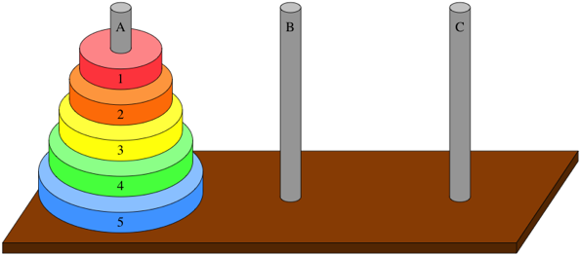

1. Given three pegs A, B and C and a set of disks 1, 2, 3, …, n. The disks have increasing diameter, such that disk 1 is smallest, then disk 2, etc.
2. The starting point is as illustrated above, i.e. all disks are on peg A, with the largest disk at the bottom.
3. The goal is to end up with all disks on peg C, in the same order as they were initially on peg A. You can move disks by obeying these rules:
   1. Only one disk can be moved at a time
   2. A disk can only be placed on a larger disk
   3. All disks (except the disc being moved) must always be on a peg

One way to solve this puzzle is simply to apply the breakdown rules from above:

* **A trivial case**: **n** = 0, no disks to move.
* **A division strategy**: This will consist of three steps:

1. Move (n – 1) disks from A to B
2. Move disk n from A to C
3. Move (n – 1) disks from B from C

* **A combination strategy**: The three steps in combination solves the original problem for **n** disks.

It might be a bit hard to spot the recursion here, but it actually occurs in steps 1 and 3. What we do in these steps is to solve a smaller Towers of Hanoi problem. In step 1, a problem with (**n** – 1) disks is solved, where A is the “source” peg and B is the “target” peg. Step 3 is similar, except that peg B is now “source” and peg C is “target”. If we denote the last peg as “extra”, we can see that the only difference between the origi­nal problem and the smaller problem is that the pegs A, B and C play different roles. In the original problem, peg A is “source”, B is “extra” and C is “target”, while the problem in step 1 has peg A as “source”, C is “extra” and B is “target”, and so forth. We can then write up this quite compact code for solving the puzzle:

**public void TowersOfHanoi(string pegA, string pegB, string pegC, int n)**

**{**

**if (n > 0)**

**{**

**TowersOfHanoi(pegA, pegC, pegB, n - 1);**

**Console.WriteLine("Move disk " + n + ": " + pegA + "->" + pegC);**

**TowersOfHanoi(pegB, pegA, pegC, n - 1);**

**}**

**}**

It is possible to write a non-recursive version of Towers of Hanoi, but it is considerably harder and not as intuitive as the above solution.

Even though several problems can be elegantly solved by recursion , it is by no means guaranteed that recursion **efficiently** solves the problem! A famous number sequence known as the **Fibonacci** sequence, is defined as:

* **Fibonacci**(**n**) = 1 for **n** = 1, 2 else
* **Fibonacci**(**n**) = **Fibonacci**(**n** – 1) + **Fibonacci**(**n** – 2)

This translates very easily to a recursive method:

**public int Fibonacci(int n)**

**{**

**return (n < 3) ? 1 : (Fibonacci(n - 1) + Fibonacci(n - 2));**

**}**

This looks very similar to the **Factorial** method, but with one extremely important difference: Each call of **Factorial** generates a single recursive call, while each call of **Fibonacci** generates two recursive calls! That may seem insignifcant, but each of those calls will in turn generate two recursive calls, an so on. In terms of run-time complexity, this has dramatic consequences. While the run-time complexity of **Factorial** is O(**n**), the run-time complexity of **Fibonacci** is O(2**n**)!

You should thus see recursion as an additional tool-in-the-toolbox, that certainly offers very elegant and compact solutions to certain problems, but can also be somewhat deceptive with regards to efficiency. Consider using recursion if

* The non-recursive solution to the problem is substantially more complex.
* The recursive solution has an efficiency comparable to the non-recursive solution.

## LINQ (Language In-Line Query)

In the previous chapter on function as parameters, we saw examples of using lambda expressions as parameters to various methods, for instance to the **FindAll** method for the **List** class. This was also an example of an extremely common problem in program­ming: Given a collection of data, find a subset of the data which fulfills certain criteria.

We have solved such problems in various ways. One way is to explicitly iterate over the colllection – typically using a **foreach** loop – and evaluate each element in the col­lection against the selection criteria. Another way was to use e.g. the **FindAll** method, which only require us to provide the selection criteria. A third way available in C# is to use so-called **Language In-Line Queries**, or just **LINQ**.

### Purpose and prerequisites

The main idea in LINQ is to provide a way of selecting data, which focuses on speci­fying the data subset to retrieve, without spefiying how to retrieve it. This idea is not new; the **Structured Query Language[15]** (SQL) used for retrieving data from relational databases also relies on this idea. In fact, the syntax used in LINQ is quite heavily inspi­red by SQL.

Another main idea behind LINQ is to make it as independent as possible from specific data structures. That is, it should not matter if data is stored in an old-fashioned array, a **List**, a **Dictionary**, or some other data structure. The only requirement LINQ sets on the data structure is that it implements the **IEnumerable** interface. This is a very small interface:

**public interface IEnumerable<out T>**

**{**

**IEnumerator<T> GetEnumerator();**

**}**

The **IEnumerator<T>** interface is also quite small:

**public interface IEnumerator<out T>**

**{**

**bool MoveNext();**

**void Reset();**

**T Current { get; }**

**}**

You can perceive the **IEnumerator<T>** interfaceas the absolutely minimal require­ment needed for being able to iterate over a collection. The interface enables you to perform these action with a collection:

* Go to the start of the collection (**Reset**)
* Get the element currently pointed to by the enumerator (**Current**)
* Move forward (if possible) to the next element in the collection (**MoveNext**)

If a collection can implement these two methods and single property, it becomes possible to iterate over the collection with a **foreach** loop:

**IEnumerable<int> collection = new List<int>();**

**foreach (var element in collection)**

**{**

**// do something with the element**

**}**

Under the covers, the **foreach** loop first calls **Reset**. It then calls **MoveNext**; if **Move­Next** returns **true**, the now pointed-to element is returned by **Current**. **MoveNext** is then called again, until it at some point returns **false**. This indicates that the end of the collection has been reached, and the loop terminates.

The point is that all collection classes in the .NET library implement **IEnumerator<T>,** so we can apply LINQ queries (yes, it should strictly speaking be written as “LIN que­ries”, but the phrase “LINQ queries” is widely accepted…) to any collection, without worrying about its specific type.

### Sample Data

Since LINQ is used for selection of data, we need a bit of data to work with. We have defined two simple classes **Movie** and **Studio**, and created collections containing the data given below:

**Movie**

|  |  |  |  |
| --- | --- | --- | --- |
| ***Title*** | ***Year*** | ***DurationInMins*** | ***StudioName*** |
| Se7en | 1995 | 127 | New Line Cinema |
| Alien | 1979 | 117 | 20th Century Fox |
| Forrest Gump | 1994 | 142 | Paramount Pictures |
| True Grit | 2010 | 110 | Paramount Pictures |
| Dark City | 1998 | 111 | New Line Cinema |

**Studio**

|  |  |  |
| --- | --- | --- |
| ***StudioName*** | ***HQCity*** | ***NoOfEmployees*** |
| New Line Cinema | Boston | 4000 |
| 20th Century Fox | New York | 2500 |
| Paramount Pictures | New York | 8000 |

The classes **Movie** and **Studio** just contain instance fields and properties correspon­ding to the columns in each of the tables above. In addition hereto, we also create two collections to store the **Movie** and **Studio** objects:

**List<Movie> movies = new List<Movie>();**

**List<Studio> studios = new List<Studio>();**

### Selection – single property

The first kind of query we address, is a query for selecting a single property from a collection. If we want to select the **Title** property for all objects in the **movies** collec­tion, this is the LINQ query for the job:

**IEnumerable<string> titles = from m in movies**

**select m.Title;**

There are several things to take note of:

* The formatting is intentionally a bit strange; you can write a LINQ query on a single line if you prefer, but the common way to format a LINQ query is to split it into sections according to operators (see below), each section on a new line.
* We use a couple of so-called **LINQ operators** (highlighted), which perform cer­tain operations on data. We will dissect them in a moment.
* Even though the original data is stored in a **List**, the return type of a LINQ query has the type **IEnumerable**. You can thus iterate over the result, but you cannot e.g. insert an element into it.

A translation of the above LINQ query to human language would read “from the col­lec­tion called **movies**, select the property **Title** from each object”. In other words, we are stating a **data source**, and a **set of properties** (in this case just one) we wish to select from each element in the data source. We can then write the query in a more general form:

**from element in collection**

**select element.PropertyName;**

You can hopefully see that **element** is simply a “placeholder” variable, that will be set equal to the elements in the collection, one by one. This is exactly as we have seen it many times for a **foreach**-loop:

**foreach (var element in collection)**

**{**

**// ...do something with element**

**}**

Returning to the specific query stated above, we can then use the result returned in **titles** in a **foreach**-loop:

**foreach (var element in titles)**

**{**

**Console.WriteLine(element);**

**}**

This will indeed print out the titles – and only the titles – of the movies in our collec­tion. The operation of selecting some of the properties from objects in a collection is also called to **project** the objects to a set of properties.

### Selection – several properties

The obvious next step is to consider how to select – or project to – several properties. Suppose we wish to select the **Title** and the **Year** property from the **Movie** objects. This complicates the query – and the returned result – a bit:

**var titlesAndYears = from m in movies**

**select new {m.Title, m.Year};**

It is probably not so surprising that we must add **m.Year** after **m.Title**, now that we need to return the **Year** property as well. But why the **new {…}** construction? The problem is that the return type of the query is now something like **IEnumerable<(pair of string and int)>**, which we cannot express in a simple way. By using the **new** opera­tor, we are creating a new object of an **anonymous type**. By anonymous is meant that we have created a new type consisting of an **int** and a **string**, but since this new type only serves as being a return type for this query, we create it on-the-fly, and do not bother giving it a name. On top of that, we let the compiler figure out what the return type actually is, by stating that the type of **titlesAndYears** is **var**, i.e. “let the compiler figure it out”…

Even though the specific type of the returned result is a bit obscure, it is pretty straight­forward to use it in a **foreach**-loop:

**foreach (var element in titlesAndYears)**

**{**

**Console.WriteLine(element.Title + " made in " + element.Year);**

**}**

In this fashion, we can create queries for selecting any set of properties we wish to be part of the result.

It may seem surprising that we can refer to named properties in the **foreach** loop above, where we iterate over the query result. Since the query result is a collection of objects of an anonymous type, how do we then know that such an object has e.g. a **Title** property? When the object of an anonymous type is constructed by “trivial” selection as in the example, the property name simply becomes the name of the property the data was selected from, i.e. **Title** and **Year** in the example. In case of a more complex selection, you can specify a property name explicitly:

**var titlesAndYears = from m in movies**

**select new**

**{**

**Summary = $"{m.Title} made by {m.StudioName}",**

**m.Year**

**};**

You can then refer to the **Summary** property when iterating over the query result:

**foreach (var element in titlesAndYears)**

**{**

**Console.WriteLine(element.Summary + " " + element.Year);**

**}**

This example also illustrates that “selection” should be understood in a broad sense. You can select simple data like the value of a property, but also “select” more com­plex data, involving logic or arithmetic expressions.

### Selection – collections containing collections

The queries in the previous examples return a collection of objects, where each object contains a couple of properties with simple types, like **int** or **string**. It is straightfoward to process such a collection, as shown in the **foreach** loops. However, you will often face scenarios where the objects contain non-simple types, like e.g. a collection. We could imagine that the **Movie** class definition also contains a list of **Actor** objects, which can be accessed through an **Actors** property of type **List**<**Actor**>. A LINQ query to retrieve this data could be:

**var titlesAndActors = from m in movies**

**select new {m.Title, m.Actors};**

This query is perfectly valid, but running it through the standard **foreach**-loop will not produce a very useful result. The loop

**foreach (var element in titlesAndActors)**

**{**

**Console.WriteLine(element.Title + " -> " + element.Actors);**

**}**

will print something like

**The Godfather -> System.Collections.Generic.List`1[LINQ01.Actor]**

This is not in itself surprising, since this is what we in general see, if we try to print a **List** object simply by handing it to **Console.WriteLine**. The fact that this object is now part of a query result does not change this. If we want a more useful output, we must print each element in the **Actors** collection explicitly, like:

**foreach (var element in titlesAndActors)**

**{**

**Console.WriteLine(element.Title);**

**foreach (var actor in element.Actors)**

**{**

**Console.WriteLine(actor.Name);**

**}**

**}**

### Filtering

If we relate the above queries to the data tables with the sample data, you can per­ceive selection as picking out vertical “slices” of the data. How do we then pick out horizontal slices of data, i.e. only include data which fulfills certain criteria? This is done by **filtering**.

The LINQ operator for filtering is named **where**. We can extend the selection from above to only include movies from earlier than 1996:

**var titlesAndYears = from m in movies**

**where m.Year < 1996**

**select new {m.Title, m.Year};**

Filtering is thus a logical condition, and only those objects for which the condition is true will be included in the result. You can create more complex conditions by using the well-known logical operators:

**var titlesAndYears = from m in movies**

**where (m.Year < 1996 && m.Year > 1980)**

**select new {m.Title, m.Year};**

Note that the order of the operators matter; the **where** operator must be placed before the **select** operator.

### Ordering

We can now pick out both horizontal and vertical slices of data, by combining the **where** and **select** operators. These operations preserve the ordering of the elements in the collection. If we wish to order the result according to the value of a specific pro­perty, we use the **orderby** operator:

**var titlesAndYears = from m in movies**

**where (m.Year < 1996 && m.Year > 1980)**

**orderby m.Year**

**select new {m.Title, m.Year};**

It is even possible to specify additional properties, like this:

**var titlesAndYears = from m in movies**

**where (m.Year < 1996 && m.Year > 1980)**

**orderby m.Year, m.Title**

**select new {m.Title, m.Year};**

This should be read as “order the result by the value of **Year**; for elements having the same value for **Year**, order by the value of **Title**”.

### Aggregation functions

It can often be useful to be able to perform various numeric operations on the query result. A set of functions – called aggregation functions – are available for such opera­tions. They can be applied to the variable holding the result of the query, or directly to the query statement. Using the simple initial LINQ query as an example, we can e.g apply the **Count** function:

**IEnumerable<string> titles = from m in movies**

**select m.Title;**

**// This is fine**

**Console.WriteLine(titles.Count());**

**// This is also fine**

**Console.WriteLine((from m in movies select m.Title).Count());**

Other useful aggregation functions of a numerical nature are **Min**, **Max**, **Sum** and **Average**, which are applied in the same style:

**Console.WriteLine((from m in movies select m.Year).Average());**

Some combinations of functions and data types do not really make sense. The below line will not compile:

**Console.WriteLine((from m in movies select m.Title).Average());**

This line will on the other hand work just fine:

**Console.WriteLine((from m in movies select m.Title).Max());**

### Joining

The examples above have all been concerned with selection from a single table. However, you can construct (more or less) sensible questions which “transcend” a single table, for instance: *“Return the title of movies produced by studios with head­quarters in New York”*. This requires combination of data from both collections, and use of the **join** operator:

**var joinTitleStudio = from m in movies**

**join s in studios**

**on m.StudioName equals s.StudioName**

**where s.HQCity == "New York"**

**select m.Title;**

The first highlighted line defines the query to work on the “joined” collection, i.e. the collection created by joining **movies** and **studios**. What does it mean to “join” two collections? A “join” is obtained by creating all combinations of an object from the first collection, and an object from the second collection. The “raw” result of joining **movies** (containing five objects, each with four properties) and **studios** (containing three objects, each with three properties) is thus a collec­tion with 3x5 = 15 objects, each with 3 + 4 = 7 properties!

The second highlighted line specifies that out of the 15 objects, we are only interested in the objects for which the two **StudioName** properties (one from **Movie**, one from **Studio**) are equal. If they are not equal, we cannot really gain useful any information from that object, since the underlying **Movie** and **Studio** objects are not related in the way we are interested in. This constraint reduces the number of objects from 15 to just five, which are exactly those objects we are interested in. To those objects, we apply the **where** clause, and finally select the movie title.

Joining of collections can be extended to involve more than two collections, but it also becomes more complex. If you need to construct very complicated LINQ queries using **join**, it may be an indication that the data model in general could need an overhaul.

### Deferred evaluation

Since a LINQ query only defines what data to retrieve – witout any details about how to retrieve the data – it is not obvious when the query is actually executed. A LINQ query is not executed when it is defined; the execution is deferred until the result of the query is needed, typically when you iterate over the query result. If you are not aware of this, you may see unexpected results. The code below illustrates this:

**// Create the collection**

**List<Movie> movies = new List<Movie>();**

**// Enter two objects**

**movies.Add(new Movie("Se7en", 1995, 127, "New Line Cinema"));**

**movies.Add(new Movie("Alien", 1979, 117, "20th Century Fox"));**

**// Define the query**

**IEnumerable<string> titles = from m in movies**

**select m.Title;**

**// Enter two objects**

**movies.Add(new Movie("Forrest Gump", 1994, 142, "Paramount Pictures"));**

**movies.Add(new Movie("True Grit", 2010, 110, "Paramount Pictures"));**

**movies.Add(new Movie("Dark City", 1998, 111, "New Line Cinema"));**

**// Iterate over the query result**

**foreach (var element in titles)**

**{**

**Console.WriteLine(element);**

**}**

Running this code will print out five elements, not two! Also, the query result is not “cached” in any way. If you later add additional **Movie** objects to the **movies** collec­tion, and subsequently iterate over the **titles** variable again, the query result will now also inclu­de the recently added objects.

If this is not the behavior you want, you can force the query to produce a result immediately. This result will be a copy of the query result, and will not change after execution. You force this behavior in a slightly cryptic way, by calling the **ToList** method in the query definition:

**// Define the query**

**IEnumerable<string> titles = from m in movies.ToList()**

**select m.Title;**

There is more to LINQ than described in this chapter, for instance methods for finding intersections, unions etc. between data sets, and also more sophisticated methods for process­ing data. As usual, there are plently of sources online providing more in-depth treatments of LINQ.

## Improving performance for resource-intensive applications

Until this point, we have not really worried about the “performance” of applications, i.e. how they behave with regards to the time needed to perform various operations, but also with regards to the “responsiveness” on an application with a user interface, when the application performs time-consuming operations. Such time-consuming operations can in general be divided into two categories:

* **CPU-bound operations**: these are typically operations that involve intense calculations, per­formed by the Central Processing Unit (CPU).
* **I/O-bound operations**: these are typically operations that involve interaction with some external data source, for storing or retrieving data. Such interaction may involve waiting for a response from the external data source.

Such operations will inevitably be part of certain applications, but why is that necessa­rily a problem? So far, we have thought of an application as a sequence of operations carried out one after another. If one of these operations takes a long time to com­ple­te, we – i.e. the rest of the application – just have to wait for that.

Suppose we have a CPU-bound operation that takes 10 seconds to complete. We assume that the algorithm as such cannot be changed, so how can we ever make this operation less time-consuming? The only way forward must be if the work involved can be divided into smaller parts, and that each part of the work can be completed simultaneously. For this to be possible, we need to:

* Be able to divide the work into independent parts of comparable size
* Have a number of “workers” available, that each can carry out part of the work

The first part is highly operation-specific. Some operations can easily be divided into such parts (we will see some examples later), but others are inherently sequential. The second part depends on the available CPU hardware, and to some extent on the computer operating system. With regards to the CPU hardware, the state of CPU hardware is currently that most CPUs from most manufacturers are so-called **multi-core** CPUs. A multicore CPU is essentially a collection of independent CPUs, capable of executing operations in parallel; one operation on each core. Also, modern operating systems are well capable of utilising multicore CPUs, so all we need to figure out is how to divide the work into smaller parts, and how to execute each part in an “opti­mal” way, depending on the available CPU. We will investigate this further very soon.

Concerning the I/O-bound operations, the challenges are of a different nature. An application may need to retrieve some data through e.g. a web service, which will involve waiting a reasonable amount of time for a response. If we implemented such an operation in the way we know, the application would appear “blocked” while waiting for the response. If this operation was invoked through a GUI, the user would experience that the application becomes unresponsive, maybe only displaying a spin­ning wait cursor. This is not a very user-friendly behavior. Instead, the user should be allowed to perform other operations, while the response is still pending. This can be achieved by turning the *waiting-for-response* operation into a separate operation, which can then be performed in parallel with the main application operation (which is to react promtly to user interaction).

The overall approach to improving the performance for both categories is thus the same; try to divide the operation into parts, which can then be allocated to separate workers. The specific approach is however somewhat different for each category, which we will see in the next two chapters.

## Managing CPU-bound operations

Let’s recall what we need to be able to do, in order to improve performance for CPU-bound operations:

* Divide the work into independent parts of comparable size
* Have a number of “workers” available, that each can carry out part of the work

The latter point is more a prerequisite; what we more specifically need to be able to do is more like:

* Divide the work into independent parts of comparable size
* Allocate the work parts to workers in an optimal way

The first part is application-specific, and is something we as programmers need to consider and implement. In the .NET class library, the **Task** class is available for this purpose. In general, we must then divide the relevant operations into a number of “tasks”, that are each represented by a **Task** object. We will go into much more detail concerning the **Task** class in a moment.

The second part is slightly more tricky. In older programming scenarios (older .NET versions, older operating systems), it was also the programmer’s responsibility to explicitly allocate such tasks to workers, more specifically to an abstraction called a **thread**. A **thread** can be thought of as a single worker, carrying out instructions one after another. The applications we have seen so far are **single-threaded applications**, i.e. only a single worker carries out the operations in the application. When we create applications using multiple **Task** objects, we are effectively creating a number of threads with­in a single application, and the application becomes a **multi-threaded application**, where several operations can be executed in parallel. However, this parallel execution of operations is also an abstraction; if you run a multi-threaded application on a single-core CPU – which is indeed possible – the operating system will create an illusion of parallel execution. In reality, each thread is given a little bit of time to work on its operation. After a certain time, the operating system will pause (usually called to **suspend**) the thread, and allow a different thread to run for a while, and so on.

If you run a multi-threaded application on a single-core processer, you don’t really gain anything by creating multiple threads. In fact, the application may even run slower, since creating and managing threads takes a bit of extra time. Conversely, if you run the application on a multi-core CPU, you should usually generate at least as many threads as you have CPU cores, so each core can execute at least one thread. The optimal allocation of tasks to threads – and subsequently threads to CPU cores – is thus highly dependent on the hardware setup, and is definitely not a trivial matter. The good news is that when using the **Task** concept, this allocation is entirely dele­gated to the .NET run-time system and the operating system! This causes the second point in the (short) bullet of responsibilities list to disappear entirely. The only thing we as programmers need to worry about is the division of operations into tasks. Once that is done, the low-level allocation is taken care of. This simplifies development of multi-threaded applications significantly.

### The Task class – creation and invocation

From this point on, we will thus focus on how to utilise the **Task** class to create well-defined units of work. Suppose we have defined a couple of methods **DoWorkUnitA** and **DoWorkUnitB**. These methods are of the **Action** type, i.e. they do not take any parameters, and do not return any value. We assume that the methods are indepen­dent, i.e. it makes sense to execute the operations in these two methods in parallel. When can then create a **Task** object for each method:

**Task taskA = new Task(DoUnitOfWorkA);**

**Task taskB = new Task(DoUnitOfWorkB);**

Note that this alone does not cause the methods to be executed! In order to do that, you call the **Start** method on the **Task** objects.

**taskA.Start();**

**taskB.Start();**

This will start execution of **DoWorkUnitA** and **DoWorkUnitB**. Depending on the avail­able hardware, the execution will be allocated appropriately to threads and cores. In case we e.g. have a dual-core CPU, the methods will most likely be executed on sepa­rate cores, and thus truly in parallel. Assuming that the tasks are of comparable size, we can then expect the running time of the application as such to be half of what it would be with traditional programming.

It may seem very restrictive to require the methods to be of type **Action**. It is also possible to create a **Task** object with a method of type **Action<Object>** (remember that **Object** is the base class that all classes inherit from). You can then pass a para­meter to the method, which is used when the method is executed:

**Object data = new List<int>();**

**Task taskC = new Task(DoUnitOfWorkC, data);**

**taskC.Start();**

The **DoWorkUnitC** method can then cast the parameter to the appropriate type. You can also combine the creation and start of a **Task** object by using the static method **Run**:

**Task taskA = Task.Run(() => DoUnitOfWorkA());**

Both constructions have the same functionality, so choosing one over another is mostly a matter of taste.

Suppose you want to create a task consisting of two method calls. Once the first me­thod call completes, the second method call should be invoked. You could choose to create a new method containing the two method calls, but a more flexible solution is to use the **ContinueWith** method:

**Task taskAD = taskA.ContinueWith(DoUnitOfWorkD);**

In order for this to work, **DoWorkUnitD** must take a parameter of type **Task**. This may not seem to add any flexibility, but you can specify a number of options controlling whether or not **DoWorkUnitD** is actually executed. A task should usually run to com­ple­tion, but it may also be cancelled (see later), or throw an exception. If you want to ensure that **DoWorkUnitD** is only executed if **DoWorkUnitA** completes normally, you can specify this like:

**Task taskAD = taskA.ContinueWith(DoUnitOfWorkD,**

**TaskContinuationOptions.OnlyOnRanToCompletion);**

You can then call **ContinueWith** yet again on **taskAD**, and thereby piece together a chain of execution, if you have that need.

### The Task class – synchronisation

Once a task has been started, it will execute in parallel with the main application task (by “main application task”, we mean that “task” which is started simply by starting the application itself. This is often also called the **main application thread**). The tasks will execute independently, and will not as such have any knowledge about the pro­gression of other tasks. Still, the logic of the application may dictate some coordina­tion between tasks. This is often referred to as **task syncronisation**. A simple example of task syncronisation is to require that execution cannot proceed beyond a certain point, until a specific task has completed. This is achieved by using the **Wait** method:

**Task taskA = new Task(DoUnitOfWorkA);**

**taskA.Start();**

**// ...do some work**

**taskA.Wait();**

It might seem a bit weird that **Wait** is called on **taskA**, since the effect is not that **taskA** should wait for something, but rather that the invoker of **taskA** should wait here until **taskA** completes. An example of a relevant use of **Wait** could be when preparing to open a dialog window. This may require that some sort of long calcula­tion must be done first; that operation could be wrapped into a **Task**. Furthermore, there might be other preparations to do before opening the dialog. If these prepara­tions are independent of the calculation, they could be done in parallel, like:

**Task taskCalculate = new Task(Calculate);**

**taskCalculate.Start();**

**// ... Do other preparations**

**// All preparations except calculation are done,**

**// so wait here until it is done**

**taskCalculate.Wait();**

**// Now we can open the dialog**

**dialog.Open(...);**

The point is that we must be absolutely sure that **taskCalculate** is done, before we open the dialog. All other preparations must be done when we reach the highlighted line of code, so we need to “sit and wait” here until **taskCalculate** has completed. Note that if **taskCalculate** has completed before we reach the call of **Wait**, the execu­tion will just proceed to the next statement.

What if we have several tasks that need to be completed before proceeding beyond a point? We can then use the static method **WaitAll**:

**Task taskA = new Task(DoUnitOfWorkA);**

**Task taskB = new Task(DoUnitOfWorkB);**

**Task taskC = new Task(DoUnitOfWorkC);**

**taskA.Start();**

**taskB.Start();**

**taskC.Start();**

**// ...do some work**

**Task.WaitAll(taskA, taskB, taskC);**

The **WaitAll** method can take any number of **Task** objects as parameters, and will wait until all tasks have completed. A **WaitAny** method is also available, which also takes a num­ber of **Task** objects as parameters, but will only wait until any one of the tasks are completed.

### The Task class – cancellation

Suppose we have an application, where we need to peform a calculation on a given set of data. For this particular calculation, two different algorithms exist, and it is not obvious which algorithm will be the fastest one for a given data set. Furthermore, we have a multi-core CPU available, so we simply decide to do both calculations at once, wrapping each calculation into a **Task** object. Our logic would then be:

1. Create and start a **Task** object for each calculation
2. Wait for one of the calculations to complete
3. Once a calculation has completed, we can discard the other calculation

This looks like an obvious case for the **WaitAny** method:

**Task taskCalcA = new Task(CalcA);**

**Task taskCalcB = new Task(CalcB);**

**taskCalcA.Start();**

**taskCalcB.Start();**

**Task.WaitAny(taskCalcA, taskCalcB);**

**// We now have a result**

The code above takes care of steps 1 and 2, but not really of step 3. How do we “dis­card” a running task? We must somehow be able to tell the task, that we would like it to stop working, since we don’t need it any more. You could imagine that you could just call some method (e.g. called **Stop** or **Cancel**) on the **Task** object, which would simply shut down the task – a sort of bullet-in-the-head solution. This is however too crude. You can easily imagine that the task in question could be in a state where some sort of cleaning up is necessary before stopping. The task could e.g. have opened a connection to a database, from which it should disconnect in an orderly manner before stopping. Task cancel­lation is therefore a cooperative effort between the task itself, and the entity requesting the cancellation.

Cancellation revolves around a so-called **cancellation token**. The entity creating a **Task** object can also create a cancellation token, and provide it as a parameter to the method being invoked by the task. Creating and invoking a **Task** object then becomes a bit more complicated:

**CancellationTokenSource tokenSource = new CancellationTokenSource();**

**CancellationToken token = tokenSource.Token;**

**Task taskCalcA = Task.Run(() => CalcA(token), token);**

This is somewhat obscure, but the essence is that the **Task** creator must create a **Can­cellationToken** object, and include it as a parameter to the **Run** method and to the method itself (in this case **CalcA**)! The reasons for this particular way of invoking the task are a bit technical, and beyond this text. If you are interested in further details, you are as always encouraged to search online for such details.

The point of this setup is that the invo­ker of the task can now “signal” to the task that it should be cancelled. It does this by calling the **Cancel** method on the **Cancellation­Token­Source** object**,** not the **Cancella­tion­Token** object!

**Task taskCalcA = Task.Run(() => CalcA(token), token);**

**// .. do some work**

**tokenSource.Cancel();**

The **CalcA** method must also be changed. **CalcA** must periodically check the status of its cancellation token, and act accordingly:

**public void CalcA(CancellationToken token)**

**{**

**while (!token.IsCancellationRequested && /* other conditions */)**

**{**

**// Keep doing work**

**}**

**if (token.IsCancellationRequested)**

**{**

**// Do any operations needed before finishing**

**}**

**}**

This is just an example; the exact manner in which the token status is checked will vary from method to method. The important point is that the task cannot be “forced” to shut down. The creator of the task can request a cancellation, and the task itself must then honor this request in an appropriate manner.

Note that the same cancellation token can be passed to multiple tasks. If a cancella­tion is requested by calling **Cancel** on the **CancellationTokenSource** object, all tasks will see this through the status of the cancellation token.

### The Task class – advanced topics

As you have probably recognised already, things get more complex once you start to divide an application into tasks. At any time, several tasks can be running in parallel in an application, and each task will be in one of several possible states:

* **Created**: Task is created, but not scheduled to run yet.
* **WaitingToRun**: Task is created and scheduled, but not running yet.
* **Running**: Task is running.
* **RanToCompletion**: Task has completed successfully.
* **Cancelled**: Task was cancelled, either before or while running.
* **Faulted**: Task terminated by throwing an exception.

Handling all possible scenarios can become quite complex. One way of managing the complexity can be to use the **ContinueWith** method, where you can specify which method to execute under specific circumstances:

**taskCalcA.ContinueWith(HandleCalcCancel, TaskContinuationOptions.OnlyOnCanceled);**

This is likely to be a simpler alternative to a complex **if-else** structure.

When multiple tasks are running, you suddenly also have a scenario where multiple exceptions can be thrown in parallel, and need to be handled somehow. For this pur­pose, the **AggregateException** class exists, which is essentially a collection of excep­tion objects, which can then be handled individually. You can even rethrow an **Aggre­gateException** containing a subset of the original set of exceptions, if you only handle some of the exceptions in your own exception handler. Proceed carefully…

### The Parallel class

Suppose your application contains some logic, where you need to perform the same calculation for a large number of values. Furthermore, the calculations can be done independently. That looks like an obvious case for using tasks…and it is! Since such a scenario is fairly common, the .NET class library contains the **Parallel** class, which makes it even easier to divide such an operation into tasks. The original calculation may look like this:

**for (int i = 0; i < 100; i++)**

**{**

**Calculate(i);**

**}**

In order to perform each iteration as a separate task, you need just a little bit of re­writing:

**Parallel.For(0, 100, Calculate);**

You can think of this as converting the loop iteration into 100 independent tasks, which are then started and waited on, until the last task has completed. Under the covers, the **Parallel** class will create a number of **Task** objects, but this number may be considerably lower than the number of iterations. This is fine, since we have assumed that the calculations are independent. You should just keep in mind that there is no guarantee about the order in which the tasks are executed. The first task might have **i** set to 0, but the next one might have **i** set to 46, and so on… As we will see in the next chapter, this poses some difficulties when the iterations have dependencies. It is actu­ally possible to use **Parallel.For** even in such cases, but some additional safety mea­sures have to be in place.

## Managing I/O-bound operations

The introduction of the **Task** class enables us to wrap up time-consuming operations in **Task** objects, which can then be executed in parallel with the code creating the task. If the application features a graphical user interface (GUI), it will often be the “GUI code” which creates tasks. By “GUI code” is more specifically meant the code which is executed in the GUI thread. If an application has a GUI, it is only the GUI thread (or task, if you prefer) which can interact with the GUI controls. This provides some additional challenges. Consider the below code, which we assume will run in response to the user clicking on e.g. a **Button** control:

**private void HandleButtonClick()**

**{**

**DoTaskA();**

**DoTaskB();**

**statusText.Text = "All done";**

**}**

We assume that **statusText** is also a GUI control. This code will execute in the usual manner, i.e. it will not finish before **DoTaskA** and **DoTaskB** are finished. The con­se­quence will be that the GUI becomes unresponsive until the method call has finished. So, if the **Do…** methods are time-consuming, the GUI will be unresponsive for an unacceptably long time. Can we fix this by using tasks? We can try. A first attempt could be this:

**private void HandleButtonClick()**

**{**

**Task taskAB = new Task(DoTaskA);**

**taskAB.ContinueWith(DoTaskB);**

**taskAB.Start();**

**statusText.Text = "All done";**

**}**

The problem with this solution lies in the call of **Start**. Remember that **Start** will invo­ke the method wrapped inside the **Task** object, and immediately return to the caller. The effect will be that the *“All done”* status text is set before the tasks are done. May­be we can fix this by adding a call of **Wait** then?

**private void HandleButtonClick()**

**{**

**Task taskAB = new Task(DoTaskA);**

**taskAB.ContinueWith(DoTaskB);**

**taskAB.Start();**

**taskAB.Wait();**

**statusText.Text = "All done";**

**}**

This is also a no-go, since we are in fact back to the starting point! Now the call to **HandleButtonClick** will (again) block the GUI, since it will not return before all of the tasks are done.

How about wrapping the GUI interaction itself into a **Task** object? This task could then be set as a continuation to **DoTaskB**, like this (we assume that **UpdateGUI** is a method containing the code for updating the GUI):

**private void HandleButtonClick()**

**{**

**Task taskAB = new Task(DoTaskA);**

**taskAB.ContinueWith(DoTaskB);**

**taskAB.ContinueWith(UpdateGUI);**

**taskAB.Start();**

**}**

It looks promising: the tasks will be executed in correct order – including update of the GUI – and control will return to the caller immediately, making the GUI respon­sive. Alas, the code will produce an error when executed… Remember the previous claim that the GUI can only be updated from the GUI thread? That’s the problem here. By executing the GUI interaction as a task, it will be executed on a different thread, hence the error message. You can actually create a workaround for this, but it is somewhat obscure, and definitely not the recommended approach. Instead, we solve the problem by using two new C# language elements called **async** and **await**.

### Programming with async and await

The high-level definition of the purpose of **async** and **await** is: to enable you to define and call methods that can run asynchronously. The first mental hurdle here is to grasp what is meant by “asynchronously”. Most important to grasp is that executing code asyn­chron­ous­ly does not mean to execute the code in a separate thread! It rather means that the code can be executed in “chunks”, and – very importantly – that the flow-of-control returns to the caller of the method, when such a “chunk” has been executed. This leads to some slightly more detailed definitions of **async** and **await**:

* **async** is a method modifier (like e.g. **public** or **static**), indicating that the method contains code that can be run asynchronously.
* **await** is an operator, which specifies where code will be executed asyn­chronously.

This is probably still hard to grasp, so let’s see an example. The below code contains a modified version of **HandleButtonClick**, and modified versions of the **Do…** methods:

**private async void HandleButtonClick()**

**{**

**await DoTaskAUpdated();**

**await DoTaskBUpdated();**

**statusText.Text = "All done";**

**}**

**private Task DoTaskAUpdated()**

**{**

**Task t = Task.Run(() => DoTaskA());**

**return t;**

**}**

**private Task DoTaskBUpdated()**

**{**

**Task t = Task.Run(() => DoTaskB());**

**return t;**

**}**

The **Do…Updated** methods wrap the original **Do…** methods into **Task** objects, and return them to the caller. The **await** operators in **HandleButtonClick** are thus applied to a **Task** object in each case. The **await** operator can in general only be applied to an object which is “awaitable”, which is exactly what a **Task** object is. However – and this is the tricky part – the **await** operator does not act like the **Wait** method in the **Task** class. The **Wait** method will suspend the thread on which it is called, and will only resume once the task it was called on has completed. **await** works by “suspending” the method call at the point it has reached, but returns the flow-of-execution back to the caller of the method! The thread itself is not suspended.

Let’s rephrase that as a sort of statement of intention for both cases. This should be understood as an answer to the question: *“What will happen when you (i.e. either* ***Wait*** *or* ***await****) are reached in a method call?”*

|  |  |
| --- | --- |
| **task.Wait()** | *“It does not make sense to proceed beyond this point in the method, until* ***the task on which I was called*** *has completed. I will therefore* ***suspend the thread*** *I was called on, until that happens. If the thread happens to be the GUI thread, the GUI will become* ***unresponsive****…”* |
| **await** | *“It does not make sense to proceed beyond this point in the method, until* ***the task which I’m awaiting*** *has completed. I will therefore* ***suspend the method call*** *until that happens.* ***I will return the flow-of-execution to the caller****. If I was called from the GUI thread, the GUI thread will still run, and the GUI will be* ***responsive****.* |

Using **await** is therefore definitely the better approach in this scenario. Still, it is a bit mind-bending to keep track of the flow-of-execution here. What happens when the task that is awaited finally completes? The flow-of-execution will then jump back into the called method (in this case **HandleButtonClick**), and continue with the next state­ment. This is what is meant by “asynchronous execution” – the code is executed in “chunks”, controlled by use of **await**. In this case, the next statement also contains an **await** operator, so we jump right back to the caller again… However, if we had added some additional statements between the two statements containing **await**, those state­ments would indeed have been executed before returning to the caller.

It is probably obvious that methods marked as **async** can behave radically different than ordinary methods. A caller of such a method should be aware of its nature, and act accordingly. To help this awareness along, it has become a standard to suffix asyn­chro­nous methods with **Async**, so the method above should have been renamed to **HandleButtonClickAsync**. The .NET class library contains quite a lot of such methods, for instance methods for reading and writing to files.

The asynchronous method in the above example did not return any value. The **await** operators in the **HandleButtonClick** method are thus applied to objects of type **Task**. If an asynchronous method must return a value, things become a bit more com­plex. Suppose we have a method called **Operation**, which performs some sort of time-consuming operation, and returns a result of type **int**. The definition of a corre­spon­ding asynchronous method **OperationAsync** could then be:

**static async Task<int> OperationAsync()**

**{**

**Task<int> task = Task.Run(() => Operation());**

**await task;**

**return task.Result;**

**}**

First, note that the type of the created **Task** object is **Task<int>**. In general, the type **Task<T>** should be read as: a **Task** object which returns a value of type **T** upon com­ple­tion. The variable **task** is thus of type **Task<int>**. However, just after having created and started the task, we **await** it… We are thereby returning the flow-of-execution to the caller of **OperationAsync**, who may decide what to do next (see later). At some point, the task will have completed, and the flow-of-execution will return to **Opera­tionAsync.** The result of the operation can now be extracted from the **Task** object itself, through the **Result** property. This result – which is of type **int** – will then be the return value of the call of **OperationAsync**. This is indeed a bit confusing; we state in the method definition that the return type of **OperationAsync** is **Task<int>**, but it seems that we are returning an **int** value!? In a sense, both are true. Let’s see how a caller can invoke **OperationAsync**. This code is legal:

**Task<int> task = OperationAsync();**

**// ...do some work**

**int operationResult = task.Result;**

This is a two-step operation; the first line contains a call to **OperationAsync**, which will return a **Task<int>** object. But when is this object returned? Recall the code for **OperationAsync**:

**static async Task<int> OperationAsync()**

**{**

**Task<int> task = Task.Run(() => Operation());**

**await task;**

**return task.Result;**

**}**

When the highlighted **await** statement is reached, the flow-of-execution returns to the caller, but it returns in the form of a **Task<int>** object. The caller can then keep a refe­rence to this **Task<int>** object, and proceed with whatever work it makes sense to per­form. At some point, the caller will need the value returned by the task, before it makes sense for the caller to proceed further. The last line in the caller’s code – where the **Result** property of **task** is referenced – will block the caller until the result is actu­ally ready. When that happens – i.e. when the task has completed – the flow-of-exe­cution will return to **OperationAsync,** more specifically to the line after the **await** operator. In that line, the result of the task – which is obviously ready now, since the task has just completed – is returned to the caller, meaning that the caller is no longer block­ed. The result of the task is then finally available to the caller.

The caller can however also invoke **OperationAsync** like this:

**int operationResult = await OperationAsync();**

How is this different from before? Since the caller now also uses **await**, the flow-of-execution will now be returned to whoever it was that called the caller! We are no longer blocking the thread until the task finishes, but are instead leaving it up to the caller-of-the-caller what should happen next. Also, the method which the above line belongs to now also becomes an **async** method. Once you start using **async** in your code, you will often experience the *async-all-the-way-up* phenomenon; once one method is made **async**, the caller of that method should also beome **async**, and the caller-of-the-caller should also beome **async**, and so on.

Due to this pervasive nature of using **async**/**await**, it becomes somewhat difficult to add it to existing code. You should carefully consider if your particular application will benefit from using this construction, and then design it into the code from the outset. Using **async**/**await** is not a magic bullet that will make any application run faster, and it defi­nitely makes it harder to develop and test the code.

## Managing concurrent data access

When we have discussed the **Task** concept in the previous chapters, we have not shown any explicit examples of code which can be wrapped into tasks. In theory, we can wrap any sort of code into tasks, and execute them in parallel. Complications do however arise, if the code running in separate tasks tries to access the same data. Consider the below class **PrimeCalc**, which contains a crude method for finding prime numbers up to a specified limit:

**public class PrimeCalc**

**{**

**private List<int> _primes;**

**public PrimeCalc()**

**{**

**_primes = new List<int>();**

**}**

**public void FindPrimes(int upper)**

**{**

**_primes.Clear();**

**FindPrimesInInterval(2,upper);**

**string text = $"Found {_primes.Count} primes in [2; {upper}]";**

**Console.WriteLine(text);**

**}**

**private void FindPrimesInInterval(int lower, int upper)**

**{**

**for (int i = lower; i < upper; i++)**

**{**

**if (IsPrime(i))**

**{**

**_primes.Add(i);**

**}**

**}**

**}**

**private bool IsPrime(int number)**

**{**

**if (number < 4) { return true; }**

**int limit = Convert.ToInt32(Math.Sqrt(number));**

**bool isPrime = true;**

**for (int i = 2; i <= limit && isPrime; i++)**

**{**

**isPrime = number % i != 0;**

**}**

**return isPrime;**

**}**

**}**

The **IsPrime** method checks if a given number is a prime number, by trying to divide it with all numbers from 2 to the square root of the number itself. If any of these divi­sions produce a remainder of zero, the number is not a prime number. More efficient algorithms exist, but this simple algorithm has the advantage that each check is inde­pendent of other checks. In the above version, all checks are done sequentially, one after another. A call of **FindPrimes(1000000)** shows that 78,498 primes exist in that interval.

Since the checks are independent, it is fairly easy to split them up into two separate tasks, like this:

**public void FindPrimes(int upper)**

**{**

**_primes.Clear();**

**int middle = upper / 2;**

**Task t1 = Task.Run(() => FindPrimesInInterval(2, middle));**

**Task t2 = Task.Run(() => FindPrimesInInterval(middle + 1, upper));**

**t1.Wait();**

**t2.Wait();**

**string text = $"Found {_primes.Count} primes in [2; {upper}]";**

**Console.WriteLine(text);**

**}**

One task checks the lower half of the interval, the other task the higher end. Quite simple. However, when running the application now, something odd happens… The reported numbers of primes is now no longer the same! Also, the number varies if you run the application several times!? A sample of five runs gave these results (you may see different result):

78,377, 78,383, 78,364, 78,384, 78,382

What is going on here? The problem lies in the data access. The method **FindPrimes­In­­Interval** – which both tasks are executing – contains the call **_primes.Add**, i.e. both tasks try to add data to the list at the same time… Unfortunately, the **Add** operation is not an “atomic” operation (an operation which is always completed in full, or not star­ted at all), so we may sometimes be in the situation that one task starts to add an ele­ment, while the other task is in the middle of adding an element. This can have very unpredictable results. The numbers from the sample runs seem to indicate that this happens rarely (all results are within 0.2 % of the correct number), but it must not happen at all! The fact that it happens rarely makes this error even more devious. It might not show up in any test, but suddenly show itself when the code runs in pro­duc­tion (hopefully not in the control system for a nuclear reactor…).

The problem is that the **List** collection is not **thread-safe**. Code is considered thread-safe if it works as expected, even if more than one thread (i.e. task) is executing the code concurrently. In order to fix this problem, we have two options:

* Use some of the so-called **synchronisation primitives** in C# for managing the data access
* Use some of the **thread-safe collection classes** in the .NET library

The first option involves adding some protective code around the data accessing code. One example of such code uses the **lock** keyword.

The **lock** keyword is used like this: **lock**(**lockObject**), where **lockObject** is an object cre­a­ted solely for acting as a locking item. You can think of such an item as an object that can only be “owned” by one thread at a time. The object itself does not need to have any specific properties, so you often simply use an object of type **Object**, i.e. the class which all other C# classes inherit from. If we suppose that an instance field **_lock** of type **Object** is added to the **PrimeCalc** class, we can then modify the code for **Find­PrimesInInterval** like this:

**private void FindPrimesInInterval(int lower, int upper)**

**{**

**for (int i = lower; i < upper; i++)**

**{**

**if (IsPrime(i))**

**{**

**lock (_lock)**

**{**

**_primes.Add(i);**

**}**

**}**

**}**

**}**

The effect of the lock is that only one thread can execute code inside the locked code block. If a thread reaches the **lock** statement while another thread is inside the code block, the thread will be blocked until the lock is released again. Since we would like to minimise the time threads are blocked, locks should contain as little code as possi­ble. In the above example, it is only the **Add** statement which needs to be inside the lock, since it is the only statement modifying the collection. Running the code after this modification always produces the correct result.

The **lock** facility is a simple strategy, and will often be sufficient to ensure orderly and efficient access to data shared between threads. If you need a more sophisticated strategy, the .NET library contains several additional classes for this purpose. They are located in the **System.Threading** namespace, with exotic names like **ManualReset­Event­Slim**, **CountdownEvent**, **Barrier** and several more. Detailed discussions of these classes are beyond the scope of this text.

The problem discussed here is a fairly common problem, so you would expect that the .NET class library contains ready-made thread-safe collection classes, and indeed it does. They are, however, not a one-to-one reflection of the ordinary collection class­es, and have somewhat limited functionality. At the time of writing, these thread-safe collection classes exist:

|  |  |
| --- | --- |
| **ConcurrentBag<T>** | Thread-safe unordered collection of elements |
| **ConcurrentDictionary<TKey, TValue>** | Thread-safe collection with dictionary-like function­ality |
| **ConcurrentQueue<T>** | Thread-safe collection with queue-like function­ality |
| **ConcurrentStack<T>** | Thread-safe collection with stack-life function­ality |

In our example, we can simply replace the use of **List<int>** with **ConcurrentBag<int>**, and remove the **lock** statement again. This modification also restores the correctness of the code.

As a final thought on the example, we mention that it could also have been imple­men­ted using the **Parallel.For** statement (assuming that we keep using **Concurrent­Bag<int>** for storing prime numbers):

**private void FindPrimesInInterval(int lower, int upper)**

**{**

**Parallel.For(lower, upper, (i) =>**

**{**

**if (IsPrime(i))**

**{**

**_primes.Add(i);**

**}**

**});**

**}**

We leave it as an exercise to consider if this implementation can be more efficient than the two-task implementation shown above, even if we only have two CPU cores available…

## Unit testing (in Visual Studio)

We have a couple of times discussed various aspects of code quality. One as­pect of code quality – which is obviously quite important – is **correctness**. By correct­ness, we more specifically mean: does the code behave in accordance with the requirements specified for the code. The activity of determining this is called **testing**, and is in itself a very large topic in software development. Testing can be performed on a number of levels[16], ranging from **system testing** (testing the functionality of a system as a whole) to **unit testing** (testing the functionality of a single, atomic unit, e.g. a class).

We will not go into details about testing as such, but primarily focus on facilities for creating unit tests in Visual Studio. In that context, a unit test will typically be a test of a single class, i.e. testing the functionality of each method in the class. The typical appro­ach to creating a unit test is to create a unit test class for each class under test. If we are developing unit tests for an entire application, the unit tests will usually be defined within a single unit test project, which in a sense mirrors the application pro­ject itself.

### Benefits of automatic unit tests

Testing is often percieved as a somewhat tedious and repetitive activity, and since a thorough unit test often involves calling a specific method with a large number of parameter combinations, it can also become a very labor-intensive task to perform manually. The consequence is that testing can become an under-prioritised task, since the investment of effort can seem disproportional to the gain. However, if the unit tests can be specified in the form of code, it becomes possible to execute unit tests with very little effort. We still need to specify the test cases and create the unit test code, but that will then become a one-off effort.

Once you have a solid set of unit tests in place, it also becomes much safer to make changes in the code. We have a couple of times mentioned the concept of **refactor­ing**, which is the activity of improving the structure of the code, without changing the functionality. The latter constraint can easily be checked, if you have defined a solid set of automatic unit tests for the code. Once a small change has been made, you simply execute the unit tests, and check if all tests still pass. If not, you know that the small change you just made must be the change that introduced the error(s), and it should then be fairly easy to track down the problem and fix it.

The idea of relying on unit tests for verifying correctness can be taken even further. A software development process called **Test-Driven Development** (TDD) promotes unit tests to the most important process artifact, and let them be the driving force in the process. An outline of the process is as follows:

1. **Write a unit test based on requirements**: The assumption is that requirements should be so clear, that it is possible to write a corresponding test up-front, i.e. before any code has been created at all. If this is not possible, it is seen as a symptom of inadequate requirements. Further work must then be done on detailing the requirements.
2. **Write code**: With the tests in order, we can now begin to write the actual appli­cation code. The code should be written with the goal of passing the tests, not creating perfectly designed code.
3. **Run and evaluate tests**: If some of the tests fail, we must go back to step 2. If they all pass, we can proceed to step 4.
4. **Refactor code**: Since all the tests pass, we can assume that the functionality is correct. However, since we have not coded with code quality as an explicit goal, the code structure may need to be improved by refactoring. The refactoring should be done according to the quality and design standards set for the code. Since we have unit tests in place, we can safely refactor.

Such a process puts testing at the center stage, and will in practice only be feasible if unit testing can be automated. This kind of development process is also knovn as **Red-Green-Refactor**

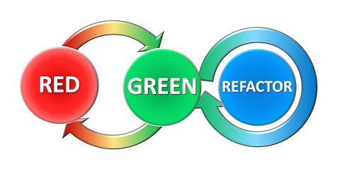

As we will see later, development environments like Visual Studio usually indicate a failed unit test with red (and passed unit tests with green), so you will usually start out with most unit tests being red, and then gradually turning more and more unit tests into green. Once they are all green, you can start refactoring, while keeping all the unit tests green.

### Structure of a Unit Test case

A single unit test case will usually consist of a single method call, involving a specific combination of parameters. In addition to this, it may also be necessary to set the state of the unit under test to a specific state, in order to conduct the test in a mea­ning­ful way. Once the method call has been performed, we will need to evaluate if the result was as expected. In general, we therefore have three phases in a unit test:

* **Arrange**: Setting up the test “scenario”, such that the test itself can be perform­ed. You can also describe this as arranging the **preconditions** of the test
* **Act**: Performing the actual action under test; this is typically a single method call (or using a property), but could also be a specific sequence of method calls. In general, the actions under test should be as atomic as possible.
* **Assert**: Once the testable action has been performed, a comparison between the expected and the actual outcome of the test must be made. The compari­son is usually a true/false comparison; either the actual outcome matches the expected outcome completely, or it doesn’t. Such a comparison is called an **assertion**. You can also describe this as comparing the actual **postconditions** of the test to the expected postconditions.

The outcome of the Assert part is thus a yes/no answer to the question: did the test pass? There is no middle ground. This answer is often used to indicate the outcome of a unit test by color, as mentioned above. Red for failed, green for passed. This makes it very easy to get an overview of the outcome of a (large) set of unit tests.

### Unit Testing in Visual Studio

Visual Studio supports unit testing directly, in the sense that you can create unit tests as described above, without having to install any third-party packages. For complete­ness, it should be mentioned that third-party frameworks for unit testing do exist, so the description here should only be seen as an example of how to create unit tests in practice.

We start out with an existing class – so we are not adopting the TDD process here – with a single method. The class is called **MediCare**, and contains a single method **SubsidisedExpense**.

**public double SubsidisedExpense(double expense)**

In Denmark, medical expenses for an individual are subsidised on a progressive scale, as given below (as of 2017):

|  |  |
| --- | --- |
| **Medical expenses (kr.)** | **Subsidy (%)** |
| 0 – 950 | 0 |
| 950 – 1.565 | 50 |
| 1.565 – 3.390 | 75 |
| 3.390 – 18.331 | 85 |
| above 18.331 | 100 |

The functionality of the method **SubsidisedExpense** can then be described in terms of the expected outcome for various values of **expense**:

|  |  |
| --- | --- |
| **expense** | **Subsidy (%)** |
| less than 0 | throw an exception of type **ArgumentException** |
| 0 or greater | return a value which is in accordance with the Subsidy table above |

This looks fairly simple, but note that this does not translate into just two test cases. The subsidy table specifies five subsidy intervals, so a covering set of test cases should at least involve one test case within each interval. Deriving a covering set of test cases is a discipline in itself, and we will not discuss it in detail here. It is, however, worth noting that there seems to be two categories of outcomes here; returning a correctly calculated value, or throwing an exception. We should be able to specify and execute unit tests for both categories.

Given the **MediCare** class – which is part of an ordinary C# application project – we now create a new C# project, with two properties:

* It will be part of the same solution as the application project
* It will be of the type **Unit Test Project**

The new unit test project is created as follows:

* Highlight the solution (not the project) in the **Solution Explorer** window
* Right-click, and choose **Add | New Project…** in the context menu
* In the **Add New Project** dialog, select the **Test** item under the **Visual C#** category. This should bring up the **Unit Test Project** project type.
* Give the unit test project a name; this is completely up to you, so you can e.g. just call it **UnitTestProject**.

After these steps, the new project be created. It will initially contain a single class called **UnitTest1**, which will look something like this:

**[TestClass]**

**public class UnitTest1**

**{**

**[TestMethod]**

**public void TestMethod1()**

**{**

**}**

**}**

Since the purpose of this class is to test the methods (in our case just one method) in **MediCare**, we rename the class to **MediCareTest**; this is a typical naming convention for a unit test class:

**[TestClass]**

**public class MediCareTest**

**{**

**[TestMethod]**

**public void TestMethod1()**

**{**

**}**

**}**

A feature to take note of are the so-called **attributes** [**TestClass**] and [**TestMethod**]. The attribute [**TestClass**] indicates to Visual Studio that this class contains unit test methods, and these methods will be executed when the unit test as a whole is execu­ted. It is possible to define classes in a test project which are not as such part of a unit test – but maybe act to support a unit test in some way – which is why the attribute is needed. Likewise, a test class may contain methods that are not as such unit tests. Only the methods marked with [**TestMethod**] are actual unit tests.

Before starting on the first unit test, note that the test project needs to have a refe­rence to the application project, before it can use classes and methods in that project. For the test project, select **References**, right-click, and choose **Add Reference…** In the **Reference Manager** window, select **Projects | Solution**, set a checkmark in the check­box for the application project, and click **OK**. Now the test project knows the applica­tion project.

Let us now consider how to write a single unit test. Suppose it has been determined that a test case with an amount equal to 1.000 kr. is needed. The expected outcome is 975 kr., according to the subsidy table. We then create one test method for this speci­fic case. The name of this method is not in itself significant, but – just as for ordinary code – we should of course choose a name that helps us understand the purpose of the method. Naming convensions for unit test methods are not as well-established as for ordinary methods; one suggestion is a convention along these lines:

**MethodUnderTest_StateUnderTest_ExceptionOrOutcome**

In our example, we could e.g. name a test case method like:

**void SubsidisedExpense_1000kr_975kr()**

This example also illustrates another important feature of test case methods: they are parameterless, and do not return any value. All establishment of preconditions must thus be done inside the method itself. We now have an outline of our test method:

**[TestMethod]**

**public void SubsidisedExpense_1000kr_975kr()**

**{**

**// Arrange**

**// Act**

**// Assert**

**}**

What remains is to fill in the code for the three stages. The **Arrange** part is fairly simp­le: it involves creating a **MediCare** object, and setting up variables for parameters and expected return values (it can be debated if the last part truly belongs to **Arrange**, but the most important point is to use your convention consistently):

**[TestMethod]**

**public void SubsidisedExpense_1000kr_975kr()**

**{**

**// Arrange**

**MediCare mCare = new MediCare();**

**double expense = 1000.0;**

**double expectedResult = 975.0;**

**// Act**

**// Assert**

**}**

The **Act** part consists of a single method call:

**[TestMethod]**

**public void SubsidisedExpense_1000kr_975kr()**

**{**

**// Arrange**

**MediCare mCare = new MediCare();**

**double expense = 1000.0;**

**double expectedResult = 975.0;**

**// Act**

**double actualResult = mCare.SubsidisedExpense(expense);**

**// Assert**

**}**

The **Assert** part involves using the **Assert** class, which is part of the Visual Studio unit test framework. The **Assert** class contains a lot of methods for comparision between expected and actual results. In this particular case, we want to compare the value of two variables of type **double**: **expectedResult** and **actualResult**. This can be done with the method **AreEqual**:

**[TestMethod]**

**public void SubsidisedExpense_1000kr_975kr()**

**{**

**// Arrange**

**MediCare mCare = new MediCare();**

**double expense = 1000.0;**

**double expectedResult = 975.0;**

**// Act**

**double actualResult = mCare.SubsidisedExpense(expense);**

**// Assert**

**Assert.AreEqual(expectedResult, actualResult, 0.01, "Fail 1000 kr.");**

**}**

The **AreEqual** method is available for a lot of types (**int**, **bool**, etc.), and usually has the structure: **AreEqual(valueA, valueB, message)**. The intention is that if **valueA** is equal to **valueB**, the assertion is considered successful. Otherwise, the assertion is failed, and the text in **message** can be used to display some additional information about the test case, if needed. In this particular case, an extra parameter is included. You might recall that care should be taken when trying to compare **double** values, due to possi­ble round­­ing errors. Therefore, you can specify a maximal acceptable difference – here set to 0.01 – between the values.

The **Assert** class is an integral part of the Visual Studio unit test framework, and the **AreEqual** method should (almost, see later) always be used for comparing expected and actual outcomes. Now that we have created a single unit test, we can run it! You can open the **Test Explorer** window by choosing **Test | Windows | Test Explorer** from the main menu. This should produce something like this:

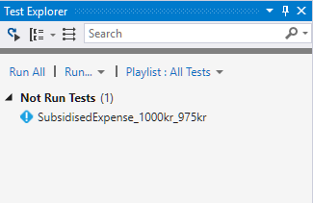

Running the tests is simply done by cliking **Run All**. Assuming we have written the test correctly, the window should after a little while change to:

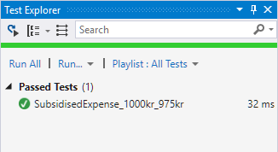

Now we are up and running with unit tests! We can then go ahead and create more unit test methods, one for each test case. After a while, we may have created a hand­ful of test cases:

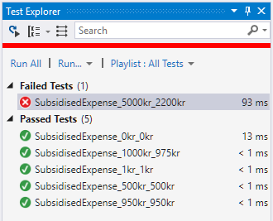

We have now included a test that fails. A failed test can of course indicate that the code being tested contains an error, but it could also be an error in the test code itself (that is actually the case here…)! We should of course be very careful when creating test code, but just as for ordinary code, errors tend to sneak in anyway… For the failed test case, additional information is shown in the **Test Explorer** window, when you select the failed test:

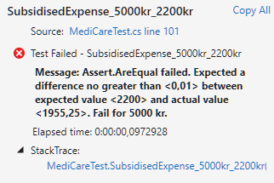

This information can be useful in figuring out why the test failed. Another useful fea­ture is the ability to start a debugging session directly from the **Test Explorer** window. If you select the failed test, right-click and choose **Debug Selected Test**, a debug ses­sion is started for that particular test case. You can then debug your code as usual.

The above test cases all follow the same pattern: create a **MediCare** object, call the **SubsidisedExpense** method, and compare the expected and actual outcome. But what about the case where an exception should be thrown (for negative amounts)? This can also be tested within the framework, but the structure of the test method will look a bit different:

**[TestMethod]**

**public void SubsidisedExpense_NegativeAmount_Exception()**

**{**

**// Arrange**

**MediCare mCare = new MediCare();**

**double expense = -1.0;**

**// Act & Assert**

**Assert.ThrowsException<ArgumentException>(() =>**

**{**

**mCare.SubsidisedExpense(expense);**

**});**

**}**

Note the use of the **ThrowsException** method. This method is a Generic method (it takes a type parameter, i.e. the type of exception we expect to be thrown), and the parameter to the method is a function of the type **Action**, i.e. no parameters and no return type. This is why we need to “wrap” the method call into a function definition, like **() => { code to test…}**. This is a bit convoluted, but enables proper testing of this case. This also illustrates an important aspect of testing: it is not enough to test that legal cases are successful; you should also test that illegal cases fail in the specified manner!

### Live Unit Testing

The setup described above enables you to execute unit tests by a simpe click, but it is still up to you to activate the tests. This can maybe be compared to the state of affairs for syntax checking several years ago. You would write your code without any help from the development environment, and then “activate” syntax checking by e.g. try­ing to compile the program. Modern development environments like Visual Studio now offer “live” checking of syntax, highlighting syntax errors as soon as you type. In Visual Studio 2017, you can also perform “live” unit testing. When activated, the set of unit tests runs continu­ously, and you get instant feedback with regards to the sta­tus of the unit tests.

It is quite simple to switch on live unit testing. Choose **Test | Live Unit Testing | Start** from the main menu. After a short while, you will see – assuming that your unit tests are successful – a number of green tick marks in the source code:

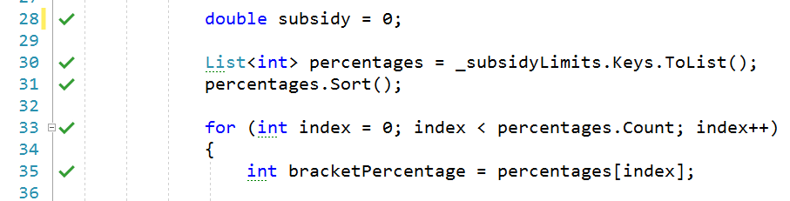

If you hover the mouse cursor over a tick mark, you will see a tooltip telling you how many unit test cases that cover that specific line of code. If you now try to change the code a bit (changed initial value of **index** from 0 to 2):

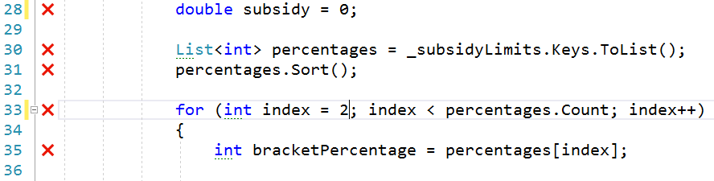

you will – after a little while – see that some of the green tick marks are replaced with red crosses, indicating that some of the unit tests covering this particular line of code have failed. If you click on one of the red crosses, a list of the status of each unit test will be displayed:

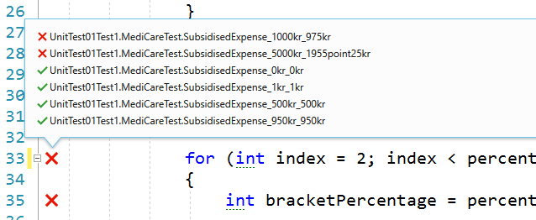

It is probably a matter of taste if you prefer this type of immediate feedback, or wish to run the unit tests on-demand. At the time of writing (late 2017), this facility is quite new in Visual Studio, and does in its current form seem to be somewhat resource-inten­sive. It is very simple to switch off live unit testing again (choose **Test | Live Unit Testing | Stop**), making it easy to use in certain periods of development, and to switch off again when it is not relevant.

### Code Coverage

A tangible benefit of the Live Unit Testing facility is the ability to see how well each line of code is covered by tests. As a minimum, all lines of source code in an applica­tion should be covered by at least one unit test. If your code contains complex logic involving several parameters, it may be difficult to design tests that explore all corners of the code. A different way to obtain such an overview is by using the **code coverage** facility.

The code coverage facility is activated by choosing **Test | Analyze Code Coverage | All Tests** from the main menu. After a short while, a **Code Coverage Results** window should open, looking like this:

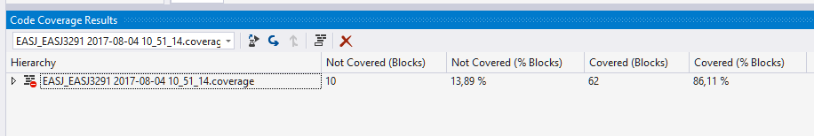

As indicated by the small triangle to the far left, it is possible to expand the result in a tree-like manner. Doing this will display a more detailed picture of the code coverage:

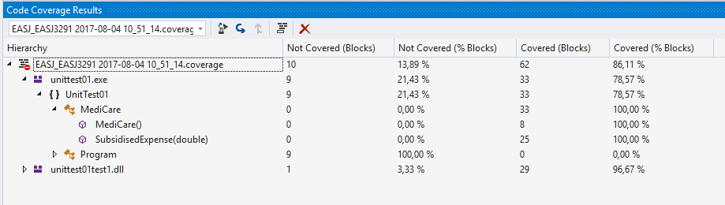

We have now “drilled down” to the finest level of detail, which is the method level. For the **MediCare** class – which is the class under test here – we see that the unit tests provide complete coverage of the source code, since both the constructor and the **Subsidi­ed­Expense** method are 100 % covered. That is, all lines of code are covered by at least one unit test. You should of course be aware that 100 % code coverage is not the same as being sure that your program is now proven error-free! Code coverage can be used to track down places in your code that are not yet covered by unit tests, and is thus a tool to aid you in creation of additional unit tests.

### Testing in more complex scenarios

In the above discussion, we have not shown any of the code in the **Subsidi­ed­Expense** method, since that code is not as such relevant. It is the functionality of the code we are testing. The code itself is fairly straightforward, and only uses elements already present in C#, like the **List** class and the **for** and **if** control statements. Why is this impor­tant to note? When using e.g the **List** class – which is a part of the .NET class library – we tacitly assume that it is a well-tested and error-free class. So, if our unit tests reveal any errors, we assume that the error must originate from our own code. This is a reasonable assumption, when using classes from the .NET class library. But what if our **MediCare** class relied an another class that we ourselves have defined? It could make perfect sense to define a class **SubsidyTable**, which manages the subsidy inter­vals defined in the table above. This class could then depend solely on elements from the class library, i.e. a dependency like:

MediCare

(.NET library)

SubsidyTable

How should this change affect our unit tests? First of all, we ought to create separate unit tests for the **SubsidyTable** class, to verify its functionality. Once these tests have been added – and are successful – we need to consider the **MediCare** units tests. Can we simply keep the existing unit tests? An argument in favor could be that since we have added unit tests for **SubsidyTable**, we can now rely on this class in the same way as we rely on a class from the .NET class library. An argument against could be that even though we have successful unit tests for **SubsidyTable**, it is still not unthinkable that it contains errors still. Another – more general – argument against is that if we allow classes under test to be dependent on “real” classes, it will become increasingly difficult to test classes, the deeper the chain of class dependencies become.

Suppose that the subsidy intervals managed by **SubsidyTable** were read from a data­base or through a web service. In order to test the **MediCare** class, we would then need to get a fully functional **SubsidyTable** class up-and-running for each test, maybe including a time-consuming connection to a database. This is clearly not optimal, and would prevent us from doing any testing before a fully functional **SubsidyTable** has been implemented…

What then? The usual approach to this problem is to use some kind of substitute class, when testing classes depending on other classes. There are different categories of such substitute classes, like Fake, Stub or Mock[17], but they are all classes that in some way try to mimic the functionality of the real class, while being much simpler with regards to implementation. A substitute class for the **SubsidyTable** class could be a class with exactly the same methods, but only containing some hard-coded values that are sufficient for testing classes depending on **SubsidyTable**.

This is as mentioned a very common approach, but how is it done in practice? In the current implementation of the **MediCare** class, the class looks like:

**public class MediCare**

**{**

**private SubsidyTable _subsidyTable;**

**public MediCare()**

**{**

**_subsidyTable = new SubsidyTable();**

**}**

**// Rest of class omitted**

**}**

The class thus contains explicit references to the **SubsidyTable** class. This makes it difficult to reconfigure the class to use a substitute class, since we would need to rewrite the code to refer to the substitute class. Can we then redesign the code to enable such reconfiguration? Indeed we can, by using interfaces! We said above that a substitute class should contain exactly the same methods as the original class. Another way to express this is to require the substitute class and the original class to implement the same interface. An interface for a class managing subsidy intervals could be:

**public interface ISubsidyTable**

**{**

**List<int> GetSortedPercentages();**

**double GetIntervalLow(int percentage);**

**double GetIntervalHigh(int percentage);**

**}**

The original **SubsidyTable** class can now inherit from this interface, but we can also create a substitute class **SubsidyTableFake**, which implements the same interface, but has a very simple implementation based on hard-coded values. With this interface in place, we can then update the implementation of **MediCare**:

**public class MediCare**

**{**

**private ISubsidyTable _subsidyTable;**

**public MediCare(ISubsidyTable subsidyTable)**

**{**

**_subsidyTable = subsidyTable;**

**}**

**// Rest of class omitted**

**}**

The **MediCare** implementation is now unaware of the specific implementation of **ISubsidyTable** provided to it in the constructor, which makes it quite easy to update the unit tests:

**public void SubsidisedExpense_1000kr_975kr()**

**{**

**// Arrange**

**MediCare mCare = new MediCare(new SubsidyTableFake());**

**double expense = 1000.0;**

**double expectedResult = 975.0;**

**// Act**

**double actualResult = mCare.SubsidisedExpense(expense);**

**// Assert**

**Assert.AreEqual(expectedResult, actualResult, 0.01, "Fail 1000 kr.");**

**}**

By introducing the **ISubsidyTable** interface, we have thus made the **MediCare** class as such more versatile, but also made it more testable!

Since this idea of using substitute classes in testing is so common, a number of third-party frameworks exist which can aid you in producing such substitute classes. One such framework is Moq[18], where you can specify the behavior of a substitute class in various ways, using lambda expressions and even LINQ.

Testing is as mentioned earlier a very large topic in its own right, and this chapter only provides a brief introduction to one aspect of testing. We have intentionally only fo­cu­s­ed on the mechanics of how to define and execute a unit test, without addressing the question of if you should define a specific test. The perfectionist view on testing would be that everything should be tested to the highest possible degree; in practice, you are seldom allocated resources to achieve this. Testing can never provide you with a 100 % guarantee for code correctness, but should rather be seen as a tool for increasing confidence in your code. Try to identify parts of your code where the bene­fits of unit testing are most obvious (e.g. complex logic or high-risk code), and concen­trate the initial effort there. Just as for many other aspects of software development, testing will always be a tradeoff between effort and benefit.

# Data Persistency

We have until this point not cared much about what happens to our data, once the appli­cation containing the data terminates. Real-life applications will usually contain functionality for saving and/or loading certain data into the application from so-called **persistent storage**. The term persistent storage just covers all those media for data storage, where data is retained even after the power for the media is shut off. Exam­ples of locations for persistent storage could be your own local hard drive, or simply “the cloud”, where the exact format and location of the data is not known.

Management of persistent storage is a large topic, and more advanced applications will often use some sort of **database** for structured storage of data. For smaller appli­cations producing small amounts of data, simpler media may suffice. Storing data in a text file on your own hard drive is a fairly easy solution to use for such situations.

## File-based persistency

Even for file-based persistency, there are several possible approaches. We will here present a fairly simple approach, specifically aimed at storing a collection of domain data objects in a text file. Our approach will also rely on using the **JSON** (**JavaScript Object Notation**) text format. JSON can be considered a sort of alternative to XML, since it is just a structured way of storing data on text form. We will not explain JSON further here, but there are plenty of sources about JSON online[19].

The reason for using JSON at all is because it provides a general and convenient way of transform­ing C# objects to a text format, which can then easily be written to a file. Likewise, the text (on JSON format) can be read from the file again, and transformed back into C# objects. There are several third-party class libraries available for JSON conversion, the most popular (at the time of writing) being the **NewtonSoft.JSON** package. This library can be installed as a NuGet package: In Visual Studio, go to **Tools | NuGet Package Manager | Manage NuGet Packages for Solution**, and choose **Browse**. The **NewtonSoft.JSON** package is usually found on the first page; if that is not the case, simply search for it using the search field. Once the package is found, simply click **Install**.

With the package in place, it is possible to create a small C# helper class targeted for our needs. We need to be able to save a collection of domain objects into a file, and load it back into the application. An example of such a class called **FilePersistency** follows below:

**public class FilePersistency<T> where T : class**

**{**

**private const string FileName = "data.json";**

**private CreationCollisionOption _options;**

**private StorageFolder _folder;**

**public FilePersistency()**

**{**

**_options = CreationCollisionOption.OpenIfExists;**

**_folder = ApplicationData.Current.LocalFolder;**

**}**

**public async Task SaveAsync(List<T> data)**

**{**

**var dataFile = await _folder.CreateFileAsync(FileName, _options);**

**string dataJSON = JsonConvert.SerializeObject(data);**

**await FileIO.WriteTextAsync(dataFile, dataJSON);**

**}**

**public async Task<List<T>> LoadAsync()**

**{**

**try**

**{**

**StorageFile dataFile = await _folder.GetFileAsync(FileName);**

**string dataJSON = await FileIO.ReadTextAsync(dataFile);**

**return (dataJSON != null) ?**

**JsonConvert.DeserializeObject<List<T>>(dataJSON)**

**: new List<T>();**

**}**

**catch (FileNotFoundException)**

**{**

**await SaveAsync(new List<T>());**

**return new List<T>();**

**}**

**}**

**}**

The file operation methods **Create**- and **GetFileAsync** are both part of the .NET class library. They are as such not particularly remarkable, but they both end with the suffix **Async**, indicating that they are both **asynchronous** methods, as discussed in a previ­ous section. Asynchronousmethods offer the possibility to continue execution of the application, even though the method has not returned a result yet! However, we must not let this alternative model for execution confuse us too much right now; the essential point is that these methods offer the functionality we need at this point.

The code above performs a two-step conversion between the file **json.data** and the list of C# objects of type **T** (**T** is a **type parameter**, so it can be any class when the **File­Per­sis­tency** class is actually used). Consider first the **SaveAsync** method. The first line creates (or opens, if the file already exists) a file, and returns a variable **dataFile** which now refers to the file. The next line converts the incoming data (i.e. a **List** of objects of type **T**) to JSON format. Since this is a text format, the result of the con­ver­­sion is of type **string**. This kind of conversion between an in-memory object and a sequ­en­ce of cha­racters is also known as **serializing** the object, which is why the called method is named **SerializeObject**. Finally, the **JSON** string is written to the file.

JSON string

List of C# objects

File

The **LoadAsync** method is essentially the same deal, just in reversed order. A **string** is read from the file, and then converted (an operation also known as **deserializing**) into a **List** of objects of type **T**

List of C# objects

File

JSON string

The **try-catch** block in the **LoadAsync** method is added to handle the case where the caller attempt­s to load data from a file that has not been created yet, e.g. the first time the appli­ca­tion is executed. In that case, the **LoadAsync** method simply calls the **SaveAsync** method with an empty list, to invoke creation of the file.

How can we then use **FilePersistency** in our MVVM setup? Sticking to the **Car** domain example, we could imagine a fairly simple class e.g. called **CarSource**, containing two methods **LoadAsync** and **SaveAsync**:

**public class CarSource**

**{**

**private FilePersistency<Car> _fileSource;**

**public CarSource()**

**{**

**_fileSource = new FilePersistency<Car>();**

**}**

**public async Task<List<Car>> LoadAsync()**

**{**

**await _fileSource.LoadAsync();**

**}**

**public async Task SaveAsync(List<Car> cars)**

**{**

**await _filePersistor.SaveAsync(cars);**

**}**

**}**

The **CarSource** class is thus just a very thin type-specific wrapper around the general **FilePersistency<T>** class. Still, it does hide the specific source of the data from the user of the class. The **CarSource** class effectively adds another element to the chain of conversions shown before:

JSON string

List<Car>

CarModel

File

The syntax **async Task** in the method declarations may look a bit strange, but you should not be too intimidated by it. It is just a bit of lingo needed when working with these asynchronous methods, and is thus related to the **await** keyword mentioned before. With the **CarSource** class in place, we can now add Load- and Save-function­ality to our MVVM application. If we define a **CarModel** class for containing the collec­tion of **Car** objects, we can add **LoadAsync** and **SaveAsync** methods to it:

**private async void LoadAsync()**

**{**

**List<Car> cars = await _source.LoadAsync();**

**...**

**}**

**private async void SaveAsync()**

**{**

**await _source.SaveAsync(All);**

**...**

**}**

The (...) just indicates that we might need to do a bit more in each method; we could imagine that we would need to refresh the **ListView** after having loaded data from the file, by calling **OnPropertyChanged** for a collection property bound to by the **ListView**. We have also assumed that the **CarModel** class contains a property **All**, which returns all of the **Car** objects stored in the model.

With the **LoadAsync** and **SaveAsync** methods in place in the model class, we can now finally tie the functionality together with the corresponding view model class. In a **Car­PageView­Model** class, we can now define **Load** and **Save** methods:

**private void Load()**

**{**

**_model.LoadAsync();**

**OnPropertyChanged(…);**

**}**

**private void Save()**

**{**

**_model.SaveAsync();**

**}**

Wrapping these methods up as commands is also pretty simple:

**private RelayCommand _loadCommand;**

**private RelayCommand _saveCommand;**

**...**

**_loadCommand = new RelayCommand(Load, CanLoad);**

**_saveCommand = new RelayCommand(Save, CanSave);**

**...**

**public ICommand LoadCommand**

**{**

**get { return _loadCommand; }**

**}**

**public ICommand SaveCommand**

**{**

**get { return _saveCommand; }**

**}**

**...**

The **async** syntax has ebbed out at this point, so the command-handling code looks just as before. These commands could then be bound to e.g. buttons or maybe menu items in the application. The exact conditions for when to allow **Load** and **Save­** to exe­cute – i.e. the exact code for **CanLoad** and **CanSave** – will of course depend on the requirements for the application.

We have now completed the system of classes needed to add Load/Save functionality to an MVVM application. Our system looks like this (with a somewhat informal nota­tion):

FilePersistency

<Car>

CarSource

CarModel

CarPage

ViewModel

Reflecting a bit on this system of classes, we could ask ourselves: how much different would this look for loading/saving of e.g. **Customer** objects? Pro­ba­bly not that much different. So, maybe we could create a more generally applicable system of classes? The first step could be to consider the public methods of the **FilePersistency** class as being an **interface** for loading and saving, without even considering it as being based on files:

**public interface IDataSource<T>**

**{**

**Task SaveAsync(List<T> objects);**

**Task<List<T>> LoadAsync();**

**}**

The **FilePersistency<T>** class is then simply a (file-based) implementation of this inter­face. Following this idea, we could also create a more general data source class **Data­Source<T>**, which would be a very thin wrapper around a **FilePersistency<T>** object. We might even drop the idea of having a separate data source class, which would change the **CarModel** class to something like:

**public class CarModel**

**{**

**private IDataSource<Car> _dataSource;**

**public CarModel()**

**{**

**_dataSource = new FilePersistency<Car>();**

**}**

**// LoadAsync and SaveAsync are not changed**

**}**

The price paid for this simplification is that the model class is now tightly coupled to a file-based implementation of the **DataSource<T>** interface. If this is an unacceptable drawback, we could let the creator of the **CarModel** object decide what implementa­tion of the interface to use:

**public class CarModel**

**{**

**private IDataSource<Car> _dataSource;**

**public CarModel(IDataSource<Car> dataSource)**

**{**

**_dataSource = dataSource;**

**}**

**…**

**}**

Who creates the **CarModel** object? The **CarPageViewModel** does have an instance field of this type, but it should probably not be a view model class that decides which specific data source to use. A natural next step in this class refactoring exercise would be to define a (type-parameterised) base class for model classes, e.g. called **Data­Model<T>**. An outline of such a base class could be:

**public class DataModel<T>**

**{**

**private IDataSource<T> _dataSource;**

**public DataModel()**

**{**

**_dataSource = new FilePersistency<T>();**

**}**

**…**

**}**

In this way, we have isolated the choice of data source to a single place; the base class constructor. A type-specific model class – which might contain type-specific methods – can then simply inherit from this base class. This will hide knowledge about specific data sources from the view model class, even if it is this class that creates a model object. As discussed earlier, we can then also consider to create type-parameterised base classes for view model classes as well.

## Accessing data stored in a relational database

As mentioned above, we will often store data in a relational database, as soon as we move past the simplest of applications. Relational databases is a very large topic in its own right, and we will not attempt to cover it here. Instead, we from now on assume that the reader is familiar with the essential terms and techniques relating to rela­tional databases.

### Creating a local database with Visual Studio

Since databases are an integral part of many applications, Visual Studio offers sub­stan­tial support for working with databases. Microsoft also offers various data­base products as part of its product suite, the primary product being **Microsoft SQL Server** (MSSQL). It is quite easy to create a relational database from within Visual Studio; for use in this chapter, we have created a database called **CarRetailDB**. The database is a local database, i.e. it simply resides on the computer we are using for this example. We will later describe how a database can be deployed to a cloud hosting service.

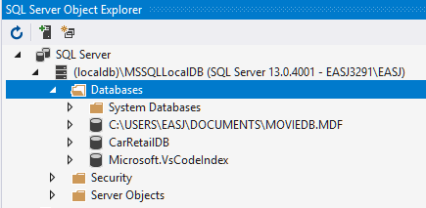

Again, we will not go into the details about how to create such a database. For com­pleteness, we will however point out that you need to install a couple of additional Visual Studio **workloads**, in order to perform the steps described in this chapter. More specifically, you need to install the workloads

* Data Storage and Processing
* Azure Development

After installing these workloads, you should be able to create a database direct­­ly in Visual Studio. Once a database has been created, a number of tables can be added to it. This can be done either by using a database script, or creating the tables directly in Visual Studio. We have created a table called **Car** in the **CarRetailDB** database.

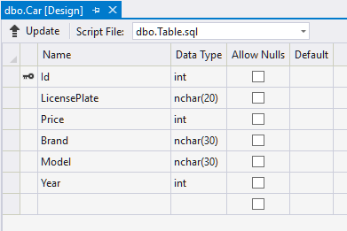

Once the table has been created, it can be populated with some sample data, again either through a script or by manually entering the data in Visual Studio.

### Accessing data from an application - overview

Creating and populating a database in this way is fairly straightforward; the much more important question is obviously: *how do we access and manipulate data from a relational database in an application written in C#?*

The short answer is: it depends. Numerous technologies for accessing data from a data­base have emerged over the years, but at the time of writing, two main technolo­gies are in play:

The **Entity Framework**: A general challenge when working with relational data in an object-oriented language, is to “translate” data properly between these two data representation paradigms: relational and object-oriented. This problem is known as the **Object-Relational Mapping** (ORM) problem, and several frameworks exist for performing this mapping. In a Microsoft context, the most widely used framework is known as the **Entity Framework** (EF). We will investigate the Entity Framework a bit further in this chapter.

**RESTful Web Service**: The Entity Framework makes it possible to manipulate data from a relational database with relative ease in C#. This is as such independent of the physi­cal loca­tion of the database, since the location is essentially just a configuration detail. Still, the Entity Framework is not always enough. If you wish to access a rela­tional database from a UWP (Universal Windows Platform) application – which has been our platform-of-choice since starting to discuss applications with GUI – it has until very recently (early 2018) not been possible to do this directly! This somewhat surprising situation has been due to some intentio­nal restrict­ions put on UWP appli­cations by Microsoft, and has imposed an extra layer of complexity onto the database access problem. Even though the restriction has to some extent been lifted now, we will still discuss how you can alleviate the problem in general, since the solution can also be applied to other scenarios where the exact data source needs to be abstracted away.

This extra layer comes in the form of a **web service**. The web service – which can be hosted locally on in a cloud hosting service, see later – can access a database using e.g. the Entity Framework (the web service itself is not a UWP application), and then make that data available for an external application, through a so-called **Web API**. API in general stands for **Application Programming Interface**, i.e. a set of methods avail­able for other programmers, to invoke functionality offered by a “server”. A Web API thus also consists of a set of “method calls”, which in practice are **HTTP[20] requests** using the standard HTTP “verbs” GET, POST, PUT and DELETE. These calls will in turn generate **HTTP responses**, including the request­ed data in a well-defined format like XML or JSON. A Web API of this kind is denoted a **RESTful** Web API, since it follows the so-called **REST**[21] paradigm.

The complete setup for a scenario involving a UWP application accessing data from a MSSQL database then becomes:

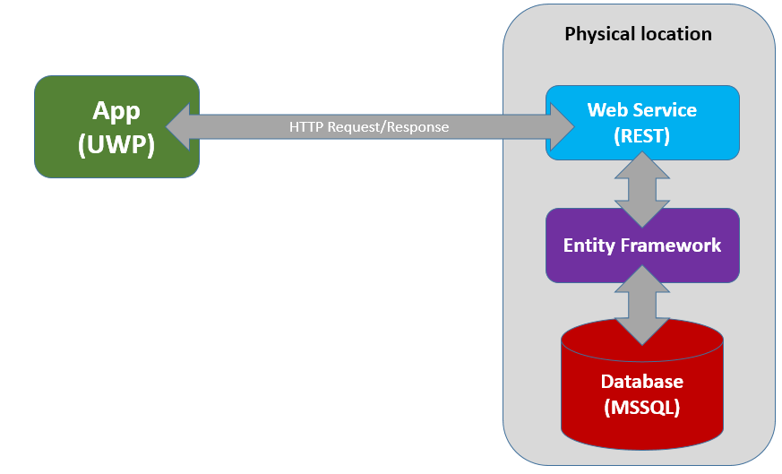

This is a quite significant increase in complexity over the file-based approach to persis­tency. Fortunately, some rather powerful tools in Visual Studio exist to help us with the creation of each layer.

### Accessing a database using the Entity Framework

The first question to answer when embarking on such an implementation is: *where does the definition of domain data structures come from?* We can imagine two sour­ces:

* The object-oriented class model
* The database table definitions

Obviously, these two representations of our data model must be consistent with each other. Making sure that this happens is the responsibility of the ORM framework, i.e. the Entity Framework. So, the question is more specifically: *Do we derive the class model from the database definition, or do we derive the database definition from the class model?*

Approaches of the first category are called **database-first**, while approaches of the second category are called **model-first**. What you choose will of course depend on your development process; we will focus on the database-first approach here.

In order to keep things simple, we will initially access a database directly from a non-UWP application, e.g. a simple Console-based application. We use the **CarRetailDB** database defined above as an example, augmented with a **Customer** table.

Once a project has been generated, the next step is to generate a class model corre­sponding to the database definition. This is done by right-clicking on the project in the **Solution Explorer** window, and then choosing **Add | New Item**. This brings up the **Add New Item** dialog:

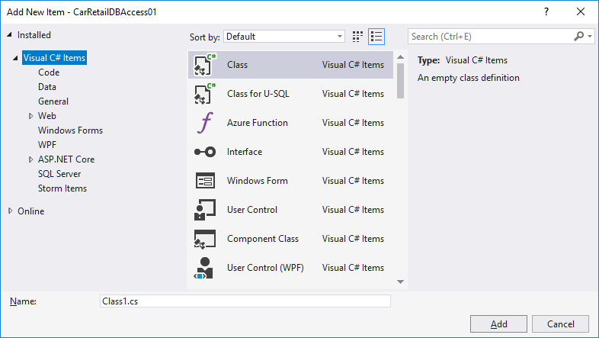

In this window, choose **Visual C# Items | Data**

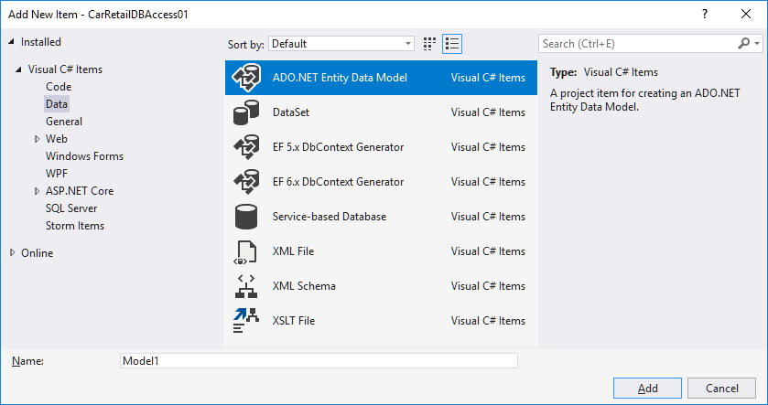

Now choose **ADO.NET Entity Data Model**, provide a name in the **Name** text box at the bottom (the usual naming convention is to use the name of the database, suffixed by the word **Context**, i.e. in this case **CarRetailDBContext**), and finally click **Add**. This will bring up the **Entity Data Model Wizard** dialog:

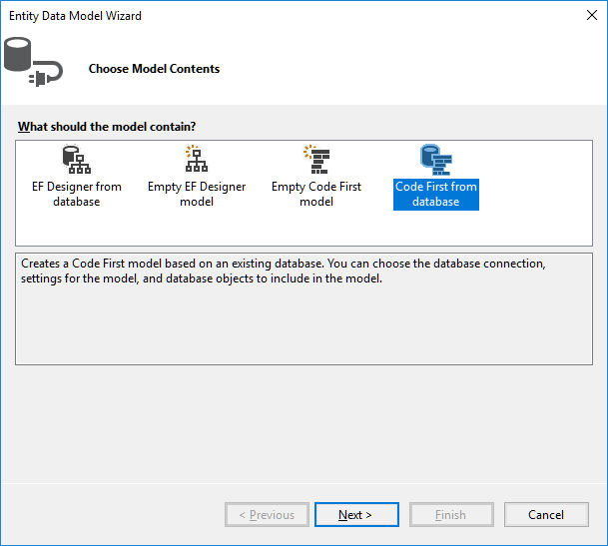

Initially, it can be a bit hard to see how these four options map to the model-first and database-first categories described before. The two options which are database-first are the **EF Designer from database** and the **Code First from database**. The main diffe­rence is that the former provides a graphical tool for model mapping, while the latter is code-centric. We choose the latter option (**Code First from Database**), even if the name is a bit misleading; it is indeed a database-first approach. This choice brings up the **Data Connection** section of the wizard:

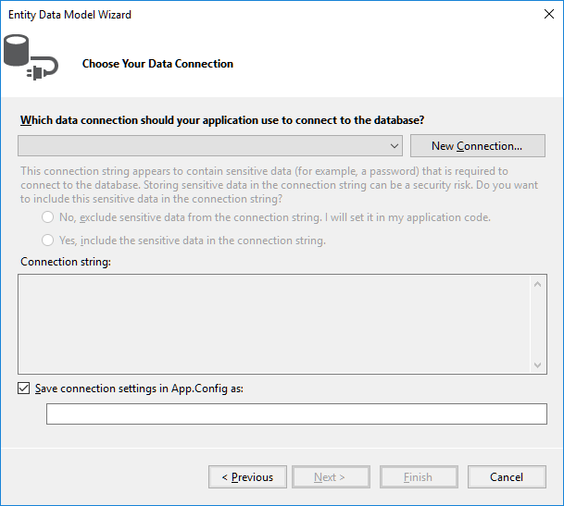

In this window, choose **New Connection**:

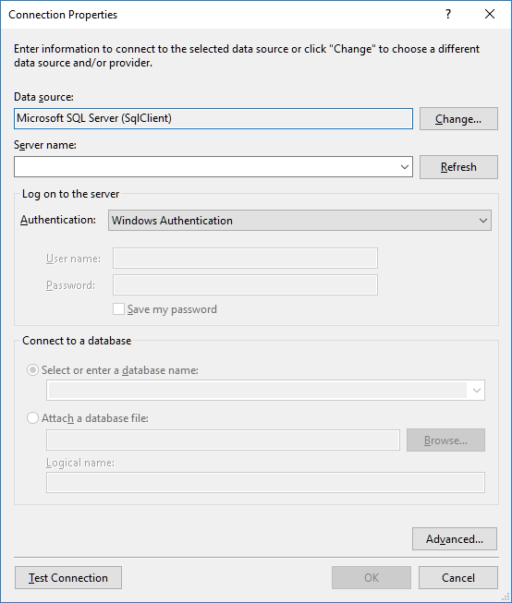

A bit of work needs to be done in this dialog. First, make sure that the **Data Source** is set to **Microsoft SQL Server (SqlClient)**; if not, change the selection to that option. Next, the server name for the MSSQL data­base must be specified in the **Server Nam**e text box. You can find the server name in the **SQL Server Object Explorer** window:

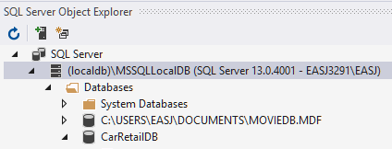

In our case, the server name is thus **(localdb)\MSSQLLocalDB**, including the brackets! If you enter the name of your server into the **Server Nam**e text box and click **Refresh**, the drop-down listbox at the **Select or enter a database name** option should become populated with database names (note that the listbox doesn’t actually get populated before you expand it!):

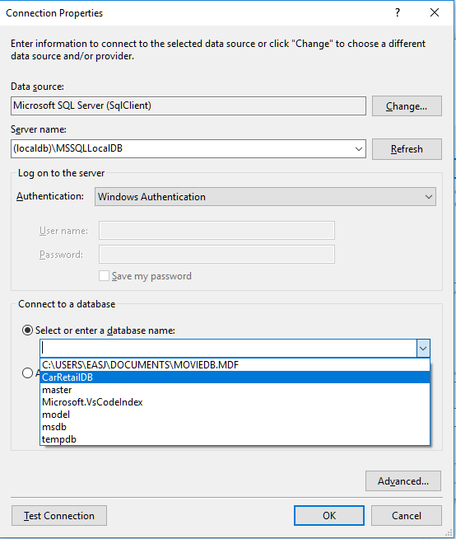

In our case, we do indeed see the **CarRetailDB** in the list. Choose your database in the list, and click **Test Connection** to see if the connection works (a small congratulatory dialog should appear…). If not, you may need to check if you have typed in the server name, etc. correctly.

When all is in order, click **OK**. This brings you back to the **New Connection** window in the wizard. This should now look something like this:

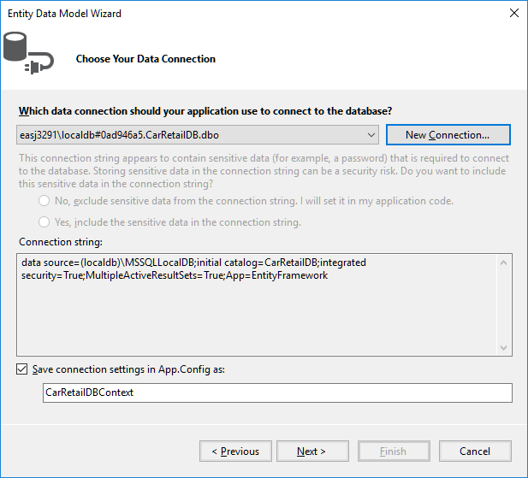

Now click **Next**. This brings up the **Choose Your Database…** section of the wizard:

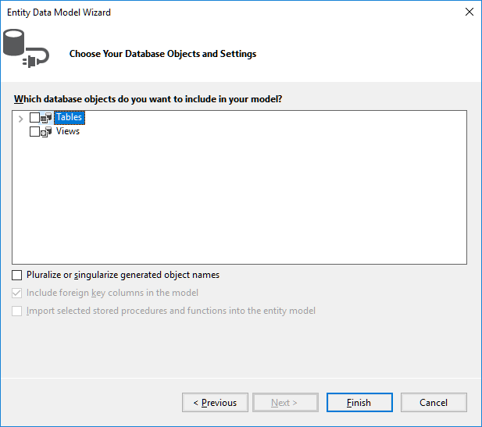

In this window, set a checkmark at **Tables**, and also at the **Pluralize…** option. Then click **Finish**. After all little while, the **Solution Explorer** window should look like this:

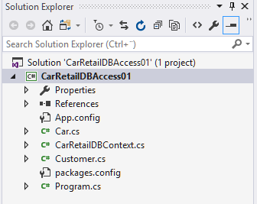

Note that a number of new classes have been generated:

* **CarRetailDBContext**
* **Car**
* **Customer**

These classes represent the mapping of the selected database (**CarRetailDB**) to a set of C# classes. The **CarRetailDBContext** class represent the database as a whole, while the classes **Car** and **Customer** correspond to the tables **Car** and **Customer** in the data­base. Let us have a look inside these classes.

The class **CarRetailDBContext** should look similar to this:

**public partial class CarRetailDBContext : DbContext**

**{**

**public CarRetailDBContext() : base("name=CarRetailDBContext")**

**{**

**}**

**public virtual DbSet<Car> Cars { get; set; }**

**public virtual DbSet<Customer> Customers { get; set; }**

**protected override void OnModelCreating(DbModelBuilder modelBuilder)**

**// Body of OnModelCreating omitted for brevity**

**}**

The most noteworthy elements of this class are the two properties **Customers** and **Cars**. They both have the type **DBSet**, and represent the records in the database tables **Customer** and **Car**, respectively (note that if you see error messages appear in these new classes, it might be because the Entity Framework NuGet Package has not been installed/restored yet. Right-click on the project, choose **Manage NuGet Pack­ages**, and check to see if you need to install/restore the package).

We have not entered any sample data into our database yet. Let us now enter this data into the tables:

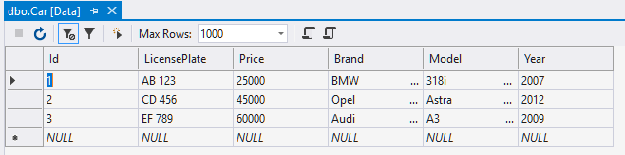

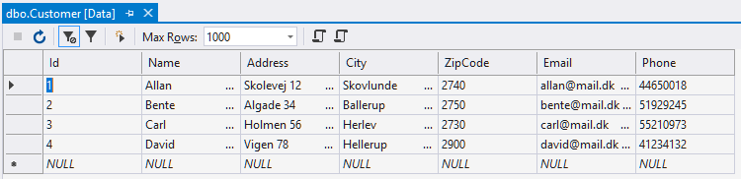

All the pieces should now be in place for actually accessing the data from the appli­cation. So, how is it done? The code needed for a simple reading of a table is quite short (a simple override of **ToString** has been added to the **Car** class):

**using (var db = new CarRetailDBContext())**

**{**

**Console.WriteLine("All records in Car table:");**

**foreach (Car c in db.Cars)**

**{**

**Console.WriteLine(c);**

**}**

**Console.WriteLine();**

**}**

First, note the use of the **using** keyword, which we have not seen before. In gene­ral, whenever you create an object which uses some sort of expensive resource (in this case a database connection), it is considered good practice to define it inside a **using** statement as above. This ensures that no matter the outcome of the code inside the code block, the resources claimed by the object will be properly released.

Next, we focus on the code inside the code block. The code written for printing out the **Car** objects is next-to-identical to code we would have written if the **Car** objects were just created directly in the code, and inserted into e.g. a **List** data structure. That is the power of the Entity Framework; once the connection to the database has been properly specified, all of the work is done behind the scenes. The data itself is then readily available as demonstrated above.

A valid question at this point is: how does the application know which database to con­nect to? This information is not found in the source code as such, but rather in the application configuration file **app.config**. This file contains various configuration infor­mation in XML format, including an element called **connectionStrings**:

**<connectionStrings>**

**<add name="CarRetailDBContext"**

**connectionString="**

**data source=(localdb)\MSSQLLocalDB;**

**initial catalog=CarRetailDB;**

**integrated security=True;**

**MultipleActiveResultSets=True;**

**App=EntityFramework"**

**providerName="System.Data.SqlClient" />**

**</connectionStrings>**

This is where the connection information is maintained.

The above code snippet illustrates that reading data from the database is quite easy. Changing the data is also relatively easy. The below code illustrates how to add a new record to the data, i.e. a **Create** operation (note that a constructor has been added to the **Car** class):

**db.Cars.Add(new Car(4, "MN 1234", 80000, "Skoda", "Octavia", 2013));**

**db.Cars.Add(new Car(5, "QR 3456", 30000, "VW", "Polo", 2009));**

**db.SaveChanges();**

That is it! Data is created simply by creating a new object of the relevant type, and ad­ding it to the corresponding **DBSet** property. This is very similar to inserting the object into e.g. a **List**. Note, however, that the data is not entered into the database before the call of **db.SaveChanges()**. Also, you should be aware that when you attempt to insert a new object/record into the database, an exception may be thrown if the data is not in accordance with the rules defined for the table (e.g. that a value may not be **null**, etc.). If such an exception is thrown, the application should of course handle it in an appropriate manner.

Deleting data (i.e. a **Delete** operation) is done using the **Remove** method:

**Car c = db.Cars.Find(2);**

**if (c != null)**

**{**

**db.Cars.Remove(c);**

**}**

Note that the **Remove** method takes an object as parameter, not e.g. a key identifying an object. However, the **Find** method can retrieve an object given a (primary) key.

How about the **Update** operation? There is no explicit method for updating an object; you simply update the object itself:

**Car c = db.Cars.Find(2);**

**if (c != null)**

**{**

**c.Price = c.Price + 10000;**

**}**

Again, remember that these changes are not entered into the database before the call of **db.SaveChanges()**.

It is thus not particularly complicated to perform **CRUD** (Create, Read, Update, Delete) operations on data, once the connection be­tween the database and the exposed data structures has been established via the Entity Framework. More sophisticated queries on the data can also be performed, e.g. using LINQ:

**var queryResult = from c in db.Cars**

**where c.Price > 70000 && c.Brand == "BMW"**

**select new {c.LicensePlate, c.Price};**

Seen in an MVVM perspective, the Entity Framework can thus almost provide us with a ready-made Model layer, or at least some data structures which it will be fairly easy to map to a Model layer.

### Creating a Web Service for database access

If we are able to utilise the Entity Framework directly in a UWP application, our job is almost done now. If this is not possible – or if we for some other reason do not want to access the database directly – we need to insert an extra layer of indirection, in the form of a **web service**.

The container for the web service is a separate application, of the type **ASP.Net Web Application**. In a new or existing Visual Studio solution, choose **Add | New Project**. Among the available of project types, choose **Web | ASP.NET Web Applica­tion**.

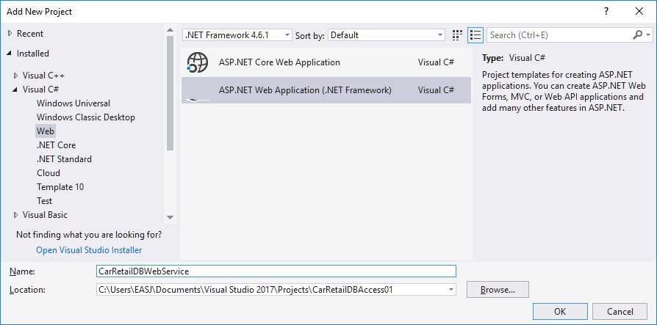

Choose a suitable name for the web service, and click **OK**. This brings up the below dialog:

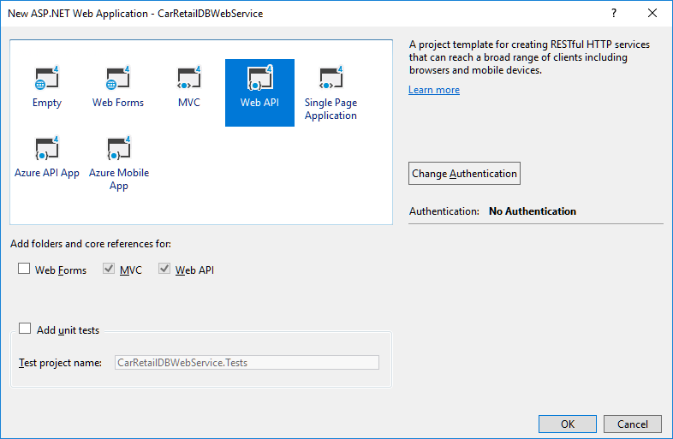

Make sure that **Web API** is highlighted, and that **MVC** and **Web API** are ticked. Before proceeding, click on **Change Authen­tication**, to bring up the below dialog:

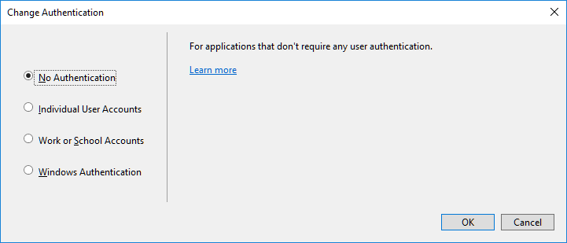

In this dialog, confirm that **No Authentication** has been selected (if not, then select it), and click **OK**. Also click **OK** in the previous dialog – this will set the creation of the web service project in motion. After a little while, the project should become visible in the **Solution Explorer** window:

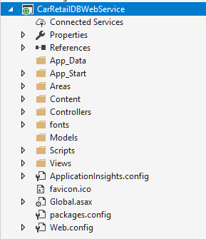

This may look a bit overwhelming, but fortunately we do not need to add that much in order to actually implement the web service. The next step is to go through the same steps as before, concerning how to add a “data item” of the type **ADO.NET Entity Data Model** to the project[22]. This is hopefully not so surprising, since we want the web service to be able to connect to the database using the Entity Frame­work, just as we did in the previous example. Once these steps have been repeated, you should have the same classes added to the project as before:

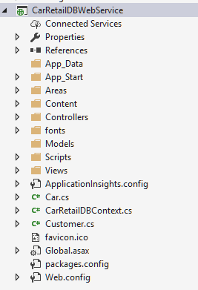

We do, however, need to add one small addition to the auto-generated code. In the constructor of **CarRetailDBContext** class, we add these two lines:

**public MovieDBContext() : base("name=MovieDBContext")**

**{**

**base.Configuration.LazyLoadingEnabled = false;**

**base.Configuration.ProxyCreationEnabled = false;**

**}**

The reasons for this addition are a bit technical, but it is essentially about preventing the service from trying to be too “smart”, with regards to how data is fetched by the service. With this addition, we should avoid unexpected behavior in that regard.

Staying on the topic of slightly obscure actions to perform before proceeding, you should also open the **Properties** window for the web service, and choose the **Web** pane. This should look something like this:

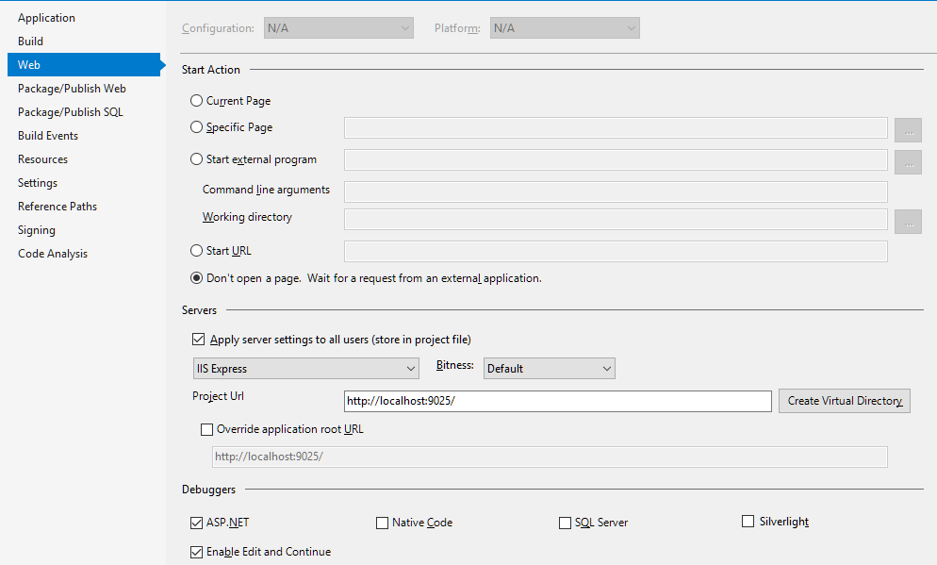

Two things are of interest here: First, we can see the specific URL for this project, i.e. the URL the client will need to specify when using the web service. Second, you must click on the **Create Virtual Directory** button, for reasons that are not yet entirely clear to me…

This completes the “back-end” of the web service. The remaining part is to make the data available to users of the web service. We said earlier that a web service essen­tially works by having a client send **HTTP requests** to the web service, which will then respond by sending **HTTP responses** to the client, including data in a suitable format, e.g. XML or JSON. This can be achieved in many different ways; one way – which has become somewhat of a current standard for web services – is to implement a so-called **RESTful** web service. **REST** (**RE**presentational **S**tate **T**ransfer) is in itself not a specific standard, but rather a set of recommendations about how a web service should be implemented. A RESTful web service essentially boils down to this:

1. A client sends a **HTTP request** – which has a standardised format – to the web service. The request contains three items of interest:
   1. An **HTTP Method Identifier**. Such an identifier is just a word, and will for most RESTful web services be either GET, PUT, POST or DELETE.
   2. A **URI** (Uniform Resource Identifier). This will also just be a string, and could e.g. be the string “api/Cars” or “api/Cars/2”
   3. **Data**. Depending on the action the web service should perform, the request may or may not include data.
2. When the web service receives the HTTP request, it will initiate actions corre­sponding to the content of the request (see below). These actions may involve:
   1. Retrieving or updating ( i.e. performing a CRUD operation) on the data source, which can e.g. be a database.
   2. Constructing an **HTTP response**, which may or may not contain data, depending on the operation performed by the server.
   3. Sending the HTTP response back to the client.

This may seem somewhat obscure, and it is definitely hard to see how this scheme can provide the data and actions we need. The crucial point is this: certain combi­nations of HTTP method identifiers and URI strings are defined as having a specific meaning, and will cause the web service to invoke specific actions. The mapping of such combinations to specific actions is what constitutes a so-called **REST API**.

The first stage of defining such an API, is to agree upon the combinations of HTTP method identifiers and URI strings which have specific meanings. A basic REST API typically includes these combinations (we use **Car** as an example below):

|  |  |  |  |
| --- | --- | --- | --- |
| **HTTP Request** | | | **HTTP Response** |
| **HTTP method** | **URI** | **Data** | **Action (by web service)**  ***Response*** |
| GET | /api/Cars | none | **Read** all Car objects in data source  *Return data to client* |
| GET | /api/Cars/[id] | none | **Read** Car object with this [id]  *Return data to client* |
| PUT | /api/Cars/[id] | Car data | **Update** Car object with this [id]  *Response code indicating ok/error* |
| POST | /api/Cars | Car data | **Create** Car object  *Response code indicating ok/error* |
| DELETE | /api/Cars/[id] | None | **Delete** Car object with this [id]  *Response code indicating ok/error* |

As you can hopefully see from the response column, we are now getter much closer to something resembling database operations (CRUD operations). In fact, the last four operations correspond exactly to single-record CRUD operations, while the first ope­ra­tion is a Read-All (Load) operation. Whether or not the request/response carries any data with it will obviously depend on the nature of the operation: A Read operation will of course return data, while an Update operation may just return an “OK” code.

The above description has hopefully convinced you that such an API can be defined in a meaningful way. Still, there are several practical questions to consider, like:

* How does a web service know what method to activate, when a specific request is received?
* How do we specifically construct such HTTP requests and responses?
* How is data “packaged” to be part of a request/response?

Fortunately, we are again aided by the tools available in Visual Studio ☺

### Creating a basic RESTful web service

The strategy for implementing a RESTful web service within an ASP.Net Web Applica­tion is to add so-called **controllers** to the application. You may have noticed that the web service project contains a folder named **Controllers**. This is where these control­lers will reside. If you right-click on the **Controllers** folder, and then choose **Add | New Scaffolded Item**, the below dialog will appear:

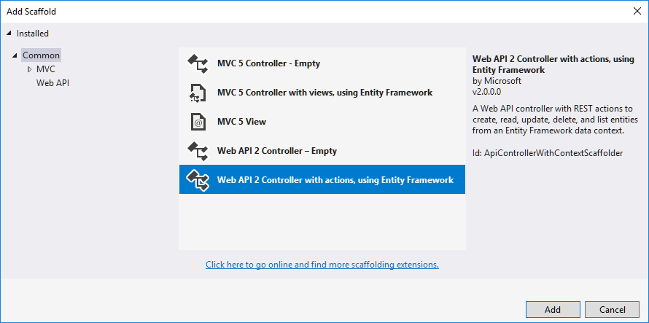

What does “scaffolding” mean in this context? The idea is that since we have already created model classes through the Entity Framework – which are thus connected to an underlying database – it is possible to auto-generate code that implements a basic RESTful web service for a specific model class. You can perceive the generated code as a “scaffold”, to which you can additional code if needed.

In the dialog, select the **Web API 2 Controller with actions…** option, and click **Add**. A new dialog now appears:

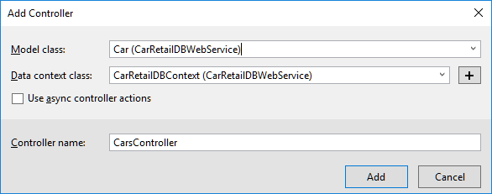

In the **Model Class** listbox, we can choose the **Car** class, and choose the “data con­text” class as well (this is the **CarRetailDBContext** class, which represents the data­base as a whole). When this is done, we click **Add**. After a short while, a class named **CarController** will be added to the **Controllers** folder (if you get an error during this process, you may need to rebuild your entire solution, and try again). Once this is done, you can repeat the procedure for the **Customer** class, which should generate a **CustomerController** class as well.

Before taking a closer look at one of these controller classes, let us briefly review the web service project as such. With the addition of the two controller classes, the pro­ject is essentially done. So…can we run it? What does it even mean to “run” a web service? A web service is not an application that a user interacts directly with; it is an application that is started at a “server” computer somewhere on the Internet, and other applications (often called “clients”) can then interact with the web service, by sending HTTP requests to it as described above. If you right-click on the web service project and choose **Set as Startup Project**, you will see that the familiar **Start** button (with the small green tri­angle), has now been replaced with a button labelled **Google Chrome** (or whatever browser you have chosen as your standard browser). If we click on the button, Google Chrome (or another browse) will be launched, and after a few seconds, a window will appear:

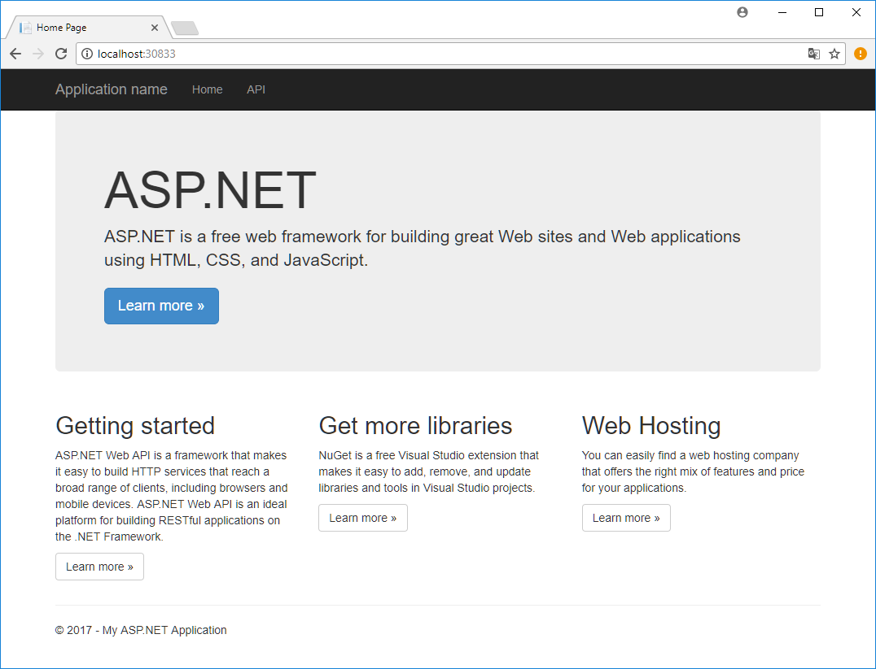

This is the “GUI” of our web service. However, the GUI is not intended as something a regular user will interact with. The GUI is more of a “help page”, intended for those who wish to create an application which interacts with the web service. You may also notice that the **Address** field in the browser reads **localhost:30833** (the number after the : may vary from project to project). The web service currently runs as a local web service, i.e. it runs on your own computer. We will later see how to deploy a web ser­vice to the Cloud. For development purposes, it is however fully adequate to run the web service locally.

Another interesting feature is the menu entry called **API**. If we click on this menu entry, the below window appears:

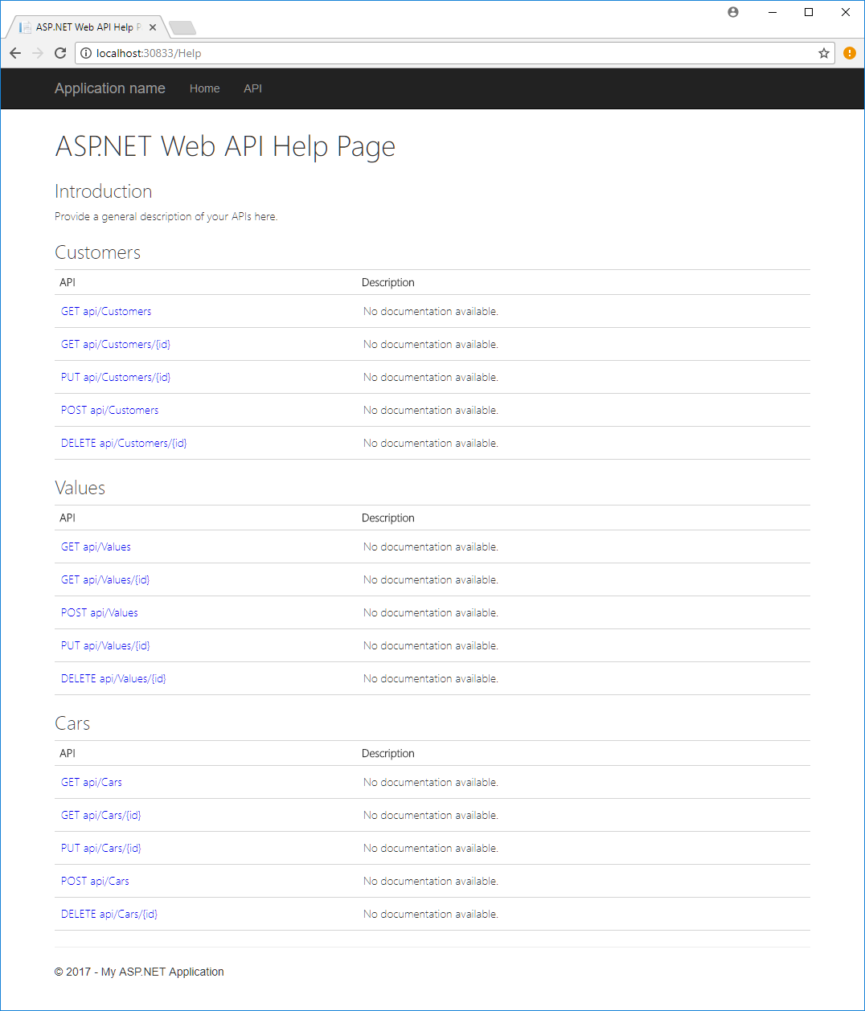

The window is divided into three sections: **Customers**, **Values** and **Cars**. The **Values** part is only included because the **Controllers** folder initially contains a sample class called **ValuesController**. If you find this class is disturbing the overview of the web service, you can safely delete it.

The **Cars** and **Customers** sections are thus the interesting sections. Each section con­tains a description of the web service API for that particular class. You can hope­fully see that this matches the earlier description of a basic RESTful Web API. We can actu­ally try out the API already. If we type **localhost:30833/api/Cars** in the **Address** field of the browser, you should see something like the below appear:

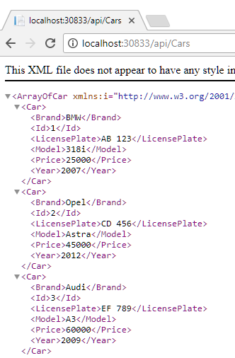

This is the data we originally stored in the **Car** table in our database! The data is here shown in XML format, but that is not in itself particularly important. The important point is that we can now pull data out of a database, transform it to objects using the Entity Framework, and make the data available to the outside world through a RESTful web service!

You could also try to write **localhost:30833/api/Cars/2** in the **Address** field, which should produce this result:

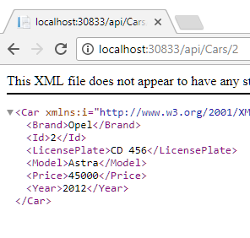

This is the parameterised version of the Read operation, which only reads a single object. Feel free to try out similar operations with the **Customers** API.

We now have a basic RESTful web service up-and-running for our two classes **Car** and **Customer**. Notice how little code we had to write ourselves, in order to make these ends meet. This again illustrates the power of the available tools; once we have defin­ed the domain classes themselves (here by means of table definitions in a database), the remaining infrastructure can almost be generated automatically. Before proceed­ing to the client side, let’s have a look inside a controller class. A “collapsed” version of the **CarsController** class looks like this:

**public class CarsController : ApiController**

**{**

**private CarRetailDBContext db = new CarRetailDBContext();**

**// GET: api/Cars**

**public IQueryable<Car> GetCars()**

**// GET: api/Cars/5**

**[ResponseType(typeof(Car))]**

**public IHttpActionResult GetCar(int id)**

**// PUT: api/Cars/5**

**[ResponseType(typeof(void))]**

**public IHttpActionResult PutCar(int id, Car car)**

**// POST: api/Cars**

**[ResponseType(typeof(Car))]**

**public IHttpActionResult PostCar(Car car)**

**// DELETE: api/Cars/5**

**[ResponseType(typeof(Car))]**

**public IHttpActionResult DeleteCar(int id)**

**}**

First of all, we see that the **CarsController** class inherits from the **ApiController** class, which comes from the **System.Web.Http** class library. The **ApiController** base class contains a lot of the generic code for implementing a RESTful web services, so the only respon­sibility left to the **CarsController** class is to implement the five **Car**-specific API methods. The issue of “routing” web service calls (in the form of an HTTP request) to the correct method is also handled by the auto-generated code.

With all this auto-generated goodness available, we do as such not need to change any of the code in a controller class. Still, it may be interesting to peek inside a couple of the method definitions. The **GetCars** method – which returns all cars in our **Car** table – is as simple as it gets:

**// GET: api/Cars**

**public IQueryable<Car> GetCars() { return db.Cars; }**

The **GetCar** method has a little bit more meat on its bones:

**// GET: api/Cars/5**

**[ResponseType(typeof(Car))]**

**public IHttpActionResult GetCar(int id)**

**{**

**Car car = db.Cars.Find(id);**

**if (car == null) { return NotFound(); }**

**return Ok(car);**

**}**

This is not so surprising, since we have two possible outcomes of this call: either a **Car** object with the given **id** was found, or it wasn’t… The **NotFound** and **OK** methods – which are defined in the **ApiController** base class – generate the appropriate HTTP responses, relieving us from dealing with the details of how to do this.

The **DeleteCar** method is structurally similar to **GetCar**, while the methods **PutCar** and **PostCar** are a bit more complex, and require a bit more effort to fully understand. Still, the main point is that the web service is now up-and-running, and we can turn our attention to how we then use the web service.

### Using a RESTful web service

To keep things simple, we illustrate use of a web service with a simple console appli­cation first. The main principles for use are of course independent of this choice.

An application using a web service is usually referred to as a **client**. We use that terminology as well. In order to make use of a web service, a client needs to know:

* The **URL** by which the web service is available
* The **API** offered by the web service

For our web service, the API follows the standard for a basic RESTful web ser­vice, and the service is available on a local URL (**localhost:****30833** in our example). With that infor­mation, the first parts of the client code can be written. Again, we make heavy use of classes from the .NET class library[23]:

**const string serverUrl = "http://localhost:30833";**

**HttpClientHandler handler = new HttpClientHandler();**

**handler.UseDefaultCredentials = true;**

**using (var client = new HttpClient(handler))**

**{**

**client.BaseAddress = new Uri(serverUrl);**

**client.DefaultRequestHeaders.Clear();**

**client.DefaultRequestHeaders.Accept.Add(**

**new MediaTypeWithQualityHeaderValue("application/json"));**

**// api-specific code follows…**

**}**

The above code can be considered client “boilerplate code”, and we will not discuss the details of it. The essense of the code is to make the URL of the web service known to the code, and to prepare an **HTTP­Client** object for use. It is through this **HTTP­Client** object we invoke the web service. We can now write code to perform specific API calls. A very simple operation is to delete a **Car** object, given its unique identifier **id**:

**await client.DeleteAsync($"api/Cars/{id}");**

The return type of **DeleteAsync** is **Task<HttpResponseMessage>**, making it possible to use the **await** operator here. This code style is admittedly a *call-and-forget* style; a more robust implementation should do some error handling by examining the nature of the **HttpResponseMessage**. The point here is to illustrate how simple it is to get up-and-running with a web service, from a client perspective. Client code for reading all **Car** objects is slightly more complex:

**Task<HttpResponseMessage> rTask = client.GetAsync("api/Cars");**

**await rTask;**

**if (rTask.Result.IsSuccessStatusCode)**

**{**

**var cTask = rTask.Result.Content.ReadAsAsync<IEnumerable<Car>>();**

**await cTask;**

**foreach (var car in cTask.Result)**

**{**

**Console.WriteLine(car);**

**}**

**}**

### Towards a general client-side implementation

The next step forward from here could be to create some sort of suitable “wrapper” or base class around the specific web service calls. Since the boilerplate code is iden­tical for all the domain-specific web service calls, it should be straightforward to sepa­rate it into a base class method. Also, the domain-specific web service calls only differ on a few places – e.g. the specific name of the API methods – meaning that it should also be possible to create parameterised versions of wrappers around these calls, and place them in a base class as well.

These considerations are similar to those considerations we discussed for the file-based approach to persistency. During that discussion, we suggested a simple, but general interface for persistency functionality:

**public interface IPersistentSource<T>**

**{**

**Task SaveAsync(List<T> objects);**

**Task<List<T>> LoadAsync();**

**}**

Would it make sense to implement a version of this interface, using a RESTful web service as the persistency provider? Concerning the **LoadAsync** method, it would make good sense. Assuming we have created a class **WebAPISource** which imple­ments **IPersistentSource**, and equipped it with some suitable instance fields and helper methods, an implementation of **LoadAsync** could be something like:

**public async Task<List<T>> LoadAsync()**

**{**

**using (var client = new HttpClient(_httpClientHandler))**

**{**

**InitHTTPClient(client);**

**Task<HttpResponseMessage> responseTask =**

**client.GetAsync($"api/{_apiID}");**

**await responseTask;**

**if (responseTask.Result.IsSuccessStatusCode)**

**{**

**Task<IEnumerable<T>> readTask =**

**responseTask.Result.Content.**

**ReadAsAsync<IEnumerable<T>>();**

**await readTask;**

**return readTask.Result.ToList();**

**}**

**return null;**

**}**

**}**

The **SaveAsync** method is more problematic. What is the actual meaning of “saving”? The assumption has so far been that “saving” means:

* All existing data is deleted from persistent storage
* The data provided as parameter to **SaveAsync** is saved to persistent storage

This is a rather crude strategy for saving data, which might be adequate for file-based persistency, where a relatively small amount of data is saved in a local file. For a REST­ful web service-based implementation, the first problem is that there is no method in the API that directly matches the intended functionality for **SaveAsync**. If we insist on imple­menting **SaveAsync**, we have two options:

**Create a custom API Save method**. This is possible, since you are free to add custom methods to the basic RESTful API. The five “standard” API methods we have seen so far are implemented by auto-generated code, but you can supplement this code with hand-written implementations. A **Save** method could e.g. be implemented by send­­ing an HTTP Request consisting of (using **Car** as an example)

* The **DELETE** verb
* The URI **/api/Cars**
* A set of **Car** object, on JSON format

The meaning of this call should then be *“delete all* ***Car*** *objects from persistent storage, and then write all of the provided* ***Car*** *objects to persistent storage”*. This is identical to how **SaveAsync** works when using files.

**Implement SaveAsync on the client side**. The standard API only provides single-object creation and deletion. A client-side implementation would then require:

* Get all identifiers for all objects currently stored. This can be achieved by calling the Read-All API method, and then filter out all identifiers
* Delete all currently stored objects. This requires calling the Delete method for each of the identifiers from the first step.
* Insert all of the provided objects. This requires calling the Create method for each object in the provided collection

Both options are feasible, but the latter sounds very inefficient. The amount of API calls across the network would be excessive; at least twice the number of objects in the collection at hand. This leaves the first option as the only viable option.

Should we then pursue this approach? An alternative could be to consider if the origi­nal **IPersistentSource** interface was simply too simplistic from the start. An alternative definition of the interface could be (we have omitted the **Async** suffix for brevity):

**public interface IPersistentSource<T>**

**{**

**Task Save(List<T> objects);**

**Task<List<T>> Load();**

**void Create(T obj);**

**T Read(int id);**

**void Update(int id, T obj);**

**void Delete(int id);**

**}**

Can we implement this interface with the file-based and Web API-based persistency approach? Not without effort, at least. The starting point with regards to interface compliance is this:

|  |  |  |
| --- | --- | --- |
| ***Method*** | ***File-based*** | ***Web API-based*** |
| **Save** | OK | No |
| **Load** | OK | OK |
| **Create** | No | OK |
| **Read** | No | OK |
| **Update** | No | OK |
| **Delete** | No | OK |

There is no clear-cut solution to this situation: one approach could be to go with this “broad” interface, and then let the implementations throw exceptions in case a non-compliant method is called. This sort of breaks the idea of client transparency with regards to data source, but could be a pragmatic solution. The client-side code can as such be written at interface level (and thus unaware of the specific choice of persis­ten­cy medi­um), but a conscious decision must be made at a higher level, concerning which stra­tegy to go with. That is, if a file-based approach is used, it will make sense to create an application with load/save functionality available (e.g having **Load** and **Save** entries in a main menu), while a Web API-based application should not have an explicit save functionality available.

We will not at this point deem one approach better than another, but you should be aware that some thought needs to go into how persistency manifests itself in a speci­fic applica­tion.

### Deploying a database and web service to the Cloud (Azure)

The web services we have looked at so far have been deployed (i.e. been located and invoked) on our local computer. This is fine for doing experiments, but sort of defies the purpose of a web service, which is to make the web service available through the World Wide Web. How can we then “publish” a service, so it becomes available? This can be done in different ways, but it essentially comes down to these steps:

* Find a web service hosting provider, to which our web service can be published. The web service will then run “in the cloud” at this provider.
* Create a data source – e.g. a database – for the web service, and set up the web service to use the data source. This will often mean publishing the data source itself to the web service provider as well.

One such hosting provider is **Microsoft Azure**, or just **Azure**. Azure is a service offered by Microsoft (other significant providers of such services are Google and Amazon), and is the service we choose to work with here. Azure offers certain limited services free-of-charge, but these services are sufficient of our purposes here. Azure is also – not surprisingly – quite well integrated with Visual Studio.

We will not in these notes make any attempt at describing Azure in depth, and also not detail any specifics about how to obtain an Azure account. Details about account types available can vary from person to person, and also over time. We will therefore in the following assume that the reader has managed to create an account at Azure.

Once you have obtained an account and log into the Azure portal, you will see an initial screen looking something like this:

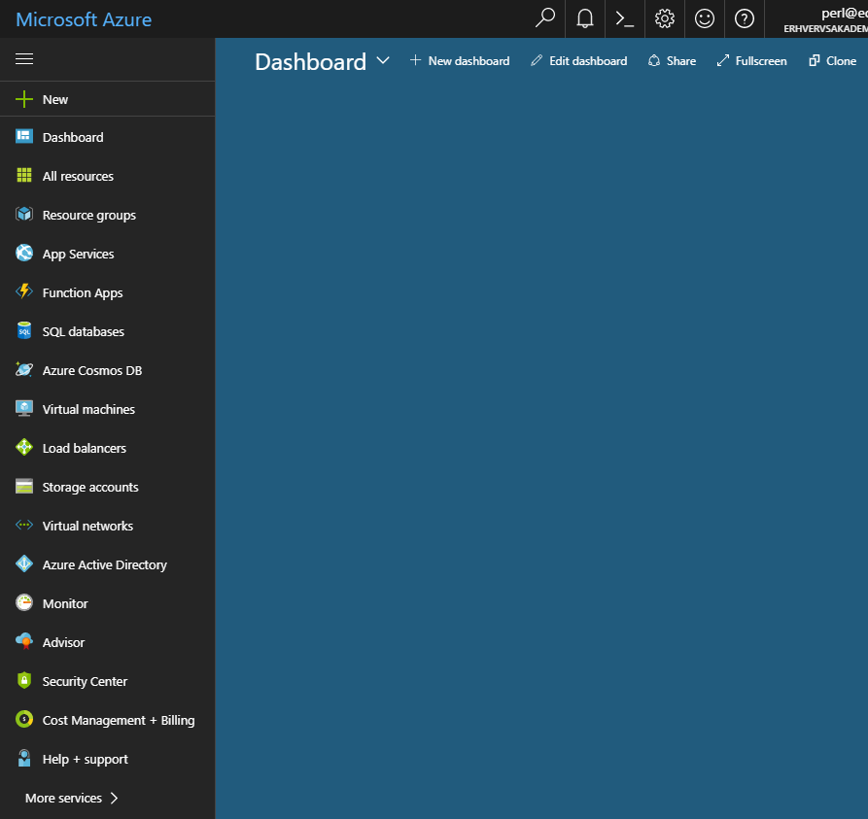

This is your “dashboard”, to which you can “pin” the services you wish to focus on. Our first task will be to create an SQL database, to which we will later connect our web service. The general principles for Azure SQL databases are:

* An SQL database runs on a (virtual) SQL Server.
* Many SQL databases can run on the same SQL Server.
* You can create many (virtual) SQL Server instances.

The reason for this two-layering is that you can specify certain settings on the server level, while other settings are specified for the individual database. Settings set on the server level will then apply to all databases running on that particular server.

We will here just create a single SQL Server, on which a single database will run. Click on **SQL databases**, and choose **Add** (if this is the first database you ever create, you might see a creation option named in a slightly different way). You should then see something like this:

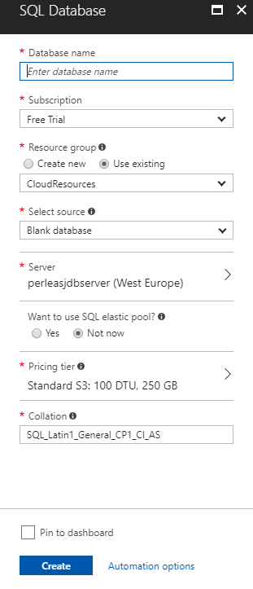

Here you just enter a suitable name for the database. If you have not created a data­base on Azure before, you will probably not have created an SQL server either. In the **Server** section, click on the right arrow, which opens this view:

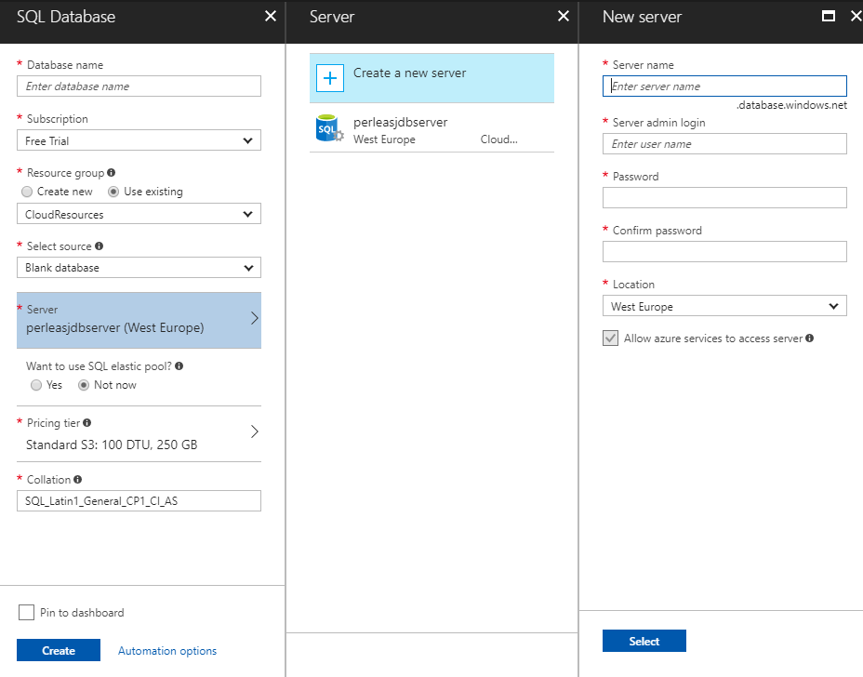

Here we have clicked on **Create a new server** in the middle pane, which opens the right-hand pane. Here you simply enter a suitable name for your database server, and choose an administrator login name and password (NB! **Remember** this login name and password, since you will need it later! Also, do **not** use an email address as user name, since the @-symbol has a special meaning in this context). Once this is done, you click on **Select**, which brings you back to the database specification pane. Finish the specification, click on **Create**, and wait for a while. The database and server crea­tion process can take a few minutes to complete.

When the database is created, it should show up when you choose **SQL databases** from the Azure main menu.

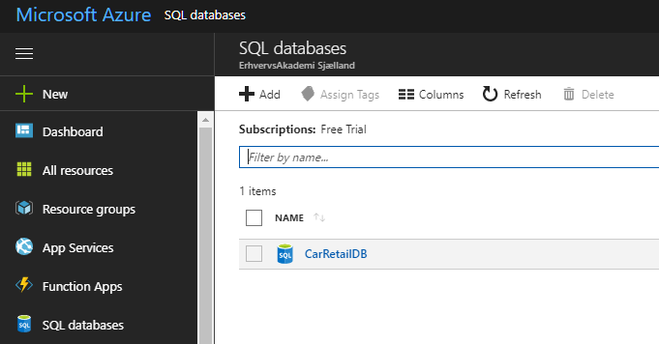

You can click on the database to see more detailed information about it. Note that the database is initially completely empty.

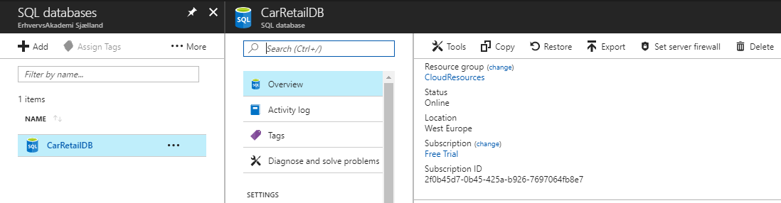

Two options are of interest initially: **Tools** and **Set server firewall**. A database is per default not accessible from the outside; you have to specify who can access the data­base (note, however, that databases per default can be accessed by your own Azure web services). If you choose **Set server firewall**, you will see this:

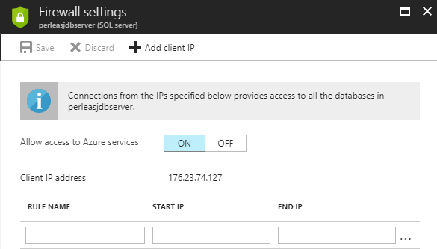

Here you can specify IP addresses which are allowed to access the database server. For convenience, you can add your own computer (or rather, the IP address on which your computer is currently connected) very easily, by clicking on **Add client IP**, and then on **Save**.

Having this out of the way, we now click on **Tools**. This brings up a rather small set of available tools:

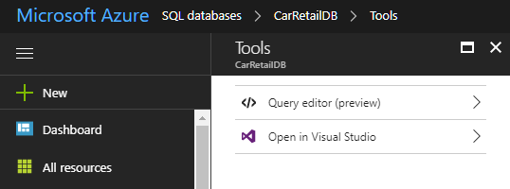

All we can do with a database here is either to execute raw SQL queries against the database, or open the database in Visual Studio. The former option is useful enough, since you can e.g. copy-paste a script into the query window. If the script contains queries for table generation and population, it is a convenient way to get the data­base up-and-running. We do however choose to open the database in Visual Studio, to leverage our experience with working with databases in Visual Studio. If that option is chosen, you will be prompted about opening Visual Studio. Accept this, and you will be transferred to Visual Studio. Here you will be met with a login dialog:

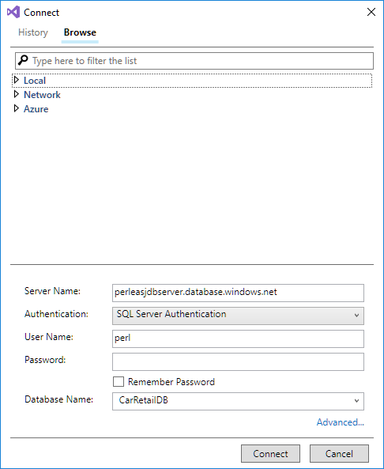

This is why you had to remember the administrator name and password you specified when creating the database server! Type in the password; if correct, the database will open in Visual Studio (Note that if you are now met with a dialog about not having set firewall settings, you must go back to Azure and set the firewall settings for the SQL server, as described previously):

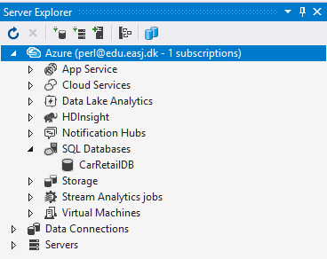 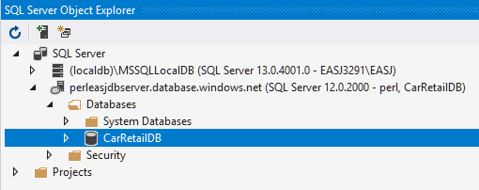

We are now back in our comfort zone, and can work with our new database just as if the database was a local database. However, be aware that many operations take considerably more time to complete. Just expanding the **Tables** node in the **Object Explorer** can take several seconds, as can simple queries.

One very convenient consequence of opening the database in Visual Studio, is that we can now create a web service connected to this database, going through the same steps as we have described previously. The only difference appears during the steps of the Entity Framework Wizard, where a new database connection must be specified:

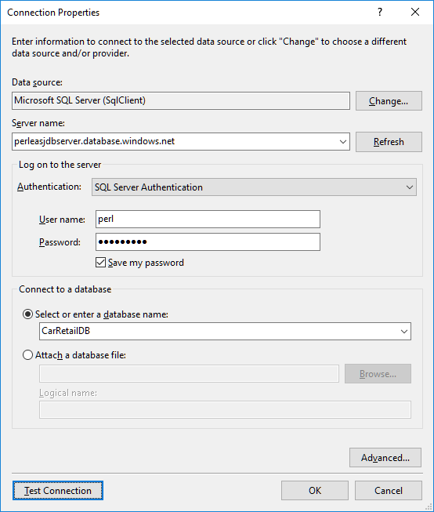

As compared to our previous encounters with this dialog, the main differences are:

* Server name must now be the name of your (virtual) SQL server on Azure. If you open the database in the Azure portal, you can find the full name of the server in the **Overview** pane.
* Authentication must now be set to **SQL Server Authentication**
* As user name and password, specify the administrator name and pass­word you chose when creating the database server (yes, it really was important to re­mem­­ber it…)

As before, you can test if everything is in order by clicking **Test Connection**. When every­thing is in order, click **OK**. You will now see a new dialog, which we have not seen before:

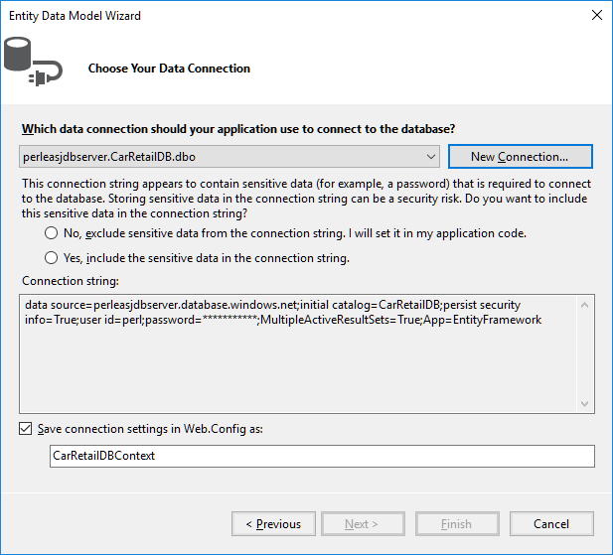

Here we are asked to decide how the password string should be handled. For this small demonstration, we assume that it is okay to save the password in readable form in the connection string. This may not be acceptable in other scenarios. Once we have chosen, the **Next** button becomes enabled, and we can continue the process. The re­main­ing steps are identical to what we have seen before.

Once we have completed the Entity Framework Wizard, we continue – just as before – with the creation of Controller classes; one for each domain class. This brings us quite close to the finish line. Assuming that we have executed a suitable script on our Azure database (if not, we couldn’t generate the domain classes with the Entity Fra­me­work…), we now have:

* An up-and-running SQL database on Azure
* A web service capable of accessing said database through the Entity Frame­work, and exposing the data by its REST API methods.

The only step left is how to “publish” the created web service to Azure. This is actually fairly easy. Once the web service project can build properly, you highlight the project in the **Solution Explorer**, right-click and choose **Publish** in the context menu:

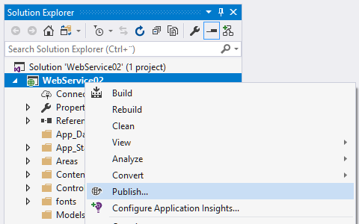

This bring up a simple project page, where the specific kind of publishing can be selected:

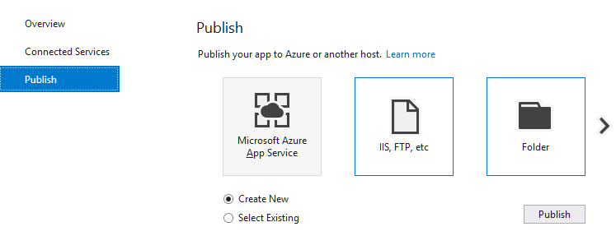

Here we choose **Create New**, click on the Azure option, and then **Publish**. This brings up a slightly compli­cated dialog:

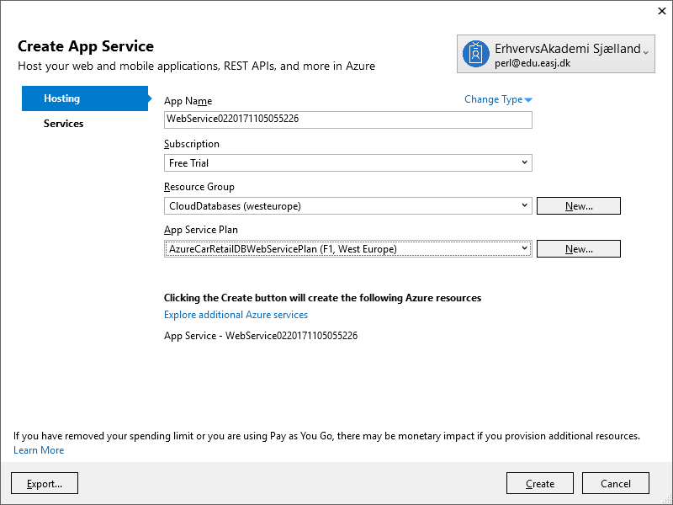

Depending on whether or not you have already logged on to Azure from Visual Studio, the first hurdle may be to actually log on. Once that is done, you have to decide on a couple of properties for your new web service. First, the web service will get a name on Azure. This must be a unique name, which is probably why the auto-suggestion looks rather odd… Feel free to choose a more de­scrip­tive name for your service, as long as it is unique. You also have to decide what subscription and resource group the web service should belong to; the default values are probably fine. Finally, the web service must be associated with a web service “plan”. A web service may in real life require few or many resources in terms of memory and CPU power, which are not free at Azure (the smallest plans are actually free, like the plans we are using here). The choice of plan thus decides how many resources Azure assigns to the web service, and how much you are then billed for this service… Again, don’t worry; if you have chosen a free subscription, you cannot suddenly be billed ☺. So, in short; choose an existing plan if you have one, otherwise create a new one.

When all properties have been specified, we are ready to publish the web service. Click on **Create**, and the publishing process will start. This process may take a few minutes to complete, and will hopefully culminate with your browser displaying something like this:

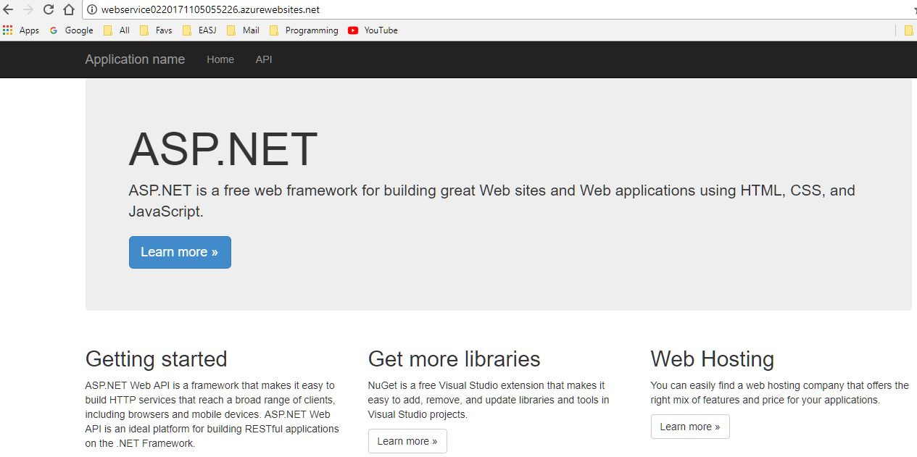

Success! A web service available on the specified not-so-descriptive URL is now up-and-running. A first small test could be to click on the **API** entry in the menu, and see if the REST API methods for the domain classes show up. If that is the case, we can try to actually use the REST API methods directly from the browser:

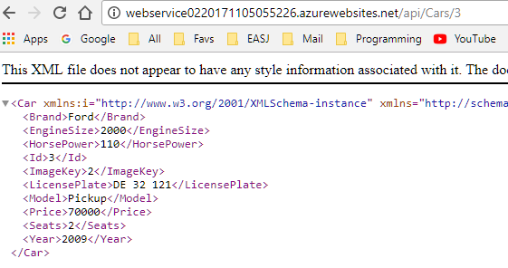

This is indeed data matching the data present in the SQL database running on Azure. We have thus completed our mission of deploying both an SQL database and a web service to Azure.

What if you want to update your web service later on? This is also quite easy. If we return to Visual Studio, we should see something like this after a successful publish:

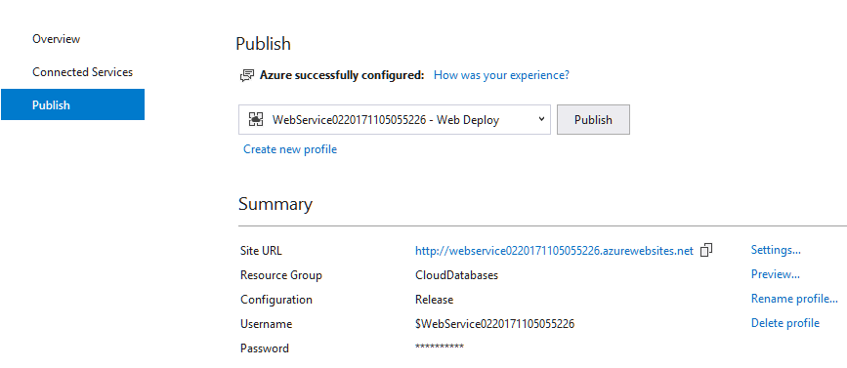

If we now change something in the Web Service code, we can publish the change by choosing **Publish** from the project context menu (just as before), which brings up the **Publish** window above. Simply click on the **Publish** button; this will start a new pub­lishing process, again ending with the browser showing the new web service in action.

This concludes the creation of the web service, now running on Azure. We can now create a client which uses the web service, just as we did earlier. In fact, if we already have a client which uses a local version of the same web service (i.e. a web service ex­po­sing the same REST API), the only thing we need to change is the URL for the web service! The URL could even be chosen at run-time. The deciding factor is the REST API, while the two web services can be considered two implementations of the same interface.

# Object-Oriented Programming III – Advanced

We have come quite a long way since the beginning of these notes. We now have a rich palette of language constructions and programming techniques available, and can create rather sophisticated applications, both with regards to user interfaces and un­der­lying logic and data structures.

The next step is to consider how to put it all together. We have to some extent done this already, since we have learned about various ways to relate classes to each other, by means of interfaces, inheritance, composition, etc.. Still, the scenarios we have in­vestigated have usually been rather simple, and perhaps also without a well-defined purpose. A seasoned software developer should also know about techniques for how to use all these tool for various real-life purposes. Such purposes – along with general techniques for achieving them – can be formulated as so-called **Design Patterns**.

A **Design Pattern** is – as the term suggests – a design (in terms of classes and inter­faces) for how to solve a commonly occurring problem in software development. Design patterns are not theoretical constructions, but rather “best practices” which have been recognised over time as sound solutions to common problems. Quite a lot of material is available on design patterns, the most well-known probably being the book Design Patterns[24], which in the mid-90s named and described 23 specific design patterns, divided into three main categories: Creational, Structural and Behavioral. The names assigned to the individual design patterns are still used today, and thus pro­vides a common “vocabulary” for software developers, enabling developers to refer to non-trivial designs by a single phrase. We will investigate a few of these de­sign patterns in more detail in this chapter.

Before diving into specific design patterns, we will try to put them into perspective. As stated above, design patterns are not theoretical constructions thought up by profes­sors in some ivory tower, but rather observed “best practices”, which have been con­densed into their very essence, both with regards to formulation and solution. But when is something considered a “best practice”? If something is a “best practice”, then it must be better than other practices, yes? This in turn requires us to think about how we measure the “goodness” of a practice, which ultimately brings us to a core question

**What goals do we strive at, when we develop software?**

This is a very tricky question, since it will be highly dependent on the specific circum­stances for a specific software development activity. A somewhat subjective answer to the question could be: to develop software of the highest possible quality. But that just begs another question: How do we define “high quality”? If we are developing soft­ware for a nuclear power plant control system, we will probably rate “lack of errors” very high on a quality scale, compared e.g. to ease of use. Sure, the software should also be easy to use, but if we have to spend a bit more money on training the operators in how to use the software, as compared with the potential consequences of releasing the software with (too) many errors in it, we will probably rather spend resources on e.g. testing rather than polishing the GUI. Other scenarios may have very different quality measures; if some company needs to get their product to market as quickly as possible – perhaps because other companies are also pushing a similar pro­duct – it might be much more important to get a “reasonable” version of the product on the market fast, rather than waiting for Quality Assurance to dissect the product for several months. Many of the globally largest software producers have – more or less explicitly – adopted an “always in beta” approach to software lifecycles, meaning that a more traditional perspective on quality as meaning “error-free” does not apply any longer.

If that is indeed the case, does it then even make sense to talk about “best practices”? Yes, it still does. Even though the traditional view on how to manage the lifecycle of a software product may have changed, there are still some properties about the soft­ware which are desira­ble to strive for.

One such property is **reusability**. This has always been a “mantra” in Object­-Oriented software development, and for good reasons. If we can develop truly re­usable classes – or even systems of classes – then it will be easier to develop other systems needing such classes as well. Why does this make it “easier”? If the class is indeed reusable as-is, then we need not spend any resources on development and quality assurance. We get the entire functionality for free. This in turn will enable us to deliver a complete product both faster and cheaper, which are two measures of quality that often score quite high on a quality scale. The obvious question is then: How do we develop soft­ware such that it does become reusable? We will return to this question in a moment.

Another property is **extensibility**. It is great if we have a pool of reusable classes at our disposal, but even greater if these classes can be “extended” in certain ways, in a fashion that is unlikely to “break” the existing classes. This will enable us to use these classes in scenarios they were not explicitly developed for, which makes them very versatile. Again, we need to ask: How do we develop soft­ware such that it does beco­me extensible?

This text does not aspire to be a complete treatment of all the useful properties a piece of software should posses. Other desirable properties are e.g. testability, reliability, per­formance, instrumentation, etc.. Discussions about such properties must be found elsewhere; we will primarily focus on reusability and extensibility.

Having convinced ourselves that reusability and extensibility are indeed positive pro­perties worth striving for, can we now jump into specific design patterns? Not quite yet. First, we will have a look at a couple of more general software design **principles**, which come into play again and again when discussing specfic design patterns. More specifically, we will look at two such principles:

* The **Open/Closed** principle
* The **Dependency Injection** principle

These two principles form the **O** and **D** in a larger set of such principles know as the **SOLID** principles, which is also a well-established term in software development. The complete list of SOLID principles is:

* **S**ingle Responsibility
* **O**pen/Closed
* **L**iskov Substitution
* **I**nterface Segregation
* **D**ependency Injection

As for Design Patters, a lot of material detailing the SOLID principles can be found elsewhere[25].

## The Open/Closed principle

The Open/Closed principle comes in several variations with regards to formulation, but the essense of the principle is:

Software entities should be **open** for extension, but **closed** for modification.

The first time you see this principle, it seems to be almost paradoxical. How can something be open for something, and also closed for something that sounds like almost the same thing? This requires a bit of clarification.

The first clarification concerns the term “software entities”. What is that? In the realm of Object-Oriented software development, we can usually substitute this with “a set of classes and interfaces, designed for one common purpose”. With that out of the way, we can address the “closed” part. This sounds very rigid. Must we then develop perfect software in the first try? That is of course unrealistic. A less draconic version of the “closed” part could be “closed for modification that requires clients of the code to change”, clients being defined as any other part of the software making use of the class in question.

Let’s illustrate these concepts with an example: Suppose a class **Client** makes use of a class **CalculatorV10** (V10: version 1.0) which in turn uses a class **Data** for providing data for some sort of calculation. Code for the **Client** class could look like this:

**public class Client**

**{**

**public CalculatorV10 _calculator;**

**public Client()**

**{**

**_calculator = new CalculatorV10();**

**}**

**public void ProcessData(Data d)**

**{**

**int result = _calculator.Calculate(d);**

**//...**

**}**

**}**

Suppose now that the developers of **CalculatorV10** find a critical error in the class, to an extent where a new version of the class must be released. How would such a bug-fix version be released? As a new release of a class called **CalculatorV10**? Or maybe as an entirely new class called **CalculatorV11**? In the first case, the new release will not require the client code to change, even though it might be required to rebuild the enti­re system, but that is more of a technicality. In the second – and probably more likely – scenario, the client code will indeed need to be updated. Is that a problem? Many companies have a policy of always testing updated versions of their code, so if a part of the client code has been updated, it might be necessary to spend resources on re-testing the system. This comes on top of the cost of actually updating the code. In short, this code is not really designed with the open/closed principle in mind.

How can we change this? In the above example, we have not stated anything about the relation between the classes **CalculatorV10** and **CalculatorV11**. They both offer some sort of (probably identical) calculation functionality, but how are they related at a class level? The worst scenario would be that they have no relation. They might be implementing almost the same functionality, and may even have a method with the same name and the same parameter list, but if they have no relation in terms of inhe­ritance or interfaces, it becomes impossible to migrate from one vesion to the other, with­out having to explicitly modify the client code.

A better strategy is to relate the classes by inheritance. Suppose the **CalculatorV10** class is implemented like this:

**public class CalculatorV10**

**{**

**public virtual int Calculate(Data d)**

**{**

**int result = 0;**

**// Code for calculating a result…**

**return result;**

**}**

**}**

Note that the method **Calculate** has been defined as being **virtual**, indicating that the method can be overrided in a derived class. The class **CalculatorV11** could then be im­plemented in this way:

**public class CalculatorV11 : CalculatorV10**

**{**

**public override int Calculate(Data d)**

**{**

**int result = 0;**

**// Bug-fixed code...**

**return result;**

**}**

**}**

Does this help us with regards to keeping the the client code unchanged? To some extent, but not completely. Let’s look at the code again:

**public class Client**

**{**

**public CalculatorV10 _calculator;**

**public Client()**

**{**

**_calculator = new CalculatorV10();**

**}**

**public void ProcessData(Data d)**

**{**

**int result = _calculator.Calculate(d);**

**//...**

**}**

**}**

Two places in the code are particularly interesting (highlighted above). The first is the declaration of the instance field **_calculator**. What objects can this instance field refer to? Obviously to objects of type **CalculatorV10**… but also objects of type **Calcula­tor­V11**, due to the inheritane relationship! This is clearly an improvement. However, the second piece of highlighted code is still problematic, since we here explicitly cre­ate an ob­ject of type **CalculatorV10**. This is an extremely central problem in software design; whenever we need to create new objects, we must state their specific type explicitly. The entire category of design patterns known as **creational patterns** are in fact varia­tions over how to “encapsulate” the object creation process.

Are we then stuck here? If we insist on creating a calculation object explicitly in the **Client** class, we cannot really do much more. However, if we assume that a calculation object can be created outside the **Client** class, and somehow be made available to the methods in the **Client** class, we suddenly have more options. Consider the below ver­sion of the **Client** class:

**public class Client**

**{**

**public CalculatorV10 _calculator;**

**public Client(CalculatorV10 calculator)**

**{**

**_calculator = calculator;**

**}**

**public void ProcessData(Data d)**

**{**

**int result = _calculator.Calculate(d);**

**//...**

**}**

**}**

The **Client** class will now no longer create a calculation object, but rather receive a calculation object through the constructor parameter. What type can this object have? Again, both **CalculatorV10** and **Calcula­torV11**, due to inheritance. In this way, the **Client** class is unaware of the specific type of calculation object; it just knows that it is – or inherits from – **CalculatorV10**. We could then release further versions of the calculator class, and make use of them in the **Client** class without any code changes, as long as they inherit from **CalculatorV10**.

This idea can be taken a bit further by bringing **interfaces** into play. Suppose an inter­face for calculation has been defined:

**public interface ICalculator**

**{**

**int Calculate(Data d);**

**}**

We now assume that all calculation classes will implement this interface. We can then update the **Client** class further:

**public class Client**

**{**

**public ICalculator _calculator;**

**public Client(ICalculator calculator)**

**{**

**_calculator = calculator;**

**}**

**public void ProcessData(Data d)**

**{**

**int result = _calculator.Calculate(d);**

**//...**

**}**

**}**

As long as all future calculator classes implement this interface, we can make use of them in the **Client** class, without the need for updating the code. This is a quite typical example of how to design with the open/closed principle in mind; the **Client** class is “open” to make use of future calculation classes – without detailed knowledge about how they specifically work – but also “closed” in the sense that there is no need to chan­ge it, just in order to use it with new calculation classes.

One thing has been swept a bit under the rug, though. Somewhere in the client code – but outside the **Client** class – somebody needs to create a calculation object, and pro­vide it to a **Client** object, like this:

**ICalculator aCalculator = new CalculatorV11();**

**Client aClient = new Client(aCalculator);**

We are thus not completely out of the woods yet. Somebody does have to choose a specific implementation of **ICalculate**, and create an object of that type. However, mo­ving that responsibility out of the **Client** class opens up for a lot more flexibility with regards to where to create that object. We will see examples of how to address this problem later in this chapter.

A common theme in strategies for implementing the open/closed principle is to remo­ve knowledge about specific types from the client code, and replace it with e.g. know­ledge about interfaces only. A third party must then somehow supply specific imple­men­­­ta­tions of these interface to the client code, e.g. as constructor parameters. This way of building relations between otherwise loosely coupled classes is in fact what the **Dependency Injection** principle is all about.

## The Dependency Injection principle

As discussed in the previous chapter, we often strive at creating “reusable” classes, which makes it possible to use such classes together with entirely new classes, with­out having to modify said reusable classes, or – in the worst of scenarios – having to write an entirely new class ourselves ☺. If we can pick a well-tested, well-documented class off-the-shelf and easily reuse it in our own project, we can probably develop bet­ter, cheaper and less error-ridden applications, as compared to having to develop the en­tire application from scratch.

The principle known as **Dependency In­ject­ion** is generally considered a very impor­tant principle with regards to developing reusable classes, so we will also investigate this principle a bit, before seeing it in action in some specific Design Patterns. We will even look a Dependency Injection in a somewhat broader perspective than just when applied to relations between classes, since it makes sense to discuss it at lower levels as well. In a sense, we have been using this principle for quite some time ☺.

The term **Dependency Injection** seems to suggest that **someone** will **inject** **something** into **something else**, as illustrated below:

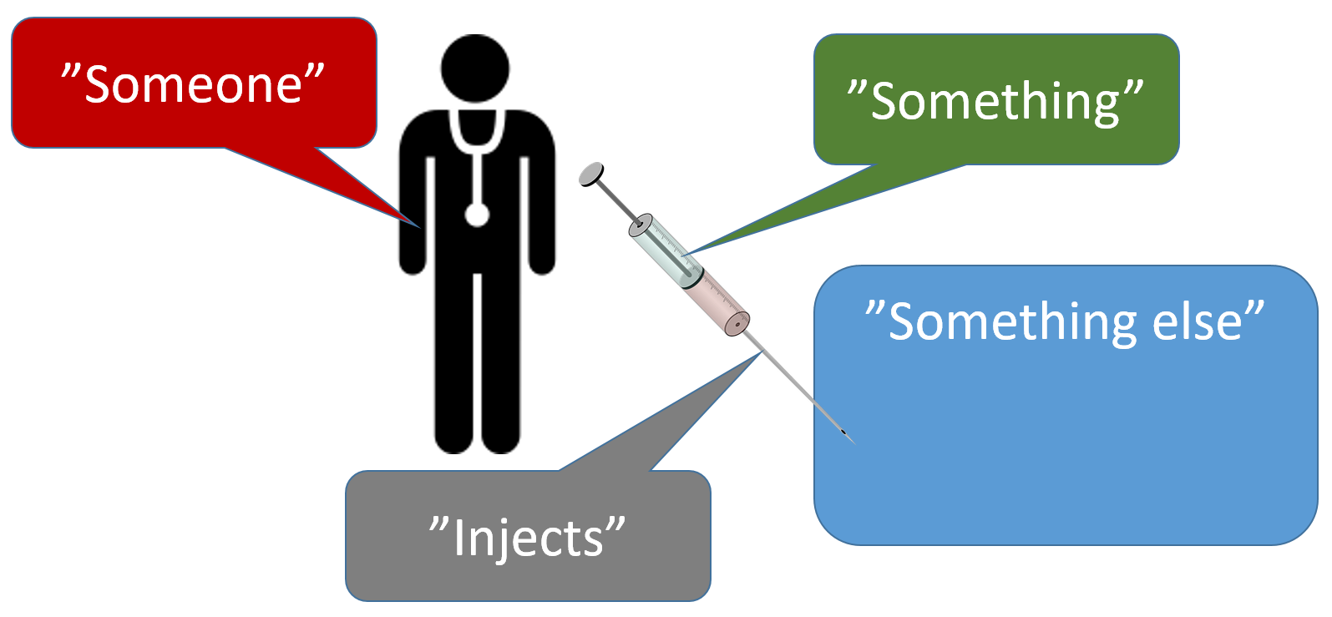

The term also suggests that this **something else** did not contain this **something** to begin with. If it did, it would then be inherently “locked” in a tightly coupled relation­ship with this **something**, which is what we want to avoid. Replacing the terms used above with the terms commonly used when discussing Dependency Injection, we get this illustration:

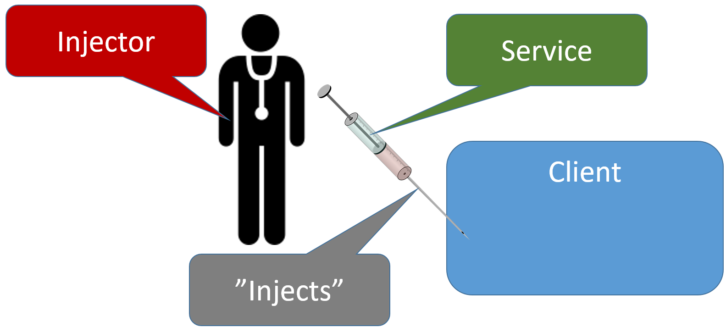

So, an **Injector** will inject a **Service** into a **Client**, and the client can then make use of this service. But how is this different than just having a hard-coded relation between the Service and the Client? Once we have performed the injection, the dependency will be the same anyway, yes? Well, no. The difference lies in the knowledge the Cli­ent will have about the specific nature of the Service.

### Dependency Injection – parameter level

Let’s illustrate this with an example. As mentioned previously, this discussion will perceive Dependency Injection in a broader context than usual, so the definition of the term “service” will be stretched a bit. Please play along…

Consider the below – quite clumsy – attempt to define a method for calculating the square of 4:

**public int SquareOf4()**

**{**

**return 4 * 4;**

**}**

The method does what it advertises; it calculates the square of the number 4. If some­one later on asks us for a method which can calculate the square of 6, we can quickly deliver:

**public int SquareOf6()**

**{**

**return 6 * 6;**

**}**

At this point in your software development training, you should hopefully be able to come up with a much better solution to this problem:

**public int Square(int n)**

**{**

**return n * n;**

**}**

Of course! This is much better than just mindlessly copying the original code, and re­placing 4 with whatever new value someone requests. This solves the problem once and for all. But what did we more specifically do? Something like this:

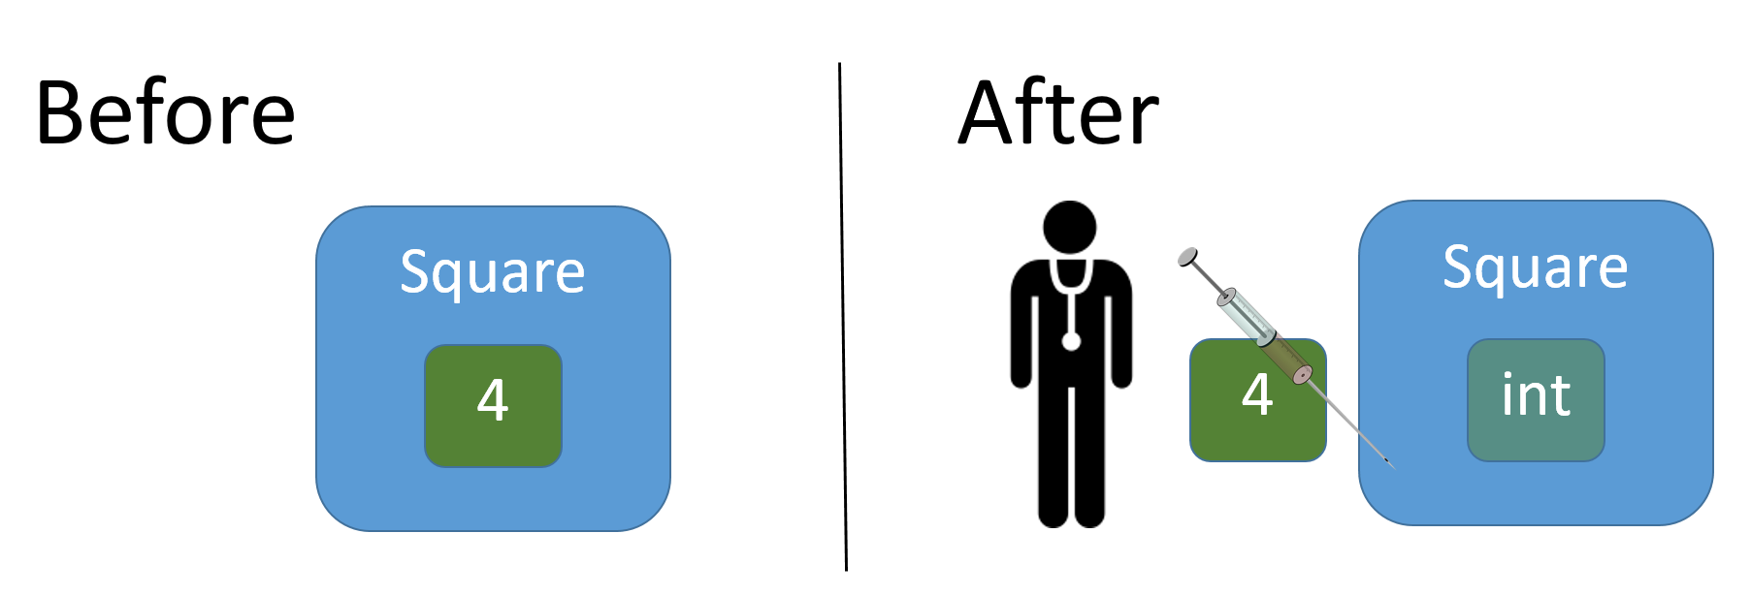

In the “Before” scenario, we had hard-coded a tight relationship between the method **Square** (the Client) and the number **4** (the Service – yes, a big word for a number…). In the “After” scenario, we removed the explicit dependency between **Square** and **4**, and turned the number into something the Injector – i.e. the caller of **Square** – must inject into the method, by providing it as a parameter to **Square**. Why was it possible to do this? The only operation happening inside **Square** is multiplication, and – and this is a very important point – multiplication works in the same way, no matter the specific number we supply! We can thus loosen up the requirements to that “thing” we do multiplication on. Can it be anything at all, then? No, since multiplication only makes sense on numerical values. It will not make sense to perform multiplication on a **string** value. So, any numerical value, then? In principle, yes. However, the return type of **Square** has been defined to be **int**, so requiring that the parameter must also be of type **int** seems to be just the right amount of restriction we need to put on the parameter. In this case, the analysis was very simple. Still, it is a valid illustration of perceiving parameterisation as a variant of the Dependency Injection principle.

Let’s see a slightly less obvious example. The below code defines a class **Die**, which is intended to model a standard 6-sided die:

**public class Die**

**{**

**private int _faceValue;**

**private static Random _random = new Random();**

**public Die()**

**{**

**Roll();**

**}**

**public int FaceValue**

**{**

**get { return _faceValue; }**

**}**

**public void Roll()**

**{**

**_faceValue = _random.Next(0,6) + 1;**

**}**

**}**

Rolling the die – by calling the **Roll** method – will set the face value to a random num­ber between 1 and 6 (the call of **Next**(0,6) will generate a number between 0 and 5, hence the +1 after the call). So, what exactly makes this a model of a 6-sided die? That is of course the number 6, used in the call of **_random.Next**. If we wanted a class for modeling a 10-sided die, we could just copy-paste the entire class, and replace 6 with 10, yes? No, let’s not go down that road again… Instead, we will solve the problem by applying the Dependency Injection principle again. But where? Should we turn the hard-coded number into a parameter to **Roll**, like this?:

**public void Roll(int noOfSides)**

**{**

**_faceValue = _random.Next(0, noOfSides) + 1;**

**}**

It’s a possible solution, but sort of breaks the idea that a **Die** object models a real-world die. A real die doesn’t change its number of sides between calls, so what then? A better solution would be to specify the number of sides when the object is construc­ted, by adding a parameter to the constructor, plus an instance field to the class:

**public class Die**

**{**

**private int _faceValue;**

**private int _noOfSides;**

**private static Random _random = new Random();**

**public Die(int noOfSides)**

**{**

**_noOfSides = noOfSides;**

**Roll();**

**}**

**public int FaceValue**

**{**

**get { return _faceValue; }**

**}**

**public void Roll()**

**{**

**_faceValue = _random.Next(0, _noOfSides) + 1;**

**}**

**}**

The revised class can now be a model for a die with any number of sides; the specific number of sides for a specific object is specified at object creation time, by the object creator, i.e. the Injector. Again, this rests on the observation that die operations are so general that they do not depend on the specific number of sides, as long as that number is an integer number (how does a die with 3.7 sides behave…?). A more com­plete implementation should probably also check that **noOfSides** is at least 2, and per­haps throw an exception if this is not the case, but that is more of an implementation detail.

### Dependency Injection – method level

We have now (hopefully) gained an understanding of the Dependency Injection prin­ciple, so let’s see it applied at a method level. Applying the principle here is conside­rably harder, and requires use of some of the more advanced language constructions in C#.

Consider the problem of filtering out certain values from a list of given values, accor­ding to some criterion. An example is given below:

**public List<int> FilterValues(List<int> values)**

**{**

**List<int> filteredValues = new List<int>();**

**foreach (var value in values)**

**{**

**if (value > 10)**

**{**

**filteredValues.Add(value);**

**}**

**}**

**return filteredValues;**

**}**

In this example, we filter out those numbers which are larger than 10, and add them to the resulting list **filteredValues**, which is returned to the caller. What if we wish to filter according to a different criterion? The method for doing this would actually be identical to the example, except for the criterion specified in the **if**-statement (as high­lighted in the code). The criterion itself is then a perfect candidate for being turned in-to a parameter. But how? Think about what characterises the criterion. It can be per­ceived as a function, taking one integer value as input, and returning a boolean value. We have learned earlier that such a function characterisation can be expressed as a C# type, in this case the type **Func<int,bool>**. That type identifies exactly those func­tions we just described. We can then rewrite the above to:

**public List<int> FilterValues(List<int> values, Func<int,bool> criterion)**

**{**

**List<int> filteredValues = new List<int>();**

**foreach (var value in values)**

**{**

**if (criterion(value))**

**{**

**filteredValues.Add(value);**

**}**

**}**

**return filteredValues;**

**}**

A caller can then call **filterValues** like this:

**List<int> filteredValues = FilterValues(someValues, v => v > 10);**

The function parameter is here expressed as a lambda expression, but it could also be a named function, as long at it conforms to the type specification. This is definitely a more elaborate example of Dependency Injection through parameterisation, but the line of reasoning behind it is actually quite similar to the next-to-trivial examples we saw earlier. We recognised that part of the logic inside the method did not need to be tightly coupled with a specific “value” (here a selection criterion, which can be expres­sed as a function of a specific type), so we parameterised that value, and let the caller inject a specific value – here a specific selection criterion – when the method is called.

### Dependency Injection – class/interface level

In order to see an example of Dependency Injection at the class/interface level, we need not look any further than one of the examples used when discussing the Open/ Closed principle. Our starting point was a **Client** class as given below:

**public class Client**

**{**

**public CalculatorV10 _calculator;**

**public Client()**

**{**

**_calculator = new CalculatorV10();**

**}**

**public void ProcessData(Data d)**

**{**

**int result = _calculator.Calculate(d);**

**//...**

**}**

**}**

The main problem with this class is the tight coupling to the **CalculatorV10** class. If we at some point need to upgrade to a newer version of the calculation – perhaps in the form of a class **CalculatorV11** – we need to change the implementation of **Client**. We can remedy this to some extent by adding a parameter of type **CalculatorV10** to the **Client** constructor, which will relieve the client of having to explicitly create a new object. Furthermore, this makes the dependency between **Client** and **CalculatorV10** more visible to the outside world. In the above code, a **CalculatorV10** object is crea­ted inside the **Client** constructor, but the only way to become aware of this fact is to inspec­t the actual source code, which may not always be possible (the class could e.g. be a third-party class). This can make it harder to test the class properly.

Adding a parameter of type **CalculatorV10** to the **Client** constructor does however not remove the tight coupling between **CalculatorV10** and **Client**; it just exposes it. If we now introduce a general calculation interface **ICalculator**, and use this interface as the type for the **Client** constructor parameter, the coupling is lifted:

**public class Client**

**{**

**public ICalculator _calculator;**

**public Client(ICalculator calculator)**

**{**

**_calculator = calculator;**

**}**

**public void ProcessData(Data d)**

**{**

**int result = _calculator.Calculate(d);**

**//...**

**}**

**}**

This version of **Client** does not depend on specific calculation classes. Instead, a third party must “inject” a specific calculation object, as part of creating a **Client** object:

**ICalculator aCalculator = new CalculatorV10();**

**Client aClient = new Client(aCalculator);**

This is exactly the same code we saw when discussing the Open/Closed principle, and Dependency Injection is indeed a very useful tool for implementing this principle. Fur­thermore, this makes testing of the **Client** class much more flexible. Whenever an ob­ject only depends on other objects known by interface type – and these objects are inject­ed into the object – it will always be possible to use “surrogate” objects, as long as these objects also implement the interface in question. Instead of having to use an implementation which e.g. connects to a remote database, a surrogate object can be used instead, which is likely to make the test both faster and more reliable. Whenever a test is performed involving objects depending on other objects, it becomes increa­singly harder to determine the actual origin of an error. Was the error caused by a bug in the class under test, or in one of the objects on which it depends? Use of surrogate objects takes this complicating factor out of the testing process.

There is not much more to Dependency Injection than this, except one – quite impor­tant – question: Who should be responsible for actually performing this dependency in­ject­ion? The next chapter will provide a couple of possible answers to this question.

## Design Patterns – Creational Patterns

In the discussions of the Open/Closed and Dependency Injection principles, a recur­ring theme was to remove tight couplings between client code and specific classes. More specifically, we saw that client code should – if at all possible – abstain from explicitly creating new objects, since creation requires the creator to explicitly state the type of the created object. Instead, client code should receive a reference to an object created by a third party, since such a reference can be of e.g. an interface type. This provides much more flexibility with regards to how to couple client code and spe­cific interface implementations together. The act of creating objects of a specific type has thus been externalised to this “third party”.

How should we then implement this “third party”? Does it manifest itself in the form of a method, a class or something else? The design patterns in the **creational patterns** category offer various approaches to this issue. We will here discuss two of these pat­terns, which are fairly closely related: the **Factory Method** pattern and the **Abstract Factory** pattern.

### Factory Method

Suppose we are developing software for a courier service, which needs to plan how to transport goods to certain locations, given e.g. a set of available vans. Such a planning process may have as objective to minimise the total number of kilometers driven, or perhaps to minimise the delays by which goods are delivered. The details are as such not im­por­tant, but planning problems like these tend to be very hard (i.e. require a lot of CPU resources) to solve optimally, where “optimally” means a 100 % guarantee that no better solution exist. However, it is also often the case that approximate solu­tions can be found much faster. There might even exist a whole suite of algo­rithms for producing solutions to the problem, where the quality of the solution will be directly proportional to the time it takes to produce the solution (the more time available, the better the solution).

This situation could be reflected in the implementation of the software. We imagine a class **PlanningManager**, with a central method **ExecutePlanning**. The method takes a single parameter, which indicates the amount of time available for finding a solution. An initial implementation of the method might look like this:

**public void ExecutePlanning(int timeAvailable)**

**{**

**PlanningData data = ReadPlanningDataFromDB();**

**PlanningResult result = null;**

**if (timeAvailable < 3)**

**{**

**ReallyFastPlannerV16 rfp16 = new ReallyFastPlannerV16();**

**result = rfp16.CreatePlanFast(data);**

**}**

**else if (timeAvailable < 12)**

**{**

**PrettyFastPlannerV24 pfp24 = new PrettyFastPlannerV24();**

**result = pfp24.CalculatePlan(data);**

**}**

**else**

**{**

**ExactPlannerV37 ep37 = new ExactPlannerV37();**

**result = ep37.FindExactSolution(data);**

**}**

**WritePlanningResultToDB(result);**

**}**

We assume that the planning process relies on some set of data, here represented by a class **PlanningData**. The planning process will produce a result in the form of a **Plan­ning­Result** object, which is then saved to a database. The specific details about this are not important either. Furthermore, we assume that various algorithms for plan­ning are available in the form of various classes; these classes might be developed in-house, or might be a third-party product. Such algorithms may be improved over time, so we assume that new versions will be produced regularly (indicated by the version numbers at the end of the class names).

The central feature of the **ExecutePlanning** method is the **multi-if-else** statement, which chooses a planning algorithm according to the available time. As it stands, this might be an acceptable implementation, but it is definitely quite fragile with regards to changes. Whenever a new version of one of the algorithms becomes available, we will have to update the code, which in turn may require re-testing, releasing the code into produc­tion, etc.. There is definitely room for improvement.

One major problem with the **ExecutePlanning** method is the dependency of specific planning classes, which induces the problem of having to frequently update the code. The **Factory Method** pattern is an appropriate tool for solving this problem. Instead of depending on specific classes, the client (here the **ExecutePlanning** method) will use a “factory” object to produce planning objects, without knowing about – and thereby depend on – their specific type. A prerequisite for this is to perform a bit of “homo­geni­sation” of the planning classes. We define a planning interface **IPlanner**, like this:

**public interface IPlanner**

**{**

**PlanningResult CreatePlan(PlanningData data);**

**}**

We now require that all planning classes must implement this interface. For planning classes produced in-house, this is probably not a problem, since it just amounts to renaming an existing method. For third-party classes, it may a bit trickier to achieve, but we will later see a design pattern (called **Adapter**) which can help us with this. For now, we assume that this is possible, such that all planning classes contain a method **CreatePlan** for creating a plan.

The **IPlanner** interface does not in itself help us much. We now define an additional inter­face **IPlannerFactory**, like this:

**public interface IPlannerFactory**

**{**

**IPlanner Create(int timeAvailable);**

**}**

The **Create** method in this interface is indeed a **Factory Method**. Calling this method will return an object which implements the **IPlanner** interface, but the caller will not be aware of the specific type of the object! This is the whole point; the caller should only know the interface type, since this is enough to make use of the object. We can now simplify the implementation of the **ExecutePlanning** method considerably:

**public void ExecutePlanning(int timeAvailable, IPlannerFactory factory)**

**{**

**PlanningData data = ReadPlanningDataFromDB();**

**IPlanner planner = factory.Create(timeAvailable);**

**PlanningResult result = planner.CreatePlan(data);**

**WritePlanningResultToDB(result);**

**}**

We have added an extra parameter to **ExecutePlanning**, which is a reference (by interface type) to a planner factory object. We can then use this factory to create a planner object when we need it, simply by calling **Create**. Since the returned object imple­ments **IPlanner**, we can call **CreatePlan** on it. **ExecutePlanning** has no know­ledge about specific planning classes, and will not need to change if new planning classes become available.

The **ExecutePlanning** method is obviously much cleaner now, but the choice of a spe­ci­fic planner class has of course not magically disappeared. It will now be implemen­ted in a factory class, e.g. like this:

**public class PlannerFactoryDay : IPlannerFactory**

**{**

**public IPlanner Create(int timeAvailable)**

**{**

**if (timeAvailable < 3)**

**{**

**return new ReallyFastPlannerV16();**

**}**

**else if (timeAvailable < 12)**

**{**

**return new PrettyFastPlannerV24();**

**}**

**else**

**{**

**return new ExactPlannerV37();**

**}**

**}**

**}**

Note that this class implements the **IPlannerFactory** interface. A call of the planning manager method could now look like this:

**PlanningManager pm = new PlanningManager();**

**pm.ExecutePlanning(GetAvailableTime(), new PlannerFactoryDay());**

We have thus extracted the responsibility of choosing the appropriate planning algo­rithm from the **ExecutePlanning** method, and placed it in a dedicated factory class instead. So, have we just moved code around? Indeed we have, but that is also a qua­lity in itself. The **ExecutePlanning** method can now concentrate on coordinating the planning process – including reading and writing data to a data source – while the factory class can focus on producing the appropriate planner object. Also, this division provides more flexibility. We have named the above implementation of the **IPlanner­Factory** interface **PlannerFactoryDay**, to suggest that an alternative implementation – maybe named **PlannerFactoryNight** – could exist. We could imagine that the criteria for choosing a specific implementation may vary between day and night, e.g. if more CPU resources are available at night. It will then be a simple matter to configure the **ExecutePlanning** method with a different factory implementation, since it only knows the factory objecty by its interface type.

In the above example, we have created a Factory Method which takes a single para­meter. There are as such no rules w.r.t. how to parameterise a Factory Method, and you can also easily imagine Factory Methods without any parameters, e.g. like this:

**public interface IPlannerFactorySimple**

**{**

**IPlanner Create();**

**}**

An implementation could then look like this:

**public class PlannerFactoryVeryFast : IPlannerFactorySimple**

**{**

**public IPlanner Create()**

**{**

**return new ReallyFastPlannerV16();**

**}**

**}**

This can be perceived as a more “low-level” factory, which only encapsulates a single aspect of planning object creation: creation of “very fast” planning objects. Such fac­to­ries could be used as building blocks in our previous factory implementation:

**public class PlanningFactoryGeneral : IPlannerFactory**

**{**

**private IPlannerFactorySimple _veryFastFactory;**

**private IPlannerFactorySimple _fastFactory;**

**private IPlannerFactorySimple _exactFactory;**

**public PlanningFactoryGeneral(**

**IPlannerFactorySimple veryFastFactory,**

**IPlannerFactorySimple fastFactory,**

**IPlannerFactorySimple exactFactory)**

**{**

**_veryFastFactory = veryFastFactory;**

**_fastFactory = fastFactory;**

**_exactFactory = exactFactory;**

**}**

**public IPlanner Create(int timeAvailable)**

**{**

**if (timeAvailable < 3)**

**{**

**return _veryFastFactory.Create();**

**}**

**else if (timeAvailable < 12)**

**{**

**return _fastFactory.Create();**

**}**

**else**

**{**

**return _exactFactory.Create();**

**}**

**}**

**}**

The final touches could be to turn the hard-coded limits for choosing between the factories into parameters as well. The factory will then be fully configurable (at least with regards to be able to choose between three categories of planners…).

### Abstract Factory

The Factory Method pattern is aimed at creating objects which all imple­ment the same interface. We can easily imagine that we would need to apply this principle several times, i.e. define factory interfaces and classes for multiple elements in an application. One example could be part of an operating system, which needs to dis­play various GUI controls like Windows, Buttons and Icons on the screen. The code for management of this should of course not rely on specific control implementations, so it would be natural to define some interfacce for the controls, like **IWindow**, **IButtton** and **IIcon**. Specific implementations of these interfaces can then present the GUI con­rol in question in a specific way. We could imagine classes like **WindowDefault**, **Win­dow­NatureTheme**, etc., and likewise for other controls. We can then create factory interfaces and classes for each type of control, like this minimal example:

**public interface IWindowFactory**

**{**

**IWindow Create();**

**}**

So far, so good. We can go ahead and create **IButtonFactory** and **IIconFactory** inter­faces as well, and imagine that some central part of the GUI management code gets configured with instances of these factories:

**public class GUIManager**

**{**

**// ...**

**public GUIManager(IWindowFactory iwf, IButtonFactory ibf, IIconFactory iif)**

**{**

**// ...**

**}**

**}**

All seems to be well… but there is a slight catch. Nothing prevents a client from crea­ting a new **GUIManager** object in this way:

**GUIManager gm = new GUIManager(**

**new WindowFactoryDefault(),**

**new ButtonFactoryNature(),**

**new IconFactoryIndustrial());**

This will likely result in a somewhat strangely looking GUI ☺. There is nothing in the code which prevents such unintended mixing between “families” of GUI controls. The solution is fortunately fairly straightforward; instead of defining three factory inter­faces with one method in each, we define one factory interface with three methods:

**public interface IGUIControlFactory**

**{**

**IWindow CreateWindow();**

**IButton CreateButton();**

**IIcon CreateIcon();**

**}**

With this interface in place, we can now implement factory classes that produce GUI controls of the same “family”, e.g. a **GUIControlFactoryNature** class. The **GUIManager** con­structor should also be changed:

**public class GUIManager**

**{**

**// ...**

**public GUIManager(IGUIControlFactory igcf)**

**{**

**// ...**

**}**

**}**

Creating a **GUIManager** object is now less error-prone:

**GUIManager gm = new GUIManager(new GUIControlFactoryNature());**

This new strategy does not completely prevent mixing of GUI control factories, since we have no control over the actual content of a factory object. If someone is really intent on messing up the GUI, he could write a factory class which does produce GUI control objects from different families. That aside, this new approach does at least state the intention of GUI control creation much clearer; GUI controls do not stand alone; they are part of a GUI control “family”, and the object creation strategy should reflect this.

## Design Patterns – Structural Patterns

The design patterns in this category are primarily concerned with the relationships needed between classes and objects, in order to achieve some sort of collaborative effort.

At the class level, such relationships are usually established through inheri­tance. A sim­ple example could be a class that implements several interfaces. From the per­spec­tive of the client code – which we assume always refers to objects by inter­face-type references – it makes no difference if the behavior exposed through the inter­faces is implemented by one or several objects, giving us freedom to choose such an approach, if it is indeed a sound approach by other measures as well.

At the object level, the relationships are established through composition. A class may refer to a completely unrelated class – be it by class type or interface type – in order to implement a certain functionality. We have seen this many times as well; a class that uses a class from the .NET class library – say, the **List<>** class – will often do this by composition, which in practice just means that the class contains an instance field of a certain type, and will either create a corresponding object itself, or receive a refe­rence to an object through a constructor or method parameter (the latter approach is often referred to as **Aggregation**).

We will take a closer look at two structural design patterns: the **Adapter** pattern and the **Proxy** pattern. They are both object-level patterns.

### Adapter

During the discussion of the **Factory Method** pattern, the starting point was a method **ExecutePlanning** used for creating a plan for optimal use of certain resources:

**public void ExecutePlanning(int timeAvailable)**

**{**

**PlanningData data = ReadPlanningDataFromDB();**

**PlanningResult result = null;**

**if (timeAvailable < 3)**

**{**

**ReallyFastPlannerV16 rfp16 = new ReallyFastPlannerV16();**

**result = rfp16.CreatePlanFast(data);**

**}**

**else if (timeAvailable < 12)**

**{**

**PrettyFastPlannerV24 pfp24 = new PrettyFastPlannerV24();**

**result = pfp24.CalculatePlan(data);**

**}**

**else**

**{**

**ExactPlannerV37 ep37 = new ExactPlannerV37();**

**result = ep37.FindExactSolution(data);**

**}**

**WritePlanningResultToDB(result);**

**}**

One of the main characteristics of this method is that the specific choice of planning object depends on the value of a parameter. We thus have a set of planning ”provi­ders” avail­able, from which we select a single instance. These planning providers may e.g. be third-party classes, and may therefore not have anything in common, except the ability to perform the given planning. The code above illustrates such a situation, where the three providers have methods with different names.

Our strategy for cleaning up this code required all planning providers to implement the same interface **IPlanner**, as defined below:

**public interface IPlanner**

**{**

**PlanningResult CreatePlan(PlanningData data);**

**}**

This may however not be feasible in practice. If the planning classes are provided by a third party, we cannot just change the definition of the classes, since we might not have access to the actual source code. What then? This is where the **Adapter** design pattern comes into play.

Suppose we create a new class called **ReallyFastPlannerAdapter**. This class must meet two requirements:

* It must implement the **IPlanner** interface.
* It should functionally be identical to the **ReallyFastPlannerV16** class.

This is not particularly hard to achieve:

**public class ReallyFastPlannerAdapter : IPlanner**

**{**

**private ReallyFastPlannerV16 _adaptee;**

**public ReallyFastPlannerAdapter()**

**{**

**_adaptee = new ReallyFastPlannerV16();**

**}**

**public PlanningResult CreatePlan(PlanningData data)**

**{**

**return _adaptee.CreatePlanFast(data);**

**}**

**}**

We simply encapsulate the “adaptee” – which is the original class that did not imple­ment the desired interface – and delegate the call of **CreatePlan** to the **CreatePlan­Fast** method of the adaptee. We can create similar adapter classes for all of the avail­able planning classes, and then achieve our goal of having a common interface for all planning providers.

This is of course a quite simple example, since the adaptation essentially boils down to delegating a method call to an adaptee method, which has the same signature (para­meter list and return type), but a different name. No pre- or post-processing is needed. An example which requires slightly more complex adaptation could be that of adapting a drawing library. Suppose we want to create a small drawing library, with a few methods define by an interface **IDraw** (we assume a class **Point** exists):

**public interface IDraw**

**{**

**void DrawPolyLine(List<Point> points);**

**void DrawRectangle(Point start, double xSide, double ySide);**

**}**

An existing drawing library **SimpleDraw** is actually available, but it only contains a single method **DrawLine**, which takes two **Point** objects as parameters. We must therefore create an adapter class **SimpleDrawAdapter** – which must implement the **IDraw** interface – and implement the methods in **IDraw** by using the (single) method available in **SimpleDraw**:

**public class SimpleDrawAdapter : IDraw**

**{**

**private SimpleDraw _adaptee;**

**public SimpleDrawAdapter()**

**{**

**_adaptee = new SimpleDraw();**

**}**

**public void DrawPolyLine(List<Point> points)**

**{**

**for (int i = 0; i < points.Count - 1; i++)**

**{**

**_adaptee.DrawLine(points[i], points[i+1]);**

**}**

**}**

**public void DrawRectangle(Point start, double xSide, double ySide)**

**{**

**Point endX = new Point(start.X + xSide, start.Y);**

**Point endY = new Point(start.X, start.Y + ySide);**

**Point endXY = new Point(start.X + xSide, start.Y + ySide);**

**_adaptee.DrawLine(start, endX);**

**_adaptee.DrawLine(start, endY);**

**_adaptee.DrawLine(endXY, endX);**

**_adaptee.DrawLine(endXY, endY);**

**}**

**}**

Not rocket science by any means, but still a bit more effort needed in order to “close the gap” between the required interface and the available implementation.

### Proxy

The purpose of the Adapter pattern was to bridge the gap between an interface requested by the client code, and the actual interface presented by a class offering the services the client needs. The Adapter class will typically contain a reference to the “adapted” object, and will implement the desired interface by calling methods in the interface of the adapted object. The **Proxy** pattern follows a similar strategy, but with a quite important difference; the object which is referenced has the same inter­face as the Proxy class itself!

How can that be useful? Why not just use the object directly, if the interface is the same? The Proxy pattern comes into play if there are reasons to restrict direct access to the object. If such reasons exist, it can be beneficial to hide access to the object behind a “placeholder” class, which is exactly what the Proxy pattern is about.

Suppose a class **RoutePlanner** exist, which is capable of route planning in a detalied road network. The class implements an interface **IRoutePlanner**. In order to be able to calculate a route plan, the **RoutePlanner** needs to load in a large data set, before cal­cu­lation is started. The **RoutePlanner** class is written in such a way that the data set is loaded when a **RoutePlanner** object is created. Crea­ting a **RoutePlanner** object is thus considered an “expensive” operation, since it may take a while to load the data set, and the loaded data set may also consume a significant amount of memory. It would therefore be useful only to create such an object if it is strictly necessary.

Let us also suppose that part of the client code uses a **RoutePlanner** object – or at least an object implementing **IRoutePlanner** – e.g. as a parameter to a method call:

**public void PrepareForPlanning(IRoutePlanner rp)**

**{**

**// Method body…**

**}**

The **PrepareForPlanning** method thus expects to receive a **RoutePlanner** object, but the method might also have a nature where actual planning is only performed when certain conditions apply. In other words; we may often experience that **PrepareFor­Planning** did not make active use of the **RoutePlanner** object, and the effort used for creating the object in the first place may therefore be wasted.

A problem like this can be resolved in various ways, depending on the degree of free­dom you have with regards to revising the code for the **PrepareForPlanning** method and the **RoutePlanner** class, but you may well be in a situation where neither of the two can be revised. Using the Proxy pattern will then be a feasible approach.

We assumed that the **RoutePlanner** class implements an interface **IRoutePlanner**. For simplicity, we assume that the interface only contains a single method:

**public interface IRoutePlanner**

**{**

**PlanningResult CalculatePlan(PlanningData data);**

**}**

We now create a new class **RoutePlannerProxy**, which also implements the **IRoute­Planner** interface. It also contains an instance field of type **RoutePlanner**:

**public class RoutePlannerProxy : IRoutePlanner**

**{**

**private RoutePlanner _planner;**

**public RoutePlannerProxy()**

**{**

**_planner = null;**

**}**

**public PlanningResult CalculatePlan(PlanningData data)**

**{**

**InitPlanner();**

**return _planner.CalculatePlan(data);**

**}**

**private void InitPlanner()**

**{**

**_planner = _planner ?? new RoutePlanner();**

**}**

**}**

Let’s review the key features of **RoutePlannerProxy**:

* It has a reference to a **RoutePlanner** object, BUT the reference is set to ***null*** in the constructor.
* It has a method **InitPlanner**, which reads *“if* ***_planner*** *is* ***null*** *when I’m called, it will be set to a new* ***RoutePlanner*** *object, otherwise* ***_planner*** *is left unchanged”*
* It implements **CalculatePlan**, BUT does so by first calling **InitPlanner**, and then calling **CalculatePlan** on the **RoutePlanner** object

With this new class available, it will be possible to call the client code method **Pre­pare­ForPlanning** in a new way:

**IRoutePlanner plannerProxy = new RoutePlannerProxy();**

**PrepareForPlanning(plannerProxy);**

From the perspective of the client code, nothing has changed. The method **Pre­pare­ForPlanning** is still called with an object implementing the **IRoutePlanner** interface, and it will use this object just as before. The fact that the “proxied” **RoutePlanner** object is only created if needed (often known as **lazy creation**) is completely hidden.

As the code stands now, the client code will now have explicit knowledge about using a proxy class, since it becomes responsible for creating a proxy object. If you wish to isolate the proxy creation further, you could encapsulate the proxy creation in a fac­tory class. It will then be a configuration issue whether or not to use a proxy; or you could even let the factory decide what to do at run-time (we assume that a class **Con­text** has been defined, which will provide decision information to the factory) :

**public class RoutePlannerFactory**

**{**

**public IRoutePlanner Create(Context c)**

**{**

**if (UseProxy(c))**

**{**

**return new RoutePlannerProxy();**

**}**

**else**

**{**

**return new RoutePlanner();**

**}**

**}**

**private bool UseProxy(Context c)**

**{**

**// Decide whether to use Proxy,**

**// based on provided context.**

**}**

**}**

The above example captures the essence of the Proxy pattern; whenever there are reasons to safeguard the creation of and/or access to an object, consider using a proxy class, which maintains a reference to the original object, and manages creation and/or use of the object. These reasons are typically grouped into a few main cate­gories; for a specific object, reasons from more than one category may apply:

**Object is expensive to create**: Use a proxy to delay creation of the object until it is really needed. Such a proxy is also known as a **virtual proxy**.

**Object is expensive to use**: In the above example, it might also be very expensive to actually perform a route planning. A proxy could be used to cache the results of pre­vious calculations, or maybe delegate the calculation to an approximation algorithm, which may not produce the optimal result, but will be much faster to complete its calculation. Another example of expensive usage occurs if the object being proxied runs remotely, and some sort of network communication is required in order to use it. A proxy can then become a local representative of that object. Such a proxy is also known as a **remote proxy**.

**Object must only be accessed by callers with certain permission**. Instead of hard-coding such permission rules into the object itself, they can be implemented in a proxy class, which will then act as a gatekeeper with regards to access to the object. Such a proxy is also known as a **protective proxy**.

**Additional bookkeeping is needed when an object is accessed**. It might be interesting to obtain various statistical data on how the object is used, or it might be required to enforce exclusive access to the object, if it contains elements which are not thread-safe. Just as it was the case for access protection, we gain much more flexibility if we place such “extra” functionality in a proxy class, instead of hard-coding them into the object itself. In the above example, we could e.g. choose to keep the **RoutePlanner** class as clean as possible, in the sense that it should focus entirely on being able to calculate routes, and leave concerns like access protection, lazy creation etc. to proxy classes. Proxies of this nature are also known as **smart proxies**.

If you dive deeper into the world of Design Patterns, you may also come across a pat­tern known as the **Decorator** pattern. The difference between the Decorator pattern and the Proxy pattern is small and somewhat subtle. As we also saw in the example above, a Proxy class will usually be responsible for creating the proxied object itself, either directly or by use of a factory. For the Decorator pattern, the ob­ject-to-be-decorated will be provided to the Decorator, usually as a parameter to the Decorator con­structor. The Decorator pat­tern is thus a bit more flexible than Proxy, since Deco­ra­­tors and decorated objects can be combined more freely at run-time. However, the scope for using Decorators is also smaller, since a Decorator will typically have no con­trol over when the decorated object is created. Examples as the above are there­fore not good candidates for use of the Decorator pat­tern, whereas the Proxy pattern is quite useful.

## Design Patterns – Behavioral Patterns

The design patterns in this category are primarily concerned with the “dynamic” rela­tionships between classes and objects. By “dynamic” is meant that it is not just the way classes and objects are wired together which is of interest here; it is in particular how these classes and objects collaborate in order to achieve a certain functionality. Just as we saw for structural patterns, we can divide these patterns into class-level and object-level patterns.

Behavioral patterns at the class level realise collaboration through inheritance, and by carefully distributing responsibilities between the involved classes. A key issue is often how to distribute responsibilities between base classes and derived classes. The rela­tionships between the involved classes is thus established at compile-time, an cannot easily be changed at run-time.

Behavioral patterns at the object level realise collaboration through composition. Dis­tribution of responsibilities is also a key issue here. Due to the use of composition, the relationships between the involved objects can in principle be changed at run-time, which add another dimension of flexibility to these pattern.

We will take a closer look at two behavioral design patterns: the **Template Method** pattern (which is a class-level pattern) and the **Chain of Responsibility (CoR)** pattern (which is an object-level pattern).

### Template Method

A very common scenario in software design occurs when we can specify a general algorithm for solving a general problem, but cannot “flesh out” all of the steps in the algorithm, because some steps need to be implemented individually for e.g. each type of data we wish to apply the algorithm to. A classic example is an algorithm for con­ver­­­ting data to a text format. If we assume that a small interface **IDataSource** has been defined with operations for Load and Save, the algorithm could look like this:

**public abstract class DataToTextConverter<T>**

**{**

**// General algorithm for data-to-string conversion**

**public List<string> ConvertDataToText(IDataSource<T> source)**

**{**

**// Read data from the data source**

**List<T> data = source.Load();**

**// This list will contain the converted data**

**List<string> dataAsText = new List<string>();**

**// For each data item: convert the item to a string,**

**// and add that string to the dataAsText List**

**foreach (T item in data)**

**{**

**string itemAsText = ConvertItem(item);**

**dataAsText.Add(itemAsText);**

**}**

**return dataAsText;**

**}**

**// This method needs to be implemented in subclasses.**

**public abstract string ConvertItem(T item);**

**}**

This is indeed a general algorithm for data-to-text conversion (at least if we assume that each data item can be converted to a single self-contained string). The only catch is the method **ConvertItem**. This method has no general implementation, since a spe­ci­fic conversion will depend on both the specific text format we wish to convert to, and on the data type **T** itself. With the base class in place, we can however fairly easily create a type-and-format specific derived class, for e.g. converting **Car** objects to XML:

**public class CarToXMLConverter : DataToTextConverter<Car>**

**{**

**public override string ConvertItem(Car item)**

**{**

**// Code for converting a Car object to XML**

**}**

**}**

That’s it. We can now create and use a **Car**-to-XML specific converter object. The derived class has two important features:

* It contains specific code for converting a specific type of object into a specific string format.
* It does not contain code that defines (or modifies) the general algorithm for data conversion.

A derived class cannot in any way interfere with the general algorithm; it only fleshes out a specific step, as it will look under specific circumstances. This is precisely the in­ten­tion of the Template Method pattern. The base class maintains absolute control over the general algorithm, while the derived class only gets called when the specific steps need to be carried out.

A Template Method – which in our example will refer to the top-level method **Con­vertData­To­Text** – will thus call methods that may be defined in the base class itself, or may be defined as abstract, and thereby being defined in derived classes. The stan­dard terminology used for describing these categories of methods follows below:

**Concrete operations**: These are methods or steps which are defined within the base class itself, and cannot be changed by a derived class. In our example, the line:

**List<T> data = source.Load();**

belongs to the group of concrete operations.

**Primitive operations**: These are the methods which are declared as abstract in the base class; in our example the **ConvertItem** method. These methods must be over­rided in a derived class.

**Hook operations**: A hook operation is a method which does have an implementation in the base class, but it may be overrided in a derived class. In C# terminology, this will be a virtual method. We do not have any such methods in our example, but it could make sense to turn the **ConvertItem** method into a hook operation:

**protected virtual string ConvertItem(T item)**

**{**

**return item.ToString();**

**}**

Deciding whether to go for an abstract or virtual approach will – of course – be highly dependent of the speficic scenario to which the pattern is applied.

The above example follows the classic approach to applying the Template Method pat­­tern; create a base class containing the Template Method itself, and create derived classes containing definitions of the primitive and/or hook operations. Cli­ent code for using the classes could then look like this:

**List<Car> cars = new List<Car>();**

**// Populate list with Car objects**

**CarToXMLConverter carToXml = new CarToXMLConverter();**

**List<string> carsAsText = carToXml.ConvertDataToText(source);**

We create an object of the derived type, and use it for conversion. However, you can also achieve the same effect without having to define derived classes. In this example, we are in practice creating a derived class in order to add in a definition of one single method. But we have learned previously that methods themselves can also be para­meters to other methods! Consider the below version of **Con­vertData­To­Text** (com­ments have been omitted for brevity):

**public List<string> ConvertDataToText(IDataSource<T> source, Func<T,string> converter)**

**{**

**List<T> data = source.Load();**

**List<string> dataAsText = new List<string>();**

**foreach (T item in data)**

**{**

**string itemAsText = converter(item);**

**dataAsText.Add(itemAsText);**

**}**

**return dataAsText;**

**}**

Suppose now that the client code contains the below method definition:

**private string CarToXML(Car item)**

**{**

**// Code for converting a Car object to XML**

**}**

The client code for data conversion would then look like this:

**List<Car> cars = new List<Car>();**

**// Populate list with Car objects**

**DataToTextConverter<Car> carConv = new DataToTextConverter<Car>();**

**List<string> carsAsText = carConv.ConvertDataToText(source, CarToXML);**

In this case, the client code creates an object of the base class type (which may now be a misleading description, since we no longer need to create derived classes…), and simply provides the single type-specific method definition which is missing, as a met­hod parameter to **ConvertDataToText**.

This approach is definitely worth considering in this case, since we only need to pro­vide a single method parameter. If the Template Method contains several primitive and/or hook operations, the benefit becomes more doubtful. Suppose the caller has to provide four methods parameters. It then becomes the responsibility of the caller to ensure that the provided method parameters are compatible with each other. One method may perform part of the conversion, and perform it with XML as the target format. Another method may perform a different part, and the caller might acciden­tally provide a method which targets a different format! That will probably not end well. In that case, it is probably a safer approach to apply the Template Method pat­tern in the traditional way, to avoid unintended mixing of incompatible methods.

### Chain of Responsibility

A pattern like Template Mehtod is usually targeted at scenarios where one particular class will perform (a variant of) a specific algorithm. Some steps may vary from class to class, but the tem­plate method defines the algorithm as a whole. This also implies that the complete algorithm for “handling” a certain request lies within that single method. Some algorithms do however have a nature that is not modeled particularly well by this approach. Consider for instance a help system for an application. The user can try to look up help on any part of the system in a context-sensitive way, e.g. by pressing the **F1** key on the keyword. The algorithm for looking up help could then look like this:

1. If detailed help is available for the specific part of the application the user is currently using, then display that help information. Otherwise:
2. If more general help is available for the general part of the application the user is currently using, then display that help information. Otherwise:
3. Open the web site for the product in a browser.

In short; we try to find help which is as detailed as possible, and if that action fails, we try to find help at a more general level. How will this strategy look in code? If we wish to express this logic in one single method **LookupAndDisplayHelp**, it could look like this (we assume that a num­ber of more specific methods like e.g. **FindDetailedHelp** and **DisplayHelp** have been defined):

**public void LookupAndDisplayHelp(Context c)**

**{**

**HelpInfo info = FindDetailedHelp(c);**

**if (info == null) // No detailed help found**

**{**

**info = FindGeneralHelp(c);**

**}**

**if (info != null) // General help found**

**{**

**DisplayHelp(info); // Display help info**

**}**

**else**

**{**

**OpenProductWebsite(); // Go to website**

**}**

**}**

It’s not super-complicated logic, but it is somewhat fragile to change. If we at some point introduce a medium-level help system, we must update this code. Furthermore, the code has a static nature; we cannot alter the order of alternatives at run-time, if that should become necessary.

The **Chain of Responsibility** (**CoR**) pattern offers an alternative strategy for organising code of this nature. The central principle is to implement each handling alternative in a sepa­rate class, but let all classes inherit from the same interface. Objects of these classes can then be chained together to form such a chain of responsibility. That is, each object of these classes will contain a reference to another object implementing the same inter­face. If an object is not capable of handling the given request, it simply forwards the re­qu­est to the object it references. At some point along this chain of handlers, some­one will actually handle the request, and the forwarding of the request stops. The last object in the chain will not refer to any object, so this should be some sort of if-all-else-fails handler.

If we wish to apply this principle in the above example, we first need to define an inter­face for a “help handler”. It looks like we only need a single method:

**public interface IHelpHandler**

**{**

**void LookupAndDisplayHelp(Context c);**

**}**

Let’s try to implement this method in a handler for detailed help. We could call a class corresponding to this level of handling for **HelpHandlerDetailed**:

**public void LookupAndDisplayHelp(Context c) // In class HelpHandlerDetailed**

**{**

**HelpInfo info = FindDetailedHelp(c);**

**if (info != null) // Help found!**

**{**

**DisplayHelp(info);**

**}**

**else**

**{**

**NextHandler?.LookupAndDisplayHelp(c);**

**}**

**}**

The logic is as described above; try to handle the request yourself, and forward the request if this proves impossible. As such, the code is pretty straightforward. How­ever, the class itself contains a few additional elements worth discussing:

**public class HelpHandlerDetailed : IHelpHandler**

**{**

**public HelpHandlerDetailed(IHelpHandler nextHandler = null)**

**{**

**_nextHandler = nextHandler;**

**}**

**public IHelpHandler NextHandler { get; set; }**

**public void LookupAndDisplayHelp(Context c)**

**{**

**// As above**

**}**

**public HelpInfo FindDetailedHelp(Context c)**

**{**

**// Code for Loking up detailed help**

**}**

**public void DisplayHelp(HelpInfo h)**

**{**

**// Show help on screen**

**}**

**}**

First, we note that the class contains a property **NextHandler**. The key features of this property are:

* It has the type **IHelpHandler**.
* It is set at construction time, through a constructor parameter. If the parameter is not explicitly specified, it defaults to **null**.
* Its value can be changed later, i.e. it is possible at run-time to change the hand­ler to which the object refers.
* If the object cannot handle the request, it forwards the request to the handler referred to by **NextHandler** (unless itis **null**, in which case nothing happens).

All handler classes should follow this strategy, so there seems to be good reasons to introduce a handler base class, e.g. named **HelpHandlerBase**. The **NextHandler** pro­perty is an obvious candidate for being moved to the base class:

**public class HelpHandlerBase : IHelpHandler**

**{**

**public HelpHandlerBase(IHelpHandler nextHandler = null)**

**{**

**NextHandler = nextHandler;**

**}**

**public IHelpHandler NextHandler { get; set; }**

**}**

Can we move additional code into the base class? The method **DisplayHelp** seems to be a general method for displaying help information, so it can probably also be moved to the base class. This leaves the method **FindDetailedHelp**, and the interface method **LookupAndDisplayHelp** itself. **FindDetailedHelp** seems to be quite specific for this level of help retrieval, so it probably needs to stay in the specialised class. But what about the interface method? Let’s have a look at it again:

**public void LookupAndDisplayHelp(Context c) // In class HelpHandlerDetailed**

**{**

**HelpInfo info = FindDetailedHelp(c);**

**if (info != null) // Help found!**

**{**

**DisplayHelp(info);**

**}**

**else**

**{**

**NextHandler?.LookupAndDisplayHelp(c);**

**}**

**}**

How much of this code is general, and how much of it is specific? It is actually only the highlighted part which is specific! The rest of the code will look exactly the same if we implemented it in a class for general help handling, e.g. named **HelpHandlerGeneral**:

**public void LookupAndDisplayHelp(Context c) // In class HelpHandlerGeneral**

**{**

**HelpInfo info = FindGeneralHelp(c);**

**if (info != null) // Help found!**

**{**

**DisplayHelp(info);**

**}**

**else**

**{**

**NextHandler?.LookupAndDisplayHelp(c);**

**}**

**}**

So, we have a general algorithm, with a single step which might vary under specific circumstances… doesn’t that sound familiar? This is exactly a case for the Template Method pattern, which we have just learned about! Applying the Template Method pattern here will give us this implementation of **LookupAndDisplayHelp** in the base class:

**public void LookupAndDisplayHelp(Context c)**

**{**

**HelpInfo info = FindHelp(c);**

**if (info != null) // Help found!**

**{**

**DisplayHelp(info);**

**}**

**else**

**{**

**NextHandler?.LookupAndDisplayHelp(c);**

**}**

**}**

**public abstract HelpInfo FindHelp(Context c);**

All that remains is a fairly trivial implementation of **FindHelp** in the specialised class­es, e.g. like this:

**// In class HelpHandlerDetailed**

**public override HelpInfo FindHelp(Context c)**

**{**

**return FindDetailedHelp(c);**

**}**

What about the if-all-else-fails class? Can we implement this class by using the base class? We can, if we are a little bit creative when implementing **FindHelp**:

**// In class HelpHandlerNoHelpFound**

**public override HelpInfo FindHelp(Context c)**

**{**

**OpenProductWebsite(); // Go to website**

**return null;**

**}**

This will force execution of the **else**-part in the base class implementation of **Lookup­AndDisplayHelp**, and since the **NextHandler** property must be null (otherwise, this would not be the if-all-else-fails handler…), the forwarding stops. If this feels like twist­ing the intention of the base class implementation of **Lookup­AndDisplayHelp** too much, you can still just implement **HelpHandlerNoHelpFound** by only inheriting from the interface **IHelpHandler**:

**public class HelpHandlerNoHelpFound : IHelpHandler**

**{**

**public void LookupAndDisplayHelp(Context c)**

**{**

**OpenProductWebsite();**

**}**

**public void OpenProductWebsite()**

**{**

**// Code for opening product website**

**}**

**}**

The requirement for participating in this particular Chain of Responsibility is (still) only that you implement the interface, not that you inherit from the base class. The base class is just a convenient implementation of the “typical” request handlers.

Proceeding in this way, we can create a set of request handler classes, which are un­aware of each other w.r.t. specific types. Handlers only reference each other by the interface type. The last remaining issue is how to set up a specific chain of responsi­bility. This will be done in a part of the client code, probably a part dedicated to appli­cation configuration in general:

**IHelpHandler noHH = new HelpHandlerNoHelpFound();**

**IHelpHandler generalHH = new HelpHandlerGeneral(noHH);**

**IHelpHandler detailedHH = new HelpHandlerDetailed(generalHH);**

**// …hand reference to detailedHH to relevant parts of the application**

The above example creates a single chain of responsibility, which may be the correct approach in many cases. You could also imagine that separate classes for different types of detailed help handling were created, which would lead to a slightly more complex setup procedure, like this:

**IHelpHandler noHH = new HelpHandlerNoHelpFound();**

**IHelpHandler generalHH = new HelpHandlerGeneral(noHH);**

**IHelpHandler createHH = new HelpHandlerCreate(generalHH);**

**IHelpHandler deleteHH = new HelpHandlerDelete(generalHH);**

**// …hand references to createHH and deleteHH**

**// to relevant parts of the application**

This effectively creates two chains of responsibility; one starting at **createHH**, and another starting at **deleteHH**. Both of these detailed handler objects will forward a request to the (single) general handler object, which makes perfect sense. There is nothing in the pattern as such that forbids many handlers to refer to the same hand­ler down the chain.

As the Chain of Responsibility pattern is described here, a request will only be handled by a single handler, i.e. the first handler which can handle the request properly. A use-ful vari­ant of this could be to allow the handler to handle the request and forward the request down the chain. This could be relevant if several parties are involved in hand­ling a single request. If we express the original handling principle in more general terms, it could look like this (**Handle** is an abstract method, which returns **true** is the request was successfully handled):

**public void HandleRequest(Request r)**

**{**

**if (!Handle(r))**

**{**

**NextHandler?.HandleRequest(r);**

**}**

**}**

Changing this to giving handlers down the chain the opportunity to the handle the request requires a very modest code change:

**public void HandleRequest(Request r)**

**{**

**Handle(r);**

**NextHandler?.HandleRequest(r);**

**}**

This can be compared with the ”rethrowing” strategy used in relation to exception handling.

This short tour-de-force through a couple of Object-Oriented design principles and a good handful of design patterns is now at an end. The two books mentioned in foot­notes provide a much more thorough treatment of these topic, and are highly recom­mendable.

1. We will in general refer to a computer program as an App (short for ”Application”), without assuming anything specific about what platform the App runs on. This could be an ordinary PC, a smartphone, a tablet, or some other device.
2. Details on how to do this may vary from course to course, and is thus found elsewhere
3. https://www.visualstudio.com/vs/visual-studio-workloads/
4. https://marketplace.visualstudio.com/
5. Draconian: To apply severe punishments to small offenses
6. One could, however, also claim that if you feel the need to add comments to your code, it might be an indication that your code should be restructured to make it clearer…
7. https://en.wikipedia.org/wiki/Integer_overflow
8. https://martinfowler.com/books/refactoring.html
9. https://docs.microsoft.com/da-dk/dotnet/
10. https://docs.microsoft.com/en-us/windows/uwp/files/file-access-permissions
11. For instance at https://msdn.microsoft.com/en-us/library/windows/apps/mt185406.aspx
12. https://docs.microsoft.com/en-us/windows/uwp/layout/layouts-with-xaml
13. https://en.wikipedia.org/wiki/GRASP_(object-oriented_design)
14. The language construction we denote as **lambda expressions** can also be denoted as **anonymous functions**. There are some subtle differences between the two concepts; we will use the term lambda expression here, even though it may in some situations not be 100 % accurate.
15. https://en.wikipedia.org/wiki/SQL
16. https://en.wikipedia.org/wiki/Software_testing#Testing_levels
17. https://www.martinfowler.com/articles/mocksArentStubs.html
18. https://github.com/Moq/moq4/wiki/Quickstart
19. https://en.wikipedia.org/wiki/JSON
20. See e.g <https://www.tutorialspoint.com/http/index.htm> for a brief introduction to HTTP
21. See e.g. <https://en.wikipedia.org/wiki/Representational_state_transfer>, or one of the many online REST tutorials
22. Note that you may need to install the **EntityFramework** NuGet package as part of this process. Right-click on the project in the **Solution Explorer**, choose **Manage NuGet Packages**, browse for **EntityFramework**, and install it. At the time of writing, the version to install was version 6.2
23. In addition to classes from the .NET class library, the client will also make use of functionality from (yet another) NuGet package called **Microsoft.AspNet.WebAPI.Client**. If the package is not installed automatically, you may need to install it manually, in the usual fashion for installing these packages.
24. Design Patterns, by Erich Gamma, Richard Helm, Ralph Johnsen and John Vlissides, ISBN 0-201-63361-2
25. A very recommendable book on SOLID is: “Adaptive Code via C# (Agile codong with design patterns and SOLID principles”, by Gary M. Hall, ISBN 978-0-7356-8320-4