Analysis of Seattle PD

# Arrest per month

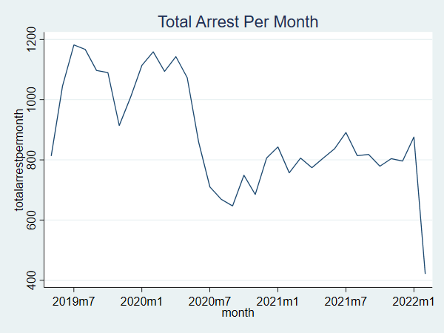

# Arrest per month per sector

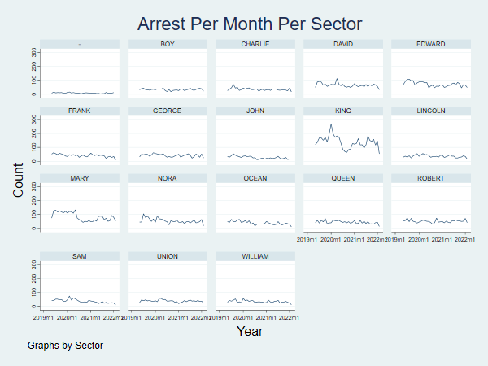

# Unique officers per month

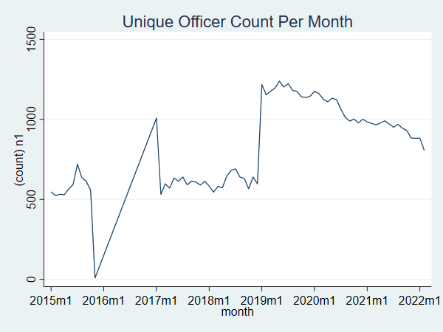

# Unique officers per month per precincts

I see some officers in differeent precincts within the same months. Latent Print Examiners, Evidence Warehousers, Photographers, Equipment and Facilities Coordinators and many more cater to more than one precincts. So, I restrict my data to include only Police Officers, Police Reserve Officers, Probation Officers, and Police Student Officers.

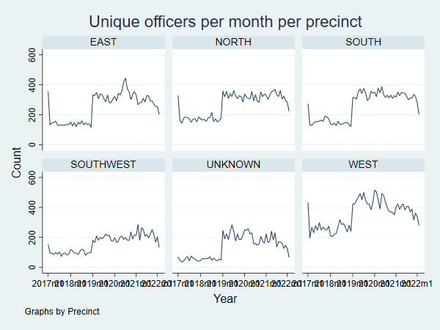

# Officer Quit per Month

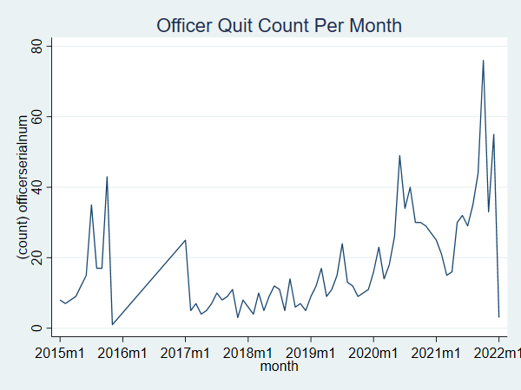

# Officer Quit per Month per Precinct

I see some officers in differeent precincts within the same months. Latent Print Examiners, Evidence Warehousers, Photographers, Equipment and Facilities Coordinators and many more cater to more than one precincts. So, I restrict my data to include only Police Officers, Police Reserve Officers, Probation Officers, and Police Student Officers.

