1.

ID: 001

Author: Victor

Assigned To: Developer

Summary: Error 400(Bad request) on page after sending a message and refreshing "Contact us" page

Description: In the Mozilla browser on the Contact page after sending a message and refreshing the page, error

Step to reproduce:

1)Open the site http://automationpractice.com/index.php

2) Click [Contact us] button in the navigation bar

3) Fill in all required fields with valid data

4) Click [Send] button

5) After successfully sent refresh page and agree with browser pop up

Actual results: 400 error on the browser page

Expected results: After refreshing the page, the user expects to see the message "Message sent successfully"

Priority: Middle

Severity: Critical

Platform: Windows 10 64x, Firefox 85.0.2 (64-битный)

Attachment:

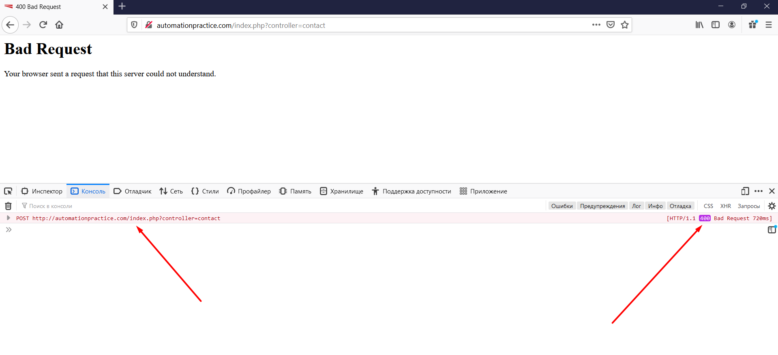

2.

ID: 002

Author: Victor

Assigned To: Developer

Summary: 403 error after using "Sort by" function on "Women" page

Description: 403 error after sorting items by any method

Steps:

1)Open the site http://automationpractice.com/index.php

2) Click [Women] tab

3) Scroll down page

4) Choose sorting method «Price: lowest first»

Actual results: 403 error in console and loading on page

Expected results: Sorting was successful, items are sorted in ascending order

Severity: **Blocker**

Priority: **High**

Platform: Windows 10 64x, Firefox 85.0.2 (64-битный)

Attachment:

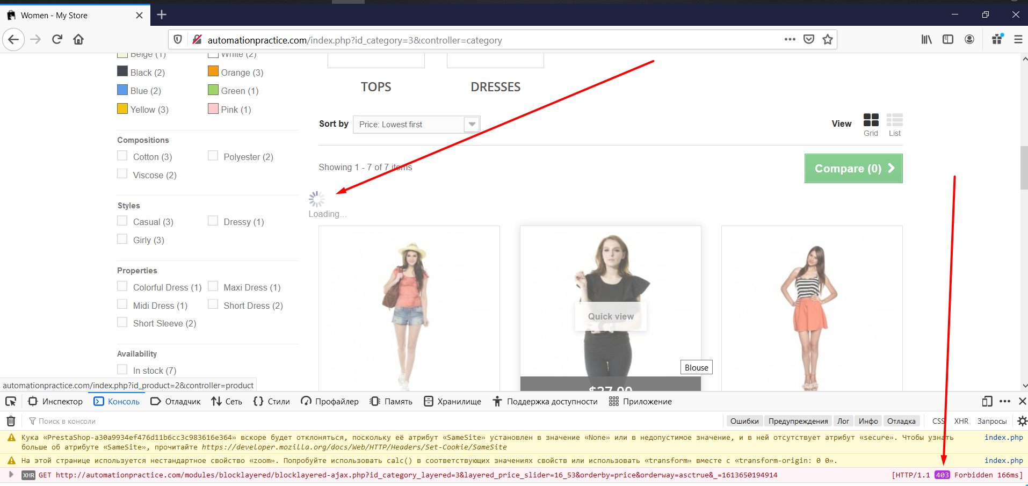

3.

ID: 003

Author: Victor

Assigned To: Developer

Summary: 403 error after clicking on the filter checkbox on the left side bar on the "Women" page

Description: 403 console error and loading bar after selecting any checkbox on the left side bar

Steps:

1) Open the site http://automationpractice.com/index.php

2) Click [Women] tab

3) Scroll down page

4) Choose any checkbox filter on the left side bar

Actual results: 403 error in console and loading on page

Expected results: Sorting was successful

Severity: **Blocker**

Priority: **High**

Platform: Windows 10 64x, Firefox 85.0.2 (64-битный)

Attachment:

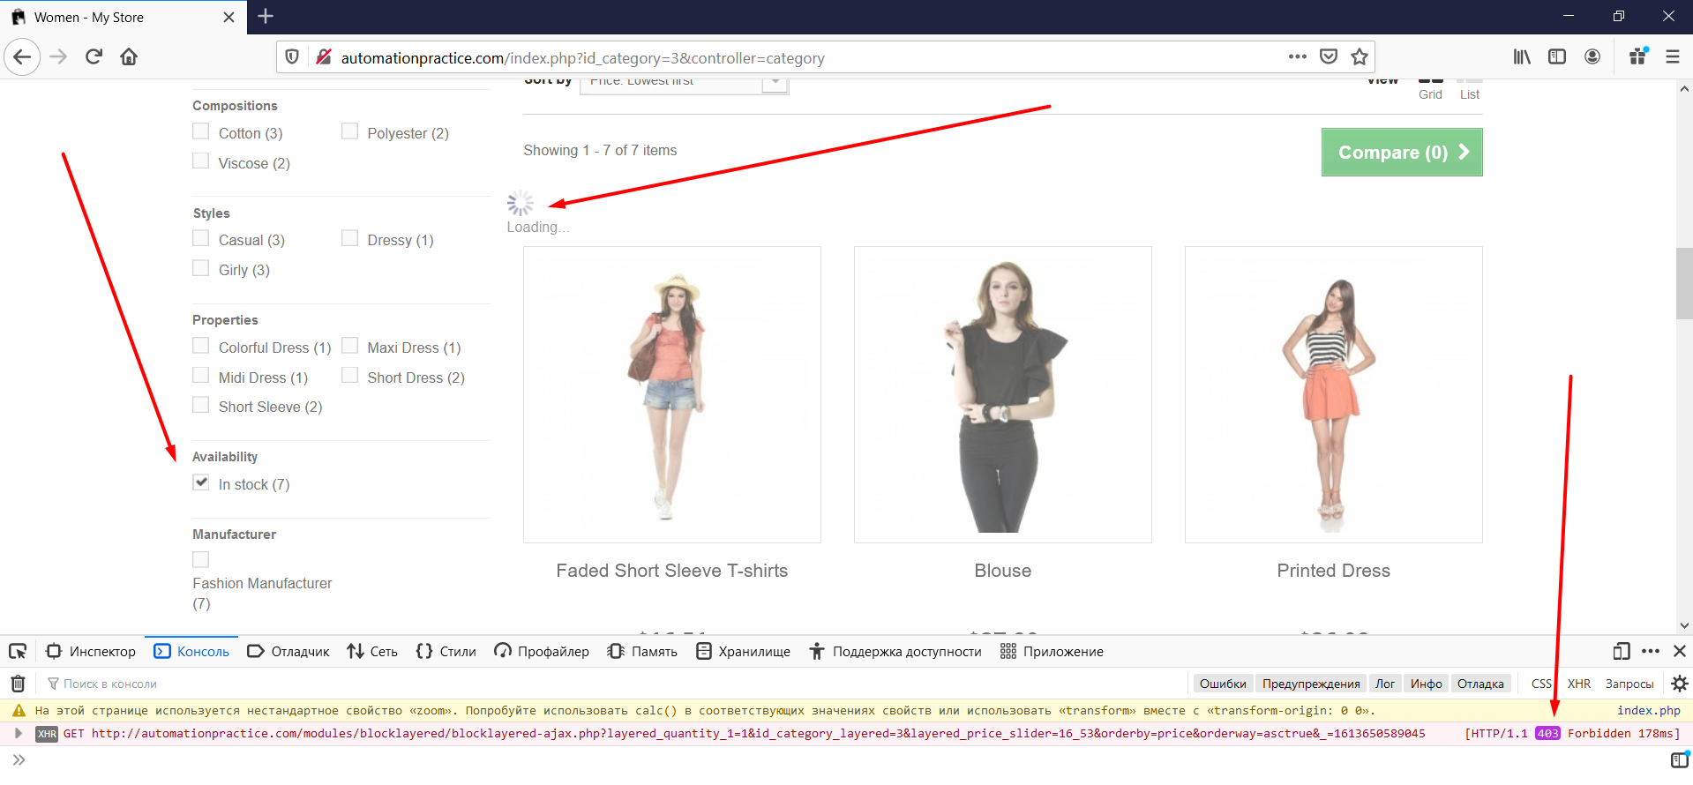

4.

ID: 004

Author: Victor

Assigned To: Developer

Summary: Nothing happens after sorting in ascending order on the "Best Sellers" page

Description: Sorting by price on the "Best Sellers" page does not work (From decreasing to increasing after from increasing to decreasing)

Steps:

1) Open the site http://automationpractice.com/index.php

2) Scroll down page to footer

3) Click on the [Best Sellers] button

4)Click on dropdown Sort by «Price: highest first»

5) Click on dropdown Sort by «Price: lowest first»

Actual results: Not sorted in ascending order after sorting in descending order

Expected results: The user expects the product to be sorted in ascending order

Severity: **Critical**

Priority: **High**

Platform: Windows 10 64x, Firefox 85.0.2 (64-битный)

Attachment:

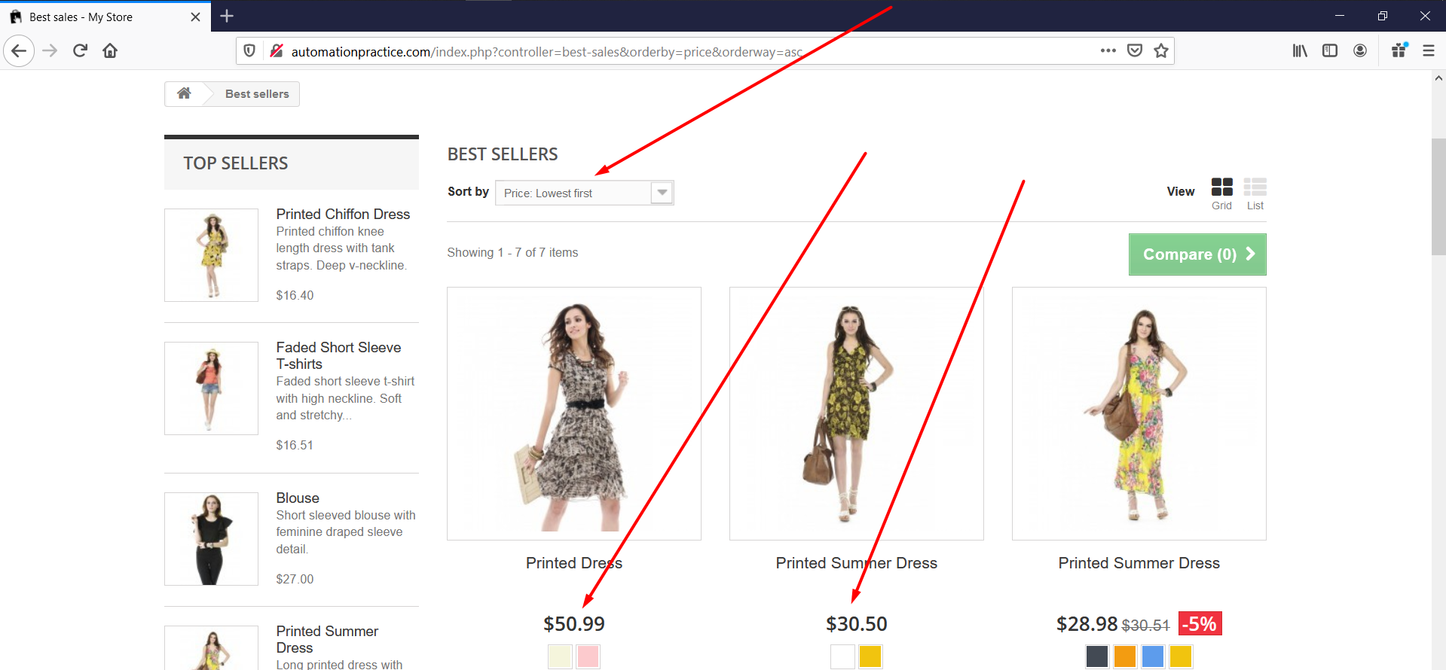

5.

ID: 005

Author: Victor

Assigned To: Developer

Summary: Nothing happens after clicking on the «Add to Compare» button

Description: Unknown product added to group «Product comparison» when the screen width is less than 767px

Steps:

1) Open the site http://automationpractice.com/index.php

2) Scroll down page to footer

3) Click [Best Sellers] button

4)Click [Add to Compare] button on any item of product

Actual results: Nothing happens after clicking on the «Add to Compare» button

Expected results: The modal window "Product added for comparison" is displayed and the button changes its name to "Remove from comparison"

Priority: **middle**

Severity: **Major**

Platform: Windows 10 64x, Firefox 85.0.2 (64-битный)

Attachment:

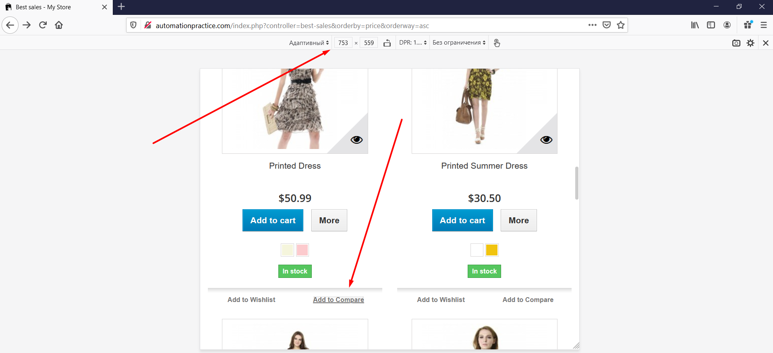

6.

ID: 006

Author: Victor

Assigned To: Developer

Summary: The latest product is returned to Product comparison after page refresh.

Description: After deleting the last product and the comparison page and refreshing the page, the product appears back

Steps:

1) Open the site http://automationpractice.com/index.php

2) Scroll down page to footer

3) Click [Best Sellers] button

4)Click [Add to Compare] button on any item of product

5)Click [Compare(1)] button

6)Click [Remove] button on this item of product

7)Refresh page

Actual results: the deleted item is restored back

Expected results: Page Product comparison is empty

Priority: **middle**

Severity: **Major**

Platform: Windows 10 64x, Firefox 85.0.2 (64-битный)

Attachment:

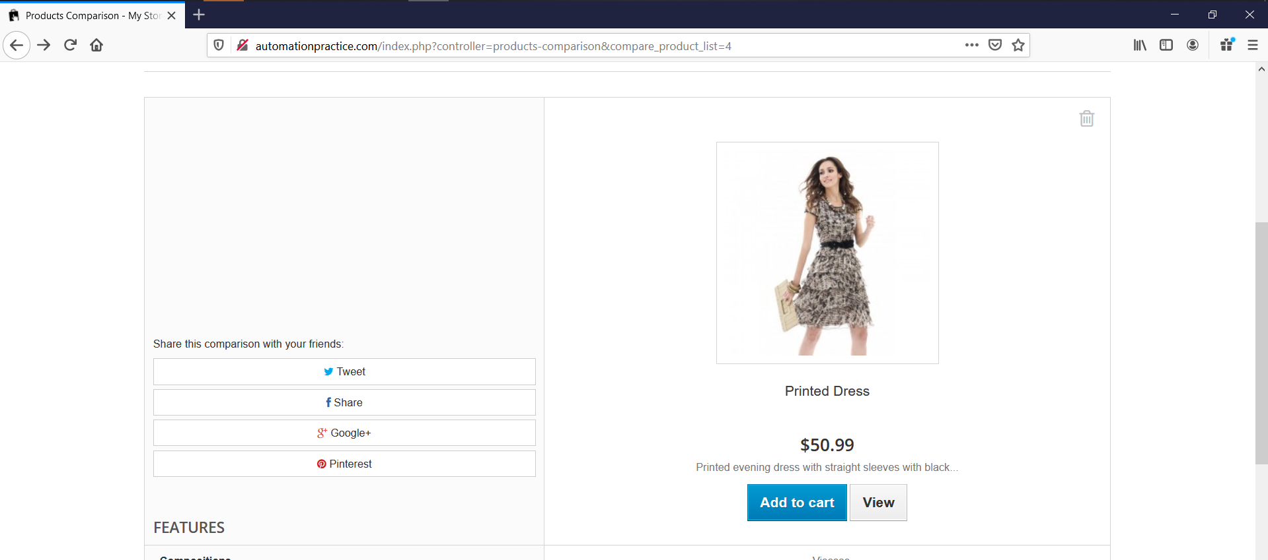

7.

ID: 007

Author: Victor

Assigned To: Developer

Summary: The page is refreshed after clicking on the "Get savings now" button

Description: The page will be updated when you click on the "Get savings now" button on any page of the site

Steps:

1) Open the site http://automationpractice.com/index.php

2) Click [Contact us] button

3) Click [Get products] button

Actual results: The page is updated

Expected results: The user is expecting to go to the discount page

Priority: **middle**

Severity: **Major**

Platform: Windows 10 64x, Firefox 85.0.2 (64-битный)

Attachment: 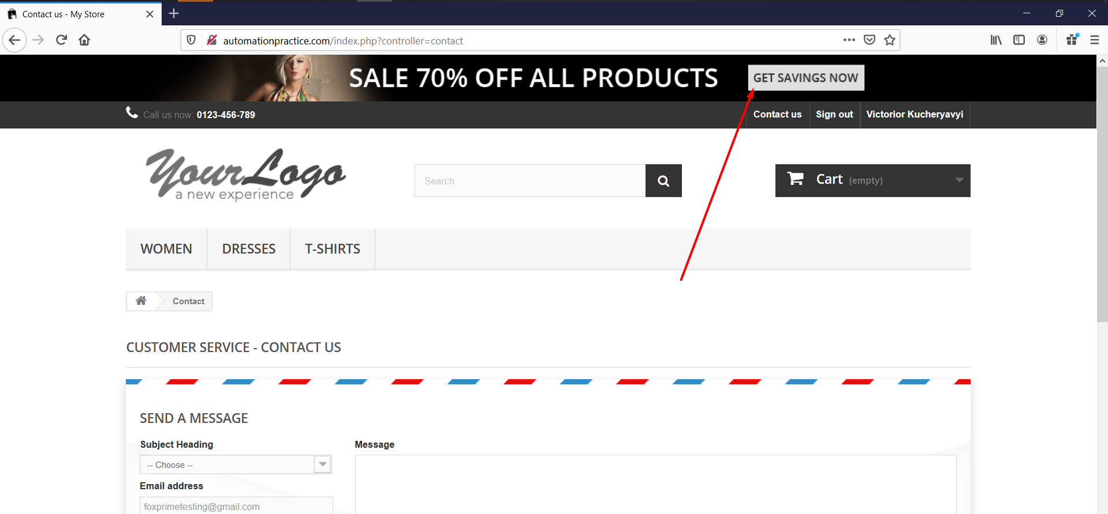

8.

ID: 008

Author: Victor

Assigned To: Developer

Summary: Possible to enter Cyrillic characters in the registration Email field

Description: Successful validation of the registration field after entering the Cyrillic alphabet in the registration Email field

Steps:

1) Open the site http://automationpractice.com/index.php

2) Click [Sign in] button

3) Fill the [Email address] field Cyrillic symbols

4)Click [Create an account] button

Actual results: Transfer to the next user registration page

Expected results: Field validation error

Priority: **middle**

Severity: **Major**

Platform: Windows 10 64x, Firefox 85.0.2 (64-битный)

Attachment:

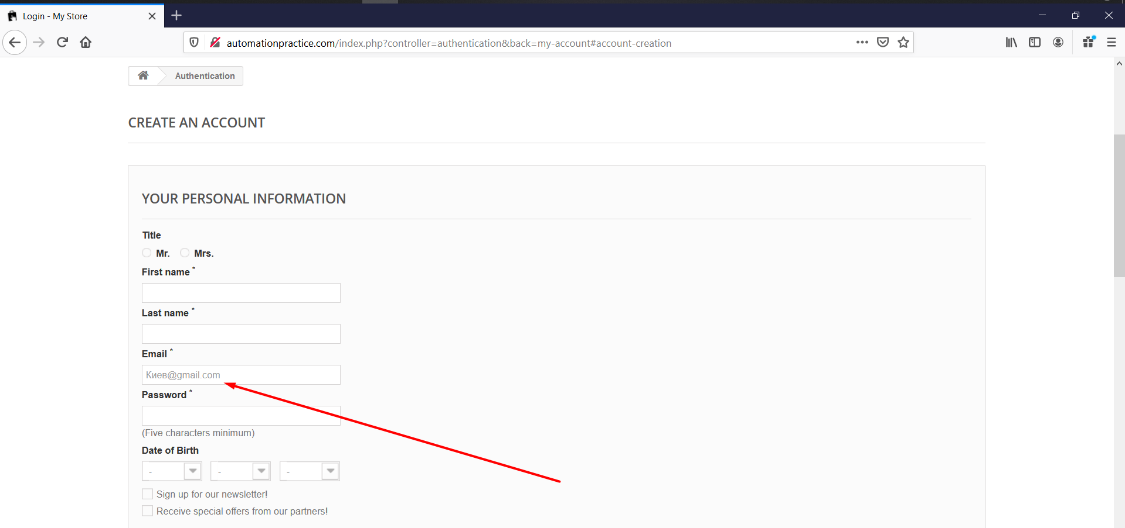

9.

ID: 009

Author: Victor

Assigned To: Developer

Summary: Possible to enter «..» characters in the registration Email field

Description: Successful validation of the registration field after entering «..» in the registration Email field

Steps:

1) Open the site http://automationpractice.com/index.php

2) Click [Sign in] button

3) Fill the [qwerty..@gmail.com] in Email field

4)Click [Create an account] button

Actual results: Transfer to the next user registration page

Expected results: Field validation error

Priority: **middle**

Severity: **Major**

Platform: Windows 10 64x, Firefox 85.0.2 (64-битный)

Attachment:

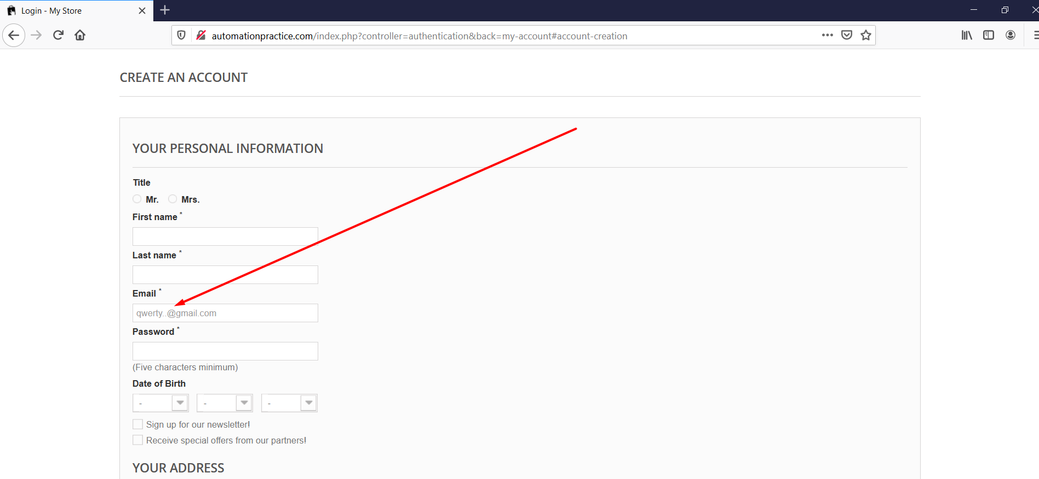

10.

ID: 010

Author: Victor

Assigned To: Developer

Summary: Button «Send this wishlist» disappears after double-clicking.

Description: The button «Send this wishlist» after the first click increases, after the second it disappears and does not copy the Permalink

Steps:

1) Open the site http://automationpractice.com/index.php

2) Login to your personal account

3) Add any item to your wishlist

4)Open wishlist

5)Double click [Send this wishlist] button

Actual results: The button disappears and the Mail box appears at the bottom of the page, where you can send the wishlist.

Expected results: The link is copied to the clipboard after the first click on the button, the link is copied to the clipboard

Priority: **middle**

Severity: **Major**

Platform: Windows 10 64x, Firefox 85.0.2 (64-битный)

Attachment:

