Name: Victor Kai Hong Wong

Student ID# : 156340200

Email : vwong75@myseneca.ca

Section : NKK

Success - Bootstrap

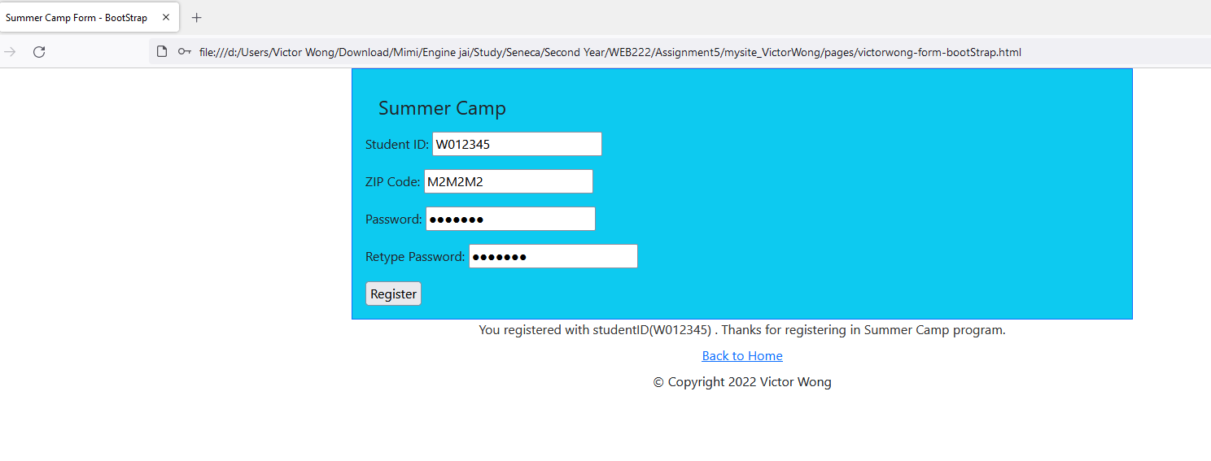

Fail – Bootstrap

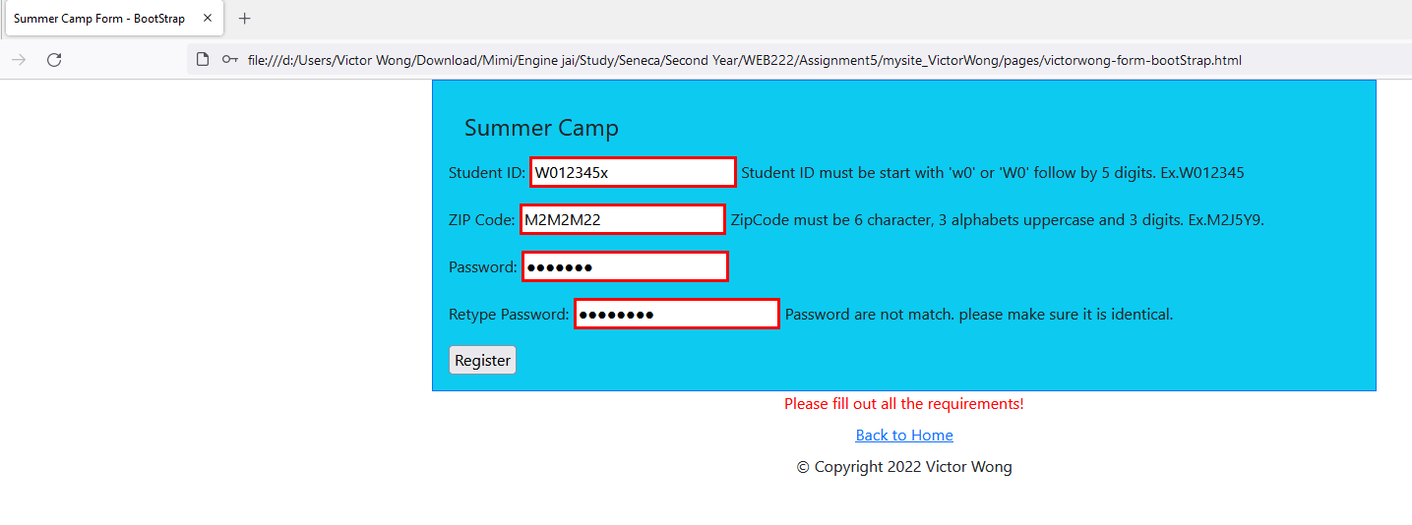

Success – Form

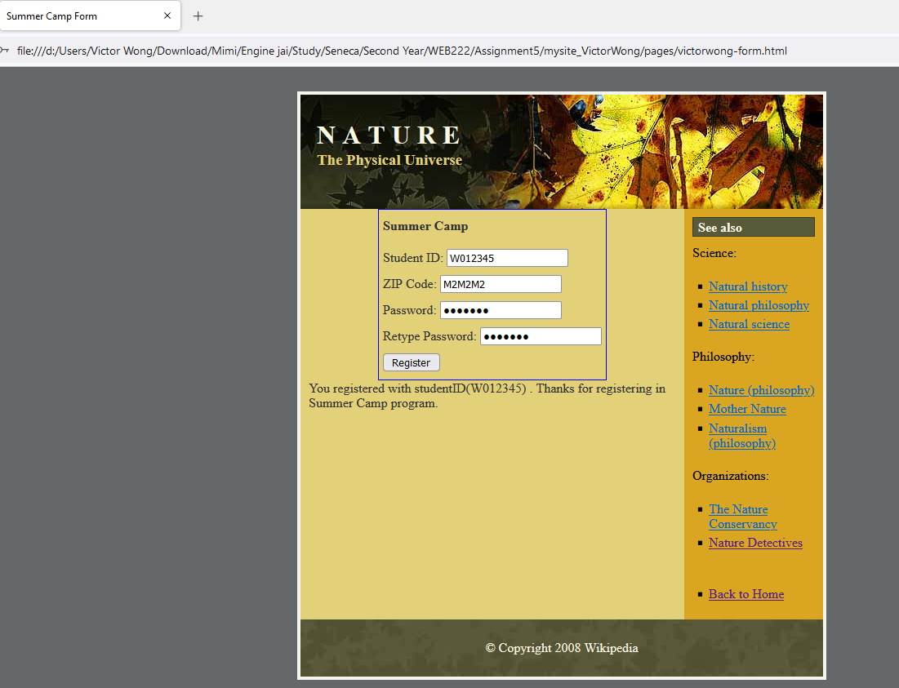

Fail – Form

