|  |
| --- |
| School of Software Design & Data Science |
| **Web Project** |
| Web222 - Project |
|  |
| **Group Member name**  **Name: Victor Wong**  **Student ID: 156340200**  **Name: Ke An Lo  Student ID: 168972214**  **Submission Date** |
| **12/11/2022** |

|  |
| --- |
| This document explains how to build a website …………………………. |

Table of Contents

Task 1: 2

Task 2: 3

Task 3: 4

Task 4: 5

Task 5: 6

Summary 7

# Task 1:

(Describe Your Store and Product/Service Inventory, Modelling your Store Data )

We store our information dynamically in the JavaScript file called product.js. Using window.example to make it globally access (instead of using export function, we tired and did not work). After that, we are using app,js to execute our code to print out the correct data in the HTML file. We are using DOM creating element and insert out data using innerHTML.

# Task 2:

(Describe the major steps for implementing Web Site Layout, draw some wireframe and sitemap, how to choose layouting tech (bootstrap, grid,…), add some screenshots of the output)

So we are focus on using HTML CSS and JavaScript on the website. The Contact page we are using bootstrap to understand how to utilize it. The other pages contains using grid, flex, and also some position CSS. We are also using Google Fonts, jQuery, Font awesome and some other small applications.

General Output:

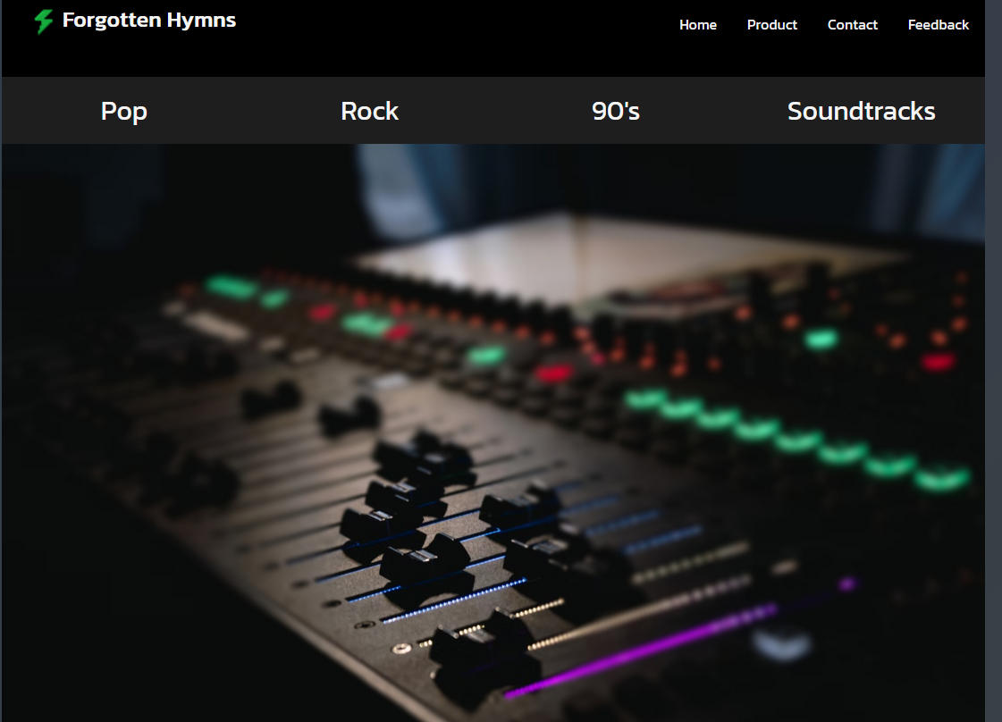

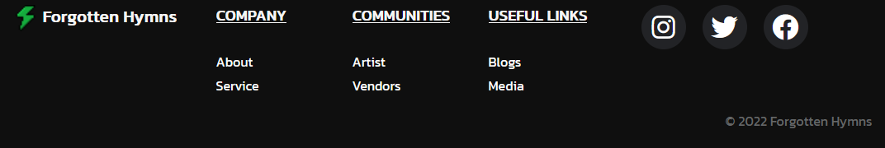

WireFrame:

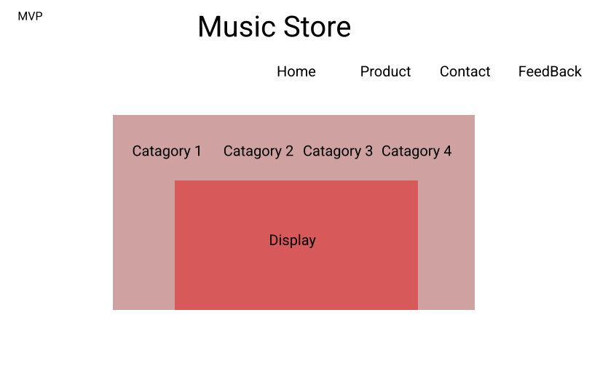

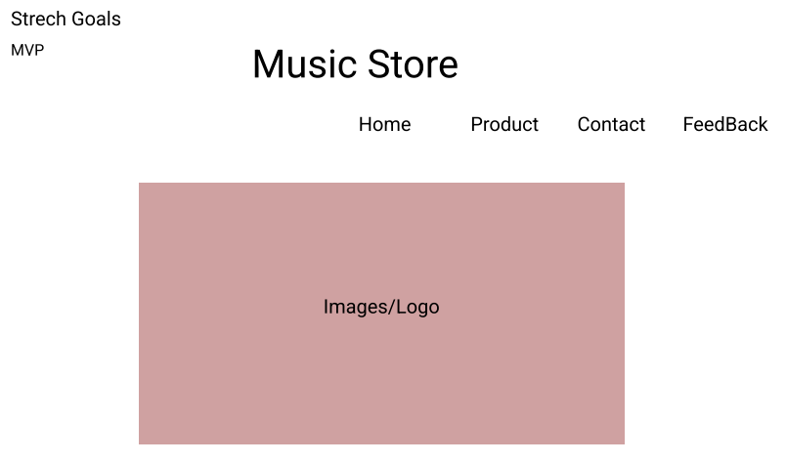

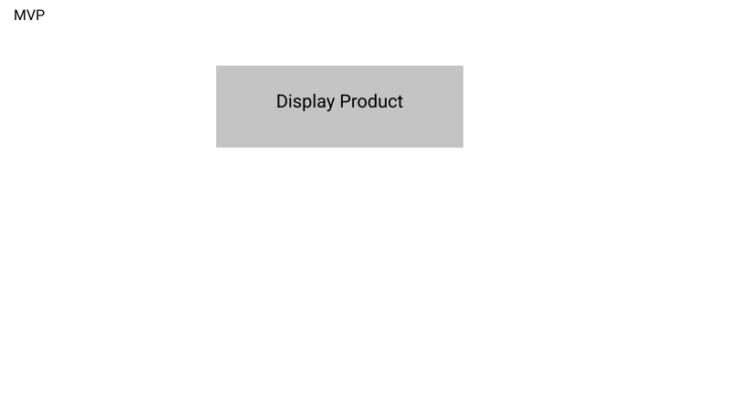

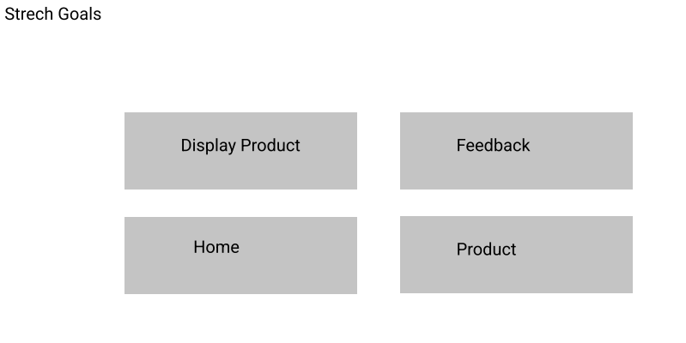

# Task 3:

(Describe the major steps for designing the Dynamic Content using JS, How to display JS aaray data in form of Cards, add some screenshots of the output)

So what we have done is in the HTML we called the function onclick, when user click the specific category, we pass in the parameters to identify the correct sets of category. For example, createProductCard(product) and product will find out which one is targeting. After that, we extract our data from product.js (Array part) and print out the information that we want using a for loop.

# Task 4:

(Describe the major steps for deploying the web project in Hosting services like Netlify or Vercel, add some screenshots of the output)

We are using the GitHub upload. We create a GitHub page and upload our website into it. Mostly because it is free and we own an account to modify the changes in to it later.

Link:  
<https://github.com/VictorKwong/WEB222-Project>  
<https://victorkwong.github.io/WEB222-Project/>  
GitHub:

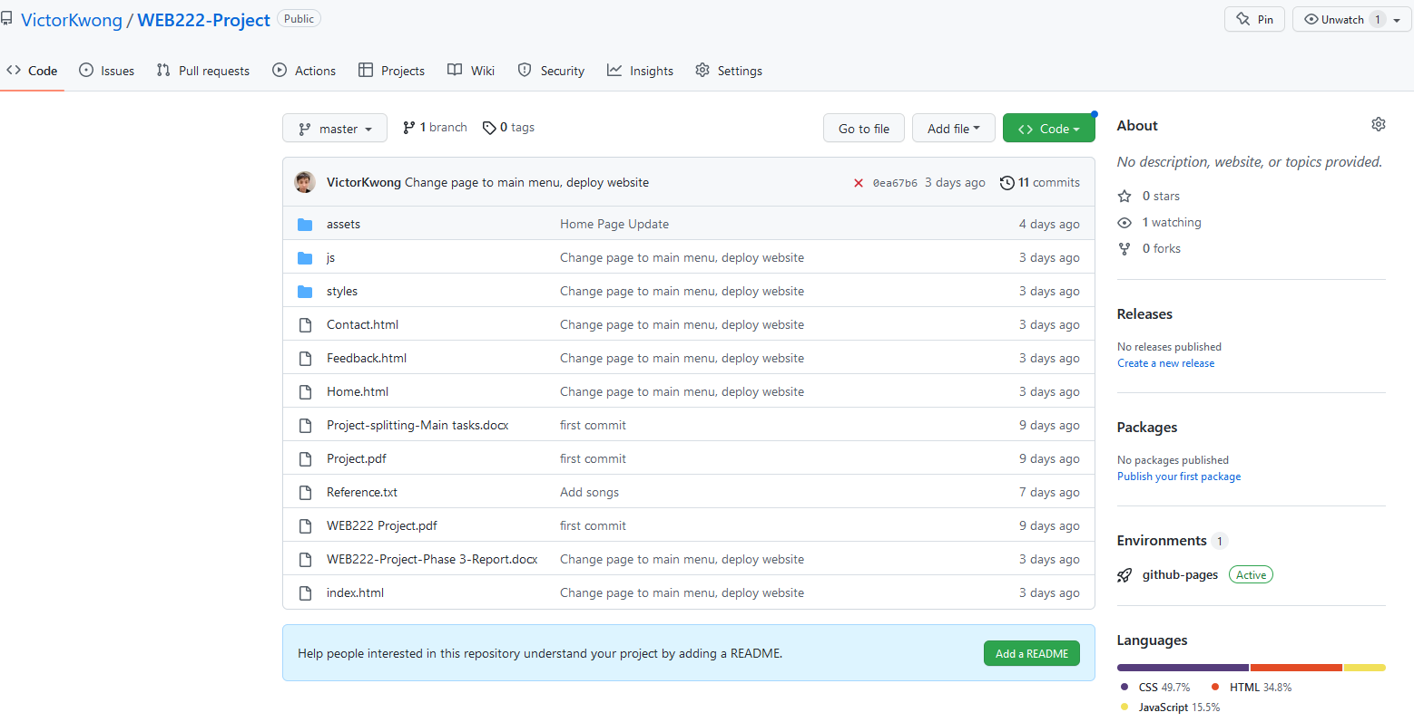

Output Page:

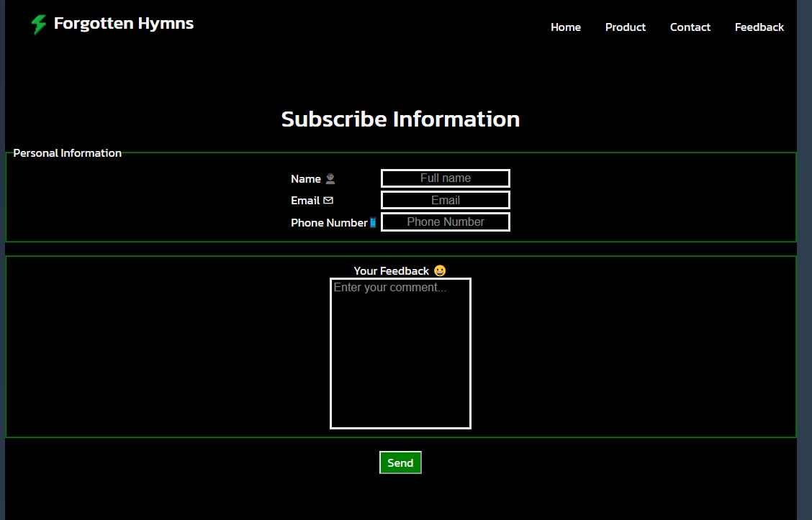

# Task 5:

(Describe the major steps for implementing bonus questions or any additional/creative functionalities!)

Our Bonus will be responsive design + the bootstrap using on one page. We are applying the responsive design using CSS layout. (Targeting phone size, and original size 1100px), and bootstrap implementation like providing a link on the top of the Header.

    <link *href*="https://cdn.jsdelivr.net/npm/bootstrap@5.2.3/dist/css/bootstrap.min.css" *rel*="stylesheet" *integrity*="sha384-rbsA2VBKQhggwzxH7pPCaAqO46MgnOM80zW1RWuH61DGLwZJEdK2Kadq2F9CUG65" *crossorigin*="anonymous">

# Summary

(Describe how did you divide the work, share your feedback about this project like new points that you learn, challenges, …)

We divide our work into smaller pieces, a person will work on the small parts of HTML and CSS. After we finished, we combine our work together into bigger picture, and find out if there is any conflict in our code. The challenges will be taking care of each other group member time schedule in order to make our project work out. We have learnt how to provide a website into live server, and debugging process during the project phase.