Site test keyboard:

<https://colemakmods.github.io/mod-dh/analyze.html>

<https://stevep99.github.io/keyboard-layout-analyzer/>

Colemak-dh, sfb = 1.64.

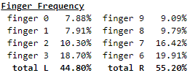

1 2 3 4 5 6 7 8 9 0 - =

q w f p b j l u y ; [ ]

a r s t g m n e i o '

x c d v z k h , . /

MTGAP, sfb = 1.29.

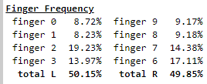

MTGAP 2.0, sfb = 1.57.

, f h d k j c u l .

o a n t g m s e r i

x b p z q y w ' v ;

Niro, sfb 1.61.

1 2 3 4 5 6 7 8 9 0 - =

q w u d p j f y l ; [ ]

a s e t g h n i r o '

c x v b z k m , . /

Aptv3, sfb = 1.40

w g d f b q l u o y

r s t h k j n e a i ;

c m p v x z , . ' /

HD neu, sfb = 1.12.

w f m p v / . q " ` z

r s n t b , a e i h j

c l d g x - u o y k

HD alt, sfb = 1.49

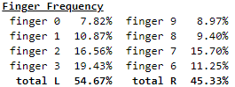

w c h f v / y u j q

r s n t g k i e o a

m l d b x z p ' , .

HD ref, sfb = 0.95

q c h p v k y o j /

r s n t g w u e i a

m l d b x z f ' , .

Sertain, nerts, nerps:

<https://www.reddit.com/r/KeyboardLayouts/comments/tpwyjc/sertain_nerts_nerps_low_redirect_low_sfb_low/>

Sertain, sfb = 0.87.

x l d k v z w o u ;

s r t n f g y e i a

j m h b q p c ' , .

Nerts, sfb = 1.0.

p l d v x z k o u ;

n r t s g y h e i a

j m c w q b f ' , .

Nerps, sfb = 1.12.

x l d p v z k o u ;

n r t s g y h e i a

j m c w q b f ' , .

Graphite (comentário no post do nerts), sfb = 1.08.

Alterações: Z com V e ‘ com K

b l d w z ' f o u j ; =

n r t s g y h a e i ,

q x m c v k p . - /

Maya (pequena variação do teclado acima), sfb = 0.91.

Alterações: J com K por causa do VIM e para português é um pouco melhor. Y com P é bem melhor por causa de português

b l d g q j f o u ,

n r t s v k h a e i

x m c w z p y ' / .