PROJECT REPORT
ON
BANK MANAGEMENT SYSTEM
(Object-Oriented Programming Using C++)

Submitted in partial fulfilment of the requirements for
OBJECT-ORIENTED PROGRAMMING USING C++

Submitted by
Victor Levine Chirenga
UID: 25BSC10051

Under the guidance of
Mr. Arvinder Singh

CHANDIGARH UNIVERSITY
2026

CERTIFICATE
This is to certify that the project report entitled “BANK MANAGEMENT SYSTEM”, submitted by Houssam Mohammed (UID: 25BSC10051), is a bona fide record of work carried out as part of the academic study of Object-Oriented Programming Using C++ at Chandigarh University.
The project demonstrates the application of fundamental C++ programming concepts, including classes, objects, encapsulation, constructors, functions, conditional statements, loops, and file handling. The work has been prepared for academic learning and demonstration purposes.
To the best of my knowledge, the work presented in this report is suitable for submission as a course project, subject to the evaluation and approval of the concerned faculty.

Project Guide | Head of Department
Mr. Arvinder Singh  Signature: __________________  Date: __________________ | Signature: __________________  Date: __________________
Place: Chandigarh University
Academic Year: 2026

DECLARATION
I, Victor Levine Chirenga , UID 25BSC10051, hereby declare that the project report entitled “Bank Management System” has been prepared by me for academic purposes as part of the study of Object-Oriented Programming Using C++ at Chandigarh University.
I confirm that this report represents my understanding of the problem, the design approach, and the C++ implementation described in the following pages. Wherever ideas, concepts, or technical information from books and learning resources have been used, they have been acknowledged in the References section.
I understand that this project is an educational prototype. It is not connected to a real bank, does not process actual payments, and must not be used to store real customer or financial information.

Student Name: Victor Levine Chirenga
UID: 25BSC10051
Signature: ____________________________
Date: ____________________________

ACKNOWLEDGEMENT
I would like to express my sincere gratitude to Chandigarh University for providing the academic environment and learning resources required to complete this project.
I am thankful to my project guide, Mr. Arvinder Singh, for his guidance and for helping me understand how programming concepts can be applied to a practical problem. His support has been valuable in shaping the design and implementation of this Bank Management System.
I also thank the faculty members and classmates who shared suggestions and learning support during the development of this project. Finally, I am grateful to my family for their encouragement and motivation.
This project has helped me improve my understanding of C++ programming, problem-solving, program structure, and the importance of designing software in a clear and systematic way.

Victor Levine Chirenga
UID: 25BSC10051

ABSTRACT
The Bank Management System is a console-based application developed using the C++ programming language. The main purpose of the project is to demonstrate how a simple banking workflow can be represented through a structured computer program. The system provides basic operations such as creating a customer account, depositing money, withdrawing money, checking account details, and displaying account information.
The project applies Object-Oriented Programming (OOP) principles to organize data and functions into a class. An account object stores information such as account number, customer name, account type, and balance. Member functions perform operations while applying basic validation rules. This approach improves code organization and makes the program easier to understand and extend.
The prototype uses a menu-driven interface so that a user can select an operation from a list. It is designed for learning and demonstration, not for real banking. A production banking application would require secure authentication, encrypted storage, transaction logging, database integration, audit controls, regulatory compliance, and professional security testing.

Keywords
C++, Object-Oriented Programming, Bank Management System, Class, Object, Encapsulation, Deposit, Withdrawal, Account Balance, File Handling.

TABLE OF CONTENTS
No. | Chapter / Section | Page
1 | Introduction | 7
2 | Problem Statement, Objectives and Scope | 8
3 | Feasibility Study and Requirements | 9
4 | System Design and Architecture | 10
5 | Object-Oriented Programming Concepts | 11
6 | System Modules and Functionalities | 12
7 | Algorithm and Program Flow | 13
8 | C++ Implementation – Part I | 14
9 | C++ Implementation – Part II | 15
10 | User Interface and Sample Output | 16
11 | Testing and Validation | 17
12 | Advantages, Limitations and Security | 18
13 | Future Enhancements | 19
14 | Conclusion and References | 20
Note: Page numbers are indicative and correspond to the planned report structure. If the document is edited, update the table of contents and page references before final printing.

1. INTRODUCTION

1.1 Background
Banks provide essential financial services such as accepting deposits, maintaining customer accounts, and allowing customers to withdraw or transfer funds. These activities involve large amounts of information and must be performed accurately. Computer-based information systems help organizations manage records and perform repetitive operations in a consistent manner.

1.2 Project Overview
The Bank Management System presented in this report is a small educational model of selected banking activities. It is implemented as a menu-driven C++ console application. The program allows a user to create an account and perform simple operations on the account during execution.

1.3 Need for the Project
A small project is useful for understanding how real-world requirements can be converted into program logic. It connects programming topics learned in class with a familiar application. It also provides practice in input validation, data organization, modular functions, and testing.

1.4 Intended Users
- Students learning C++ and Object-Oriented Programming.
- Teachers or evaluators reviewing a basic programming project.
- Users who want to understand a simplified account-management workflow.

1.5 Project Boundary
The project demonstrates basic account operations only. It does not connect to a bank network, verify identity, handle interest calculations, or execute real financial transactions.

2. PROBLEM STATEMENT, OBJECTIVES AND SCOPE

2.1 Problem Statement
Manual handling of account information can become confusing when records are not organized. A beginner-level software model can demonstrate how customer and account data may be structured and how common operations can be performed through a controlled interface.

2.2 Main Objectives
- To design a simple menu-driven Bank Management System using C++.
- To represent a bank account through a class and an object.
- To implement account creation, deposit, withdrawal, and balance enquiry.
- To apply encapsulation by keeping account data within a class.
- To validate user input and prevent invalid transactions.
- To improve programming, debugging, and documentation skills.

2.3 Scope
The scope is limited to one account object during a program run in the basic implementation. The system can be extended to support multiple accounts and permanent storage. The report includes a proposed file-handling extension as a future improvement.

2.4 Assumptions
- The user enters numeric values when the program requests an amount.
- The account number is entered as a positive integer.
- Deposits must be greater than zero.
- Withdrawals cannot exceed the available balance.
- The prototype is used only with fictional sample data.

3. FEASIBILITY STUDY AND REQUIREMENTS

3.1 Technical Feasibility
The project can be developed using a standard C++ compiler such as GCC, MinGW, or an IDE that supports C++. It requires no special hardware, network connection, or paid software. A basic computer with a keyboard and a console terminal is sufficient.

3.2 Economic Feasibility
The prototype has very low development cost because the programming language, compiler, and common development tools are available in free distributions. The main cost is the time required for learning, coding, testing, and documentation.

3.3 Operational Feasibility
The menu-driven interface is straightforward. Users select an operation by entering a menu number and then provide the requested information. Clear messages guide the user when an operation succeeds or when an invalid value is entered.

3.4 Hardware Requirements
- Computer or laptop with a keyboard and display.
- At least 2 GB RAM recommended for a basic C++ development environment.
- A small amount of free disk space for source files and compiler tools.

3.5 Software Requirements
- Operating System: Windows, Linux, or macOS.
- Language: C++ (C++11 or later recommended).
- Compiler: GCC / MinGW / Clang or a compatible IDE.
- Editor or IDE: Visual Studio Code, Code::Blocks, or Visual Studio.

3.6 Functional and Non-Functional Requirements
Functional requirements define the operations the application must perform: create an account, deposit, withdraw, view account details, and exit. Non-functional requirements include clarity, reliability for valid inputs, maintainability, portability, and ease of use.

4. SYSTEM DESIGN AND ARCHITECTURE

4.1 Design Approach
The application follows a simple class-based design. The Account class contains account data and the functions that operate on that data. The main() function creates an object and displays the menu. The selected menu option calls the corresponding member function.

4.2 High-Level Architecture
USER
↓
MENU-DRIVEN MAIN PROGRAM
↓
ACCOUNT OBJECT
↓
Create Account | Deposit | Withdraw | Display Details
↓
VALIDATION AND RESULT MESSAGE

4.3 Data Design
Field | Data Type | Purpose
Account number | Integer | Unique identifier for the demo account
Customer name | String | Name of the account holder
Account type | String | Savings or Current
Balance | Double | Current amount in the account

4.4 Input–Process–Output
Input: account details, menu choice, and transaction amount. Process: validate the input, update the account balance when permitted, and prepare a result. Output: confirmation messages, account details, or an error message.

4.5 Design Considerations
The design keeps the program small and readable. Data members are private to protect them from direct modification. Public member functions provide controlled access to account operations.

5. OBJECT-ORIENTED PROGRAMMING CONCEPTS

5.1 Class and Object
A class is a user-defined data type that groups data members and member functions. In this project, Account is the class. An object of Account represents a particular account and stores its account number, holder name, type, and balance.

5.2 Encapsulation
Encapsulation combines data and related functions in one unit and restricts direct access to internal data. The account data members are declared private. Public functions such as deposit(), withdraw(), and display() provide controlled operations.

5.3 Abstraction
Abstraction means showing essential operations while hiding internal implementation details. A user selects Deposit or Withdraw without needing to know how the balance is stored or updated.

5.4 Constructors
A constructor is a special member function that is called when an object is created. It can initialize data members so that the object begins in a known state. The example below initializes the balance to zero.
Account() {
accountNumber = 0;
accountType = "Not Set";
balance = 0.0;
}

5.5 Member Functions
Member functions define the behaviour of an object. This project uses functions to create an account, add money, withdraw money, and display information.

5.6 Reusability and Maintainability
Organizing code in a class makes it easier to reuse the Account design and add more functions later. For example, a future version can add multiple accounts, transaction history, or file storage.

6. SYSTEM MODULES AND FUNCTIONALITIES

Account Creation
Accepts an account number, customer name, and account type. It initializes the account balance to zero.

Deposit
Accepts an amount and adds it to the balance only if the amount is positive.

Withdrawal
Accepts an amount and subtracts it only when it is positive and does not exceed the available balance.

Balance Enquiry
Displays the current balance without changing account information.

Account Details
Displays account number, customer name, account type, and balance.

Exit
Terminates the program in a controlled manner.

6.1 Validation Rules
- Account number must be a positive integer.
- Customer name must not be left blank.
- Deposit amount must be greater than zero.
- Withdrawal amount must be greater than zero.
- Withdrawal amount must not be greater than the current balance.

6.2 Error Handling
The program displays a clear message when an account has not yet been created or when an entered amount is invalid. A production version should also handle non-numeric input, input stream failures, and unexpected termination more comprehensively.

7. ALGORITHM AND PROGRAM FLOW

7.1 Main Algorithm
- Start the program.
- Create an Account object.
- Display the main menu.
- Read the user's menu choice.
- If the choice is Create Account, collect and validate account information.
- If the choice is Deposit, read the amount and update the balance when valid.
- If the choice is Withdraw, check the amount and available balance before updating.
- If the choice is Display, show account details and current balance.
- If the choice is Exit, terminate the program.
- Otherwise, display an invalid-choice message and return to the menu.

7.2 Deposit Algorithm
Step 1: Read the deposit amount. Step 2: Check whether the amount is greater than zero. Step 3: If valid, add it to the balance and display the updated balance. Step 4: Otherwise, show an error message.

7.3 Withdrawal Algorithm
Step 1: Read the withdrawal amount. Step 2: Check that it is greater than zero. Step 3: Compare it with the available balance. Step 4: If sufficient funds exist, subtract the amount. Step 5: Otherwise, reject the transaction and display the reason.

7.4 Flow Description
The program repeatedly displays the menu until the user selects Exit. Each menu option calls one operation. After the operation is completed, control returns to the menu so that the user can perform another task.

8. C++ IMPLEMENTATION – PART I
The following source code shows the class definition and the core account operations. It is a compact educational implementation. The code can be copied into a file named bank_management.cpp and compiled using a C++ compiler.
#include <iostream>
#include <string>
#include <iomanip>
using namespace std;

class Account {
private:
int accountNumber;
string holderName;
string accountType;
double balance;
bool created;

public:
Account() {
accountNumber = 0;
holderName = "";
accountType = "";
balance = 0.0;
created = false;
}

void createAccount() {
cout << "\nEnter account number: ";
cin >> accountNumber;
cin.ignore();

cout << "Enter customer name: ";
getline(cin, holderName);

cout << "Enter account type (Savings/Current): ";
getline(cin, accountType);

if (accountNumber > 0 && !holderName.empty()) {
balance = 0.0;
created = true;
cout << "Account created successfully.\\n";
} else {
created = false;
cout << "Invalid account information.\\n";
}
}

void deposit() {
if (!created) {
cout << "Please create an account first.\\n";
return;
}

double amount;
cout << "Enter deposit amount: ";
cin >> amount;

if (amount > 0) {
balance += amount;
cout << "Deposit successful.\\n";
} else {
cout << "Amount must be greater than zero.\\n";
}
}

The private section protects account information. The public section exposes only the operations required by the menu. The created flag indicates whether account details have been entered successfully.

9. C++ IMPLEMENTATION – PART II
void withdraw() {
if (!created) {
cout << "Please create an account first.\\n";
return;
}

double amount;
cout << "Enter withdrawal amount: ";
cin >> amount;

if (amount <= 0) {
cout << "Amount must be greater than zero.\\n";
} else if (amount > balance) {
cout << "Insufficient balance.\\n";
} else {
balance -= amount;
cout << "Withdrawal successful.\\n";
}
}

void display() {
if (!created) {
cout << "No account available.\\n";
return;
}

cout << fixed << setprecision(2);
cout << "\\n--- ACCOUNT DETAILS ---\\n";
cout << "Account Number: " << accountNumber << endl;
cout << "Customer Name: " << holderName << endl;
cout << "Account Type: " << accountType << endl;
cout << "Balance: " << balance << endl;
}
};

int main() {
Account acc;
int choice;

do {
cout << "\\n===== BANK MANAGEMENT SYSTEM =====\\n";
cout << "1. Create Account\\n";
cout << "2. Deposit Money\\n";
cout << "3. Withdraw Money\\n";
cout << "4. Display Account Details\\n";
cout << "5. Exit\\n";
cout << "Enter your choice: ";
cin >> choice;

switch (choice) {
case 1: acc.createAccount(); break;
case 2: acc.deposit(); break;
case 3: acc.withdraw(); break;
case 4: acc.display(); break;
case 5: cout << "Thank you. Goodbye!\\n"; break;
default: cout << "Invalid choice. Try again.\\n";
}
} while (choice != 5);

return 0;
}

9.1 Compilation
Example using GCC: g++ bank_management.cpp -o bank_management. On Windows, run bank_management.exe; on Linux or macOS, run ./bank_management. The exact command may vary depending on the compiler and operating system.

9.2 Implementation Note
This version keeps the account in memory while the program is running. When the program closes, the information is lost. Permanent file or database storage is recommended for an extended version.

10. USER INTERFACE AND SAMPLE OUTPUT
The application uses a text-based menu. The following examples illustrate the expected interaction. They are sample console outputs for documentation and should be replaced with genuine screenshots captured after compiling and running the program if screenshots are required by the instructor.

10.1 Main Menu
===== BANK MANAGEMENT SYSTEM =====
1. Create Account
2. Deposit Money
3. Withdraw Money
4. Display Account Details
5. Exit
Enter your choice: 1

10.2 Account Creation
Enter account number: 1001
Enter customer name: Alex Kumar
Enter account type (Savings/Current): Savings
Account created successfully.

10.3 Deposit Transaction
Enter deposit amount: 5000
Deposit successful.

10.4 Withdrawal Transaction
Enter withdrawal amount: 1200
Withdrawal successful.

10.5 Account Details
--- ACCOUNT DETAILS ---
Account Number: 1001
Customer Name: Alex Kumar
Account Type: Savings
Balance: 3800.00

10.6 Invalid Transaction
Enter withdrawal amount: 9000
Insufficient balance.

The examples use fictional information only. No real customer or banking data should be entered.

11. TESTING AND VALIDATION
Testing checks whether the program behaves according to its requirements. The following test cases describe expected results for the basic implementation.
Test ID | Test Scenario | Input | Expected Result | Evaluation
TC-01 | Create account with valid details | Account number 1001; name Alex | Account created | Pass when confirmed
TC-02 | Deposit positive amount | Deposit 5000 | Balance increases by 5000 | Pass when correct
TC-03 | Deposit zero | Deposit 0 | Amount rejected | Pass when rejected
TC-04 | Withdraw valid amount | Balance 5000; withdraw 1200 | New balance 3800 | Pass when correct
TC-05 | Withdraw above balance | Balance 3800; withdraw 9000 | Insufficient balance | Pass when rejected
TC-06 | Display account | Select display option | Account details shown | Pass when correct
TC-07 | Exit application | Select option 5 | Program terminates | Pass when terminated

11.1 Testing Types
- Unit testing: checking each member function separately.
- Functional testing: confirming that each menu option performs its intended task.
- Boundary testing: checking zero, negative, and unusually large amounts.
- Usability testing: checking that menu labels and messages are understandable.

11.2 Test Result
The listed cases define the expected behaviour of the prototype. Actual results should be recorded after compiling and running the program in the student's environment. Testing should be repeated after any code changes.

12. ADVANTAGES, LIMITATIONS AND SECURITY

12.1 Advantages
- Simple and easy-to-understand menu-driven interface.
- Demonstrates practical use of classes and objects in C++.
- Encapsulation protects account data from direct external access.
- Basic validation prevents zero, negative, and excessive withdrawals.
- Modular member functions make the code easier to maintain.

12.2 Limitations
- The basic version supports only one account object.
- Account information is not saved after the program closes.
- There is no login, password, or identity verification.
- There is no transaction history, receipt generation, or fund transfer.
- It does not connect to a database or real banking service.

12.3 Security Considerations
A real banking application must protect confidential information throughout its lifecycle. It should use strong authentication, role-based authorization, encryption in transit and at rest, secure password hashing, input validation, audit logs, backup procedures, and independent security testing.
The prototype in this report is not secure enough for real financial use. It should use fictional test data only. A production system must also comply with applicable financial regulations, privacy laws, and institutional security policies.

12.4 Reliability
For improved reliability, the program should validate all input streams, prevent duplicate account numbers, handle unexpected errors, and maintain a transaction log. These features are suitable extensions for a more advanced version.

13. FUTURE ENHANCEMENTS
The current application is intentionally limited so that the basic OOP structure remains easy to understand. Several improvements can turn it into a more complete academic system.
Multiple Accounts: Store many Account objects in a collection such as vector<Account> and allow searching by account number.
File Handling: Save account records in a file and load them when the application starts, so data remains available after closing.
Database Integration: Connect the application to a database such as MySQL or SQLite for structured and persistent storage.
Authentication: Add a secure login process and separate permissions for customers and administrators.
Transaction History: Record deposits and withdrawals with date, time, amount, and transaction type.
Fund Transfer: Allow transfers between accounts after validating both accounts and the available balance.
Improved Interface: Develop a graphical user interface with forms, buttons, and clear status messages.
Reports and Backup: Generate account statements and maintain secure backups.

13.1 Recommended Development Path
A practical development sequence is to first add robust input validation, then multiple accounts, followed by file handling. After these features are tested, database integration and authentication can be considered. Security and data protection should be designed from the beginning rather than added at the end.

14. CONCLUSION AND REFERENCES

14.1 Conclusion
The Bank Management System project demonstrates how C++ can be used to model a simple real-world process. By creating an Account class and defining member functions for account creation, deposits, withdrawals, and displaying details, the project applies important Object-Oriented Programming concepts in a practical way.
The project also highlights the importance of input validation, structured program design, testing, and clear documentation. The menu-driven interface makes the application easy to operate, while encapsulation keeps account information and related operations together.
Although the prototype is not suitable for real banking, it provides a foundation for further learning. Multiple accounts, file handling, database integration, authentication, and transaction records are logical next steps for future development.

14.2 References
- Stroustrup, B. The C++ Programming Language. Addison-Wesley.
- Deitel, P. and Deitel, H. C++ How to Program. Pearson.
- cplusplus.com. C++ Language Reference and Tutorials. https://cplusplus.com/
- cppreference.com. C++ Reference. https://en.cppreference.com/
- ISO C++ Working Group. C++ documentation and language resources. https://isocpp.org/
- Course notes and classroom learning materials for Object-Oriented Programming Using C++.

14.3 Appendix – Project Summary
Project: Bank Management System | Language: C++ | Paradigm: Object-Oriented Programming | Main class: Account | Core operations: Create, Deposit, Withdraw, Display, Exit | Project type: Educational console prototype.
End of Report

APPENDIX A – SAMPLE PROGRAM OUTPUTS
Illustrative console screens for the Bank Management System
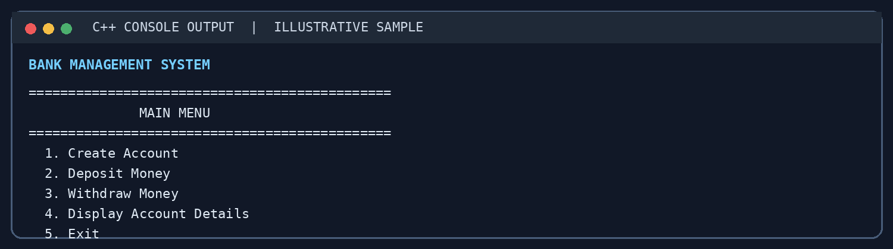
Figure A1. Main menu of the Bank Management System.
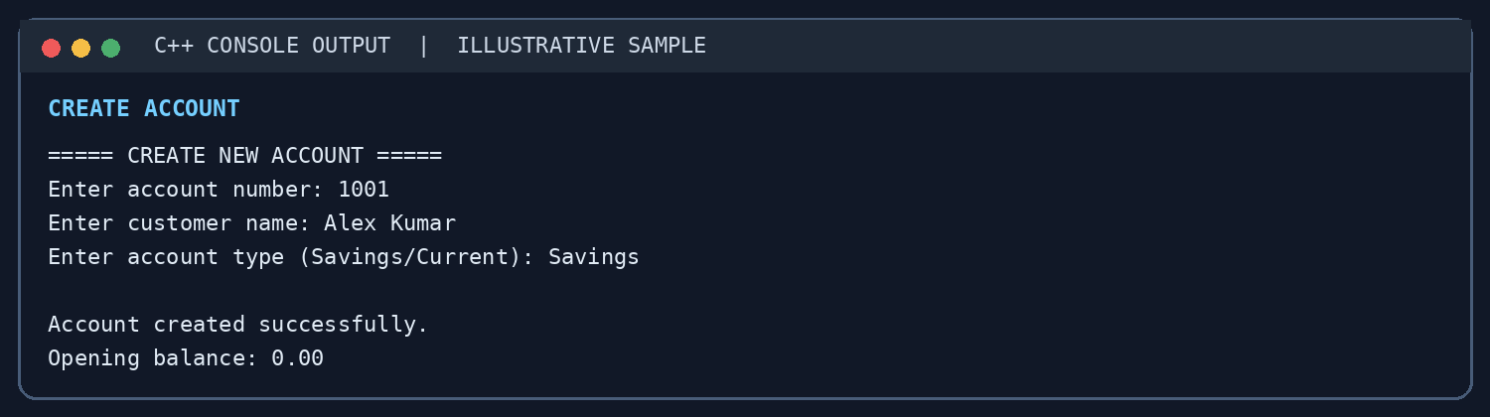
Figure A2. Example of creating a new customer account.

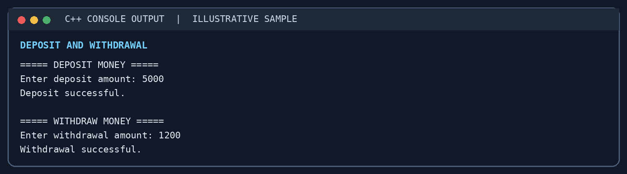
Figure A3. Example deposit and withdrawal transactions.
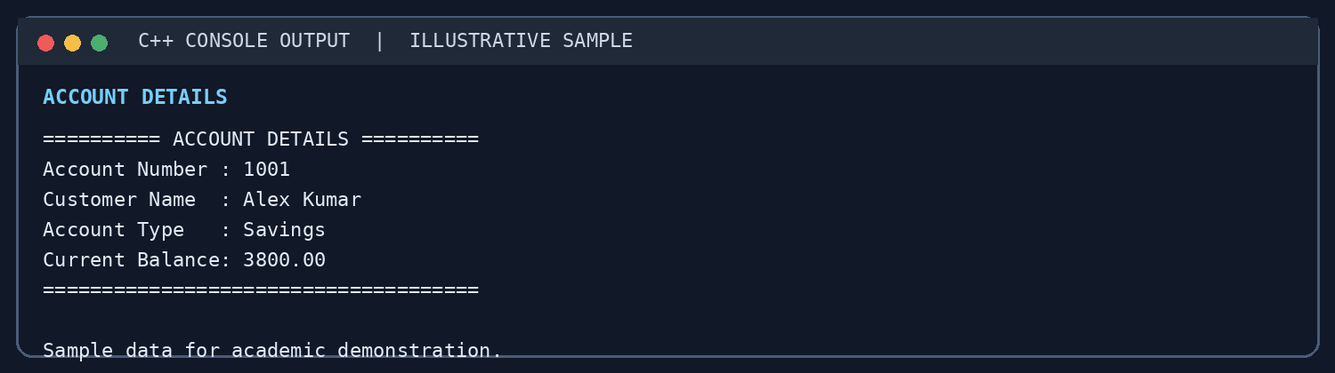
Figure A4. Account details and updated balance display.
Note: These figures are illustrative examples prepared for the report. Replace them with screenshots captured from the compiled program if the instructor specifically requires evidence of actual execution.

