a. All titles of the document
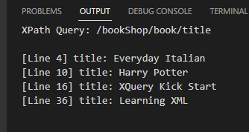

b. All titles of a book of the document
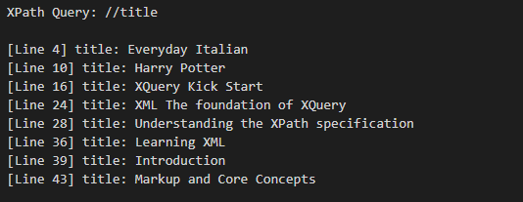

c. All elements of a chapter
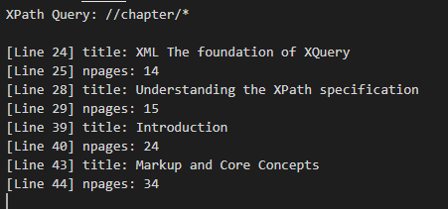

d. All elements of a chapter in a section
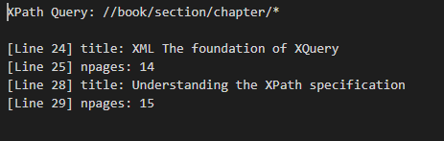

e. All elements

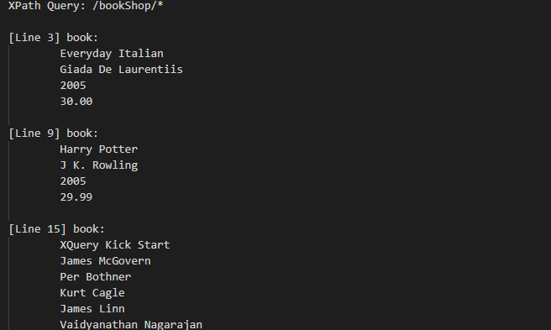
f. Titles that have a chapter 1
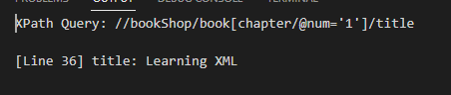

g. The third book with all its information
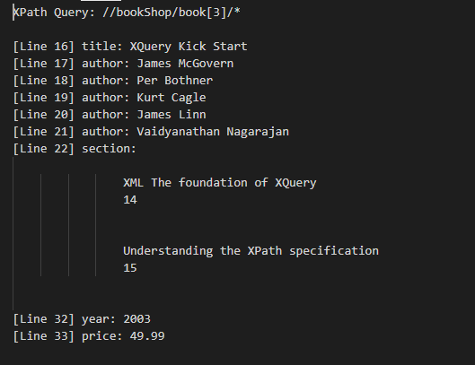

h. All elements with attributes
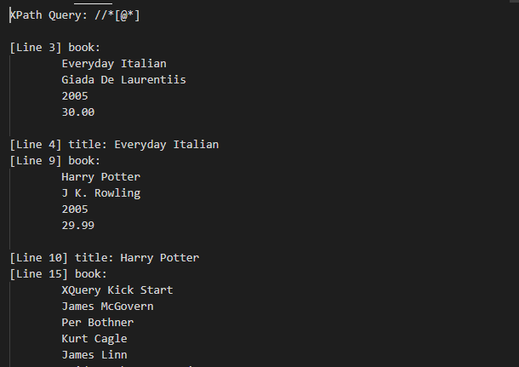
i. All elements with a category attribute
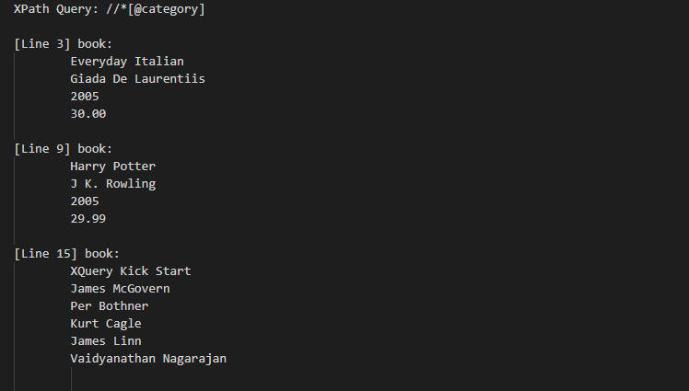

j. Books with no cover attribute
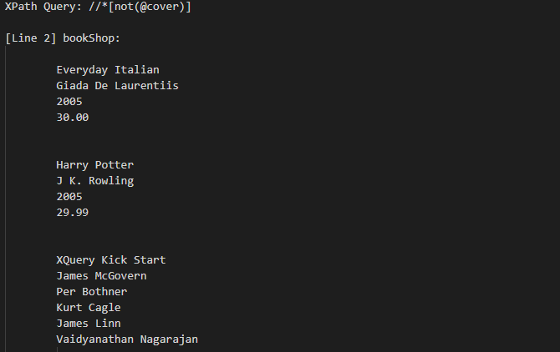
k. Elements with two chapters
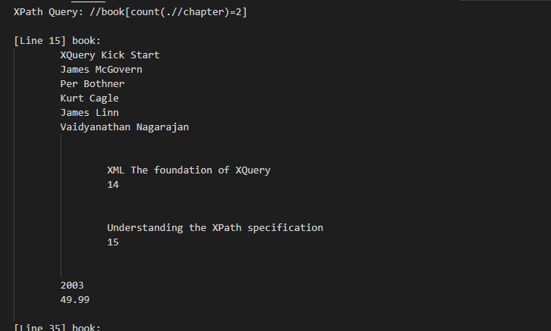

l. Book’s about markup languages
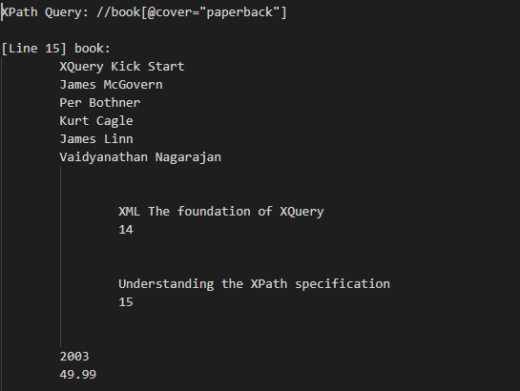

m. Titles whose author’s name value has more than 15 characters
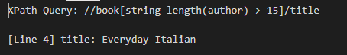

n. Title of paperback books with more than 30 pages in any chapter
