CS 311 Yoshii HW7 - Graph Algorithms (based on Notes-10B and 11B)

DUE: Week 12 Sat

TOTAL 34 points Your score:

*NAME: Victor Nguyen

*DATE SUBMITTED: 11/16/19

Exercise: Shortest Path Algorithm [16pts] Your score:

Use the following directed graph.

A: to B is 4 & to F is 2
B: to A is 1 & C is 3 & to D is 4
C: to A is 6 & to B is 3 & to D is 7
D: to A is 6 & to E is 2
E: to D is 5
F: to D is 2 & to E is 3

a) Do Dijkstra's shortest path algorithm starting with C ending with E. Trace the algorithm using the same format as I use. Replace ?’s and give the table per step.

Initially:
Tree has: C
Fringe (F*) has: A6, B3 and D7
DistTo of these are initialized to be the edge weights from C.

DistTo CandidateEdge
T* C 0 start
F* A 6 from C
F* B 3 from C
F* D 7 from C
E inf
F inf

Step1:
Pick B (show that B is T* in the table)
B is next to A1, C3, D4.
Note that C is already *T.
Note that A and D are already in Fringe. Should we update them?
DistTo to these vertices when going through B:
  - DistTO[A] = DistTo[B] + 1 = 4 update (it is better)
  - DistTO[D] = DistTo[B] + 4 = 7 no change (it is not better)
DistTo CandidateEdge
T* C 0 start
F* A 4 from B updated
T* B 3 from C
F* D 7 from C unchanged
E inf
F inf

Step 2:
Pick A (show that A is T* in the table)
A is next to: B4, F2 (show that they are F* if not already)(ignore if already *T)
Note that B is already in *T
DistTo to these Fringe (F*) vertices when going through A:
- DistTO[F] = DistTO[A] + 2 = 6 Entered
(Update the table and indicate updated or unchaged in the table)
DistTo CandidateEdge
T* C 0 start
T* A 4 from B
T* B 3 from C
F* D 7 from C
E inf
F* F 6 from A Entered

Step 3:
Pick F (show that F is T* in the table)
F is next to: D2, E3 (show that they are F* if not already)(ignore if already *T)
Note that D is already in fringe
DistTo to these Fringe (F*) vertices when going through F:
- DistTO[D] = DistTO[F] + 2 = 8 Updated
- DistTO[E] = DistTO[F] + 3 = 9 Entered
(Copy and Update the table and indicate updated or unchaged in the table)
DistTo CandidateEdge
T* C 0 start
T* A 4 from B
T* B 3 from C
F* D 8 from F Updated
F* E 9 from F Entered
T* F 6 from A

Step 4:
Pick D (show that D is T* in the table)
D is next to: A6, E2 (show that they are F* if not already) (ignore if already *T)
Note that A is already in *T
Also note the E is already in fringe and the last vertex to stop at
DistTo to these Fringe (F*) vertices when going through D:
- DistTO[E] = DistTO[D] + 2 = 10 Update because last vertex
(Copy and Update the table and indicate updated or unchaged in the table)
DistTo CandidateEdge
T* C 0 start
T* A 4 from B
T* B 3 from C
T* D 8 from F
F* E 10 from D Update
T* F 6 from A

Step 5:
Pick E (show that E is T* in the table)
E is next to: D5 (show that they are F* if not already) (ignore if already *T)
Note that D is already in *T
Note E is in fringe and we have to stop at E
DistTo to these Fringe (F*) vertices when going through E:
- DistTO[E] = DistTO[D] + 2 = 10 Unchanged
(Copy and Update the table and indicate updated or unchaged in the table)
DistTo CandidateEdge
T* C 0 start
T* A 4 from B
T* B 3 from C
T* D 8 from F
T* E 10 from D Unchanged
T* F 6 from A

Stop as soon E becomes *T.

b) What was the path from C to E found by the algorithm? Indicate the vertices on the path and the total distance.
C -> B - > A -> F -> D -> E Total distance is 10.
Program: Implementation DFS of a Graph [2+16=18pts] Your score:
Header:
Implementation:
Client:
Test results:
Total 16 points:
Q’s 2 points:
- State of the program statement [2pts]
- Did you fix all the errors in HW6 as advised? Yes I fixed all the errors, I just had to implement a boundary check in findAdjacency and findOutDegree functions.
- Does your program compile without errors? My program compiles with no errors.
- List any bugs you are aware of, or state “No bugs”: Not a bug to my knowledge but in my hw7client.cpp file, instead of creating a slist object in the beginning of the program I have to create a slist object in the while loop or else I encounter a segmentation fault. (Picture provided)
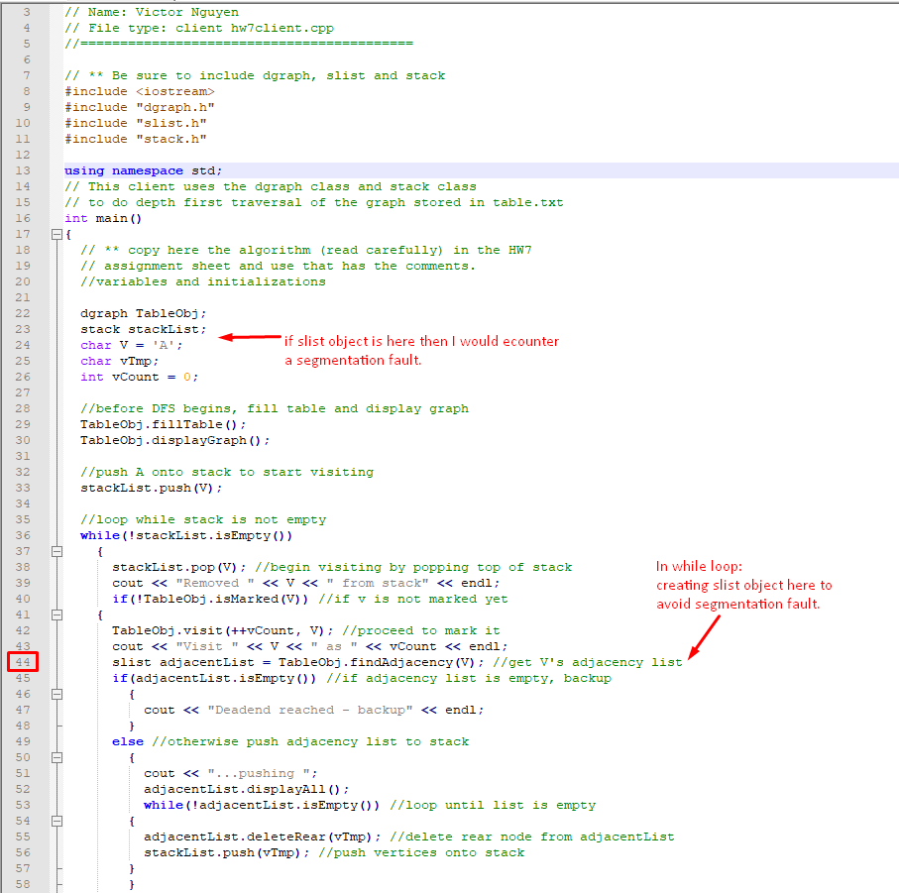

Now that you have a directed graph class from HW6, you can implement DFS.
Recall that you did this manually as Week10B In Class EX.

You also need a stack class (from HW1) and update it
so that you can push vertex names (char) onto a stack.
(Where do you need to include stack.h? What do you compile?)

You need to add the following 2 functions to dgraph.h and dgraph.cpp:
- void visit(int, char) which will enter the given visit number for a given vertex
  - this is to indicate the order in which vertices were visited.
  - Do not use a loop. Convert A to slot 0, B to slot 1 etc.
- bool isMarked(char) which returns true if a given vertex was already visited
(0 means not visited)
- Do not use a loop. Convert A to slot 0, B to slot 1 etc.
Make sure displayGraph now displays the visit numbers as well.

Your client (hw7client.cpp) should implement the DFS algorithm from Notes-10B.doc using the stack class and the graph class functions as follows: (Check hw7.out first)

Display the graph before DFS begins.
Push A onto the stack to start.
While the stack is not empty do:
{
Remove a vertex v from the stack.
Display the vertex name. E.G. “Removed B from stack”
If v is not marked yet (visit number is 0) then
- mark it (visit it **) and inform the user E.G. “Visit B as 2”
- get its adjacency list
  - if no adjacent ones inform the user E.G. “Deadend reached – backup”
  - else put adjacent ones on the stack (delete from the rear and push) informing the user
else inform the user E.G. “B had been visited already - backup.”
Display the stack clearly labeling it as the current stack
}
Display the Graph nicely with visit numbers for all vertices.

(**) visit numbers will start at 1 and increase as you traverse and visit.

Requirement:
- Make sure you have removed all “trace” messages from llist and slist.
(e.g. being in the constructor/destructor)
- Make your ouput look nice with indentation etc.

Testing: Use the same input file as for HW6.
Submit the output for starting at vertex A ➔ Test.txt

Note that EC2 includes HW7’s EC for detecting cycles.

SUBMIT THESE 5 (or 6) FILES: All files must be commented well!!!
If you were told to resubmit HW6 results, submit TestHW6.txt from HW6.
Otherwise I will not grade HW7.
- This assignment sheet with your answers.
- dgraph.h - header,
- dgraph.cpp - implementation
- hw7client.cpp - client
- Test.txt – script of test results showing what you compiled and ran

