VIETNAM GENERAL CONFEDERATION OF LABOR
TON DUC THANG UNIVERSITY
FACULTY OF INFORMATION TECHNOLOGY



NGUYEN QUANG HUY - 523H0140
NGUYEN GIA NHAT KHANH - 523H0149

MIDTERM ESSAY

DATA ANALYTICS AND VISUALIZATION

HO CHI MINH CITY, 2025
VIETNAM GENERAL CONFEDERATION OF LABOR
TON DUC THANG UNIVERSITY
FACULTY OF INFORMATION TECHNOLOGY

NGUYEN QUANG HUY - 523H0140
NGUYEN GIA NHAT KHANH - 523H0149

MIDTERM ESSAY

DATA ANALYTICS AND VISUALIZATION

Advised by
Dr. Tran Luong Quoc Dai

HO CHI MINH CITY, 2025
ACKNOWLEDGEMENT
We would like to express our sincere gratitude to Dr. Tran Luong Quoc Dai, our instructor and mentor, for his valuable guidance and support throughout the mid-term report. He has been very helpful and patient in providing us with constructive feedback and suggestions to improve our work. He has also encouraged us to explore new technologies and techniques to enhance our system's functionality and performance. We are honored and privileged to have him as our teacher and supervisor.

Ho Chi Minh city, 9nd November 2025.
Author
(Signature and full name)
Huy
Nguyen Quang Huy
Khanh
Nguyen Gia Nhat Khanh

DECLARATION OF AUTHORSHIP
We hereby declare that this is our own project and is guided by Dr. Tran Luong Quoc Dai. The content research and results contained herein are central and have not been published in any form before. The data in the tables for analysis, comments and evaluation are collected by the main author from different sources, which are clearly stated in the reference section.
In addition, the project also uses some comments, assessments as well as data of other authors, other organizations with citations and annotated sources.
If something wrong happens, we'll take full responsibility for the content of my project. Ton Duc Thang University is not related to the infringing rights, the copyrights that We give during the implementation process (if any).

Ho Chi Minh city, 9nd November 2025.
Author
(Signature and full name)
Huy
Nguyen Quang Huy
Khanh
Nguyen Gia Nhat Khanh

TABLE OF CONTENT

TABLE OF CONTENT 3
LIST OF FIGURES 5
LIST OF TABLES 6
INTRODUCTION 7
CHAPTER 1. EXPLORATORY DATA ANALYSIS 8
1.1 Data Summary 8
1.2 Missing and Duplicated Data Processing 9
1.3 Descriptive Statistical Analysis 9
1.3.1 S&P 500 10
1.3.2 Macroeconomic indicators 10
1.3.3 Comparison and Insights 11
1.4 Data Visualization 11
1.4.1 Candlestick Chart + Volume Bar Chart 11
1.4.2 Boxplot 12
1.4.3 Histogram 13
1.4.4 Line Chart 14
1.4.5 Heatmap 15
1.5 Anomaly Detection 16
1.5.1 Methodology 16
a. Z-score Method 16
b. Interquartile Range (IQR) Method 17
c. Rolling Z-score 18
d. Seasonal Decomposition Residuals 18
e. ARIMA Residuals 18
f. Isolation Forest 19
1.5.2. Aggregation of Outliers 19
CHAPTER 2. PROABILITY DISTRIBUTION ANALYSIS 21
2.1 Purpose 21
2.2 Visualization 21
2.3 Analysis 22
2.3.1 Close 22
2.3.2 Volume 22
2.3.3 IEF 22
2.3.4 VIXY 22
2.4 Normality Test and Distribution Fit 23
CHAPTER 3. HYPOTHESIS TESTING 24
3.1 Purpose 24
3.2 Independent t-test 24
3.2.1 Research Question 24
3.2.2 Hypotheses 24
3.2.3 Method 24
3.2.4 Results 24
3.3 One-way ANOVA Test 25
3.3.1 Research Question 25
3.3.2 Hypotheses 25
3.3.3 Method 25
3.3.4 Results 26
CHAPTER 4. CORRELATION ANALYSIS 26
4.1 Theoretical Basis 26
4.2 Visualization 26
4.3 Conclusion 29
CHAPTER 5. MULTIPLE LINEAR REGRESSION 30
5.1 Theoretical Basis 30
5.2 Model Implementation 30
5.3 Model Evaluation 31
5.4 Model Conclusion 33

LIST OF FIGURES
Figure 1.2.1. Missing Data Processing Method 9
Figure 1.4.1. Candlestick chart for Open, High, Low, Close Price and Trading Volume 12
Figure 1.4.2. Boxplot of SP500 Close Index 13
Figure 1.4.3. Boxplot of SP500 Trading Volume Index 13
Figure 1.4.5. Histogram of SP500 Close Index and Trading Volume 14
Figure 1.4.7. Line Chart of SP500 Close Index 15
Figure 1.4.8. Line Chart of SP500 Trading Volume 15
Figure 1.4.16. Correlation matrix with Pearson method 16
Figure 1.5.1. Z-Score method formula 17
Figure 1.5.2. IQR method formula 17
Figure 1.5.3. Seasonal Decomposition Residuals Visualization 18
Figure 1.5.4. Isolation Forest Visualization 19
Figure 1.5.5. Anomalies Detection Visualization 20
Figure 2.1.1. Distribution of SP500 Close Index and Trading Volume 21
Figure 2.1.2. Distribution of IEF and VIXY 21
Figure 4.2.1. Spearman Correlation Matrix 27
Figure 4.2.2. Pearson Correlation Matrix 27
Figure 4.2.3. Scatter between Close and IEF, VIXY 28
Figure 5.3.1. Actual vs Predicted Close Price Over Time 32
Figure 5.3.2. Scatter Plot of Actual vs Predicted Close Prices 32
Figure 5.4.1. Actual vs Predicted Close Price (Lag feature added) 33

LIST OF TABLES
Table 1.1.1. Data Type and Description 8
Table 1.3.1. Data Descriptive Statistical 9
Table 1.3.2. SP500 Index Descriptive Statistical Analysis 10
Table 1.3.3. Macroeconomics Indicators Descriptive Statistical Analysis 10
Table 1.5.1. Example of Anomalies Flagging 20
Table 2.4.1. Shapiro-Wilk test and Kolomogorov-Smirnov (Ks) test 23
Table 3.2.1. T-test result 25
Table 3.3.1. ANOVA test result 26

INTRODUCTION
Financial markets are complex, dynamic systems driven by a vast number of factors, from firm-specific performance to global macroeconomic shifts. Understanding the behavior of these markets requires data analysis to uncover patterns, manage risk and make decisions.
The primary objective of this report is to conduct an analysis of the S&P 500 Index (representing the performance of 500 of the largest U.S. companies) by applying a structured data analysis methodology. This report will conduct statistical and visual techniques to analyze the index's historical behavior.
To achieve this, the analysis will utilize a comprehensive time-series dataset of the S&P 500 Index merged with macroeconomic indicators (CPI, GLD, IEF, VIXY, UUP, USO). The final dataset spans from January 4, 2011, to December 12, 2023.
This report is structured into five core sections as required by the project syllabus:
- Exploratory Data Analysis (EDA): To summarize, visualize, and identify the main characteristics of the data.
- Probability Distribution Analysis: To test whether the index's returns follow a standard normal distribution.
- Hypothesis Testing: To apply statistical tests to answer a specific research question about market behavior.
- Correlation Analysis: To quantify the relationships between the financial index and key macroeconomic variables.
- Multiple Linear Regression: To build and evaluate a model aimed at explaining the drivers of the index's returns.

EXPLORATORY DATA ANALYSIS

Data Summary
The dataset was collected from two main sources: Yahoo Finance (yFinance) for daily index values and Alpha Vantage for macroeconomic indicators. The objective of this analysis is to perform Exploratory Data Analysis (EDA) to understand the dataset’s structure, trends, and potential relationships among variables.
- Number of records (rows): 3257
- From 4th January, 2011 to 12th December, 2023 (04/01/2011 - 12/12/2023)
- Number of features (variables): 11
Variable | Type | Description
Date | datetime | The trading date corresponding to each record
Open | float | Opening price of the index on a given trading day
High | float | Highest price of the index during the trading day
Low | float | Lowest price of the index during the trading day
Close | float | Closing price of the index at the end of the trading day
Volume | int | The total number of shares traded for the index constituents on that day
VIXY | float | CBOE Volatility Index, representing expected market volatility
IEF | float | U.S. 10-Year Treasury Yield, reflecting long-term interest rate expectations
UUP | float | U.S. Dollar Index, measuring the value of the U.S. dollar against a basket of major currencies
USO | float | Crude oil price per barrel (WTI benchmark)
GLD | float | Gold spot price per ounce, representing a key safe-haven asset
CPI | float | U.S. Consumer Price Index, representing inflation levels

Table 1.1.1. Data Type and Description

Missing and Duplicated Data Processing
The initial check for missing values across the merged time-series dataset revealed inconsistencies, particularly at the beginning and end of the collected timeframe where certain macroeconomic indicators were not yet available. To ensure a coherent and continuous time-series for all subsequent statistical analysis and modeling, the dataset was trimmed to the largest continuous period where a complete set of non-null values existed for all observed variables. After crop, data remaining 3257 rows (data records).
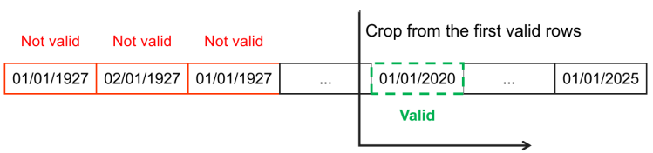

Figure 1.2.1. Missing Data Processing Method

Descriptive Statistical Analysis
 | mean | median | std | min | max | q1 | q3 | iqr
Open | 2.634.749 | 2429.2 | 1.029.353 | 1097.42 | 4804.51 | 1861.46 | 3380.86 | 1519.4
High | 2.649.095 | 2439.27 | 1.035.696 | 1125.12 | 4818.62 | 1873.34 | 3399.54 | 1526.2
Low | 2.619.422 | 2413.54 | 1.022.738 | 1074.77 | 4780.04 | 1849.69 | 3366.15 | 1516.46
Close | 2.635.274 | 2429.01 | 1029.48 | 1099.23 | 4796.56 | 1862.49 | 3383.54 | 1521.05
Volume | 3.890.499.324.532 | 3735980000.0 | 928.314.382.463 | 0.0 | 9976520000.0 | 3336880000.0 | 4253920000.0 | 917040000.0
CPI | 26.661 | 26.67 | 0.86 | 23.92 | 28.52 | 26.108 | 27.399 | 1.29
GLD | 142.763 | 137.97 | 24.546 | 100.5 | 193.89 | 120.78 | 166.39 | 45.61
IEF | 106.222 | 105.8 | 6.886 | 88.95 | 123.06 | 102.14 | 109.99 | 7.85
USO | 31.879 | 32.12 | 20.762 | 2.13 | 91.99 | 12.28 | 39.39 | 27.11
UUP | 24.727 | 24.93 | 2.226 | 20.93 | 30.67 | 22.548 | 26.07 | 3.523
VIXY | 25.921 | 21.24 | 17.384 | 5.25 | 121.95 | 14.62 | 29.97 | 15.35

Table 1.3.1. Data Descriptive Statistical

S&P 500
Column | Analysis
Open | The mean and median are close so the distribution is roughly symmetric. Large standard deviation indicates high price variability over the period.
High | Similar to Open; the daily high is slightly above Open/Close.
Low | Daily low is lower than Open/High; variability is high.
Close | Close price is close to Open mean → intraday movements roughly balanced.
Volume | Extremely variable; zero volume on some days may indicate missing data or non-trading days.

Table 1.3.2. SP500 Index Descriptive Statistical Analysis
- Prices fluctuate widely over time; large std and range.
- Mean and median are close, suggesting a roughly symmetric distribution, though extreme highs exist.
- Volume shows large variability and may need outlier handling before analysis.

Macroeconomic indicators
Column | Analysis
CPI | Inflation is stable; very low variability.
GLD | Gold prices show moderate variability; large max-min reflects market spikes during crises.
IEF | Medium-term government bonds are stable; low variability.
USO | Oil prices are highly volatile; large std indicates significant market swings.
UUP | The USD index is relatively stable; low variability.
VIXY | Volatility index shows strong fluctuations; extreme spikes exist (fear spikes).

Table 1.3.3. Macroeconomics Indicators Descriptive Statistical Analysis
- CPI, IEF, and UUP are stable → suitable as benchmarks or for long-term correlations.
- GLD, USO, VIXY are highly variable → reflect market risk, commodity price swings, or investor sentiment.
- Small IQR → data concentrated; large IQR → wider distribution, more prone to outliers.

Comparison and Insights
- SP500 price columns (Open, High, Low, Close) are highly correlated and show large variability.
- Volume is extremely variable → consider log transformation or normalization for regression/correlation analysis.
- Stable economic indicators (CPI, IEF, UUP) are useful for long-term trend analysis.
- Volatile indicators (USO, GLD, VIXY) should be normalized (e.g., Min-Max scaling) when plotting together with SP500 to compare relative movements.

Data Visualization
Due to the characteristics of the stock market dataset, the Close price is often considered the most representative indicator of daily performance, as it reflects the final consensus of value after intraday fluctuations. Therefore, subsequent analyses primarily focus on the Close price, along with selected macroeconomic indicators and technical stock indicators, while Open, High, and Low are excluded from detailed visualization (except Candlestick Chart).

Candlestick Chart + Volume Bar Chart
- Apply to: Open, High, Low, Close Price and Volume.
- Purpose: This pair effectively visualizes price movement patterns and market strength through trading volume.
- Why chosen: Candlesticks reveal intra-period volatility, while volume bars explain how strongly each movement is supported by market activity.
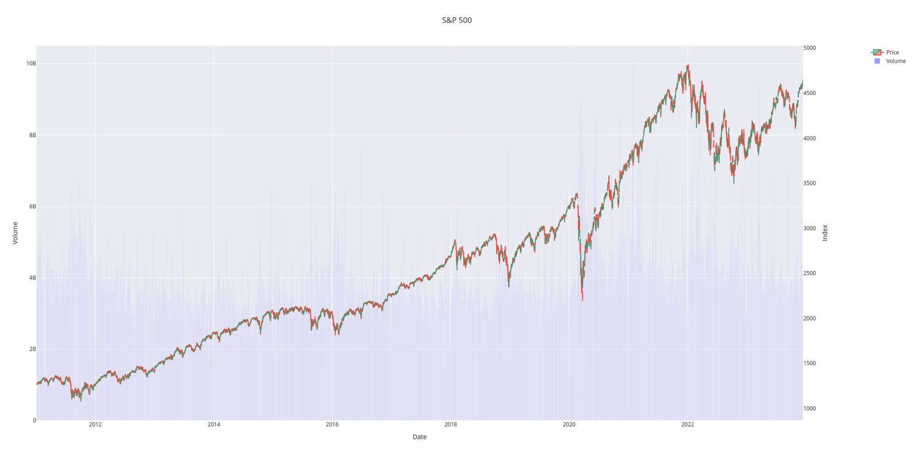

Figure 1.4.1. Candlestick chart for Open, High, Low, Close Price and Trading Volume

Boxplot
- Apply to: Representative numerical features such as technical indicators or macroeconomic factors.
- Purpose: Shows data spread, quartiles, and outliers.
- Why chosen: Directly supports the Anomaly Detection part (1.5) and helps compare scale and variability between variables.
- Normalization: All selected numerical features are scaled to a [0, 1] range using Min-Max normalization to remove differences in units and magnitudes. This ensures that each variable contributes proportionally when visualizing boxplots, allowing clearer comparison of distributions, quartiles, and outliers across diverse indicators.

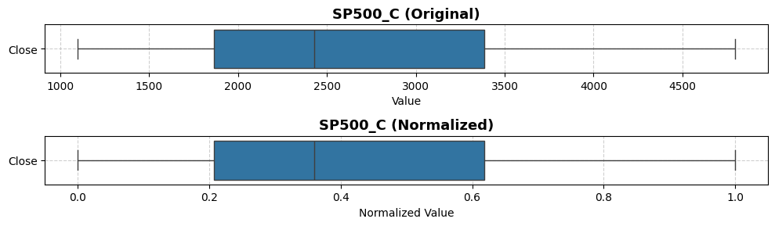

Figure 1.4.2. Boxplot of SP500 Close Index
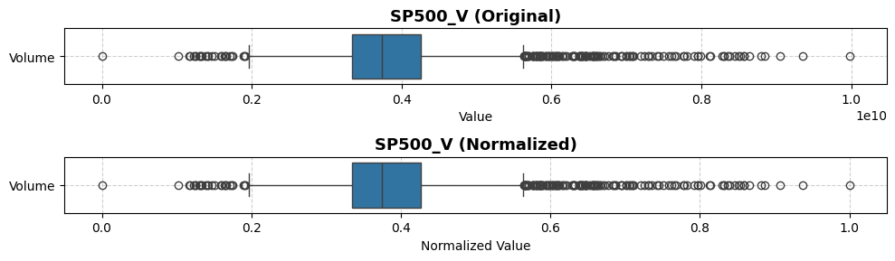

Figure 1.4.3. Boxplot of SP500 Trading Volume Index

Histogram
- Apply to: Representative numerical features such as SP500 Close, Trading Volume, and macroeconomic indicators (CPI, GLD, IEF, USO, UUP, VIXY).
- Purpose: Visualizes the distribution of individual variables, showing frequency, skewness, and potential multimodal patterns.
- Why chosen: Histograms provide insight into how data is distributed across values, highlighting asymmetries, peaks, and potential anomalies that may not be visible in summary statistics alone.
- Normalization: When comparing multiple variables with different units, values are scaled to a [0, 1] range using Min-Max normalization to allow consistent visual comparison of distributions across variables.
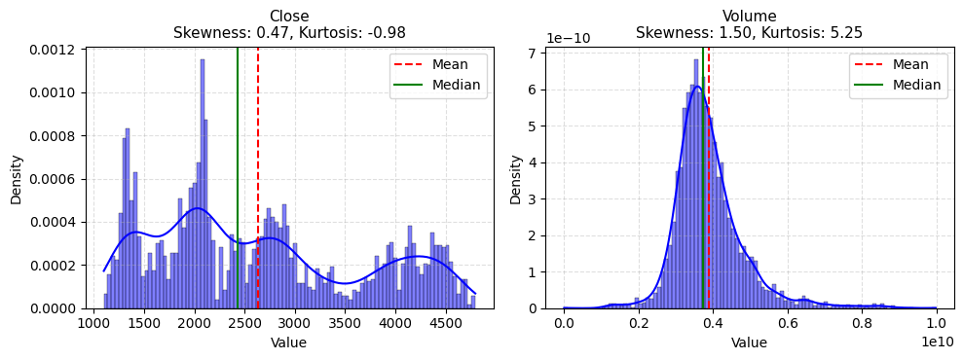

Figure 1.4.5. Histogram of SP500 Close Index and Trading Volume

Line Chart
- Apply to: SP500 Close index, Trading Volume, and macroeconomic indicators over time.
- Purpose: Shows temporal trends, patterns, and potential correlations between variables.
- Why chosen: Line charts effectively illustrate how values evolve over time, making it easier to identify trends, seasonality, sudden spikes, and relationships between market performance and macroeconomic factors.
- Normalization: To compare multiple indicators on the same chart, all selected numerical features are scaled to a [0, 1] range using Min-Max normalization, ensuring that each variable contributes proportionally and trends are visually comparable.

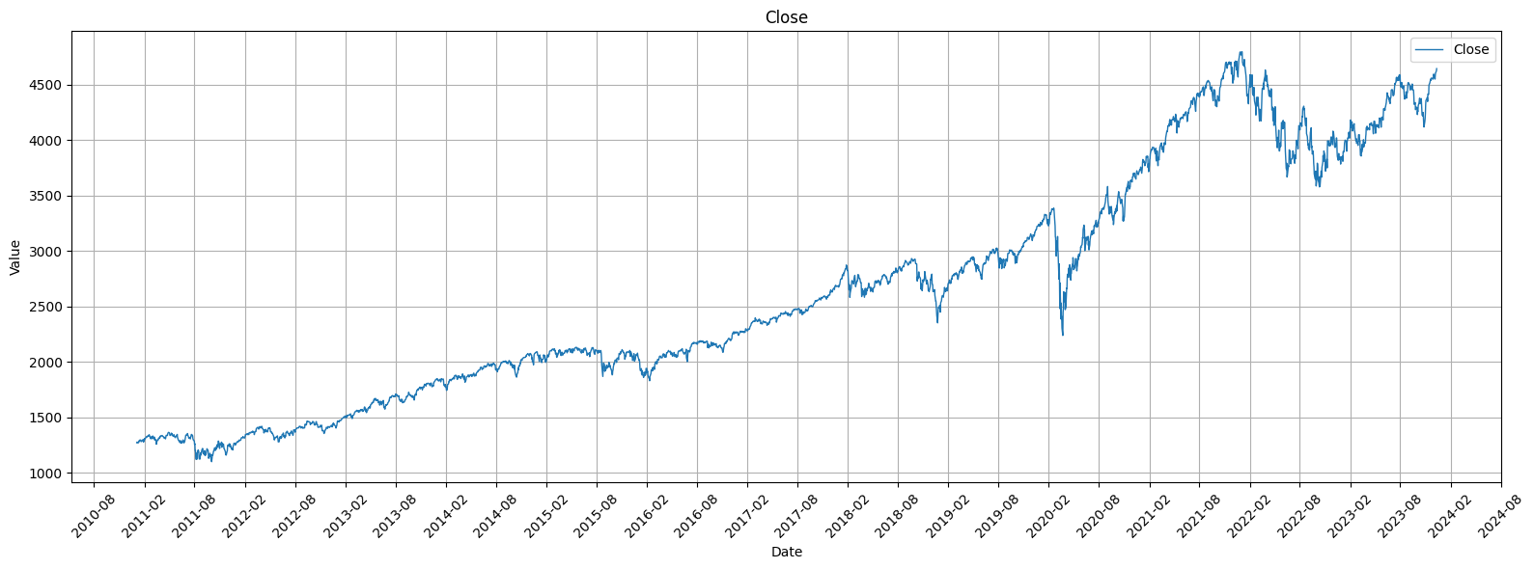

Figure 1.4.7. Line Chart of SP500 Close Index

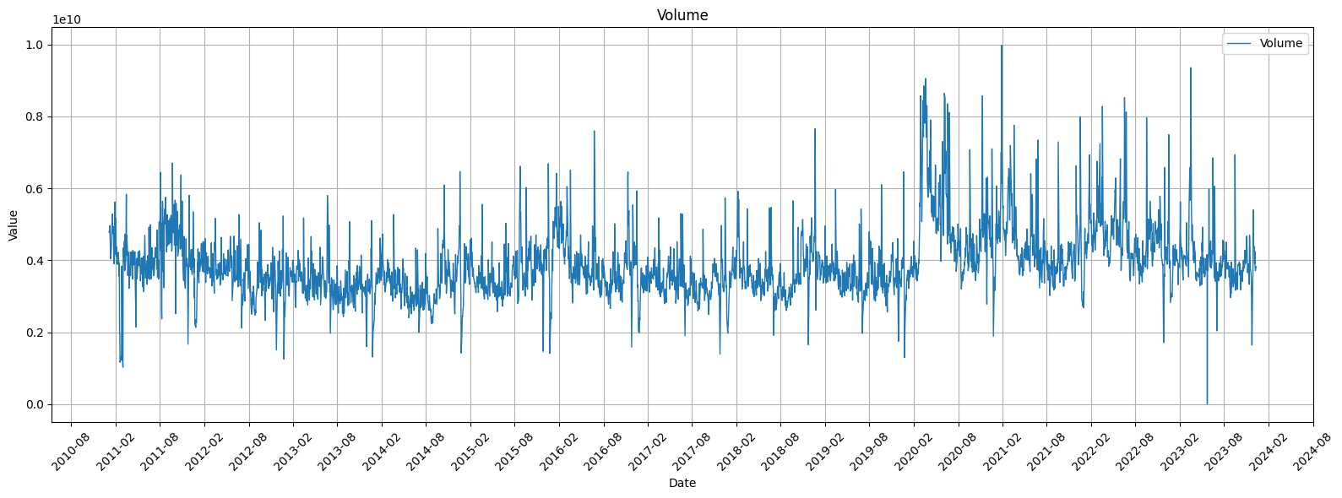

Figure 1.4.8. Line Chart of SP500 Trading Volume

Heatmap
- Apply to: Correlation matrix of SP500 Close, Trading Volume, and macroeconomic/technical indicators.
- Purpose: Visualizes the strength and direction of relationships among variables, helping identify positive or negative correlations.
- Why chosen: Heatmaps provide an intuitive way to detect strong associations or dependencies between variables, which can guide feature selection, multivariate analysis, and anomaly detection.
- Normalization: Correlation values are inherently bounded between -1 and 1, so no additional normalization is required. Color intensity directly represents correlation magnitude, allowing immediate visual assessment of inter-variable relationships.

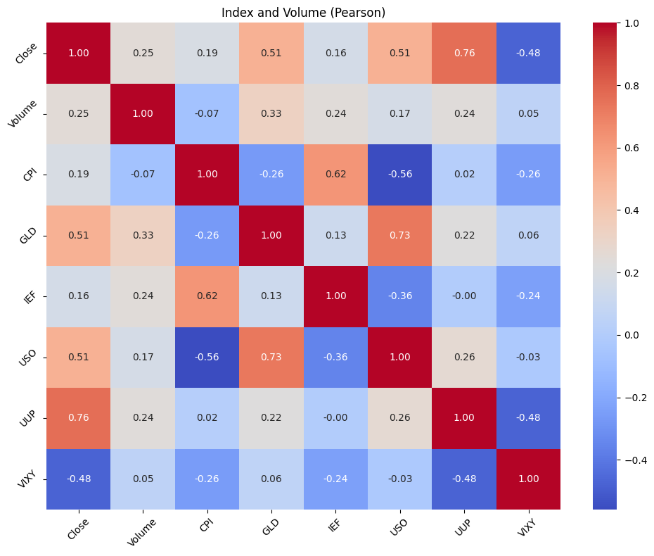

Figure 1.4.16. Correlation matrix with Pearson method

Anomaly Detection
To identify anomalies in the dataset, multiple methods were applied to both the SP500 Close price and other numerical indicators. The methods include:

Methodology

Z-score Method
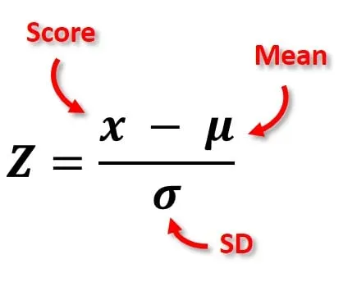

Figure 1.5.1. Z-Score method formula
- Measures the number of standard deviations a value is from the mean.
- Threshold of 3.0 was used; values beyond ±3 standard deviations were flagged as outliers.
- Applied to all numerical features in the dataset.

Interquartile Range (IQR) Method

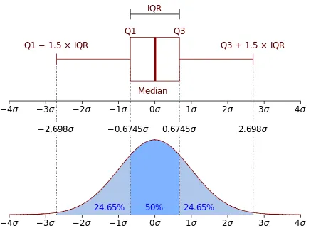

Figure 1.5.2. IQR method formula
- Calculates the difference between the 75th percentile (Q3) and 25th percentile (Q1).
- Observations outside [Q1 - 1.5×IQR, Q3 + 1.5×IQR] are considered outliers.
- Captures extreme values in skewed distributions.

Rolling Z-score
- For time series, computes z-score based on a rolling window of 20 periods.
- Flags observations that deviate significantly from their local context, capturing short-term spikes.

Seasonal Decomposition Residuals
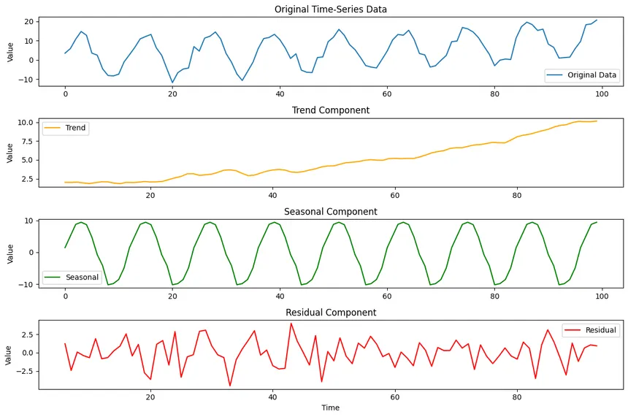

Figure 1.5.3. Seasonal Decomposition Residuals Visualization
- Decomposes the time series into trend, seasonal, and residual components.
- Outliers are identified from residuals exceeding 3 standard deviations.
- Highlights points deviating from expected seasonal patterns.

ARIMA Residuals
- Fits an ARIMA(1,1,1) model to the Close price and examines residuals.
- Residuals with absolute z-score above 3.5 are flagged.
- Captures anomalies unexplained by autoregressive trends.

Isolation Forest
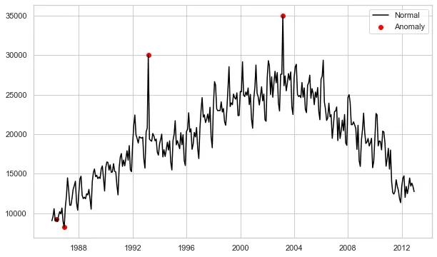

Figure 1.5.4. Isolation Forest Visualization
- A machine learning approach detecting anomalies in multivariate space.
- Applied to all numerical features after standard scaling.
- Flags observations that are isolated in feature space, complementing univariate methods.

1.5.2. Aggregation of Outliers
Out of the full dataset, multiple significant spikes in the Close price were detected by several methods.
Points flagged by multiple methods tend to coincide with periods of extreme market volatility, consistent with known historical events (e.g., market crashes or rallies).
The plot_time_series_with_flags visualization highlights these points:
- Red dots mark outliers, with size and opacity proportional to the number of methods flagging them.
- This allows easy identification of strong anomalies versus minor deviations.
Date | 2020-03-26 | 2020-03-27 | 2020-03-28 | 2020-03-28
z_close | True | True | False | False
iqr_close | False | False | True | False
decomp_close | False | True | False | False
arima_close | False | False | False | False
iso_multivariate | False | True | True | False
rolling_close | False | False | True | False
any_outlier | True | True | True | False
n_methods_flagged | 1 | 3 | 3 | 0

Table 1.5.1. Example of Anomalies Flagging
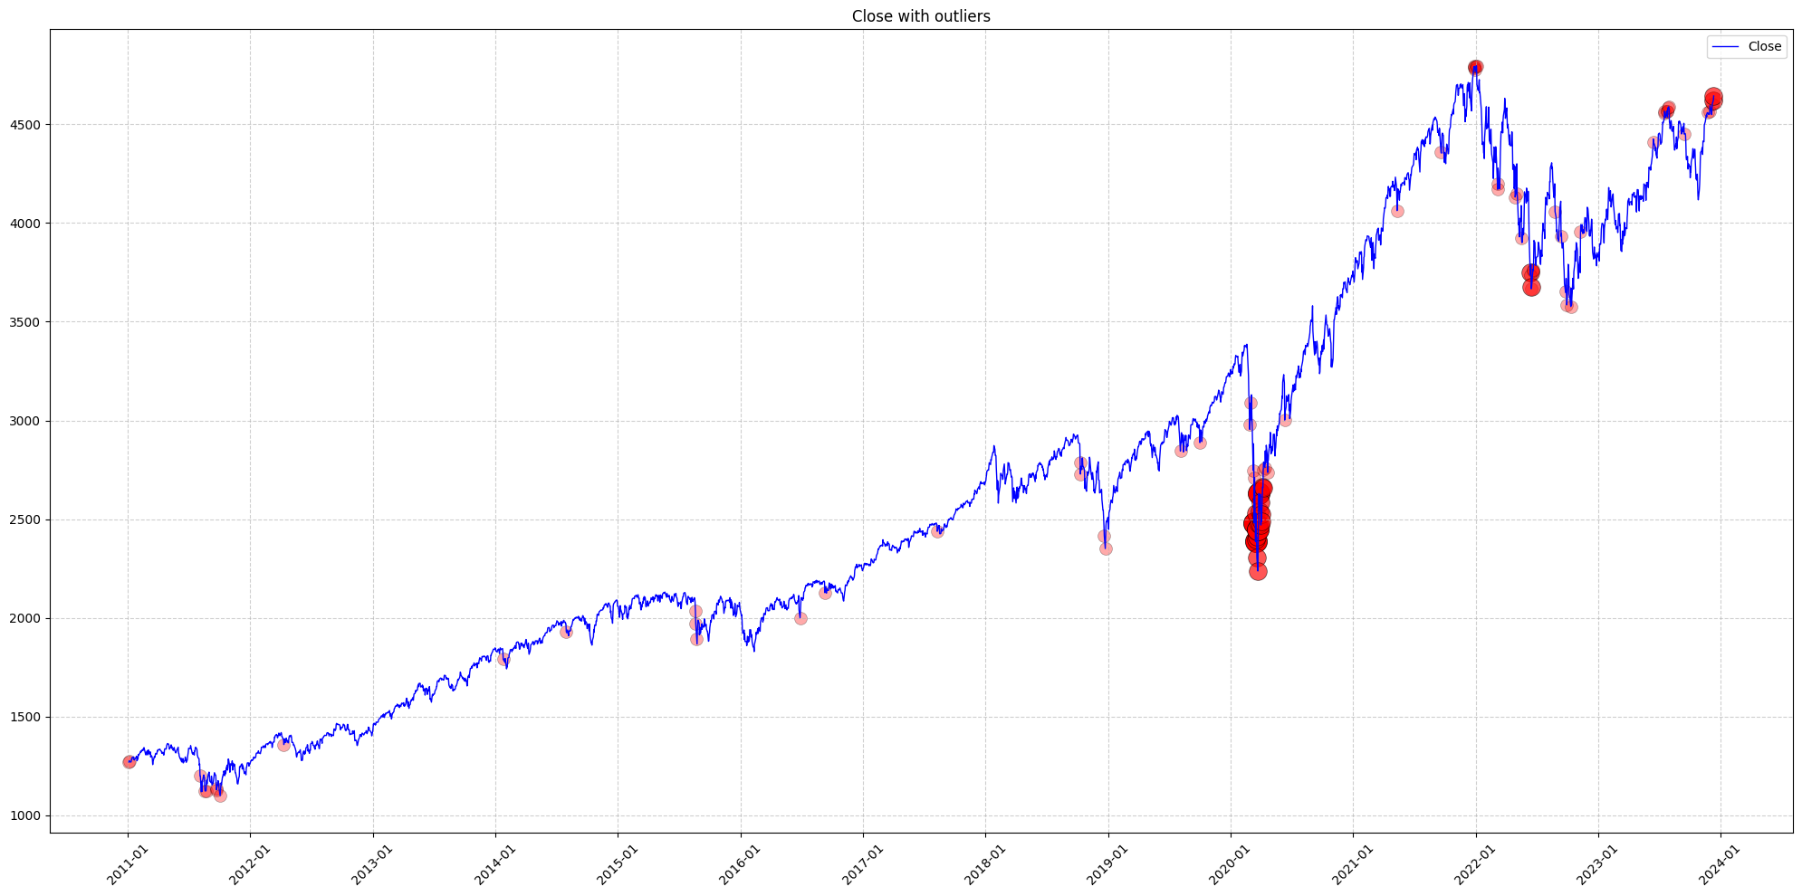

Figure 1.5.5. Anomalies Detection Visualization

PROABILITY DISTRIBUTION ANALYSIS

Purpose
This step aims to identify the probability distributions of the dataset’s quantitative variables. Understanding their shapes helps evaluate market characteristics such as volatility, skewness, and the presence of extreme values. The variables selected represent both stock-specific behavior (Close, Volume) and macroeconomic indicators (IEF, VIXY).

Visualization

Figure 2.1.1. Distribution of SP500 Close Index and Trading Volume
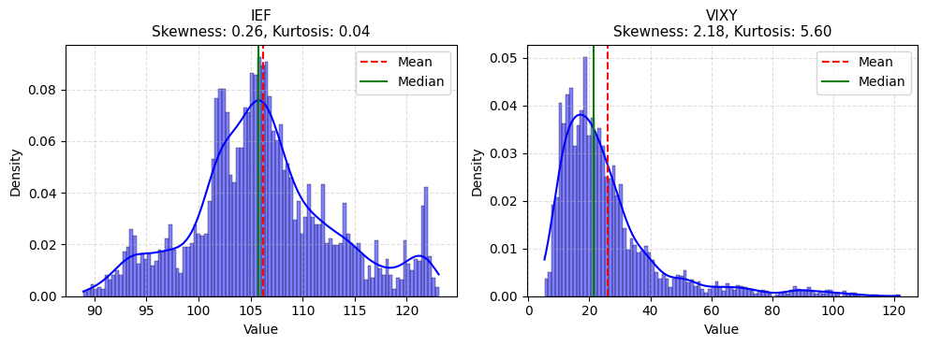

Figure 2.1.2. Distribution of IEF and VIXY

Analysis

Close
The closing prices exhibit a distinct multimodal distribution with peaks around various price ranges, reflecting the long-term, multi-phase growth of the S&P 500 from 2011 to 2023. The Mean (approx. 2,635) is slightly higher than the Median (2,429.01), which is a subtle indication of a minor positive skewness influenced by the long-term upward trend and high price outliers. Crucially, the lack of symmetry and the multiple peaks strongly confirm the price data does not follow a normal distribution, suggesting the presence of different underlying market regimes over the observed period.

Volume
The trading volume follows a severely positively skewed (right-skewed) distribution. This is quantitatively supported by the Mean (approx. 3.89 billion) being substantially greater than the Median (approx. 3.74 billion). The distribution is also highly leptokurtic (heavy-tailed), evidenced by the sharp peak and the long right tail extending to extreme values. This pattern is typical, indicating that while most days have moderate liquidity, rare macroeconomic or crisis events trigger exceptionally high volume spikes (outliers).

IEF
The IEF (U.S. 10-Year Treasury Yield ETF) price distribution is the closest to symmetric among the variables analyzed, with the Mean (106.222) and Median (105.8) being very close. It exhibits a bell shape with a minor negative (left) skewness. The data concentration around the central value (105–110) suggests relative price stability. Unlike the equity and volatility indices, this distribution suggests lower kurtosis and variance, characteristic of a stable, fixed-income asset.

VIXY
The VIXY distribution is highly positively skewed, demonstrated by the Mean (25.921) being significantly greater than the Median (21.24). This indicates a large majority of low-volatility observations, but the Mean is pulled upward by extreme, rare spikes. Furthermore, the distribution is extremely leptokurtic (heavy-tailed), with values stretching well above 100. This heavy-tailed nature is characteristic of volatility indices, which experience long periods of calm (low median) interrupted by rare, intense surges driven by market panic.

Normality Test and Distribution Fit
To verify whether the selected variables follow a normal probability distribution, both the Shapiro–Wilk and Kolmogorov–Smirnov (K–S) tests were applied. The null hypothesis H0: the variable following a normal distribution was tested at the 5% significance level.
Index | Variable | Shapiro_p | KS_p | Distribution
0 | Close | 4.426160e-37 | 3.073666e-43 | Non-normal
1 | Volume | 2.883589e-42 | 2.667348e-31 | Non-normal
2 | IEF | 2.947230e-21 | 5.636244e-14 | Non-normal
3 | VIXY | 1.150930e-54 | 5.995955e-74 | Non-normal

Table 2.4.1. Shapiro-Wilk test and Kolomogorov-Smirnov (Ks) test
Since all p-values are far below 0.05, we reject H0​ for every variable. Thus, none of the selected variables follow a normal distribution. The strong deviations observed in the histograms and KDE plots (multimodal, right-skewed, and heavy-tailed shapes) are consistent with these results.
These findings confirm that the dataset exhibits non-Gaussian behavior, typical of financial time series, characterized by volatility clustering and extreme fluctuations. For later analysis (hypothesis testing and regression), data transformation (e.g., log-return computation or scaling) may be necessary to improve statistical validity.

HYPOTHESIS TESTING

Purpose
The goal of this section is to statistically verify whether there are significant differences between different market conditions or economic periods. By performing hypothesis tests on selected quantitative variables, we can determine if the observed changes are statistically meaningful rather than random fluctuations.

Independent t-test

Research Question
Is there a significant difference in trading volume (Volume) between periods of low volatility and high volatility in the stock market?

Hypotheses
- Null hypothesis (H0): The mean trading volume during low-volatility and high-volatility periods are equal.
- Alternative hypothesis (H1): The mean trading volumes differ between the two periods.

Method
The variable VIXY (Volatility Index ETF) was used as a proxy for market volatility. The dataset was divided into two groups based on the median of VIXY:
- Low-volatility period: VIXY < median(VIXY)
- High-volatility period: VIXY ≥ median(VIXY)
The Independent Two-Sample t-test (assuming unequal variances) was applied to compare the means of Volume between the two groups.

Results
Statistic | Value
t-statistic | 2.325
p-value | 0.02012

Table 3.2.1. T-test result
Since the p-value (0.02012) is less than the significance level alpha = 0.05, we reject the null hypothesis. There is a statistically significant difference in trading volume between low- and high-volatility periods.
During periods of high volatility (high VIXY), the average trading volume tends to increase significantly. This reflects investors’ heightened trading activity in response to market uncertainty – consistent with the behavioral finance notion that fear and uncertainty drive liquidity spikes.

One-way ANOVA Test

Research Question
Is there a significant difference in the S&P 500 closing price (Close) among different economic periods?

Hypotheses
- Null hypothesis (H0): The mean closing prices are the same across all economic periods.
- Alternative hypothesis (H1): At least one period has a different mean closing price.

Method
The data was divided into three economic phases:
- Before COVID-19: 2011–2019
- During COVID-19: 2020–2021
- After COVID-19: 2022–2023
A One-Way ANOVA (Analysis of Variance) test was conducted to determine whether the average S&P 500 closing prices differ significantly across these periods.

Results
Statistic | Value
f-statistic | 4588.007
p-value | 0.000

Table 3.3.1. ANOVA test result
The p-value is effectively zero (p < 0.001), which strongly rejects the null hypothesis. Therefore, there are significant differences in the mean closing price among three economic periods.
The results confirm that the S&P 500 underwent major structural shifts between the pre-COVID, COVID, and post-COVID eras. The sharp increase in mean closing prices after 2020 reflects unprecedented monetary expansion and post-pandemic recovery effects. This demonstrates that macroeconomic regimes have a profound and statistically measurable impact on equity valuations.

CORRELATION ANALYSIS

Theoretical Basis
- Pearson Correlation: Measures the strength and direction of a linear relationship between two continuous variables. It is sensitive to outliers.
- Spearman Correlation: Measures the strength and direction of a monotonic relationship (i.e., as one variable increases, the other consistently increases or decreases, but not necessarily at a constant rate). It is "non-parametric" and robust to outliers.

Visualization

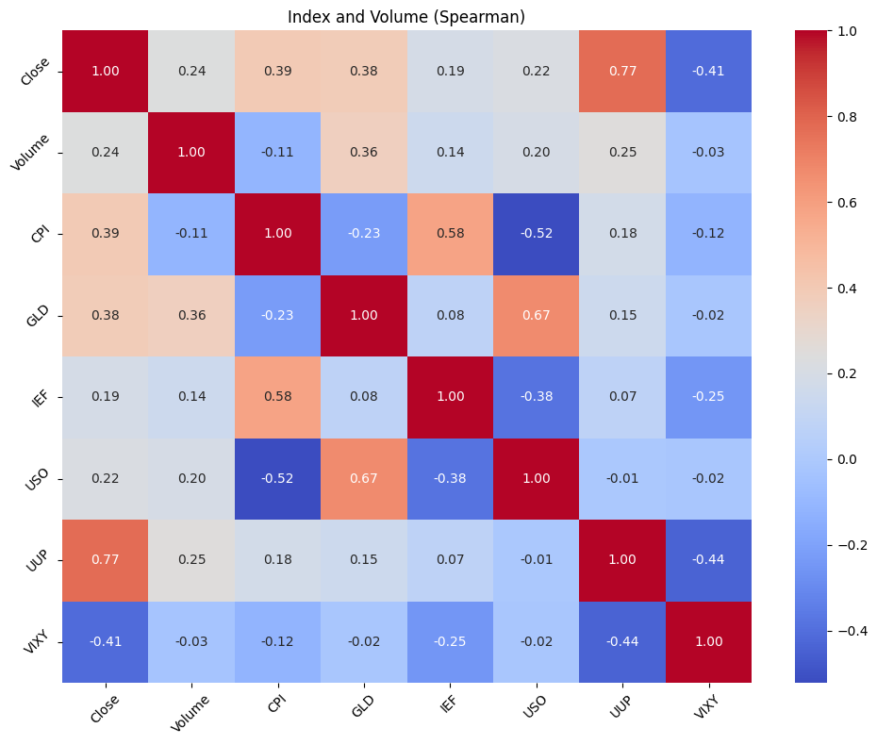

Figure 4.2.1. Spearman Correlation Matrix

Figure 4.2.2. Pearson Correlation Matrix
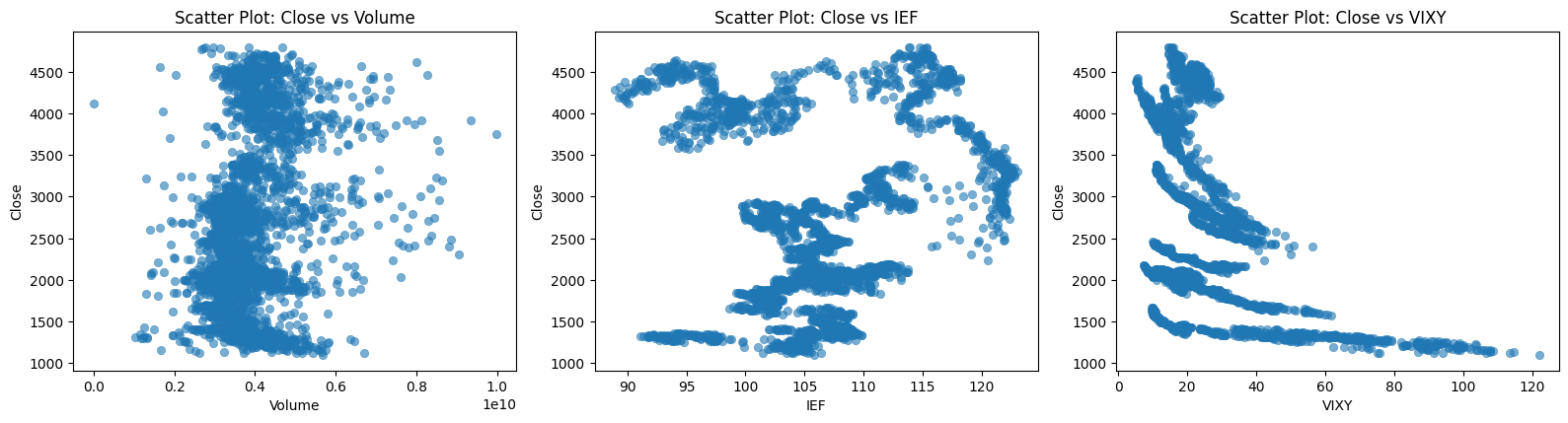

Figure 4.2.3. Scatter between Close and IEF, VIXY
- Close vs. VIXY:
  - Matrix: The medium negative correlation (Pearson: -0.48) is highly expected. This confirms the index and volatility tend to move in opposite directions.
  - Scatter Plot Insight: The plot visually confirms this inverse relationship, clearly showing that as the S&P 500 Close price drops, market volatility (VIXY) rises. The distribution emphasizes the extreme "fear spikes" that occur at lower index levels.
- Close vs. IEF:
  - Matrix: The Pearson correlation is a very weak 0.16.
  - Scatter Plot Insight: The scatter plot for the S&P 500 Close versus the IEF (U.S. 10-Year Treasury Yield ETF) provides critical visual context. While a traditional inverse relationship might be expected, the plot reveals that their covariance is heavily influenced by the secular bull market trend. The spread of data points will likely confirm the non-stationarity of the two series, showing that the weak positive correlation is likely a spurious effect of both rising over the observed time.
- Close vs. Volume:
  - Matrix: The Pearson correlation of 0.25 indicates a weak positive linear relationship.
  - Scatter Plot Insight: This plot visually demonstrates an almost negligible linear relationship. The data points form a large, amorphous cloud, confirming the conclusion from EDA: Volume is highly volatile and its raw value has little immediate linear predictive power on the Close price. This visual evidence supports the decision to use Volume as a feature in the regression model only after transformation or incorporation of autoregressive features.
- Extreme Correlations (Spuriousity):
  - The strong positive correlation observed between Close and UUP (Pearson: 0.76) is clear visual and numerical evidence of spurious correlation. Since both the S&P 500 and the U.S. Dollar Index (UUP) trend upwards over the time horizon (2011–2023), the high correlation is caused by the underlying common trend (non-stationarity) rather than a direct, true economic linkage.
  - Correction: The low correlation of Close with CPI (Pearson: 0.19) suggests that the raw, non-stationary time series does not exhibit the same spurious correlation observed with UUP.

Conclusion
The combined analysis of the correlation matrices and the scatter plots confirms that the raw time-series data is highly non-stationary. Key evidence includes:
- Strong Trend-Based Spurious Correlation: The high correlation (approx. 0.76) between Close and UUP is a hallmark of non-stationary data, where a common underlying trend dominates the relationship.
- Volatile/Non-Linear Relationships: The medium negative correlation of Close vs. VIXY and the very weak correlation of Close vs. Volume require further feature engineering to be useful in a linear model.
Therefore, the correlation analysis confirms that running a Multiple Linear Regression (MLR) model directly on these raw price levels would be statistically questionable due to the presence of spurious correlations and multicollinearity. This mandates the use of data transformation (such as calculating daily returns or incorporating lagged features and a time-based index, as employed in Section 5) to achieve a robust and meaningful regression model.

MULTIPLE LINEAR REGRESSION

Theoretical Basis
Multiple Linear Regression (MLR) is a statistical technique used to model the relationship between a single dependent variable (target) and multiple independent variables (predictors). The general equation is:
where:
- Y: The dependent variable (S&P500 Close Price).
- x_1, x_2, …, x_k: The independent variables.
- Beta_0: The bias.
- Beta_1, …, Beta_k: he regression coefficients representing the change in y for a one-unit change in x.
- Epsilon: The error term (residual).
Time Series Adaptation: Standard MLR assumes observations are independent, which is not true for time series data. To adapt MLR for stock prediction, we employ Autoregressive features (Lagged values), allowing the model to use past prices to predict future prices. Additionally, Temporal features are introduced to capture trends (linear growth over time) and seasonality (patterns within a week or month).

Model Implementation
To ensure a robust predictive model and avoid data leakage (look-ahead bias), the daily concurrent metrics Open, High, and Low were excluded from the feature set. These values are not known until the end of the trading day, making them unsuitable for forecasting the closing price of that same day.
The feature set was engineered as follows:
- Lag Features: Close_lag1, Close_lag2, and Close_lag3 (Closing prices of the previous 1, 2, and 3 days).
- Macroeconomic Indicators: Volume, CPI, GLD, IEF, USO, UUP, VIXY.
- Temporal Features:
  - TimeIndex: A linear increment to capture the long-term upward trend of the market.
  - DayOfWeek: (0-4) to capture weekly seasonality.
  - Month: (1-12) to capture monthly seasonality.
The data was split into a training set (80%) and a testing set (20%) to evaluate out-of-sample performance.

Model Evaluation
The model was evaluated using the Test Set to determine its predictive accuracy on unseen data.
Performance Metrics:
- R-squared (R^2): 0.9503. The model explains approximately 95% of the variance in the S&P 500 Close price on the test data.
- Root Mean Squared Error (RMSE): 61.02. On average, the model's prediction deviates from the actual stock price by roughly 61.02.
Visual Evaluation:
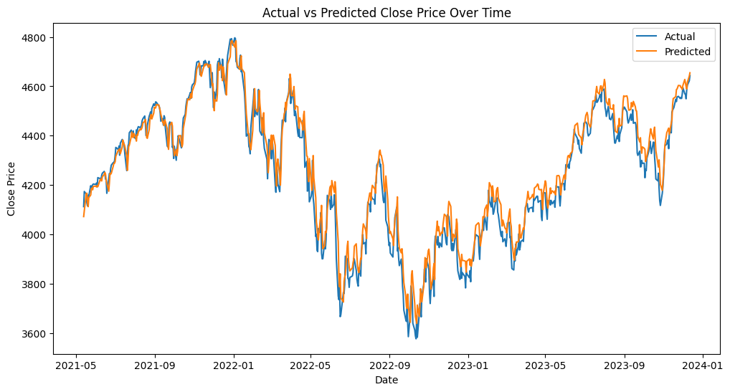

Figure 5.3.1. Actual vs Predicted Close Price Over Time
As seen in Figure 5.3.1, the predicted line (Orange) closely follows the actual price trend (Blue). The model successfully captures the major market movements, though slight deviations occur during periods of extreme volatility.
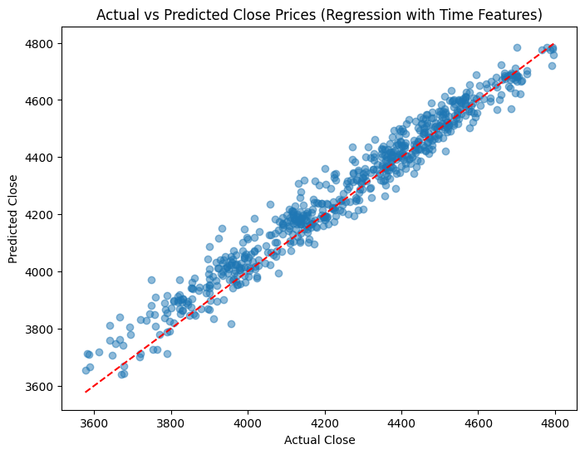

Figure 5.3.2. Scatter Plot of Actual vs Predicted Close Prices
Figure 5.3.2 shows the observations clustered tightly around the diagonal red line (perfect fit). This confirms a strong linear relationship between the engineered features and the target variable.

Model Conclusion
An OLS (Ordinary Least Squares) summary was generated to analyze the significance of individual predictors.
Variable | Coeff | P-value | Significance | Interpretation
Close_lag1 | 0.8857 | 0.000 | Significant | The strongest predictor Yesterday's price dictates ~88% of today's price level
Close_lag2 | 0.1318 | 0.000 | Significant | Positive influence from the day before yesterday
Close_lag3 | -0.0401 | 0.022 | Significant | A small negative correction, suggesting mean reversion behavior over 3 days
TimeIndex | 0.0239 | 0.000 | Significant | Captures the long-term secular bull market trend
CPI | 3.7879 | 0.005 | Significant | Inflation has a positive correlation with nominal stock prices in this model
USO | 0.2636 | 0.001 | Significant | Oil prices show a positive relationship with the index
UUP | -1.462 | 0.018 | Significant | A stronger USD (UUP) negatively impacts the index (likely due to multinational earnings)
Volume | -3.7e-09 | 0.000 | Significant | High volume has a statistically significant, though numerically tiny, negative impact
GLD, IEF, VIXY | N/A | > 0.0 | Not Significant | These indicators did not provide unique predictive power after controlling for lags
Day/Month | N/A | > 0.0 | Not Significant | No simple weekly or monthly seasonality was found

Figure 5.4.1. Actual vs Predicted Close Price (Lag feature added)
Key Findings:
- Market Memory: The stock market is highly autoregressive. The most significant predictors are the Lag features (Close_lag1 and Close_lag2), confirming that recent price history is the best predictor of immediate future price.
- Macro Influence: Unlike the previous naive model, specific macro indicators are now significant. CPI (Inflation) and USO (Energy) positively drive the index, while UUP (USD Strength) acts as a drag.
- Multicollinearity: The Condition Number is extremely high (2.97 x 10^11). This is expected in time-series regression because Close_lag features and TimeIndex are highly correlated. While this does not affect predictive accuracy (R^2=0.95), it implies that the specific coefficient values should be interpreted with caution.

