Analysis and Design Document

Student: Oltean Victor

**Group: 30431**

Table of Contents

1. Requirements Analysis 3

1.1 Assignment Specification 3

1.2 Functional Requirements 3

1.3 Non-functional Requirements 3

2. Use-Case Model 4

3. System Architectural Design 4

4. UML Sequence Diagrams **Error! Bookmark not defined.**

5. Class Design 7

6. Data Model 8

7. System Testing 10

8. Bibliography 10

1. Requirements Analysis

# Assignment Specification

Use JAVA/C# API to design and implement an application for the National Theater of Cluj. The application should have two types of users (a cashier user represented and an administrator) which must provide a username and a password to use the application.

# Functional Requirements

*The administrator user can perform the following operations:*

*- CRUD on cashiers’ information.*

*- CRUD on the list of shows that are performed at the theater. Keep track of the Genre (Opera, Ballet), Title, Distribution list (a long string is enough), Date of the show and the Number of tickets per show.*

*- From time to time he can export all the tickets that were sold for a certain show (either in a csv or xml file).*

*The cashier can perform the following operations:*

*- Sell tickets to a show. A ticket should hold information about the seat row and seat number.*

*- The system should notify the cashier that the number of tickets per show was not exceeded.*

*- A cashier can see all the tickets that were sold for a show, cancel a reservation or edit the seat.*

*• The data will be stored in a database.*

*• Use the Layers architectural pattern to organize your application.*

*• Passwords are encrypted when stored to the database with a one-way encryption algorithm.*

*• Provide unit tests for the number of tickets for show exceeded validation and the encryption algorithm.*

*• Use factory method (not factory) for export to csv/xml.*

# Non-functional Requirements

*All requests should load in under 200 ms.*

2. Use-Case Model

Use case: administrator

Level: user-goal level

Primary actor: administrator

Main success scenario: The Admin signs in and performs CRUD on the Cashiers

Extensions: CRUD fails because the connection to the database was not properly made

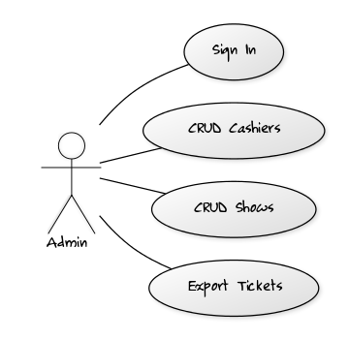

Use case: cashier

Level: user-goal level

Primary actor: cashier

Main success scenario: The cashier signs in and performs CRUD on the tickets

Extensions: CRUD fails because the connection to the database was not properly made

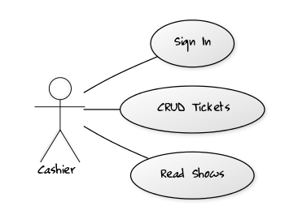

3. System Architectural Design

**3.1 Architectural Pattern Description**

The used architectural pattern is called Layers. In this pattern, the system is organized in three layers: Data Access, Business Layer, Presentation Layer. Each layer communicates only with the layer below it, such that The Presentation Layer shouldn’t have any connection to the Data Access Layer.

**3.2 Diagrams**

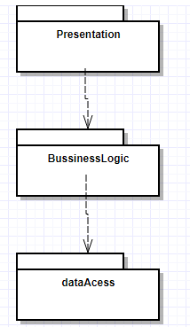

**Bussiness Layer Package**

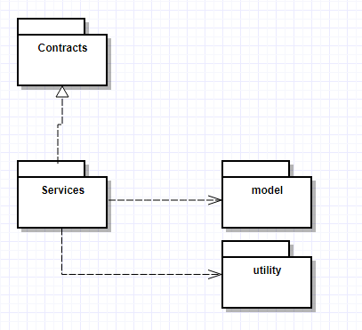

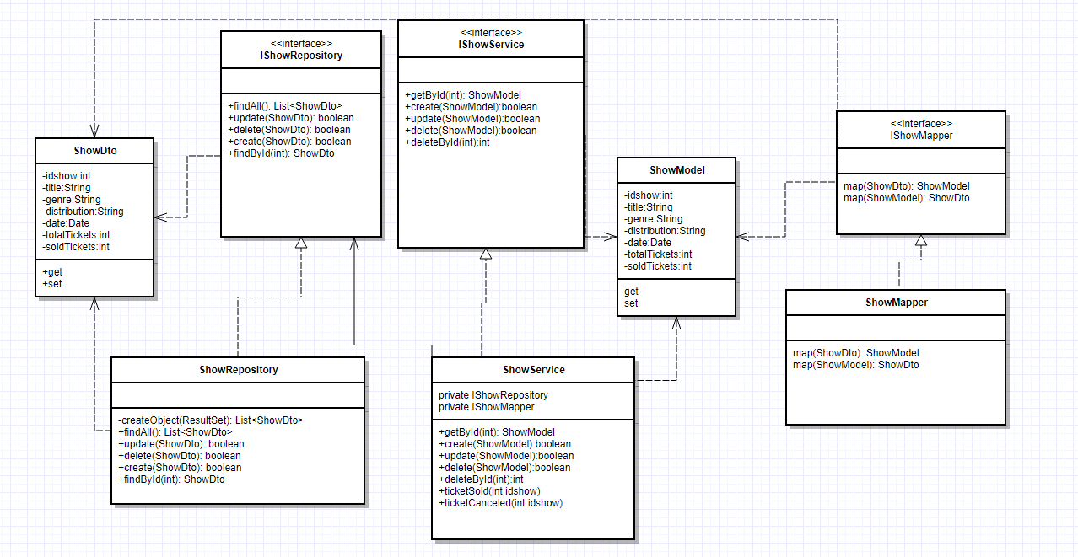

5. Class Design

**5.1 Design Patterns Description**

### SINGLETON

*Singleton has been used in order to make the connection to the database.*

*The Singleton class produces a single instance of an object, which can then be reused.*

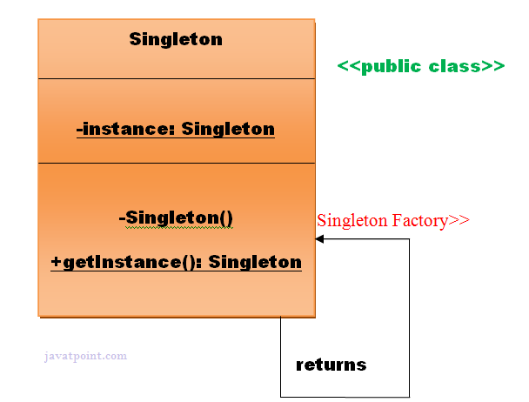

### Dependency Injection and Inversion

*According to the SOLI****D*** *principles, higher level modules shouldn’t depend on lower level modules, and they should depend on abstractions.*

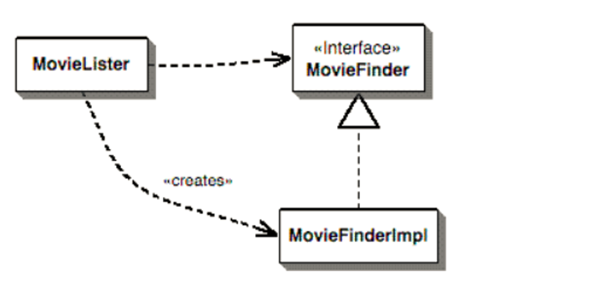

*In this photo, MovieLister depends both on the abstraction(the interface), and also on the implementation. This can be resolved through dependency Injection.*

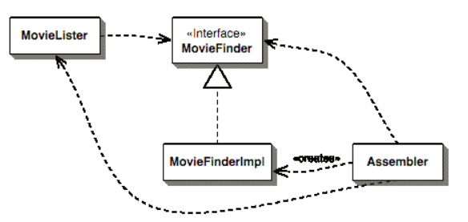

*Right now, the MovieFinderImplementation is created by the assembler, which is then fed to the MovieLister, in our case through a setter.*

*If MovieLister and MovieFinder were in different packages, the MovieLister package would still depend on the MovieFinder package. However, if we move the MovieFinder Interface to Movie Finder’s package, there is no dependency anymore from high level to low level. This is dependency inversion.*

MovieLister’s Package

Classes:

MovieLister

MovieFinder’s Package

Classes:

IMovieFinder

MovieFinderImplementation

MovieLister depends on MovieFinder because of the IMovieFinder interface

By moving the interface to MovieLister’s package, the dependency has been inverted.

The higher lever module no longer depends on the lower level module

MovieLister’s Package

Classes:

MovieLister

IMovieFinder

MovieFinder’s Package

Classes:

MovieFinderImplementation

6. Data Model

**Show**

int idshow

String title

String genre

String distribution

Date date

int totalTickets

int soldTickets

**Ticket**

int idticket

int idshow

int seatNb

int rowNb

String onName

**User**

int idUser

String username

String Password

String permission

String name

7. System Testing

*Testing has been done using JUNIT, testing whether a new ticket can be put on a seat which is already taken. There is also a JUNIT test for testing wether*

8. Bibliography

[www.stackoverflow.com](http://www.stackoverflow.com)

SD Lectures from UTCN