Sportshop website

SD Project

Oltean Victor

30431

Contents

2 VISION 2

2.1 Project Objectives 2

2.2 Users 2

2.3 Main Scenarios 2

2.3.1 Normal users 2

2.3.2 Admin 2

3 Use Case Model 3

3.1 Normal User 3

3.1.1 Use Case Diagram 3

3.1.2 Flow Charts 4

3.2 Admin 5

3.2.1 Use Case Diagram 5

4 Supplementary Specification 6

4.1 Availability 6

4.2 Performance 6

4.3 Security 6

4.4 Testability 6

4.5 Usability 6

4.6 Design Constraints 6

5 Glossary 7

# VISION

## Project Objectives

A website where customers can shop for sports articles. The items are sorted into categories in order to make browsing the website as easy as possible. Each customer has a shopping cart where they can put the items that they have chosen. At the end, they are required to pay for everything in the basket.

The data will be saved in a MySQL Database.

The programming language employed is JAVA, using the Spring Framework.

## Purpose

The purpose of the Vision chapter is to showcase the main objectives of the project, and to introduce the reader in the project’s scope and the reason for its creation.

## Problem Statement

|  |  |
| --- | --- |
| The problem of | having to walk through malls and a lot of shops to find what you like. Another problem which is more important is that in certain places there may be no shops which offer certain products. |
| affects | most people in the world. |
| the impact of which is | big for people from remote areas. |
| a successful solution would be | having an online shop which delivers almost anywhere |

## Product Position Statement

|  |  |
| --- | --- |
| For | Sport Lovers |
| Who | Want to Purchase Easier Online |
| The Sports online shop | is an Online Shop |
| That | eases the purchase of sport products from the comfort of your own home |
| Unlike | normal shops, where one must walk and browse around, wasting more time |
| Our product | offers time efficiency and a larger range of products |

## Stakeholder Summary

|  |  |  |
| --- | --- | --- |
| **Name** | **Description** | **Responsibilities** |
| Producer | This Stakeholder produces the products which are then sold to the online shop. | Provide products  Assures the quality of products  Offers products in time to the shop |
| Delivery Firm | The products need to be transported from the shop’s deposit to the clients’ homes. This is done through the Delivery Firm | Assures the transportation of products  Assures that the product arrives intact at the buyer.  Assures, in the case of returning of a product, the transport from the client back to the shop’s deposit |
| Technical Team | Developers and Site Architects. | Design the Site  Implement the Site Design  Site Maintenance |

## User Summary

There are two types of users. The administrators and the normal users, the customers.

|  |  |  |  |
| --- | --- | --- | --- |
| **Name** | **Description** | **Responsibilities** | **Stakeholder** |
| Customer | Client, which buys products from the website | Add/Remove Products from the Shopping Cart  Create his own Orders  View his Past Orders | No stakeholder |
| Admin | Administrator, takes care of the stock and filters the user reviews. | Creates new Products  Deletes Products  Increase/Reduce stock  Filter User Reviews  Bans Users | No stakeholder |

## User Environment

The user can buy products from the website, by using a web browser. They can make changes to the current shopping cart, such as adding or removing products. Afterwards, they can purchase the products which are in the shopping cart. For this, only one user is needed.

## Product Requirements

Any platform which has a web browser, and at least 2GB of RAM.

## Main Scenarios

### Normal users

A normal user is the customer which wants to gain a product in exchange for money. This customer should be able to:

* Log in
* Register
* Change personal data (E-mail)
* Change password
* Browse the website
* Choose an object category
* From that category, choose objects which meet certain requirements (for example, if buying shoes, the user should be able to select the shoe size)
* See all products which are currently on sale
* Sort objects by price and model date
* Add products to the shopping cart
* Remove products from the shopping cart
* Pay for the objects in the shopping cart
* Cancel an order
* See past orders
* Write Reviews

### Admin

An admin should be able to, besides what a normal user can do:

* Increase/decrease the stock of an object
* Add a new Product
* Remove a Product

# Use Case Model

## Normal User

**Use case: Browse Products**

**Level: user-goal level**

**Primary actor: Normal User**

**Main success scenario: See all the products offered by the online shop**

**Use case: Add Product to Cart**

**Level: user-goal level**

**Primary actor: Normal User**

**Main success scenario: The chosen product is successfully added to the shopping cart**

**Use case: Pay for the Products in the Cart**

**Level: user-goal level**

**Primary actor: Normal User**

**Main success scenario: The Payment Arrives at the Shop. The products are being sent to the customer.**

**Use case: Change Personal Data**

**Level: user-goal level**

**Primary actor: Normal User**

**Main success scenario: The user’s Data is changed.**

### Use Case Diagram

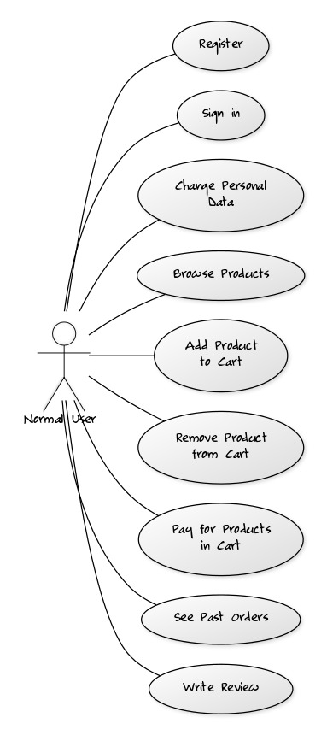

### Flow Charts

#### https://www.lucidchart.com/publicSegments/view/165738f5-3636-42f7-8b0c-f2968d9a8732/image.pngShop

#### https://www.lucidchart.com/publicSegments/view/67292e9a-333c-46fe-b787-bd4483dce0d4/image.pngReview

## Admin

**Use case: Increase Stock**

**Level: user-goal level**

**Primary actor: Admin**

**Main success scenario: The stock of a certain product is increased**

### Use Case Diagram

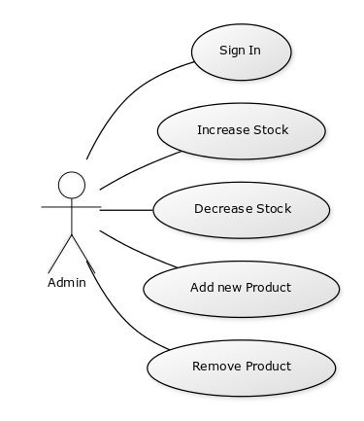

### Flow Charts

#### Increase Stock

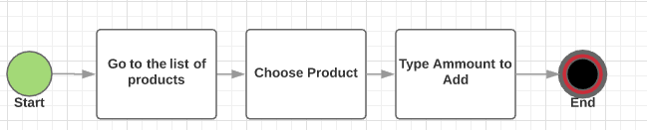

# Supplementary Specification

## Availability

The web application should be available anytime and work on any browser.

## Performance

Everything should run smoothly. There shouldn’t be too many products per page, as to not increase the loading time since there are also pictures.

## Security

The passwords are encrypted, and several methods will be employed to avoid hacking methods, such as SQL injection

## Testability

Unit tests can be created to increase the testability. Tests will check a normal data flow: adding an object to the cart, paying for it and looking at the order history.

## Usability

The usage should come naturally, to both the administrator and the normal user.

## Design Constraints

The software is written in Java using the Spring Framework. The data is stored in a SQL Database

# Glossary

|  |  |
| --- | --- |
| **Term** | **Definition and Information** |
| Management system | System used to control and create certain objects, placing them in a controlled environment. |
| Product | An object sold by the website |
| Database | A collection of information that can be easily manipulated. |
| Warehouse | The place where all the products are sold |
| Retail | The sale of goods to the public in relatively small quantities for use or consumption rather than for resale. |
| Sports Shop | A shop where sport related products are sold |