

Module: **Advanced Database**

Student Number: C17387213

Student Name: Victor Olasupo

Project Title: **HOT JUICE LTD.**

**I. Project description**

Hot Juice Limited is a company that produces Vape Juice. The company buys ingredients for their juice from several suppliers. They keep a monthly record of their purchases.

Hot Juice has employed several employees who prepare the juice from the ingredients. Some Juices are harder to produce than others so they are produced in different departments. These employees are split into these departments. The juices produced are then sold to several retail stores. These sales are recorded in inventory on a monthly basis.

The company would like to keep track of their purchases of ingredients and their suppliers. They would also like to keep track of their employees along with their salary. There are 30 employees currently employed. These employees specialize in different juice manufacturing departments based on their experience.

Hot Juice Ltd like to keep track of the value of their sales, when the sales were made and who they were purchased by.

Unfortunately, the company have a lot of expenses and they are curious to see where costs could be cut within the company. An example would be to examine how much would be saved if they released the highest paid employees and replace them with lower skilled staff.

They would also like to keep track of where their employees live with the idea of releasing staff who live too far away from the company building to ensure time efficiency and long hours can be worked.

The management also proposed also take notice of the location of their customers in order to reduce costs by having one single delivery system to each city rather than multiple delivery systems to the same city.

**II. Entity Relationship diagram**

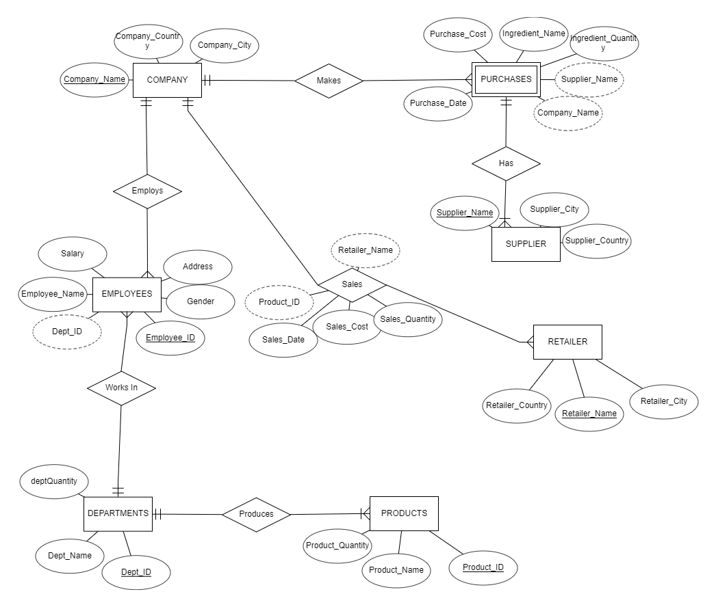

**III. Relational model**

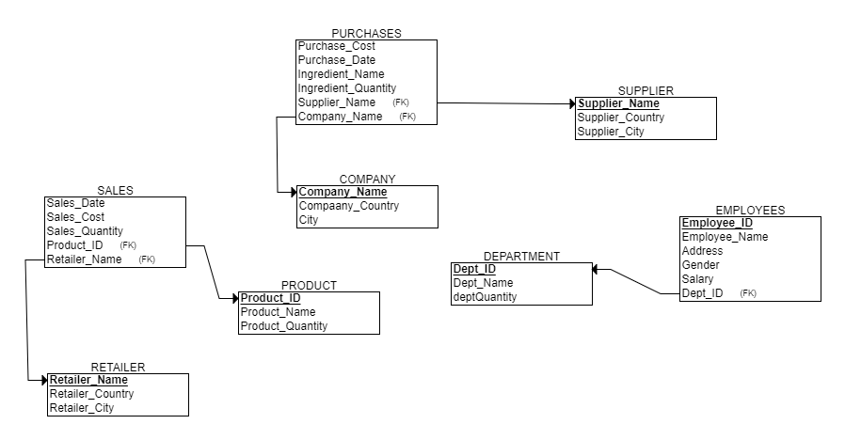

**IV. SQL scripts**

**'Create table Company**

CurrentDb.Execute ("CREATE TABLE Company (companyName Text (40) PRIMARY KEY, companyCountry Text (40), companyCity Text (40))")

**'Create table Supplier**

CurrentDb.Execute ("CREATE TABLE Supplier (supplierName Text (40) PRIMARY KEY, supplierCountry Text (40), supplierCity Text (40))")

**'Create table Retailer**

CurrentDb.Execute ("CREATE TABLE Retailer (retailerName Text (40) PRIMARY KEY, retailerCountry Text (40), retailerCity Text (40))")

**'Create table Products**

CurrentDb.Execute ("CREATE TABLE Products (productID Text PRIMARY KEY, productName Text (40), productQuantity Short)")

**'Create table Purchases**

Sql = "CREATE TABLE Purchases (supplierName Text (40) REFERENCES Supplier (supplierName), “+ _

“CompanyName Text (40) REFERENCES Company (companyName),” + _

“ingredientName Text (40),” + _

“ingredientQuantity Short,” + _

“purchaseCost Currency, “+ _

“purchaseDate DateTime)"

CurrentDb.Execute (sql)

**'Create table Departments**

Sql = "CREATE TABLE Departments (deptID Text PRIMARY KEY, “+ _

“deptName Text (40),” + _

“deptQuantity Short)"

CurrentDb.Execute (sql)

**'Create table Employees**

Sql = "CREATE TABLE Employees (employeeID Text PRIMARY KEY, “+ _

“deptID Text REFERENCES Departments (deptID), “+ _

“employeeName Text (40), “+ _

“Gender Text (40),” + _

“Address Text (40),” + _

“Salary Currency)"

CurrentDb.Execute (sql)

**'Create table Sales**

Sql = "CREATE TABLE Sales (productID Text REFERENCES Products (productID), “+ _

“retailerName Text (40) REFERENCES Retailer (retailerName), “+ _" salesDate DateTime,” + _

“salesCost Currency, “+ _

" salesQuantity Short)"

CurrentDb.Execute (sql)

**'Insert data into DB**

**'Company Data**

CurrentDb.Execute ("INSERT INTO Company (companyName, companyCountry,companyCity)VALUES ('HOT JUICE LTD', 'IRELAND', 'Dublin')")

**'Supplier Data**

CurrentDb.Execute ("INSERT INTO Supplier (supplierName, supplierCountry,supplierCity)VALUES ('DAVES JUICE', 'IRELAND', 'Waterford')")

CurrentDb.Execute ("INSERT INTO Supplier (supplierName, supplierCountry,supplierCity)VALUES ('ELIZABETH FLAVOURS', 'ENGLAND', 'Manchester')")

CurrentDb.Execute ("INSERT INTO Supplier (supplierName, supplierCountry,supplierCity)VALUES ('ROYAL JUICE', 'FRANCE', 'Paris')")

**'Retailer Data**

CurrentDb.Execute ("INSERT INTO Retailer (RetailerName, RetailerCountry, RetailerCity)VALUES ('PURPLEBOX VAPOURS', 'IRELAND', 'Dublin')")

CurrentDb.Execute ("INSERT INTO Retailer (RetailerName, RetailerCountry, RetailerCity)VALUES ('VIP E CIGARETTE', 'IRELAND', 'Cork')")

CurrentDb.Execute ("INSERT INTO Retailer (RetailerName, RetailerCountry, RetailerCity)VALUES ('IVAPE', 'IRELAND', 'Kildare')")

CurrentDb.Execute ("INSERT INTO Retailer (RetailerName, RetailerCountry, RetailerCity)VALUES ('KIX VAPING', 'IRELAND', 'Dublin')")

CurrentDb.Execute ("INSERT INTO Retailer (RetailerName, RetailerCountry, RetailerCity)VALUES ('TRIUMPH LIGHTING', 'IRELAND', 'Donegal')")

CurrentDb.Execute ("INSERT INTO Retailer (RetailerName, RetailerCountry, RetailerCity)VALUES ('VAPE CLUB', 'IRELAND', 'Dublin')")

CurrentDb.Execute ("INSERT INTO Retailer (RetailerName, RetailerCountry, RetailerCity)VALUES ('IRON STONE VAPE', 'IRELAND', 'Dublin')")

**'Purchases Data**

CurrentDb.Execute ("INSERT INTO Purchases (supplierName, companyName,ingredientName,ingredientQuantity,purchaseCost,purchaseDate)VALUES ('DAVES JUICE', 'HOT JUICE LTD', 'BLUE J',100,70,'18-MAY-18')")

CurrentDb.Execute ("INSERT INTO Purchases (supplierName, companyName,ingredientName,ingredientQuantity,purchaseCost,purchaseDate)VALUES ('ELIZABETH FLAVORS', 'HOT JUICE LTD', 'RED J',100,400,'20-APR-18')")

CurrentDb.Execute ("INSERT INTO Purchases (supplierName, companyName,ingredientName,ingredientQuantity,purchaseCost,purchaseDate)VALUES ('ROYAL JUICE', 'HOT JUICE LTD', 'GREEN J',100,2000,'19-MAR-18')")

**'Products Data**

CurrentDb.Execute ("INSERT INTO Products (productID, productName,productQuantity)VALUES ('P230', 'DARK BLUE JUICE',20 )")

CurrentDb.Execute ("INSERT INTO Products (productID, productName,productQuantity)VALUES ('P231', 'NAVY BLUE JUICE',60 )")

CurrentDb.Execute ("INSERT INTO Products (productID, productName,productQuantity)VALUES ('P232', 'CADET BLUE JUICE',20 )")

CurrentDb.Execute ("INSERT INTO Products (productID, productName,productQuantity)VALUES ('P233', 'RED JUICE',35 )")

CurrentDb.Execute ("INSERT INTO Products (productID, productName,productQuantity)VALUES ('P334', 'SCARLET RED JUICE',40 )")

CurrentDb.Execute ("INSERT INTO Products (productID, productName,productQuantity)VALUES ('P335', 'CORAL-RED JUICE',25 )")

CurrentDb.Execute ("INSERT INTO Products (productID, productName,productQuantity)VALUES ('P436', 'LIME GREEN JUICE',20 )")

CurrentDb.Execute ("INSERT INTO Products (productID, productName,productQuantity)VALUES ('P437', 'EMERALD GREEN JUICE',10 )")

CurrentDb.Execute ("INSERT INTO Products (productID, productName,productQuantity)VALUES ('P238', 'SHAMROCK GREEN JUICE',70 )")

**'Departments Data**

CurrentDb.Execute ("INSERT INTO Departments (deptID, deptName,deptQuantity)VALUES ('D100', 'BEGINNER LAB',4 )")

CurrentDb.Execute ("INSERT INTO Departments (deptID, deptName,deptQuantity)VALUES ('D200', 'INTERMEDIATE LAB',3 )")

CurrentDb.Execute ("INSERT INTO Departments (deptID, deptName,deptQuantity)VALUES ('D300', 'PRO LAB',2)")

**'Employees Data**

CurrentDb.Execute ("INSERT INTO Employees (employeeID, deptID,employeeName,Gender,Address,Salary)VALUES ('E100', 'D100','Ryley Blakely','Male','40 Gorey, Co.Wexford',20000 )")

CurrentDb.Execute ("INSERT INTO Employees (employeeID, deptID,employeeName,Gender,Address,Salary)VALUES ('E300', 'D300','Evette Langley','Female','Market sq Trim, Co.Meath',65000 )")

CurrentDb.Execute ("INSERT INTO Employees (employeeID, deptID,employeeName,Gender,Address,Salary)VALUES ('E500', 'D100','Ella Kimberly','Female','3 cormac st, Dublin 20',18000 )")

CurrentDb.Execute ("INSERT INTO Employees (employeeID, deptID,employeeName,Gender,Address,Salary)VALUES ('E700', 'D200','Daly Joseph','Male','22 Ashgrave manor, Dublin 2',35000 )")

CurrentDb.Execute ("INSERT INTO Employees (employeeID, deptID,employeeName,Gender,Address,Salary)VALUES ('E900', 'D200','Gerrard Waller','Male','45 the square, Dublin 15',35000 )")

CurrentDb.Execute ("INSERT INTO Employees (employeeID, deptID,employeeName,Gender,Address,Salary)VALUES ('E200', 'D100','Branson Tucker','Male','88 the sullivans quay, Co.Cork',20000 )")

CurrentDb.Execute ("INSERT INTO Employees (employeeID, deptID,employeeName,Gender,Address,Salary)VALUES ('E400', 'D300','Lionel Messi','Male','88 the sullivans quay, Co.Cork',70000 )")

CurrentDb.Execute ("INSERT INTO Employees (employeeID, deptID,employeeName,Gender,Address,Salary)VALUES ('E600', 'D100','Tiana Perkins','Female','11 market sq, Co.Meath',25000 )")

CurrentDb.Execute ("INSERT INTO Employees (employeeID, deptID,employeeName,Gender,Address,Salary)VALUES ('E900', 'D200','Watt Barber','Male','93 patrick square, Co.Cork',40000 )")

**'Sales data**

CurrentDb.Execute ("INSERT INTO Sales (productID, retailerName,salesDate,salesCost,salesQuantity)VALUES ('P438', 'PURPLE BOX VAPOURS','14-JUN-18',350,10 )")

CurrentDb.Execute ("INSERT INTO Sales (productID, retailerName,salesDate,salesCost,salesQuantity)VALUES ('P230', 'IRON STONE VAPE','25-AUG-18',150,50 )")

CurrentDb.Execute ("INSERT INTO Sales (productID, retailerName,salesDate,salesCost,salesQuantity)VALUES ('P232', 'IVAPE','10-FEB-18',120,25)")

CurrentDb.Execute ("INSERT INTO Sales (productID, retailerName,salesDate,salesCost,salesQuantity)VALUES ('P231', 'TRIUMPH LIGHTING','23-JUN-18',20,5 )")

CurrentDb.Execute ("INSERT INTO Sales (productID, retailerName,salesDate,salesCost,salesQuantity)VALUES ('P233', 'PURPLE BOX VAPOURS','21-JAN-18',250,40 )")

CurrentDb.Execute ("INSERT INTO Sales (productID, retailerName,salesDate,salesCost,salesQuantity)VALUES ('P435', 'VAPE CLUB','15-JUN-18',400,35 )")

CurrentDb.Execute ("INSERT INTO Sales (productID, retailerName,salesDate,salesCost,salesQuantity)VALUES ('P237', 'VAPE E-CIGARETTE','2-JUN-18',100,20 )")

CurrentDb.Execute ("INSERT INTO Sales (productID, retailerName,salesDate,salesCost,salesQuantity)VALUES ('P336', 'KIX VAPING','30-JUN-18',200,35 )")

CurrentDb.Execute ("INSERT INTO Sales (productID, retailerName,salesDate,salesCost,salesQuantity)VALUES ('P334', 'PURPLE BOX VAPOURS','18-JUN-18',130,20 )")