Fundamentos Matemáticos y Físicos para Informática Gráfica

Estructuras y Algoritmos con Mallas de Triángulos (Práctica 1)
Víctor Orrios Barón – v.orrios.2026@alumnos.urjc.es

Ejercicio 1.
mannequin2.ply
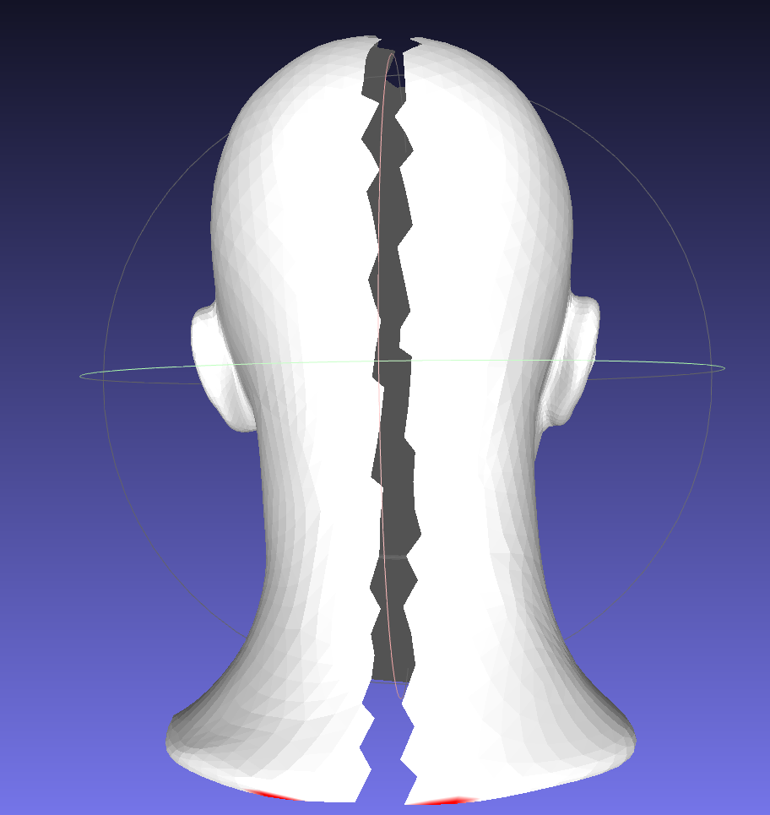
Loading file mallas/mannequin2.ply
Num vertex: 6706 Num triangles: 13255 Unreferenced vertex: 0
Area min: 0.0013 max: 0.7581 average: 0.1191 total: 1578.9170
Angle min: 0.1189 max: 2.7538
EdgeLen min: 0.0382 max: 1.8653 average: 0.4935
ShapeF min: 0.1370 max: 0.9978 average: 0.7183
VertexA min: 0.0045 max: 1.3521 average: 0.2354 total: 1578.9170
Triangle 2014 has ShapeFactor < 0.1441
Triangle 3484 has ShapeFactor < 0.1370
Triangle 3748 has ShapeFactor < 0.1420
Saving output to output_statistic.ply
Executing external command: …

mask2.ply
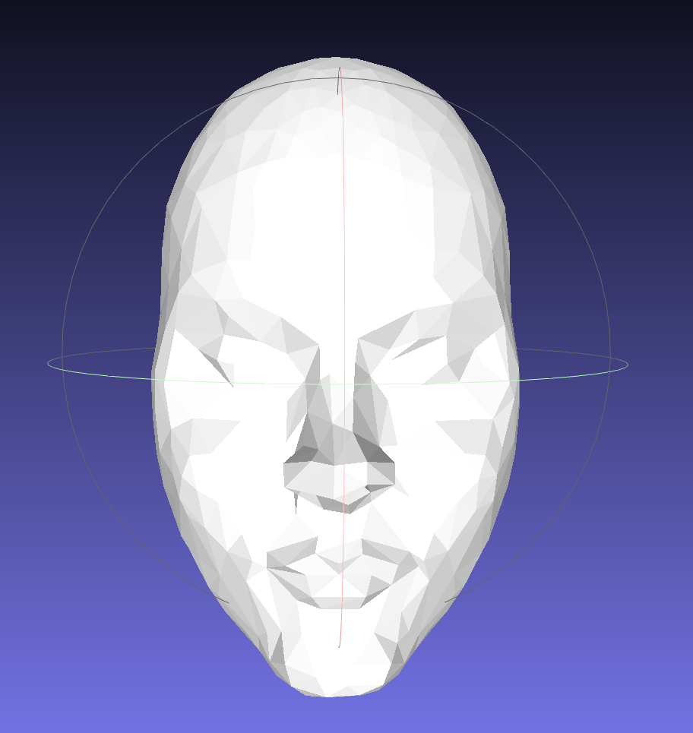
(Ningún triangulo en rojo)
Loading file mallas/mask2.ply
Num vertex: 326 Num triangles: 595 Unreferenced vertex: 0
Area min: 0.0009 max: 0.0158 average: 0.0048 total: 2.8641
Angle min: 0.1790 max: 2.5062
EdgeLen min: 0.0316 max: 0.2674 average: 0.1118
ShapeF min: 0.2056 max: 0.9774 average: 0.6834
VertexA min: 0.0011 max: 0.0206 average: 0.0088 total: 2.8641
Saving output to output_statistic.ply
Executing external command: ...

Ejercicio 2
mannequin2.ply
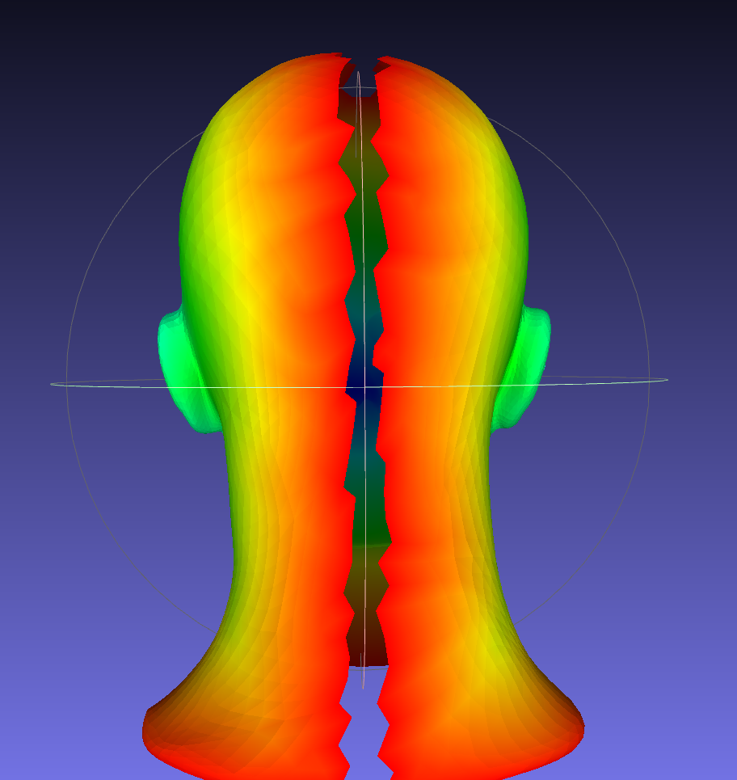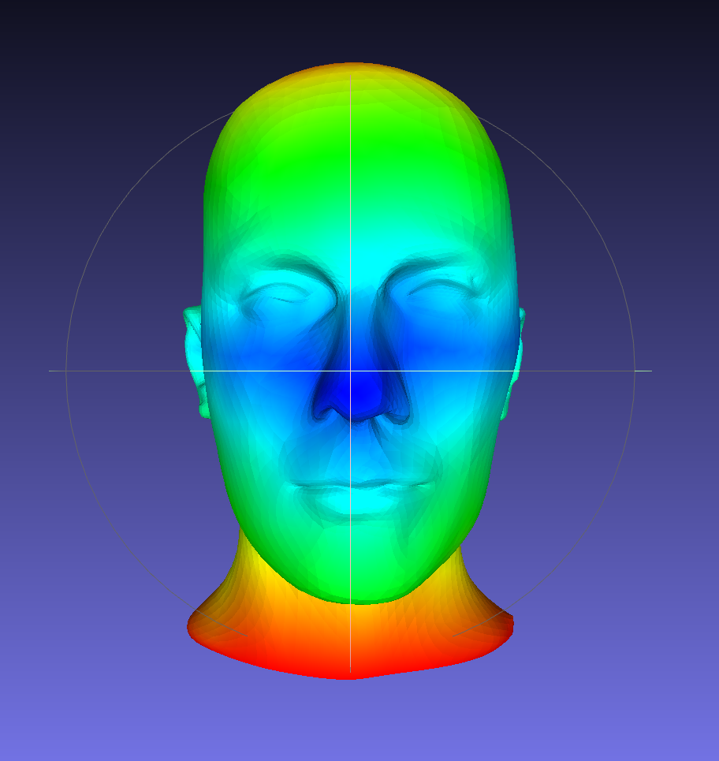
Loading file mallas/mannequin2.ply
Num vertex: 6706 Num triangles: 13255 Unreferenced vertex: 0
Done updateEdgeLists() 0.00218388 seconds
155 boundary edges
19805 internal edges
Edges in the boundary:
[3440->3437] [3437->3434] [3434->3432] [3432->5667] [5667->5669] [5669->5672] [5672->4310] [4310->43
11] [4311->4313] [4313->4318] [4318->4316] [4316->5936] [5936->5933] [5933->5930] [5930->5928] [5928
->6704] [6704->6702] [6702->6700] [6700->4838] [4838->4905] [4905->4906] [4906->4908] [4908->3937] [
3937->3949] [3949->3946] [3946->3943] [3943->3941] [3941->5614] [5614->5611] [5611->5608] [5608->368
4] [3684->5197] [5197->5198] [5198->5200] [5200->2941] [2941->2942] [2942->2937] [2937->2935] [2935-
>2461] [2461->2462] [2462->2464] [2464->2467] [2467->2359] [2359->2360] [2360->2362] [2362->2365] [2
365->2203] [2203->5941] [5941->6029] [6029->6027] [6027->1079] [1079->1078] [1078->616] [616->617] [
617->611] [611->609] [609->585] [585->5496] [5496->5497] [5497->5499] [5499->233] [233->69] [69->70]
[70->68] [68->42] [42->41] [41->45] [45->43] [43->6] [6->12] [12->14] [14->21] [21->22] [22->40] [4
0->131] [131->134] [134->132] [132->5948] [5948->176] [176->183] [183->179] [179->313] [313->312] [3
12->5796] [5796->750] [750->752] [752->749] [749->747] [747->5245] [5245->5600] [5600->5598] [5598->
1503] [1503->1511] [1511->1507] [1507->1505] [1505->1506] [1506->1502] [1502->1500] [1500->1501] [15
01->5247] [5247->5248] [5248->5246] [5246->743] [743->744] [744->5797] [5797->386] [386->384] [384->
177] [177->178] [178->175] [175->174] [174->36] [36->37] [37->39] [39->35] [35->18] [18->19] [19->13
] [13->6343] [6343->7] [7->8] [8->11] [11->10] [10->9] [9->71] [71->5336] [5336->5337] [5337->143] [
143->142] [142->144] [144->6174] [6174->583] [583->588] [588->586] [586->653] [653->612] [612->619]
[619->618] [618->5939] [5939->5940] [5940->5942] [5942->2200] [2200->2205] [2205->2204] [2204->2208]
[2208->2206] [2206->2386] [2386->2387] [2387->2391] [2391->2389] [2389->2693] [2693->2691] [2691->2
689] [2689->2545] [2545->3440]
Boundary length: 130.406
Euler Characteristic: 1
Done boundDist() 0.00348756 seconds
maxDistance to boundary: 20.4994 at vertex: 5187
Saving output to output_boundary.ply
Done colorize by distance to boundary 0.00616269 seconds
Executing external command: ...
mask2.ply
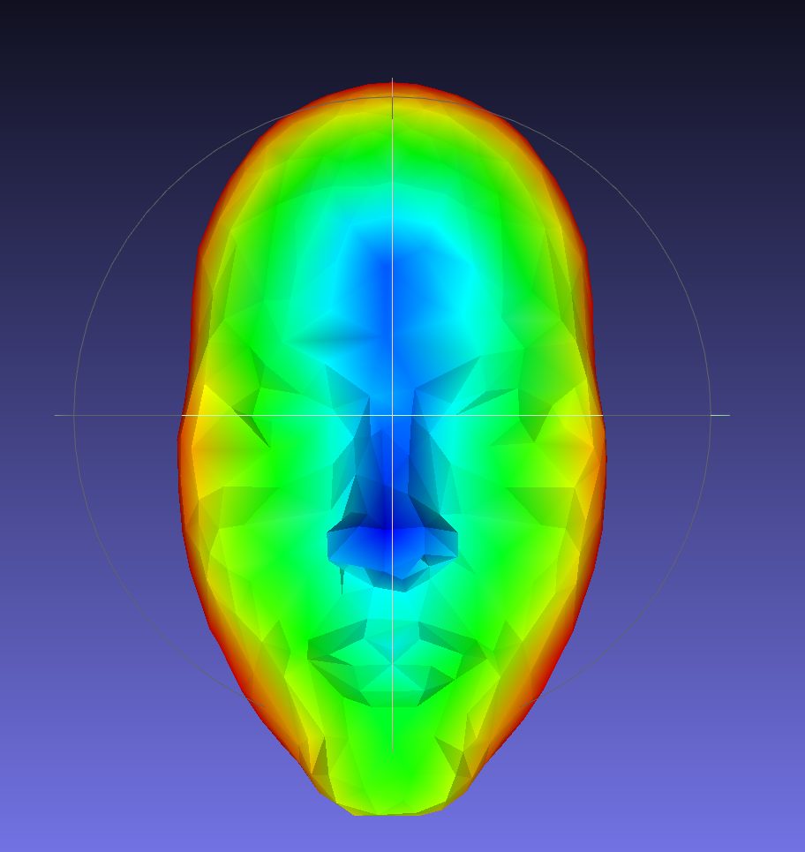
Loading file mallas/mask2.ply
Num vertex: 326 Num triangles: 595 Unreferenced vertex: 0
Done updateEdgeLists() 9.5508e-05 seconds
55 boundary edges
865 internal edges
Edges in the boundary:
[318->320] [320->319] [319->192] [192->205] [205->269] [269->189] [189->204] [204->187] [187->263] [
263->203] [203->266] [266->265] [265->198] [198->39] [39->104] [104->36] [36->105] [105->27] [27->43
] [43->30] [30->44] [44->42] [42->45] [45->152] [152->154] [154->144] [144->143] [143->145] [145->12
3] [123->151] [151->150] [150->165] [165->114] [114->115] [115->21] [21->20] [20->13] [13->17] [17->
16] [16->14] [14->173] [173->175] [175->172] [172->178] [178->179] [179->276] [276->275] [275->196]
[196->313] [313->316] [316->315] [315->314] [314->301] [301->317] [317->318]
Boundary length: 5.19081
Euler Characteristic: 1
Done boundDist() 0.000164297 seconds
maxDistance to boundary: 0.866628 at vertex: 99
Saving output to output_boundary.ply
Done colorize by distance to boundary 0.000368672 seconds
Executing external command: …

Nefertiti.990kv.ply
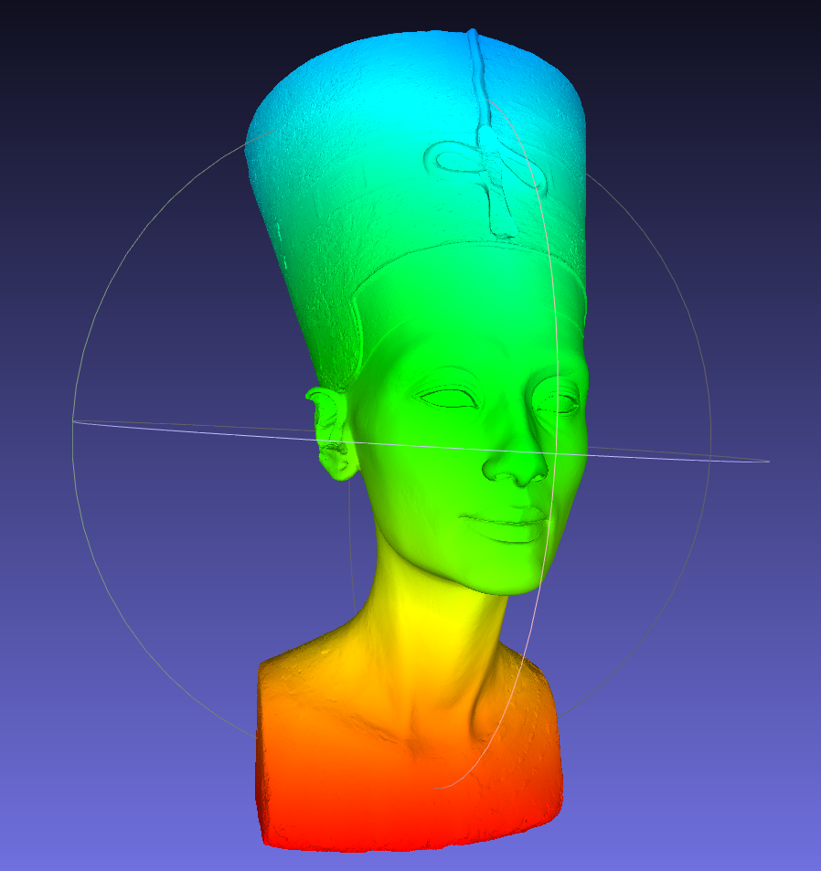
Loading file mallas/Nefertiti.990kv.ply
Num vertex: 990781 Num triangles: 1980517 Unreferenced vertex: 0
Done updateEdgeLists() 1.28514 seconds
1043 boundary edges
2970254 internal edges
Edges in the boundary:
[865110->865109] [865109->865089] [865089->865092] [865092->865091] [865091->865090] [865090->865094
] [865094->865084] ...[865185->865173] [865173->865150] [865150->865148] [865148->865139] [865139->865133] [86
5133->865134] [865134->865110]
Boundary length: 644.293
Euler Characteristic: 1
Done boundDist() 1.77563 seconds
maxDistance to boundary: 628.777 at vertex: 429856
Saving output to output_boundary.ply
Done colorize by distance to boundary 2.05711 seconds
Executing external command: …

angel_kneeling.150kv.ply
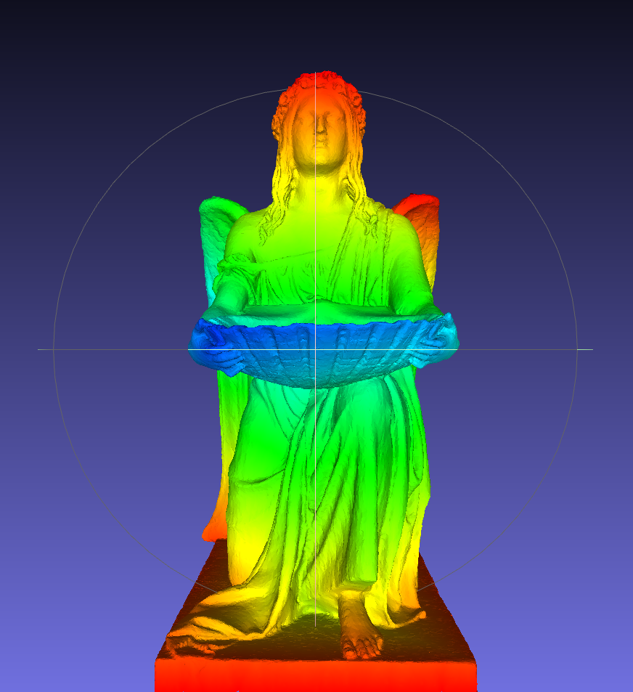
Loading file mallas/angel_kneeling.150kv.ply
Num vertex: 150372 Num triangles: 299992 Unreferenced vertex: 0
Done updateEdgeLists() 0.0702919 seconds
766 boundary edges
449605 internal edges
Edges in the boundary:
[90757->91693] [91693->91819] [91819->85650] [85650->90176] [90176->91772] [91772->91851] [91851->90
736] [90736→85646] ... [147467->150357] [150357->149582] [149582->149579] [149579->142156]
Boundary length: 50.2121
Euler Characteristic: -7
Done boundDist() 0.114899 seconds
maxDistance to boundary: 13.7901 at vertex: 44431
Saving output to output_boundary.ply
Done colorize by distance to boundary 0.168078 seconds
Executing external command: ...

Ejercicio 3
mask2.ply
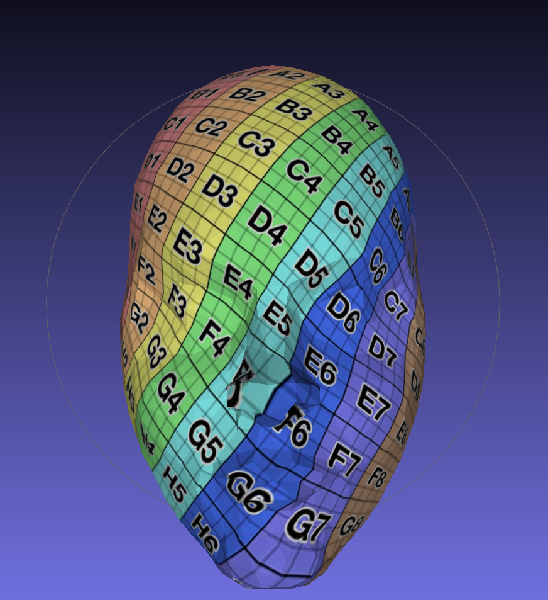
Loading file mallas/mask2.ply
Num vertex: 326 Num triangles: 595 Unreferenced vertex: 0
55 vertex in external boundary:
[318->320] [320->319] [319->192] [192->205] [205->269] [269->189] [189->204] [204->187] [187->263] [
263->203] [203->266] [266->265] [265->198] [198->39] [39->104] [104->36] [36->105] [105->27] [27->43
] [43->30] [30->44] [44->42] [42->45] [45->152] [152->154] [154->144] [144->143] [143->145] [145->12
3] [123->151] [151->150] [150->165] [165->114] [114->115] [115->21] [21->20] [20->13] [13->17] [17->
16] [16->14] [14->173] [173->175] [175->172] [172->178] [178->179] [179->276] [276->275] [275->196]
[196->313] [313->316] [316->315] [315->314] [314->301] [301->317] [317->318]
Done compute Boundary. 0.000109868 seconds
Computing Laplacian matrix (sparse):
Done matrix init. 0.000188387 seconds
Done Laplacian matrix (sparse). 0.000198867 seconds
Computing System matrix:
Done System matrix. 0.000282545 seconds
Computing contour conditions:
Done contour conditions. 0.000286195 seconds
Solving the system using Eigen (sparse):
Done solving the system. 0.000916605 seconds
Saving parameterization mesh to output_UVMesh1.ply
Saving texture mesh to output_UVMesh2.ply
Executing external command: …

MaxPlanck.45kv.ply
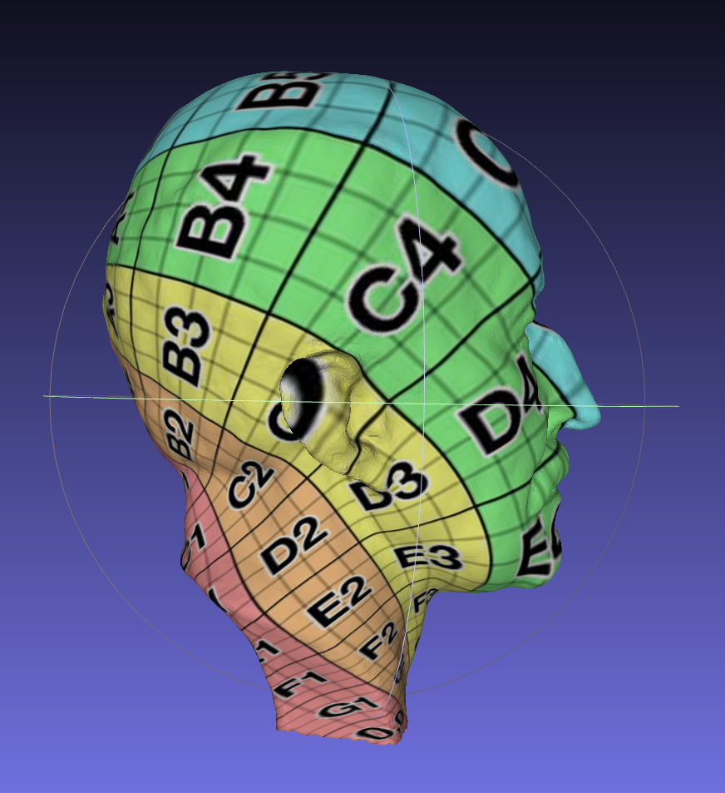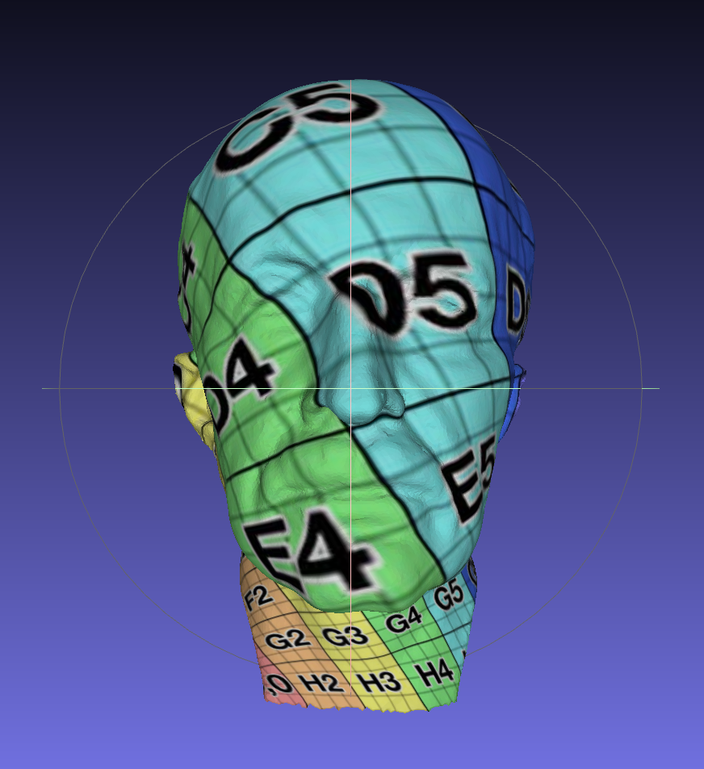
Loading file mallas/MaxPlanck.45kv.ply
Num vertex: 45045 Num triangles: 89641 Unreferenced vertex: 0
447 vertex in external boundary:
Done compute Boundary. 0.0150644 seconds
Computing Laplacian matrix (sparse):
Done matrix init. 0.0214511 seconds
Done Laplacian matrix (sparse). 0.0221815 seconds
Computing System matrix:
Done System matrix. 0.0908542 seconds
Computing contour conditions:
Done contour conditions. 0.0908883 seconds
Solving the system using Eigen (sparse):
Done solving the system. 0.286151 seconds
Saving parameterization mesh to output_UVMesh1.ply
Saving texture mesh to output_UVMesh2.ply
Executing external command: ...

Nefertiti.990kv.ply
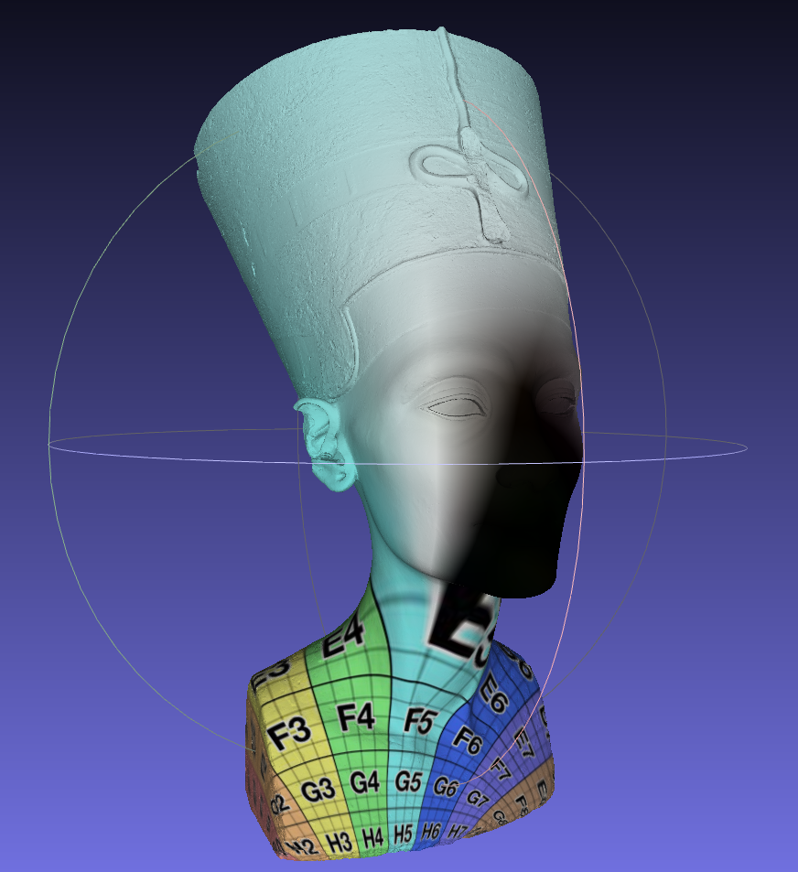
Loading file mallas/Nefertiti.990kv.ply
Num vertex: 990781 Num triangles: 1980517 Unreferenced vertex: 0
1043 vertex in external boundary:
Done compute Boundary. 1.24172 seconds
Computing Laplacian matrix (sparse):
Done matrix init. 1.37235 seconds
Done Laplacian matrix (sparse). 1.39521 seconds
Computing System matrix:
Done System matrix. 5.57332 seconds
Computing contour conditions:
Done contour conditions. 5.57395 seconds
Solving the system using Eigen (sparse):
Done solving the system. 17.9993 seconds
Saving parameterization mesh to output_UVMesh1.ply
Saving texture mesh to output_UVMesh2.ply
Executing external command: ...

