**Introduction**

The purpose of this memo is to advise the New York City Department of Transportation (DOT) on issues of equity in access to adequate bike infrastructure. It is in support of streamlining the reception of feedback from Community Boards in the process of building bike lanes to more efficiently expand bike infrastructure to key areas of the city.

**Background: Cyclist Safety Is a Privilege of the Rich**

New York City has the largest number of bicycle commuters of any U.S. city[1], but lacks the robust bike infrastructure necessary to keep its cyclists safe[2]. More so, good bike infrastructure is concentrated in wealthier[3], whiter[4] areas of the city, presenting a pressing issue of equity in access to safe streets. Likely because of this discrepancy, New York’s more diverse boroughs[5] (particularly Queens and the Bronx) bear a disproportionate amount of cyclist fatalities relative to their cyclist commuter population[6]. This effect is the opposite in Manhattan, the borough with the most substantial bike infrastructure, which has seen only 24% of cyclist fatalities in the city since 2016 despite being home to 39% of its cyclist commuters[7]. In this way, a lack of access to better bike infrastructure is not just inconveniencing residents of more diverse and low-income areas of the city, it is killing them at disproportionately high rates compared to their whiter and wealthier neighbors.

Bike lanes make roads safer for pedestrians, cyclists and drivers alike. In particular, protected bike lanes have been found to increase safety significantly[8], and are the primary solution sought after by cyclist activists. However, a map of protected bike lanes shows they are concentrated in Manhattan and North Brooklyn and virtually nonexistent in South Brooklyn, much of the Bronx and Queens[9].

**The Problem: Community Boards Are a Time Suck**

A key barrier to building out bike infrastructure in these areas is opposition by local Community Boards. Community Board opposition has played a clear and significant role in preventing the expansion of bike lanes and safety improvements to key areas of the Bronx, Brooklyn and Queens, and has caused various projects proposed by the DOT to be stalled for multiple years[10]. This is because despite Community Board approval being completely advisory, the DOT can be swayed to stop a project if the local Community Board votes against it.

In low-income, diverse areas which often are most in need of bike lane improvements, bike lanes can be seen as a sign of gentrification and an inconvenience to local drivers. Additionally, poor bike infrastructure is correlated with poor access to other forms of public transit[11], which leads to higher rates of car ownership[12]. For this reason, the convenience of cars can be weighted more heavily when Community Boards are making decisions about bike lanes in these areas[13]. This can manifest in vehement community opposition to any bike lanes or safety measures proposed, causing the DOT to pause or do away with infrastructural improvements.

An egregious example of this is Gerritsen Avenue in South Brooklyn. Known to be a dangerous road, the DOT took action to improve safety by adding a painted median and a four-lane-to-three-lane road diet in 2005 after a motorist severely injured a child cyclist[14]. However, proposals in 2008 and 2009 presented to the local community board to add concrete pedestrian islands and painted bike lanes were dropped due to community opposition[15]. It was not until 2016, when a drunk driver fatally struck a teenage cyclist, that the DOT took action and decided it would install a two-way protected bike lane despite community opposition[16], completing the project in 2018[17]. In this case, it took 10 years and multiple lives to improve the safety of a street known to be dangerous, solely because the community opposed it. Other examples include projects to add bike lanes on Clinton Avenue in Brooklyn, proposed in 2016[18] and Harding Avenue, Emerson Avenue to Pennyfield Avenue in the Bronx, proposed in 2020[19], both of which have not been completed at the time this memo was written after local Community Board opposition.

An additional cause for concern is the fact that Community Boards are often not representative of their communities. Demographic data on the bodies released in 2019 shows that they tend to be whiter, more male and older than the populations they represent[20]. This adds another layer to the issue and more reason for questioning the weight given to Community Board decisions.

To be clear, not every Community Board opposes bike lanes. On the contrary, they can be some of the most outspoken advocates for them[21], and in certain instances have been instrumental in pushing the DOT to install bike lanes in given areas. This memo seeks to maintain Community Boards’ ability to do so, while addressing the aspect of the community feedback process which allows for dogged disapproval to end discussions about how to improve cyclist and pedestrian safety, and consequently efforts to do so as well.

**The Solution: Improve Communication, Shorten the Feedback Process**

In order to improve the DOT’s ability to efficiently install bike lanes, this memo proposes that the DOT remove the option for Community Boards to vote “no” on a bike lane proposal. Instead, the DOT should present three possible ways bike lanes could be added to a given area and allow Community Boards to vote on which of the three they feel is best and provide additional feedback on the proposal they decide on. Although this takes some agency away from Community Boards, by doing so the DOT should be able to greatly improve cyclist safety across the city at record speeds.

Additionally, the DOT should continue to conduct outreach in these communities like it currently does but limit the process to 90 days after presenting to a Community Board. The DOT is required by law[22] to notify local City Council Members and Community Boards of an impending project 90 days prior to construction beginning. So, conducting the feedback process within this timeframe would conform with local law while expediting construction of bike infrastructure.

Lastly, the DOT should increase decision-maker involvement in the community feedback process. Interviews with members of Community Board 7, which has been a strong advocate of bike lanes and communicated with other Community Boards on this topic, suggest that the DOT does not always accept Community Board feedback. Part of the problem, according to aforementioned members, is that the current middlemen between the DOT and Community Boards — community liaisons — do not have any power in the DOT’s decision-making process regarding how bike lanes are built. For this reason, although the Community Board members had a positive view of their liaison and believed they were accurately communicating their concerns to the DOT, they claim their feedback was not incorporated into any final proposals in multiple instances. Therefore, liaisons should be given a role in the decision-making process, or someone who already is in a decision-making role should be in direct contact with Community Boards throughout the process.

If these suggestions are followed, Community Boards will still play a significant role in the shaping of their communities through bike infrastructure, but the DOT will no longer take years to build a single stretch of bike lanes. Since Community Board opposition tends to eventually be overridden, this proposal would not only eliminate an unnecessary and time-consuming back-and-forth with Community Boards, but it would also increase the useful feedback received. This is because when the DOT does eventually override a “no” from a Community Board, it often means that no feedback is incorporated into its final plans. By removing that option, communities are forced to provide feedback on DOT proposals rather than simply oppose them, which the DOT can and should incorporate into the final product.

**Implementation: DOT Organizational Structure Must Emphasize Accountability**

Policy changes within the DOT can be a difficult organizational undertaking. The biggest challenge to this is leadership apathy: DOT leadership must believe in and commit to the changes and hold workers below them accountable.

According to Community Board 7 members who have worked closely with DOT officials in multiple administrations, DOT efficiency has dropped significantly under the De Blasio administration compared to his predecessors, Bloomberg and Giuliani. But in 2022, there will be a new mayor and a new team around him or her. This will be a key opportunity to adjust the DOT’s current organizational culture.

To best implement the proposed solutions, incoming leadership should emphasize order and purpose as defined in “The Leader’s Guide to Corporate Culture.”[23] Order means to focus on respect, structure and commitment to rules. In order to achieve high levels of efficiency, leaders must emphasize the importance of working within a given structure. This will encourage accountability to deadlines. Purpose means leaders should emphasize shared ideals and a greater good. In this case, it is essential for DOT leadership to make the bureaucracy have an underlying higher purpose to keep workers motivated toward completing their objectives. For those working with Community Boards, the ideals of pedestrian safety, transparency and equity will encourage better outcomes. In particular, leaders should seek to make incorporating feedback seen as a means of accountability rather than an administrative hurdle.

**Potential Backlash and Next Steps**

If framed incorrectly, this proposal could face backlash from various communities. Opponents to bike lanes would see this as an attack on their beliefs. It could also be seen as undermining Community Boards, which could draw broader criticism from those who favor localized decision-making. Particularly in the current political climate, with the rise of Democratic Socialism in the city[24], pro-community organizing, and anti-establishment sentiments are high. For this reason, it is essential the DOT does what it can to prevent the proposal from being put in the framework of local communities versus government establishment.

The DOT must conduct significant outreach to key stakeholders such as Community Boards, cyclist advocacy groups and City Council Members before changing the current policy. The DOT should re-assert its commitment to incorporating community feedback and emphasize that this proposal would improve feedback mechanisms, allowing for more input from skeptical community boards in comparison to the current overriding process.

Additionally, the values of equity and safety should be at the forefront of any such discussions, as these are values shared by many of the aforementioned groups and which continue to receive greater emphasis in New York City politics. When it comes to advocacy groups, the DOT should highlight the expected improvement in efficiency and additional miles of bike lanes which could be built as a result of the proposed policy change, as many of these groups have been pushing for just that for years.

To avoid this policy receiving intense backlash, communication is essential. Although it is uncommon for a government agency to discuss internal policy with outside groups, it is a vital part to the success of this proposal.

Appendix A: Maps of Bike Infrastructure and Demographic Data

Figure 1: Bike Infrastructure Grades by Council District

Source: <https://nyc.streetsblog.org/2019/10/17/in-nyc-the-best-bike-lanes-are-in-rich-neighborhoods/>

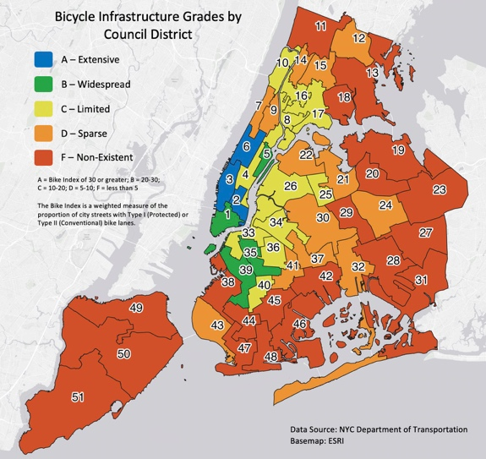

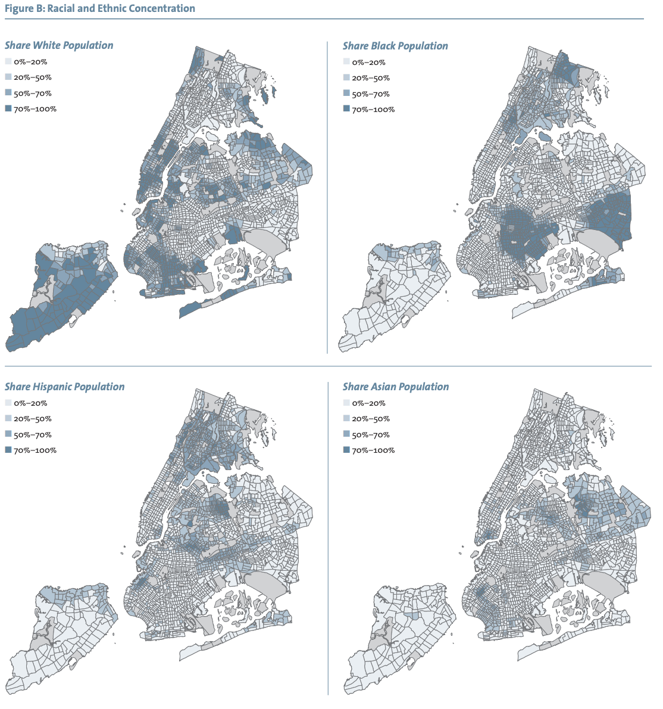

Figure 2: Racial and Ethnic Concentrations

Source: <https://furmancenter.org/files/sotc/The_Changing_Racial_and_Ethnic_Makeup_of_New_York_City_Neighborhoods_11.pdf>

Figure 3: Median Income by Census Tract

Source: <https://www.businessinsider.com/new-york-city-income-maps-2014-12>

Source: U.S. Census Bureau <https://data.census.gov/cedsci/table?q=demographics%20borough%20new%20york%20city&g=0500000US36005,36047,36061,36081,36085&tid=ACSDP1Y2019.DP05&hidePreview=true>

**Appendix C: Fatality and Commuter Data by Borough**

|  |  |  |  |  |
| --- | --- | --- | --- | --- |
| **Borough** | **Commuters** | **Percent of Total Commuters** | **Cyclist Fatalities** | **Percent of Total Cyclist Fatalities** |
| Manhattan | 20,092 | 39% | 27 | 24% |
| Brooklyn | 21,918 | 43% | 51 | 46% |
| Queens | 5,795 | 11% | 18 | 16% |
| Bronx | 2,457 | 5% | 13 | 12% |
| Staten Island | 632 | 1% | 2 | 2% |
| **Total:** | **50,894** |  | **111** |  |

Source of Commuter Data: NYC DOT Cycling in the City Report, 2020 <https://www1.nyc.gov/html/dot/downloads/pdf/cycling-in-the-city-2020.pdf>

Source of Cyclist Fatality Data: NYC Crash Mapper, using fatalities from 2016-2021

<https://crashmapper.org/#/>

**Appendix D: Transit Deserts vs Good Bike Infrastructure**

Figure 1: Bike Infrastructure Grades by Council District

Source: <https://nyc.streetsblog.org/2019/10/17/in-nyc-the-best-bike-lanes-are-in-rich-neighborhoods/>

Figure 2: Transit Deserts in NYC

Source: <https://www.nytimes.com/2019/10/11/realestate/whos-afraid-of-a-transit-desert.html>

1. “CYCLING IN THE CITY” May 2019 presentation by the NYC DOT. <https://www1.nyc.gov/html/dot/downloads/pdf/cycling-in-the-city.pdf>
2. The city’s 2016 figure of 2.4 miles of biking infrastructure per square mile is above average, but lags significantly behind other major cities like Boston, San Francisco, Philadelphia, and Sacramento according to “Bicycling & Walking in the United States,” Alliance for Bicycling & Walking 2016 Benchmark presentation. <https://bikeleague.org/sites/default/files/2016BenchmarkingReport_web.pdf>
3. “In NYC, the Best Bike Lanes are in Rich Neighborhoods,” by Gersh Kuntzman for StreetsblogNYC. <https://nyc.streetsblog.org/2019/10/17/in-nyc-the-best-bike-lanes-are-in-rich-neighborhoods/>
4. See Appendix A, Figures 1 & 2.
5. See Appendix B.
6. See Appendix C.
7. See Appendix C.
8. NYC DOT data shows protected bike lanes in select areas decreased pedestrian injuries by 22%, crashes with injuries by 17% and total injuries by 20% over three years. <https://www1.nyc.gov/html/dot/downloads/pdf/2014-11-bicycle-path-data-analysis.pdf>
9. See interactive map created by the author of this memo for this report: <https://victorporcelli.github.io/leaflet-nyc-biking-map/>. This map uses Census data on median income: <https://data.census.gov/cedsci/map?q=ACSST5Y2019.S2001%20New%20York%20city,%20New%20York&g=0400000US36.140000&tid=ACSST5Y2019.S2001&mode=customize&layer=VT_2019_140_00_PY_D1&cid=S2001_C01_001E>, cyclist fatality data from NYC Crash Mapper: <https://crashmapper.org/#/>and NYC Open Data bike lane data: <https://data.cityofnewyork.us/Transportation/Bicycle-Routes/7vsa-caz7>
10. See comments by Polly Trottenberg on this issue in StreetsblogNYC: <https://nyc.streetsblog.org/2019/03/15/dot-commissioner-bike-lane-delays-are-not-about-the-money/>, comments by City Councilmember Antonio Reynoso: <https://brooklyneagle.com/articles/2019/04/11/want-a-bigger-bike-network-reduce-community-boards-role-says-one-local-pol/> and the bottom paragraph on the left side of pg. 82 in City Council Speaker Corey Johnson’s 2019 Transit Report: <http://council.nyc.gov/wp-content/uploads/2019/07/LetsGo_TransitReport_05.pdf>
11. See Appendix D.
12. See data from New York City Economic Development Corporation: <https://edc.nyc/article/new-yorkers-and-their-cars>
13. “Most New Yorkers Don’t Own Cars. Do Community Boards Reflect That?” by David Meyer for StreetsblogNYC. <https://nyc.streetsblog.org/2016/01/11/most-new-yorkers-dont-own-cars-do-community-boards-reflect-that/>
14. “CAR SLAMES BIKE KID, 12” by Bridget Harrison for the New York Post. <https://nypost.com/2004/12/06/car-slams-bike-kid-12/>
15. See NYC DOT presentation on this topic. <http://www.nyc.gov/html/dot/downloads/pdf/gerritsen-ave-traffic-calming-oct2016.pdf>
16. “No More Stalling: DOT Redesigns Gerritsen Ave After Teen Cyclist’s Death” by David Meyer for StreetsblogNYC. <https://nyc.streetsblog.org/2016/10/24/no-more-stalling-dot-redesigns-gerritsen-ave-after-teen-cyclists-death/>
17. Based on last mention of the project on the DOT’s “Current Projects” page. <https://www1.nyc.gov/html/dot/html/about/projects-2018.shtml>
18. “DOT Defers Action on Clinton Avenue Bikeway” by David Meyer for StreetsblogNYC. <https://nyc.streetsblog.org/2016/05/20/dot-defers-action-on-clinton-avenue-bikeway/>
19. “Community Board 10 and residents vehemently oppose DOT plans road diets and bus bulb” by Jason Cohen for BronxTimes. <https://www.bxtimes.com/community-board-10-and-residents-vehemently-oppose-dot-plans-for-road-diets-and-bus-bulb/>
20. See coverage by THE CITY: <https://www.thecity.nyc/government/2020/1/29/21210566/does-your-community-board-reflect-you-and-your-neighbors-find-out>, The Queens Daily Eagle: <https://queenseagle.com/all/older-adults-dominate-queens-community-boards-data-shows> and City Limits: <https://citylimits.org/2016/08/25/community-boards-face-questions-over-demographics/>.
21. See examples in Manhattan Community Board 2 (<https://nyc.streetsblog.org/2020/03/25/definition-of-insanity-dot-still-seeking-community-board-yea-for-bikes-lanes/>) and Brooklyn Community Board 7’s (<https://nyc.streetsblog.org/2016/08/24/carlos-menchaca-wants-to-make-fourth-ave-protected-bike-lane-a-reality/>) advocacy for bike lanes.
22. See City Council Int 412: <https://legistar.council.nyc.gov/LegislationDetail.aspx?ID=803592&GUID=A9FD01B1-E217-4AA6-BC43-5127068542F3>.
23. [https://hbr.org/2018/01/the-leaders-guide-to-corporate-culture#](https://hbr.org/2018/01/the-leaders-guide-to-corporate-culture)
24. “Wins Pile Up for the New York Left” by Victor Porcelli and Ben Max. <https://www.gothamgazette.com/state/9620-wins-pile-up-for-the-new-york-left-primaries-wfp-dsa-assembly-senate> “Inside the NYC Democratic Socialists’ Powerhouse Electoral Machine” by Sam Mellins. <https://jacobinmag.com/2020/10/new-york-city-democratic-socialists-of-america-elections>