PizzaNow User Manual

PizzaNow server, allwos to administrate the entrance orders, the database and the server.

Run aplication

In the dist directory there is a PizzaNow.jar file. To execute, open a terminal and put next command:

$ java -jar PizzaNow.jar

Order Manager

The order manager is where you can manage the entrance orders, when the order arrive you can see the basic information in the screen. If you want to see all information push the button show info. And in the left size apears the list of products in the orders.
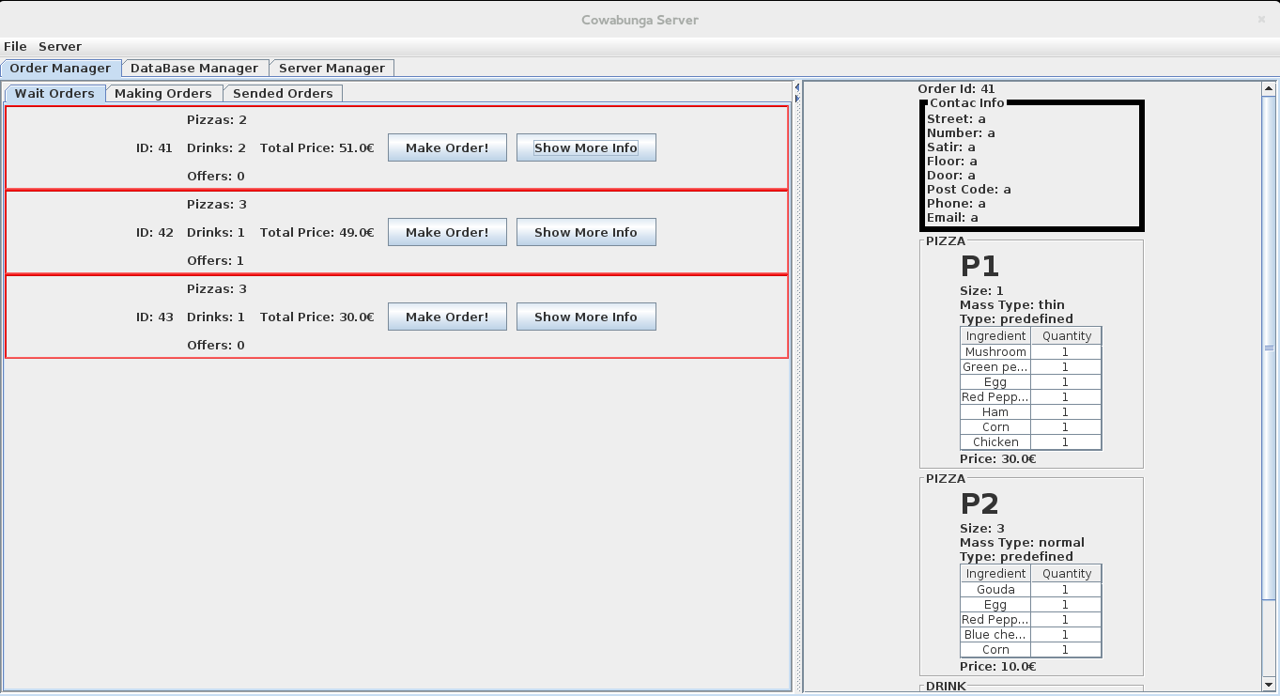
When you want to start make the order push the button make order! And that order pass to next tab, make order. Then the client recive a mail that his order is start making, when the order is maked push the button send order, and the order pass to next tab, sended order, and the client recive an other mail that his order is sending to his house.
To save the order in database push button save order. And the order desapear from the screen and is is saved in database.

Server Manager
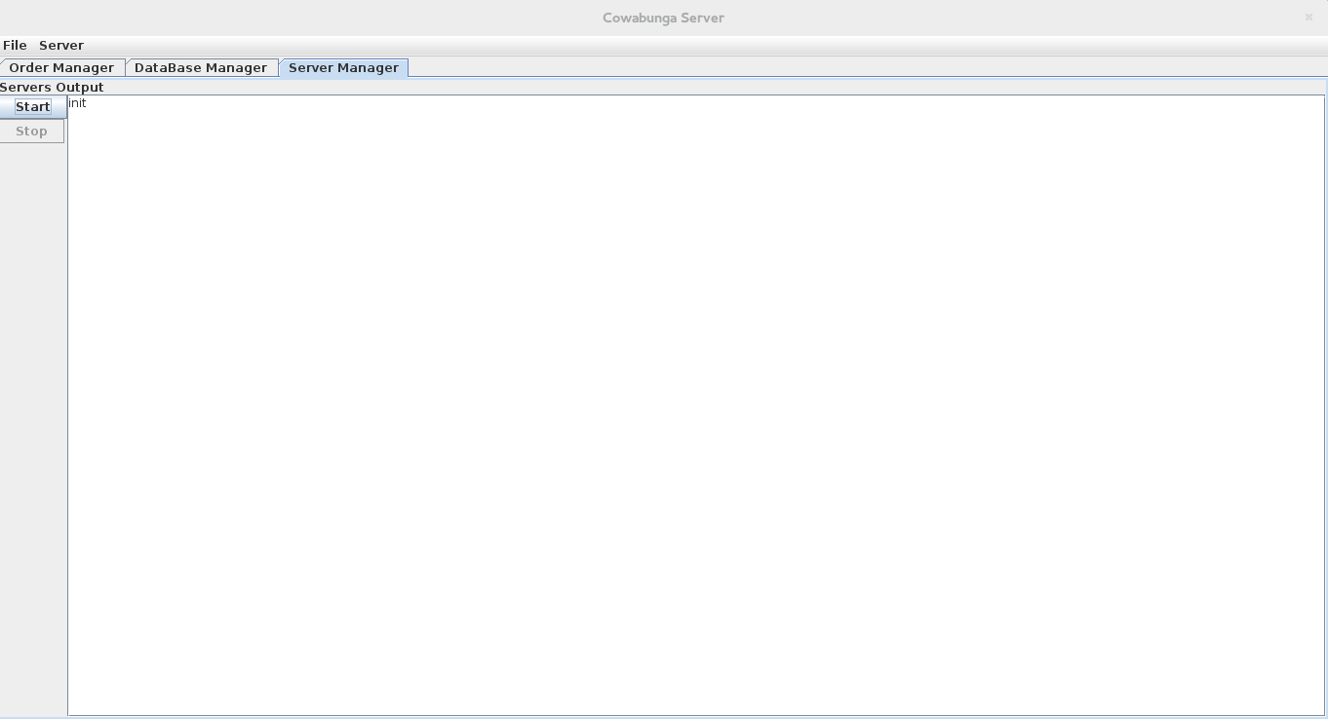
The server manger allows client connect to the server to sent his orders. To start server click in tab Server Manager and click start, then the clients will can send her orders.

Then you can see all information of server and connection in the white screen.

Database Manager

The Database manager allows you to adminstrate the database.

You can query all information about the pizzas, ingredients, offers, addresses, orders, preferences and resources in the Select tab.
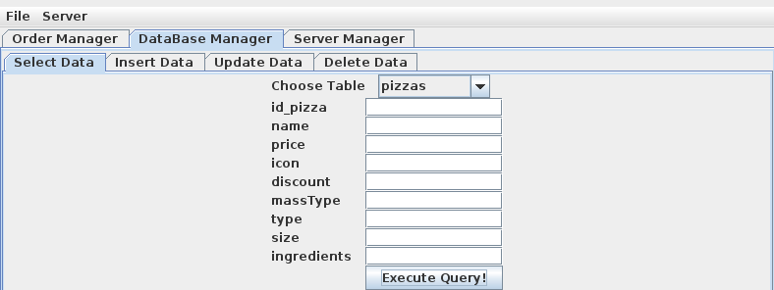
You can see a concrete information about one or more pizzas putting information in the text fields.
Choose one table and put the information that you want to see and then click execute query.

If you don't put any information then you can see all rows of that table.

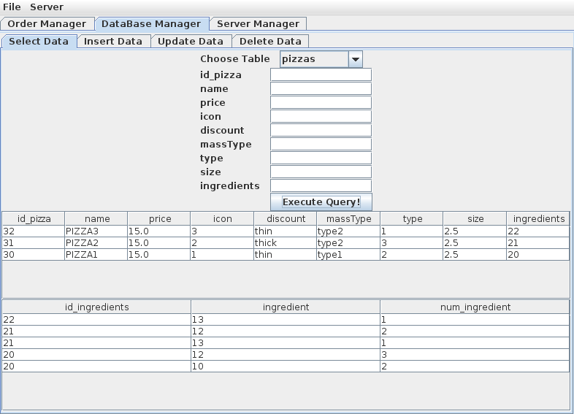

To Insert data click in Insert data tab, choose one table, and put the information that you want to add in the database.
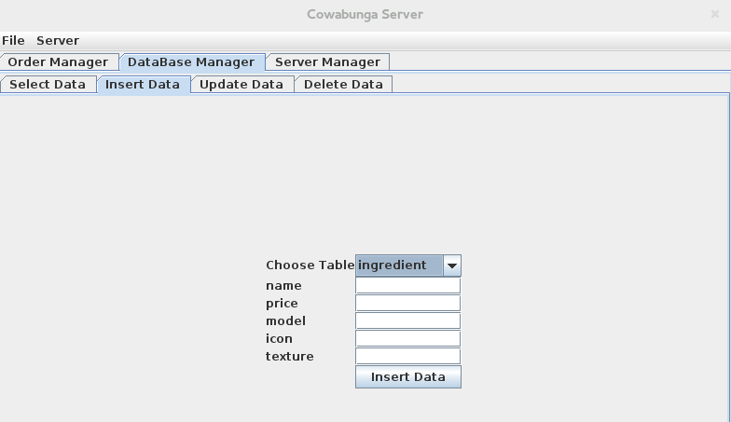
If the innsertation is correct the data is added to the database, else apears a little window to alert you of the error.

In update data tab you can update data form the database. You can choose a table, and then apears all data of that table, then you can edit, the table and update all fields that you want.

In the case of pizzas and offer tables, you can add or delete, ingredients or products.
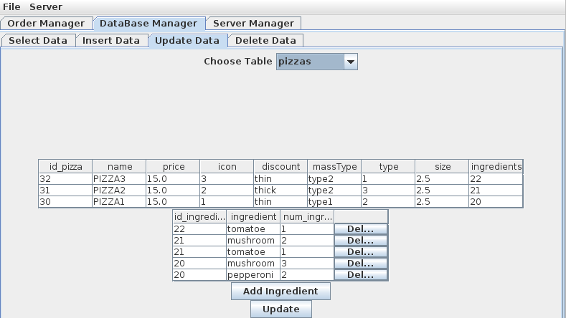

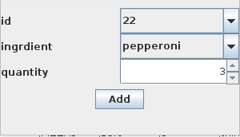
If you want to delete a row click on delete button. If you want to add, in this case ingredient, click on Add ingredient and the apears a window to allow you to add an ingredient in the pizza. Click add and the ingreedient apears in the table. The id references to the list of ingredeints in field ingredient of table pizzas.
Example Pizza2 has the list of ingredinets with id 21, in this case has 2 mushroom and 1 tomatoe.
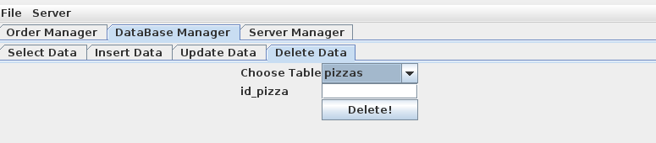
Finally the delete tabs allow you to delete one row of any table putting his id.

