[VENTION]
Take-Home Assignment.

Victor Schwoertzig

17th Aprile 2026

This document has been written as part of a recruitment process for the company Vention.
Senior Robotics and Automation Developer

Assumptions on the robotic cell
- The robot is located at the global origine of the 3D environment.
- The robot base frame and the global frame are superimposed.
- The global z-axis is pointing up.
- The global X-axis is pointing toward the end-effector of the robot.
- The camera mounting pose is given with respect to the global frame.
- The pallet sits on the floor. Its global coordinate on z-axis is equal to 0.
- The robot is not equipped with a tool. The robot’s flange frame is our tool frame (TCP).

The vision palletizer API offers different features.

/palletizer/configure
- Configure the pallet grid with respect to the box dimensions, pallet origin and spacing.
- From the pallet grid, compute all TCP placing poses with respect to the robot frame.
- From the file “camera_detection.json”, compute all TPC picking poses with respect to the robot frame.
- Send the TCP placing and picking poses to the state machine.
- Display the grid dimensions.

/palletizer/start
- Start the pick and place application. The robot will load the entire 2x2 pallet.
- The first motion is a joint motion to the home joint target.

/palletizer/stop
- Stop the palletizer.

/palletizer/reset
- Reset the palletizer.

/palletizer/status
- Get the current palletizer state machine status.

/palletizer/vision/detect
- Emulate the vision detection with user inputs for testing.

/palletizer/debug/positions
- Display all TCP placing poses computes in /configuration.

/palletizer/debug/transform
- From a user pose input, return the pose with respect to the robot frame and with respect to the camera frame.

Palletizer configuration
The Figure 1 sums up our palletizer configuration: box dimensions, pallet origin, number of box (4). In the code, we defined spacing equal to 10 mm.
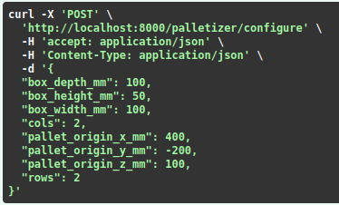
Figure 1: Palletizer configuration
Based on our configuration, we compute the grid dimensions as shown on Figure 2.
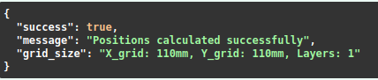
Figure 2: Grid dimensions

Transform coordinates
We used homogeneous transformations to compute coordinates. The Figure 3 shows our approach.
The transform coordinates of an object $i$ with respect to an object $j$ is given by the following equation, where $H_{i}^{j}$ is a 4x4 homogeneous matrix, $R_{i}^{j}$ a 3x3 rotation matrix and $T_{i}^{j}$ a 3x1 translation vector.
$$H_{i}^{j}=\left[\begin{matrix}R_{i}^{j} & T_{i}^{j} \\ 0 & 1\end{matrix}\right]$$ | (1)

We define the robot base frame $\left\{R\right\}$, the camera frame $\left\{C\right\}$ and the detected box frame $\left\{B\right\}$.
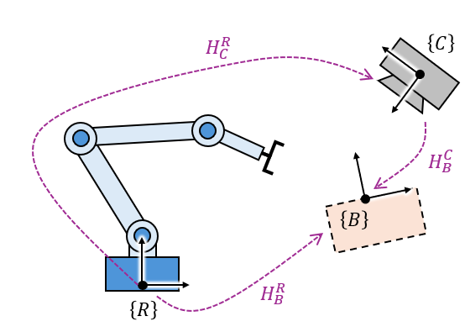
Figure 3: Transform coordinates
In our application, we have the following relationship. We use this equation in the function camera_to_robot() to compute the box coordinates with respect to the robot base frame, given the box coordinates with respect to the camera and the camera mounting pose with respect to the robot base frame.
$$H_{B}^{R}= H_{C}^{R}* H_{B}^{C}$$ | (2)

The following equation is used in the function robot_to_camera() to compute the box coordinates with respect to the camera frame given the box coordinates with respect to the robot frame et the camara mounting pose with respect to the robot base frame.
$$H_{B}^{C}={\left( H_{C}^{R}\right)}^{-1}* H_{B}^{R}$$ | (3)

The equations (2) and (3) are tested in the unit test section.

TCP poses

TCP picking poses
We consider the box on the floor. The picking poses z-coordinates are equal to the box height. The picking orientation are computed based on the camera pose with respect to the robot and the box pose with respect to the camera.
Index | X (m) | Y (m) | Z (m) | Rx (rad) | Ry (rad) | Rz (rad)
0 | 0.557 | 0.293 | 0.050 | 0.262 | -0.175 | 0.785
1 | 0.601 | 0.360 | 0.050 | 0.262 | -0.175 | 1.047
2 | 0.452 | 0.346 | 0.050 | 0.262 | -0.175 | 0.611
3 | 0.604 | 0.284 | 0.050 | 0.262 | -0.175 | 0.873

TCP placing poses
We consider the default orientation when placing the box on the pallet.
Index | X (m) | Y (m) | Z (m) | Rx (rad) | Ry (rad) | Rz (rad)
0 | 0.400 | -0.200 | 0.150 | 0 | π | 0
1 | 0.400 | -0.090 | 0.150 | 0 | π | 0
2 | 0.510 | -0.200 | 0.150 | 0 | π | 0
3 | 0.510 | -0.090 | 0.150 | 0 | π | 0

Motion program
A move to the home joint target is called on the startup and at the end of the entire palletizing sequence. The home joint target is: Home_Joint = [0, - π/2, - π/2, 0, π/2, 0].
The motion sequences are handled by the state machine.
The approach and retracted heights are equal to 0.1m.
The speed and acceleration are adapted: LOW during approaching and retracting; HIGH otherwise.
A delay has been added after the gripper state changes.

TCP pose validation
The picking and placing TCP poses are validated before the cartesian motion is executed.
To validate a TCP pose, we check if the pose is within the robot boundaries. From the robot documentation, we found the workspace definition as shown in the Figure 4.
The workspace is a sphere with a hollow. The sphere radius is 0.85m and the hollow radius is 0.2m. We consider the TCP pose within the workspace if the following conditions are respected:
$$\left|\sqrt{x^{2}+y^{2}}-r_{c}\right|<ϵ$$  $$\left|\sqrt{x^{2}+y^{2}+z^{2}}-r_{s}\right|<ϵ$$ | (4)

$x$, $y$, $z$, the position of the tested TCP poses with respect to the robot frame.
$r_{c}$, $r_{s}$ respectively the cylinder and the sphere radius.
$ϵ$ a small scalar, we used $ϵ=1e^{-12}$.
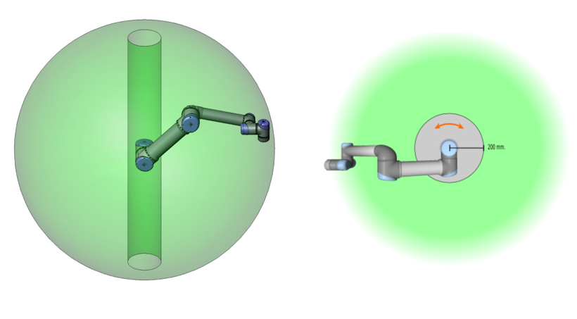
Figure 4: UR5 workspace

Simulation in MOCK
The logic has been tested in MOCK mode as shown on the Figure 5.
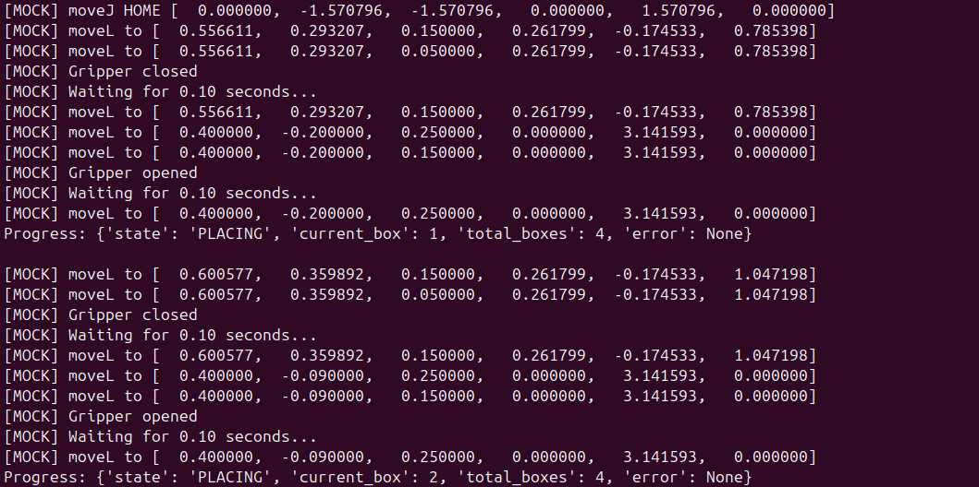

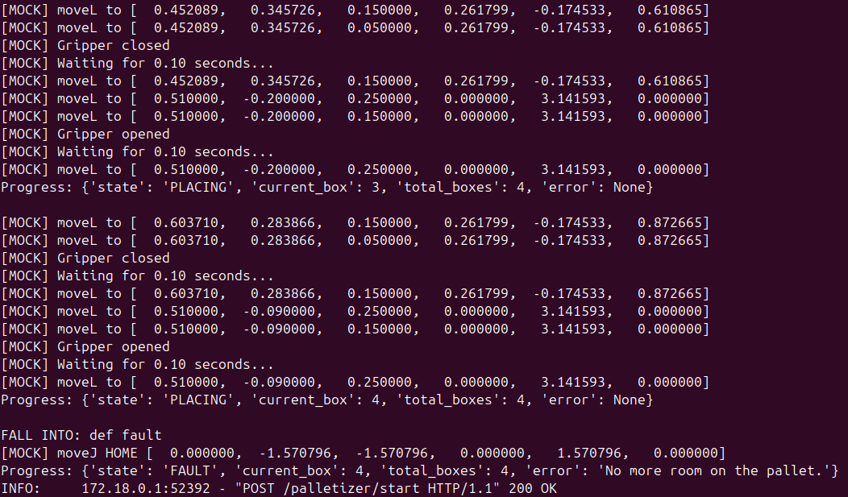
Figure 5: Simulation in MOCK mode

Simulation connected with URSim – Discussion on the faced issues
I encountered challenges with this section but made progress.
I successfully set up my docker – API – URSim. I identified that the robot must be switched to “Remote Mode” to enable control via the python script. In this mode, however, the URSim interface is not accessible. It prevents visualization of the robot’s palletizing motion.
I explored several alternative approaches:
- Visualize with RoboDK: I was able to command the robot, but I could not access real-time joint state data from URSim.
- ROS RViz: I attempted to set up RViz in a virtual machine environment but was unable to complete the installation and configuration within the available time.
- Socket communication with URScript: I initiated this approach, but I did not have sufficient time to fully implement it.
Given more time to deepen my familiarity with URSim, and a helping hand, I am confident I could complete a full working demonstration.
In a professional setting, I would have escalated earlier and sought guidance from a supervisor or team members to unblock progress more efficiently.

Unit tests

Presentation
The purpose of the unit tests is to validate the equation (2) and (3) implementations. To do so, we create a unit test script in MATLAB that computes equations (2) and (3).
We set up our MATLAB script and our python program with the same input parameters, and we compare the results from both algorithms.
The MATLAB script is given at the end of this section.
The camera coordinates with respect to the robot ($H_{C}^{R}$) are constant.
To validate the equation (2), the input values are the coordinates of the box with respect to the camera ($H_{B}^{C}$). The output result is the coordinates of the box with respect to the robot base frame $(H_{B}^{R}$).
$$H_{B}^{R}= H_{C}^{R}* H_{B}^{C}$$ | (2)

To validate the equation (3), the input values are the coordinates of the box with respect to the robot base frame ($H_{B}^{R}$). The output result is the coordinates of the box with respect to the camera $(H_{C}^{R}$).
$$H_{B}^{C}={\left( H_{C}^{R}\right)}^{-1}* H_{B}^{R}$$ | (3)

Scenario #1
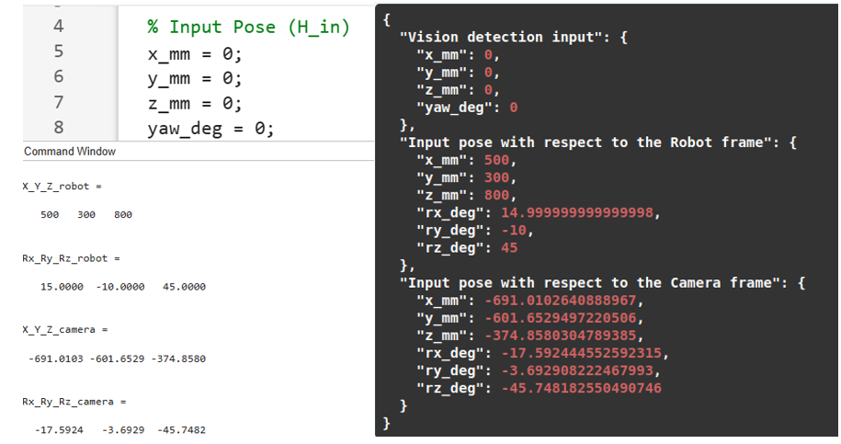
Figure 6: Unit test #1

Scenario #2
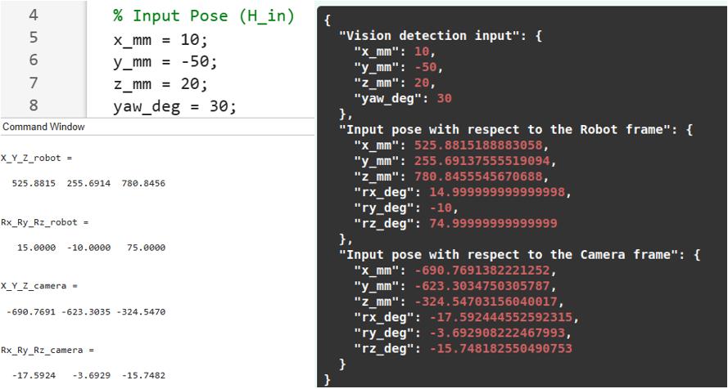
Figure 7: Unit test #2

Scenario #3
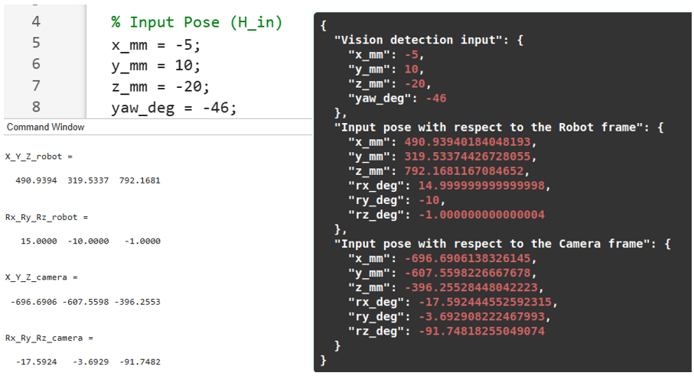
Figure 8: Unit test #3

MATLAB script
clear all
clc

% Input Pose (H_in)
x_mm = -5;
y_mm = 10;
z_mm = -20;
yaw_deg = -46;
H_in = get_H(x_mm, y_mm, z_mm, 0, 0, yaw_deg);

% Camera mounting pose (H_RC)
x_mm = 500;
y_mm = 300;
z_mm = 800;
roll_deg = 15;
pitch_deg = -10;
yaw_deg = 45;
H_RC = get_H(x_mm, y_mm, z_mm, roll_deg, pitch_deg, yaw_deg);

% Equation (2): camera_to_robot()
H_R = H_RC * H_in;
X_Y_Z_robot = get_position(H_R)'
Rx_Ry_Rz_robot = get_eulerAngles(H_R)

% Equation (3): robot_to_camera()
H_C = inv(H_RC) * H_in;
X_Y_Z_camera = get_position(H_C)'
Rx_Ry_Rz_camera = get_eulerAngles(H_C)

function p = get_position(H)
p = 1000 * H(1:3, 4);
end

function eul = get_eulerAngles(H)
R = H(1:3, 1:3);
eul = rad2deg(rotm2eul(R, "ZYX"));
end

function H = get_H(x_mm, y_mm, z_mm, roll_deg, pitch_deg, yaw_deg)
R = eul2rotm([deg2rad(roll_deg), deg2rad(pitch_deg), deg2rad(yaw_deg)]);
p = 0.001 * [x_mm; y_mm; z_mm];
H = [R, p;
0 0 0 1];
end

function H = get_H_inv(H)
R = H(1:3, 1:3);
p = H(1:3, 4);
H = [R', -R'*p;
0 0 0 1];
end

