Docker Notes

general info:
sudo docker version

when we run “docker run hello-world”, various things happen, first our docker client starts and then our docker server takes over which looks for hello-world in the image cache and if not found it will look for it in the docker hub.(check image below)
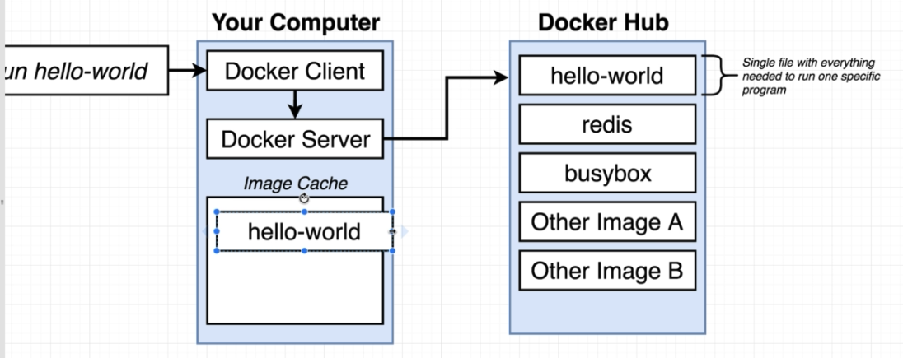

This happens in the background, the image has a snapshot and the container just runs that image.
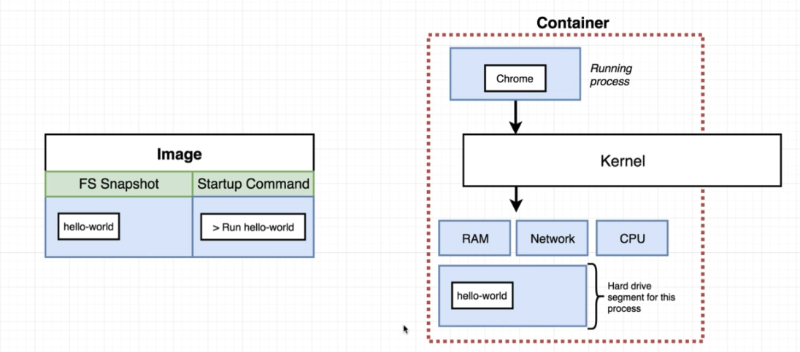

To create a container for a image run the following command: check image below.

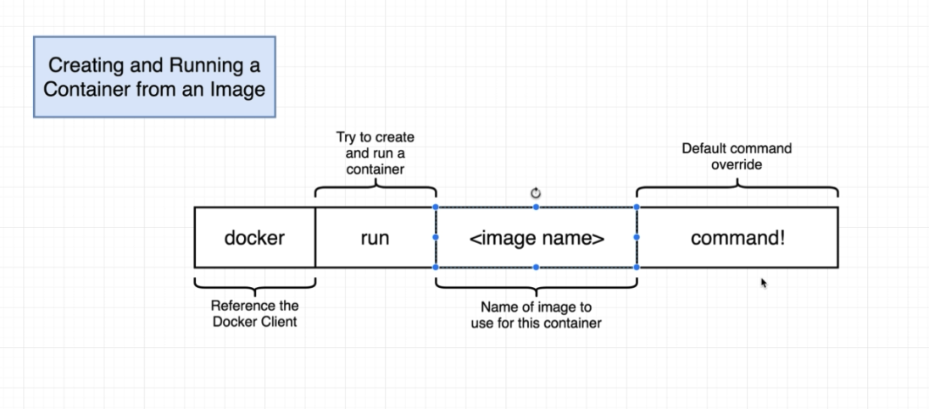
The image below uses busybox and echo hi there is the override.
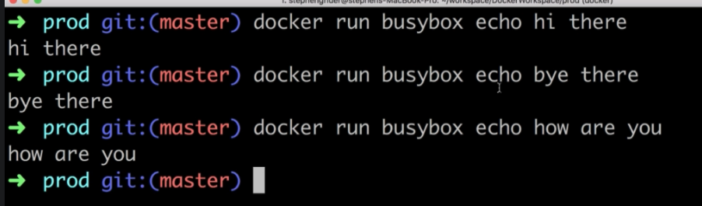
BusyBox has the below mentioned folders.
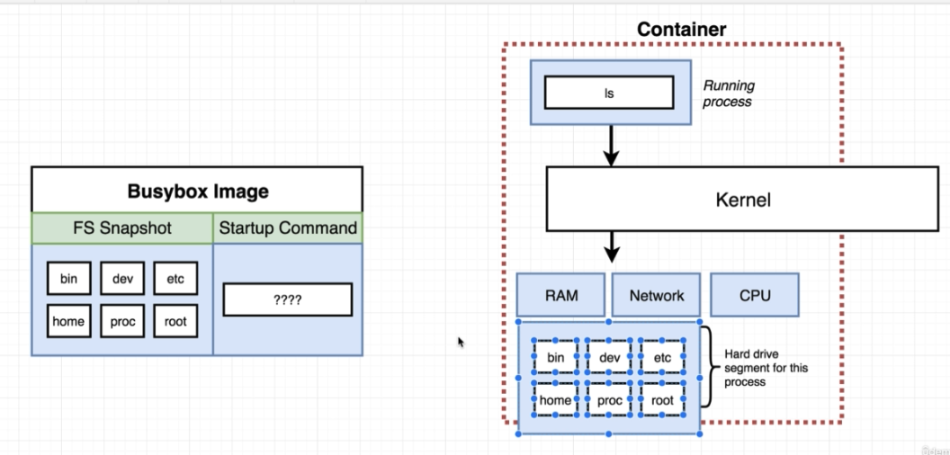

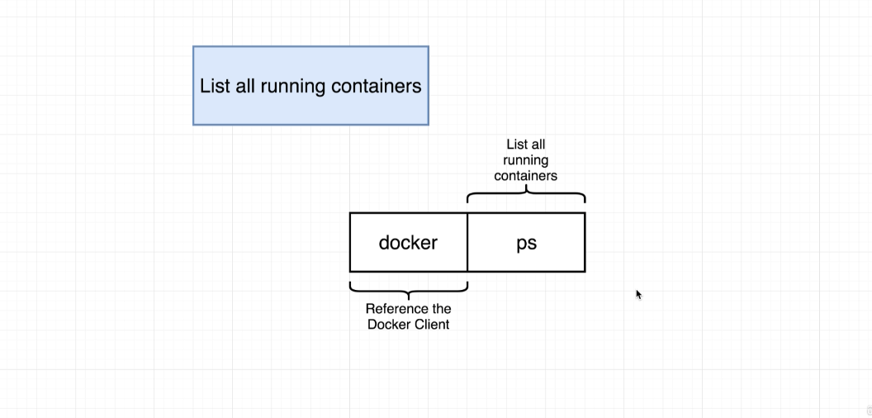

To view all containers ever created
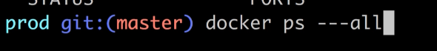

Life cycle of a container

Docker run creates and starts container.
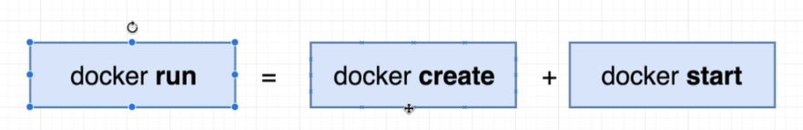

Docker run will show you all the logs and information coming out of the container. While docker start is not going to show you information coming from the terminal.
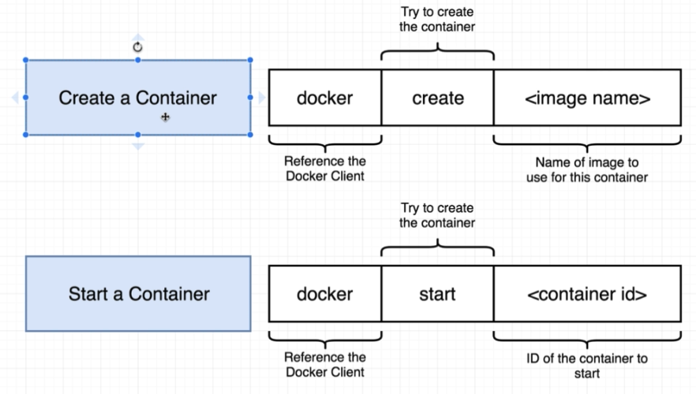

To restart a container use the following, use the start cmd.

To delete all:
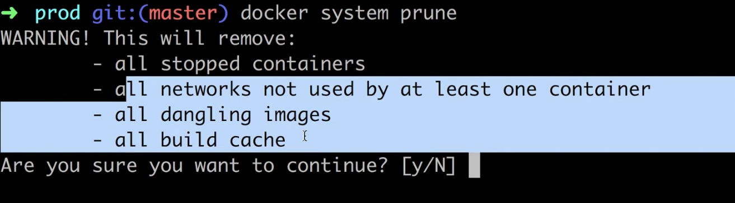

Retrieving logs from container, this only gets records emitted from container.
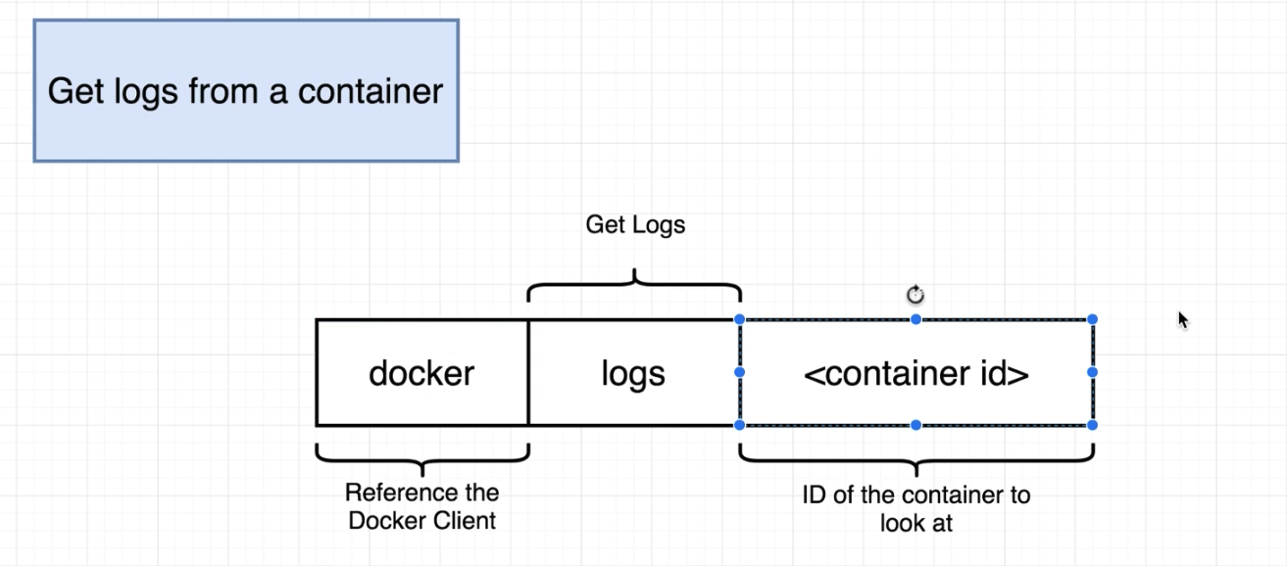

Stopping Container,
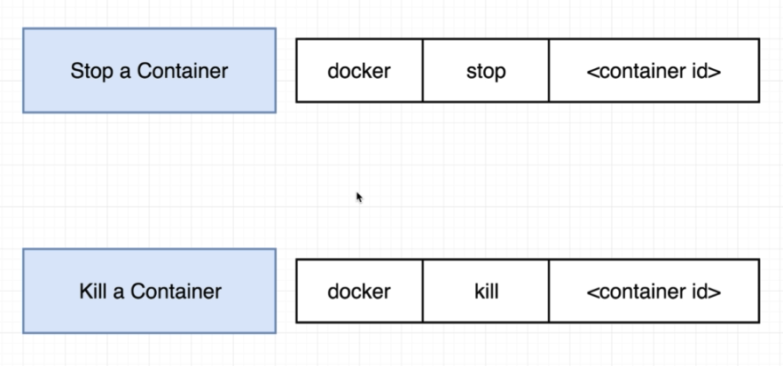

Multi-Command Container
run : sudo docker run redis
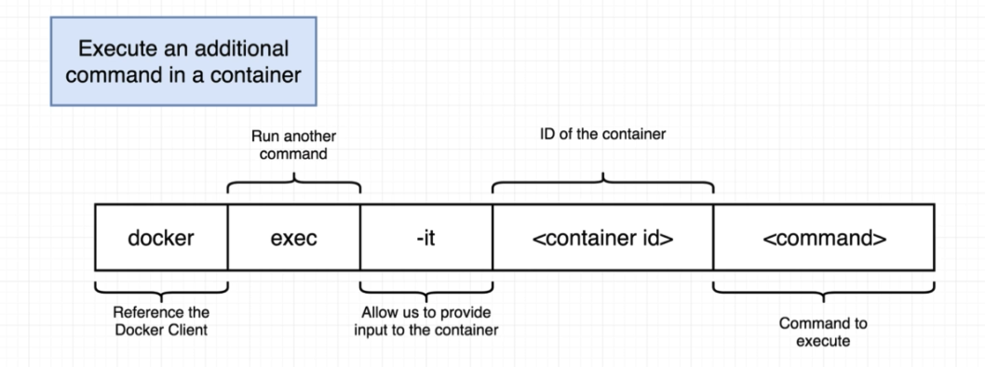

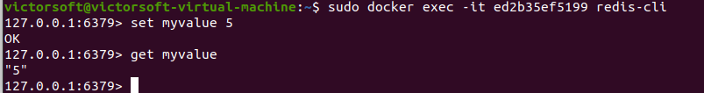

Purpose of IT Flag:

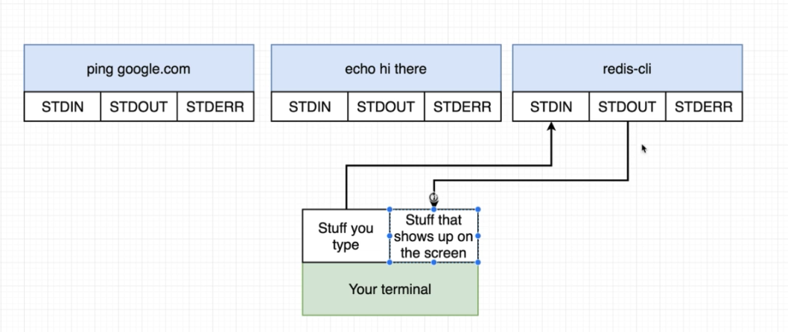

SSH
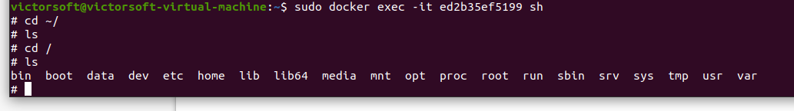
to exit: crtl-c or ctrl-d

to create a container and execute with ssh
