@staticmethod  
def is_variable_number_valid(var: str) -> bool:  
 try:  
 if int(var) >= 2:  
 return True  
 return False  
 except ValueError:  
 return False

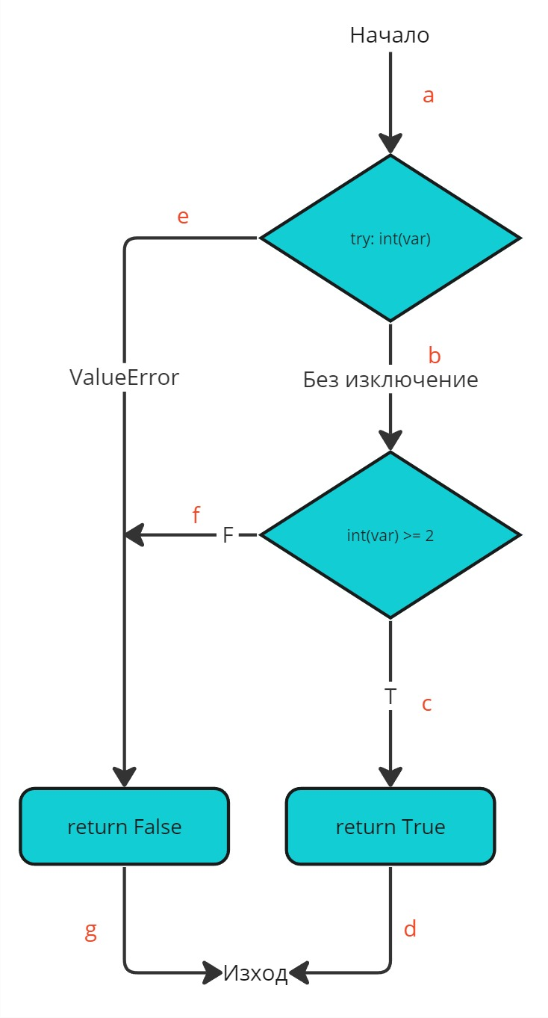

**Case 1:**

var = “string”

Result: False

a e g

**Case 2:**

var = “1”

Result: False

a b f g

**Case 3:**

var = “2”

Result: True

a b c d

**Statement Coverage:** Case 1: 1/2 = 50%

Case 2: 1/2 = 50%

Case 3: 1/2 = 50%

**Decision Coverage:**

Case 1: 1/2 = 50%

Case 2: 2/2 = 100%

Case 3: 2/2 = 100%