# CHAPTER FOUR

## RESULT AND DISCUSSION

## 4.0 DESCRIPTIVE STATISTICS

### 4.1 SUMMARY STATISTICS

#### 4.1.1 **Demographic information**

## **AGE** **GENDER** **COLLEGE** **DEPARTMENT** **LEVEL**    
## 18 - 23: **165** Female: **104** COLPHYS :**87** STS : **33** 100: **29**   
## 24 - 29: **72** Male : **135** COLPLANT:**39** CPT : **18** 200: **48**   
## 30 - 35: **2** COLANIM :**27** CSC : **18** 300: **77**   
## COLBIOS :**21** CHM : **15** 400: **68**   
## COLPHEC :**21** MTS : **15** 500: **16**   
## COLERM :**17** FST : **14** 600: **1**   
## (Other) :**27** (Other):**126**

## **RELIGION G.P.A C.G.P STATUS**    
## Christianity:**202** 1.5- 2.4 : **8** 1.5- 2.4 : **8** Cohabiting: **2**   
## Islamic : **36** 2.5 - 3.4: **71** 2.5 -3.4 : **92** Married : **2**   
## Other : **1** 3.5 - 4.4:**125**  3.5 -4.4 :**116** Single :**235**   
## 4.5 - 5.0: **35** 4.5- 5.0 : **23**   
##   
##   
## **SPONSOR SCORE STRESS**   
## Guardian: **12** Min. : **0.0** Major :**59**   
## Other : **6** 1st Qu.:**137.0** Mild :**43**   
## Parent :**208** Median :**208.0** Moderate :**32**   
## Self : **13** Mean :**222.0** Serious :**34**   
## 3rd Qu.:**297.5** Very little:**71**   
## Max. :**513.0**

### 4.2 DATA VISUALIZATION

#### 4.2.1 Students mental stess

##   
## **Major Mild Moderate Serious Very little**  
## **Female** **31** 14 13 16 30  
## **Male** 28 **29** **19** **18** **41**

#### **4.2.2 Male mental state**

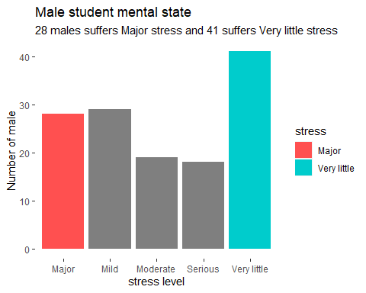

FIGURE :

#### **4.2.3 Female mental state**

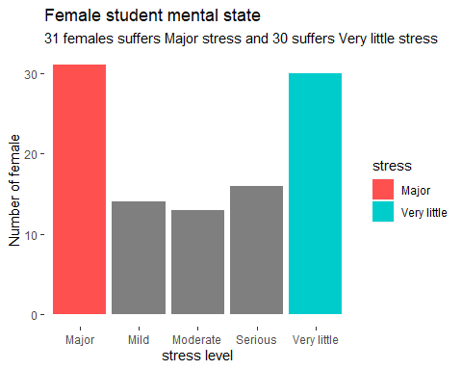

#### **4.2.4 Students Mental state**

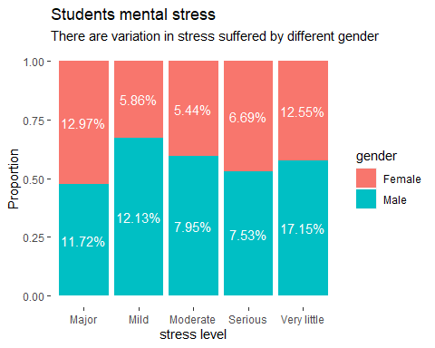

### 4.3 EXPLORATORY FACTOR ANALYSIS

### NORMALITY TEST

### 

**LINEARITY HOMOGENEITY**

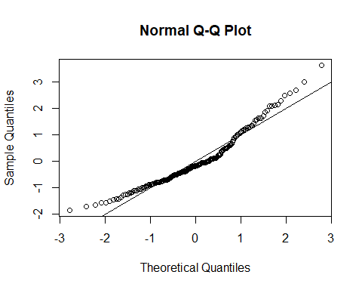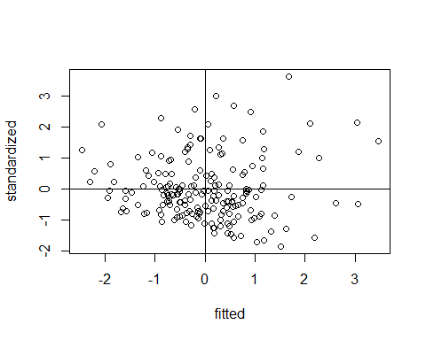

**ASESSING NUMBER OF FACTORS**

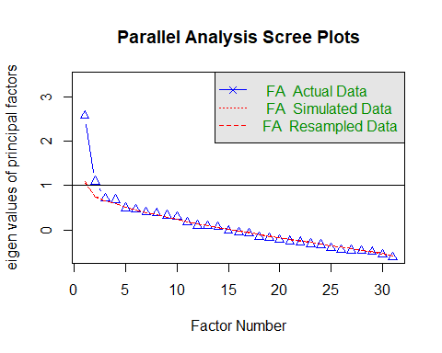

## Parallel analysis suggests that the number of factors = 4

## Theoretical number of factors suggested = 3

Call: fa.parallel(x = noout, fm = "ml", fa = "fa")  
Parallel analysis suggests that the number of factors = 4

## Old kasier criteria suggested 2 factors

## new kaisier criteria suggested 3 factors

**ANALYSIS**

**CORRELATION ADEQUACY BARTTLETTS TEST RESULT**  
chisq = **809.436** , p.value = **6.962424e-25**, df = 435

**SAMPLING ADEQUACY KMO TEST**  
Kaiser-Meyer-Olkin factor adequacy  
Call: KMO(r = correl)  
Overall MSA = **0.58**  
MSA for each item = E1 E2 E3 E4 E5 E6 E7 E8 E9 E10 E11   
 0.44 0.68 0.42 0.44 0.42 0.47 0.53 0.37 0.62 0.44 0.64   
 E12 E13 E14 E15 E16 E17 E18 E19 E20 E21 E22   
 0.68 0.34 0.45 0.45 0.60 0.59 0.66 0.59 0.63 0.38 0.51   
 E23 E24 E25 E26 E27 E28 E29 E30   
 0.56 0.69 0.71 0.61 0.51 0.52 0.74 0.68  
   
  
**CFI = 0.9547**

**Factor Analysis using method = ml  
Call: fa(r = noout[, -1], nfactors = 3, rotate = "oblimin", fm = "ml")  
Standardized loadings (pattern matrix) based upon correlation matrix**  
 ML2 ML3 ML1  
SS loadings 1.88 1.79 1.31  
Proportion Var 0.06 0.06 0.04  
Cumulative Var 0.06 0.12 0.17  
Proportion Explained 0.38 0.36 0.26  
Cumulative Proportion 0.38 0.74 1.00  
  
 With factor correlations of   
 ML2 ML3 ML1  
ML2 1.00 0.29 -0.01  
ML3 **0.29** 1.00 0.02  
ML1 **-0.01** **0.02** 1.00  
  
Mean item complexity = **1.6**  
Test of the hypothesis that 3 factors are sufficient.  
  
The degrees of freedom for the null model are 435 and the objective function was 4.57 with Chi Square of 809.44  
The degrees of freedom for the model are 348 and the objective function was 2.38   
  
**The root mean square of the residuals (RMSR) is 0.06**   
The df corrected root mean square of the residuals is 0.07   
  
The harmonic number of observations is 189 with the empirical chi square 613.14 with prob < 6.6e-17   
The total number of observations was 189 with Likelihood Chi Square = 416.24 with prob < 0.007   
  
**Tucker Lewis Index of factoring reliability = 0.767  
RMSEA index = 0.032 and the 90 % confidence intervals are 0.018 0.043  
BIC = -1407.89**  
Fit based upon off diagonal values = 0.7  
Measures of factor score adequacy   
 ML2 ML3 ML1  
Correlation of (regression) scores with factors 0.87 0.83 1.00  
Multiple R square of scores with factors 0.75 0.69 1.00  
Minimum correlation of possible factor scores 0.50 0.39 0.99  
  
  
**alpha fit.off for new factors  
factor1 = 0.9823171  
factor2 = 0.988517  
factor3 = 1**

Summary statistics of new factors  
 f1 f2 f3   
 Min. :0.000 Min. :0.000 Min. :0.0000   
 1st Qu.:2.000 1st Qu.:0.200 1st Qu.:0.0000   
 Median :3.000 Median :0.800 Median :0.0000   
 Mean :2.847 Mean :1.182 Mean :0.7778   
 3rd Qu.:3.667 3rd Qu.:1.800 3rd Qu.:1.5000   
 Max. :5.000 Max. :4.000 Max. :5.0000   
   
 standard deviation   
 factor 1 = 1.1711  
 factor 2 = 1.0534  
 factor 3 = 1.1661  
   
 Grouping of new factors

### 

### 4.4 ORDINAL LOGISTIC REGRESSION

SUMMARY STATISTICS

## **GENDER C.G.P SCORE STRESS**   
## Female:95 First class :**17** Min. : 0.0 Major :**44**   
## Male :94 Second class :**92** 1st Qu.:136.0 Mild :**35**   
## Second class lower:**74** Median :205.0 Moderate :**24**   
## Third class : **6** Mean :217.3 Serious :**30**   
## 3rd Qu.:294.0 Very little:**56**   
## Max. :508.0

## f1 f2 f3   
## Not Applicable : **8** Not Applicable :**47** Not Applicable :**120**   
## Strongly Agree :**17** Strongly Agree :**60** Strongly Agree : **14**   
## Agree :**49** Agree :**46** Agree : 41   
## Neutral :**51** Neutral :**22** Neutral : **6**   
## Disagree :**51** Disagree :**14** Disagree : **6**   
## Strongly Disagree:**13** Strongly Disagree: **0** Strongly Disagree: **2**

## Likelihood ratio tests of cumulative link models:  
##   
## formula: link: threshold:  
## modelnull C.G.P ~ 1 logit flexible   
## model1 C.G.P ~ stress + gender logit flexible   
##   
## no.par AIC logLik LR.stat df Pr(>Chisq)  
## modelnull 3 400.54 -197.27   
## model1 8 403.58 -193.79 6.962 5 0.2235

## $Models  
##   
## Model: "clm, C.G.P ~ stress + gender, my_data, logit"  
## Null: "clm, C.G.P ~ 1, logit, my_data"   
##   
## $Pseudo.R.squared.for.model.vs.null  
## Pseudo.R.squared  
## McFadden 0.0176458  
## Cox and Snell (ML) 0.0361656  
## Nagelkerke (Cragg and Uhler) 0.0412848  
##   
## $Likelihood.ratio.test  
## Df.diff LogLik.diff Chisq p.value  
## -5 -3.481 6.962 0.22348  
##   
## $Number.of.observations  
##   
## Model: 189  
## Null: 189  
##   
## $Messages  
## [1] "Note: For models fit with REML, these statistics are based on refitting with ML"  
##   
## $Warnings  
## [1] "None"

## formula: C.G.P ~ stress + gender  
## data: my_data  
##   
## link threshold nobs logLik AIC niter max.grad cond.H   
## logit flexible 189 -193.79 403.58 6(0) 7.36e-08 4.6e+01  
##   
## **Coefficients:**  
## **Estimate Std. Error z value Pr(>|z|)**   
## stressMild -0.94581 0.44893 -2.107 **0.0351** *  
## stressModerate -0.27757 0.47631 -0.583 0.5601   
## stressSerious 0.05059 0.45004 0.112 0.9105   
## stressVery little -0.38488 0.38947 -0.988 0.3230   
## genderMale -0.22666 0.28158 -0.805 0.4209   
## ---  
## Signif. codes: 0 '***' 0.001 '**' 0.01 '*' 0.05 '.' 0.1 ' ' 1  
##   
## **Threshold coefficients:**  
## **Estimate Std. Error z value**  
## First class|Second class -2.79610 0.39787 -7.028  
## Second class|Second class lower -0.09837 0.31750 -0.310  
## Second class lower|Third class 3.05013 0.49195 6.200

**## 2.5 % 97.5 %**  
## stressMild -1.8372957 -0.07306888  
## stressModerate -1.2175060 0.65614843  
## stressSerious -0.8326559 0.93712828  
## stressVery little -1.1533437 0.37694734  
## genderMale -0.7808956 0.32466352

## **First class|Second class Second class|Second class lower**   
## 0.06104771 0.90631428   
## Second class lower|Third class stressMild   
## 21.11818285 0.38836519   
## stressModerate stressSerious   
## 0.75762162 1.05188684   
## stressVery little genderMale   
## 0.68053154 0.79719443

## 2.5 % 97.5 %  
## stressMild 0.1592475 0.9295368  
## stressModerate 0.2959674 1.9273547  
## stressSerious 0.4348927 2.5526404  
## stressVery little 0.3155798 1.4578275  
## genderMale 0.4579956 1.3835650

## **Pearson's Chi-squared test**  
##   
## data: my_data$C.G.P and unlist(predict(model1))  
## X-squared = 567, df = 90, p-value < 2.2e-16

**## Estimate Std. Error z value** Pr(>|z|)  
## **First class|Second class** -2.79609966 0.3978687 -7.0276941 2.099746e-12

## **Second class|Second class lower** -0.09836915 0.3174965 -0.3098275 7.566921e-01

## **Second class lower|Third class** 3.05013442 0.4919493 6.2000995 5.642748e-10

## **stressMild** -0.94580916 0.4489292 -2.1068113 3.513394e-02

## **stressModerate** -0.27757120 0.4763051 -0.5827592 5.600554e-01

## **stressSerious** 0.05058554 0.4500409 0.1124021 9.105046e-01

## **stressVery little** -0.38488111 0.3894713 -0.9882144 3.230477e-01

## **genderMale** -0.22665668 0.2815843 -0.8049335 4.208580e-01