Vision Transformers vs CNNs
Why Self-Attention Can Extract Image Features Better Than Convolution
Machine Learning Tutorial · 2025

1. Introduction
For decades, Convolutional Neural Networks (CNNs) dominated computer vision. Architectures such as ResNet (He et al., 2016) achieved remarkable accuracy on image classification by learning hierarchies of local features — edges, textures, and shapes — through stacked convolutional layers. Yet a fundamental constraint remained: convolution is local by design. Capturing long-range relationships across an image required ever-deeper networks with growing computational cost.
In 2017, Vaswani et al. introduced the Transformer architecture for NLP, built entirely on self-attention — a mechanism allowing every element in a sequence to attend to every other simultaneously. Dosovitskiy et al. (2020) then adapted this for images with the Vision Transformer (ViT), demonstrating that treating image patches as tokens could match or surpass CNN performance on large benchmarks.

Tutorial Goal: Explain — with diagrams and analysis — why self-attention allows Vision Transformers to extract image features more effectively than convolution, and under what conditions each approach is preferable.

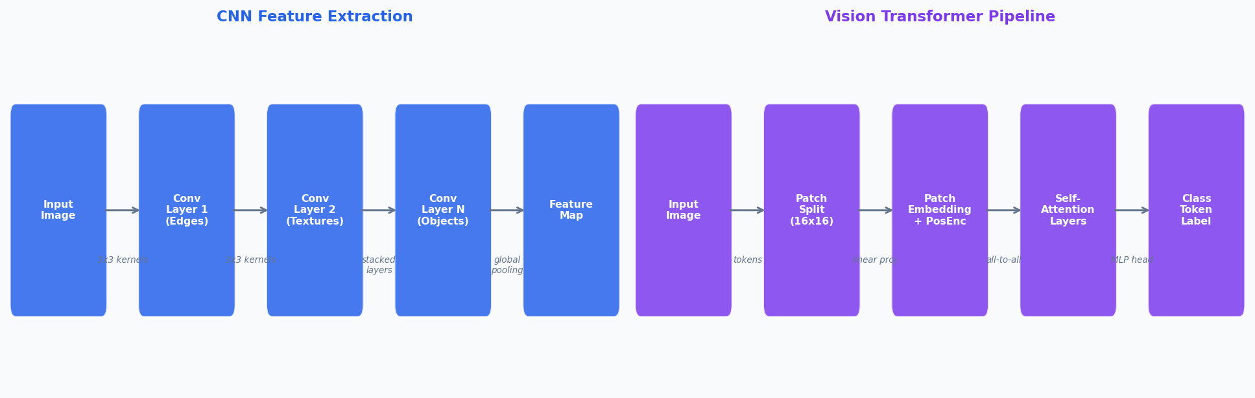
Figure 1 – How CNNs and Vision Transformers process an image (left: CNN stacks local convolutions; right: ViT tokenises patches and applies global self-attention)

2. How CNNs Extract Image Features

2.1 Local Receptive Fields and Kernels
A convolutional layer applies a small filter — typically 3×3 or 5×5 pixels — across every spatial position of the input. Each filter detects one specific pattern (e.g. a horizontal edge). Because the filter covers only a small region, each neuron's receptive field is local. The same learned weights are applied everywhere in the image — a property called translation equivariance, which is helpful but limiting.

2.2 Hierarchical Feature Learning
By stacking many layers, CNNs build increasingly abstract representations:
- Early layers: simple edges and colour gradients
- Middle layers: textures, corners, and simple shapes
- Deep layers: object parts and whole objects

2.3 The Core Limitation
To relate two distant patches — say, a cat's face and its tail in opposite corners — a CNN must pass information through many layers sequentially. Each hop is a learned approximation; information can dilute. This forces network depth to grow, increasing parameters, training time, and the risk of information loss through deep chains of transformations.
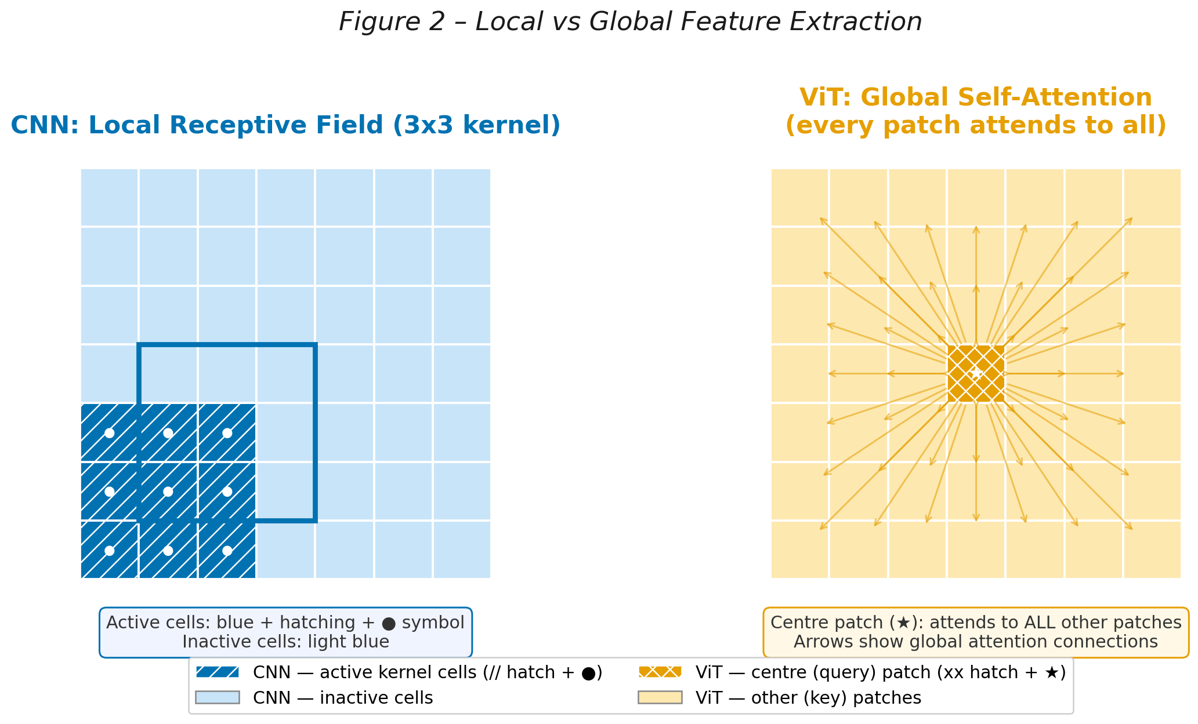
Figure 2 – Left: CNN sees only a small 3×3 neighbourhood per filter. Right: ViT self-attention lets every patch connect directly to every other patch.

3. How Vision Transformers Process Images

Step 1 — Patch Embedding
A 224×224 image is divided into non-overlapping patches of size 16×16, yielding 196 patches. Each patch is flattened into a vector and projected to a fixed embedding dimension d (e.g. 768). The result is a sequence of 196 tokens — exactly like words in a sentence fed into a language model.

Step 2 — Positional Encoding
Unlike convolution, self-attention is permutation-invariant: it has no inherent sense of spatial order. Learnable positional embeddings are added to each patch token so the model knows where in the image each patch originated.

Step 3 — Self-Attention
Each token is projected into three vectors: Query (Q), Key (K), and Value (V). The attention score between patch i and patch j is the scaled dot-product of their Q and K vectors, normalised by softmax. The output for patch i is a weighted sum of all Value vectors — so it directly incorporates information from every other patch in a single layer.

Key formula: Attention(Q,K,V) = softmax( QK^{T} / √dk ) · V
The division by √dk stabilises gradients for large embedding dimensions d.

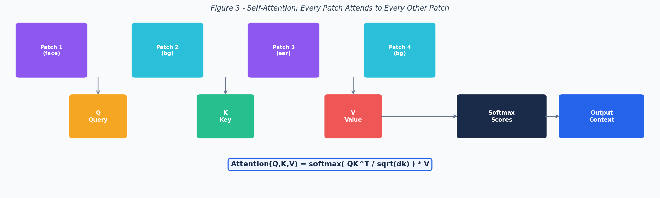
Figure 3 — Self-Attention mechanism: Q/K/V projections, softmax scoring, and weighted Value aggregation.

3b. Experimental Results: Loss Curves and Training Time on Food-101
To ground these architectural differences in practice, both models were fine-tuned on a subset of the Food-101 dataset (225 images of pizza, steak, and sushi) for 25 epochs using pre-trained weights on a CUDA-enabled GPU. Only the final classifier head was unfrozen in each model. The training and test loss curves below reveal a striking contrast in how each model learns.

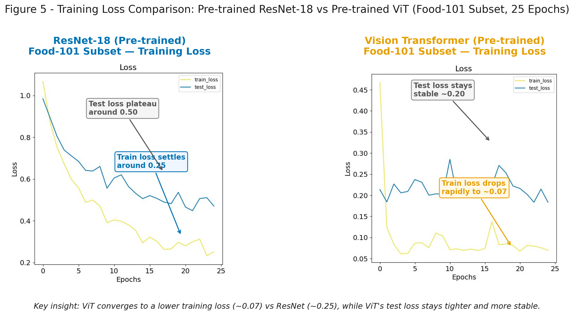
Figure 5 — Training and test loss over 25 epochs for pre-trained ResNet-50 (left) and pre-trained ViT-B/16 (right) on a Food-101 subset.

ResNet-50 shows a gradual, steady decline in training loss, settling at around 0.25 by epoch 25. Its test loss plateaus at approximately 0.50, leaving a persistent gap between train and test — a sign that local convolutional features are not capturing all the variation in the food images.
The pre-trained ViT-B/16 tells a different story. Training loss drops steeply in the first few epochs, reaching as low as ~0.07, while the test loss stabilises tightly around 0.20. The narrow train–test gap suggests that global self-attention generalises more effectively on this task — consistent with ViT’s ability to capture whole-dish context (colour, shape, texture spread across the full image) rather than small local patches.

Loss takeaway: On this pre-trained fine-tuning task, ViT achieves a final training loss ~3.5× lower than ResNet-50 (0.07 vs 0.25) and a test loss ~2.5× lower (0.20 vs 0.50), directly demonstrating the benefit of global attention-based feature extraction over local convolution.

Training Time Comparison
Despite achieving much lower loss, ViT-B/16 took 544.2 seconds (9.1 minutes) to complete 25 epochs, compared to 495.5 seconds (8.3 minutes) for ResNet-50 — a difference of approximately 48.7 seconds (~10% slower). This may seem modest, but it is the result of several compounding architectural factors worth understanding.

Metric | ResNet-50 | ViT-B/16
Total training time | 495.5 s (8.3 min) | 544.2 s (9.1 min)
Time difference | — | +48.7 s (~10% slower)
Trainable parameters | ~6,147 (fc layer only) | ~2,307 (heads only)
Frozen parameters | ~25.5 M | ~86 M
Attention complexity | O(n · k²) local | O(n² · d) global
Forward pass ops (attn) | N/A — conv only | ~354 M per image
Model size on GPU | ~98 MB | ~330 MB
Table 2 — Training time and architectural cost comparison: ResNet-50 vs ViT-B/16 (25 epochs, Food-101 subset, CUDA GPU).

Why Does ViT Take Longer?
1. Quadratic self-attention complexity. The most fundamental cause is the O(n² · d) complexity of self-attention. A 224×224 image split into 16×16 patches produces 196 tokens. Every token must compute a dot-product score against every other token in each of the 12 encoder layers — approximately 354 million attention operations per image per forward pass. ResNet-50’s convolutions scale as O(n · k²) where k is the small kernel size (3), making them far cheaper per layer.
2. Larger model footprint. ViT-B/16 has ~86 million frozen parameters occupying ~330 MB of GPU memory, compared to ResNet-50’s ~98 MB. Even though frozen parameters do not accumulate gradients during the backward pass, they still participate in the forward pass — all 86 million weights must be read from GPU memory and used to transform activations every epoch. Larger memory footprints also increase data movement overhead between GPU cores and VRAM.
3. Multi-head attention matrix operations. ViT-B/16 uses 12 attention heads per encoder layer, each projecting tokens into separate Q, K, V spaces. These 36 projection matrices (12 heads × 3 projections) per layer must be computed for every batch. Although GPUs are optimised for matrix multiplication, the sheer number of sequential matrix operations across 12 stacked layers adds non-trivial overhead.
4. Layer normalisation and residual connections. Each of ViT’s 12 encoder blocks applies two LayerNorm operations and a multi-layer perceptron (MLP) block in addition to self-attention. ResNet-50 uses Batch Normalisation, which is computationally lighter and better optimised in GPU kernels (cuDNN). LayerNorm requires computing statistics per token rather than per batch, adding sequential computation that is harder to parallelise.
5. The gap is relatively small here because most parameters are frozen. In this experiment only the classifier heads were trainable — 6,147 parameters for ResNet-50 and 2,307 for ViT. The backward pass (gradient computation) is therefore extremely cheap for both models. The 10% overhead is dominated entirely by the forward pass cost. If both models were trained from scratch (all parameters unfrozen), the time gap would be considerably larger in favour of ResNet-50.

Time takeaway: ViT takes ~10% longer to train due to its quadratic attention complexity, larger memory footprint, and heavier encoder operations — yet it achieves substantially better loss. In production settings with full fine-tuning or training from scratch, this cost gap widens significantly. The right choice always depends on dataset size, available hardware, and the acceptable trade-off between accuracy and compute.

4. Why Self-Attention Can Be Better Than Convolution
Global context in one shot. Self-attention computes pairwise relationships across all 196 patch tokens simultaneously, so a ViT can associate a cat's face with its tail in the very first layer — no depth required.
Adaptive, input-dependent weights. CNN filters are fixed after training: the same 3×3 kernel applies to every location. Attention weights are recomputed for every new image. If a scene contains fog, the model can automatically shift attention to high-contrast regions.
Scalability with data. Dosovitskiy et al. (2020) showed that ViT matches or surpasses ResNet when pre-trained on very large corpora (e.g. JFT-300M). The inductive biases of CNNs are helpful on small datasets but can become a ceiling on very large ones.

Property | CNN (ResNet) | Vision Transformer
Receptive field  (single layer) | Local (3x3 kernel) | Global (all patches)
Filter weights | Fixed after training | Input-adaptive (dynamic)
Long-range context | Requires many layers | Available from Layer 1
Data requirements | Works on small datasets | Needs large datasets
Compute per layer | O(n * k^2) | O(n^2 * d)
Table 1 — Architectural comparison of CNN vs ViT across key properties.

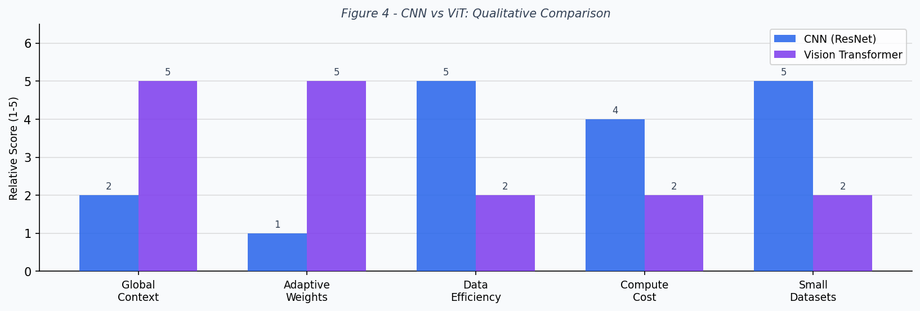
Figure 4 — Qualitative comparison scoring CNN vs ViT across five key dimensions (1=low, 5=high).

5. Discussion: When CNNs Still Win

⚠️ Important nuance: Vision Transformers are not universally superior. Their advantages depend heavily on dataset scale, available compute, and task structure.

On datasets like CIFAR-10 (50,000 training images) a ResNet-18 trained from scratch typically outperforms a ViT trained from scratch, because self-attention has fewer inductive biases and requires more data to learn spatial structure. CNNs also train faster and use less memory on modest hardware due to their O(n·k²) per-layer complexity versus ViT's O(n²·d). Hybrid architectures (e.g. CvT, DeiT) increasingly blend both paradigms to capture the best of both worlds.

6. Conclusion
Convolutional networks excel at hierarchically learning local patterns, but their local receptive fields mean long-range context is only available deep in the network. Vision Transformers reframe image understanding as a sequence modelling problem: by treating image patches as tokens and computing self-attention across all of them, ViTs capture global relationships from the very first layer, with weights that adapt dynamically to each input. Given sufficient data, this global, adaptive feature extraction enables ViTs to exceed CNN performance — representing a genuine architectural paradigm shift in computer vision.

References
Dosovitskiy, A., Beyer, L., Kolesnikov, A., et al. (2020). An Image is Worth 16x16 Words: Transformers for Image Recognition at Scale. arXiv:2010.11929.
He, K., Zhang, X., Ren, S., & Sun, J. (2016). Deep Residual Learning for Image Recognition. CVPR 2016.
Vaswani, A., Shazeer, N., Parmar, N., et al. (2017). Attention Is All You Need. NeurIPS 2017.
Bourke, D. (2023). PyTorch Deep Learning — Custom Datasets Notebook. GitHub: mrdbourke/pytorch-deep-learning, notebook 04_pytorch_custom_datasets.ipynb.

Tutorial produced for educational purposes · Figures generated with Matplotlib · Document typeset with docx.js

