02 — Technical Requirements Document (TRD)

Status: Draft v1, 2026-10-12. Recommended stack, not yet scaffolded.
Related: 01-PRD.md (what), 05-Backend-Schema.md (data and API), 06-Implementation-Plan.md (build order).
Versions and prices were checked on 2026-10-12. Third-party prices change, so re-verify before paying for anything.

1. Recommended stack
Layer | Choice | Why this one
Language | TypeScript everywhere (front end, server, domain logic, eval scripts) | One language for the UI, API, allocation solver and evaluation harness, with types shared end to end.
Web framework | Next.js 16 (App Router; 16.4.0 is current stable) | Server Components for data-heavy dashboards; Route Handlers/Server Actions for the API; streaming for the Co-Pilot. Matches the stack you already use.
UI | Tailwind CSS + shadcn/ui (Radix primitives), TanStack Table, lucide icons | Accessible primitives (focus, keyboard, ARIA) out of the box. You own the component code, so the design brief (04) applies directly.
Database | Supabase Postgres | Relational data with strong constraints suits the shared data model. Row-Level Security enforces roles in the database itself.
Auth | Supabase Auth (email + password, admin-created accounts) | Works directly with RLS (auth.uid()). No email sending is needed if Admin sets temporary passwords.
Realtime | Supabase Realtime (Postgres changes + broadcast) | Live dashboard, driver, accommodation and housekeeping screens without running a separate socket server.
Scheduled jobs | Supabase pg_cron + pg_net → calls the app's /api/jobs/* routes | Vercel Hobby crons are limited to once per day with ±59 min precision, which is too coarse for flight polling. pg_cron runs every minute on any Supabase plan.
Validation | Zod | One schema per entity, used for form validation, API input validation and as the AI structured-output schema.
AI (LLM) | Claude API via @anthropic-ai/sdk, model claude-opus-5-5 | Strong at messy-text extraction and tool use. Supports structured outputs (schema-valid JSON) and strict tool definitions. See §4.3.
Speech-to-text | Deepgram Nova-3 (pre-recorded endpoint) with keyterm prompting | Keyterm prompting lets us pass the event's guest names and titles, which directly addresses "names and titles can be misheard". Claude does not take audio input, so speech-to-text is a separate service.
Flight data | AeroDataBox (primary), FlightAware AeroAPI (fallback), Simulated provider (testing/demo) | See §4.1.
Bot protection | Cloudflare Turnstile on the public intake form | Free, privacy-friendlier than image CAPTCHAs, and low friction for VIP assistants.
Hosting | Vercel (Next.js) + Supabase (managed Postgres) | No servers to run. Preview deployments per branch. Free tiers cover development.
Testing | Vitest (unit/domain), pgTAP via supabase test db (RLS and DB functions), Playwright (end-to-end) | RLS is security-critical, so it gets its own tests.
Tooling | pnpm, ESLint, Prettier, Supabase CLI (local stack in Docker, migrations, type generation)

Alternatives considered: a separate Python/FastAPI backend (rejected: two languages and two deploys for no real gain at this size); Firebase (rejected: a document store is a poor fit for a constraint-heavy relational model, and there is no RLS equivalent); text-to-SQL for the Co-Pilot (rejected: hard to secure and hard to evaluate, see §3.6).

2. Architecture
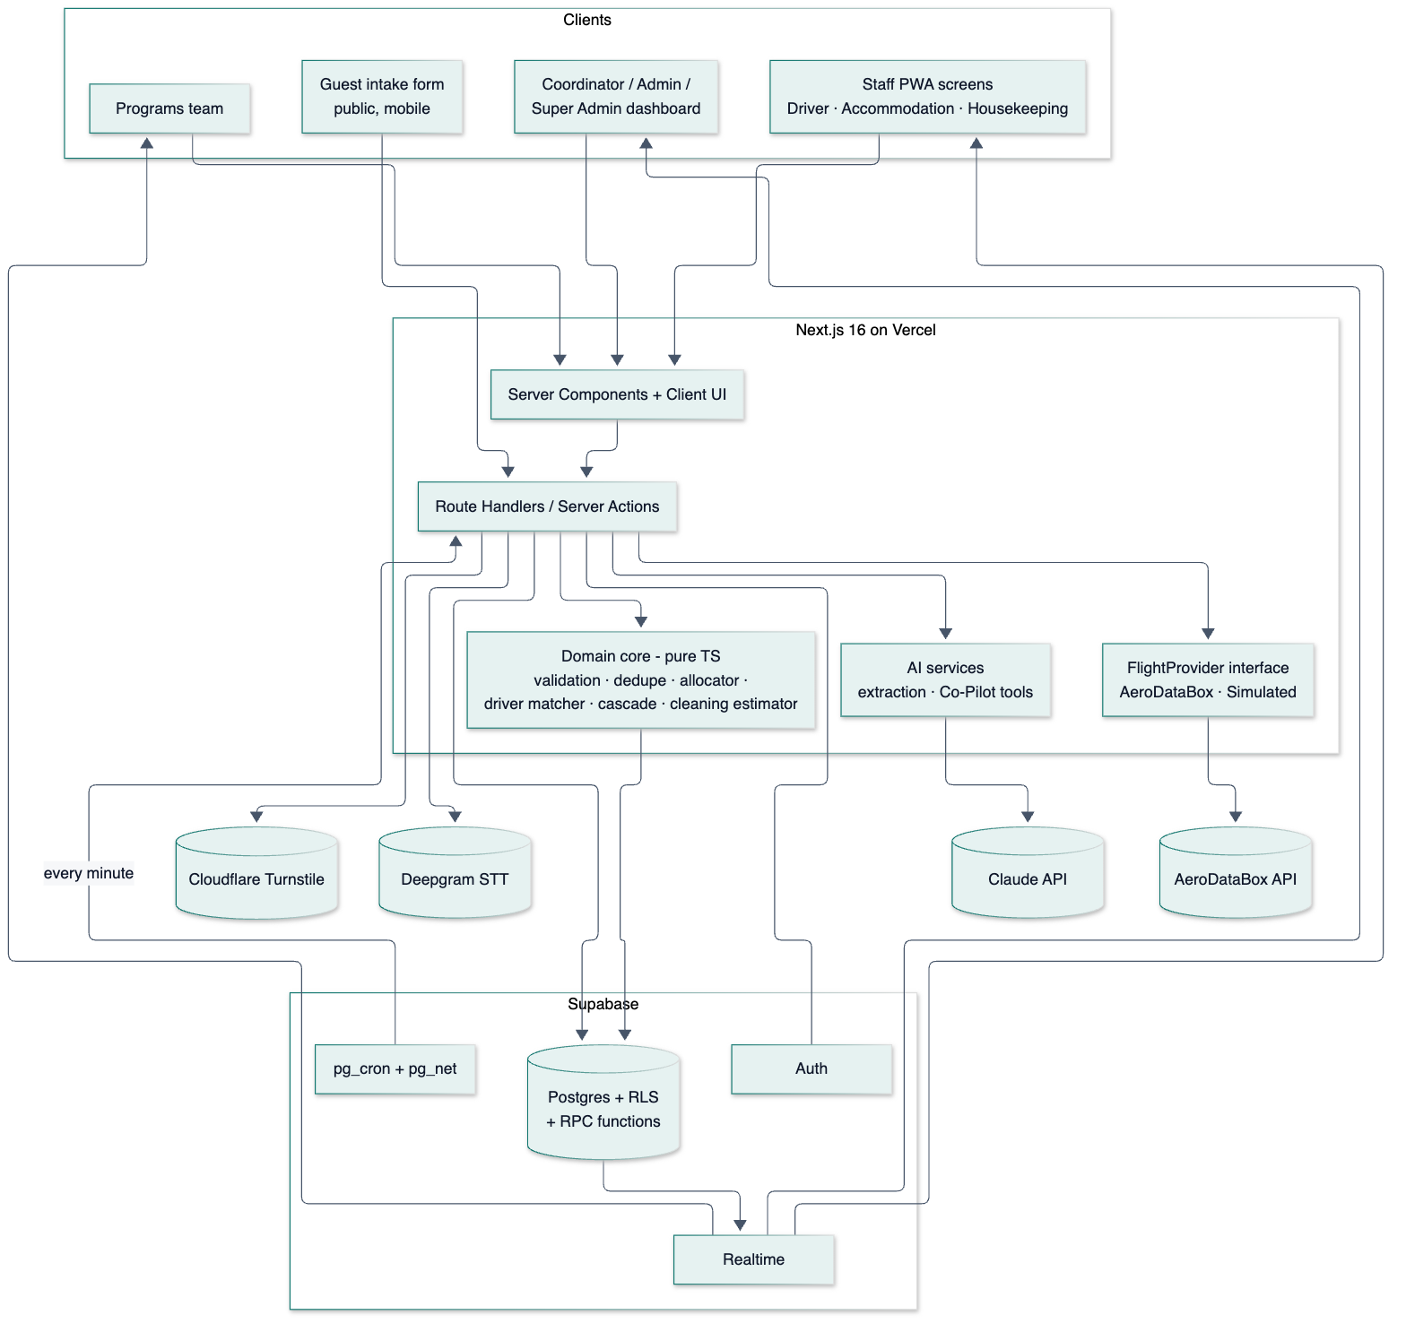

2.1 Key architectural decisions
- Domain core is pure TypeScript. Validation, duplicate scoring, the room allocator, the driver matcher, cascade planning and cleaning estimates are pure functions: (state snapshot, now) → result. They have no database or network calls. This makes them unit-testable, lets the evaluation harness run them directly on datasets, and makes simulation deterministic.
- Reads in TypeScript, multi-row writes in Postgres functions. Anything that must be atomic runs as a single SECURITY DEFINER RPC that also writes the audit row: approving a proposal, checking out (first wins), reversing a checkout, undo, ingesting a flight update. This means "half-applied" states cannot exist.
- Proposal engine. Anything the PRD puts on the "propose" side of P1 becomes a row in proposals with a machine-executable payload and a human-readable rationale. Approving calls approve_proposal(id), which re-validates against current data (the world may have changed), executes, and logs. Room plans are a parent proposal with child lines, so they can be approved all at once or line by line.
- Injected clock. All domain logic takes now as a parameter. In simulated mode, now = virtual time (virtual_start + (real_elapsed × speed)), so a 6-hour delay scenario can be demonstrated in 6 minutes.
- Event-driven cascade inside one transaction boundary per step. A flight update runs: ingest → update arrivals (auto) → recompute pickups (auto) → check driver feasibility → create proposals and notifications → re-check room readiness and program conflicts. Each step is logged with timings, which gives the latency metric directly.

2.2 Code layout (planned)
app/ Next.js routes (see 03-App-Flow.md)
(public)/intake/[token]
(staff)/driver | accommodation | cleaning
(console)/dashboard | guests | intake-review | flights | transport | rooms | program | activity | simulation | admin/*
api/ route handlers (intake, jobs, copilot, webhooks)
lib/
domain/ pure logic: intake/, flights/, transport/, allocation/, cleaning/, program/
providers/flights/ FlightProvider + aerodatabox.ts + simulated.ts
ai/ extraction.ts, copilot/ (tools, prompts), transcribe.ts
db/ typed Supabase clients, generated types, query helpers
auth/ role guards
components/ UI (shadcn/ui based)
supabase/
migrations/ SQL migrations (schema, RLS, RPC functions)
tests/ pgTAP tests
seed/ seed SQL + TS generators
eval/ datasets (JSONL), runners, results
docs/ these documents

3. Module technical design

3.1 Intake pipeline (M1)
submit → [Turnstile + rate limit] → store raw submission
→ normalize (deterministic)
→ AI extract "others" (structured output → Zod-validated)
→ validate (rule checks, optional flight lookup)
→ dedupe (exact / likely / none)
→ high-confidence? yes → auto-create records (RPC, logged, undoable)
no → review queue + coordinator notification
- Duplicate scoring: normalized-name trigram similarity (pg_trgm) combined with the same flight + date, the same arrival date, or the same contact phone/email. Exact = all key fields identical after normalization → auto-link. Likely = similarity ≥ threshold (tuned on the eval set, start at 0.6) with a matching date/flight or contact → review.
- AI cost and latency are recorded per submission (model, tokens, ms) for the evaluation chapter.

3.2 Flight tracking (M2)
- FlightProvider interface: getStatus(flightNumber, date) → FlightSnapshot. Implementations: AeroDataBoxProvider, SimulatedProvider (reads simulation_scenarios), and optionally FlightAwareProvider. The event setting flight_mode = live | simulated picks the provider.
- Adaptive polling: each flight row stores next_check_at. pg_cron calls /api/jobs/flight-poll every minute (authenticated with a shared secret). The route polls only flights where next_check_at ≤ now, then sets the next check time by distance to arrival:

Time to scheduled arrival | Check every
> 24 h | once at T−24h
24 h → 6 h | 2 h
6 h → 2 h | 30 min
< 2 h, until landed/cancelled | 10 min

This is about 15–25 calls per flight, and many guests share one flight. For example, 50 distinct flights ≈ 1,000 calls. That fits AeroDataBox's paid "Pro" quota once the per-endpoint unit cost (1–6 units/call) is confirmed (§4.1).
- Push upgrade (optional): AeroDataBox's Flight Alert API can POST to a webhook on changes. /api/webhooks/flights is designed to accept it, so polling can drop to a safety net. Not required for the MVP.
- Delay is a badge, not a phase: status ∈ {scheduled, in_air, landed, cancelled, diverted, unknown}, and delayed = estimated_arrival − scheduled_arrival > threshold. A flight can be "in the air and delayed".

3.3 Transport and cascade (M2)
- Trip window for a pickup = [pickup_at − travel_time, pickup_at + travel_time], using fixed event buffers (no traffic prediction).
- Driver feasibility: active, on shift for the whole window, no overlapping active assignment, capacity ≥ passengers (or a minimal set of drivers whose capacities add up).
- Ranking: keep the current driver if feasible → fewest jobs that day → smallest idle gap. The top choice becomes the proposal, with up to 2 alternatives in rationale.
- Latency metric: flight_updates.observed_at → proposals.created_at, stored per update.

3.4 Room allocator (M3)
- Model: guests are grouped into room groups (one guest, or a coordinator-defined share group). Each room group gets one room.
- Hard constraints (filter): free for the stay window (capacity-aware across overlapping stays), capacity ≥ group size, ready by expected arrival (clean, or the cleaning task's estimated_ready_at ≤ expected_arrival), not out of service, and never move checked-in guests.
- Soft score (weighted, normalized to 0–100%):
  - tier ↔ VIP rank match,
  - ground floor when requested or when an accessibility need was extracted,
  - proximity to principal = f(floor difference, same wing, |position difference|), weighted by the member's proximity priority (high/normal/low),
  - same-team clustering.
- Algorithm: (1) order delegations by principal rank, then size; (2) place the principal in the best-scoring feasible room; (3) place members, minimizing distance to the principal; (4) local search: pairwise swaps within feasibility that raise the total score, up to an iteration cap; (5) emit the plan plus a per-line explanation (which rules and preferences were met or missed). Deterministic for a given input.
- Baseline for evaluation: a naive "first free room that fits" allocator over the same inputs. Optional extension: an exact ILP formulation solved with HiGHS (WASM) on small instances, to report how close the heuristic gets to optimal.

3.5 Turnaround and cleaning (M5)
- First confirmation wins: check_out_assignment(id) runs UPDATE … SET checked_out_at = now(), checked_out_by = auth.uid() WHERE id = $1 AND checked_out_at IS NULL RETURNING *. If zero rows are updated, it returns the existing checked_out_by/at, and the UI shows "Already checked out by X at T". There is no lock juggling; Postgres row-level atomicity is enough.
- Estimate: estimated_ready_at = checkout_at + room_type.cleaning_minutes + event.cleaning_delay_buffer_min.
- Priority: needed_by = the next allocation's expected arrival for that room. The queue is ordered by needed_by (nulls last), then estimated_ready_at.

3.6 Co-Pilot (M4)
- Surface: Claude API tool use through the SDK's tool runner (client.beta.messages.toolRunner + betaZodTool), streaming to the chat panel.
- Read tools are typed, parameterized query functions that run with the signed-in user's Supabase session, so RLS applies to the Co-Pilot too: find_arrivals, get_guest, get_flight_status, list_pickups, list_rooms, get_cleaning_queue, get_program, who_is_affected, get_pending_decisions.
- Write tools (propose_room_move, propose_driver_assignment, add_note) only create proposals. The tool result tells the model that a proposal is awaiting the coordinator. Approval happens in the UI, never through the model.
- Why not text-to-SQL: typed tools mean (a) RLS and parameterization by construction, (b) a small, enumerable action space to measure "picked the right action" against, and (c) answers that are reproducible on a seed dataset.
- Prompting and caching: a stable system prompt + tool list first (prompt-cached), with volatile context (current time, event timezone) after the cache breakpoint.
- Voice: browser MediaRecorder (push-to-talk) → /api/copilot/transcribe → Deepgram Nova-3 with keyterms (names/titles of guests arriving in the next 48h, wing names, airline names; capped to the provider's keyterm limit). The transcript is returned to the input box for editing. Audio is not stored; only the original and edited transcripts are kept (for the WER metric).

3.7 Program (M6)
- program_conflicts is a SQL view: participant expected_arrival_at + venue_travel_buffer + lead_time > item.starts_at. It is re-evaluated after every arrival change. Newly at-risk items notify the programs team and the coordinator.

4. Integrations

4.1 Flight data API — recommendation
Option | Cost (checked 2026-10-12) | Pros | Cons
AeroDataBox (via API.Market / RapidAPI / direct) — recommended | Free "Basic": 400 units/mo (RapidAPI). Pro: $7.50/mo for 5,000 units. Direct "Starter": $19/mo for 40,000. Calls cost 1–6 units depending on endpoint tier. | Cheapest viable paid tier. Flight status by number + date. Optional Flight Alert webhooks (push). Aimed at small developers and students. | Positioned as "best-effort". Coverage of specific (especially African) airports must be tested. Exact unit cost of the status endpoint still needs confirming.
FlightAware AeroAPI — fallback | "Personal": no monthly minimum, about $5/mo of free usage, 10 result sets/min. Alerts (push) require "Standard" ($100/mo minimum). | High-quality data and strong global coverage. | Per-query billing. Push alerts are too expensive for a student project.
Aviationstack | Free: 100 requests/mo. Paid from about $49.99/mo. | Simple. | Free tier too small for adaptive polling. Expensive for what it adds.

Recommendation: build against the FlightProvider interface, implement AeroDataBox first, and keep the simulated provider as the default in development. Before committing: (1) run a coverage test, querying 10–20 real flights into the event's arrival airport(s) on AeroDataBox and AeroAPI Personal and comparing completeness and timeliness; (2) confirm the unit cost of /flights/number/{number}/{date}; (3) subscribe to Pro only for the evaluation/demo month.

4.2 Speech-to-text
- Deepgram Nova-3, pre-recorded. Third-party sources report about $0.0043/min, keyterm prompting as a small add-on, and $200 of free starting credit. Coordinator queries are 5–15 s, so cost is negligible. Verify on deepgram.com/pricing.
- Opt out of provider model-improvement programs where offered, and confirm the data-retention terms.
- Alternative considered: the browser's Web Speech API. It is free, but inconsistent across browsers, offers no custom vocabulary, and sends audio to the browser vendor.

4.3 Claude API
Use | Model | Settings | Notes
Intake extraction | claude-opus-5-5 | Structured output (output_config.format) from the Zod schema; effort low (to tune) | Short, high-volume calls.
Pasted-message → draft intake | claude-opus-5-5 | Same schema as the form; effort low–medium
Co-Pilot | claude-opus-5-5 | Tool runner, strict: true tools, streaming, effort medium (to tune) | Check stop_reason (including refusal) before reading content. Enable the server-side fallbacks option.

- Pricing (Opus 5.5): $4 / $20 per million input/output tokens; cache reads $0.20 per million.
- Cost lever (your call): once the eval sets exist, measure whether a cheaper model (e.g. Claude Haiku 5.5 at $0.10 / $0.50 per million tokens) holds the extraction F1 target. Switch only if the numbers support it.
- Note for implementation: forced tool_choice is not supported on this model. Use auto + strict tools, or structured outputs.

4.4 Cloudflare Turnstile
- Widget on the intake form, verified server-side in POST /api/intake/[token], combined with per-IP-hash rate limiting stored in Postgres.

5. Hosting, environments, deployment
Environment | Web | Database | Flight provider
Local | next dev | Supabase CLI local stack (Docker) | Simulated
Preview (per PR) | Vercel preview | Supabase dev project (or branch) | Simulated
Production / demo | Vercel production | Supabase production project | Live (switchable to simulated)

- Migrations are in supabase/migrations, applied by the Supabase CLI. Types are generated into lib/db/types.ts.
- Secrets (Anthropic, AeroDataBox, Deepgram, Turnstile secret, Supabase service role, cron shared secret) live only in Vercel/Supabase environment variables. They are server-only and never in the browser bundle.
- Free-tier caveats: Supabase free projects pause after 7 days of inactivity. Keep the project active, or upgrade to Pro ($25/mo) during the evaluation/demo window. Vercel Hobby is for non-commercial use, which suits a student project.
- Region: choose the Supabase region closest to the venue (TBD, see open questions).

6. Constraints
From 00 §10: one event, one venue, one coordinating team; seeded/synthetic plus volunteer data; real flight API plus simulated mode; every important action confirmed and logged; each part measurable.
Technical constraints:
- No outbound WhatsApp/SMS/email to guests. In-app notifications only.
- No live traffic data. Fixed, configurable buffers.
- No trained ML models. AI is limited to LLM extraction/Co-Pilot and speech-to-text. Estimates are arithmetic.

7. Non-functional requirements
Area | Requirement
Security | RLS on every table, deny by default. Staff routes are role-guarded on the server. Service-role key only in server code. Public intake has Turnstile + rate limiting + payload size limits. All AI tool calls run as the calling user. The audit log is append-only (no update/delete grants).
Privacy | VIP itineraries are sensitive. Collect only what is needed. Least-privilege views (housekeeping sees no guest names; drivers see only their jobs). Consent notice on intake. [Proposed] Purge or anonymize guest PII 90 days after the event (Super Admin action). The applicable data-protection law depends on the venue country (e.g. Nigeria's NDPA 2023 if held there). TBD.
Performance | A dashboard update appears within 2 s of a database change (Realtime). Cascade from flight update to proposal p95 ≤ 5 s. Intake submit → confirmation ≤ 3 s (AI extraction may finish asynchronously after confirmation). Co-Pilot first token ≤ 3 s typical.
Reliability | Idempotent job endpoints (re-running a poll is safe). Provider errors back off and mark the flight unknown, never crash the cascade. Approving a proposal re-validates against current data.
Accessibility | WCAG 2.2 AA (see 04). Status never conveyed by color alone. Full keyboard support on the console. 48 px touch targets on staff screens.
Time | All timestamps stored as timestamptz (UTC) and displayed in the event timezone. Flight times are converted from airport-local time.
Browser support | Latest two versions of Chrome, Safari, Edge and Firefox. Staff screens are tested on a mid-range Android phone and an iPhone.
Observability | Structured server logs. Per-call AI usage (tokens, latency, model). Per-update cascade timings. Provider call counts per day (quota watch).
Testability | Pure domain core. Seed generators for every scenario in 00 Decision 5. Injected clock. Deterministic allocator.

8. Testing and evaluation strategy
Layer | Tooling | What
Unit | Vitest | Domain core: validators, normalizers, dedupe scoring, allocator, driver matcher, estimators, polling schedule
Database | pgTAP (supabase test db) | RLS per role, RPCs (first-wins checkout, approve proposal, undo), constraints
Integration | Vitest + local Supabase | Intake pipeline end-to-end; cascade on a simulated scenario
End-to-end | Playwright | Main flows in 03-App-Flow.md across roles
Evaluation | eval/ runners (pnpm eval:<module>) | Produces the PRD §8 metrics as JSON + Markdown tables for the report

Evaluation datasets (all versioned in eval/datasets/):
- intake.jsonl: ≥ 100 intake texts (synthetic + volunteer, anonymized) with gold fields and gold issues, including duplicates, missing data and contradictions.
- scenarios/*.json: flight scenarios (delay, early arrival, cancellation, diversion, multiple guests on one flight, driver conflicts).
- allocation/*.json: venue + guest sets of increasing size and difficulty, with known-feasible solutions.
- copilot.jsonl: ≥ 50 questions with expected answers and ≥ 20 action requests with the expected tool + arguments, on a fixed seed.
- voice/: recorded name-heavy questions with reference transcripts (recorded by volunteers with consent).

9. Rough running costs (development + one evaluation month)
Item | Estimate
Vercel Hobby | $0
Supabase Free (Pro $25/mo optional during evaluation) | $0–25
AeroDataBox (Basic free for development, Pro for one month) | $0–7.50
Deepgram (free starting credit) | ~$0
Cloudflare Turnstile | $0
Claude API (Opus 5.5): roughly $0.01–0.03 per intake, $0.03–0.10 per Co-Pilot question; eval runs dominate | Roughly $20–60 total. Measure with real usage logs.

10. Risks
Risk | Mitigation
Flight API lacks coverage for the event's airports | Coverage test before committing; FlightAware fallback; simulated mode for the demo.
API quota exhausted mid-event | Adaptive polling; one poll per distinct flight; daily quota counter with a coordinator warning at 80%.
AI extracts wrongly and it is auto-processed | Auto-processing is limited by rule-based confidence; flags force review; everything is undoable; tracked by the "auto-processing safety" metric.
Co-Pilot takes an unsafe action | Write tools only create proposals; RLS applies to tool calls; approval only in the UI.
Race conditions between staff | Atomic RPCs (first-wins checkout); proposals re-validated on approval; optimistic version checks on edits.
Free-tier project paused before the demo | Keep-alive or a Pro upgrade during the demo window.

11. Open technical decisions
- Venue country, timezone and arrival airport(s): needed for the flight coverage test, Supabase region and the data-protection regime.
- Confirm AeroDataBox after the coverage test (§4.1).
- Whether to add the ILP exact-solver comparison (§3.4) to the evaluation chapter.
- Whether to adopt AeroDataBox Flight Alert webhooks (push) or stay with polling.

12. Answers to open technical decisions
Venue Country is Nigeria
Arrival Airport is Muritala Mohhamed Airport in Lagos. Every other detail should be decided based on this decision.
Yes, please, add the ILP exact-solver comparison (§3.4) to the evaluation chapter ifwe don’t end up changing anything or reworking it.
As for Whether to adopt AeroDataBox Flight Alert webhooks (push) or stay with polling, the web developer will determine that and after that is done in the long wrong, we will update you and give necessary documentation.

