03 — App Flow

Status: Draft v1, 2026-10-12. Planned screens, none built yet.
Related: requirements in 01-PRD.md, routes/API in 05-Backend-Schema.md §7, visual rules in 04-UI-UX-Design-Brief.md.

1. Surfaces
Surface | Who | Form factor | Shell
Public intake | Guests / secretariat (no login) | Mobile-first web form | Minimal: event name, form, confirmation
Console | Super Admin, Admin, Coordinator, Programs | Desktop/tablet (phone usable for the Co-Pilot) | Sidebar nav, top bar (event clock, simulated-mode banner, decisions badge, notifications, Co-Pilot button)
Staff app (installable PWA) | Driver, Accommodation & logistics, Housekeeping | Phone | Single screen: task list + one status button per task, notification banner
Co-Pilot panel | Coordinator, Admin, Super Admin | Right-side drawer (full screen on phone) | Chat, push-to-talk mic, inline proposal cards

2. Screen inventory

Public
Route | Screen | Purpose
/intake/[token] | Intake form | Conditional fields by "How are you arriving?", team members, diet, others, consent, Turnstile
/intake/[token]/done | Confirmation | Reference code, what happens next
/intake/closed | Closed/invalid link | Plain message with a contact line

Auth
Route | Screen | Purpose
/login | Sign in | Email + password
/account/password | Change password | Forced on first sign-in

Console — Coordinator (also Admin, Super Admin)
Route | Screen | Purpose / key actions
/dashboard | Home | ① Needs your decision (proposals + review items, one-tap approve/reject) ② Next 6 hours arrivals timeline (flight phase, delay badge, pickup and room readiness) ③ Alerts (program at risk, flights unknown, quota warnings) ④ Counters
/decisions | Decisions queue | Full list of pending proposals and review items. Filters by kind. Bulk approve plans.
/guests | Guests | Table of delegations/guests: filters (VIP category, arrival mode, status, missing driver, no room, needs attention)
/guests/[id] | Guest / delegation detail | Profile, members (add/rename placeholders, member role, proximity priority, share groups), VIP category, requirements, arrival(s) + flight, pickup + driver, room(s), program participation, history (audit)
/intake-review | Intake review | Submissions needing review: issues list, AI-extracted items, duplicate side-by-side. Approve (with edits) / link / reject. Paste a message tool.
/flights | Flight board | All tracked flights: phase, scheduled vs estimated, delay, guests on board, last checked. Refresh, override time.
/transport | Transport board | Pickups timeline by driver (lanes) + an unassigned lane. Propose/assign driver. Driver shifts.
/rooms | Room plan | Grid by floor × wing with room status and occupants. Unallocated guests tray. Run allocator → plan review. Drag or pick to move (with rule check).
/rooms/plan/[proposalId] | Plan review | Per-line assignments with score breakdown, overall satisfaction %. Approve all/selected.
/housekeeping | Cleaning overview | Same queue housekeeping sees, plus estimates vs needed-by
/program | Program timeline | Read-only for the coordinator. At-risk items highlighted.
/activity | Activity log | Audit log, filters, Undo on automatic entries
/simulation | Simulation | Scenarios list, start/stop a run, speed, live event feed

Console — Programs team
Route | Screen | Purpose
/program | Program editor | Timeline + list. Create/edit/publish items. At-risk badges.
/program/[id] | Program item | Details, participants (search guests), each participant's arrival status and at-risk reason

Console — Admin (also Super Admin)
Route | Screen | Purpose
/admin/event | Event settings | Dates, timezone, airports, buffers, intake link (open/close/regenerate/copy)
/admin/venue | Venue | Wings, floors, room types (tier, capacity, cleaning minutes), rooms (CSV import, out of service)
/admin/drivers | Drivers | Drivers, vehicles, shifts, linked logins
/admin/vip-categories | VIP categories | Ordered rank list (coordinators can also edit)
/admin/users | Users | Create (temporary password), role, deactivate. Only Super Admin can manage Admin/Super Admin accounts.
/admin/system | System (Super Admin only) | Flight provider mode (live/simulated), provider status and quota, AI usage, data export, post-event purge

Staff app
Route | Role | Screen | Single status button
/driver | Driver | My pickups (next first): time, guest title + name, flight + live status, pickup point, passengers, changes highlighted | Acknowledge change → En route → Picked up → Completed
/accommodation | Accommodation & logistics | Today's arrivals (expected time, room(s), readiness) and in-house guests | Check in / Check out (first wins)
/cleaning | Housekeeping | Prioritized rooms: number, floor/wing, type, needed by, estimated ready | Start → Done

3. Navigation map
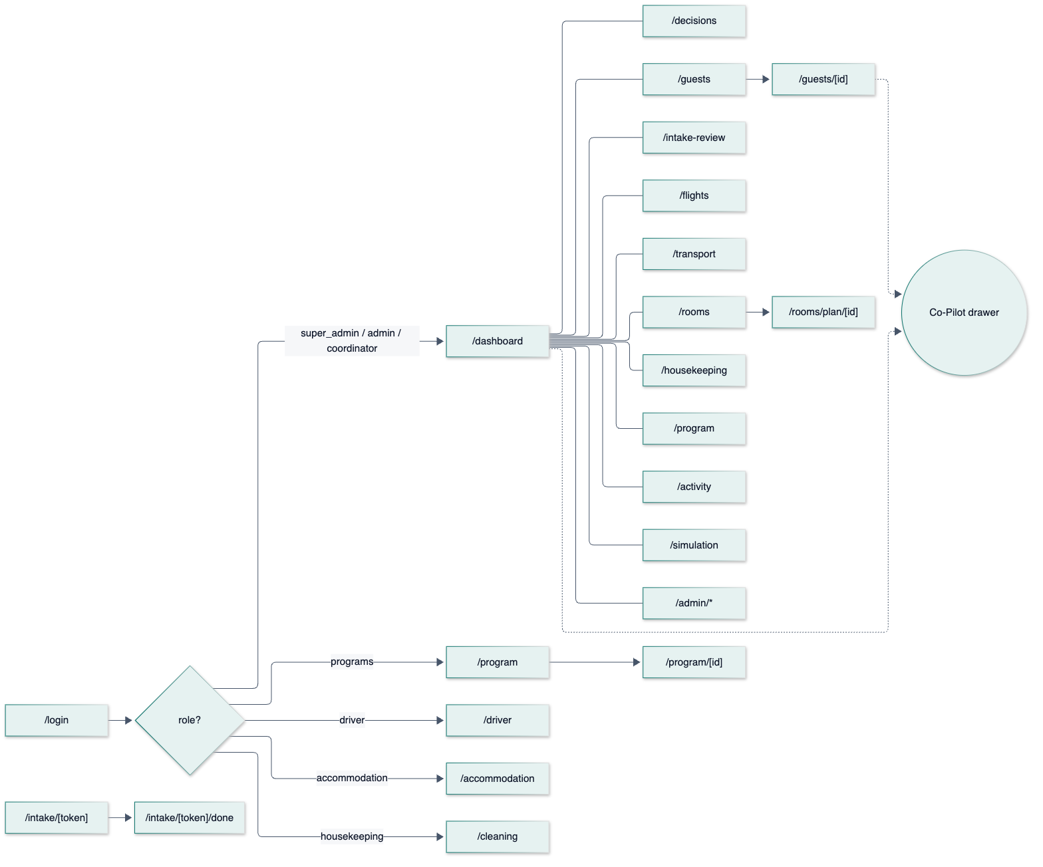
After sign-in: users go to their role's home route. A user who opens a route their role cannot access gets a 403 page with a link to their home (RLS blocks the data either way). A user with must_change_password is sent to /account/password first.
Deep links: every notification links to its entity (/guests/[id], /decisions?focus=<proposal>, /driver#<pickup>, …).

4. Key flows

F1 — Guest intake (shared link)
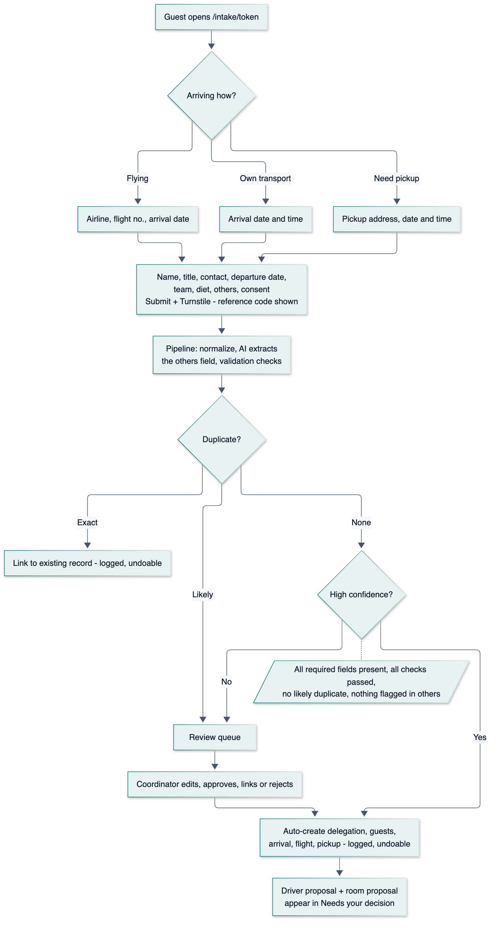

F2 — Pasted message
- The coordinator opens Intake review → Paste a message, pastes the text and presses Extract.
- The AI returns a draft in the same shape as the form, with missing fields highlighted and extracted items listed.
- The coordinator completes or corrects the draft and presses Create. It then goes through validation and duplicate checks. Because a human created it, it never auto-processes silently: the coordinator sees the issues before confirming.

F3 — Duplicate review
Side-by-side view: the existing delegation vs the new submission, with differences highlighted. Actions: Link (the submission becomes a linked duplicate; optionally apply chosen field updates), Treat as new, Reject. Nothing is auto-merged.

F4 — Flight delay cascade
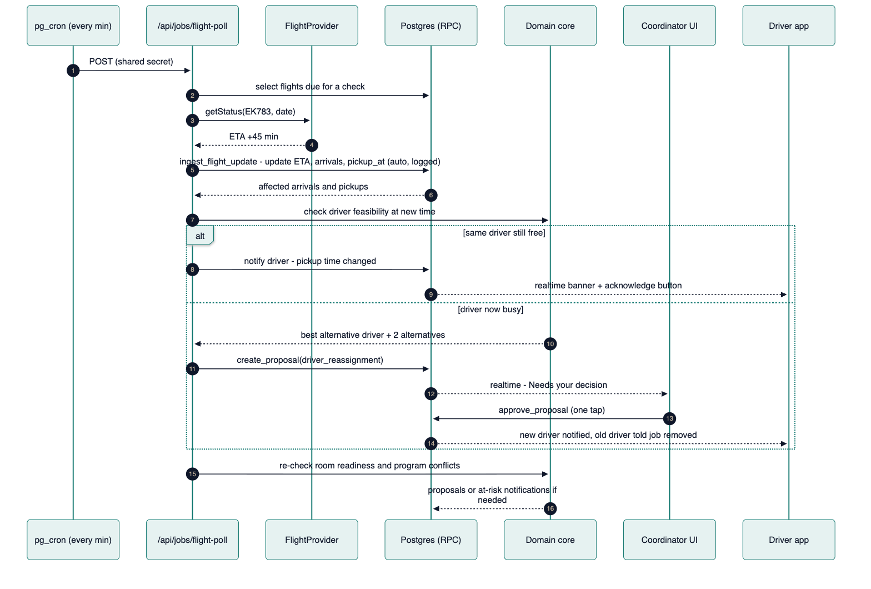

F5 — Driver trip lifecycle
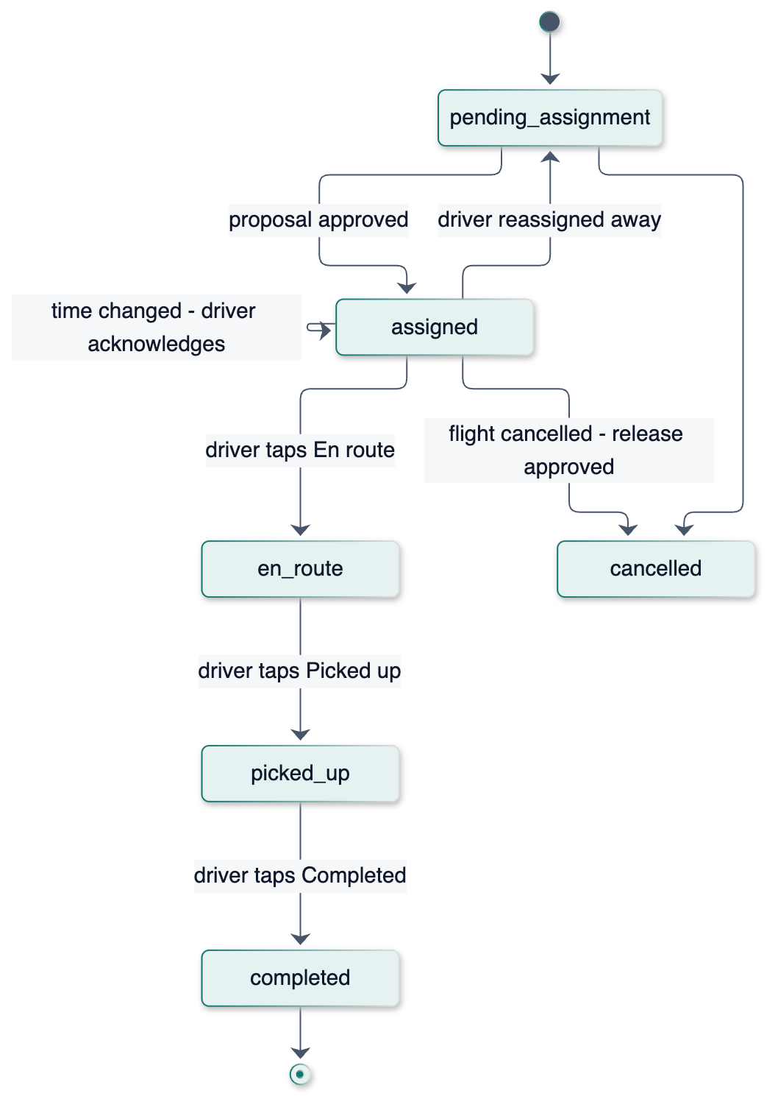

F6 — Room plan and manual override
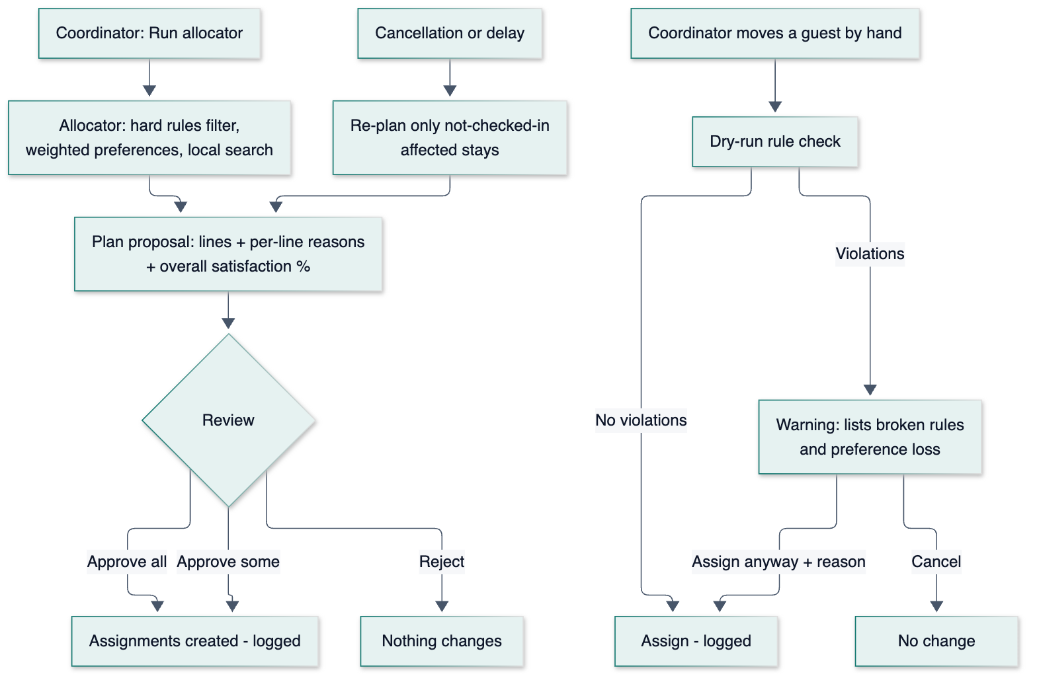

F7 — Check-in, check-out and cleaning (first confirmation wins)
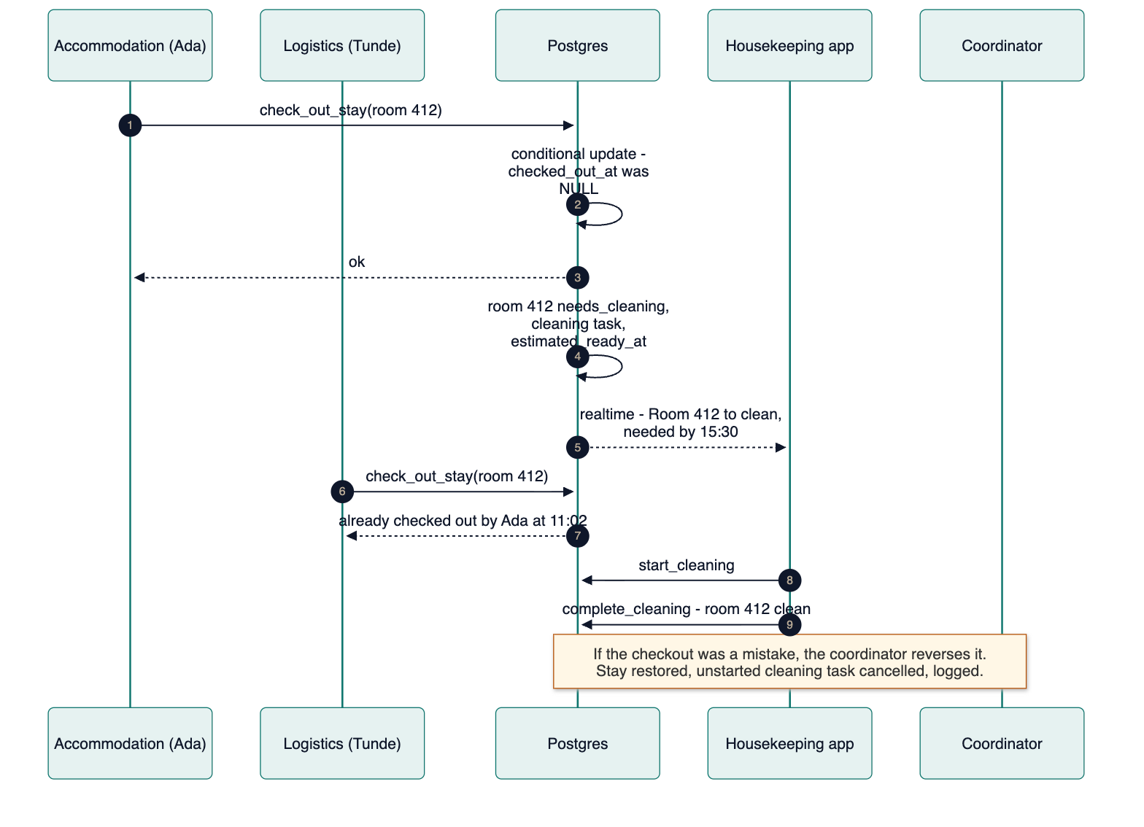

F8 — Co-Pilot question and action (typed or voice)
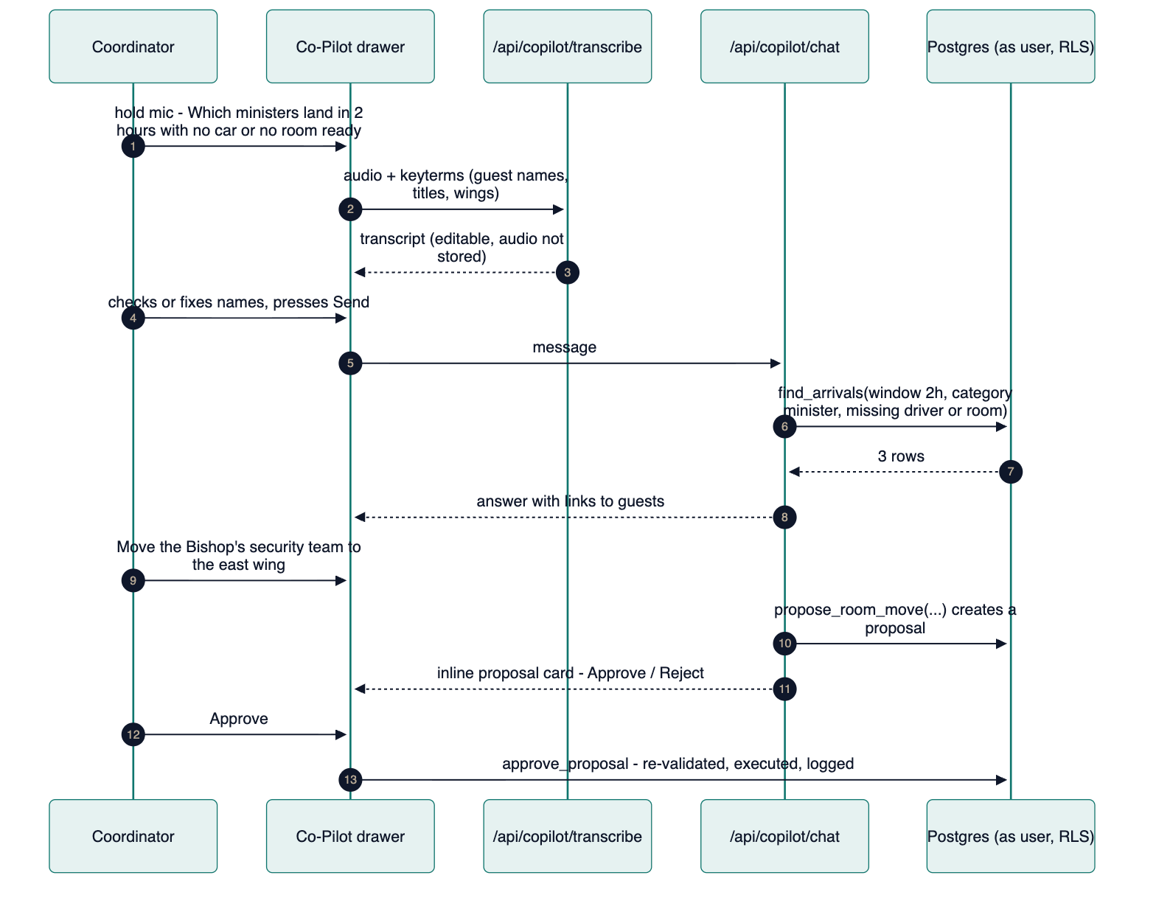

F9 — Program at risk
- The programs team publishes "Opening ceremony 10:00" with speakers A, B and C.
- Speaker B's flight ETA moves, so B's expected_at_venue_at + lead time is now later than 10:00.
- v_program_conflicts returns B. The programs team and the coordinator are notified ("Opening ceremony at risk: Speaker B expected 10:20").
- The programs team adjusts the order or time, or the coordinator acts on transport. The badge clears automatically when the conflict is gone.

F10 — Undo an automatic action
Activity → filter "Automatic" → choose an entry (e.g. "Auto-created delegation from VIP-7K3Q" or "Arrival time changed by flight API") → Undo → confirm. The system checks that the record hasn't changed since (version). If it has, undo is refused with "Changed since by <who> at <when>; edit manually instead." The undo itself is logged.

F11 — Simulation demo
Simulation → choose a scenario (e.g. "3 flights delayed, 1 cancelled, shared flight") → speed ×60 → Start. A banner shows "SIMULATED MODE · virtual time 14:20" on every console screen and staff screen. pg_cron ticks apply steps through the same ingest_flight_update path, so all of F4–F9 happen live. Stop ends the run, and the metrics (cascade latency, proposal correctness) are viewable afterwards.

F12 — First-run setup (Admin)
/admin/event (dates, timezone, airports, buffers) → /admin/venue (room types with cleaning minutes → rooms CSV import) → /admin/vip-categories → /admin/drivers (drivers, vehicles, shifts) → /admin/users (create staff accounts) → /admin/event Open intake → copy the link and share it with the secretariats.

5. Status lifecycles (reference)
Intake submission
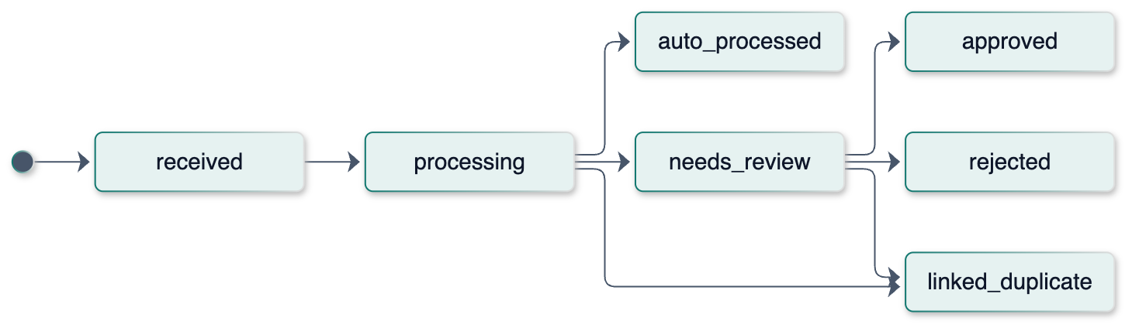
Stay (room assignment)
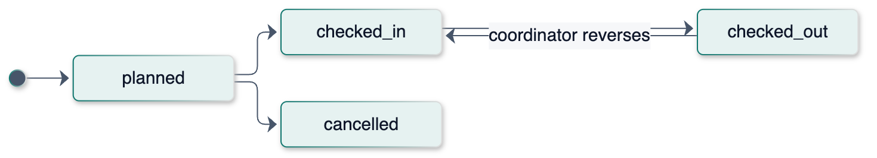
Cleaning task
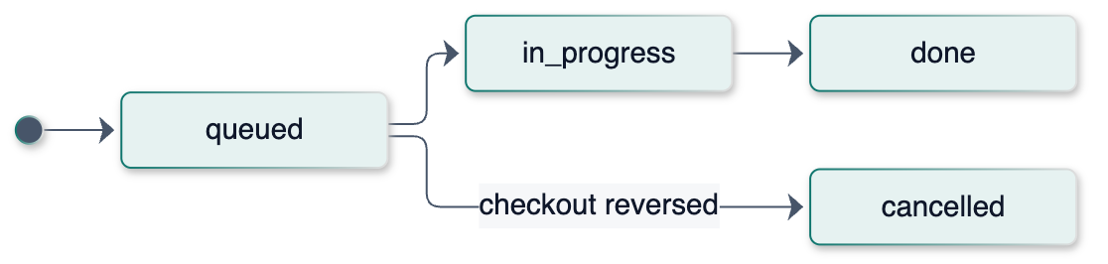
Proposal
