06 — Implementation Plan

Status as of 2026-10-12: Phase 0 (documentation) drafted. No application code exists yet.
Rule from 00 §10: a phase is done when it works end to end and can be measured, not when it has the most features. Each phase below has explicit exit criteria.
Legend: ⬜ pending · 🟨 in progress · ✅ done · ⏸ deferred

1. Phase overview and dependencies
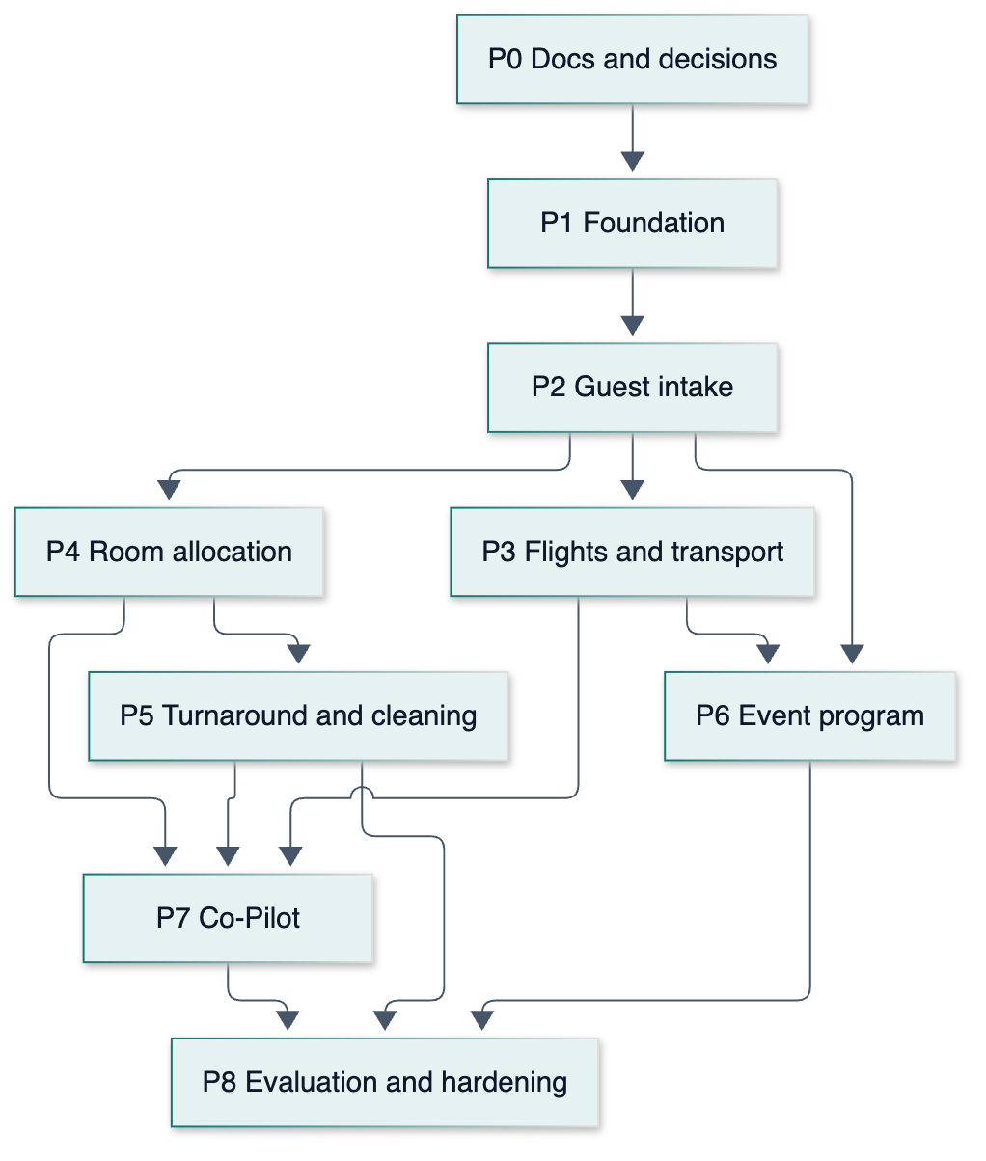
- Critical path: P0 → P1 → P2 → P4 → P5 → P7 → P8.
- Can run in parallel after P2: P3 (transport) alongside P4 (rooms). P6 (program) is small and can slot in after P3.
- Evaluation is continuous: each phase adds its own eval dataset and runner, and P8 consolidates them for the report.
- Dates: not scheduled yet. Waiting for the project submission/demo dates (see §4).

Phase | Status | Modules | Depends on
P0 Docs and decisions | 🟨 drafted, awaiting confirmation of [Proposed] items | — | —
P1 Foundation | ⬜ | M0 Platform | P0
P2 Guest intake | ⬜ | M1 | P1
P3 Flights and transport | ⬜ | M2 | P2
P4 Room allocation | ⬜ | M3 | P2
P5 Turnaround and cleaning | ⬜ | M5 | P4
P6 Event program | ⬜ | M6 | P2 (P3 for conflict checks)
P7 Co-Pilot | ⬜ | M4 | P3, P4, P5
P8 Evaluation and hardening | ⬜ | All | All

2. Phases in detail

P0 — Docs and decisions 🟨
- ✅ Revised project understanding: 00-Project-Breakdown.md (v2, decisions of 2026-10-12)
- ✅ Six core docs drafted (01–06)
- ⬜ Confirm the [Proposed] items (01-PRD.md §9)
- ⬜ Venue country/timezone/arrival airports → flight API coverage test (02-TRD.md §4.1)
- ⬜ Agree success-metric targets with the supervisor

Exit: open questions answered, AeroDataBox confirmed (or the fallback chosen).

P1 — Foundation (M0) ⬜
- ⬜ Scaffold Next.js 16 + TypeScript + Tailwind + shadcn/ui; ESLint/Prettier; Vitest; Playwright
- ⬜ Supabase project + local stack (CLI); base migration: extensions, enums, events, profiles, vip_categories, room_types, rooms, drivers, driver_shifts
- ⬜ Auth: sign-in, forced password change, role guard helpers; RLS deny-by-default + pgTAP tests per role (FR-PL-01/02)
- ⬜ Cross-cutting tables + RPCs: audit_log, proposals, notifications, notify_*, approve_proposal skeleton, undo_audit_entry (FR-PL-07/08/09)
- ⬜ App shell: console layout (sidebar, top bar, event clock), staff-app shell (PWA manifest), design tokens from 04 (light/dark)
- ⬜ Admin screens: event settings, venue (room types, rooms, CSV import), drivers and shifts, VIP categories, users (FR-PL-03…06)
- ⬜ Injected clock utility + flight_mode setting; SimBanner
- ⬜ Seed generator v1 (venue, drivers, staff users)
- ⬜ CI: typecheck, lint, unit, pgTAP on every push; Vercel preview deploys

Exit: each role can sign in and sees only its own shell. Admin can configure the full venue. RLS tests pass for every role. An audited write + undo works on one sample entity.

P2 — Guest intake and validation (M1) ⬜
- ⬜ Migrations: delegations, guests, guest_requirements, arrivals, flights (basic), pickups (basic), intake_submissions, intake_rate_limits
- ⬜ Public form /intake/[token] with conditional arrival-mode fields, members, consent, Turnstile, rate limit (FR-IN-01…03)
- ⬜ Zod intake schema (shared by the form, API and AI structured output)
- ⬜ Normalizers (names/titles, phone E.164, flight numbers, dates→UTC) (FR-IN-07)
- ⬜ AI extraction of the "others" field + pasted-message draft (FR-IN-04/05)
- ⬜ Validation checks (FR-IN-06) + duplicate detection (exact / likely, pg_trgm) (FR-IN-08)
- ⬜ Rule-based high-confidence gate + create_records_from_submission RPC (FR-IN-09)
- ⬜ Intake review screen (issues, side-by-side duplicates, approve/link/reject, paste tool) (FR-IN-10)
- ⬜ Guests list + guest/delegation detail: VIP category, members, share groups, proximity priority (FR-IN-11)
- ⬜ Dashboard v1: decisions queue (review items), counters
- ⬜ Eval: eval/datasets/intake.jsonl (≥ 100 items, synthetic + volunteer) + pnpm eval:intake → field F1, problem detection P/R, auto-processing rate

Exit: a volunteer can submit on a phone. Clean submissions auto-create records, and unclear ones land in review. The eval script produces the M1 metrics.

P3 — Flight tracking and transport (M2) ⬜
- ⬜ FlightProvider interface; SimulatedProvider; AeroDataBoxProvider (FR-FT-10)
- ⬜ flight_updates, pickup_assignments, simulation_scenarios, simulation_runs, provider_usage_daily
- ⬜ pg_cron → /api/jobs/flight-poll with adaptive schedule (FR-FT-03) + quota counter
- ⬜ ingest_flight_update RPC: ETA → arrivals → pickups (FR-FT-04/05)
- ⬜ Driver matcher (pure TS) + proposals for assignment/reassignment (FR-FT-06/07); cancellations/diversions (FR-FT-08)
- ⬜ Flight board, transport board (driver lanes), manual refresh/override (FR-FT-11)
- ⬜ Driver app: my pickups, acknowledge, status button (FR-FT-09)
- ⬜ Simulation screen + /api/jobs/simulation-tick + scenario fixtures
- ⬜ Eval: eval/datasets/scenarios/* + pnpm eval:cascade → latency p50/p95, proposal feasibility %

Exit: a simulated 45-minute delay produces the right automatic updates or reassignment proposal within the latency target. Approving it reaches the driver's phone in real time. One real flight is tracked end to end in live mode.

P4 — Room allocation (M3) ⬜
- ⬜ room_assignments + capacity-aware availability checks in RPCs
- ⬜ Allocator (pure TS): hard filter → weighted score → greedy by rank → local search; per-line explanations (FR-RA-01…04)
- ⬜ Naive baseline allocator (for evaluation)
- ⬜ Room grid UI, unallocated tray, plan review with partial approve (FR-RA-04/08)
- ⬜ Manual assign/move with dry-run rule check + RuleWarningDialog (FR-RA-06)
- ⬜ Incremental proposals for new guests; re-plan of not-checked-in stays on change (FR-RA-05/07)
- ⬜ Accommodation app: today's arrivals, Check in (FR-RA-09)
- ⬜ Eval: eval/datasets/allocation/* + pnpm eval:allocation → hard-rule satisfaction (must be 100%), preference % vs baseline, runtime
- ⏸ Optional: HiGHS ILP comparison on small instances

Exit: the allocator plans the seeded venue with 100% hard-rule satisfaction and beats the baseline on preferences. The coordinator can approve a plan and override by hand with warnings. Check-in locks stays.

P5 — Room turnaround and cleaning (M5) ⬜
- ⬜ cleaning_tasks; check_out_stay (first wins), reverse_checkout, start/complete_cleaning RPCs (FR-CL-01/02/06)
- ⬜ Estimated ready time + priority ordering (v_cleaning_queue) (FR-CL-03/04)
- ⬜ Accommodation app: Check out with the "already checked out by…" state
- ⬜ Housekeeping app: ordered list, Start → Done (FR-CL-05)
- ⬜ Room readiness feeds back into the allocator's hard rule and the dashboard
- ⬜ Eval: scripted checkout trials → notification reliability %, estimate MAE; a concurrency test for first-wins

Exit: a checkout appears on the housekeeping phone within 5 s. A double checkout shows the right message. The reversal works. MAE is reported.

P6 — Event program (M6) ⬜
- ⬜ program_items, program_participants, v_program_conflicts (FR-PG-01…03)
- ⬜ Programs editor + item page; coordinator read-only timeline (FR-PG-04)
- ⬜ At-risk notifications on arrival changes

Exit: a simulated delay flags the right program item for the programs team and the coordinator, and the flag clears when resolved.

P7 — Co-Pilot (M4) ⬜
- ⬜ Read tools as typed query functions running as the user (RLS) (FR-CP-02)
- ⬜ Chat route with the tool runner, streaming, citations/links (FR-CP-01/03)
- ⬜ Write tools → proposals with inline cards (FR-CP-04)
- ⬜ Conversation logging (FR-CP-06)
- ⬜ Voice: push-to-talk, /api/copilot/transcribe with keyterms, editable transcript (FR-CP-05)
- ⬜ Eval: eval/datasets/copilot.jsonl (≥ 50 questions, ≥ 20 actions) + pnpm eval:copilot; voice/ WER with vs without keyterms

Exit: the Co-Pilot meets the accuracy targets on the fixed seed, can never write without approval (tested), and voice works on a phone.

P8 — Evaluation and hardening ⬜
- ⬜ Consolidated pnpm eval:all → Markdown/JSON tables for the report
- ⬜ Volunteer data round (consented) through the real intake link
- ⬜ Small usability test: 3 coordinator tasks vs a spreadsheet + chat baseline
- ⬜ Accessibility audit (axe + manual keyboard/screen reader pass) against 04 §7
- ⬜ Security review: RLS matrix re-test, secrets, rate limits, intake abuse, Co-Pilot prompt-injection via guest free-text
- ⬜ Performance check against the 02 §7 targets
- ⬜ Demo script using simulated mode; Supabase keep-alive or Pro for the demo window
- ⬜ Post-event purge procedure tested

Exit: every PRD §8 metric has a measured value with a reproducible script, and the demo runs end to end.

3. Cross-cutting rules while building
- Update 05-Backend-Schema.md in the same change as any migration, and update this file's checkboxes as items land.
- Every new write path goes through the audit log. Every resource-committing action goes through proposals (01 §4 P1).
- Domain logic stays pure (no DB/network in lib/domain), so the eval harness can call it directly.
- Treat guest-supplied free text as untrusted data in AI prompts (it may contain instructions). The Co-Pilot's tools enforce permissions regardless of what the model is told.

4. Blockers and open items
# | Item | Blocks
1 | Confirm [Proposed] items in 01 §9 | Final scope of P1–P7
2 | Venue country, timezone, arrival airport(s) | Flight API coverage test (P0 exit), Supabase region, privacy regime
3 | Submission and demo dates | Scheduling these phases
4 | Brand colors (if any) | P1 design tokens (defaults are usable meanwhile)

