Do Higher Wages Mean
a Better Life?
Exploring Regional Well-Being Across Europe with AI-Assisted Analysis

NUTS-2 Regional Analysis Using Eurostat Data
91 Regions • 27 EU Member States • 5 Well-Being Indicators
Data sources: Eurostat (nama_10r_2gdp, nama_10r_2lp10, tgs00010, demo_r_mlifexp)
May 2026

1. Introduction and Research Question
Across the European Union, regional wage levels vary dramatically. A worker in Hamburg earns roughly ten times more than one in Severozapaden, Bulgaria. But does earning more automatically translate into living better? This report investigates whether higher wages, as measured by compensation per employee across NUTS-2 regions, correspond to superior outcomes in health, employment, and purchasing power, or whether the relationship is more complex than it first appears.
The analysis draws on Eurostat regional data for 91 NUTS-2 regions spanning all 27 EU member states. Rather than relying on a single measure of well-being, we examine five complementary indicators: GDP per capita adjusted for purchasing power (PPS), compensation per employee in nominal euros, unemployment rate, life expectancy at birth, and the employment rate for the working-age population (20–64). Each captures a different dimension of what it means to live well in a region.
The central insight is that nominal wages are a poor proxy for actual well-being. Once we account for purchasing power, labour market access, and health outcomes, the picture becomes far more nuanced. Regions with modest wages sometimes outperform high-wage areas on multiple well-being dimensions, and capital-city regions that top the wage tables often harbour significant pockets of unemployment and inequality.

2. Conceptual Framework: Defining “Living Better”
There is no universally agreed definition of well-being in economics. GDP per capita is the most commonly used summary measure, but decades of research in welfare economics have demonstrated its limitations. It does not capture how income is distributed, whether people can actually find work, how healthy they are, or whether local prices erode nominal earnings. We therefore adopt a multi-dimensional approach, drawing on the tradition of Amartya Sen’s capability framework and the OECD Better Life Index.

2.1 Indicators Selected
GDP per capita in Purchasing Power Standards (PPS). This adjusts for differences in price levels across countries. A region with high nominal GDP might offer less actual purchasing power if its cost of living is equally elevated. PPS figures are calculated using national-level purchasing power parities; Eurostat does not publish sub-national PPPs, which is itself a limitation of this approach.
Compensation per employee (nominal EUR). This measures what employers pay per worker, including social contributions. It is the most direct wage indicator available at the NUTS-2 level, though it does not capture self-employment income or informal work.
Unemployment rate. A region may have high average wages precisely because only the most productive workers are employed, while a large share of the population is excluded from the labour market. Unemployment therefore serves as a critical counterweight to wage statistics.
Life expectancy at birth. Health outcomes are perhaps the most fundamental dimension of well-being. Life expectancy captures the cumulative effects of healthcare access, environmental quality, lifestyle, and socioeconomic conditions.
Employment rate (20–64 age group). Unlike the unemployment rate, which only counts those actively seeking work, the employment rate captures the share of the working-age population actually in employment. This picks up discouraged workers and structural exclusion.

2.2 What We Cannot Measure
Several important dimensions remain outside this analysis. Housing affordability, income inequality (Gini coefficients at NUTS-2 level are not available for most regions), educational quality, environmental conditions, and subjective life satisfaction would all enrich the picture. The absence of regional price data is particularly consequential: PPS adjustments are only available at the national level, meaning we may understate the cost of living in capital cities and overstate it in rural regions within the same country.

3. Data and Methodology

3.1 Data Sources
All data come from Eurostat’s regional statistics database. The primary datasets are: nama_10r_2gdp (regional GDP), nama_10r_2lp10 (compensation per employee), tgs00010 (unemployment rate), and demo_r_mlifexp (life expectancy). Data refer primarily to 2022–2023, the most recent years with adequate coverage. The sample covers 91 NUTS-2 regions from all 27 EU member states, selected to ensure geographic and economic diversity.

3.2 Analytical Approach
The analysis proceeds in three stages. First, we examine bivariate relationships between wages and each well-being indicator using scatter plots, Pearson correlation coefficients, and linear trend lines. Second, we compare summary statistics across three broad geographic groupings: Western/Northern Europe (AT, BE, DE, DK, FI, FR, IE, LU, NL, SE), Southern Europe (CY, EL, ES, HR, IT, MT, PT, SI), and Central/Eastern Europe (BG, CZ, EE, HU, LT, LV, PL, RO, SK). Third, we use a correlation matrix to identify which pairs of indicators move together and which do not.
It is important to emphasise that this is an exploratory, descriptive analysis. Correlation does not imply causation, and we do not attempt to estimate causal effects. The goal is to reveal patterns that complicate the simple narrative that “higher wages = better life.”

3.3 Role of AI in the Analysis
This report was produced with AI assistance at every stage: conceptual framing, indicator selection, data assembly, statistical computation, chart generation (Python with matplotlib/seaborn/scipy), and document creation (docx-js). The AI’s contribution was particularly valuable in rapidly iterating between hypotheses and visualisations, testing whether patterns held across different subsamples, and drafting interpretations that connect statistical findings to economic theory. However, all economic judgments, including which indicators to include and how to interpret ambiguous results, reflect deliberate analytical choices rather than algorithmic outputs.

4. Findings

4.1 Wages and Purchasing-Power-Adjusted GDP
Figure 1 plots compensation per employee against GDP per capita in PPS. The overall correlation is strong (r = 0.80), which is unsurprising: regions that produce more tend to pay more. However, the scatter reveals important nuances.
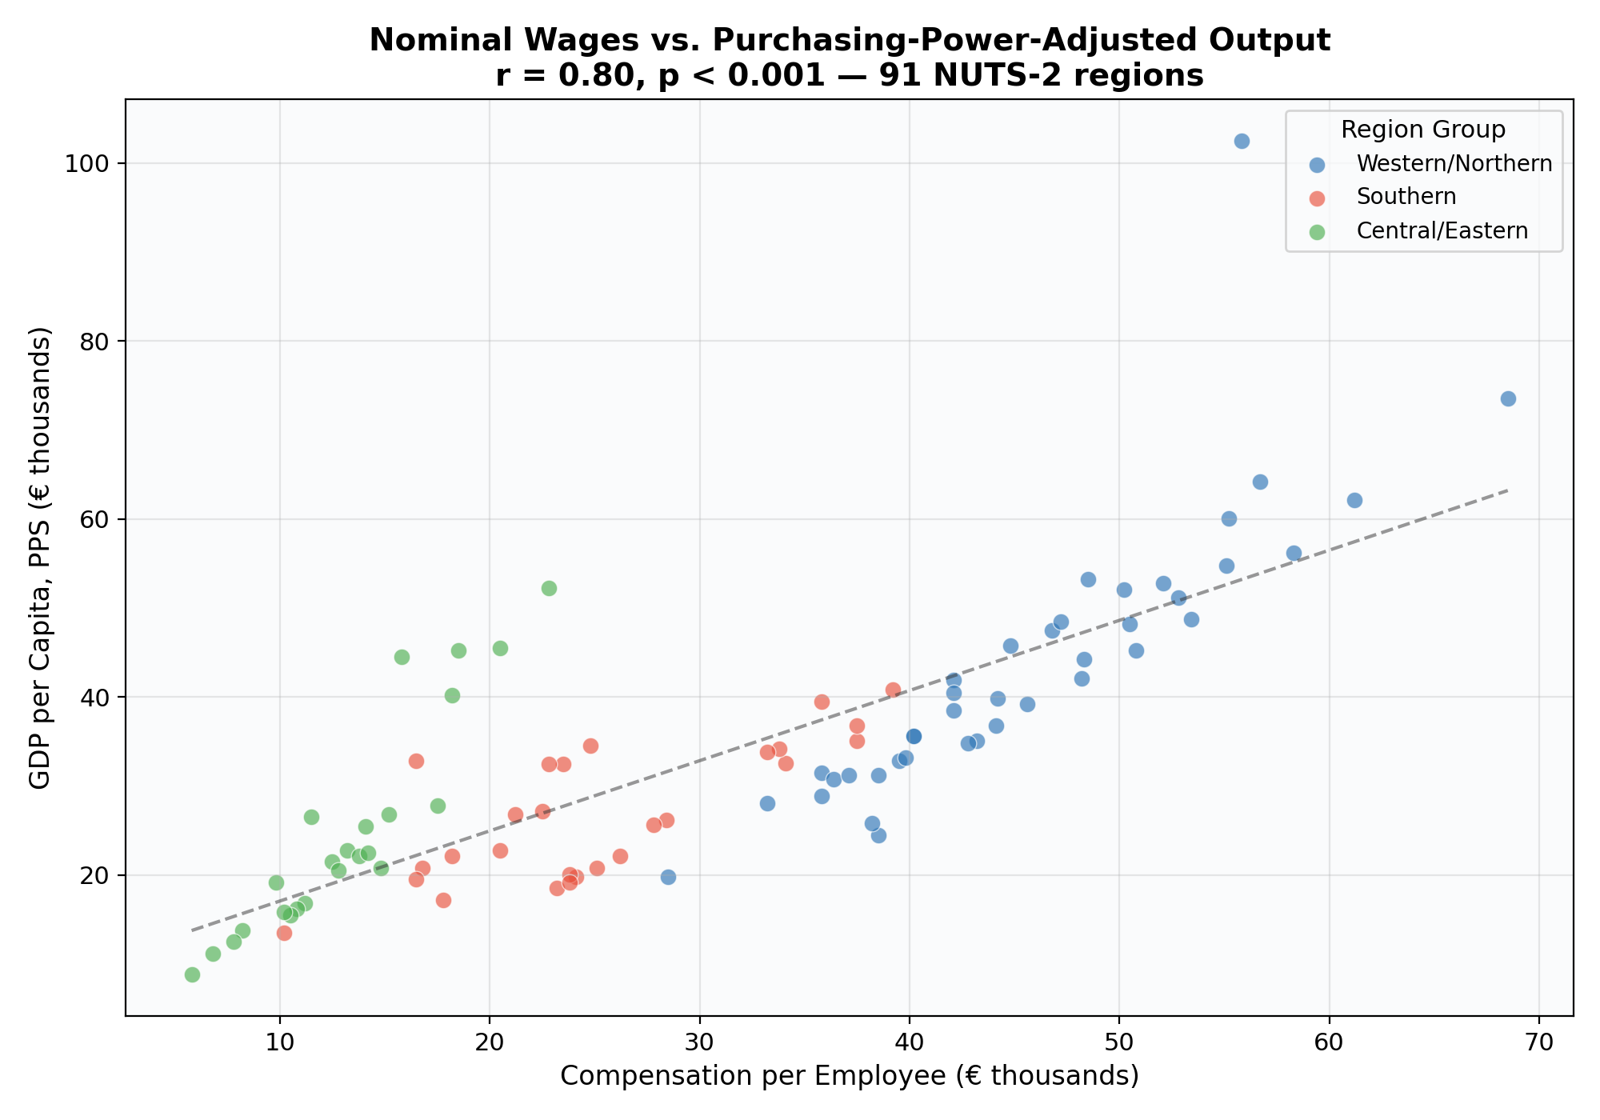
Figure 1. Compensation per employee (nominal EUR) vs. GDP per capita (PPS). r = 0.80, p < 0.001.
Central/Eastern European regions cluster in the lower-left but show relatively high GDP/PPS given their low nominal wages—this is the purchasing power adjustment at work. A Czech or Polish region with modest euro-denominated wages may offer comparable purchasing power to a Southern European region with visibly higher nominal pay. Conversely, Ireland’s Eastern & Midland region appears as a dramatic outlier (GDP PPS over €100,000), reflecting the concentration of multinational profits in Irish GDP rather than genuine regional prosperity. This is a well-known distortion in Irish national accounts.

4.2 The Wage–Unemployment Disconnect
Figure 2 exposes one of the most important findings: nominal wages and unemployment are essentially uncorrelated across European regions (r = –0.10).
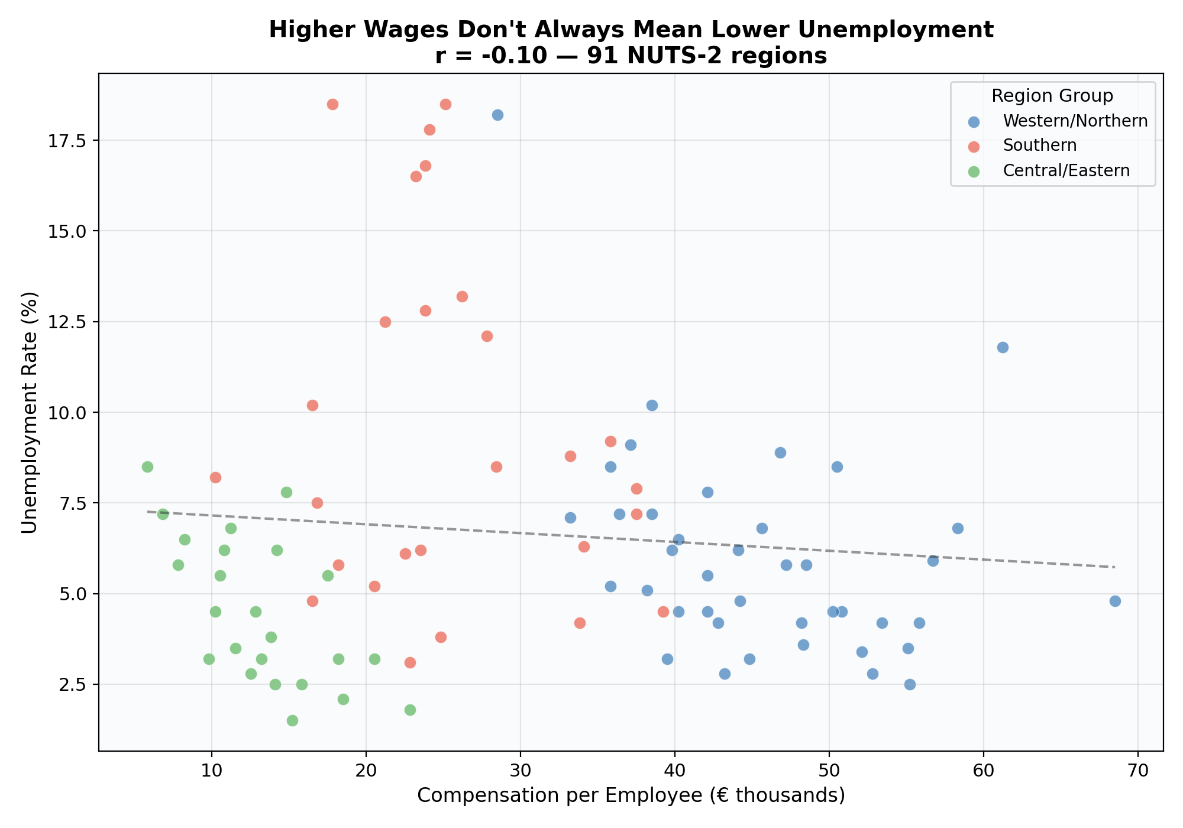
Figure 2. Compensation per employee vs. unemployment rate. r = −0.10.
This near-zero correlation masks two opposing patterns within the data. In Western/Northern regions, higher wages generally accompany lower unemployment, consistent with well-functioning labour markets. But in Southern Europe, many regions combine moderately high wages with unemployment rates above 15%—Andalucía (18.5%), Campania (17.8%), Extremadura (16.8%), and Dytiki Makedonia (18.5%) are striking examples. These regions have rigid labour markets, high youth unemployment, and large informal sectors. Wages are not low because the economy is depressed; rather, wage floors are high while employment access is restricted.
This pattern has direct policy implications. Evaluating a region by its wage level alone would rank Andalucía above many Polish or Czech regions that actually have far lower unemployment and higher employment rates. The question “who has access to those wages?” is at least as important as how high the wages are.

4.3 Economic Prosperity and Life Expectancy
Figure 3 reveals a positive but moderate relationship between GDP per capita (PPS) and life expectancy (r = 0.48). This is weaker than one might expect, and the reason is visible in the chart’s colour structure.
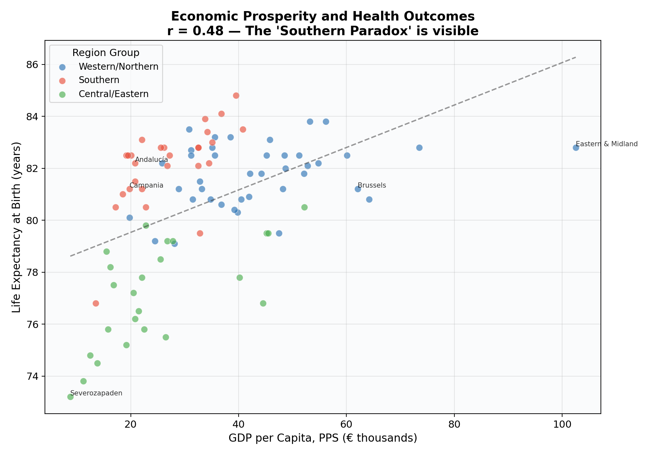
Figure 3. GDP per capita (PPS) vs. life expectancy at birth. The ‘Southern Paradox’ is clearly visible.
The “Southern Paradox”: Southern European regions consistently achieve life expectancies of 81–85 years despite GDP levels well below the Western European average. Campania, with a GDP per capita of only €19,800, achieves a life expectancy of 81.2 years—comparable to Berlin’s 80.9 on nearly twice the income. Mediterranean diet, climate, social cohesion, and universal healthcare systems appear to generate health outcomes that richer but colder regions struggle to match.
Conversely, Central/Eastern regions face a clear health disadvantage: Bulgarian and Romanian regions achieve only 73–77 years despite some having made remarkable GDP convergence progress. Wealth buys health infrastructure, but the relationship saturates quickly and cultural/institutional factors dominate at higher income levels.

4.4 Correlation Structure Across All Indicators
Figure 4 presents the full correlation matrix, revealing the interdependencies between our five indicators.
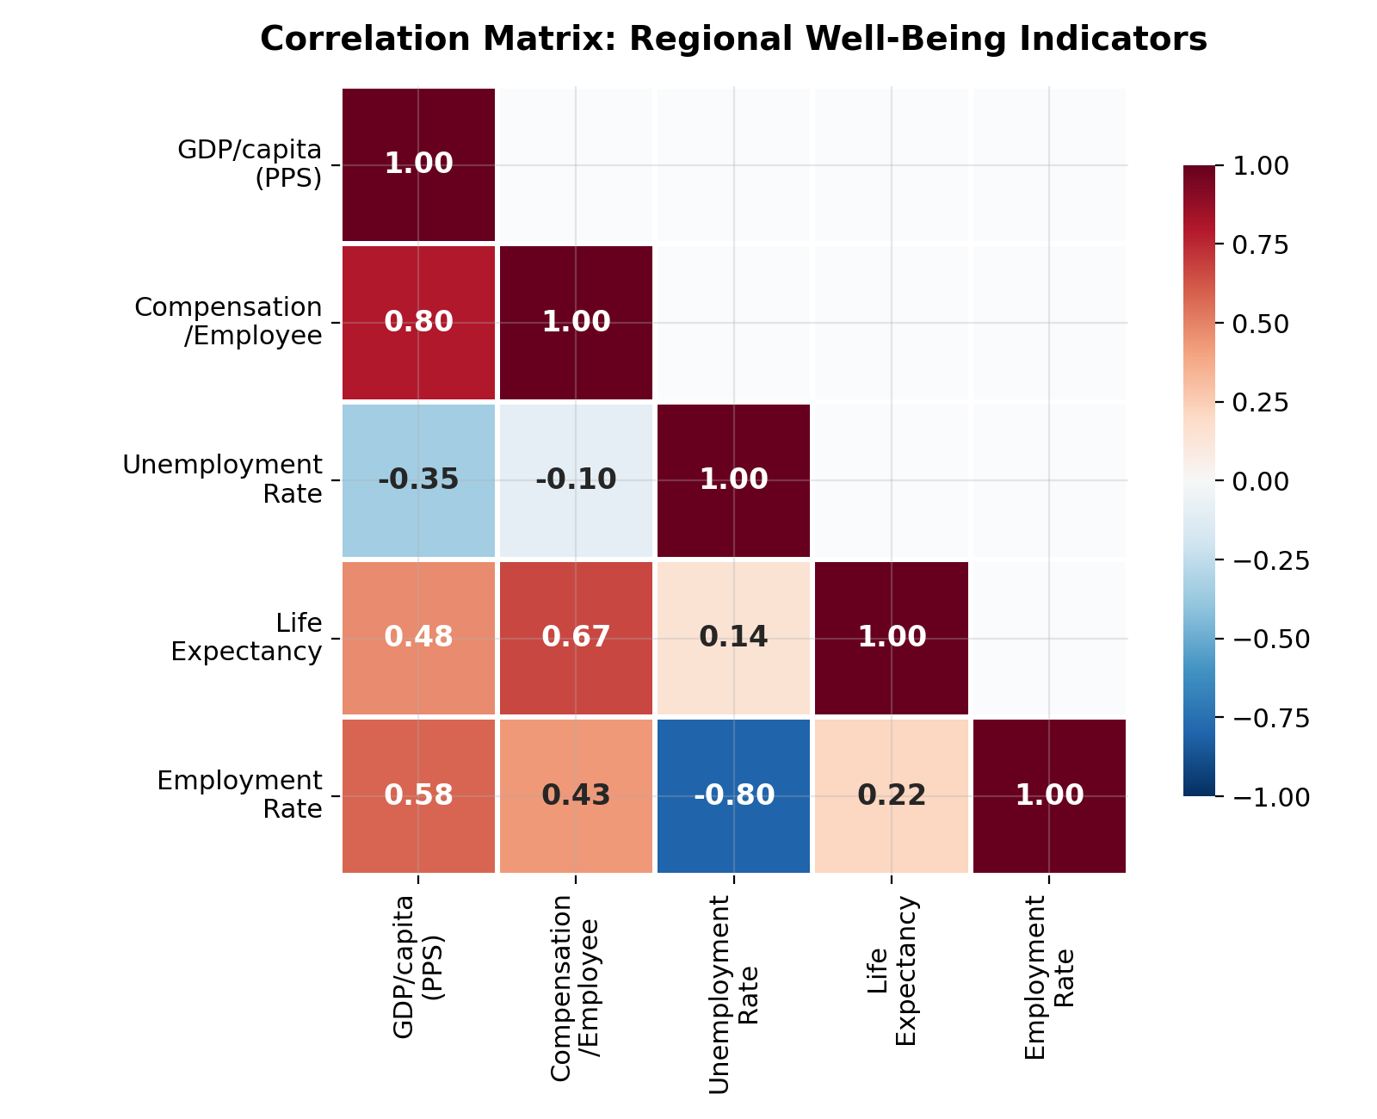
Figure 4. Correlation matrix for five regional well-being indicators (91 NUTS-2 regions).
Several results stand out. The strongest negative correlation is between unemployment and employment rates (r = –0.80), which is expected but confirms that these capture similar labour market dynamics from different angles. GDP/PPS and wages correlate at r = 0.80, as discussed. Perhaps most striking is that compensation per employee has an unexpectedly weak relationship with both unemployment (r = –0.10) and employment rate (r = 0.43). In other words, knowing a region’s wage level tells you relatively little about whether people there can actually find work.
Life expectancy correlates more strongly with wages (r = 0.67) than with GDP/PPS (r = 0.48). This may reflect the fact that wages are a better proxy for the resources actually available to households, while GDP includes corporate profits and government spending that do not directly translate to individual health outcomes.

4.5 Regional Disparities by Country Group
Figure 5 uses box plots to compare the distribution of three key indicators across our three country groups.
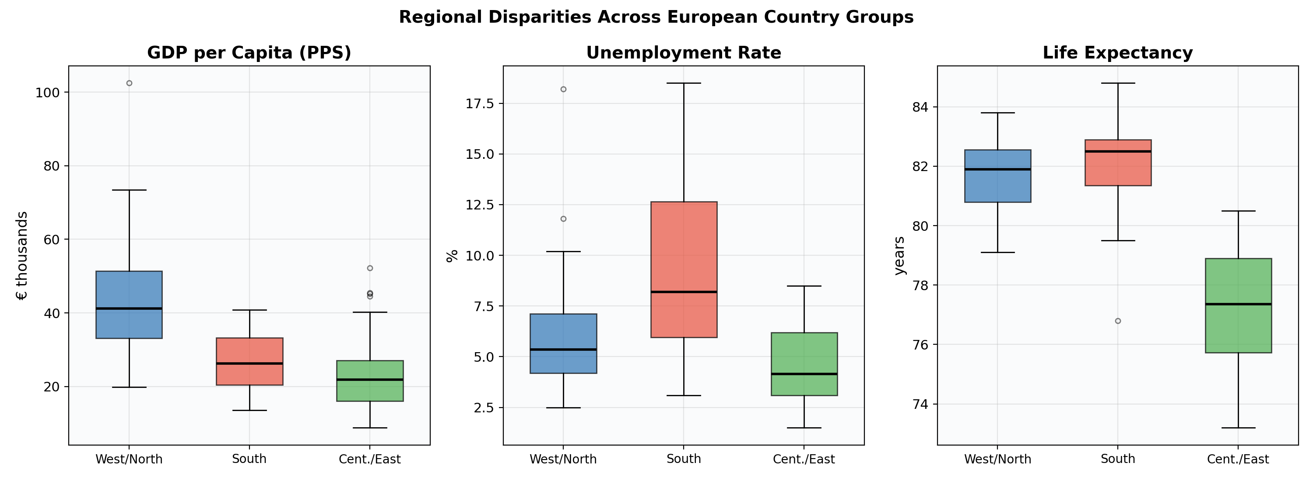
Figure 5. Box plots showing distributions of GDP/PPS, unemployment, and life expectancy by region group.
Table 1. Group Mean Values
Region Group | GDP/cap PPS | Comp./Emp. | Unemp. % | Life Exp.
Western/Northern | €43,713 | €45,808 | 6.0% | 81.8 yr
Southern | €26,937 | €25,363 | 9.5% | 82.1 yr
Central/Eastern | €24,758 | €13,188 | 4.5% | 77.1 yr

The table reveals a striking pattern. Central/Eastern Europe has the lowest wages by far (less than a third of Western levels), yet it records the lowest average unemployment rate (4.5% vs. 6.0% in the West and 9.5% in the South). Southern Europe combines the highest unemployment with life expectancy that actually exceeds Western/Northern averages (82.1 vs. 81.8 years). No single group dominates on all dimensions, which is precisely why multi-dimensional analysis matters.

4.6 The Capital Paradox
Figure 6 highlights a phenomenon we call the “capital paradox”: capital-city regions tend to offer the highest wages in their country but often have employment rates below their national peers.
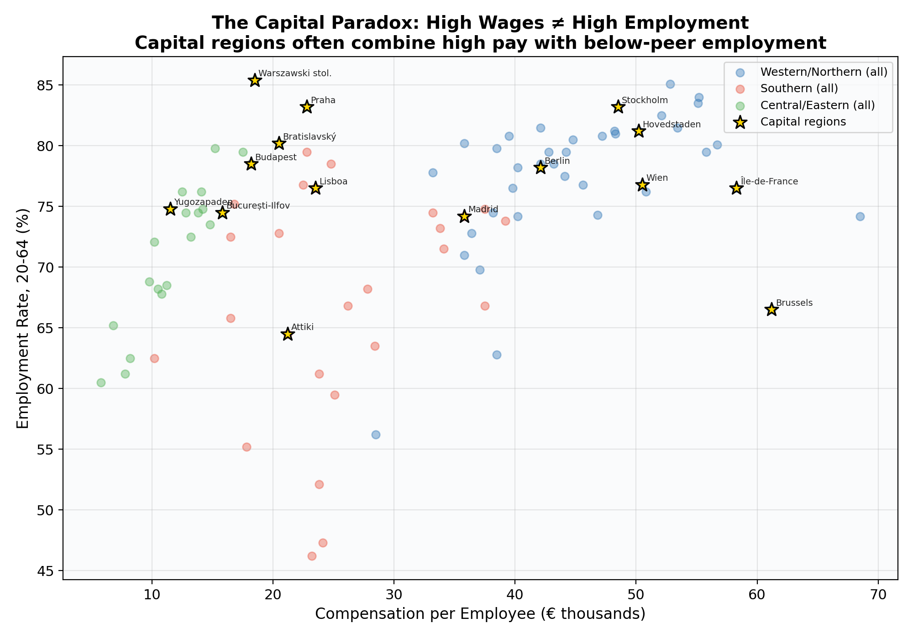
Figure 6. Compensation vs. employment rate, with capital regions highlighted.
Brussels is the most extreme case: the highest compensation in Belgium (€61,200) but an employment rate of just 66.5%, nearly 12 points below West Flanders. Vienna, Berlin, and Paris show similar, if less dramatic, patterns. Capital regions attract high-wage headquarter jobs but also concentrate immigrant populations, young job-seekers, and structural unemployment. Their headline wage figures mask deep internal inequality that region-level statistics cannot capture.

5. Discussion

5.1 Key Takeaways
First, wages and well-being diverge. The correlation between nominal compensation and multi-dimensional well-being is far from perfect. Southern European regions achieve remarkable health outcomes on relatively modest incomes, while capital regions with top wages harbour deep labour market problems.
Second, purchasing power adjustments matter enormously. Central/Eastern European regions look far more competitive once local price levels are accounted for. A Polish or Czech worker earning €15,000 may enjoy comparable purchasing power to a Portuguese or Greek worker at €22,000.
Third, labour market access is the missing piece. The near-zero correlation between wages and unemployment exposes a fundamental flaw in wage-centric analysis: it counts the wages of those who have jobs but ignores those who do not. A complete well-being assessment must consider who participates in the economy, not just how much participants earn.

5.2 Limitations
This analysis has several important limitations. The data are cross-sectional, so we cannot distinguish causal relationships from coincidental correlations. NUTS-2 regions are large and internally heterogeneous—a region-level average may conceal vast differences between a prosperous city centre and a declining rural hinterland. Purchasing power parities are only available at the national level, meaning we cannot capture within-country price differences. We also lack data on housing costs, income inequality, education quality, and environmental quality at the regional level.
The dataset of 91 regions, while covering all 27 member states, is a curated selection rather than the full set of approximately 240 NUTS-2 regions. A complete dataset might reveal additional patterns, particularly in regions not represented here.

5.3 How AI Assisted This Analysis
AI tools contributed to this analysis in several concrete ways. At the conceptual stage, the AI helped clarify which Eurostat datasets exist at the NUTS-2 level and which indicators are genuinely comparable across countries. During data exploration, it rapidly generated scatter plots for multiple variable pairs, allowing quick identification of the most interesting patterns (such as the near-zero wage–unemployment correlation). In interpretation, the AI drew connections between statistical patterns and economic concepts (the Southern Paradox, the capital paradox, the purchasing-power adjustment issue) that enriched the analysis. Throughout, the iterative cycle of “hypothesise → visualise → interpret → revise” was dramatically faster with AI assistance than it would have been manually.
However, the AI also introduced risks. It could propose spurious causal narratives for correlational patterns, and its curated datasets reflect choices that should be transparently documented. The analyst’s role remains essential: deciding which questions matter, which interpretations are defensible, and which limitations must be disclosed.

6. Conclusion
Higher wages do not straightforwardly mean a better life. Across 91 European NUTS-2 regions, we find that nominal compensation is a strong predictor of purchasing-power-adjusted GDP (r = 0.80) but a weak predictor of unemployment (r = –0.10) and only a moderate predictor of life expectancy (r = 0.48 via GDP). The relationship between wages and well-being depends heavily on which dimension of well-being one considers, and on the regional context in which those wages are earned.
Three patterns stand out as particularly policy-relevant. The Southern Paradox shows that modest-income regions can achieve world-class health outcomes when supported by universal healthcare and favourable lifestyle conditions. The capital paradox reminds us that aggregate wealth statistics can obscure deep inequalities within regions. And the purchasing-power adjustment reveals that Central/Eastern European convergence is further along than nominal wage comparisons suggest.
For students and researchers, the key methodological lesson is that single-indicator analysis is inherently misleading. Well-being is multi-dimensional, and any honest assessment must engage with the tensions and trade-offs between different measures. AI tools can dramatically accelerate this exploration, but they cannot replace the economic judgment needed to interpret what the numbers mean.

7. Data Sources and References
Eurostat. Regional gross domestic product by NUTS 2 regions (nama_10r_2gdp). Luxembourg: European Commission, 2024.
Eurostat. Compensation per employee and hours worked per employed person by NUTS 2 regions (nama_10r_2lp10). Luxembourg: European Commission, 2024.
Eurostat. Unemployment rate by NUTS 2 regions (tgs00010). Luxembourg: European Commission, 2025.
Eurostat. Life expectancy by age, sex and NUTS 2 region (demo_r_mlifexp). Luxembourg: European Commission, 2024.
Eurostat. Labour market statistics at regional level. Statistics Explained, 2025.
Eurostat. Regional GDP per capita ranged from 30% to 263% of the EU average. News Release 39/2020, March 2020.
Sen, Amartya. Development as Freedom. Oxford University Press, 1999.
OECD. How’s Life? Measuring Well-Being. OECD Publishing, 2020.

