Android Device Examination Using ADB
  - Digital Forensics Bonus Assignment Option 1
Viktoriia Lavrenchuk
Lab completed October 25 2026
I installed Ubuntu in VMware Workstation on a Windows computer and connected my Samsung Android phone using USB debugging. After resolving installation and connection issues, I used Android Debug Bridge to retrieve device properties, installed application packages, usage statistics, battery statistics, and system settings.

Equipment and environment
- Phone: Samsung Galaxy A13 5G, model SM-A136U.
- Phone software: Android 13 with One UI Core 5.1.
- Computer environment: Windows host with an Ubuntu 64 bit virtual machine in VMware Workstation.
- Virtual machine configuration: 30 GB virtual disk split into multiple files, 4096 MB RAM, 2 CPU cores, NAT networking, and a USB controller.
- Connection: USB cable with the phone connected to the Ubuntu virtual machine and USB debugging authorized.

Outcome
The final adb devices output lists the phone with the status device, confirming an authorized ADB connection. The remaining collection commands returned output and completed. The following pages present the successful command results, followed by the full installation and troubleshooting screenshot record.
This was an examination of information accessible through an authorized ADB shell. It was not a full physical acquisition, and the results do not establish recovery of private app databases, deleted messages, or browser history.

Installation and troubleshooting

Ubuntu installation
I created an Ubuntu virtual machine with the configuration shown in the setup screenshot, selected Install Ubuntu, and proceeded through the installer. The screenshots include installation choices, account creation, and progress screens. I used the virtual disk for the installation; the Windows host remained the environment running VMware.
Installation was slow. I reported starting at approximately 5:15 PM and still waiting at 6:01 PM, about 46 minutes later. Some installer controls appeared gray or unresponsive. The installer eventually requested a restart, and Ubuntu started successfully. I also encountered a freeze and powered the virtual machine off before restarting it. The exact cause of the delay and freeze was not established.

ADB installation
I ran sudo apt update. One password authentication attempt failed, after which authentication succeeded and the package lists were refreshed. I then installed android-sdk-platform-tools-common and its USB rules. Running adb devices initially returned Command adb not found because the ADB executable was not yet installed. Installing the adb package resolved that issue.

Phone detection and authorization
I initially opened the developer settings inside TalkBack, which did not provide the USB debugging option needed for this lab. I then enabled the phone system Developer options through About phone, Software information, and Build number, and turned on USB debugging.
The first adb devices commands showed an empty list. The first lsusb output showed only Linux and VMware USB devices. After connecting the Samsung phone to the Ubuntu virtual machine, lsusb identified a Samsung Galaxy device in MTP mode. I accepted the phone USB debugging authorization prompt and the phone data access prompt. ADB briefly reported unauthorized and then changed to device after authorization.

Long command output
Device properties, package lists, and system statistics produced long outputs. The terminal prompt returned after collection. Some screenshots show the end of the output rather than the command itself. The battery output reports that measured charge statistics are not supported on this device; this applies to that particular measurement and does not mean the entire collection failed.

Collected information and evidence guide

Figure 1 adb devices
Confirms that the connected phone is recognized and authorized.

Figure 2 adb shell getprop
Lists Android system properties and device configuration values.

Figure 3 adb shell pm list packages -f
Lists installed package identifiers and associated APK paths.

Figure 4 adb shell dumpsys usagestats
Returns Android usage statistics and activity records available to the shell.

Figure 5 adb shell dumpsys batterystats
Returns battery statistics and activity accounting maintained by Android.

Figure 6 adb shell settings list system
Lists current system setting names and values. These settings are configuration data rather than browsing history.

Assignment resources
DouglasFreshHabian, AndroidForensics GitHub tutorial
https://github.com/DouglasFreshHabian/AndroidForensics
Associated assignment video
https://www.youtube.com/watch?v=hICezC7mI68
The screenshot record includes repeated attempts because they document the transition from installation and detection problems to a successful connection. Device identifiers remain visible in the original evidence images.

Results

Figure 1 Authorized phone connection
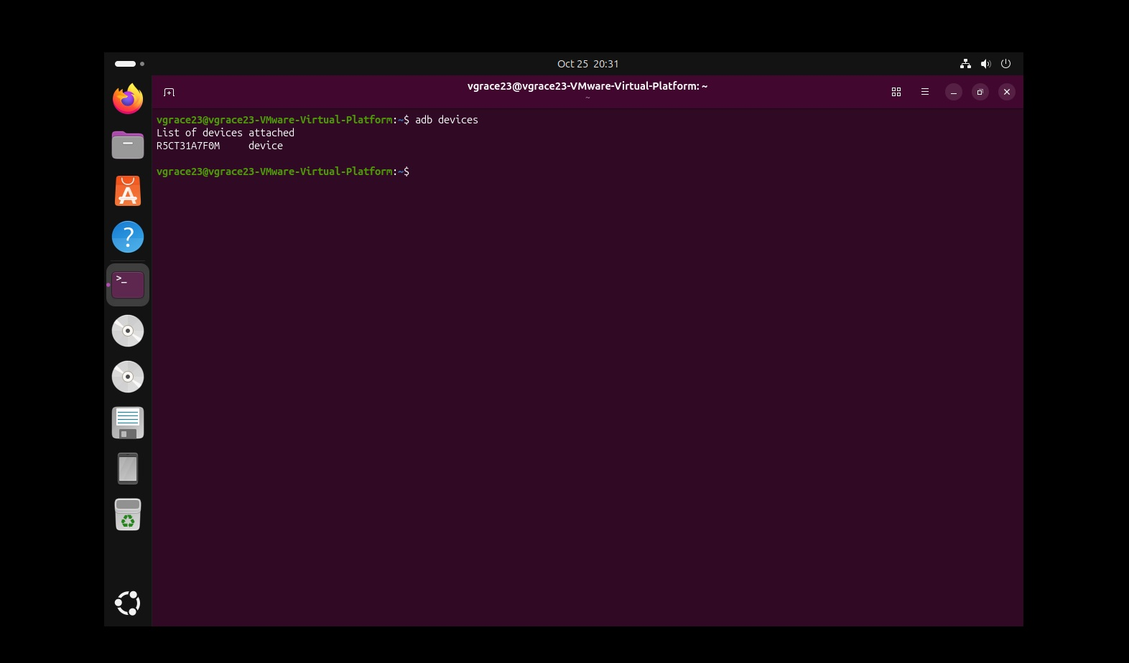
The clean adb devices result shows the connected phone with status device. This is the successful connection evidence for the first submission requirement.

Results

Figure 2 Android device properties
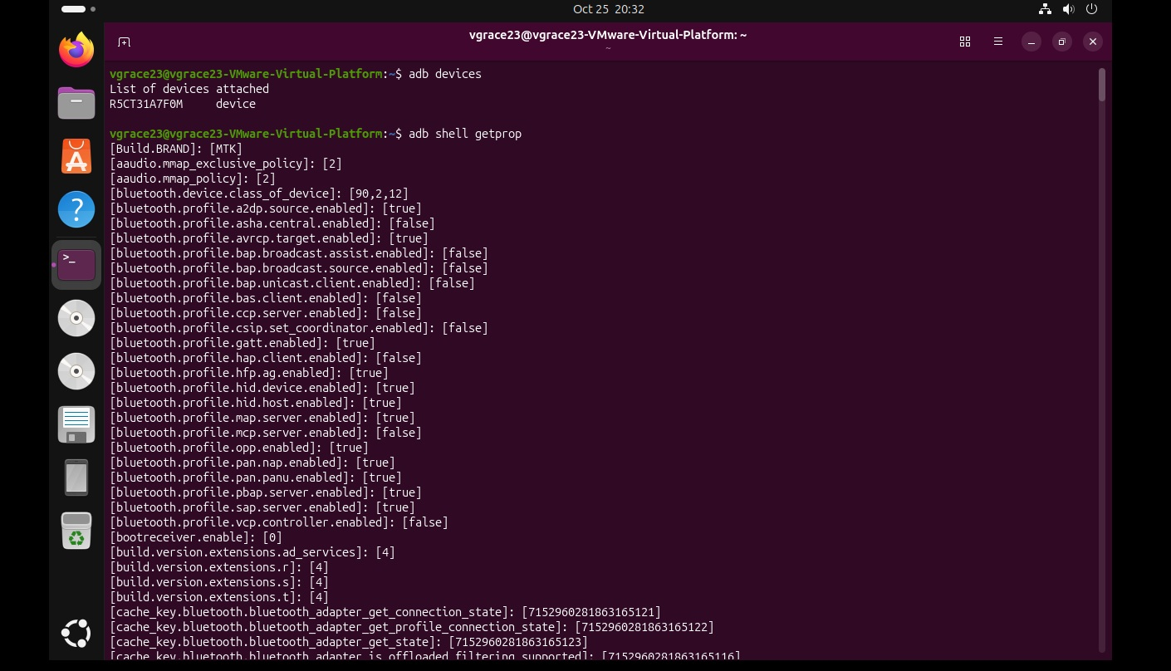
The adb shell getprop command and property values are visible. This is the device information evidence for the second submission requirement.

Results

Figure 3 Installed application packages
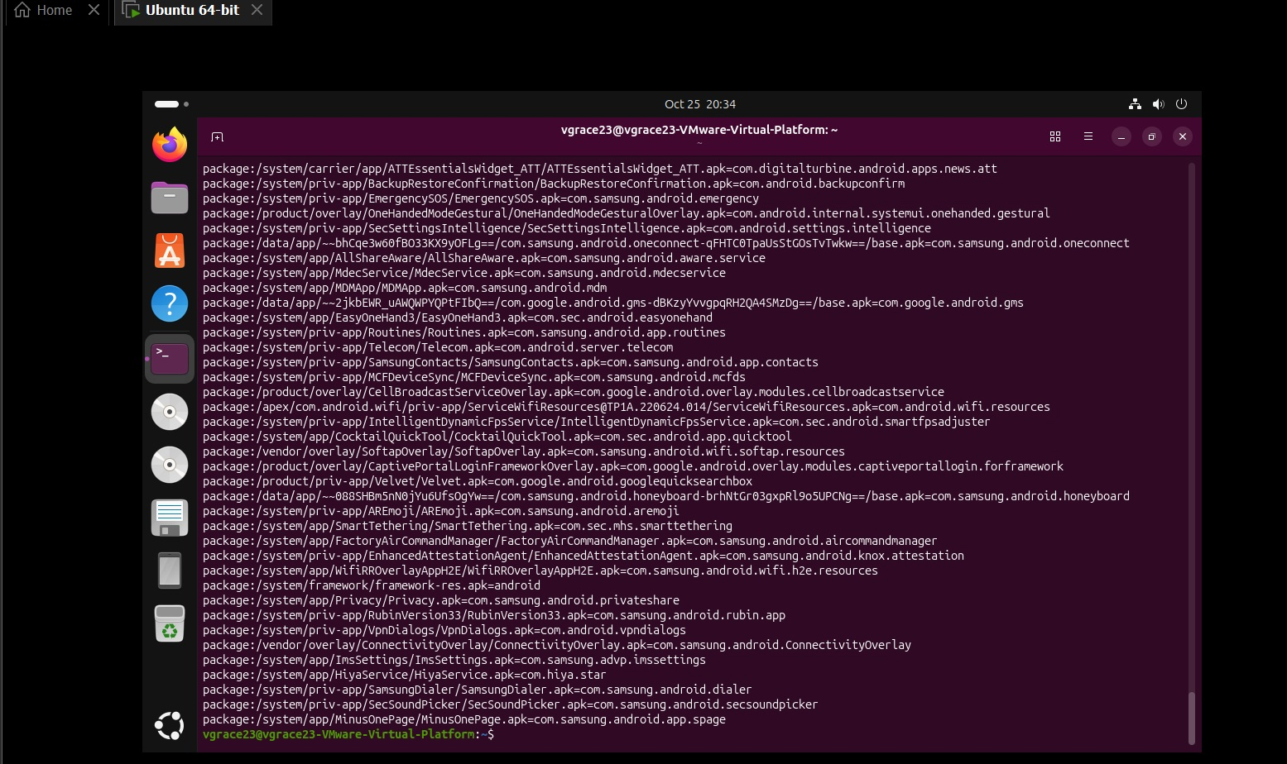
The terminal shows package identifiers and APK paths from adb shell pm list packages -f. This screenshot captures the end of the output and the returned shell prompt.

Results

Figure 4 System usage statistics
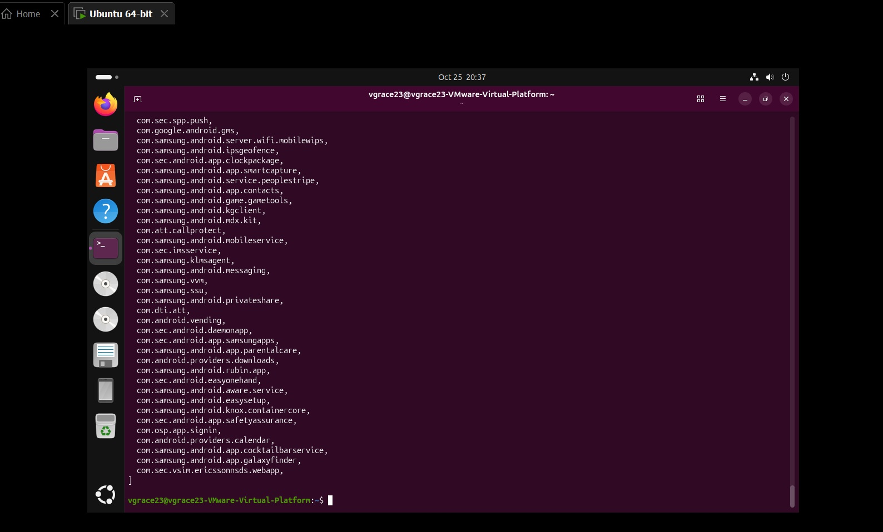
The terminal shows the end of the output collected with adb shell dumpsys usagestats. This image documents output completion; the command line and earlier usage records are outside this view.

Results

Figure 5 Battery statistics
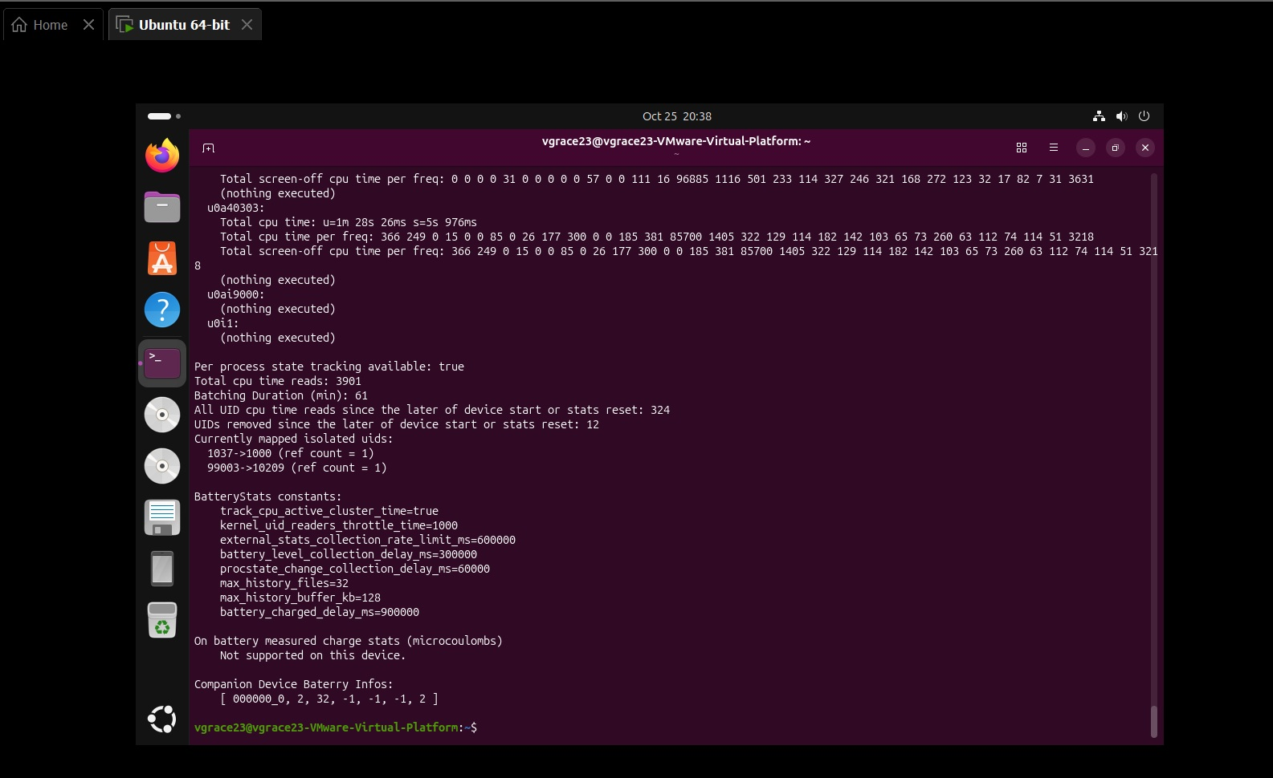
The terminal shows battery statistics, constants, and the returned shell prompt. The measured charge statistics section reports that the specific measurement is not supported on this phone.

Results

Figure 6 System settings
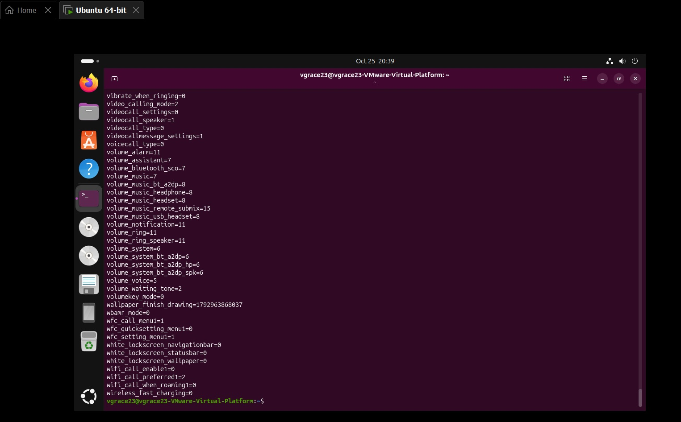
The terminal shows settings such as volume and Wi Fi calling values from adb shell settings list system, followed by the shell prompt.

Installation and troubleshooting evidence

Figure 7 VMware installation account screen
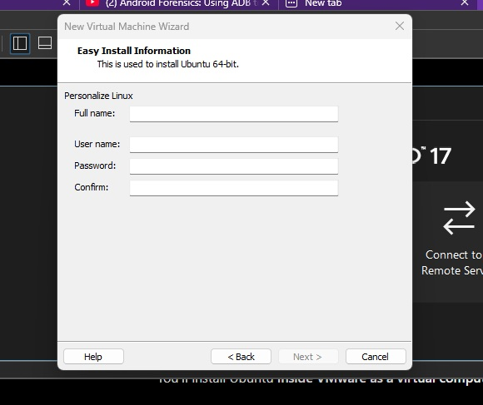
The VMware Easy Install screen requests Linux account information during virtual machine setup.

Installation and troubleshooting evidence

Figure 8 Virtual machine configuration
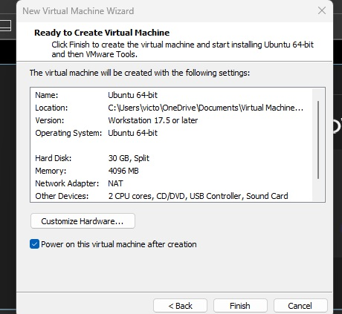
The VMware summary records a 30 GB split virtual disk, 4096 MB RAM, NAT networking, 2 CPU cores, and a USB controller.

Installation and troubleshooting evidence

Figure 9 Ubuntu installation selection
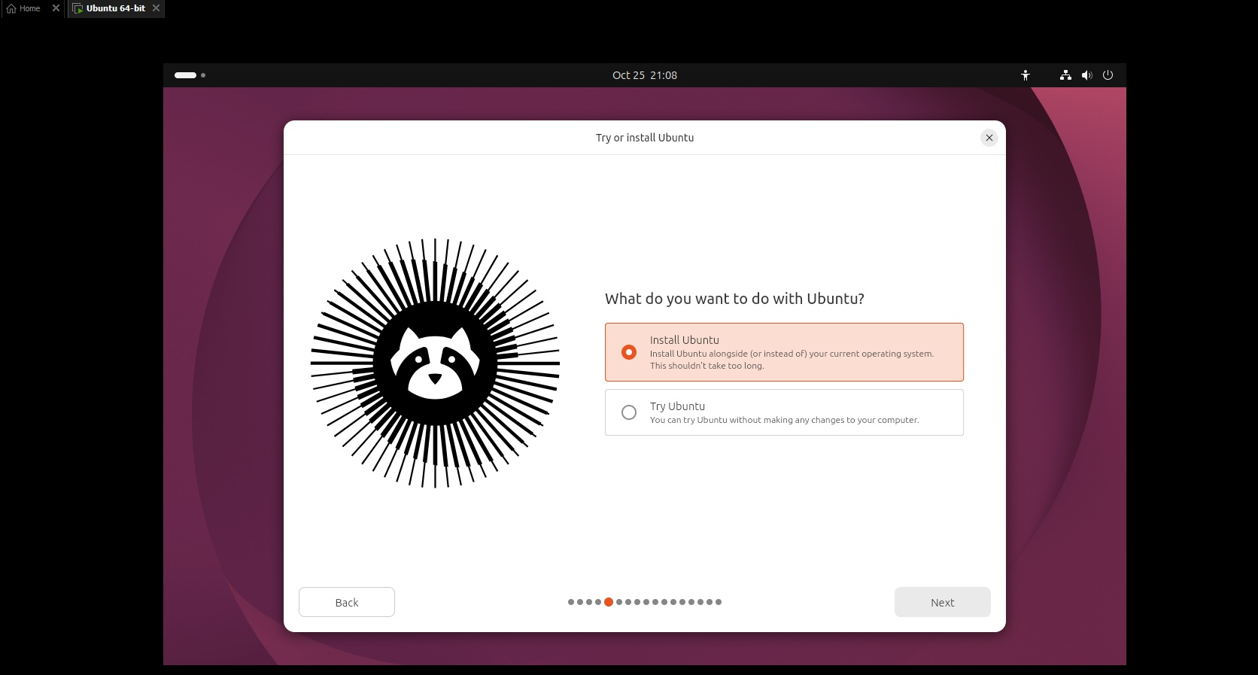
Install Ubuntu is selected in the Ubuntu installer inside VMware.

Installation and troubleshooting evidence

Figure 10 Ubuntu installation photograph
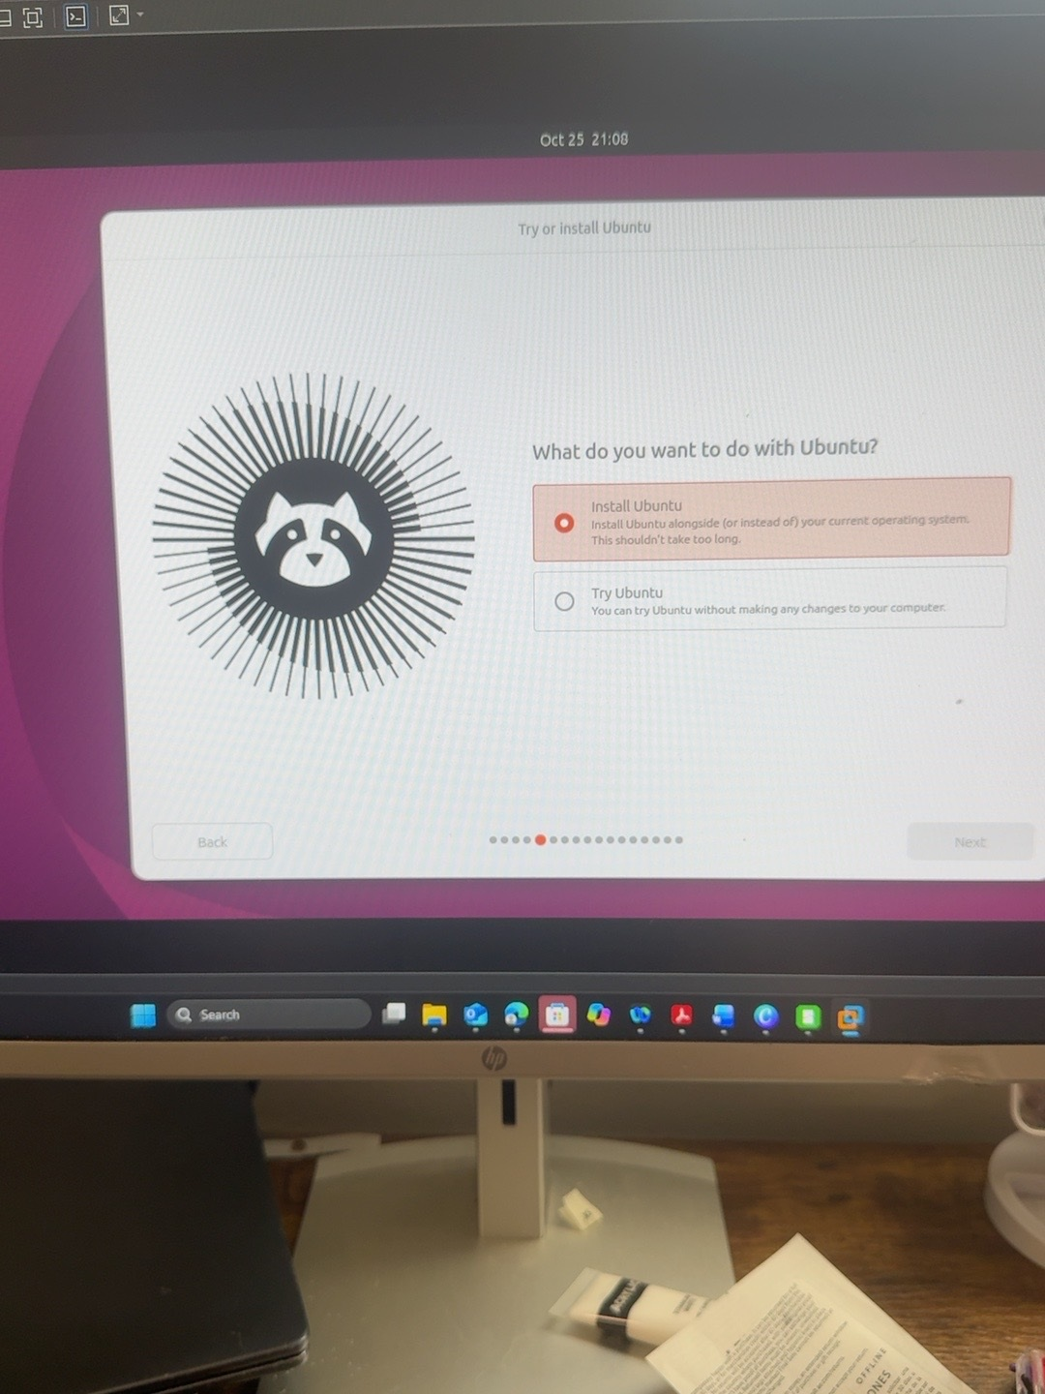
A second view of the Install Ubuntu selection documents the installer running on the Windows host through VMware.

Installation and troubleshooting evidence

Figure 11 Ubuntu disk installation choice
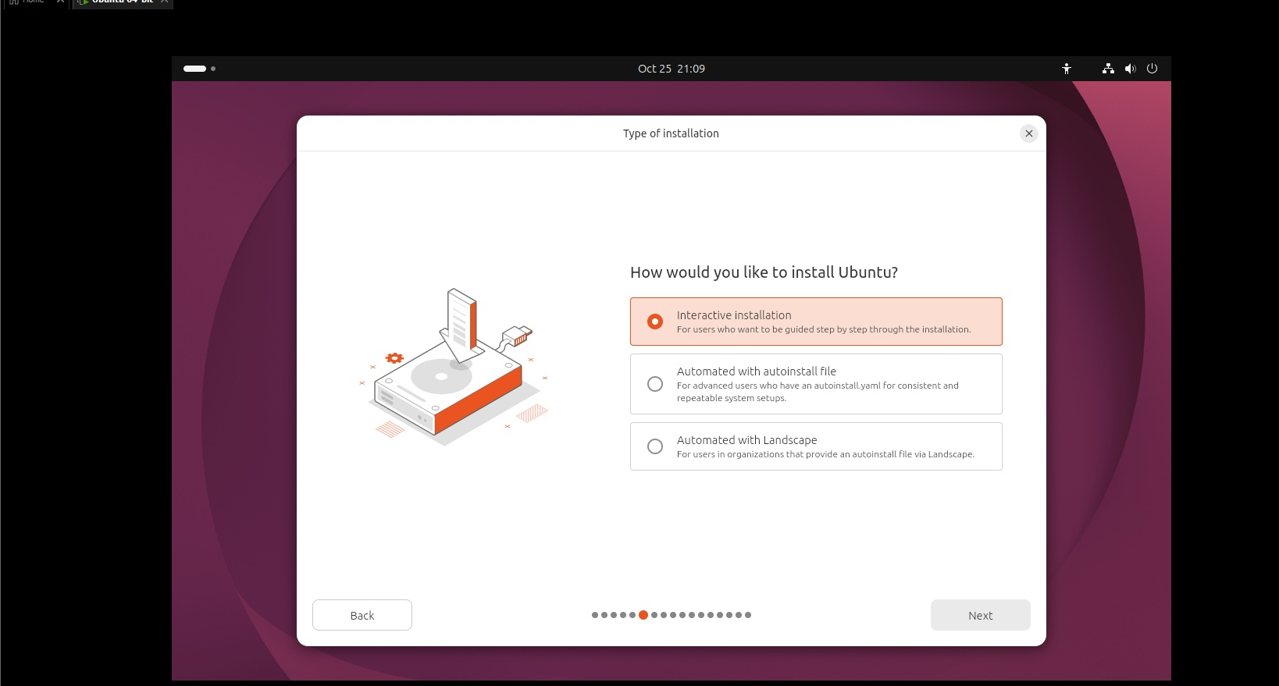
The installer presents Erase disk and install Ubuntu and Manual installation. The disk being configured belongs to the virtual machine.

Installation and troubleshooting evidence

Figure 12 Ubuntu encryption selection
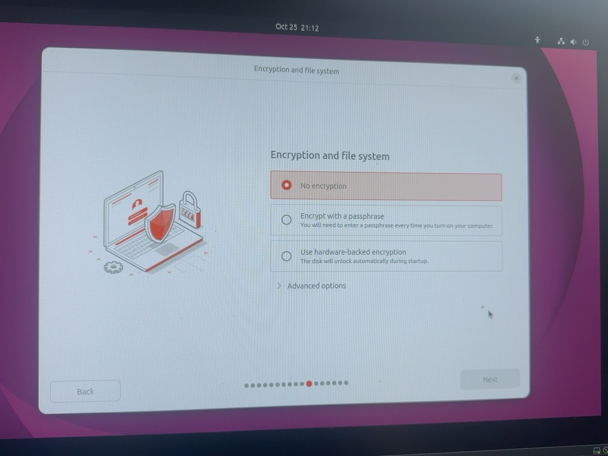
The encryption and file system screen shows No encryption selected. This photo has been rotated for readability.

Installation and troubleshooting evidence

Figure 13 Optional Ubuntu software
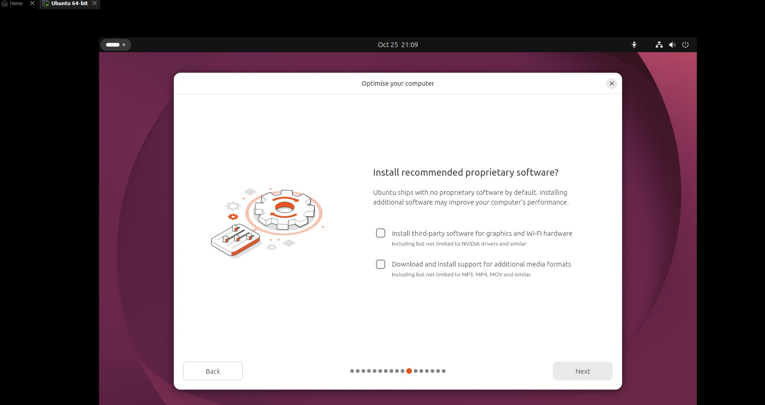
The installer presents optional proprietary software and additional media format support.

Installation and troubleshooting evidence

Figure 14 Ubuntu account creation
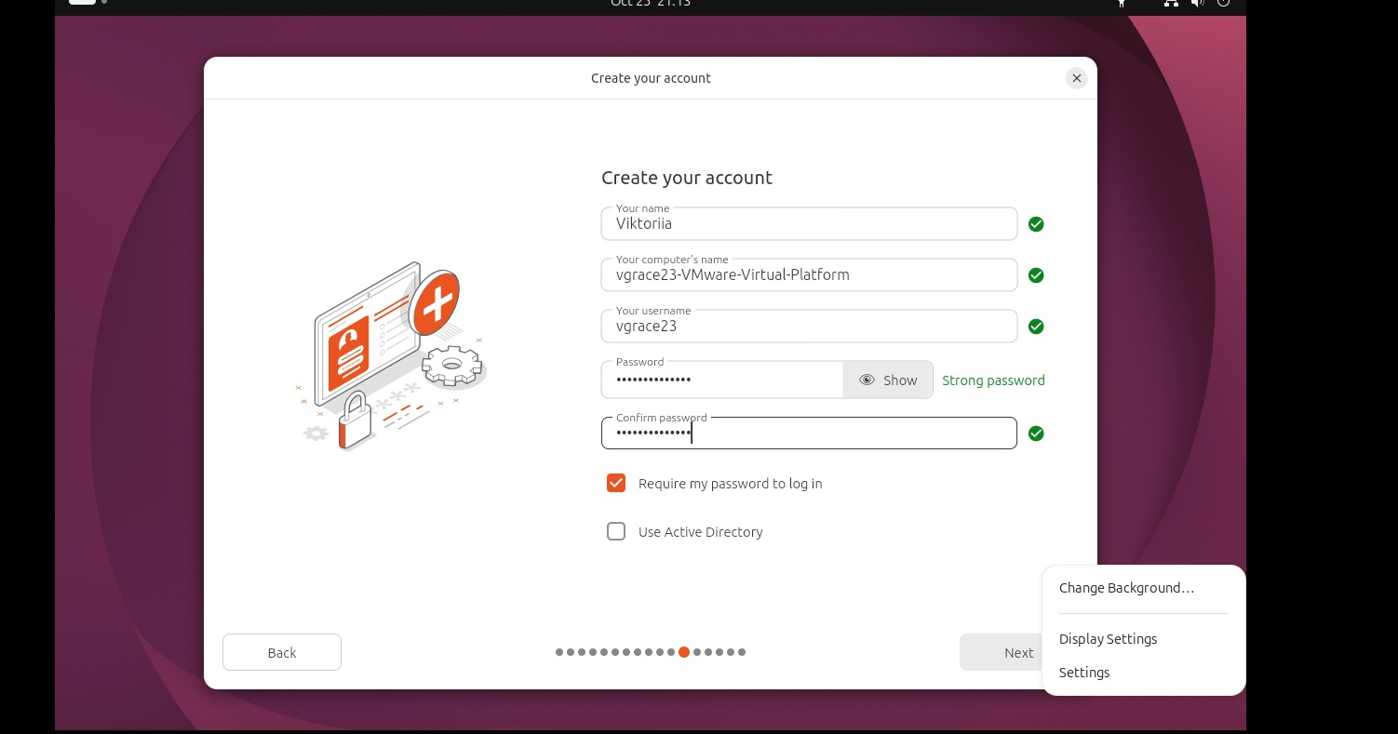
The installer account screen records the local account setup stage.

Installation and troubleshooting evidence

Figure 15 Ubuntu installation progress
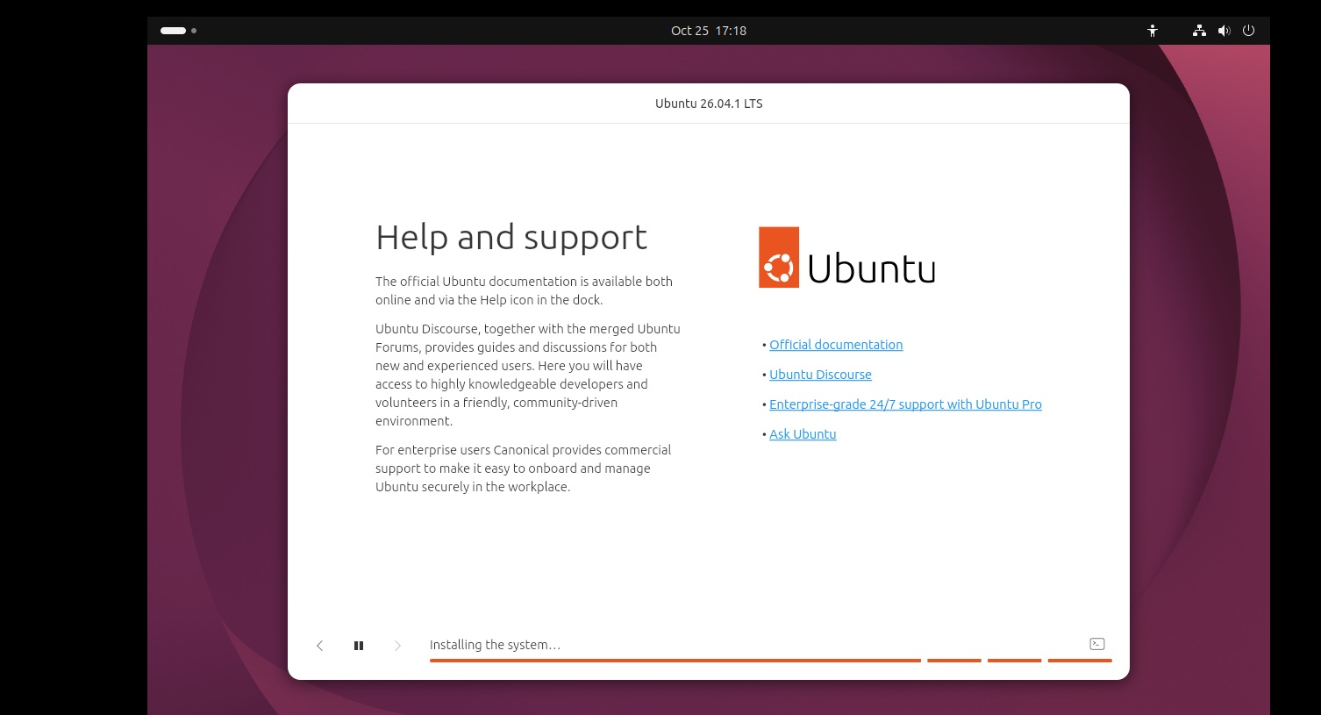
The Help and support installer screen shows the installation continuing.

Installation and troubleshooting evidence

Figure 16 Later installation progress
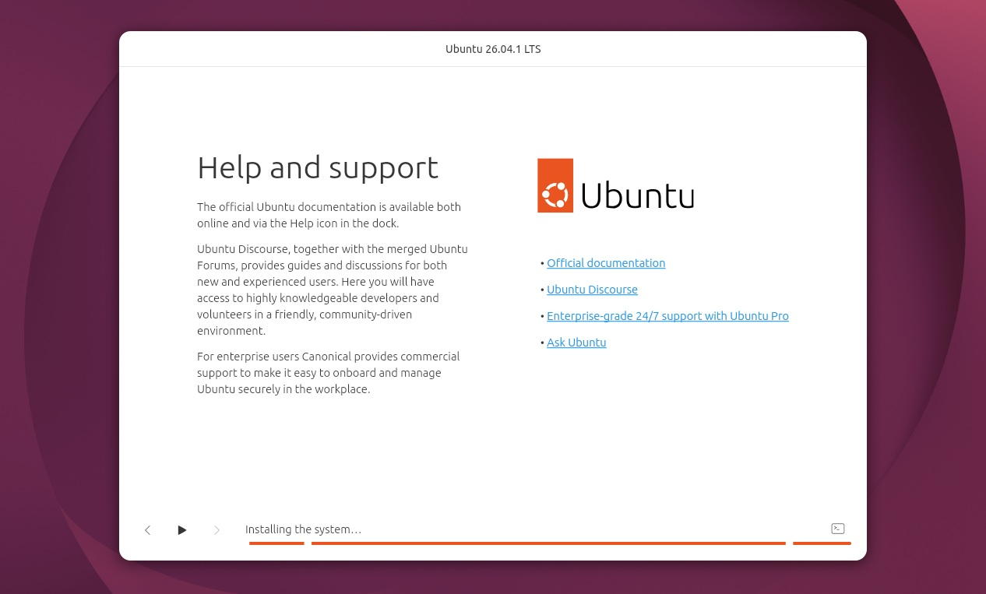
A subsequent progress screenshot records the extended installation wait.

Installation and troubleshooting evidence

Figure 17 Package list update
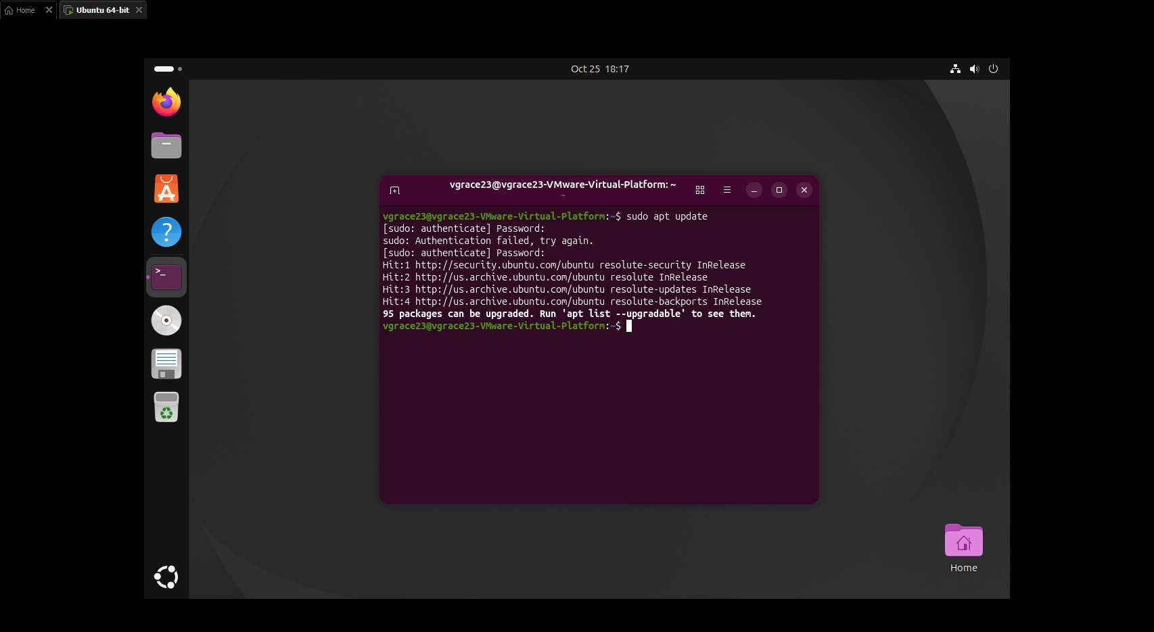
sudo apt update completes after one failed password authentication attempt. The output reports that package upgrades are available.

Installation and troubleshooting evidence

Figure 18 USB rule package installation
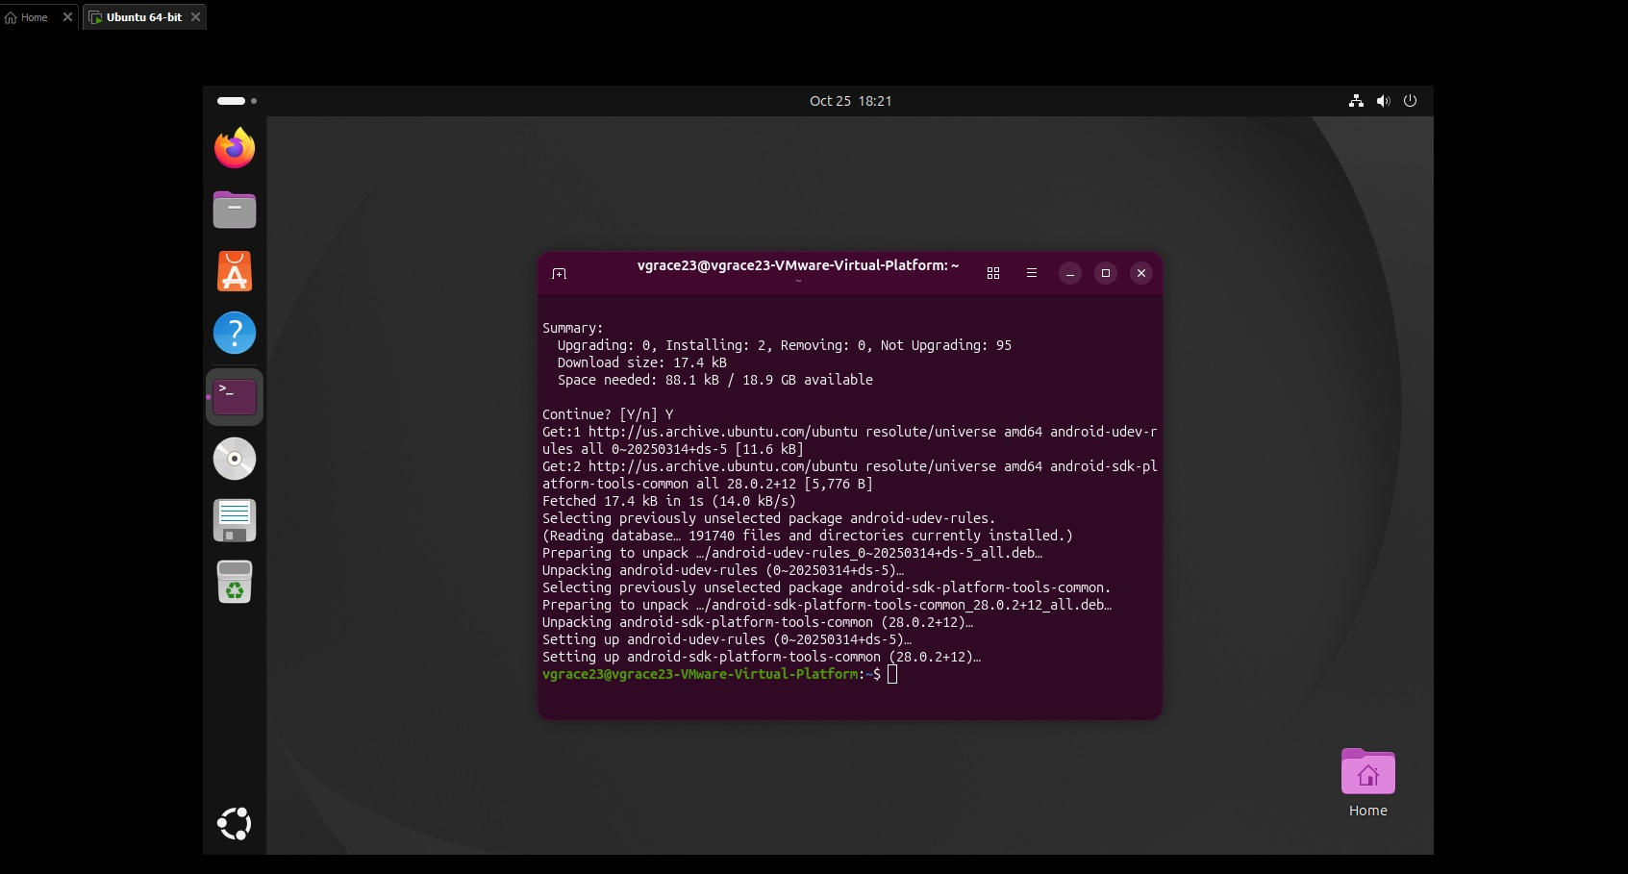
android-sdk-platform-tools-common and android-udev-rules are installed. This stage provides USB rules but does not by itself install the adb executable.

Installation and troubleshooting evidence

Figure 19 ADB command initially missing
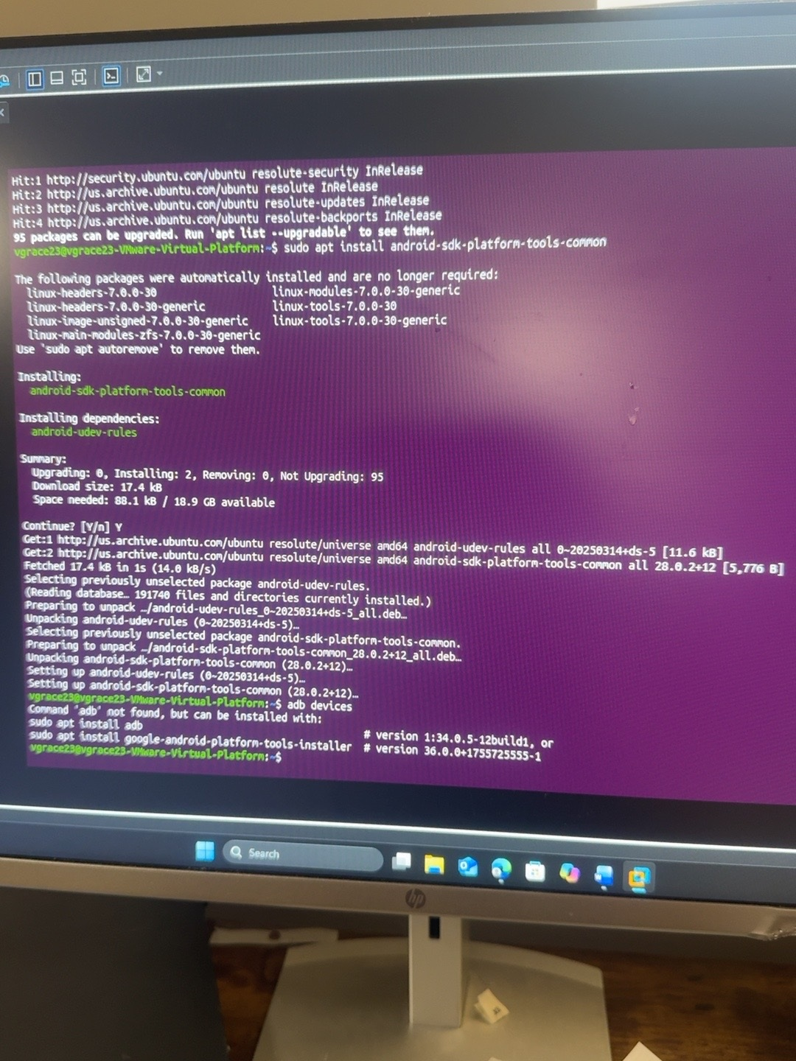
After the common platform tools package is installed, adb devices returns Command adb not found and suggests installing adb.

Installation and troubleshooting evidence

Figure 20 ADB package installed
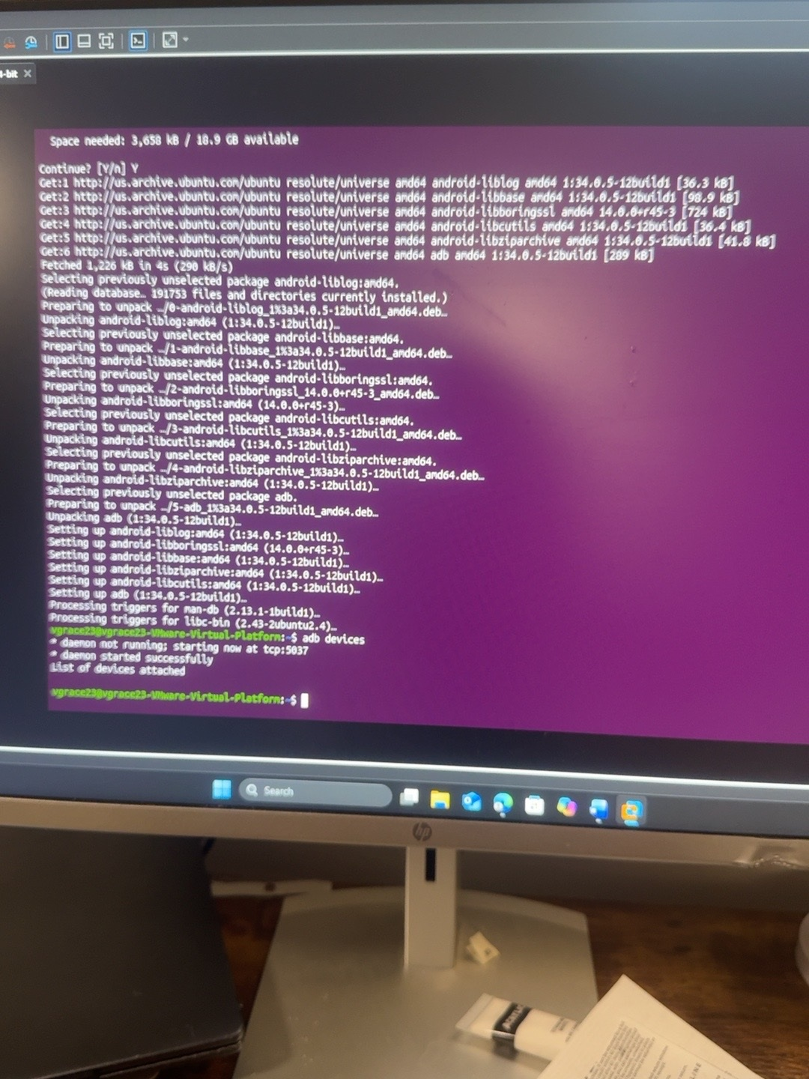
The adb package and dependencies finish installing. The ADB daemon starts successfully, but no phone is listed yet.

Installation and troubleshooting evidence

Figure 21 TalkBack developer settings
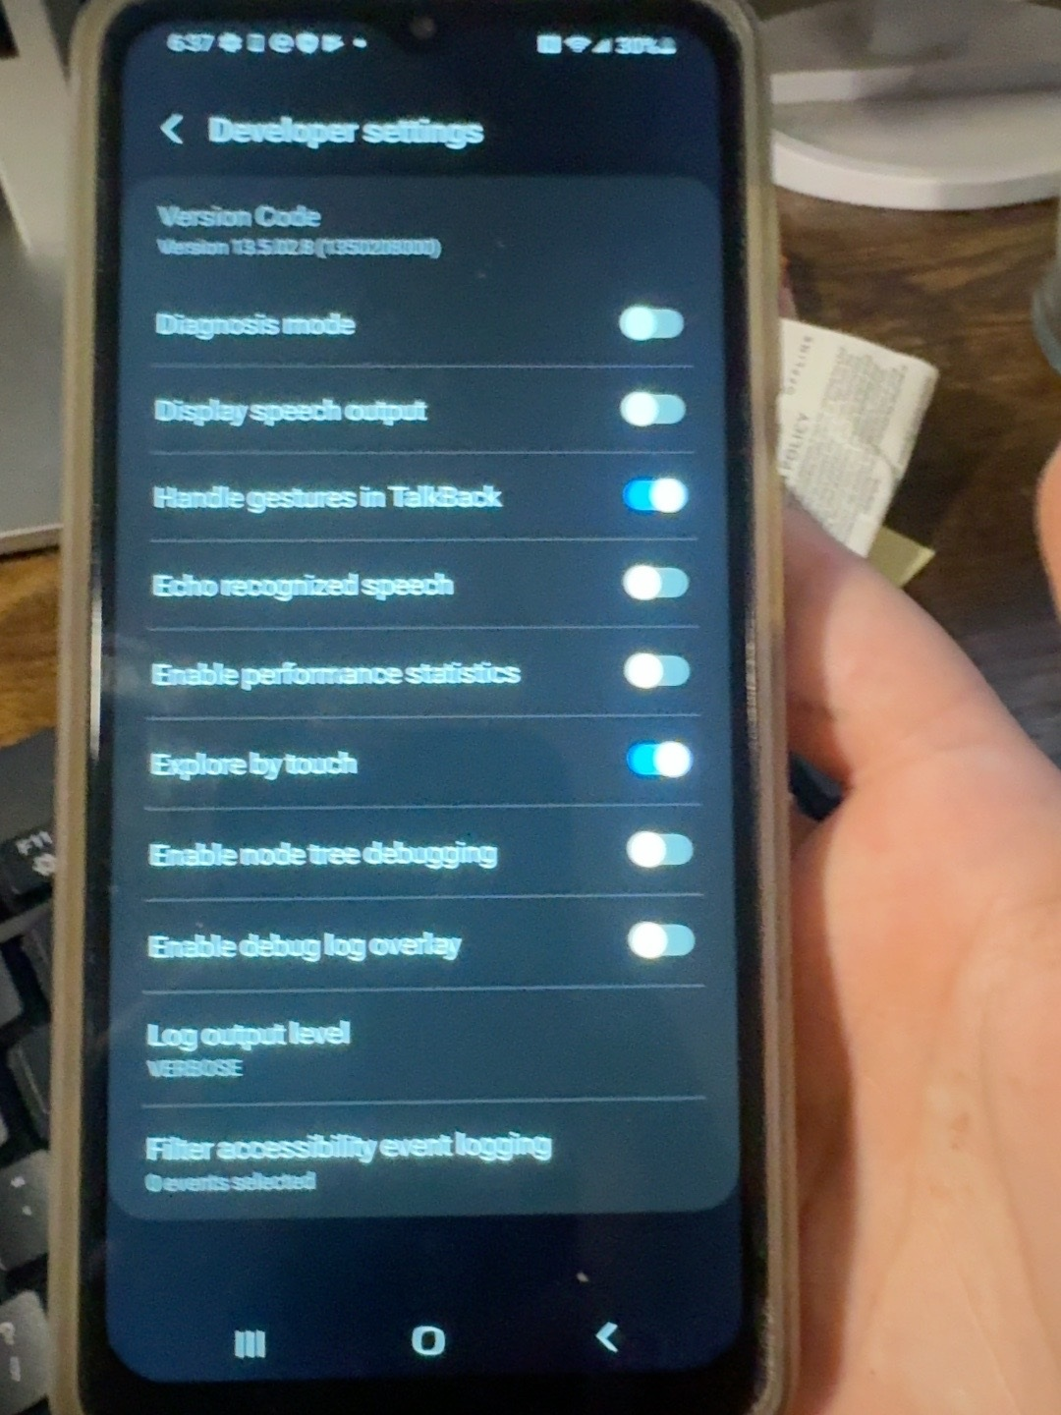
This screen is the TalkBack developer settings page. It was an initial navigation mistake when looking for the phone system Developer options.

Installation and troubleshooting evidence

Figure 22 Second TalkBack settings view
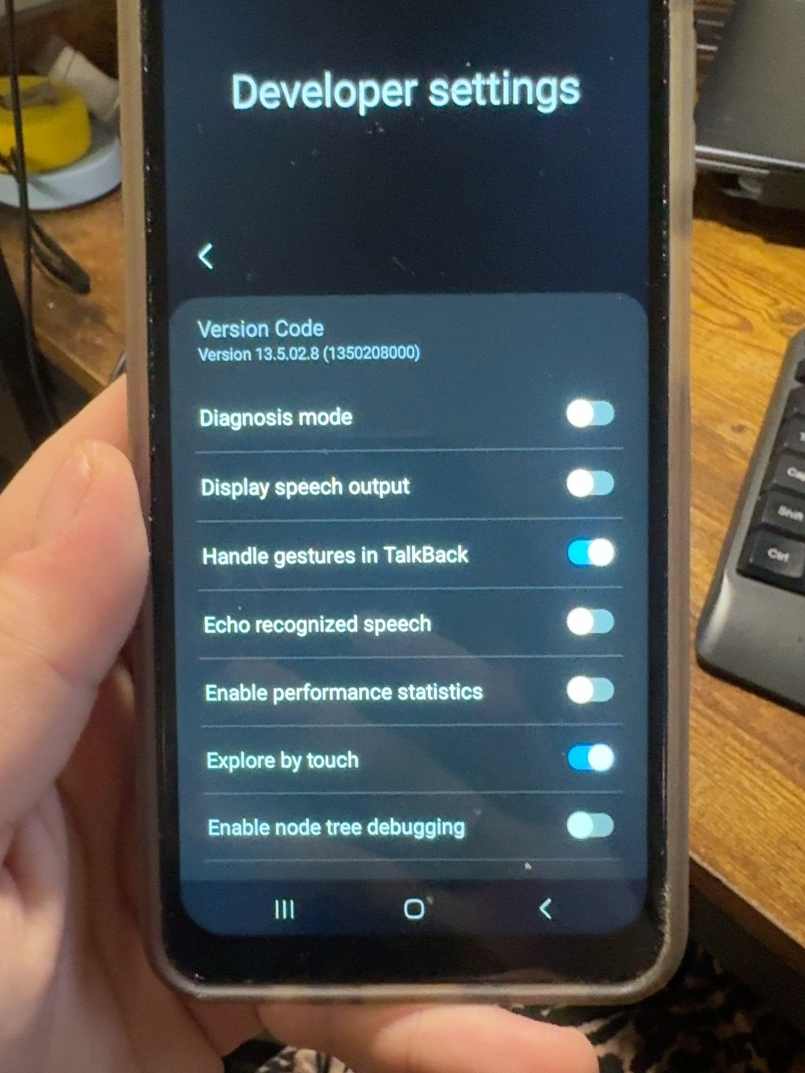
A closer view of TalkBack settings documents the same navigation issue before enabling system USB debugging.

Installation and troubleshooting evidence

Figure 23 Samsung phone identification
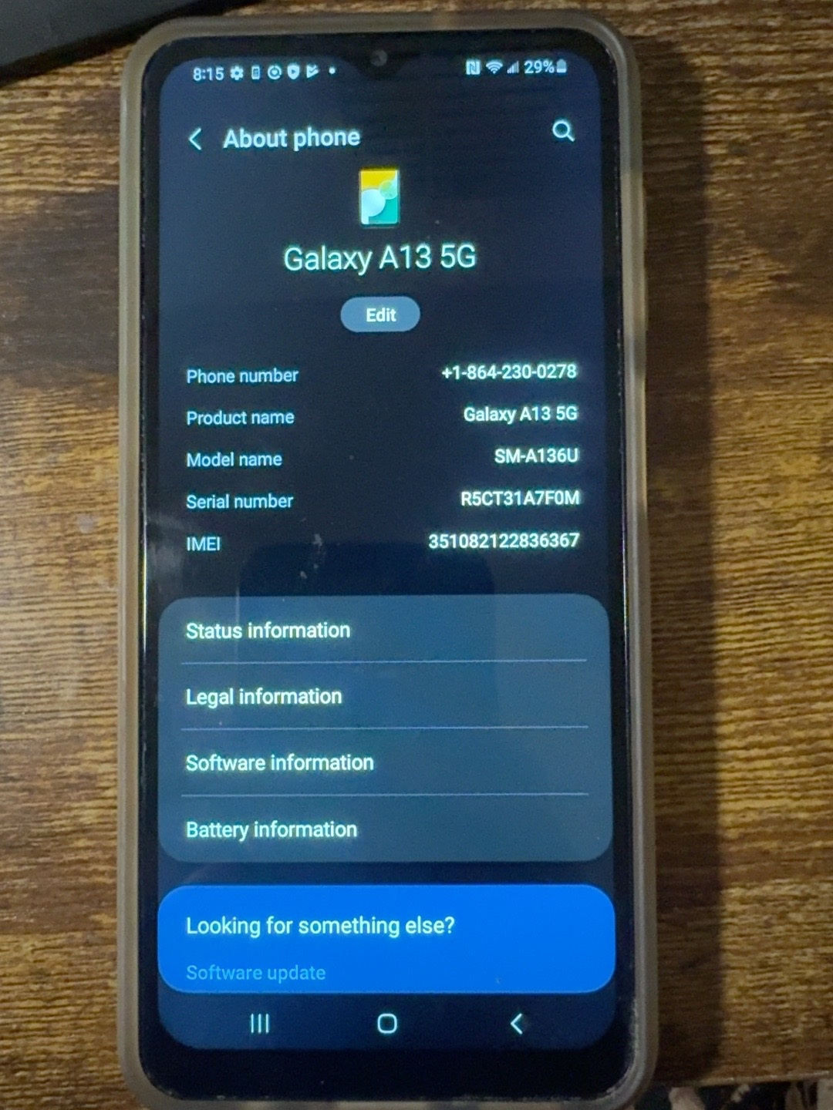
About phone identifies the device as a Samsung Galaxy A13 5G with model SM-A136U.

Installation and troubleshooting evidence

Figure 24 Android software identification
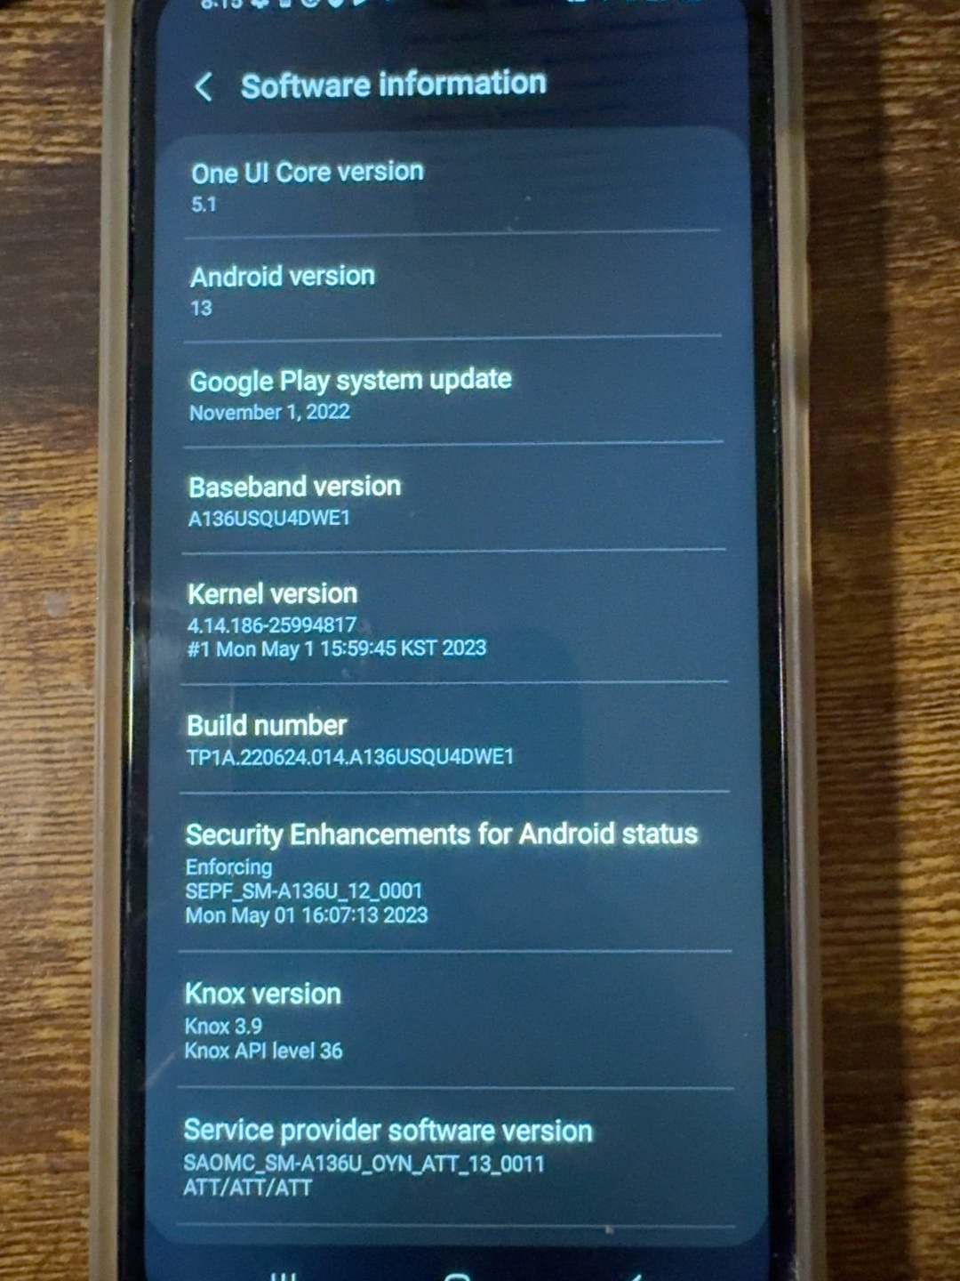
Software information shows Android 13, One UI Core 5.1, and the Build number entry used to enable Developer options.

Installation and troubleshooting evidence

Figure 25 USB connection to the virtual machine
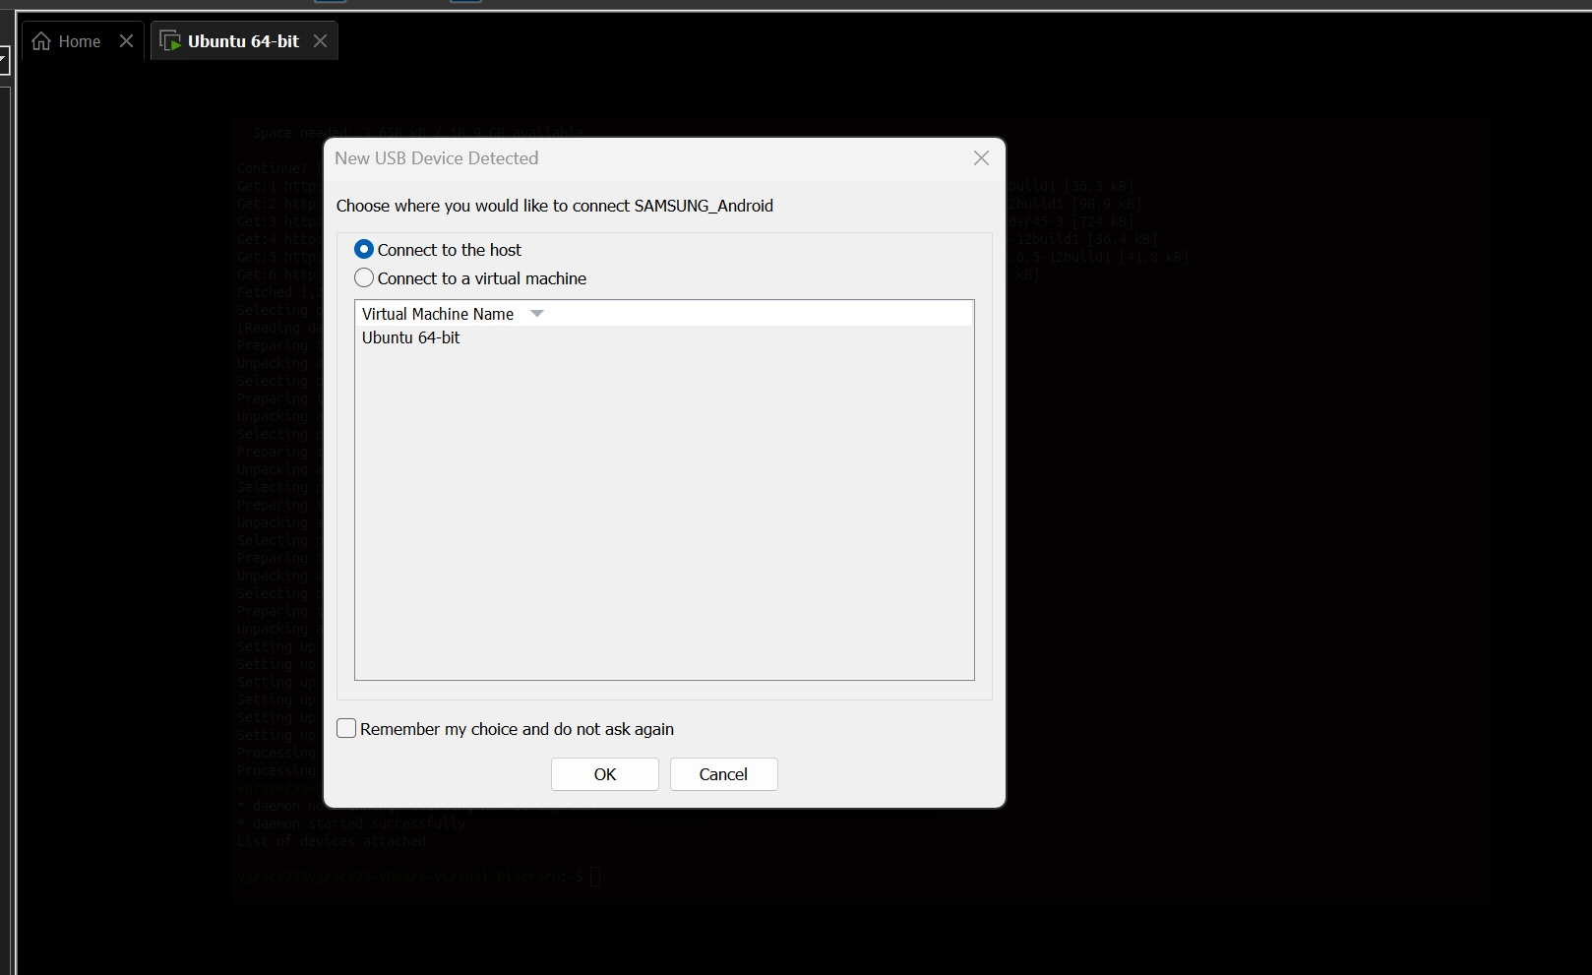
The USB connection dialog offers the running Ubuntu virtual machine as the target for the connected device.

Installation and troubleshooting evidence

Figure 26 First ADB detection attempt
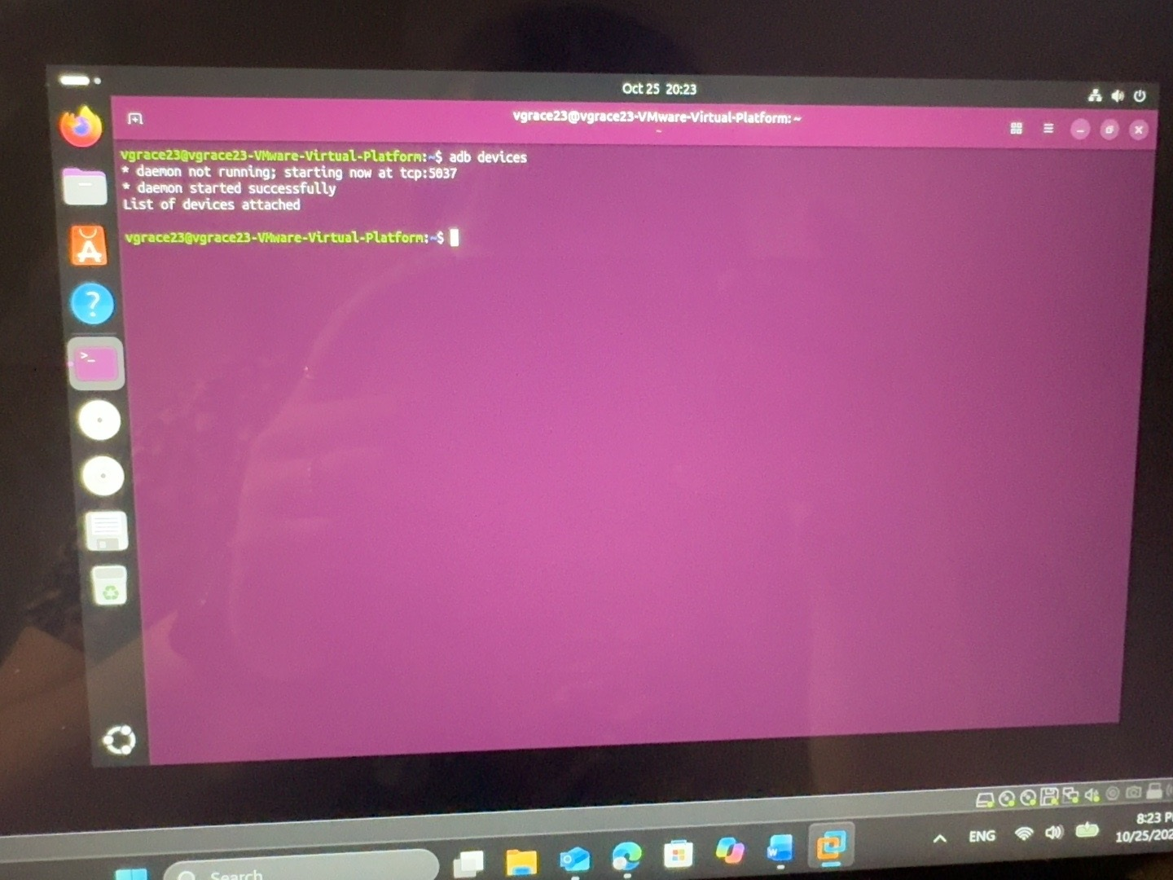
The ADB daemon starts, but the device list is empty. This photo has been rotated for readability.

Installation and troubleshooting evidence

Figure 27 Repeated empty ADB device list
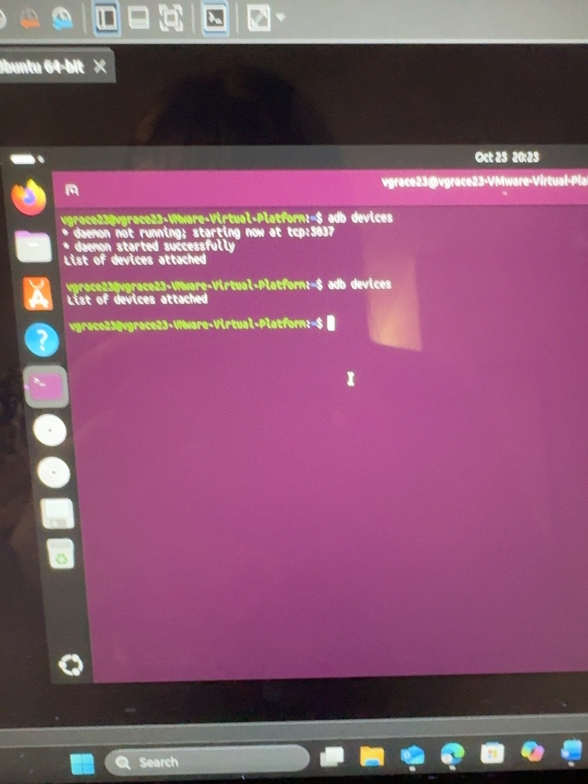
Another adb devices attempt returns an empty list before the phone connection is fully configured.

Installation and troubleshooting evidence

Figure 28 USB inventory without the phone
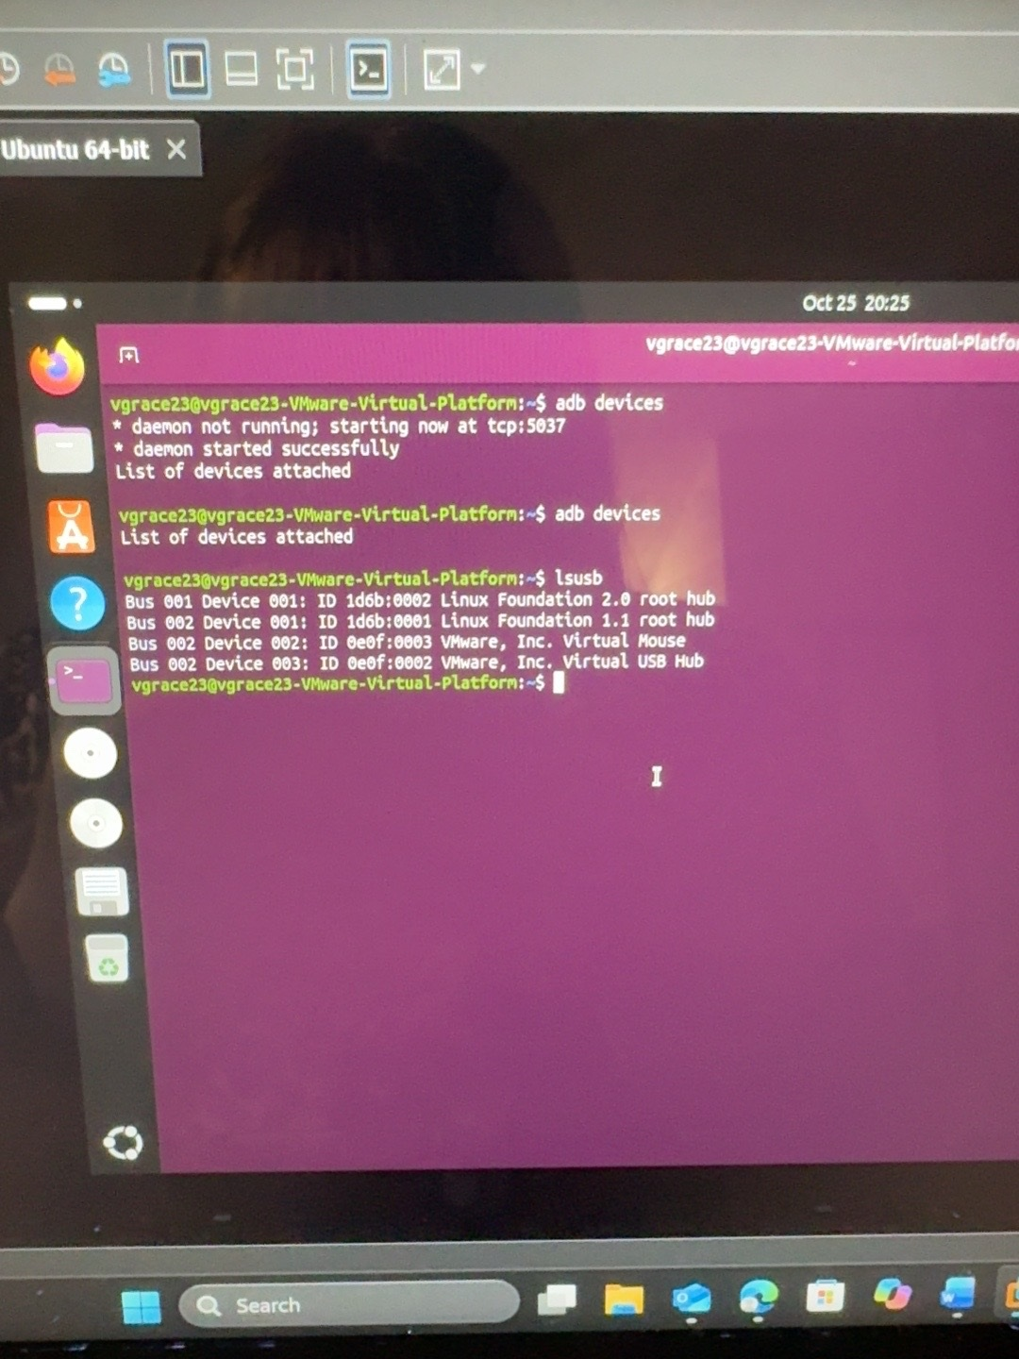
The lsusb output lists Linux root hubs and VMware virtual USB devices, with no Samsung phone present.

Installation and troubleshooting evidence

Figure 29 Samsung detected over USB
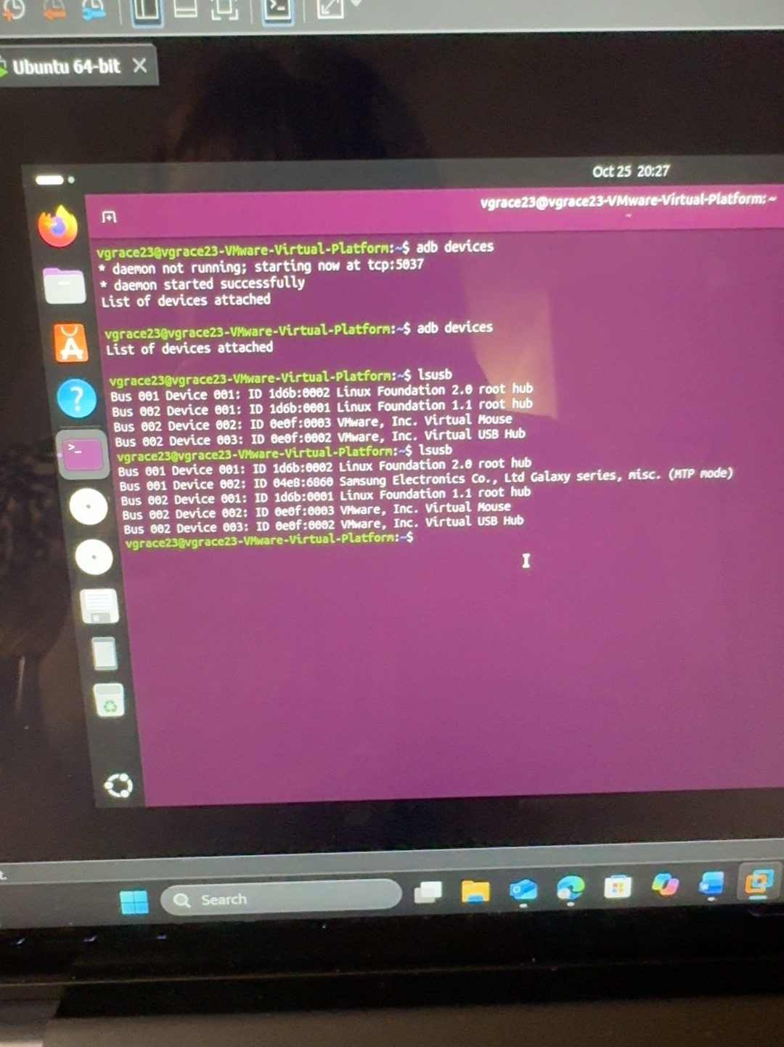
The later lsusb output includes Samsung Electronics Galaxy series in MTP mode, showing that Ubuntu now sees the phone over USB.

Installation and troubleshooting evidence

Figure 30 USB detection before ADB authorization
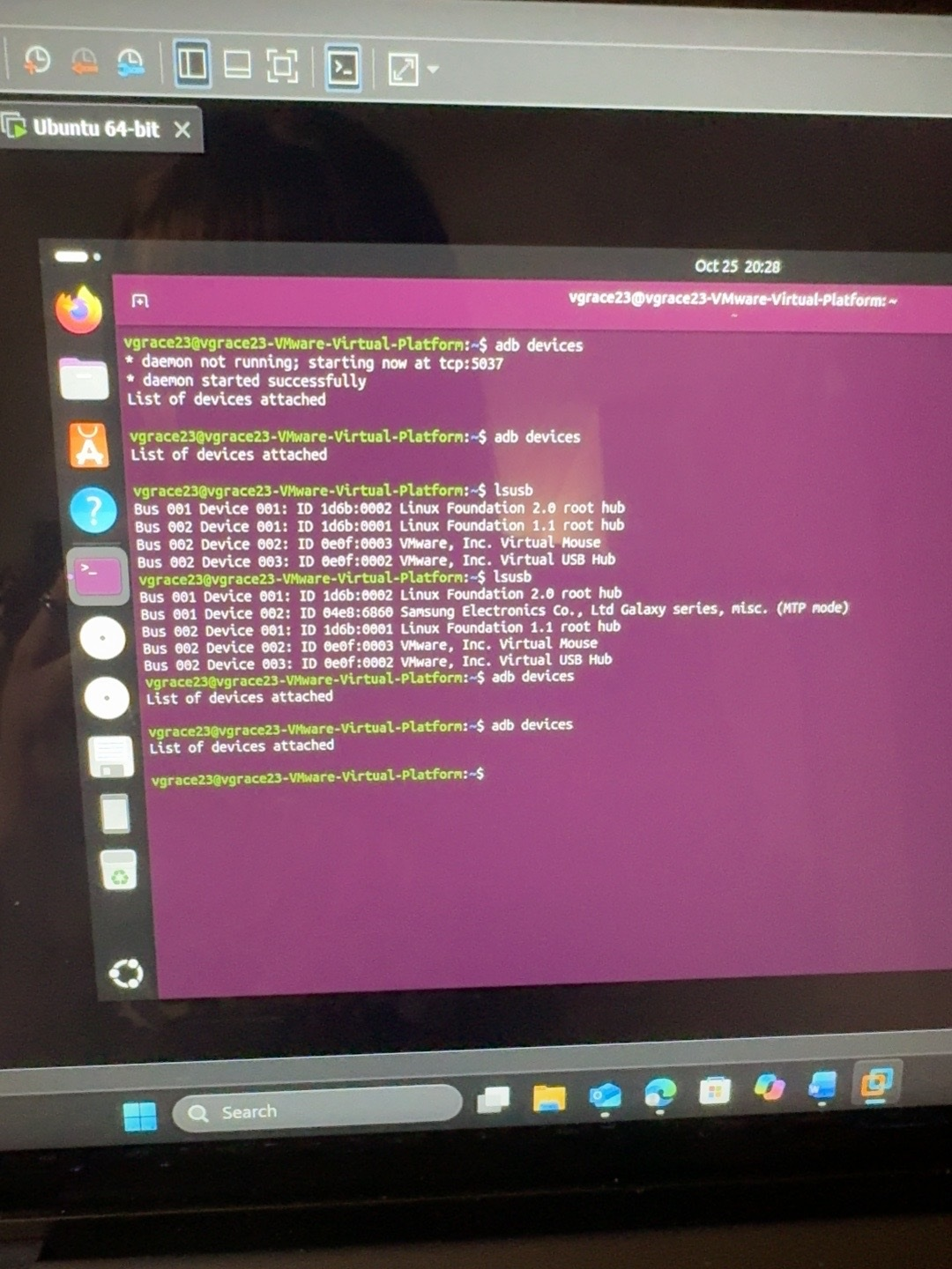
Although lsusb identifies the Samsung phone, subsequent adb devices attempts still return an empty list at this stage.

Installation and troubleshooting evidence

Figure 31 USB debugging authorization prompt
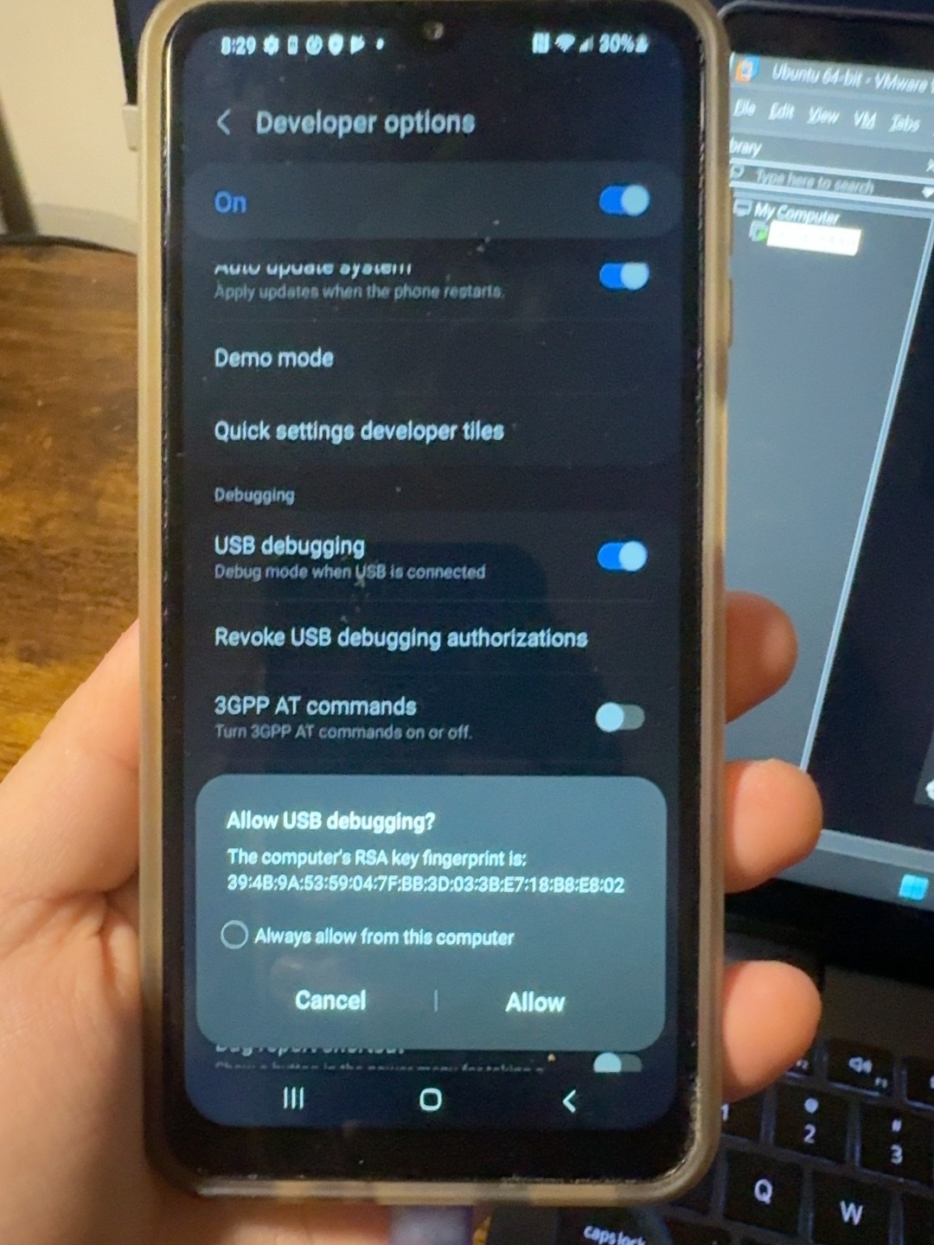
The phone has USB debugging enabled and displays the Allow USB debugging prompt with the computer RSA fingerprint.

Installation and troubleshooting evidence

Figure 32 Phone data access prompt
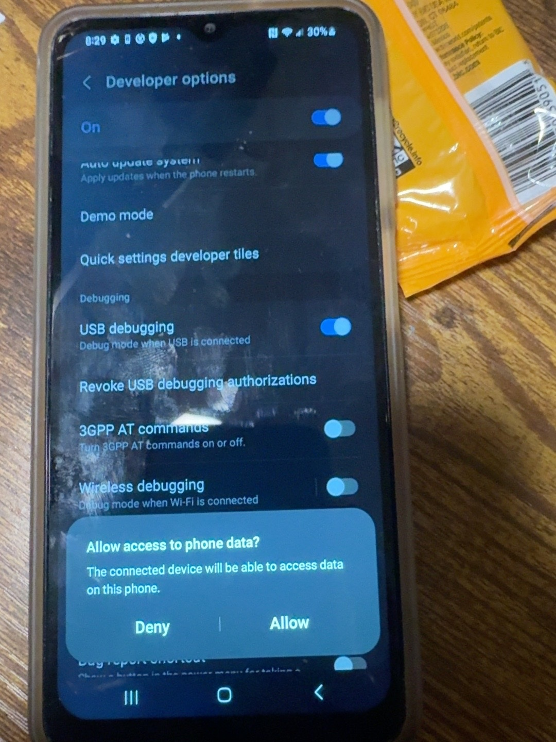
The phone displays Allow access to phone data for the connected computer.

Installation and troubleshooting evidence

Figure 33 ADB authorization transition
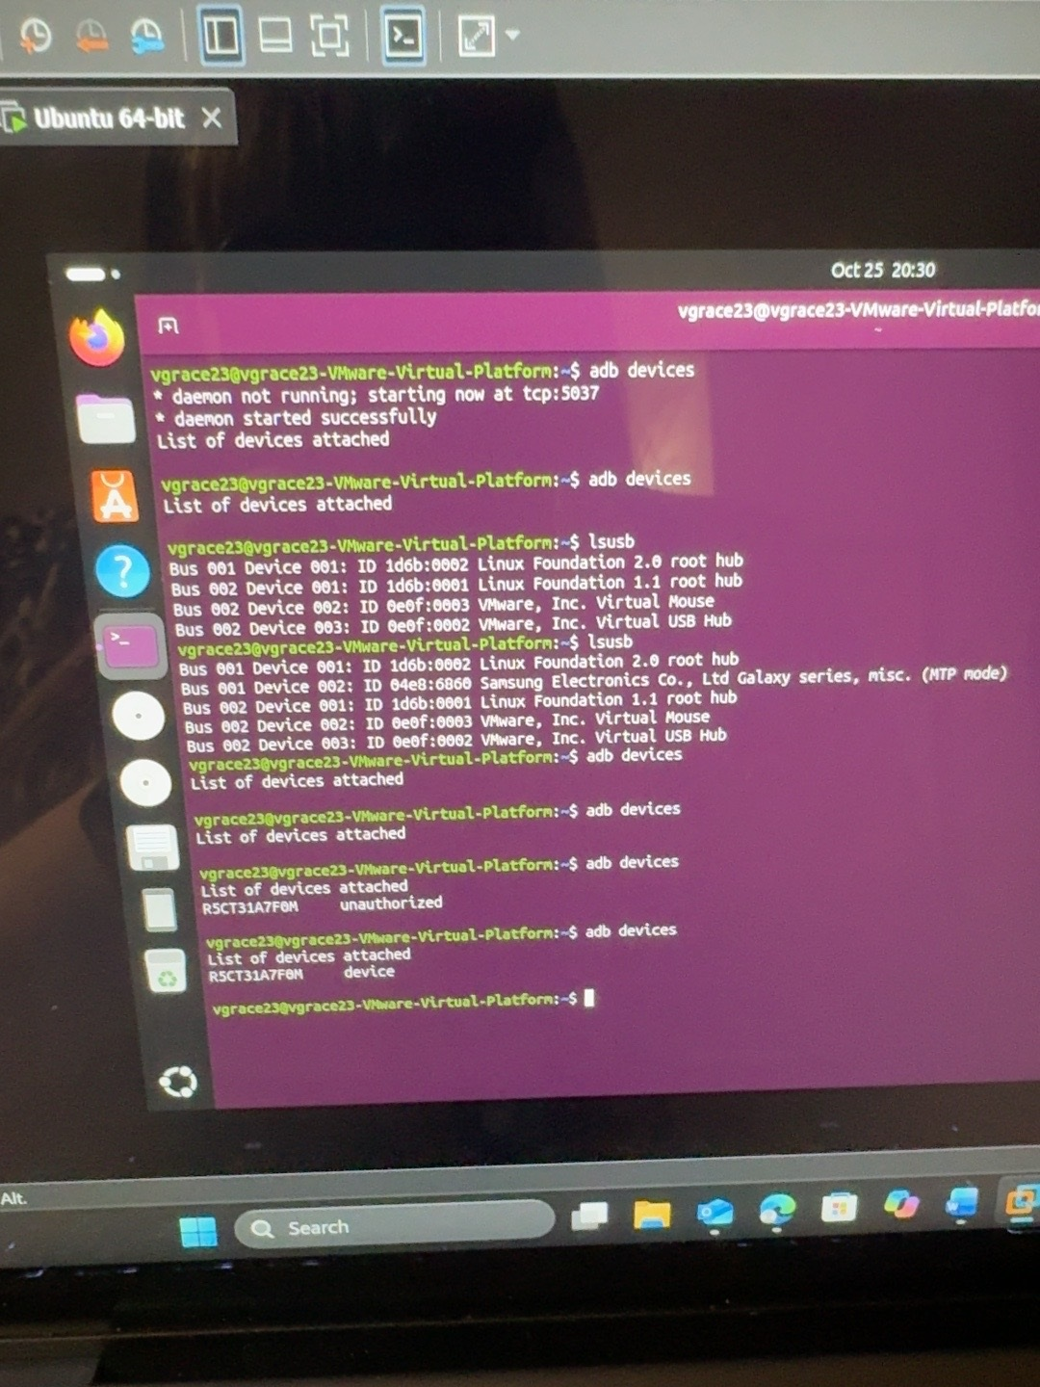
The terminal shows the phone first as unauthorized and then as device after the debugging authorization is accepted.

