Credit Risk or Structural Barriers? Racial and Geographic Disparities in Texas Mortgage Denial Rates, 2018–2023

Victoria Kwamboka¹, Nacasius Ujah², Thomas Brandenburger³, and Hossein Moradi Rekabdarkolaee¹
¹Bowling Green State University, Department of Business Analytics, Economics, and Information Systems, OH, USA
²South Dakota State University, Department of Economics, SD, USA
³South Dakota State University, Department of Mathematics and Statistics, SD, USA
Email addresses: vkwambo@bgsu.edu, nacasius.ujah@sdstate.edu, tom@rprofet.com, hmrekab@bgsu.edu,

Abstract:
Racial and ethnic disparities in mortgage denial persist in the United States. This study analyzes Texas county-level mortgage denials from 2018 - 2023 to assess how race, geography, and applicant credit risk shape lending outcomes. Using cross-validated LASSO logistic regression and Standardized Incidence Ratios (SIRs), we estimate risk-adjusted denial probabilities based on debt-to-income ratio, loan-to-value ratio, income, and property value. Debt-to-income ratio is the strongest and most consistent predictor of denial, with applicants above 50% DTI facing substantially higher odds across all years. All minority racial and ethnic groups experience significantly higher denial likelihoods than Non-Hispanic White applicants, with Black applicants generally showing the highest log-odds. At the county level, risk-adjusted SIRs reveal that in 2018, counties with larger minority populations had lower-than-expected denial rates - reversal of unadjusted patterns - indicating that elevated raw denial rates may largely be attributable to applicant risk rather than geography. By 2023, this advantage is more subtle as SIRs converge statewide. Counties with persistently low SIRs tend to have lower property values and higher minority population shares. These results highlight the interplay between individual credit risk, racial composition, and local economic conditions, and emphasize the importance of risk adjustment when assessing geographic lending disparities.

Keywords: Mortgage, standardized incidence ratios, minority, disparity.

- Introduction
Homeownership remains a central pathway to wealth accumulation in the United States, yet access to mortgage credit remains unequally distributed across racial and ethnic groups. A substantial body of research documents persistent disparities in lending outcomes, with Black and Hispanic applicants facing higher denial rates and less favorable loan terms than White borrowers, even decades after the passage of the Fair Housing Act of 1968 and the Equal Credit Opportunity Act of 1974. Although these policies prohibit discrimination on the basis of race, ethnicity, and gender, unequal outcomes persist in practice.
Recent empirical evidence shows that racial gaps in mortgage approval remain even when lenders apply ostensibly race‑neutral underwriting criteria. Bhutta et al. (2022) find that Black and Hispanic applicants continue to receive lower algorithmic approval rates and exhibit higher leverage ratios and weaker credit indicators than similarly qualified White borrowers. These patterns suggest that automated underwriting systems and credit‑scoring models may reproduce historical inequities under the guise of objective risk assessment. The Consumer Financial Protection Bureau (2023) further reports that, even after controlling for loan-to-value ratios, debt-to-income ratios, and credit scores, Black and Hispanic borrowers remain more likely to be denied credit or charged higher interest rates, leaving a residual disparity unexplained by measurable risk factors. This persistent gap indicates the presence of structural and possibly algorithmic biases embedded within modern lending practices.
Despite federal efforts to eliminate discriminatory lending, racial and ethnic inequities continue to characterize the mortgage landscape. Historical redlining practices, documented by Avery and Buynak (1981), entrenched racial segregation and restricted credit access in minority neighborhoods. Although formally outlawed, redlining’s legacy persists in the form of lower property valuations, concentrated poverty, and persistently higher denial rates for applicants in historically marginalized areas. Contemporary studies, including those by the Urban Institute (2020), show that homes in predominantly Black neighborhoods remain undervalued relative to comparable properties, reinforcing the racial wealth gap. Additional research reveals that Latino borrowers are disproportionately subjected to higher origination fees and subprime lending, even when credit‑qualified (Loya, 2021; Avery et al., 2008), further limiting wealth‑building opportunities.
Texas offers a particularly valuable context for examining these patterns, given its diverse demographic composition, with Black and Hispanic residents comprising more than half of the state’s population. This study investigates mortgage approval disparities across Texas counties from 2018 to 2023, focusing on the extent to which racial inequities persist after controlling for key credit risk indicators. Using Standardized Incidence Ratios (SIRs), we compare observed denial rates with expected rates conditioned on loan‑to‑value and debt‑to‑income ratios. This method assesses whether inequities remain after accounting for legitimate credit considerations and enables spatial comparison across counties.
We further employ penalized binomial regression models to examine whether risk factors are weighted differently for minority and White applicants. The results reveal that counties with persistently lower SIRs tend to have lower median property values, newer housing stock, and higher proportions of minority residents. Minority applicants in these counties experience lower denial rates on average than those in counties with older housing, higher property values, and smaller minority populations. These findings underscore the role of local economic conditions and demographic composition in shaping mortgage outcomes.
This study advances the literature in three ways. First, it applies epidemiological standardization methods - rarely used in mortgage research - to provide county‑level assessments of inequities beyond what economic factors predict. Second, it highlights the understudied intersection of race, gender, and mortgage access, particularly for women of color in rapidly growing metropolitan areas in Texas. Third, it clarifies how demographic, geographic, and socioeconomic factors interact to produce differential lending outcomes for Black and Hispanic applicants. As structural inequities continue to shape access to homeownership, this analysis offers insights for policymakers and lending institutions seeking to reduce barriers and promote more equitable financial systems.
The paper is structured as follows: Section 2 reviews the relevant literature; Section 3 outlines the data and methodology; Section 4 reports the results; and Section 5 offers the discussion and conclusion.
- Literature Review
Research on racial and ethnic disparities in mortgage lending sits at a productive intersection of social science and medicine, reflecting growing recognition that access to homeownership has far‑reaching implications for wealth accumulation, community stability, and long‑term health. Scholars in sociology, economics, public health, and epidemiology have long demonstrated that unequal access to mortgage credit reinforces structural inequities. Williams and Collins (2001) identify residential segregation as a fundamental cause of racial health disparities because it restricts minority communities’ access to essential resources, including wealth through homeownership.

2.1 Epidemiological Approaches to Social Inequality
Epidemiological tools have increasingly been adapted to assess disparities beyond the biomedical domain. The Standardized Incidence Ratio (SIR)—a measure traditionally used to compare observed and expected disease rates (Breslow & Day, 1987)—has been employed to quantify social inequalities. Krieger et al. (2003) argue that the conceptual logic of disease surveillance applies directly to discriminatory outcomes in housing, employment, and criminal justice, as social inequalities become “embodied” at the population level. This aligns with the broader social epidemiology paradigm, which emphasizes how social conditions shape health and well‑being across the life course (Berkman & Kawachi, 2000). Krieger (2012) provides further theoretical grounding for applying standardized population metrics to social disparities, offering a clear precedent for using SIRs to examine mortgage denial patterns.
Within housing economics, methodological debates focus on the risk of underestimating discrimination when models control for variables that may themselves reflect discriminatory processes. Yinger (1996) warns that adjusting for credit‑related characteristics shaped by long‑term inequality can obscure the true extent of racial discrimination. The SIR approach mitigates this concern by comparing observed denial rates with expected rates drawn from a reference population, reducing the need for extensive individual‑level controls and enabling meaningful county‑level comparisons.
2.2 Spatial Dimensions of Lending Disparities
Recent work using HMDA and administrative data underscores the value of spatially explicit methods in detecting lending disparities. Besbris et al. (2019) employ geographically weighted regression to show that the relationship between race and mortgage denial varies substantially across metropolitan areas, often mirroring historically redlined neighborhoods. Their findings highlight that racial lending disparities are spatially uneven, and that county‑level analysis reveals patterns masked by national or statewide averages.
Texas presents a particularly compelling setting for such analysis. With a large Hispanic population and significant Black urban communities in Houston, Dallas–Fort Worth, San Antonio, and Austin, Texas exhibits substantial county‑level variation in demographics, economic structure, and mortgage market conditions (Courchane, Surette, & Zorn, 2004). Applying the SIR methodology to Texas counties allows researchers to assess whether denial rates experienced by minority applicants exceed those predicted solely by economic and credit-related factors, enabling fine‑grained identification of spatially concentrated disparities.
2.3 Historical and Contemporary Racial Dynamics in Lending
Racial disparities in mortgage access cannot be understood apart from the historical foundations of housing discrimination in the United States. Jackson (1987) documents the role of federal housing policy - especially HOLC redlining - in systematically excluding racially mixed or predominantly minority neighborhoods from mortgage credit. Rothstein (2017) further shows how government actions entrenched segregation and produced durable wealth inequalities. Massey and Denton (1993) describe these patterns as the result of deliberate institutional practices, linking residential segregation to concentrated poverty, reduced wealth accumulation, and poorer health outcomes.
Empirical research using HMDA data confirms that discrimination continues despite formal policy prohibitions. Studies by Munnell et al. (1996) and Ross and Yinger (2002) find persistent racial gaps in denial rates even after adjusting for credit indicators and loan‑to‑value ratios. Squires (2003) introduces the concept of “predatory inclusion,” arguing that minority borrowers often gain access to credit on more exploitative terms. These concerns intensified following the 2007–2009 financial crisis, when Black and Hispanic borrowers were disproportionately steered toward subprime loans irrespective of creditworthiness (Rugh & Massey, 2010). Segregation amplified the crisis’s unequal impact, demonstrating the contemporary relevance of the structural framework articulated by Massey and Denton.
The mechanisms underlying racial disparities differ across groups. For Black borrowers, evidence consistently points to a combination of direct discrimination, credit disadvantages linked to historical inequity, and appraisal bias that depresses property values in predominantly Black neighborhoods. Perry, Rothstein, and Harshbarger (2018) estimate that homes in majority‑Black neighborhoods are undervalued by about $48,000 relative to comparable homes in White neighborhoods, weakening collateral strength and increasing denial risk.
For Hispanic borrowers, disadvantages often include language barriers, immigration‑related documentation challenges, and informal employment structures that complicate income verification (Apgar & Calder, 2005). Bocian, Ernst, and Li (2008) find that Hispanic borrowers with similar credit profiles to White borrowers were more likely to receive high‑cost subprime loans, with disproportionately large effects in Texas cities with significant Spanish‑speaking populations. Because HMDA does not record immigration status, analyses of Hispanic denial rates may understate the scale of exclusion.
Spatial disadvantage compounds these racial dynamics. Lichter, Parisi, and Taquino (2015) observe growing racial and ethnic isolation in small and mid‑sized Texas cities and rural counties, where segregation is strongly associated with economic disadvantage. In such areas, mortgage denial can further entrench spatial inequality by limiting opportunities for residential mobility and wealth accumulation.
2.4 Housing, Health, and Structural Inequality
Housing is widely recognized as a central social determinant of health. Frameworks developed by the WHO Commission on Social Determinants of Health (2008) and Marmot (2005) highlight how stable, adequate housing influences physical and mental health through exposure to environmental hazards, stress from housing insecurity, social cohesion, and the financial buffer provided by accumulated home equity.
Empirical studies link homeownership to improved health outcomes, even after controlling for socioeconomic status. Rohe and Stegman (1994) find that homeowners report greater psychological well‑being due to increased residential stability and autonomy. Fang et al. (2010) show that homeownership is associated with lower rates of depression, hypertension, and all‑cause mortality among older adults. Denial of mortgage credit, therefore, not only limits access to wealth-building opportunities but also restricts access to health-protective resources.
Neighborhood disinvestment further magnifies health disparities. Kramer and Hogue (2009) document strong associations between segregated, high‑poverty neighborhoods and elevated morbidity and mortality. Smedley, Stith, and Nelson (2003) find that segregation restricts access to quality healthcare infrastructure. Leal and Hess (2010) show that Hispanic residents in segregated areas have lower preventive care utilization, linking these disparities to limited economic mobility - partly shaped by unequal access to homeownership.

3. Data and Methodology
3.1 Data
We use publicly available mortgage application data collected under the Home Mortgage Disclosure Act (HMDA) from 2018 to 2023 (CFPB, 2022). HMDA provides comprehensive, annually reported information on mortgage applications submitted to financial institutions regulated by the Federal Financial Institutions Examination Council (FFIEC). These data support oversight of lending practices and the enforcement of fair‑lending laws, including the Community Reinvestment Act (CRA), under which institutions with low CRA scores may face regulatory scrutiny intended to discourage discriminatory lending (Loya, 2021).
The HMDA dataset includes applicant income, race, ethnicity, gender, loan amounts, property values, and geographic identifiers. Although co‑applicant data are recorded, our analysis focuses on primary applicants because many applications do not include co‑applicant information. Despite its breadth, HMDA does not contain key creditworthiness measures - such as credit scores, down payments, or final sale prices - which constrains the level of risk adjustment. To maintain consistency and avoid confounding eligibility differences, the sample is restricted to non‑institutional buyers seeking conventional, first‑lien mortgages for home purchase. FHA and VA loans are excluded due to their specialized underwriting rules. We further limit the sample to 30‑year fixed‑rate mortgages for site‑built, single‑unit, owner‑occupied properties. Only completed applications - those neither withdrawn nor closed for incompleteness - are retained.
Counties with fewer than ten applications are excluded to minimize instability in approval and denial rates. The dataset also provides county‑level contextual variables, including population size, minority population share, the proportion of 1‑to‑4‑unit housing, median loan amounts, income percentiles, the number of owner‑occupied units, and the median age of housing stock (CFPB, 2023). To ensure meaningful representation of Black and Hispanic applicants, only counties with adequate demographic diversity are included. According to the 2020 Census, Black and Hispanic residents comprise roughly 54% of the Texas population (U.S. Census Bureau, 2024).
After cleaning and filtering, the final analytic dataset contains 1,999,145 applications with nine numerical and twelve categorical variables. Mortgage outcomes are classified as approved, denied, or withdrawn/incomplete. Applicant gender is categorized as male, female, not applicable, or other. Denial reasons include debt‑to‑income ratio, employment history, credit history, insufficient collateral or cash, unverifiable information, incomplete applications, insurance denial, and other unspecified factors. Applicants are grouped into age categories: under 25, 25–34, 35–44, 45–54, 55–64, 65–74, above 74, and missing.
We code race as follows:
- Joint, for applicants whose derived ethnicity, race, or sex was categorized as joint or who filed with a co-applicant;
- Hispanic White, for individuals identifying as Hispanic or Latino and White;
- Non-Hispanic White, for applicants identifying as White and either non-Hispanic or with missing ethnicity information;
- Asian for those identified as Asian;
- Black or African American for those categorized as Black;
- Other Minority Races for Native Hawaiian or Other Pacific Islander, multi-racial, Alaska Native, etc., which had smaller representation; and
- Missing for all remaining cases without race or ethnicity data.

Table 1: Application Profile by Demography
YEAR &  # of APPLICATION | RACE | APPLICATIONS | I | II | III
2018 (293,976) | Asian | 12,261 | 4.17% | 1,602 | 13.07%
 | Black or African American | 17,029 | 5.79% | 3,126 | 18.36%
 | Hispanic White | 44,394 | 15.10% | 6,419 | 14.46%
 | Joint | 117,751 | 40.05% | 12,006 | 10.20%
 | Missing | 22,999 | 7.82% | 3,359 | 14.60%
 | Non-Hispanic White | 77,732 | 26.44% | 7,732 | 9.95%
 | Other Minority Races | 1,810 | 0.62% | 303 | 16.74%
2019 (321,588) | Asian | 12,788 | 3.98% | 1,595 | 12.47%
 | Black or African American | 18,754 | 5.83% | 3,363 | 17.93%
 | Hispanic White | 50,590 | 15.73% | 6,772 | 13.39%
 | Joint | 127,851 | 39.76% | 12,437 | 9.73%
 | Missing | 28,078 | 8.73% | 3,621 | 12.90%
 | Non-Hispanic White | 81,394 | 25.31% | 7,355 | 9.04%
 | Other Minority Races | 2,133 | 0.66% | 320 | 15%
2020 (375,749) | Asian | 15,896 | 4.23% | 2,037 | 12.81%
 | Black or African American | 24,274 | 6.46% | 4,358 | 17.95%
 | Hispanic White | 60,686 | 16.15% | 8,467 | 13.95%
 | Joint | 145,363 | 38.69% | 14,639 | 10.07%
 | Missing | 31,666 | 8.43% | 5,386 | 17.01%
 | Non-Hispanic White | 95,045 | 25.29% | 8,421 | 8.86%
 | Other Minority Races | 2,819 | 0.75% | 387 | 13.73%
2021 (375,463) | Asian | 21,543 | 5.74% | 2,522 | 11.71%
 | Black or African American | 25,499 | 6.79% | 4,466 | 17.51%
 | Hispanic White | 60,951 | 16.23% | 7,584 | 12.44%
 | Joint | 142,151 | 37.86% | 13,252 | 9.32%
 | Missing | 32,749 | 8.72% | 5,614 | 17.14%
 | Non-Hispanic White | 89,360 | 23.80% | 7,834 | 8.77%
 | Other Minority Races | 3,210 | 0.85% | 455 | 14.17%
2022 (334,508) | Asian | 24,693 | 7.38% | 3,466 | 14.04%
 | Black or African American | 23,555 | 7.04% | 4,633 | 19.67%
 | Hispanic White | 51,097 | 15.28% | 7,356 | 14.40%
 | Joint | 131,258 | 39.24% | 13,666 | 10.41%
 | Missing | 28,237 | 8.44% | 4,842 | 17.15%
 | Non-Hispanic White | 72,982 | 21.82% | 7,509 | 10.29%
 | Other Minority Races | 2,686 | 0.80% | 444 | 16.53%
2023 (297,903) | Asian | 21,868 | 7.34% | 2,725 | 12.46%
 | Black or African American | 20,946 | 7.03% | 3,952 | 18.87%
 | Hispanic White | 47,610 | 15.98% | 6,921 | 14.54%
 | Joint | 121,927 | 40.93% | 12,345 | 10.12%
 | Missing | 23,573 | 7.91% | 3,822 | 16.21%
 | Non-Hispanic White | 59,110 | 19.84% | 6,004 | 10.16%
 | Other Minority Races | 2,869 | 0.96% | 488 | 17.01%
Note: In the first column, the number in parentheses is the number of applications for 30-year mortgage single-family homes in Texas for the stated year. The second column identifies the race classification. We use the identifier’ missing’ to disclose the number of applicants for whom their racial identity was not available. The third column shows the number of applications by the race identified in the second column. The fourth column with ’I’ denotes the percentage of applicants for the given year. The fifth column with ’II’ denotes the number of denials for each race. The sixth column, labeled ‘III’, shows the denial rate for each race.

Table 1 presents the annual distribution of mortgage applications and provides a detailed breakdown of application counts and denial rates across racial groups. Joint applications consistently accounted for the largest share of total submissions, ranging from 37% to 41% during the six-year period. In contrast, applicants categorized as Other Minority Races accounted for less than 1% of total submissions, reflecting their comparatively limited representation in the dataset. Non-Hispanic White and Hispanic White applicants were the second- and third-largest groups, contributing, on average, roughly 23% and 16% of total applications, respectively. Among the single-race categories, Asian and Black African American applicants consistently submitted the fewest applications.
A notable temporal shift is observed in the proportion of applications submitted by Non-Hispanic White applicants, which declined substantially from approximately 26.4% in 2018 to 19.8% in 2023. Mortgage denial rates declined slightly during the COVID-19 years (2019–2021) before resuming an upward trajectory in 2022. This pattern appears consistently across racial groups and aligns with empirical evidence indicating that pandemic-era policy interventions, most notably, historically low interest rates and borrower-targeted market incentives, expanded access to mortgage credit and facilitated higher approval rates during this period. The “Pandemic Mortgage Boom” documented in prior research suggests that favorable credit conditions, reduced borrowing costs, and elevated refinancing and purchasing activity contributed to this temporary easing in denial rates (Diamond et al., 2024; Divringi & Calem, 2022; Fuster et al., 2021).
To evaluate geographic variation in mortgage denial patterns, we constructed a time series of county-level denial rates and annual rate changes, as illustrated in Figure 1. Each year, some counties were excluded either because they had genuinely missing data or because they reported fewer than 10 applications, which did not meet our threshold for reliable estimation. The analysis reveals consistently higher denial rates in counties in Texas's western and northwestern regions than in those in the state's central and eastern regions.
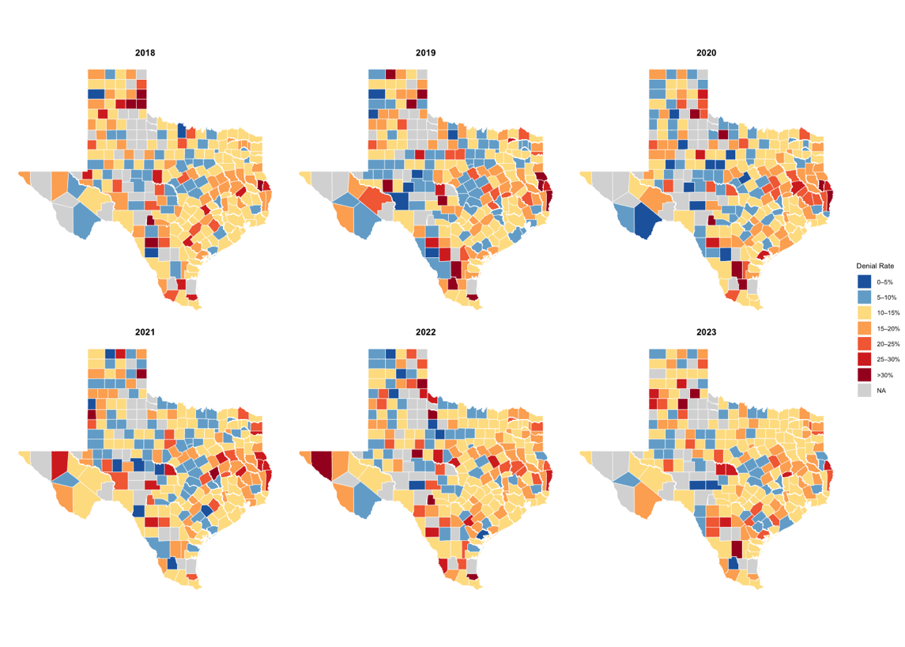
Figure 1: Denial Rate by County and Year
Additionally, we observe a persistent pattern in which applicants voluntarily omit their racial identification, resulting in these cases’ race being coded as ‘missing’. As demonstrated in the log-likelihood models reported in subsequent sections, applicants with missing race information exhibit significantly higher denial rates compared to several specified racial groups. This pattern raises the possibility that strategic non-disclosure or underlying unobserved characteristics may influence the likelihood of denial for this subset of applicants.
Table 2 summarizes the numerical variables, except for race, which is detailed in Table 1. The numerical variables are log of income, property value, loan-to-value ratio, debt-to-income ratio, age bracket of the primary applicant, activity year, loan type, action taken, income bins, property value bins, tract minority population percent, tract-to-MSA income percentage, number of owner-occupied units, number of one-to-four-family homes, median age of housing units by county, number of banks per county, FFIEC median family income for the applicant’s tract, and applicant income (in thousands). A detailed description of each variable is available in Appendix A1.

Table 2: Summary Statistics of Numerical Variables.
Variable | Max | Mean | Median | Min | S.D
Median Family Income | 122,300.00 | 81,352.84 | 80,000.00 | 38,900.00 | 14,395.39
Loan Amount (k) | 725.00 | 278.46 | 255.00 | 5.00 | 116.23
Log Income | 16.30 | 4.53 | 4.51 | 0.00 | 0.55
Property Value (k) | 28,235.00 | 322.08 | 285.00 | 5.00 | 161.28
Median Housing Age (Yrs) | 80.00 | 24.51 | 21.00 | 0.00 | 14.66
Minority Pop.% | 100.00 | 48.86 | 45.13 | 0.00 | 24.15
1-to-4 Family Homes | 15,386.00 | 2,283.24 | 1,949.00 | 0.00 | 1,524.55
Owner-Occupied Units | 13,975.00 | 1,762.61 | 1,468.00 | 0.00 | 1,330.77
Note: The ′k′ denotes missing ′000 for the variables Loan Amount and Property Value. Minority Pop. (Population) is expressed as a percentage. The Median Housing age is in years. The data sample, consisting of the number of loan applications, has 1,999,145 observations.

3.2 Logistic Regression Analysis using $l_{1}$Regularization
To understand the impact of credit risk factors on mortgage approval/denial rates, we employed a penalized binomial logistic regression (with Least Absolute Shrinkage and Selection Operator (LASSO) regularization for feature selection (Vasquez et al., 2016). Let $Y_{1},…,Y_{n}$ denote the binary response, where $Y_{i}=1$ indicates a denied application and $Y_{i}=0$ indicates approval, and let $x_{i}=\left(x_{i1},…,x_{ip}\right)$ be the predictors for applicant $i$. For logistic regression, the conditional mean satisfies
$$\text{Pr}\left(Y_{i}=1 ∣ x_{i}\right)=π_{i}, \text{where log}\left(\frac{π_{i}}{1-π_{i}}\right)=β_{0}+\sum_{j=1}^{p}{β_{j}}x_{ij}.$$
The LASSO estimator is obtained by minimizing the negative log-likelihood with an $l_{1}$ penalty:
$${\hat{β}}^{lasso}=\text{arg}\underset{β}{\text{min}}\left\{-\frac{1}{n}\sum_{i=1}^{n}{\left[y_{i}\text{log}\left(π_{i}\right)+\left(1-y_{i}\right)\text{log}\left(1-π_{i}\right)\right]}+λ\sum_{j=1}^{p}{|}β_{j}|\right\},$$
where $λ≥0$ controls the amount of shrinkage and larger values of $λ$ set more coefficients exactly to zero. We implemented this model using the glmnet package (Hastie et al., 2024).

The reference categories for the regression model are defined as follows: Non-Hispanic White applicants (Race), joint applicants (Applicant Sex), applicants aged 35–44, individuals with a loan-to-value (LTV) ratio between 90% and 100%, applicants with a debt-to-income (DTI) ratio below 50%, and properties valued between $200,000 and $400,000. These reference groups were selected because they represent the modal categories in the dataset, thereby enhancing the interpretability of coefficient estimates and contributing to more stable model estimation.
Centering the model around the most common applicant and loan characteristics reduces the risk of multicollinearity among indicator variables, stabilizes parameter estimates, and facilitates meaningful comparisons relative to the majority group (Friedman et al., 2021). This specification ensures that deviations from baseline characteristics, such as belonging to a minority racial group, falling into a less common age bracket, or applying for a mortgage outside typical LTV or DTI ranges, are clearly captured and readily interpretable within the model’s log-odds framework. The response variable is the binary indicator Denied, coded as 1 for denied applications and 0 for approved ones.
Although the glmnet procedure standardizes predictors by default and does not require the specification of reference categories for estimation, the choice of baseline groups remains important for post-estimation interpretation, particularly when models include numerous categorical indicators (Friedman et al., 2021). Establishing theoretically and empirically coherent reference categories thus improves the clarity with which the model communicates how applicant and loan characteristics influence mortgage denial outcomes.

3.3 Standardized Incidence Ratios
The Standardized Incidence Ratio (SIR) is a comparative statistical measure used to evaluate whether an observed number of events differs from what would be expected based on a reference population. It has been widely applied in epidemiology, particularly in cancer surveillance by the Centers for Disease Control and Prevention (CDC, 2024), to quantify deviations from baseline risk. Conceptually, the SIR assesses the occurrence of an event within a specific population relative to the expected count had that population experienced the event at the same rate as a normal or reference group, defined at the state or national level.
In this study, we adopt Texas’s overall mortgage approval rate as the expected rate against which county-level approval patterns are standardized. Although commonly used in healthcare analytics, the SIR is well suited for examining socioeconomic disparities, including spatial inequities in mortgage outcomes. Its application here enables a clear, interpretable comparison of county-level approval dynamics before adjusting for credit risk factors.
The SIR before adjusting for credit risk factors was computed as
$$SIR_{j}=\frac{O_{j}}{E},$$
where $O_{j}$ is the observed denial rate for county $j$ and $E$ is the statewide expected denial rate. A ratio less than 1 indicates that the county’s denial rate is lower than the state’s baseline rate, while a ratio greater than 1 indicates that the county’s denial rate exceeds the expected rate (Spors & Michael, 2021).
After adjustment, the expected denial rate for each county is derived from the LASSO model’s predicted probabilities, which incorporate borrower-level and tract-level risk characteristics. The adjusted SIR, therefore, reflects whether a county denies more or fewer loans than would be expected for applicants with the same risk profile. A decrease in SIR after adjustment suggests that higher raw denial rates were largely attributable to differences in applicant risk, whereas an increase indicates that counties denied loans at rates exceeding those predicted by the risk model.
Model fit was assessed using the Mean Square Error (MSE) computed as
$$\text{MSE}=\frac{1}{n}\sum_{i=1}^{n}{(}y_{i}-{\hat{y}}_{i})^{2}$$
where $y_{i}$ is the observed fate of the application (1 for a denied application and 0 for an approved application) and ${\hat{y}}_{i}$ is predicted likelihood of mortgage denial. MSE measures the magnitude of the error, and lower values indicate a better model.

- Empirical Results
All statistical analyses were conducted using R version 4.5.1 (R Core Team, 2020), using the tidyverse (Wickham et al., 2023), ggplot2 (Wickham, 2023), sf (Pebesma, 2018), and glmnet (Hastie et al., 2024) packages.
  - Correlation
In mortgage market analysis, examining correlations among key variables is essential for identifying systemic patterns, structural biases, and disparities in lending outcomes (Bartlett et al., 2021; Bayer et al., 2018; Fuster et al., 2021). The Pearson correlation matrix for the years 2018 and 2023 have been included in figure 2. The evidence shown in these two periods is consistent with the years not shown. The darker blue indicates stronger positive correlations, and the darker red indicates stronger negative associations. Because the dataset combines both county-level and individual-level variables, we interpret the observed correlations within the mixed spatial structure.
Across both years, applications from counties with larger minority populations exhibit a modest negative correlation with county-level property values, with coefficients fluctuating around –0.32. Minority population shares also show a weak negative correlation with tract income, ranging from –0.43 in 2018 to –0.4 in 2023. These patterns align with evidence documenting the historical devaluation of homes in minority neighborhoods and the persistence of place-based racial inequities in housing markets. Consistent with the literature, property values between 2018 and 2023 display a small but persistent negative correlation with the percentage of minority residents in an applicant’s county.
The number of one-to-four-family homes is mildly negatively correlated with the median age of the housing unit, suggesting that areas with more such units tend to have newer housing. Overall, correlation strengths and directions remain stable across the six-year period, indicating consistent structural relationships between demographic and housing characteristics.
Loan amounts display a strong positive correlation with property values, averaging approximately 0.85 across all years. An expected relationship given that borrowers typically seek larger loans for more expensive properties. By contrast, the loan-to-value ratio shows little correlation with property values in both years.
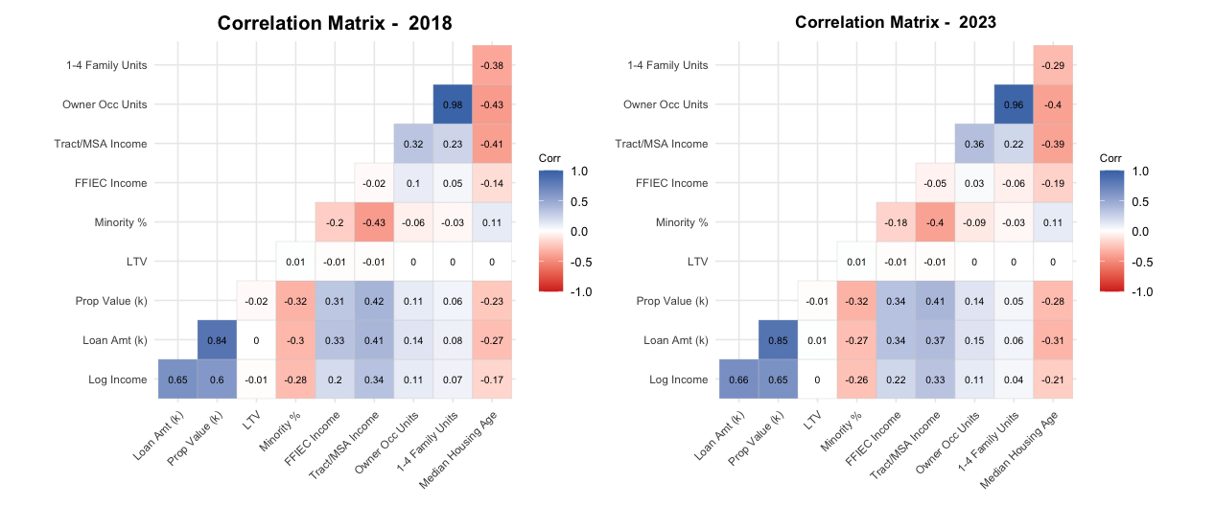
Figure 2: Correlation Plots of Mortgage Applications in 2018 and 2023

  - Logistic Regression Results
We adopt a generalized linear model (GLM) with a logit link to estimate the probability that a mortgage application will be denied. To improve interpretability and align with the empirical distribution of key variables, several categorical predictors were grouped into meaningful bins based on the ranges within which most applicants typically fall. For example, the majority of borrowers have debt-to-income ratios below 50%, a threshold commonly associated with higher approval likelihood. Likewise, applicant incomes are most concentrated between $200,000 and $400,000, particularly among joint applicants. These binned categories allow the model to capture salient patterns in the data that would be less apparent without such structuring. The resulting logistic regression estimates are summarized in Table 3.
Table 3 indicates that the set of statistically significant predictors remains largely consistent across all six years, although the magnitude of their effects varies over time. Debt-to-Income (DTI) emerges as one of the strongest and most stable determinants of mortgage denial. Applicants with DTI ratios exceeding 50% consistently face substantially higher odds of denial relative to those in the reference group with ratios below 50%. This pattern persists throughout the entire study period and becomes even more pronounced in the post-COVID years (2021–2023), when underwriting standards tightened (FRBSF Economic Letter 2022-16). These findings align with Larson and Martinez (2025), who show that elevated borrower leverage amplifies sensitivity to mortgage rate shocks, resulting in higher denial rates in markets with stricter lending environments.
Income is a key determinant of mortgage denial outcomes. In the pre-COVID period, applicants earning between $50,000 and $100,000 exhibited higher denial rates than those in the reference income category of $200,000 to $300,000. This pattern shifted in 2020 and 2021: applicants in the $50,000 to $100,000 range experienced slightly lower denial rates than the reference group, although the differences were modest and non-significant. A similar reversal occurred for applicants earning between $300,000 and $400,000, who faced higher denial rates than the reference category, with the difference being significant only in 2020 and 2021. For higher income brackets (above $400,000), relatively small sample sizes likely contribute to the larger coefficients observed in some years, reflecting greater variability rather than a stable underlying pattern. By 2022 and 2023, as sample sizes increased, these coefficients became more stable. In the post-pandemic period, the relationship between income and mortgage denial realigned: among income categories with statistically significant effects, all showed higher denial rates relative to the reference group.
The reference category for race is Non-Hispanic White applicants. Across all six years, applicants in every other racial group – including those classified under the Joint category – exhibited significantly higher odds of mortgage denial relative to this baseline. With the exception of 2018 and 2020, Black or African American applicants consistently showed the highest log odds of denial after accounting for observable credit-related factors. In those two years, applicants categorized as Other Minority Races (in 2018) and Asian applicants (in 2020) demonstrated the highest likelihood of denial. A notable pattern also emerges for Joint applications: their odds of denial decreased over time relative to the reference category, suggesting a gradual convergence toward more favorable outcomes. These findings complement the work of Dillbary and Edwards (2019), who show that intersectionality – particularly the combined effects of race and gender – shapes lending outcomes, with same-sex and mixed-race applicants experiencing distinct forms of discrimination.
Age and sex also emerge as meaningful predictors of mortgage denial. Applicants aged 34 or younger were consistently less likely to be denied than those in the 35-44 reference group, and this difference remained statistically significant across all six years of the study. The reference category for sex is Joint applicants, reflecting their predominance in the dataset. Relative to this group, both male and female applicants exhibited higher odds of denial. The effect was even more pronounced for applicants who did not disclose their sex – particularly among those classified as male – suggesting that missing demographic information may signal unobserved risk factors or trigger more conservative lending responses.

  - SIR Results
Drawing on the evidence in Table 3, we examine mortgage denial patterns at the county level to better understand how race, geography, and credit risk interact within the approval process. To facilitate these comparisons, we employ the Standardized Incidence Ratio (SIR) to assess county-level denial rates in Texas, both before and after adjusting for credit risk factors in 2018 and 2023. Standardization allows us to account for underlying credit risk characteristics within the statewide applicant pool, thereby enabling more meaningful comparisons across demographic and geographic contexts. By controlling for factors such as income, employment, and creditworthiness, the SIR highlights counties whose denial rates deviate from what would be expected given their risk profiles. Counties with SIR values above 1 exhibit higher-than-expected denial rates, suggesting potential structural barriers or localized socioeconomic conditions that may influence lending practices, whereas counties with SIR values below 1 indicate more favorable lending environments relative to statewide norms.
For this analysis, we focus on comparing 2018 with 2023, as results in the years in between were similar. Prior to adjusting for credit risk, county-level observed denial rates were calculated and benchmarked against Texas’s overall denial rate, which was 11.75% in 2018 and 12.17% in 2023. Figure 3 displays the resulting SIR maps before the adjustment. As noted, an SIR below 1 signifies denial rates lower than the statewide average, while an SIR above 1 indicates higher-than-average rates. The right-hand panel of Figure 3 shows the SIR for the 2 years while the one on the left depicts the change in SIR over the five-year period.

Table 3: Logistic Regressions (2018 – 2023)
Variable | Category | 2018 | 2019 | 2020 | 2021 | 2022 | 2023
Intercept |  | -2.801*** | -3.016*** | -2.749*** | -3.027*** | -3.29*** | -3.394***
DTI (%) | ≥ 50 | 1.216*** | 1.196*** | 1.351*** | 1.442*** | 1.444*** | 1.411***
Income(K) | [0,50] | 0.512*** | 0.574*** | 0.423*** | 0.514*** | 0.789*** | 1.149***
 | (50,100] | 0.088* | 0.093* | -0.017 | -0.016 | 0.075** | 0.232***
 | (100,150] | 0.011 | 0.022 | -0.061. | -0.062. | -0.019 | 0.023
 | (150,200] | 0.055 | 0.007 | -0.067. | -0.027 | -0.024 | -0.006
 | (300,400] | 0.001 | 0.122 | 0.274*** | 0.211** | 0.076 | 0.004
 | (400,500] | 0.474*** | 0.335** | 0.42*** | 0.36** | 0.241** | 0.152.
 | (500,600] | -0.005 | 0.419* | 0.526*** | 0.294. | 0.113 | 0.058
 | (600,1000] | 0.546** | 0.793*** | 0.612*** | 0.463** | 0.32* | 0.229*
 | (1000,2000] | 1.122*** | 1.075*** | 0.813*** | 1.487*** | 0.277 | 0.567**
 | (2000, Inf] | 0.921* | 1.391** | 1.653*** | 2.383*** | 0.618. | 0.646*
Race | Asian | 0.366*** | 0.404*** | 0.512*** | 0.474*** | 0.477*** | 0.35***
 | B/AA | 0.407*** | 0.503*** | 0.497*** | 0.504*** | 0.483*** | 0.472***
 | H-White | 0.13*** | 0.152*** | 0.219*** | 0.078*** | 0.133*** | 0.158***
 | Joint | 0.256** | 0.413*** | 0.346*** | 0.314*** | 0.255*** | 0.18**
 | Missing | 0.244*** | 0.232*** | 0.337*** | 0.376*** | 0.413*** | 0.233***
 | Other | 0.442*** | 0.365*** | 0.237*** | 0.315*** | 0.321*** | 0.368***
LTV (%) | [0,60] | 0.1** | 0.069. | -0.102** | 0.025 | 0.034 | -0.058.
 | (60,80] | 0.001 | 0.034. | -0.09*** | -0.001 | 0.108*** | 0.091***
 | (80,90] | 0.142*** | 0.175*** | 0.09*** | 0.152*** | 0.195*** | 0.188***
 | (100,150] | 0.489*** | 0.194*** | 0.191*** | 0.334*** | 0.822*** | 0.318***
 | (150, Inf] | 2.913*** | 1.876*** | 3.022*** | 3.562*** | 3.913*** | 3.593***
Age | <25 | -0.182*** | -0.096*** | -0.132*** | -0.099*** | -0.123*** | -0.241***
 | 25-34 | -0.212*** | -0.182*** | -0.18*** | -0.155*** | -0.135*** | -0.2***
 | 45-54 | 0.116*** | 0.159*** | 0.153*** | 0.153*** | 0.11*** | 0.113***
 | 55-64 | 0.158*** | 0.148*** | 0.158*** | 0.187*** | 0.091*** | 0.122***
 | 65-74 | 0.021 | -0.007 | -0.027 | -0.009 | 0.001 | 0.006
 | >74 | 0.083 | -0.05 | -0.126* | -0.028 | -0.066 | -0.195**
 | 8888 | 1.465*** | 0.654* | 0.715. | 0.356 | 3.187** | 0.745
Minority Pop. (%) |  | 0.003*** | 0.004*** | 0.003*** | 0.002*** | 0.002*** | 0.002***
Sex | Female | 0.157. | 0.267*** | 0.09 | 0.171** | 0.202** | 0.111.
 | Male | 0.239** | 0.331*** | 0.211** | 0.25*** | 0.265*** | 0.196**
 | Not Available | 0.441*** | 0.438*** | 0.658*** | 0.704*** | 0.417*** | 0.535***
Property Value(K) | [0,200] | -0.062** | -0.019 | -0.124*** | 0.049* | 0.186*** | 0.244***
 | (400,500] | 0.195*** | 0.168*** | 0.148*** | -0.036 | 0.055** | 0
 | (500,1e+03] | 0.326*** | 0.265*** | 0.274*** | -0.019 | 0.146*** | 0.167***
 | (1e+03,1.5e+03] | 0.944*** | 0.5* | 0.716*** | 0.149 | 0.276** | 0.113
 | (1.5e+03, Inf] | 0.003 | -0.098 | 0.72* | -0.057 | 0.579** | 0.578***
Loan Amount(K) |  | -0.001*** | -0.001*** | -0.002*** | -0.001*** | 0* | 0*
MSA Income |  | 0 | - | 0*** | 0*** | 0*** | 0 ***
Note: Coefficients are log-odds estimates from a binomial GLM refitted on variables selected by 10-fold cross-validated LASSO using lambda.min. A dash (“-”) indicates the variable was shrunk to zero by LASSO and excluded from the model for that year. Significance levels: *** p<0.001; ** p<0.01; * p<0.05; . p<0.1. " Reference categories: Non-Hispanic White (Race), Joint (Sex), 35–44 (Age), LTV 90–100%, DTI <50%, Income $200k–$300k, Property Value $200k–$400k. The entries with 0 had a value really close to but not exactly 0.
In 2023, more counties had missing data or reported fewer than ten mortgage applications – resulting in 33 counties with missing SIR values in 2018, 34 in 2023, and 39 in the map showing changes in SIR between the two years. Despite these limitations, several consistent spatial patterns emerge. A cluster of northern and eastern counties exhibited above-average denial rates in 2018. By 2023, although the SIR values in these clusters were somewhat weaker, the overall pattern of elevated denial ratios persisted. At the same time, some counties experienced notable improvements, while others saw worsening outcomes over the six-year period. Taken together, these trends highlight both the persistence of the spatial disparities in mortgage access across Texas and the intensification of these disparities in certain regions.

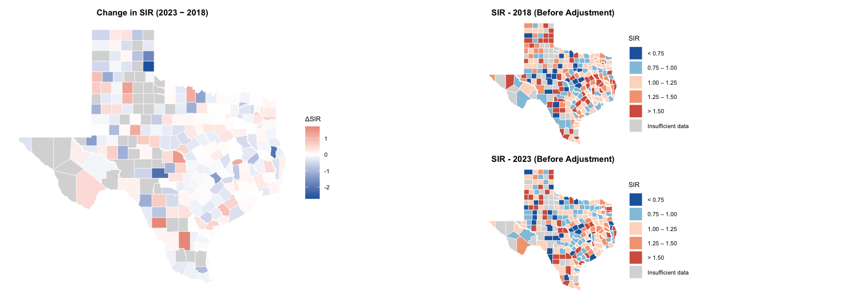
Figure 3: SIR before Modeling

The outcome models were retrained on 80-20 train test split. The model estimated on the 2018 data predicted the likelihood of mortgage denial with an accuracy of 88.23% and a mean squared error (MSE) of 0.0980. The corresponding 2023 model achieved an accuracy of 88.12% with an MSE of 0.0970. These models were then used to compute updated expected denial rates, adjusted for observed credit risk characteristics, averaged statewide. The predicted and observed denial rates for all the years is in the Appendix A2.
Figure 4 presents the 20 counties with the largest absolute change in risk-adjusted SIR between 2018 and 2023, alongside their population profiles relative to the Texas statewide average. Counties that worsened disproportionately include Duval and Dimmit – both with minority population shares exceeding 88%, well above the statewide average – suggesting that some majority-minority counties experienced a widening gap in denial disparities over the period. However, the pattern is not uniform: Zavala County, which has the highest minority share in the panel at 93.6%, improved over the same period, and Clay County – with a minority share of just 10.2% – worsened substantially. Income appears as a more consistent signal: several of the counties that worsened show median incomes below the statewide average (darker blue in the income column), while DTI profiles show less systematic differentiation. These findings suggest that while racial composition plays a role in some counties' worsening denial disparities, income disadvantage may be a more consistent structural factor across the top movers. Similarly, we observe high DTI ratios for the counties whose SIR got worse after adjusting for the risk factors.

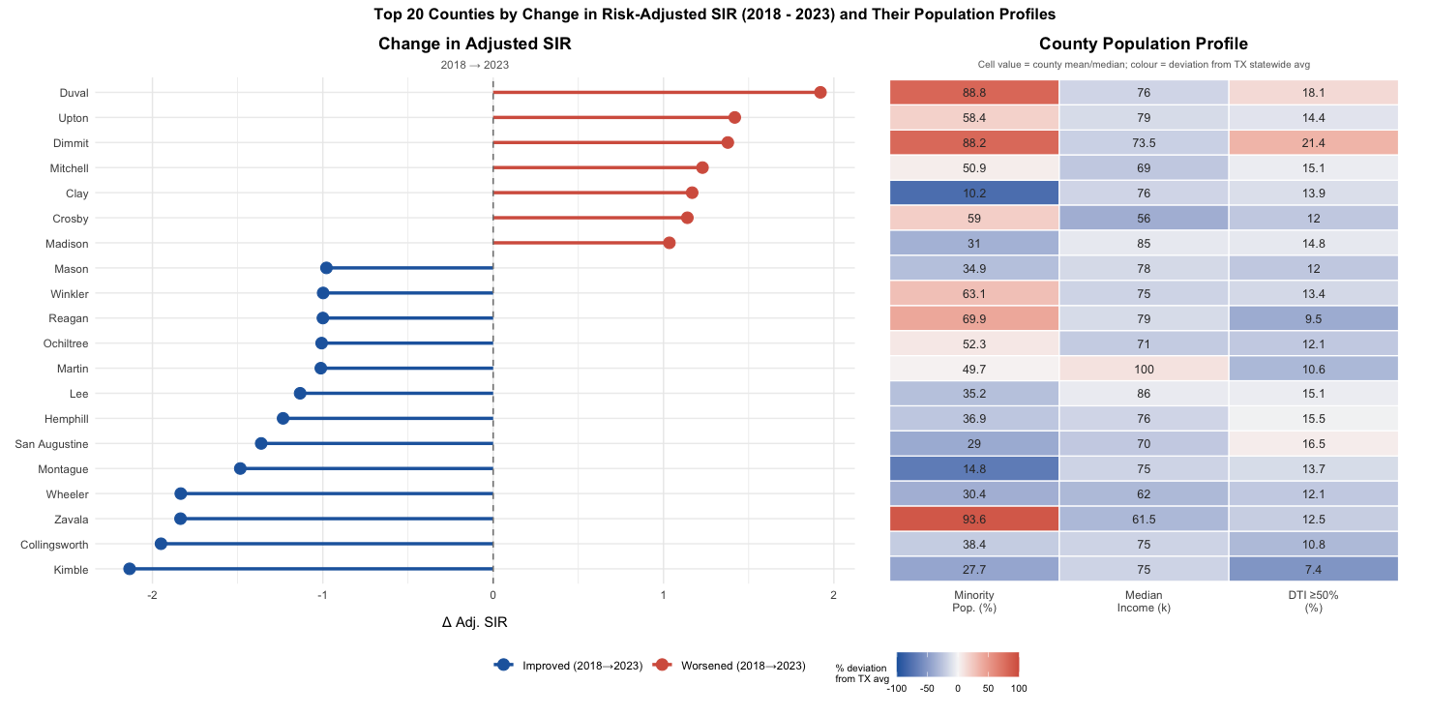
Figure 4: SIR post risk adjustment

The county profiles for characteristics before and after adjusting for credit risk factors are presented in Figure 5. We observe notable trends in the minority population share (Panel C). In 2018, the risk unadjusted SIR shows that counties with higher minority concentrations are generally associated with higher denial risk. However, after adjusting for risk factors, an opposing trend emerges: the median minority population is notably higher in counties with the “Low” SIR category (<0.75) compared to those in the “High” SIR category. By 2023, the relationship transitions to a flat trend where the median minority population percentage is generally uniform across for all SIR categories.
Other county characteristics remain relatively stable across both unadjusted and risk-adjusted models. Median property values (Panel A) trend higher in “High” SIR categories, a trend that is particularly pronounced in the 2023 risk-adjusted results. The median age of housing units (Panel B) shows that counties with higher denial risk often possess slightly older housing stock. Finally, the minority applicant denial rate (Panel D) maintains a consistent positive correlation with SIR categories, with counties in the “High” SIR group exhibiting the highest raw denial rates for minority populations both before and after adjustment.

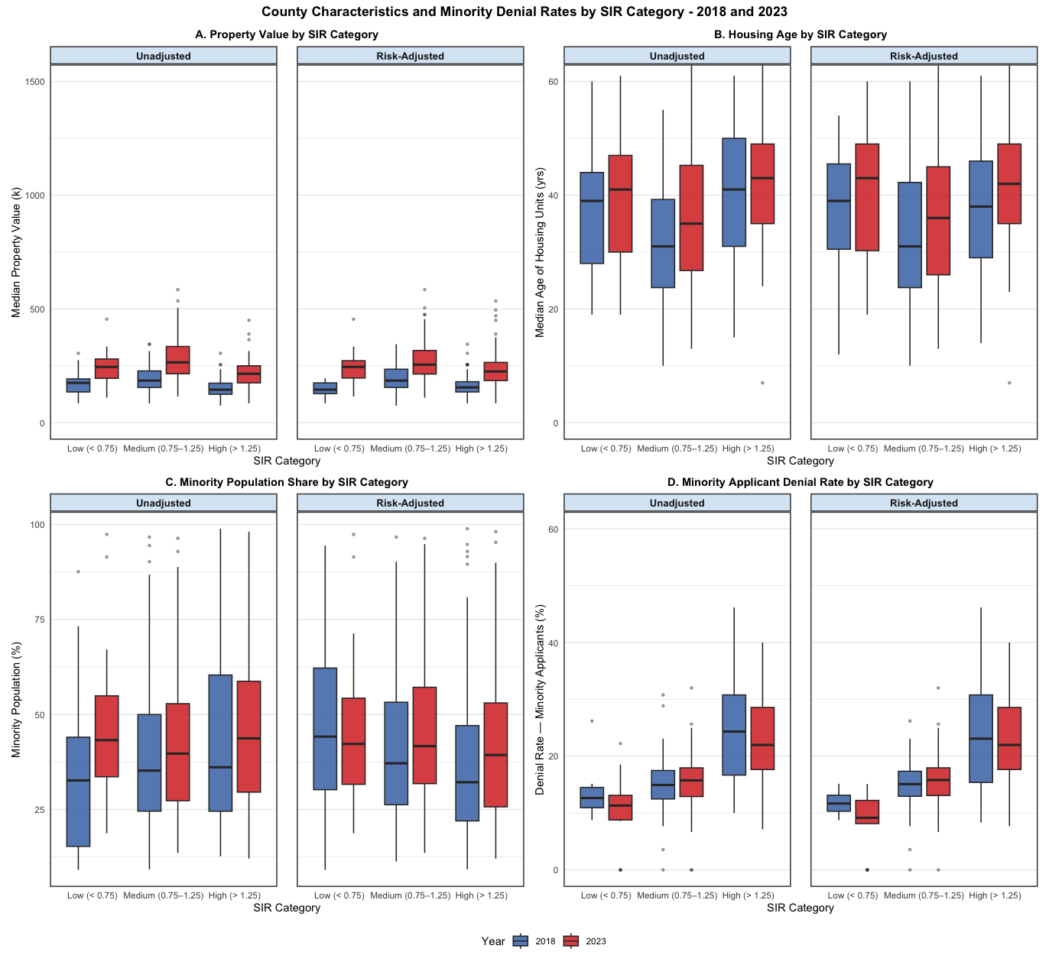
Figure 5: Trends in county profiles before and after adjusting for the risk factors.

- Conclusion
A core finding of this study is the reversal of the relationship between minority population density and mortgage denial risk, especially in the 2018 risk-adjusted model. The emergence of the opposing trend in 2018 suggests that once individual credit factors are controlled for, counties with high minority populations actually performed better (denying fewer loans) than the statewide expected rate. This indicates that the higher raw denial rates in these areas are largely explained by observable risk factors rather than geography location alone.
The transition from the opposing trend in 2018 to a flatter one in 2023 reflects a shift in mortgage approval dynamics. The initial protective effect seen in minority dense areas may be attributed to local economic conditions: specifically lower property values and older housing units (typically found in western Texas counties) can make mortgages more affordable for lower-income buyers, thereby reducing the denial rates relative to wealthier urban centers. Furthermore, the improvement in these areas during the early study period may have been bolstered by targeted lending programs and COVID‑19–related assistance initiatives designed to promote fair lending in historically disadvantaged regions. The stabilization of these trends by 2023 suggests that the geographic advantages once present in these high minority counties have largely dissipated, leading to a more uniform distribution of denial risk across the state’s diverse demographic landscape. Taken collectively, the observed variation in SIR across Texas counties underscores the complex interplay between demographic structure, local economic conditions, and policy environments. Understanding these interconnected dynamics is essential for developing strategies that foster more equitable mortgage lending practices.
Although the initial dataset appeared to indicate evidence of contemporary redlining, defined as disproportionate mortgage denials affecting certain neighborhoods or applicant groups (Pearson et al., 2023), further analysis that controls for relevant risk factors offers a more nuanced interpretation and helps explain part of the observed variability. The strong predictive role of minority population share aligns with Loya’s (2021) conclusion that borrowers in predominantly minority communities remain more likely to experience loan denials or be offered high‑cost alternatives.
This study advances the literature by integrating advanced statistical techniques, including LASSO regression and SIR estimation, to identify and control for significant risk factors associated with mortgage denials. These methods helped clarify the extent to which demographic and economic characteristics contribute to disparities across Texas counties. However, several limitations should be noted. A primary challenge was the lack of access to comprehensive applicant-level data, particularly actual credit scores and complete information on loan origination costs. Additionally, defining minority status remains complex in the Texas context: although 40.2% of Texas residents identify as Hispanic (“Texas Tribune,” 2022), Hispanics continue to be categorized as a minority group under the Financial Institutions Reform, Recovery, and Enforcement Act of 1989 (FIRREA, 1989). We also acknowledge that this study does not establish causality, and further work is needed to determine whether the observed associations reflect underlying causal mechanisms.
Future research should address these data limitations by incorporating more granular, comprehensive datasets. Investigating potential causal relationships among demographic, economic, and policy variables, as well as the influence of additional confounding factors such as local labor market conditions, housing supply constraints, and spatial patterns of development, would further enhance our understanding of disparities in mortgage approvals. Continued refinement of the modeling framework and expansion of available data will allow researchers and policymakers to more effectively identify drivers of inequitable lending outcomes and design informed policies that help narrow racial and ethnic gaps in homeownership.

References
Amuedo-Dorantes, C., & Mundra, K. (2013). Immigrant homeownership and immigration status: Evidence from Spain. Review of International Economics, 21(2), 204–218. https://doi.org/10.1111/roie.12031
Apgar, W. C., & Calder, A. (2005). The dual mortgage market: The persistence of discrimination in mortgage lending. In X. de Souza Briggs (Ed.), The geography of opportunity: Race and housing choice in metropolitan America (pp. 101–126). Brookings Institution Press.
Avery, R. B., Brevoort, K. P., & Canner, G. B. (2008). The 2007 hmda data. Federal Reserve Bulletin, A107–A107.
Avery, R. B., & Buynak, T. M. (1981). Mortgage redlining: Some new evidence. Economic Review, 17 (3), 15–31.
Bartlett, R., Morse, A., Stanton, R., & Wallace, N. E. (2021). Consumer-lending discrim-ination in the fintech era. Journal of Financial Economics, 143 (1), 1–26. https:
//doi.org/10.1016/j.jfineco.2021.04.030
Bayer, P., Ferreira, F., & Ross, S. L. (2018). What drives racial and ethnic differences in high-cost mortgages? the role of high-risk lenders. Review of Financial Studies, 31 (6), 2192–2235. https://doi.org/10.1093/rfs/hhx121
Buchanan, D. (2003). Social Epidemiology: Berkman, LF, Kawachi, I (Eds). Oxford University Press, New York, 2000, pp. 391.
Besbris, M., Faber, J. W., & Sharkey, P. (2019). Disentangling the effects of race and place in economic transactions: Findings from an online field experiment. City & Community, 18(2), 529-555.
Bhutta et al. (2022). How much does racial bias affect mortgage lending? evidence from human and algorithmic credit decisions [Accessed: 2024-01-15]. https : / / www . federalreserve.gov/econres/feds/how- much- does- racial- bias- affect- mortgage-lending.htm
Bocian, D. G., Ernst, K. S., & Li, W. (2008). Race, ethnicity and subprime home loan pricing. Journal of Economics and Business, 60(1–2), 110–124.
Breslow, N. E., & Day, N. E. (1987). Statistical methods in cancer research, Vol. 2: The design and analysis of cohort studies. International Agency for Research on Cancer.
CDC. (2024). Standardized incidence ratio fact sheet [Accessed: 2024-07-26]. https:// www.cdc.gov/cancer-environment/media/pdfs/Standardized-Incidence-Ratio-Fact-Sheet-508.pdf
CFPB. (2022). Home mortgage disclosure act (hmda) data for 2022 [Accessed: 2023-01-28]. https://ffiec.cfpb.gov/data-browser/data/2022?category=nationwide.
CFPB. (2023, September). Mortgage market activity and trends (Accessed: 2023-12-21).
Courchane, M. J., Surette, B. J., & Zorn, P. M. (2004). Subprime borrowers: Mortgage transitions and outcomes. Journal of Real Estate Finance and Economics, 29(4), 365–392.
Diamond, W. F., Landvoigt, T., & S´anchez, G. S. (2024, June). Printing away the mort-gages: Fiscal inflation and the post-covid boom (Working Paper No. 32573). Na-tional Bureau of Economic Research. https://doi.org/10.3386/w32573
Dillbary, J. S., & Edwards, G. (2019). An empirical analysis of sexual orientation discrimination. The University of Chicago Law Review, 86 (1), 1–76.
Divringi, E., & Calem, P. (2022). The pandemic mortgage boom: A breakdown by race and income [Accessed January 26, 2025]. Economic Insights, 3-4. https://www. philadelphiafed.org/-/media/frbp/assets/economy/articles/economic-insights/ 2022/q3-q4/eiq3q422-the-pandemic-mortgage-boom.pdf
Fang, P., Dong, S., Xiao, J., Liu, C., Feng, X., & Wang, Y. (2010). Regional inequality in health and its determinants: evidence from China. Health policy, 94(1), 14-25.
Federal Reserve Bank of San Francisco. (2022). Credit conditions in the pandemic mortgage market. https://www.frbsf.org/research-and-insights/publications/economic-letter/2022/06/credit-conditions-in-pandemic-mortgage-market/
FIRREA. (1989). Financial institutions reform, recovery, and enforcement act of 1989 [Section 1204(c)]. U.S.C. 1811 note.
Fishbein, A., & Bunce, H. (2000). Subprime market growth and predatory lending. In S. M. Wachter & R. L. Penne (Eds.), Housing policy in the new millennium. U.S. Department of Housing and Urban Development.
Friedman, J., Hastie, T., & Tibshirani, R. (2021). An introduction to glmnet [Accessed: 2025-01-23]. https://glmnet.stanford.edu/articles/glmnet.html
Fuster, A., Hizmo, A., Lambie-Hanson, L., Vickery, J., & Willen, P. S. (2021, May). How resilient is mortgage credit supply? evidence from the covid-19 pandemic (Working Paper No. 28843). National Bureau of Economic Research. https://doi.org/10. 3386/w28843
Hastie et al. (2024). Glmnet [Accessed: 2024-06-14]. https://glmnet.stanford.edu/articles/ glmnet.html.
Jackson, K. T. (1987). Crabgrass frontier: The suburbanization of the United States. Oxford University Press.
Kramer, M. R., & Hogue, C. R. (2009). Is segregation bad for your health? Epidemiologic Reviews, 31(1), 178–194. https://doi.org/10.1093/epirev/mxp001
Krieger, B. N. (2012). Epidemiology and the People’s Health. American Journal of Epidemiology, 175(8), 854-856. https://doi.org/10.1093/aje/kws005
Krieger, N., Chen, J. T., Waterman, P. D., Soobader, M. J., Subramanian, S. V., & Carson, R. (2003). Choosing area based socioeconomic measures to monitor social inequalities in low birth weight and childhood lead poisoning: The Public Health Disparities Geocoding Project (US). Journal of Epidemiology & Community Health, 57(3), 186-199.
Leal, D. L., & Hess, F. M. (Eds.). (2010). Education and the Hispanic challenge. Columbia University Press.
Lichter, D. T., Parisi, D., & Taquino, M. C. (2015). Toward a new macro‐segregation? Decomposing segregation within and between metropolitan cities and suburbs. American Sociological Review, 80(4), 843–873.
Loya, J. (2021). Racial stratification among latinos in the mortgage market. Race and Social Problems, 14, 1–14. https://doi.org/10.1007/s12552-021-09326-3
Marmot, M. (2005). Social determinants of health inequalities. The Lancet, 365(9464), 1099–1104.
Marmot, M., & Wilkinson, R. (Eds.). (2006). Social determinants of health (2nd ed.). Oxford University Press.
Massey, D. S., & Denton, N. A. (1993). American apartheid: Segregation and the making of the underclass. Harvard University Press.
Munnell, A. H., Tootell, G. M. B., Browne, L. E., & McEneaney, J. (1996). Mortgage lending in Boston: Interpreting HMDA data. American Economic Review, 86(1), 25–53.
Pearson, A. L., Zhou, Y., Buxton, R. T., Horton, T. H., Pfeiffer, K. A., & Beyer, K. M. M. (2023). The effects of contemporary redlining on the mental health of black res-idents [PMID: 37456619; PMCID: PMC10339054]. SSM - Population Health, 23, 101462. https://doi.org/10.1016/j.ssmph.2023.101462
Pebesma, E. (2018). Simple features for r: Standardized support for spatial vector data.
The R Journal, 10 (1), 439–446.
Perry, A. M., Rothstein, R., & Harshbarger, C. (2018). Devaluation of assets in Black neighborhoods: The case of residential property. Brookings Institution.
Popick, S. (2022). Did minority applicants experience worse lending outcomes in the mortgage market? a study using 2020 expanded hmda data. FDIC Center for Financial Research Paper, (2022-05).
R Core Team. (2020). R: A language and environment for statistical computing. R Foun-dation for Statistical Computing. Vienna, Austria. https://www.R-project.org/
Rohe, W. M., & Stegman, M. A. (1994). The impact of home ownership on the social and political involvement of low-income people. Urban Affairs Quarterly, 30(1), 152–172.
Ross, S. L., & Yinger, J. (2002). The color of credit: Mortgage discrimination, research methodology, and fair-lending enforcement. MIT Press.
Rothstein, R. (2017). The color of law: A forgotten history of how our government segregated America. Liveright Publishing.
Rugh, J. S., & Massey, D. S. (2010). Racial segregation and the American foreclosure crisis. American Sociological Review, 75(5), 629–651.
Smedley, B. D., Stith, A. Y., & Nelson, A. R. (Eds.). (2003). Unequal treatment: Confronting racial and ethnic disparities in healthcare. National Academies Press.
Spors, E., & Michael, S. (2021). Standardized incidence ratio of the covid-19 pandemic: A case study in a midwestern state. medRxiv, 2021–09.
Squires, G. D. (2003). Predatory lending: Redlining in reverse. Shelterforce Online, 129, 12–15.
Texas tribune [Retrieved from https : / / www . texastribune . org / 2022 / 09 / 15 / texas - demographics-census-2021/]. (2022). The Texas Tribune.
Urban Institute. (2020). Why do households of color own only a quarter of the nation’s housing wealth when they compose a third of the nation’s households? [Accessed: 15 Sept. 2024]. https://urban.org/sites/default/files/publication/105020/why-do-households-of-color-own-only-a-quarter-of-the-nations-housing-wealth-when-they-compose-a-third-of-the-nations-households.pdf?force isolation=true
Vasquez, M. M., Hu, C., Roe, D. J., Chen, Z., Halonen, M., & Guerra, S. (2016). Least absolute shrinkage and selection operator type methods for the identification of serum biomarkers of overweight and obesity: Simulation and application. BMC Medical Research Methodology, 16 (1), 154. https://doi.org/10.1186/s12874-016-
0254-8

Williams, D. R., & Collins, C. (2001). Racial residential segregation: A fundamental cause of racial disparities in health. Public Health Reports, 116(5), 404–416.
World Health Organization Commission on Social Determinants of Health (WHO CSDH). (2008). Closing the gap in a generation: Health equity through action on the social determinants of health. World Health Organization.
Yinger, J. (1996). Discrimination in mortgage lending: A literature review. In J. Goering & R. Wienk (Eds.), Mortgage lending, racial discrimination, and federal policy (pp. 29–73). Urban Institute Press
Appendix A1: Variable Names and Descriptions
Variable | Symbol | Description
Activity Year | activity year | Year the activity took place
Derived Race | race | Derived race of the applicant
Derived Sex | sex | Derived sex of the applicant
Age | age | Age of the applicant
Income | income | Income of the applicant
Property Value | p value | Property value of the unit
Loan-To-Value | ltv | Loan-to-value ratio of the applicant
Debt-To-Income | dti | Debt-to-income ratio of the applicant
Median Minority % | minority pp | % of minority population per county
Age of Units | age nits | Median age of units per county
Loan Type | loan type | Type of loan (e.g., conventional, FHA)
Tract Minority Population Percent | tract minority pp | % of minority population in the tract
FFIEC Median Family Income | ffiec income | FFIEC Median Family Income of the MSA/MD
Tract-to-MSA Income % | tract msa income pc | Ratio of tract median income to
Owner-Occupied Units | owner occ units | Number of owner-occupied units in the MSA/MD median income tract
One-to-Four Family Homes | one to four homes | Number of one-to-four family homes in the tract
Action Taken | action taken | Action taken on the application: approved or denied
Income Bins | income bins | Applicant income grouped in bins
Property Value Bins | p value bins | Property value grouped in bins
Loan Amount | loan amt | Loan amount in thousands of dollars

Appendix A2: Observed and Predicted Denial Rates
Year | Number of Applications | Observed Denial Rate | Predicted Denial Rate
2018 | 293,976 | 11.75% | 11.77%
2019 | 321,588 | 11.03% | 11.04%
2020 | 374,749 | 11.72% | 11.62%
2021 | 375,463 | 10.96% | 11.15%
2022 | 334,508 | 12.63% | 12.56%
2023 | 297,903 | 12.04% | 12.05%

Appendix A3: Denial Rate by Race and Income

