Project Overview
Client: Svetlana Latiseva Mortgages (SL Mortgages)
Tone: Professional but friendly.
Deployment: Should be hostable on any platform (React + Vite preferred, not Next.js).
Core Objectives
- Present Svetlana’s mortgage and protection services in a clear, trustworthy way.
- Allow users to:
  - Request conveyancer/survey quotations.
  - Book an appointment via calendar.
  - Submit career or referral enquiries.
  - Read and leave testimonials (via Google Reviews).
  - Contact the advisor directly (email, phone).
- Ensure compliance with FCA and Openwork disclaimers on all pages.
- Build with scalability in mind for future additions (e.g., blog, CRM integration).

Website pages
1/ Home page and services
2/ About me ?
3/ Conveyancer quotation
4/ Book an appointment ( integrate calendar?)
5/ Career opportunities
6/ Refer friend
7/ Testimonial – feedback ( integrate google review?)
8/ Partners – (separate page or just put logo as bottom line?)

- Home page and services
Purpose: Introduction and overview of all services.
Content: Marketing copy + lists of mortgage and protection products.
Dynamic content: None.
Elements:
- Hero section with call to action (e.g., Get in Touch).
- Sections for Mortgages and Protection Products.
- “Contact Me” button linking to booking form or contact page.
Content includes:
Expert Mortgage & Protection Advice in the UK.
Looking for clear, hassle-free mortgage advice? I'm here to help! As a dedicated Mortgage & Protection Advisor, I’m passionate about making the process simple and stress-free for you.
From our very first meeting to the final completion, I’ll guide you every step of the way—explaining everything in plain, easy-to-understand language.
Whether you're a first-time buyer, remortgaging, or looking for protection solutions, I’ll find the most competitive products tailored to your circumstances.
Get in touch today for fast, friendly, and no-obligation advice—let’s secure the right deal for you!
MORTGAGES:
* Mortgages (First time buyers, Home movers, 2nd residential)
* Government schemes including Shared Ownership (purchase and staircasing) and Right to Buy/Acquire
* Remortgages
* Buy to Lets under Personal name or under Limited company (including residential BTL, HMO BTL, Holidays Apartments BTL)
* Debt Consolidation
* Commercial and unregulated mortgages (referrals)
PROTECTION PRODUCTS:
* Life Cover (Life cover for dependents or Mortgage protection Cover)
* Critical Illness Cover (including Upgraded options and less advanced cancer)
* Income Protection (limited period benefit of 1, 2 or 5 years or full-term benefit until the retirement)
* Accident and Sickness Multicover from only £10
* Global treatment (access to overseas medical treatments and a second medical opinion) only £3
* Home Insurance (Building, Content, Landlord`s insurance)
* Private Medical Insurance (referrals)
* Commercial insurance (referrals)
2. About me
Purpose: Personal story of the advisor.
Content: English
Dynamic content: None (static text).
My Path to Becoming a Mortgage & Protection Advisor
My journey into the world of mortgages and protection began with a deep passion for helping people achieve financial security and homeownership. Over the years, I have gained extensive knowledge and hands-on experience, allowing me to provide tailored advice that truly makes a difference.
From the very first consultation to the moment your mortgage completes, I am committed to making the process as clear, simple, and stress-free as possible. I believe in breaking down complex financial matters into easy-to-understand language, ensuring you feel confident every step of the way.
Today, as a Mortgage & Protection Advisor based in London, I specialize in finding competitive mortgage solutions and protection plans suited to individual needs. Whether you're a first-time buyer, remortgaging, or exploring protection options, my goal is to secure the best deal for you.
That’s when everything aligned, and I decided to study to become a mortgage broker. Now, I absolutely love what I do—helping people navigate the mortgage process, find the best deals, and ensure they have the right protection in place to safeguard their homes, finances, and future.
If you’re looking for expert guidance with a friendly, no-obligation approach—let’s connect!

- Conveyancer & Survey quotation
Are you looking for the right conveyancer to assist with your property purchase, sale, or remortgage?
Interested in a quote? Simply fill out the form below, and I'll provide a quotation within 24 hours.
I can help you find the best deal by instantly comparing quotes from hundreds of conveyancers, ensuring you get the most competitive offer based on your preferred service and property type.

Are you looking to get a survey before purchasing a property? I can help with that too!

Please provide following details:

- Deal type: Purchase; Sale and Purchase; Sale; Remortgage; Survey
- Title ( Mr, Mrs and etc), First name, Last name
- Location: Where property located: England, Scotland, Wales, Northern Ireland
- Property Purchase/Sale price
- Tenure: Freehold or Leasehold
- Property address
- Are you 1st time buyer (do not have and never had a property anywhere in the world)

Checkbox group for : Considerations ( please tick if anything from the consideration below is applicable) for purchase

Auction
Buy to Let
Freehold with Management Company
Gifted Deposit
Help to Buy - Equity Loan
High Rise Building ( over 11 meters/or more then 4 floors)
House of Multiple Occupancy
HTB ISA/Lifetime ISA
Joint Borrower, Sole Proprietor
Limited Company BTL
Multi-unit Block
New Build ( no one lived before)
Repossession
Right to Buy
Second Property
Separate Representation
Shared Ownership
Unregistered Land

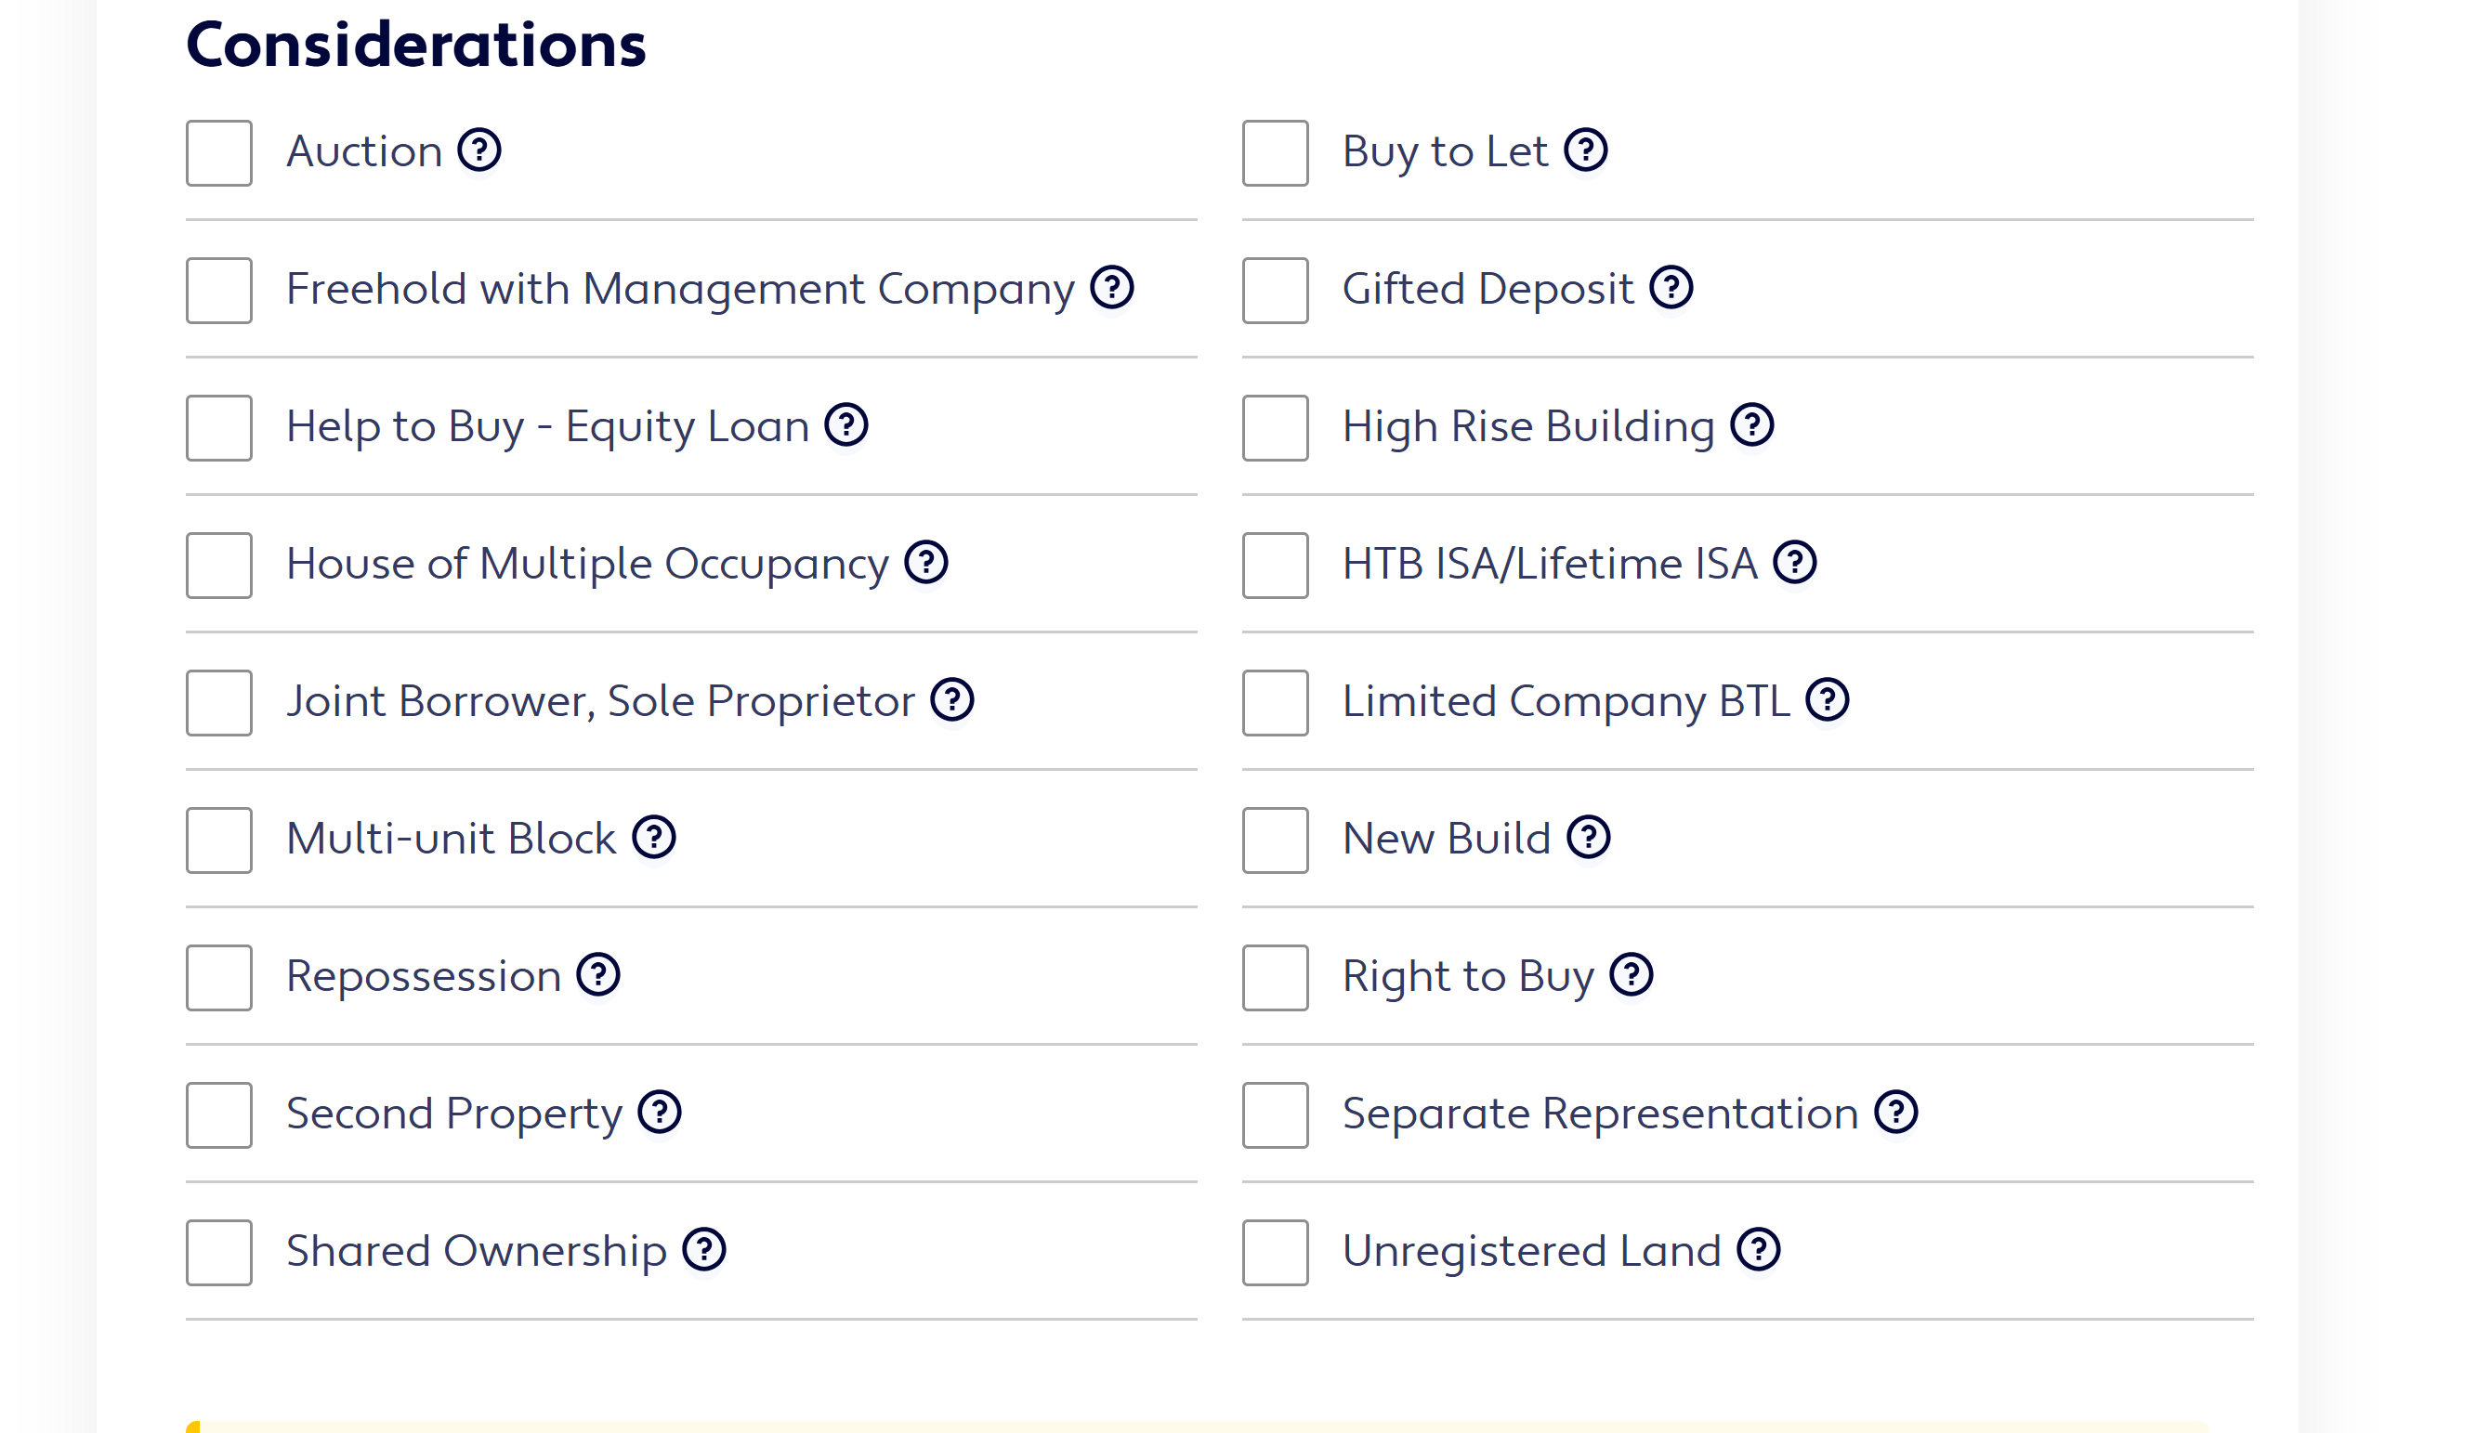

Checkbox group for : Considerations ( please tick if anything from the consideration below is applicable) for sale or remortgage

Buy to Let
Help to Buy - Equity Loan
High Rise Building (over 11 meters/or more then 4 floors)
House of Multiple Occupancy
Joint Borrower, Sole Proprietor
Limited Company BTL
Multi-unit Block
Shared Ownership
Staircasing
Transfer of Equity
Unregistered Land

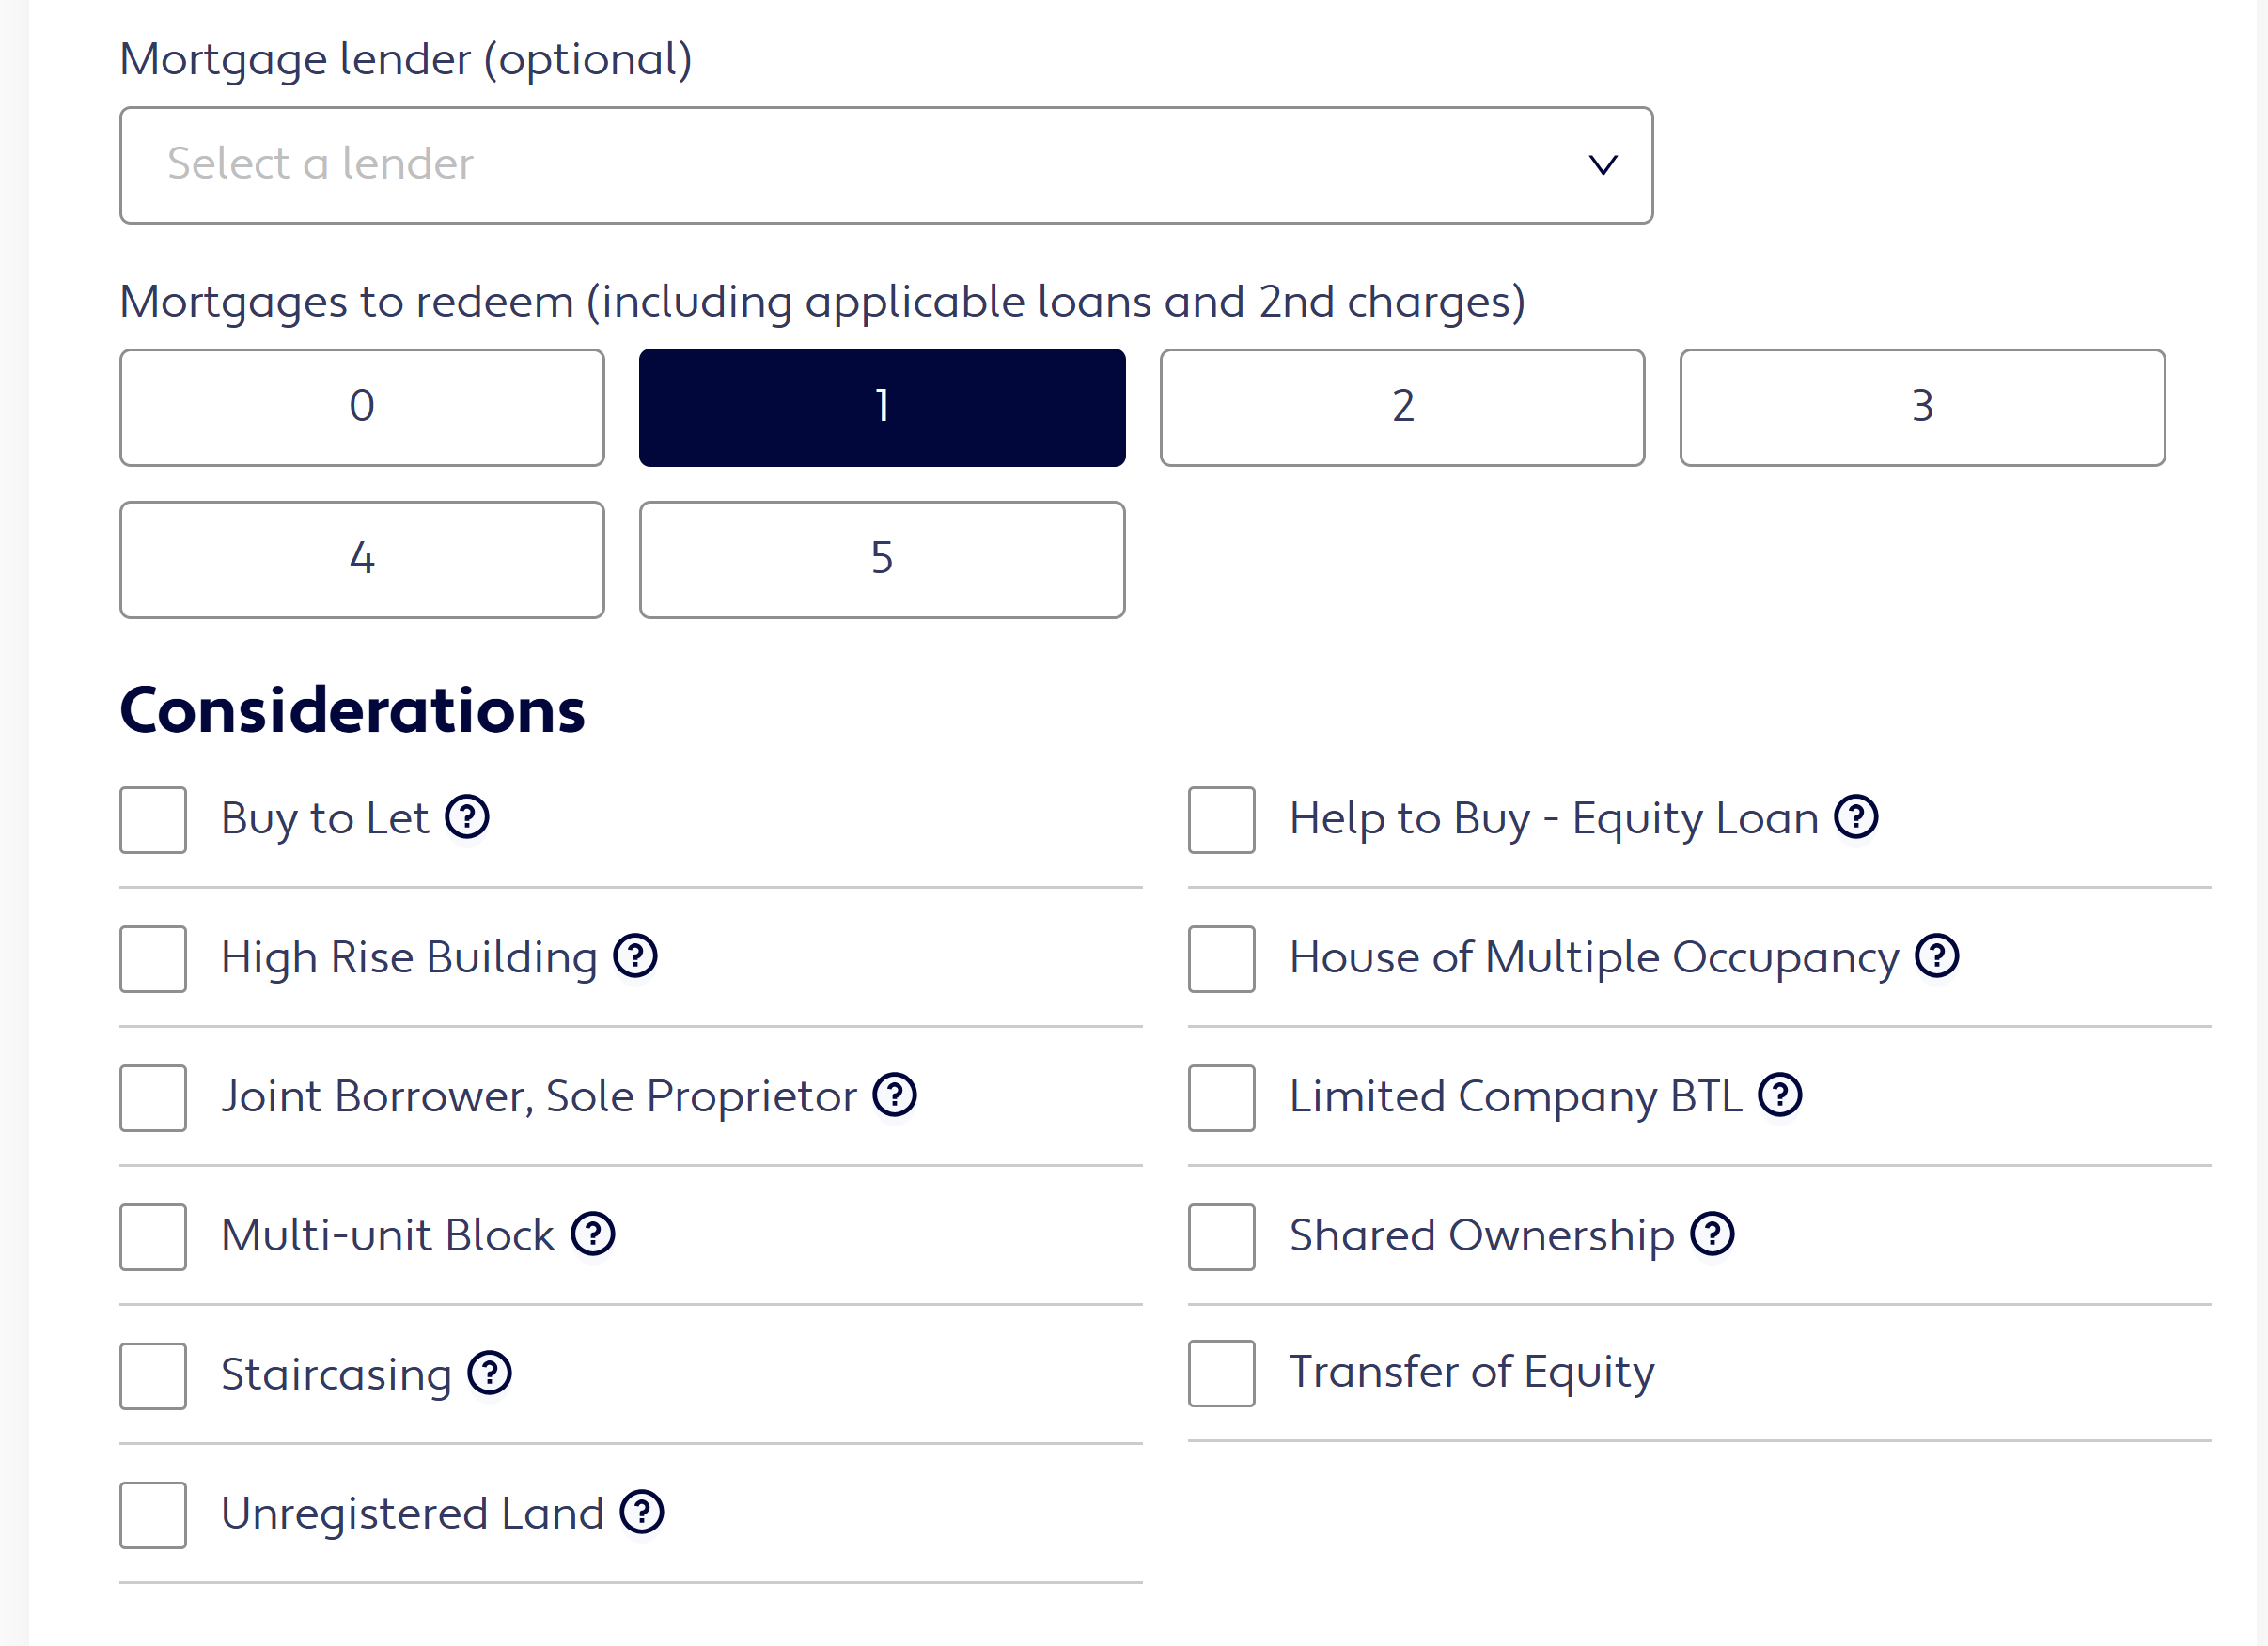

- Book an appointment (integrate calendar?)
Purpose: Allow users to schedule a meeting.
Dynamic content: ✅ Calendar integration (Google Calendar or Calendly embed).
Elements: Embedded calendar iframe + contact form fallback.
- Career opportunities
Purpose: Recruit new advisors.
Dynamic content: Optional (contact form).
Elements:
Static text about benefits.
Button to call or send email (mailto:s.latiseva@slmortgages.co.uk).
Optional: form to upload CV.
Content includes:
Join us as a:
- Protection Adviser
- Mortgage Broker
- Financial Adviser

Benefits For You When Joining Our Team:
- Excellent earnings potential via competitive commission splits
*earn in the region of £50 - 60K + pa once established, however this is uncapped!
- Commission paid weekly
- Working remotely
- Working hours are flexible to suit you.
- Amazing career opportunities
*starting as a Protection Advisor. You can expand your knowledge by studying mortgages, actively recruit to become a manager, and even build your own team. And if that's not enough, you can work towards becoming a qualified Financial Advisor.
- As much support as you need (compliance, sales, process, etc)

- By joining us, you will be part of a busy and reputable team driving our business and reputation forward.
- By joining us, you will be part of one of UK’s largest and longest-established financial advice and investment companies

Whether you're new to the industry or an experienced professional, we welcome you to apply.

To find out more call
Svetlana Latiseva 07778 906 161
Or send your CV to s.latiseva@slmortgages.co.uk

6. Refer a Friend

Purpose: Referral program.
Dynamic content: ✅ Simple form.
Form fields: Referrer name/email + Friend name/email.
Form handling: Same method as quotation form.
Success message: “Thank you for your referral! You’ll receive your £50 voucher after completion.”

Content:

Refer a Friend and Receive £50
We greatly appreciate your support of Svetlana Latiseva Mortgages! As a valued customer, we invite you to share your positive experience with your friends and family. And as a token of our gratitude, when they secure a mortgage with our assistance, you will receive a £50 voucher of your choice.

Thank you for being a loyal supporter of Svetlana Latiseva Mortgages!

Referral Program Terms & Conditions:
This offer does not apply to Product Transfers
The referral fee will be paid within 30 days of mortgage completion
​A minimum mortgage value of £300,000 applies
Only one referral fee will be paid per client
We will reward up to a maximum of 5 successful referrals per year
We value your trust and appreciate your referrals. Rest assured that we will handle each referral with utmost professionalism and ensure a smooth mortgage process.

Пример, как оформленно: https://www.beechwoodmortgages.com/about-us/refer-a-friend

- Testimonial – feedback ( integrate google review?)
Purpose: Display and link to Google Reviews.
Dynamic content: ✅ Google Reviews embed.
Implementation:
- Embed Google review widget using provided placeid.
- Option to add static testimonials manually if API not available.

https://search.google.com/local/writereview?placeid=ChIJvdBfFy5HxkkR1fX4HTL3tyg&source=g.page.m.kd._&laa=lu-desktop-review-solicitation

- Partners

Purpose: Showcase professional affiliations.
Dynamic content: Optional (logos carousel or static grid).
Elements: Partner logos in footer or on separate page.

9. Footer (Global)
Content:
- FCA and Openwork disclaimers.
- Links to external legal pages:
  - Terms of Use
  - Privacy & Cookies
  - Trading Terms
- Cookie consent banner.
Dynamic content: Optional (cookie banner only).

Global footer content:

Terms of Use | Privacy & Cookie Policy | Trading Terms

Terms of Use - https://business.yell.com/legal/terms-of-use/
Privacy - https://business.yell.com/websites-privacy-cookie-policy/
Trading - https://business.yell.com/legal/trading-terms/

The content on this website is owned by us and our licensors. Do not copy any content (including images) without our consent.
We use cookies to ensure that we give you the best experience on our website. To learn more, go to the Privacy Page.

On every page bottom

THINK CAREFULLY BEFORE SECURING OTHER DEBTS AGAINST YOUR PROPERTY. YOUR PROPERTY MAY BE REPOSSESSED IF YOU DO NOT KEEP UP REPAYMENTS ON YOUR MORTGAGE.
SOME BUY TO LET & LET TO BUY MORTGAGES ARE NOT REGULATED BY THE FINANCIAL CONDUCT AUTHORITY.
COMMERCIAL FINANCE IS NOT PART OF THE OPENWORK PARTNERSHIP AND IS OFFERED ON OUR OWN RIGHT. OPENWORK LIMITED ACCEPT NO RESPONSIBILITY FOR THIS ASPECTS ON OUR BUSINESS. THESE PRODUCTS AND SERVICES ARE NOT REGULATED BY FINANCIAL CONDUCT AUTHORITY.
Supreme Financial Solutions Limited is an appointed representative of The Openwork Partnership, a trading style of Openwork Limited which is authorised and regulated by the Financial Conduct Authority.

Design Guidelines:
Color palette: Based on client leaflet
Typography: Clean, readable sans-serif (e.g., Inter, Lato).
Imagery: Stock photography related to homeownership, families, mortgages.
Layout: Modern, minimalist, responsive (mobile-first), compliance with accessibility rulers

Legal & Compliance Notes
Every page must include FCA disclaimers and cookies notice.
Do not copy third-party content or images without consent.

