Troubleshooting and Tool Report

Victoria Lee

Network Problem Selected
On Day 2 of full operational capability (FOC), our connection to the internet was becoming intermittent. We could establish connections to our globally hosted servers some of the time. The connection would drop at seemingly random periods, and we do not understand the reasons and why it is doing this. We have experienced this day and night, and it has been consistent for the past three days. This is a problem because when utilizing the FOC internet connection is crucial to access globally hosted servers. The constant drops or outages prevent the internet connection impact data exchange, monitoring, and affecting communication to global hosted servers. These lead to unauthorized access or the application of security measures to maintain a secure and stable network. We need a way to utilize the network troubleshooting tools and methodology to solve possible network congestion, misconfigured routers, ISP issues, or possible VLAN hopping attacks.

Troubleshooting Steps
All of the steps of the Troubleshooting Methodology are below:
- Define the Problem: Intermittent random internet connectivity dropping when accessing globally hosted servers which impacts data exchange and communications for FOC.
- Hypothesize the Probable Cause: The possible causes are network congestion regarding traffic high or bottleneck, misconfigured routers regarding connectivity issues, and ISP (internet service provider). If it continues to persist, then it may be issues related to VLAN hopping.
- Test Hypothesis (If hypothesis is not valid, go back to step 2): To check for network congestion, we must test it during peak hours, verify router settings, and contact ISP. The tools such as ping, ipconfig, and tracert will help identify the bottleneck traffics. Ping will help detect the two connections between the network devices as well as if it will receive the ping back through a response timing message. Ipconfig will help identify the issues correlating to the IP address of the router hop and the round-trip delay of that router hop within the globally connected servers. This allows us to trace the route between the system and services to see if there is a bottleneck traffic somewhere. Tracert will help identify the issues. Checking the router configuration settings and ISP will also help if there is not just a package mishandling, but also user fault regarding setting. If the issues persists, then the user must check the VLAN issues through viewing the port mappings and understanding VLANS within a network segmentation.
- Create an Action Plan: From the hypothesis, if there is congestion, we must optimize network traffic considering the settings and utilize the tools to assist the changes. If the routers are misconfigured due to user-fault, correct the settings and reboot routers. If it is relating to ISP issues, contact the provider to ask for diagnosis and monitor the other suspicious activity. ISP are usually the last case solution if all else fails. And if there are suspicious activities, the user must investigate the VLAN hopping through viewing the port mappings and monitor activity. The user can reassign those port mappings if necessary.
- Implement Action Plan: Based on the action plan previously, do the steps required by utilizing the commands to adjust network settings, if it is user-fault, reconfigure then reboot the routers, and as a last resort consult with an ISP support if the case is still not resolved. Then, if there are suspicious activities, perform a VLAN monitoring and port mappings by assigning it.
- Verify Problem Resolution: After implementing the action plan, monitor the network over a period of time, check if it persists including the last resort option, and then confirm stable connectivity to globally hosted servers. As for the VLAN hopping attack, continue to monitor it as well as it plays a role in segregating traffic which may also be a possible causation factor.
- Create a Postmortem Report: Once the resolution is done, document the steps taken, lessons, and results to share with the company or group to prevent this issue from recurring in the future.
From all seven troubleshooting steps, there is a systematic approach to solve the issue. I have determined the problem, inferred theories, developed a plan of action, and verified a resolution. Utilizing the tool commands in Windows PowerShell is the solution to help troubleshoot the issue in this scenario. Windows PowerShell has commands such as ping, ipconfig, and tracert that will be utilized in order to fix the random internet connectivity issues impacting global servers and FOC. Another tool to utilize when solving these issues if there is a VLAN Hopping attack is to utilize PuTTYSSH (IOU1 terminal) which is a popular SSH and Telnet Client providing a secure way to access remote systems. In addition, Graphical Network Simulator-3 (GNS3) software must be installed to utilize PuTTYSSH. These two applications will help monitor VLAN hopping activity, view and reassign port mappings for suspicious activities related to traffic issues.

Tool and Description
To solve this issue, utilizing the terminal emulator (Windows PowerShell) to access command line interface when maintaining or trouble shooting network is beneficial. There are three tool command lines that are beneficial to solve this case which are ping, ipconfig, and tracert. From lesson 17, this case may also possibly be an VLAN hopping attack in which the attacker uses Q-in-Q tunneling to send packets into a VLAN from an unauthorized VLAN. Some of those random droppings could be the attacker gaining unauthorized access to different VLANS within the same network, exploiting the vulnerabilities of your settings. It is quite dangerous to let this happen for global servers as it allows cybercriminals to carry out malicious actions without detection exploiting both the global servers and the VLAN. You can check through the tool commands, but if there are suspicious activities then ensure proper VLAN segmentation, switch configurations, and prevent unauthorized access.
Firstly, the ping command can check IP connectivity between two network devices through ICMP (Internet Control Message Protocol) which is a Layer 4 protocol. By utilizing the ping command, it sends an ICMP echo message to the specified destination host and if reachable, the host responds with an ICMP echo reply message back. But if it is unreachable, it will indicate that the host is unreachable, timed out or a TTL value has expired. This command allows testing connectivity to the globally hosted servers and verifies if the servers are reachable with the response time. It is significant to utilize this tool to help diagnose the network issues, latency, or packet lass. It utilizes the command in this format:
ping [-t] [-n count] [-l size] [-f] [-I TTL] [-S srcaddr] target_name
Secondly, the ipconfig command can display IP address configuration parameters and it can also be used to release and renew a DHCP (Dynamic host configuration protocol) lease. When utilizing the ipconfig, you can check the IP address configuration of local hosts. By doing this way, it ensures that the DHCP is functioning correctly, that the hosts receive valid IP address, and it diagnoses IP related issues within internal network. It utilizes the command in this format:
ipconfig [/all | /renew | /release | /renew6 | /release6]
Thirdly, the tracert (traceroute) command can determine which router hop along the path from a source device to a destination device is having issues, which is beneficial in determining which network segment might be causing excessive delay due to congestion. It can show the IP address of the router hop and the round-trip delay of that router hop. This is important to help trace the route between your system and the servers. It finds where packets are being dropped or the area where there are issues. It also pinpoints network bottlenecks along the path. It utilizes the command in this format:
tracert [website link]
Fourthly, the PuTTY console can determine if there is a possible VLAN hopping attack through monitoring the port mappings and understanding how VLAN plays a role in segregating traffic . It is significant to understand this possible attack because VLAN is a logical grouping of network devices to separate broadcast domains in Layer 2 network. VLANs purpose is to segment a network into multiple broadcast domains to segregate traffic for security and performance reasons. By learning to reassign those port mappings and also learn to monitor the traffic hopping with tracert, it will prevent future cyber VLAN hopping attacks. It utilizes the inputs from Host Name (or IP address), Port number, Telnet connection which then pops up a IOU1 terminal window to input commands. It utilizes all the possible commands in this format:
[configure terminal] [vlan (value here)] [name (name here)] [end] [show vlan]
Consequently, utilizing these three commands from the terminal and the application regarding VLAN hopping detection allows the users to find where there are issues relating to globally connected servers, saves time while ensuring the issue is resolved with the best-case solutions.

Tool Operational Use Case
Utilzing the tool commands in Windows PowerShell and the PuTTY SSH Client to diagnose and analyze the problems identified above is the solution to keep the global connectivity of the servers intact. Once implemented and properly configured, we expect the tool commands in the Windows PowerShell such as ping, ipconfig, and tracert to monitor the traffic flows, connectivity of network devices, routers, and ISP for continuing unsolved troubleshooting. The tool commands for the PuTTY SSH Client will also monitor the suspicious traffic activities within VLAN hopping by viewing the port mappings. In modern day society, it is essential and significant to learn to solve these simplistic issues to prevent future incidents impacting connectivity for global servers and FOC. Understanding how to utilize the tools for similar scenarios such as VLAN attacks, internet dropping, or packages not sent to other global servers is beneficial to ensure a stable internet connectivity. Troubleshooting systems, computers, and network devices allow users to investigate regarding internet dropping or user-fault when applying those settings. Solving this case with the tool commands in Windows PowerShell and PuTTY SSH Client will also save time and resources for an event where no connectivity happens. Therefore, the tool commands of ping, ipconfig, tracert, and PuTTY console will enable proper troubleshooting methods to respond to critical global connectivity sever dropping randomly, while ensuring the settings and devices are not badly affected when solving the issues.

Tool Functionality
Lesson 23, lab sessions provides you with a straightforward and practical understanding of the ping, ipconfig, and tracert commands in Windows PowerShell. And Lesson 11, lab sessions, provides you with the understanding of VLAN. In the next page will showcase all the possible commands that will assist in solving this problem.
The command functionality includes multiple options for ping, ipconfig, and tracert:
- ping [-t] [-n count] [-l size] [-f] [-I TTL] [-S srcaddr] target_name
- ping [-t] (this command repeatedly sends pings, ICMP echo messages, until you stop it by pressing Ctrl+C.)
- ping [-n count] (this command specifies the number of pings to send)
- ping [-l size] (this command sends buffer size in bytes. The default is 32.)
- ping [-f] (this command sets the “don’t fragment” bit in a packet’s header. If the packet tries to cross a router that attempts to fragment the packet, the packet is dropped, and an ICMP error message is returned)
- ping [-I TTL] (this command sets the TTL value in a packet’s header. The TTL value is decreased for each router hop. A packet is discarded when its TTL value reaches 0)
- ping [-S srcaddr] (this command is for more than one IP address, and you can specify the source IP address from which the ICMP echo messages should be sent.)
- ping target_name (this command specifies the name or the IP address of the device to which you are sending ICMP echo messages.)
- ipconfig [/all | /renew | /release | /renew6 | /release6]
- ipconfig (this command displays the summary information about the IP address configuration)
- ipconfig /all (this command parameter gives more verbose information, including DNS, MAC address, and IPv6 address information)
- ipconfig /renew (this command renews a DHCP lease for an IPv4 and IPv6 address, respectively)
- ipconfig /release (this command releases a DHCP lease for an IPv4 and IPv6 address, respectively)
- ipconfig /renew6 (this command renews a DHCP lease for an IPv4 and IPv6 address, respectively)
- ipconfig /release6 (this command releases a DHCP lease for an IPv4 and IPv6 address, respectively)
- tracert [website link] (this command traces the path of each hop or router encountered and the time it take to reach its destination.)
- PuTTY Config-> HostName (or IP address): ###.##.##.### -> Port: #### -> Telnet -> IOU1 terminal window
- configure terminal (this command allows you to enter global mode/configuration commands on a router)
- vlan [value] (this command is used to create a VLAN with ID value)
- name [string] (this command is used to configure the VLAN name as string value)
- interface e0/3 (this command is used to specify and enter interface configuration mode for the Ethernet interface e0/3 interface
- switch point mode access (this command is used to configure the VLAN membership mode)
- switch port access vlan [value] (this command is used to sasin the port or range of ports into access ports)
- end (this command ends the configuration terminal in the IOU1 terminal window)
- show vlan (this command displays the current VLANs and their assignments)

Lesson 23 Lab sessions (ping, ipconfig, tracert):
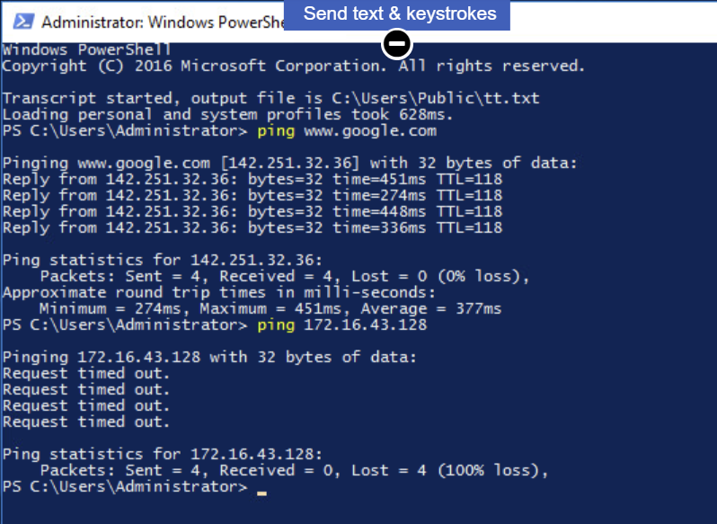
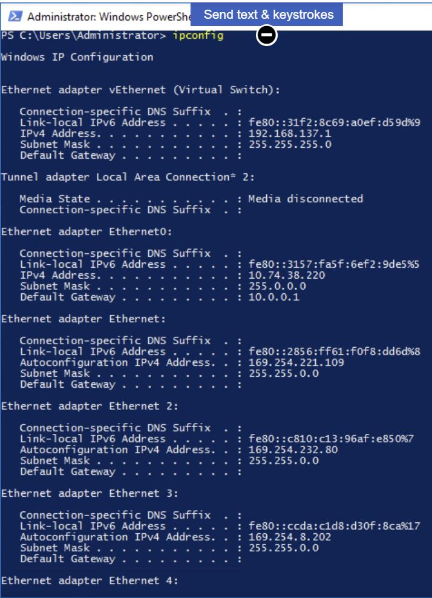
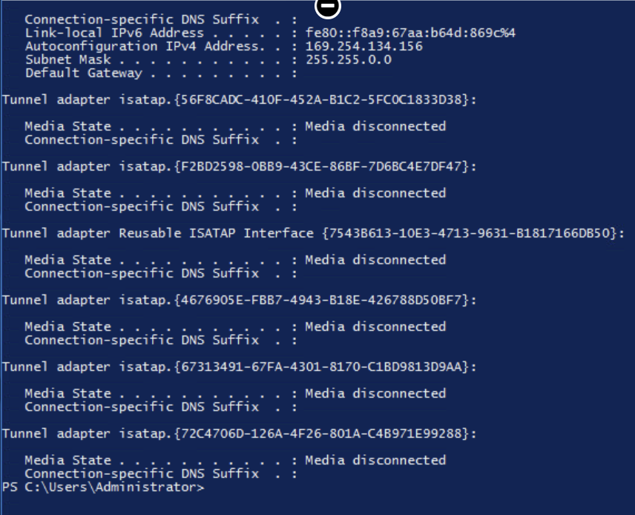

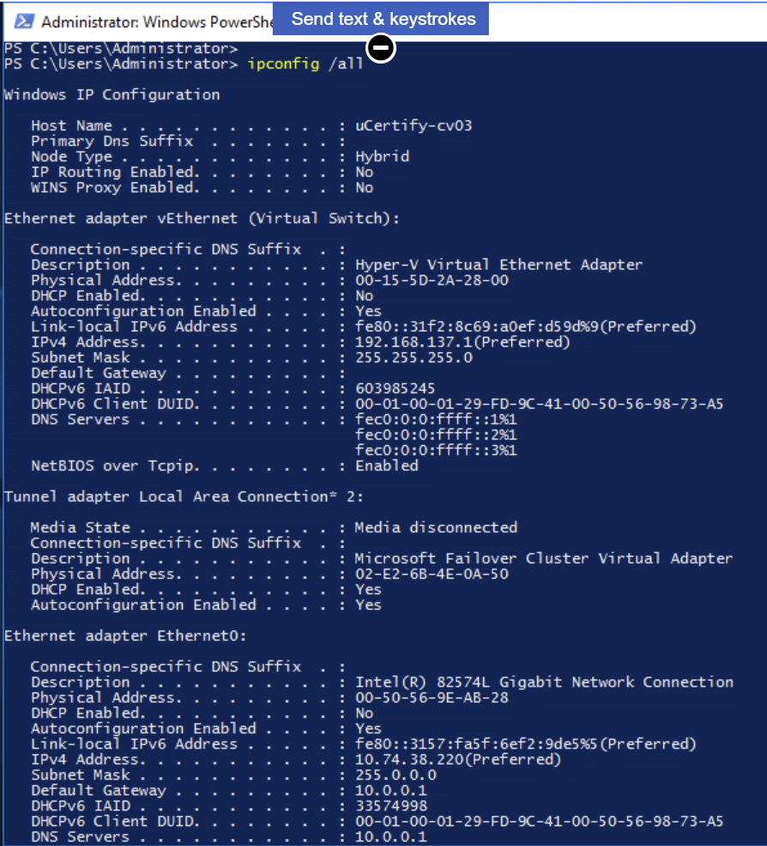
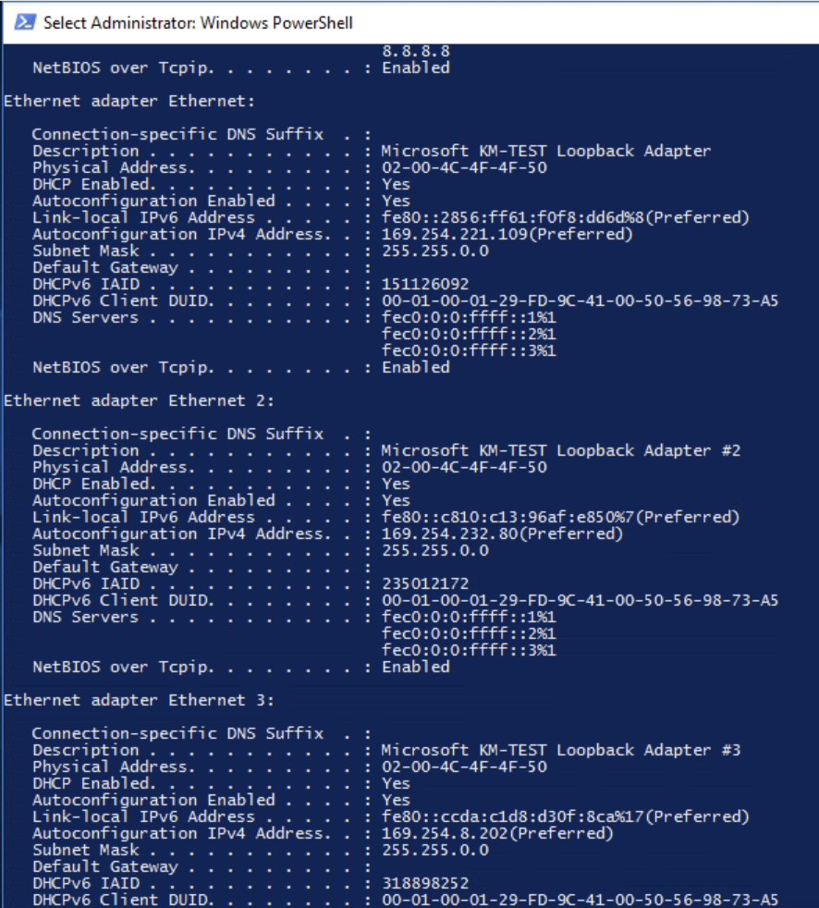
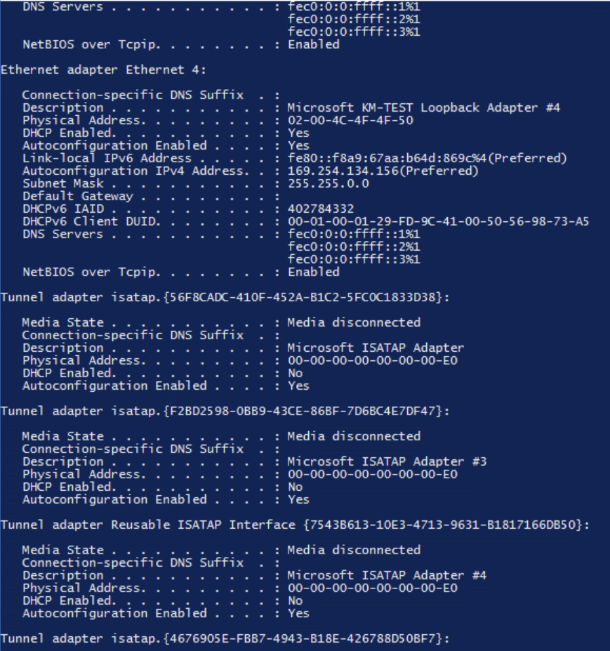
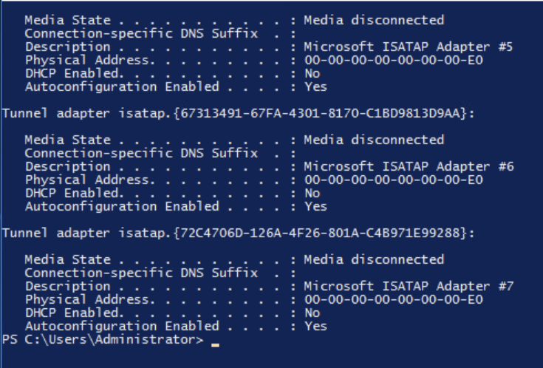
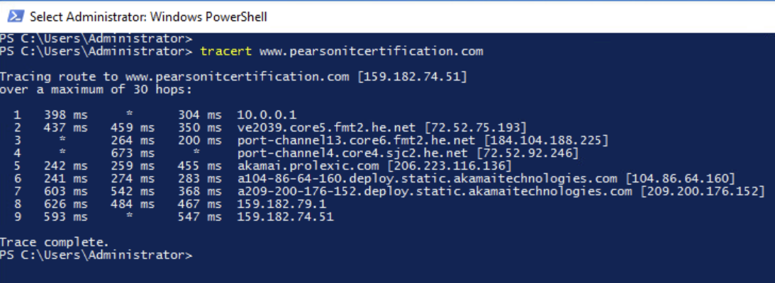
Lesson 11, Lab Sessions (VLAN assinging, configuring, and viewing port mappings):


