“Quick User Guide”

| Translator-Language-Dictionary-App |

(By: VictoriaRaven)

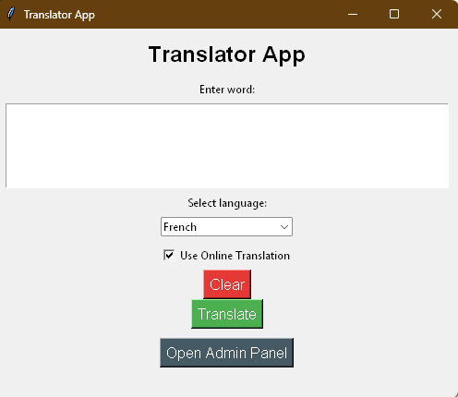

Table of Contents
PART 1 — INTRODUCTION & SYSTEM REQUIREMENTS 1
1. Overview 1
2. Features 1
3. Supported Languages 1
4. System Requirements 1
PART 2 — INSTALLATION & SETUP 2
1. Downloading the Application 2
2. Setting Up Python Environment 2
3. Running the Application 2
PART 3 — USING THE GUI 2
1. Translator Tab 2
2. Dictionary Tab 2
3. History Tab 2
4. Admin Panel 2
PART 4 — EXPORTING, TROUBLESHOOTING & TIPS 2
1. Export Tools 2
2. Troubleshooting 2
3. Best Practices 2
4. Getting Help 2

PART 1 — INTRODUCTION & SYSTEM REQUIREMENTS

1. Overview

The Translator-Language-Dictionary-App is a Python-based desktop translator that supports multiple languages using:
- Offline dictionary text files
- Optional online translation (MyMemory API)
- SQLite-powered translation history
- Tkinter GUI

No internet is required for standard translation. Online mode is only used if offline data is missing.

2. Features
- Offline & online translation
- Multi-language dictionary search
- Sorting, filtering, pagination
- Translation and history logging
- Export tools: JSON, PDF, Excel (.xlsx)
- Email integration (Outlook or mailto)
- Admin tools for managing dictionary & history
- UTF-8 support for accented, Ukrainian, Russian, Polish, and more

3. Supported Languages
English, French, Spanish, Portuguese, Italian, German, Dutch, Polish, Ukrainian, Russian

4. System Requirements

Software Requirements
- Python 3.9+
- Pip
- Tkinter
- Internet (optional)

OS Compatibility
- Windows 10/11
- macOS
- Linux / Ubuntu

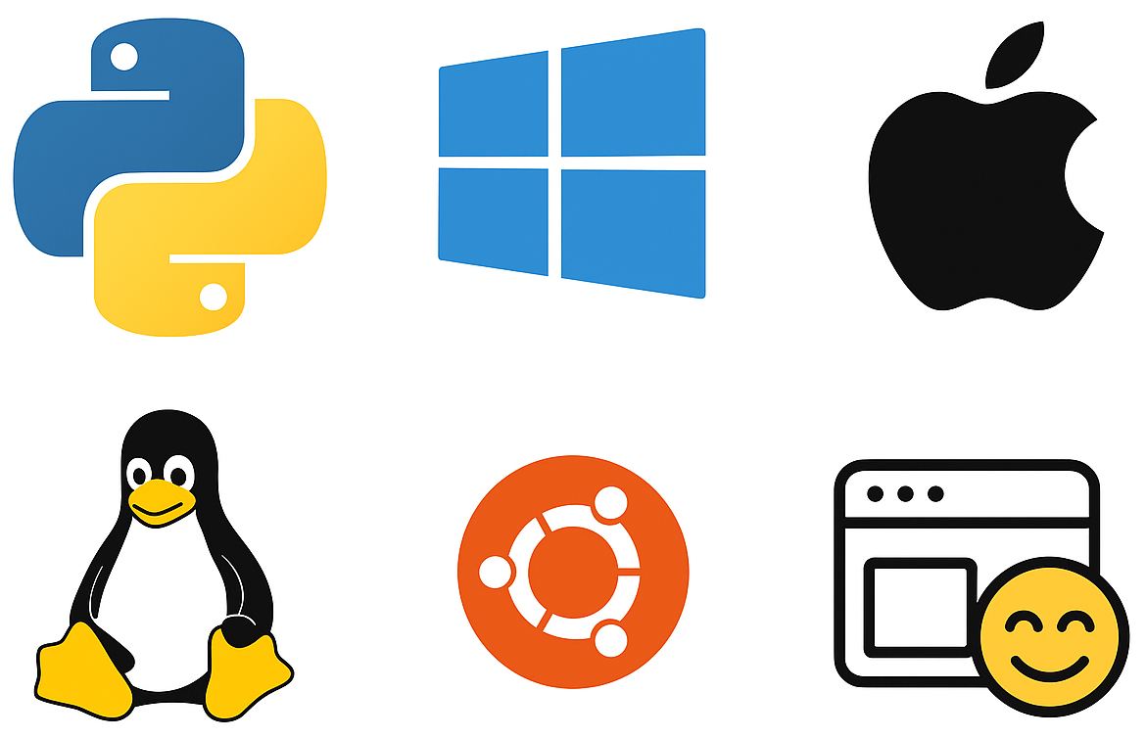

PART 2 — INSTALLATION & SETUP

1. Downloading the Application

Option A — Download ZIP
1. Open GitHub repository.
2. Click Code → Download ZIP.
3. Extract ZIP.
4. Open in IDE or terminal.

Option B — Clone via Git
git clone https://github.com/VictoriaRaven/Translator-Language-Dictionary-App.git

2. Setting Up Python Environment

Create Virtual Environment

Windows:
python -m venv venv
venv\Scripts\activate

macOS/Linux:
python3 -m venv venv
source venv/bin/activate

Install Dependencies
pip install -r requirements.txt
pip install -r requirements-dev.txt

3. Running the Application
python main.py

PART 3 — USING THE GUI

1. Translator Tab

Steps:
1. Select From Language and To Language.
2. Type a word.
3. Click Translate.
4. View offline/online result + timestamp.
- Spelling Auto-Correction
- Misspelled words are auto-corrected.

2. Dictionary Tab

Tools:
- Search
- Sort
- Pagination
- Load dictionary

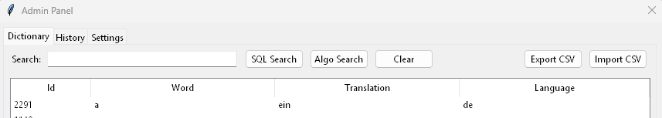

3. History Tab
- Filtering
- Sorting
- Pagination
- Export JSON, PDF, Excel

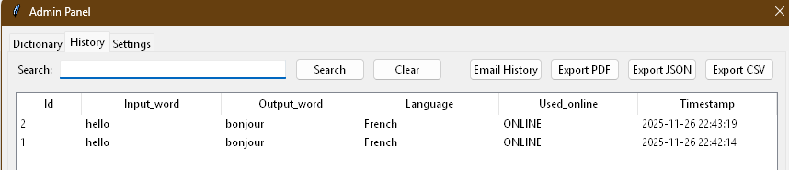

4. Admin Panel

Admin Functions:
- Clear history
- Reload dictionary
- Export dictionary
- Manage database

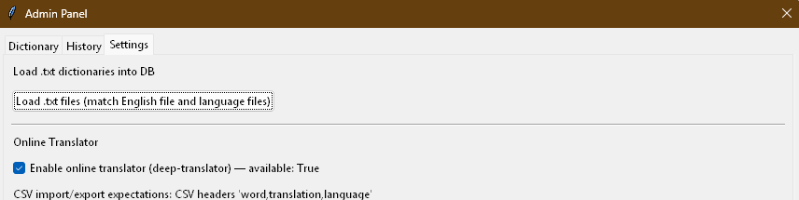

PART 4 — EXPORTING, TROUBLESHOOTING & TIPS

1. Export Tools
JSON Export
PDF Export (DejaVuSans.ttf required)
Excel Export (UTF-8)
Email Export

2. Troubleshooting
App won't start: install requirements, check Python version, Tkinter.
PDF fail: ensure DejaVuSans.ttf exists.
Online translation fail: check internet or API limits.
Excel unreadable: import using UTF-8.

3. Best Practices
- Use offline/online mode when possible
- Export history regularly

4. Getting Help
Open GitHub Issue or contact project author VictoriaRaven.

