-- Question 1, those code was produced by ChatGPT
SELECT
strftime('%Y', release_date) AS year, -- extract the year
title AS first_movie,
(
SELECT title --subquery finds another movie title from the SAME year, looks for the last movie
FROM movies AS m2
WHERE strftime('%Y', m2.release_date) = strftime('%Y', m1.release_date) -- the last movie must be within the same year
LIMIT 1
) AS last_movie
FROM movies AS m1
WHERE release_date = (
SELECT MIN(m2.release_date) -- find the earliest release date, is "first movie"
FROM movies AS m2
WHERE strftime('%Y', m2.release_date) = strftime('%Y', m1.release_date) -- only look at movies from the same year as m1
);
-- Question 2
SELECT
strftime('%Y', release_date) AS year,
sum(revenue) AS total_revenue
FROM movies
WHERE release_date
GROUP BY year
ORDER BY revenue DESC;
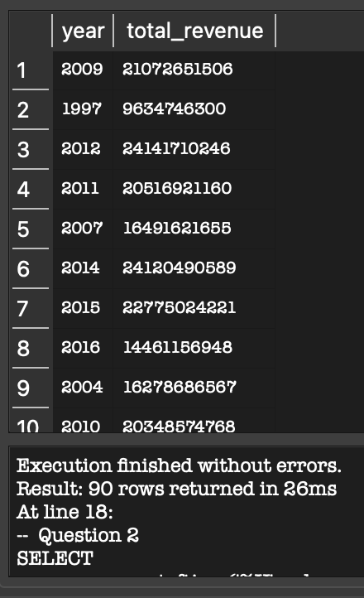

-- Question 3
SELECT
movies.title,
movies.release_date,
directors.name AS director_name
FROM movies
JOIN directors ON movies.director_id = directors.id
WHERE strftime('%m', movies.release_date) BETWEEN '01' AND '06';

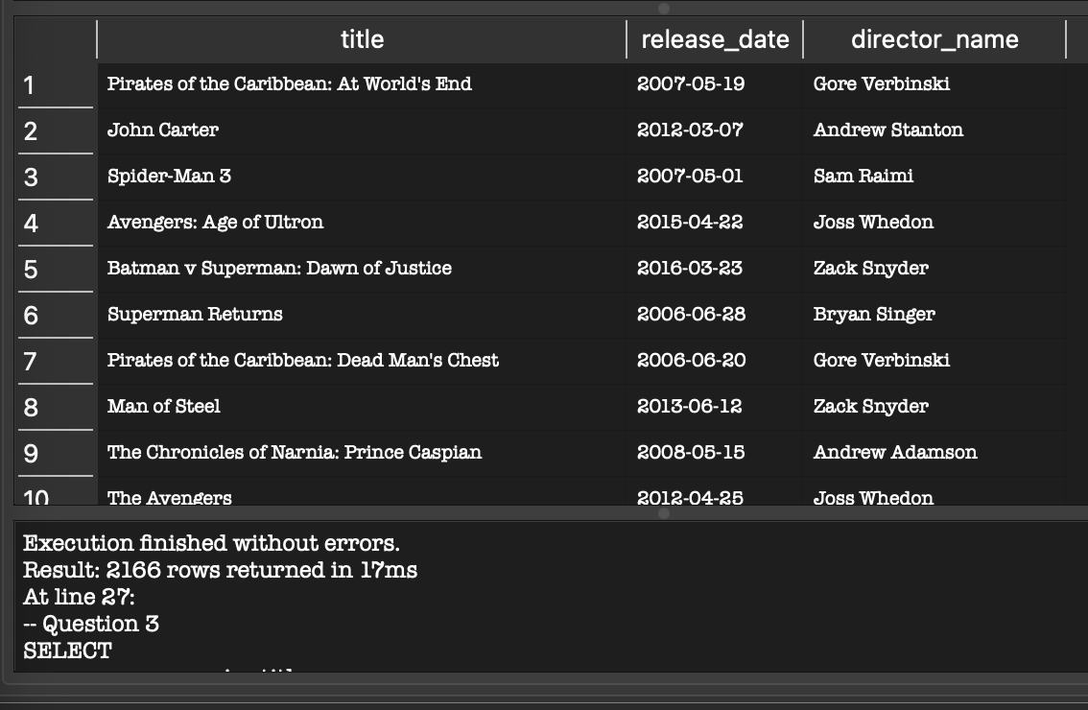

-- Question 4
SELECT count(*) AS weekend_movie_count
FROM movies
WHERE strftime('%w', release_date) IN ('0', '6');


-- Questoin 5, code was produced by GEMINI
SELECT
directors.name AS director_name,
SUM(movies.revenue) AS total_revenue,
CASE
WHEN SUM(movies.revenue) > 1000000000 THEN 'High Revenue'
WHEN SUM(movies.revenue) BETWEEN 500000000 AND 1000000000 THEN 'Moderate Revenue'
ELSE 'Low Revenue'
END AS revenue_category
FROM directors
JOIN movies
ON directors.id = movies.director_id
GROUP BY directors.id, directors.name
ORDER BY total_revenue DESC;
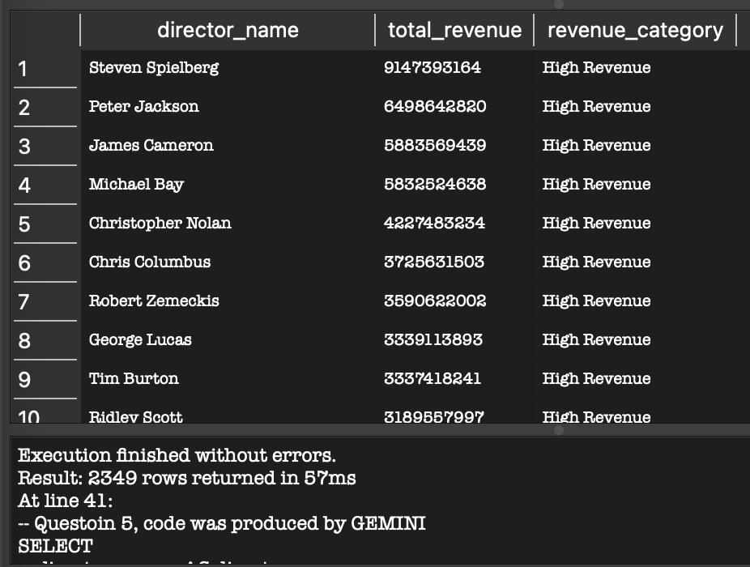

-- Question 6
SELECT title, popularity, revenue,
CASE
WHEN popularity > 100 AND revenue > 500000000 THEN 'Blockbuster'
WHEN popularity > 50 AND revenue BETWEEN 100000000 AND 500000000 THEN 'Hit'
ELSE 'Average'
END AS movie_category
FROM movies
ORDER BY revenue DESC;
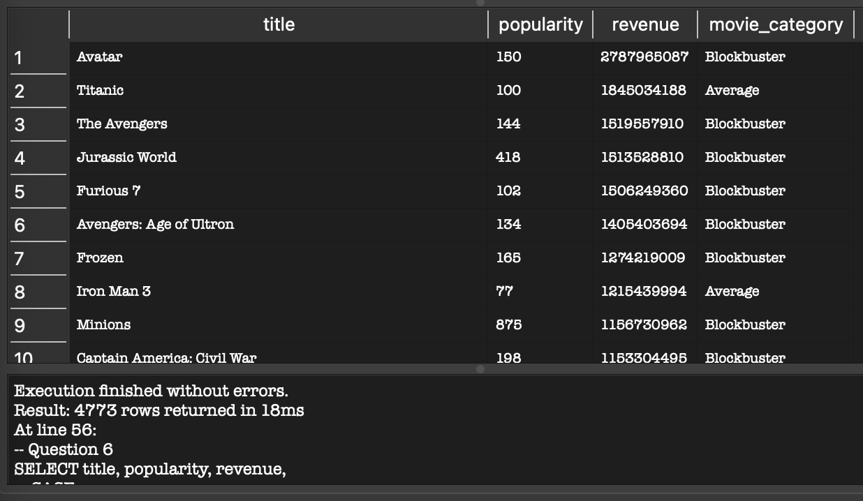

-- Question 7
SELECT
directors.name AS director_name,
SUM(CASE WHEN movies.vote_average >= 8 THEN 1 ELSE 0 END) AS critically_acclaimed_count,
SUM(CASE WHEN movies.vote_average < 5 THEN 1 ELSE 0 END) AS poorly_rated_count
FROM directors
JOIN movies
ON directors.id = movies.director_id
GROUP BY directors.id, directors.name
ORDER BY critically_acclaimed_count DESC;
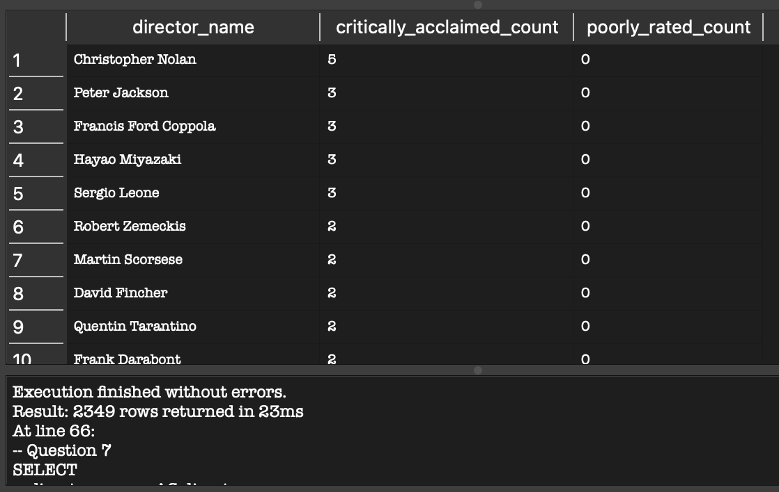
AI Usage
AI was only used for Question 1. I copy and paste the question into ChatGPT and asked how it would code it. The part where I was stumped at was how to code the “first” and “last” movie that was made each year. The logic is still a little hard for me to understand because of the subqueries being in a weird order, but each block of code/individual subqueries are understandable to me.

