# Analysis of the WeRateDogs Twitter account

If you’re into memes, then you probably know Brent and his inexplicable misunderstanding about how to rate properly a dog. But if you’re not, I can easily explain you that giving a dog a rating in a scale from 1 to 10 is simply not fair, have you seen how cute they are? And let’s not forget… **They’re good dogs Brent**.

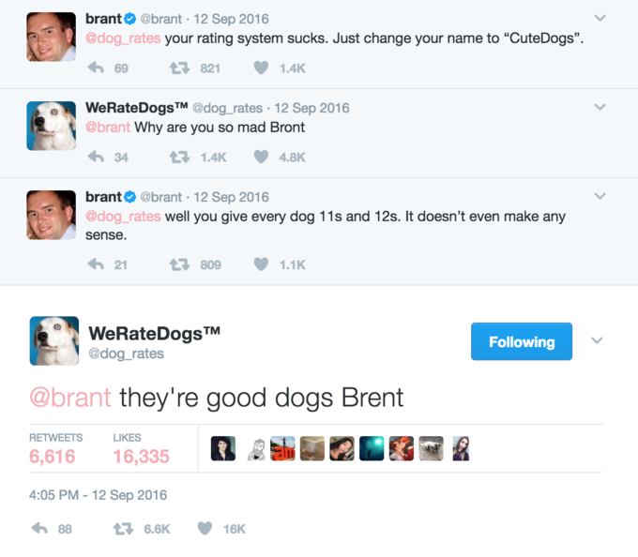

Having that said, you’re either on Brent’s side or WeRateDogs’ side, a twitter account that rates people's dogs with a humorous comment about the dog.

If you’re still not convinced, and Brent’s side looks like the greener side to you, don’t worry, I have plenty of graphs to show you a thing or two.

# About the Data

You can’t make graphs without the data, and here is how I recollected the cold, hard data that will turn you to the brighter side of dogs.

First, I downloaded a CSV file with the Twitter archive from the WeRateDogs account ([@dog_rates](https://twitter.com/dog_rates)).

Secondly, I used those tweet Id’s to get more information on the favourites and the retweets trough the Twitter API.

Lastly, I downloaded programmatically a file with the predictions on the dog breed from each tweet. Results that came from a neural network, which is not a meaningless fact, because some dogs have been categorized as helicopters. Can you imagine that?

# About the findings

Without further ado, this is what I’ve found:

## The most common dog breed

With a dataset with over two thousands records, the first thing you may want to know is what are all those dogs, so I gathered every dog breed and transform it into a word cloud to have an idea of what dogs I would find the most. It was no surprise to find that the golden retriever was so present in photos, can you blame them Brent? I would also share those cuties nonstop.

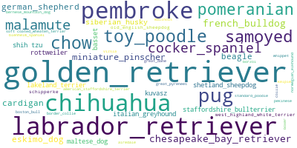

But I promised some graphs, not just words and colours, so if you’re a number person here’s is the distribution of the top 5 most frequent dog breeds:

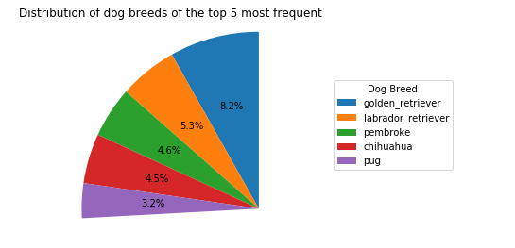

## The better rated dogs

So you can understand properly why the rating is so important, I also run some numbers on the most rated dogs, and would it surprise you if I said, that dogs in all stages are equally deserving of a good off the charts rating?

I knew you’ll be a bit skeptical, so here’s is the graph:

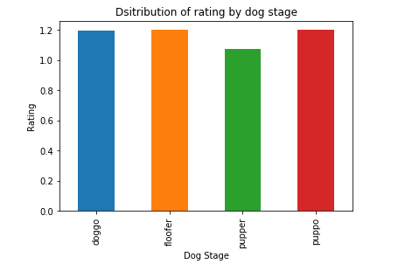

But there is a clear winner above all, with no less than 1776/10:

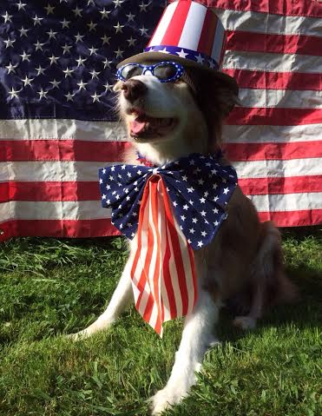

**This is Atticus. He's quite simply America af. 1776/10 https://t.co/GRXwMxLBkh**

## The most fav dogs

But not only WeRateDogs understand how cute these dogs are, people fav them like crazy!

There’s a lot of favs on the opposite side Brent.

What’s interesting here is that the people opinion doesn’t agree so much with the ratings, since the most liked dogs are puppo without any doubts:

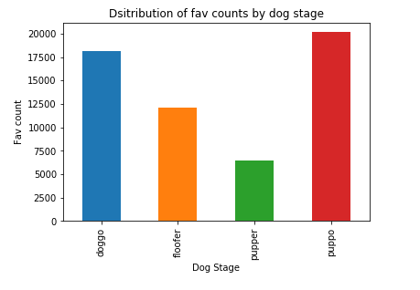

And not only there’s a preference in the dog stage, but also the breed has a lot of influence. This is the distribution of the fav counts by dog breed, for the 10 most liked dog breeds:

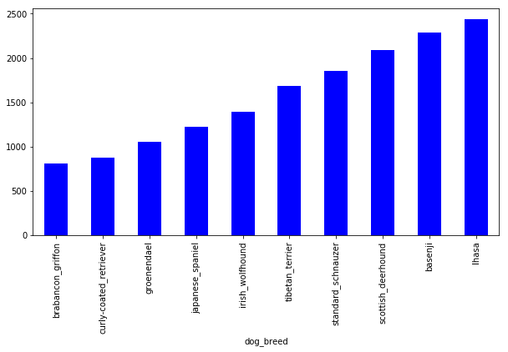

So there you go Brent, there’s a lot of them, they have off the chart ratings and people loved them like crazy, conviced yet?

If not, check out the most fav dog ever:



**Here's a doggo realizing you can stand in a pool. 13/10 enlightened af (vid by Tina Conrad) https://t.co/7wE9LTEXC4**