**CHAPTER I**

**INTRODUCTION**

**Background of the study**

Coconut farming, particularly of the Cocos Nucifera species, plays a significant role in the agricultural economy of many tropical countries. Despite its importance, many coconut farmers struggle with challenges such as poor crop management, pests, and inconsistent yield due to limited access to timely and reliable farming advice. Traditional sources of agricultural information are often outdated, inaccessible, or impractical for small-scale farmers, contributing to inefficiencies in farming practices.

In recent years, coconut farmers in the Philippines have experienced declining productivity due to factors like senile palms, poor agronomic practices, and environmental challenges. A significant issue is the lack of fertilizer application, which leaves yield gaps of 31% to 87% between farmer-managed and well-maintained coconut plantations. This problem highlights the potential of integrated nutrient management (INM) to enhance coconut productivity. By testing various fertilizer treatments, the goal is to demonstrate how proper nutrient management can help close the yield gap and improve the overall productivity of coconut farms in different climate conditions across the country. (Crisostomo et al., 2023)

Given the widespread use of mobile technology, CocoTips aims to bridge this gap by offering a mobile-based platform tailored to the specific needs of coconut farmers. The application provides real-time, easily accessible tips on best practices, pest management, fertilization schedules, and harvesting techniques. By leveraging this technology, the goal is to empower farmers with the information they need to enhance their productivity and improve their overall farm management practices, ultimately supporting a more sustainable coconut farming industry.

There's an app that stands out as a crucial asset for coconut farmers, consolidating a wealth of resources and insights into coconut cultivation into one comprehensive platform. This app named Coconut App is designed to support farmers by offering integrated solutions and practical guidance, making it an essential tool for enhancing coconut production and productivity. With its user-friendly interface and well-thought-out features, it provides easy access to valuable information and resources, empowering growers to implement sustainable practices and achieve better results in their farming efforts. This app truly exemplifies innovation in supporting the coconut industry and is an excellent guide for farmers and industry stakeholders alike. (<https://play.google.com/store/apps/details?id=zincat.net.cocoguru&pcampaignid=web_share>)

The current resources and tools available for coconut farming, particularly for Cocos nucifera, are often outdated or inaccessible to many farmers, creating a significant gap in practical and modern farming support. From a research perspective, there is a pressing need for a user-friendly solution that provides up-to-date information and guidance. Our study, CocoTips: Mobile App for Coconut Farming, aims to address this issue by developing a mobile application that offers practical support and timely information to coconut farmers. By bridging the gap in current knowledge and resources, CocoTips will enhance farming practices and productivity, ultimately benefiting the farming community with a more accessible and modern tool.

**Objectives of the Study**

1. To design and create an intuitive and user-friendly mobile application interface tailored specifically for coconut (Cocos nucifera) farmers.
2. To develop and implement functionalities within the CocoTips application to support various aspects of coconut farming, such as soil analysis, pest control and weather.
3. To test procedures to evaluate the effectiveness, usability, and efficiency of the CocoTips mobile application in real-world coconut farming scenarios, ensuring its practicality and reliability for end-users.

**Significance of the Study**

The android based mobile application will be of great importance to following target beneficiaries:

**Coconut Farmers.** The CocoTips app will assist coconut farmers by providing essential guidance on best farming practices, pest and disease management, and crop optimization. Through real-time notifications and expert tips, the app helps farmers make informed decisions, improve yield quality, and enhance overall productivity, ultimately leading to better profitability and sustainability in coconut farming.

**Local Farmers.** The study helps local farmers to improve their agricultural livelihood in the field of coconut farm.

**Local Government Unit (LGU).** This study provides LGUs with significant information and benefits that can help them boost their agriculture sector, support rural development, and improve the overall well-being of the community.

**Future** **Researchers.** This study may help future researchers to conceptualize studies of similar nature. They can utilize this study as one of their related studies.

**Scope and Limitations of the Study**

This project aims to provide comprehensive information for coconut production, including Farming Basics, Seasonal Tips and Varieties. As an offline app, CocoTips ensures that coconut farmers can access valuable information without requiring an internet connection. However, technical constraints such as limited resources may impact the app's overall effectiveness. Cultural and socioeconomic factors could influence the acceptance and implementation of CocoTips among coconut farming communities.

**Definition and Terms**

The following terms were defined operationally to give the readers a clear understanding of the study.

**Coconut Farming**. The practice of cultivating coconut palms (Cocos Nucifera)for the production of coconuts and coconut-related products (Merriam-Webster Dictionary, n.d.). In this study, coconut farming will be a core focus of the CocoTips app, providing farmers with insights, best practices, and recommendations to optimize their coconut cultivation efforts, enhance yield, and improve the quality of their produce.

**Cocos Nucifera.** Is a member of the palm tree family (Arecaceae) and the only living species of the genus Cocos (Lima et al., 2015). In this study, Cocos Nucifera is the primary subject of the CocoTips app, which will offer targeted advice and information specific to this species to support farmers in managing their coconut palms effectively.

**Alpha Test.**  It is a type of software testing performed to identify bugs before releasing the software product to the end users. It is a type of [acceptance testing.](https://www.guru99.com/user-acceptance-testing.html) The main objective of alpha testing is to refine the software product by finding and fixing the bugs that were not discovered through previous tests (Hamilton, 2023). In this study, alpha test was the second test that the researchers will undergo. This will be evaluated by the stakeholders of the University and some IT students.

**Agriculture.** The science or practice of farming, including cultivation of the soil for the growing of crops and the rearing of animals to provide food, wool, and other products (Oxford University Press 2023). In this study, it helps to enhance productivity, efficiency, and sustainability in cassava farming, leading to improved livelihoods for farmers and the growth of the agricultural sector.

**Beta Test.** Beta testing is an opportunity for real users to use a product in a production environment to uncover any bugs or issues before a general release. Beta testing is the final round of testing before releasing a product to a wide audience (ProductPlan,2023). In this study, beta test was the last test that executed. This was evaluated by the end-users who are farmers.

**Benchmark Test.** is a metric or a point of reference against which software products or services can be compared to assess the quality measures. In other words, Benchmark means a set standard that helps to determine the quality of a software product or service. We can benchmark a software product or service to assess its quality (Hamilton,2023). In this study, benchmark test was the first test conducted and evaluated by the researchers and the capstone adviser.

**Economy.** The wealth and resources of a country or region, especially in terms of the production and consumption of goods and services (Oxford University Press,2023). In this study highlight the interconnectedness between cassava production, resource utilization, and economic development. It recognizes the importance of the cassava sector as a contributor to the broader economy and emphasizes the role of the information management system in supporting economic activities, livelihoods, and sustainable economic growth.

**Efficiency.**  Efficiency indicates that by allocating your resources as effectively as possible, you can obtain results. In this study, efficiency involves reaching an end goal with little to no waste, labour, or energy. The system’s response and processing times and throughput rates when performing its functions, meet requirements.

**Farmers.** A person who owns or manages a farm. (Oxford University Press,2023). In this study, farmers are used as the one who manages the harvest and planting of the coconut.

**Functionality**. The quality of having practical use; the particular use or set of uses for which something is designed (Merriam-Webster Dictionary). In this research, functionality refers to the systems quality and capacity to accomplish the tasks for which it was designed.

**Livelihoods.** A means of securing the necessities of life (Oxford University Press,2023). In this study it underscores its commitment to assisting farmers' economic well-being, income generation, asset use, skill development, market access, and sustainability. It seeks to improve farmers' livelihoods by providing them with timely and relevant information and resources to help them improve their coconut production techniques and achieve long-term livelihood results.

**Mobile Application.** Is a software application developed specifically for use on small, wireless computing devices, such as smartphones and tablets, rather than desktop or laptop computers (TechTarget, 2021). In this study, the CocoTips app is a mobile application designed to deliver real-time, accessible guidance to coconut farmers directly on their mobile devices, facilitating easier access to essential information and tools for managing their farming activities.

**Maintainability**. It is described as the likelihood that a damaged part or system will be fixed or restored to its original state within a certain time frame. When maintenance is carried out in accordance with instructions. In this study, maintainability means the ability to adjust the software system or component to repair problems, improve performance, or adapt to a changing environment.

**Production.** the action of making or manufacturing from components or raw materials, or the process of being so manufactured (Oxford University Press,2023). In this study, it focuses on the process of cassava cultivation, input utilization, yield optimization, effective resource management, and quality assurance are all important considerations. It emphasizes the significance of leveraging information and technology to improve production techniques, productivity, and overall cassava farming performance.

**Usability**. Degree to which a product or system can be used by specified users to achieve specified goals with effectiveness, efficiency and satisfaction in a specified context of use (ISO, 1998). In this study, this is how the users test or use the application it’s function if it is usable or need to improve.

**Pest Management.** Is a system of integrated preventive and corrective measures to reduce or prevent pests from causing significant harm to humans or the environment (Bennett et al., 2005). In this study, it will provide information and tools for effective pest management specific to coconut palms, including preventive measures and corrective actions to protect crops from pest-related damage.

**Climate Adaptation**. Taking action to prepare for and adjust to the current and projected impacts of climate change. (Global Center on Adaptation,2024). In this study, the CocoTips app will offer guidance on climate adaptation strategies for coconut farming, helping farmers understand and implement practices that address climate change impacts, such as shifting weather patterns and extreme conditions.

**CHAPTER II**

**REVIEW OF RELATED LITERATURE AND STUDIES**

This chapter contains a review of related literature and studies which guided the researcher in the conceptualization of this study.

**Related Literature**

The development of an index to measure the managerial competency of coconut growers in coconut-based farming systems has been studied using the Normalized Rank Order Method recommended by Guilford, resulting in a standardized scale consisting of 10 indicators and 55 sub-items with high reliability (0.99). While this study provides a valuable tool for assessing managerial skills, it leaves a gap in understanding how technology, particularly mobile-based solutions, can further enhance these competencies. (Sasidharan et al., 2024) Current research has not extensively explored the integration of mobile technology into coconut farming, especially its impact on decision-making and farm management. To address this gap, CocoTips: A Mobile-based Coconuts (Cocos Nucifera) Farming seeks to examine how mobile applications can improve farming practices by providing real-time information and resources. This study aims to empower coconut farmers by enhancing their managerial competencies through technology, fostering more sustainable and productive farming systems.

The integration of technology to enhance productivity and income in coconut farming was a key focus of the NAIP sub-project on 'Value Chain in Coconut,' implemented by ICAR-Central Plantation Crops Research Institute. Through the formation of 10 clusters involving 534 farmers across 250 hectares in Kasaragod, Kerala, various production technologies such as intercropping, organic recycling, and integrated nutrient management were introduced. Group actions were also organized to implement disease management strategies, particularly for bud rot disease. Training programs helped improve farmers' knowledge and skills, leading to an increase in coconut productivity from 60 to 112 nuts per palm, and higher net incomes. Despite these advances, a gap remains in understanding how mobile technology can further streamline farming practices and provide real-time support for smallholder farmers.(Thamban et al., 2016) CocoTips: A Mobile-based Coconuts (Cocos Nucifera) Farming seeks to address this gap by exploring how mobile applications can enhance access to farming technologies, knowledge sharing, and decision-making processes, thereby empowering coconut farmers to boost productivity and income through more accessible, technology-driven solutions.

According to the study of (Satheesan, 2024) Tropical coconut agriculture faces numerous challenges that threaten its productivity and sustainability, including diseases like Rhincosporium Palm Leaf Spot, Lethal Yellowing Disease, and infestations by coconut mites. The impacts of climate change, such as rising temperatures and unpredictable rainfall, along with coastal issues like soil erosion and salinity intrusion, further weaken coconut palms. Monoculture practices exacerbate soil nutrient depletion, increasing vulnerability to pests and diseases, while poor water and nutrient management hinders coconut growth. Additionally, urbanization, market fluctuations, and limited access to farming technologies, coupled with financial constraints and unstable land tenure, reduce profitability and impede the adoption of sustainable practices. Despite the recognition of these challenges, a gap exists in the exploration of mobile-based solutions to address real-time issues in coconut farming.

Coconut trees are cultivated in over 93 countries, covering 12 million hectares with an annual production of 59.98 million tonnes of nuts. India, the third-largest producer, contributes 10.56 million tonnes annually, underscoring the economic significance of coconut farming, particularly in rural areas where it provides employment opportunities. Despite its value, coconut palms face serious threats from over 900 insect-pests, with the rhinoceros beetle, red palm weevil, coconut mite, and coconut black-headed caterpillar being the most harmful. Farmers primarily rely on chemical pesticides, which lead to issues such as pest resistance, resurgence, and disruption of natural enemies. Integrated Pest Management (IPM) offers a more sustainable approach, combining cultural, physical, mechanical, and biological methods to manage pest populations below economic injury levels while preserving ecological balance. However, there is a gap in research regarding the role of mobile technology in disseminating IPM strategies to coconut farmers in real time. (Ts & Dwivedi, 2021)

(Malshe et al., 2024) A field trial conducted during the rabi season of 2022-23 at the Regional Coconut Research Station in Bhatye, Ratnagiri, assessed the performance of a coconut and bitter gourd intercropping system in a 30-year-old West Coast Tall coconut plantation. Bitter gourd was planted in two rows 2.5 meters from the coconut palms, with hills spaced 1 meter apart. Results showed that the highest yield of bitter gourd (1.958 t/ha) was achieved in sole cropping, while intercropping yielded less (1.779 q/ha). The coconut yield was 17,027.5 nuts/ha/year in the intercropping system, compared to 16,940 nuts/ha/year in sole cropping, yielding a land equivalent ratio (LER) of 1.91 for the intercropping system. While these findings highlight the potential benefits of intercropping in maximizing land use efficiency, gaps remain in understanding how to effectively disseminate this information to farmers and integrate technology into their practices. The current study, *CocoTips: A Mobile-based Coconuts (Cocos Nucifera) Farming*, aims to address this gap by providing coconut farmers with mobile access to information on intercropping systems and best practices, thereby enhancing productivity and promoting sustainable agricultural practices.

The Integrated Pest Management (IPM) approach was developed to mitigate the adverse effects of synthetic pesticide use in agroecosystems, promoting a multidisciplinary, environmentally sensitive strategy that incorporates biological, cultural, genetic, mechanical, physical, and other methods for pest management. The concept of IPM has evolved over time, leading to various definitions and adaptations to address pest issues in diverse agroecosystems, including coconut cultivation. This paper reviews different IPM approaches for managing coconut pests, referencing the conceptual framework introduced by Stenberg (2017) and the modern IPM paradigm conceptualized by Dara (2019). While these frameworks provide valuable insights into effective pest control, there remains a gap in integrating mobile technology to facilitate real-time implementation of IPM strategies among coconut farmers. (Caoili & Lee, 2023)

Integrated Pest Management (IPM) is a multifaceted strategy that combines cultural, physical, mechanical, and biological control methods, using pesticides as a last resort. This approach not only enhances cost-effectiveness but also prioritizes human and environmental safety, relying on farmers' local knowledge and education. In the Asia-Pacific region, several pests threaten coconut palms, including the rhinoceros beetle, red palm weevil, coconut hispine beetle, coconut black-headed caterpillar, and coconut scale. Effective management strategies include sanitation, biological control agents, and pheromone trapping. While these methods are documented, there is a significant gap in integrating mobile technology to provide real-time pest management information to farmers. (Winotai, 2014)

This study developed three fermented beverages incorporating different percentages of green coconut pulp (30%, 50%, and 70%), analyzing them over a 21-day storage period. Results showed that the microbiological and physical-chemical parameters were comparable to a conventional dairy drink. Lactic acid bacteria counts were initially high (7 log10 CFU g-1) on the first day but decreased to 6 log10 CFU g-1 after seven days. Sensory evaluation revealed similar flavor attributes across formulations, with the 50% and 70% pulp formulations receiving higher scores for color and texture due to the coconut's presence. Overall acceptance exceeded 70%, with the 50% formulation achieving a purchase intention of 45%. While these findings highlight the potential of utilizing green coconut pulp to reduce waste and add economic value to the coconut industry in Brazil, there remains a gap in research regarding the scalability of production and consumer awareness of these innovative products. (Oliveira et al., 2023)

(Aguilar et al., 2023) Climate extremes, including strong typhoons and unpredictable rainfall, have devastated many coconut-producing areas in the Philippines, severely impacting farmers' livelihoods and the entire coconut supply chain. To address these challenges, a clustering system for farmers has emerged as a key strategy for sustaining the coconut industry, promoting the adoption of good agricultural practices that align with domestic and international market standards. Despite the potential benefits, there is a lack of scientific guidance and market linkages for implementing climate-resilient integrated farming systems through multi-purpose cooperatives. Previous coconut and coconut-based farming system (CBFS) projects have demonstrated the effectiveness of a learning-by-doing approach, which involves training core trainers to empower farmer groups in developing location-specific climate-resilient practices. This study aims to fill these knowledge gaps by exploring the integration of climate forecasts and complementary enterprises, thereby improving farm productivity and resilience against climate-related hazards.

Coconut is a key commodity in small-scale plantations, particularly in Bireuen Regency, Aceh Province, where stakeholders are actively pursuing development strategies for coconut farming. This study identifies alternative strategies through purposive sampling of stakeholders, including government officials, extension workers, academics, farmer groups, traders, and industry players, using the Analytical Hierarchy Process facilitated by the Expert Choice application. The findings reveal that the top priorities for enhancing coconut farming include increasing production and quality (0.293), establishing partnerships with traders and industry (0.257), developing farmer institutions (0.231), and expanding access to capital (0.220). However, gaps remain in understanding how these strategies can be effectively implemented in practice, particularly in terms of fostering collaboration among diverse stakeholders and addressing the unique challenges faced by small-scale farmers. This study aims to bridge these knowledge gaps by exploring practical approaches for integrating these strategies into a cohesive framework for sustainable coconut farming development. (Baihaqi et al., 2023)

**Related Studies**

Coconut (Cocos nucifera L.) is a versatile tree cultivated for its numerous nutritional and medicinal benefits, producing a range of products including tender coconut water, copra, coconut oil, and coir. Each part of the coconut is utilized in daily life, particularly in traditional growing areas, highlighting its importance in local economies. The fruit's components, such as the kernel and coconut water, possess significant medicinal properties, including antibacterial, antifungal, antiviral, and antioxidant effects, making them essential for human health, especially in tropical regions. Recognized as 'Kalpavriksha' or the "all-giving tree" in Indian literature, the coconut palm serves as a crucial resource for both health and industrial applications. This review underscores the potential of coconut as a sustainable agricultural product, supporting the development of practices that enhance its cultivation and utilization in health and disease prevention, thus providing a valuable context for the CocoTips mobile application aimed at improving coconut farming practices and farmer engagement. (DebMandal & Mandal, 2011).

According to (Beveridge, 2022) Coconut (Cocos nucifera L.) is a vital perennial crop adapted to various habitats, yet its production is declining despite rising global demand, primarily due to issues like palm senility and abiotic and biotic stresses. The lack of good quality seedlings hampers replanting efforts, making the improvement of traditional seed propagation essential. Understanding the biology of coconut fruits—encompassing morpho-anatomy, germination biology, seed dispersal, and storage—can enhance propagation methods. This highlights the need for comprehensive research in these areas to address current gaps and optimize seed propagation techniques. By integrating these insights, the CocoTips mobile application can provide valuable resources and guidelines for farmers, ultimately supporting sustainable coconut farming practices and meeting the increasing market demand.

Coconut (Cocos nucifera L.) is a widely distributed perennial palm that plays a crucial role in the socio-economic framework of rural smallholders in producing countries, providing a primary income source for 30 million farmers and impacting 60 million households through various sectors of the coconut industry. However, challenges such as stagnant production, inadequate planting materials, climate change effects, and pest and disease pressures must be addressed urgently. Advances in biotechnology, including genomic-assisted breeding, next-generation sequencing (NGS), and genome editing, offer promising solutions to improve genetic variation and enhance trait development more efficiently. This review underscores the importance of integrating these biotechnological approaches with high-throughput phenotyping and speed breeding to accelerate genetic gains in coconut breeding. (Arumugam & Hatta, 2022).

According to Roopan, (2016). Cocos nucifera is renowned for its high nutritional and medicinal value, with various protein fractions exhibiting significant biological activities, including antimicrobial, anti-inflammatory, anti-diabetic, anti-neoplastic, anti-parasitic, insecticidal, and leishmanicidal properties. This review explores the biotechnological and biomedical potential of different solvent extracts from various coconut parts and their phytochemical constituents. The findings underscore the importance of these extracts in advancing research focused on disease diagnosis and treatment. By integrating this knowledge, the CocoTips mobile application can provide valuable insights into the health benefits of coconut and promote the utilization of its diverse products, thereby enhancing both the economic viability and nutritional value of coconut farming for local communities.

The coconut palm remains a distinctive feature of the Philippine landscape, thriving in saline coastal areas and providing essential ecological services as a substitute for the original tropical rainforest cover. Its resilience to typhoons gives it a unique advantage over other industrial tree crops like oil palm and rubber, which are limited in their geographic viability. To enhance the productivity and sustainability of the Philippine coconut industry, four complementary pathways have been identified: increasing the primary productivity of coconut trees, implementing intensive and sustainable multiple canopy farming, maximizing the utilization of coconut fruits and vegetative parts for various products, and integrating coconut production with oleochemical processes. With the necessary natural resources, technologies, and institutional support available, the effective use of coconut levy funds can catalyze these efforts.( Javier, 2015)

The study of (Yousefi et al., 2023) Coconut is an economically significant palm species with a rich history of human use, valued for its applications in food, nutraceuticals, and cosmetics, particularly due to its unique nutritional and medicinal properties. However, the sustainable growth of the coconut industry is challenged by a shortage of high-quality seedlings, compounded by the difficulties inherent in traditional breeding methods, such as the perennial nature of the plant, its long juvenile period, and high heterozygosity. Advances in molecular biotechnology, including molecular markers and next-generation sequencing (NGS), have the potential to accelerate genetic improvement in coconut. These tools have been utilized to assess genetic diversity among populations and construct genetic maps, facilitating breeding programs worldwide. The wealth of genomic and transcriptomic data generated from various coconut varieties enhances the understanding of molecular mechanisms that influence crop performance, paving the way for the development of high-yielding and disease-resistant coconuts.

The increasing demand for coconut-based products has led to a rise in food fraud, prompting authorities to focus on product authentication. Traditional quality assessment methods are often destructive, making non-destructive techniques like nuclear magnetic resonance (NMR), infrared (IR), mid-infrared (MIR), near-infrared (NIR), and Raman spectroscopy more desirable. These methods are effective in assessing the oxidative stability of coconut oil, detecting adulteration, and identifying harmful additives. This review highlights the successful application of these spectroscopic techniques combined with chemometrics for quality determination and authenticity verification. Findings indicate that NMR and FTIR are particularly effective in evaluating coconut oil's chemical properties and oxidation levels. These advancements can support the CocoTips mobile application in promoting food safety and quality assurance practices among coconut farmers and producers.( Pandiselvam et al., 2022)

Coconut is a versatile crop that presents numerous opportunities for value-added products through the utilization of its various parts. While coconut products have long been a staple in food, their significance in nutraceuticals has surged in recent decades. Biochemical studies have primarily focused on macromolecules such as fatty acids, proteins, and fiber; however, emerging research highlights the nutraceutical potential of coconut's bioactive compounds, with clinical trials currently in progress. This chapter underscores the future perspectives of coconut-derived biomolecules, particularly in relation to human nutrition. (S.V & Praveen, 2024)

The Philippine government has aimed for self-sustainability in food production, particularly focusing on the coconut industry, where the country is a leading producer and exporter. However, numerous studies indicate that small-scale coconut farmers face significant challenges, including financial constraints, lack of technical assistance, and socio-cultural issues, resulting in persistent poverty among them. This study, conducted in Bacong, Negros Oriental, explores the perspectives of small-scale coconut farmers regarding aging, succession, and the obstacles and opportunities within farming, as well as the potential ecological impacts. Findings reveal a decline in family involvement in coconut farming, with many young family members opting for non-farming jobs, leading to concerns about farm neglect. (Yap, 2014). These insights highlight critical issues in the coconut industry that the CocoTips mobile application can address by providing resources and support for sustainable practices and succession planning, thereby promoting the longevity of coconut farming in the region.

In Ifugao, farming families have historically played a key role in preserving natural resources through their conservation of the rice terraces. However, recent trends show that younger generations, particularly children of farming families, are less engaged in farming activities, with many migrating to urban areas and abandoning farming roles. This study, using a conversational method and thematic analysis from an Indigenous perspective, reveals that while family members continue to contribute to farming, there is a need to revive traditional practices and re-engage the younger generation. These findings emphasize the importance of sustaining family involvement in agriculture to protect natural resources. (Marasigan & Serrano, 2014).

**Theoretical Framework**

The study adheres to the theoretical Waterfall Software Development Life Cycle, as depicted in Figure 1. This framework will direct the development process sequentially through the phases of Requirement Gathering, System and Software Design, Implementation, System Testing, Deployment, and Maintenance, characteristic of the waterfall-style software development life cycle.

**Requirements**

**Gathering**

**System**

**Design**

**Implementation**

**Testing**

**Deployment**

**Maintenance**

**Figure 1.** Waterfall Model-Software Development Life Cycle (SDLC)

**Requirement Gathering.** Identify and document the needs of coconut farmers through surveys and interviews to define clear objectives for improving farming practices with the CocoTips app.

**System Design.** Design the app's architecture and user interface to ensure it is secure, scalable, and user-friendly, catering to the specific needs of coconut farmers.

**Implementation.** Develop the CocoTips app using suitable programming languages and frameworks, creating a functional prototype to validate design and functionality.

**System Testing.** Test the app for functionality, usability, and reliability to ensure it meets all requirements and performs well under different conditions.

**Deployment.** Prepare for the app’s launch by setting up servers, creating user training materials, and ensuring a smooth rollout to coconut farming communities.

**Maintenance.** Provide ongoing support by fixing bugs, enhancing features, and integrating user feedback to continually improve the application.

**CHAPTER III**

**PLANNING, DESIGN AND SPECIFICATION**

This chapter presents and discusses the materials, methods, and procedures that will be used in the implementation of the study.

**Gantt Chart**

The development process for the CocoTips application is structured to ensure a successful outcome. The Requirement Gathering and Analysis phase will take 100 days, focusing on identifying and documenting the specific needs of coconut farmers and analyzing them to define clear requirements. The System Design and Development phase, spanning 90 days, includes designing the application's architecture, developing the mobile app, and ensuring it aligns with the identified requirements. System Testing will be conducted over 20 days to verify that the app meets all requirements and functions correctly. System Deployment is allocated 20 days for the successful launch and distribution of the app to users. Lastly, the Documentation phase, estimated at 15 days, involves creating detailed user manuals and guides to support the effective use of CocoTips. These well-planned phases and timelines are essential for a smooth and efficient development process.

**Table 1.**

|  |  |  |  |  |  |  |  |  |  |  |  |  |  |
| --- | --- | --- | --- | --- | --- | --- | --- | --- | --- | --- | --- | --- | --- |
| **ID** | **Task Name** | **Duration Days** | **March 2023** | **April 2023** | **May**  **2023** | **June 2023** | **July**  **2023** | **August**  **2023** | **September**  **2023** | **October 2023** | | **November 2023** | **December 2023** |
| 1 | Requirement Gathering and Analysis | 100 |  | | | |  |  |  |  | |  |  |
| 2 | System Design and Game Development | 90 |  |  |  |  |  | | |  |  | |  |
| 3 | System Testing | 20 |  |  |  |  |  |  |  |  |  | |  |
| 4 | System Deployment | 20 |  |  |  |  |  |  |  |  |  | |  |
| 5 | Documentation | 15 |  |  |  |  |  |  |  |  |  | |  |

**Data Flow Diagram**

Figure 2 shows the context diagram for the CocoTips mobile app system. The Users interact with the CocoTips mobile app to receive information, updates, and tips related to coconut farming. The mobile app provides users with information, updates, and tips. Admins input data and updates into the CocoTips system. The app provides admins with feedback, user data, and other relevant information. Direct interaction between the system and admins for manage data.

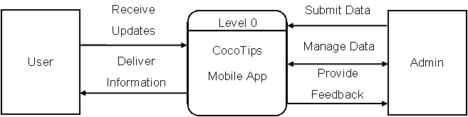

**Figure 2.** Data Flow Diagram

**System Flowchart**

The below figure illustrates structures of the CocoTips. It shows what happens to the mobile app and where it goes. These flowcharts were developed in the design stage.

Figure 3 shows the CocoTips Main Page where users can select various options to assist with coconut farming. The options include Farming Basics, offering guides on planting, watering, and pest management. In Seasonal Tips, providing month-by-month farming advice; Varieties, giving information on different coconut types; and an About Page, explaining the purpose of the app.

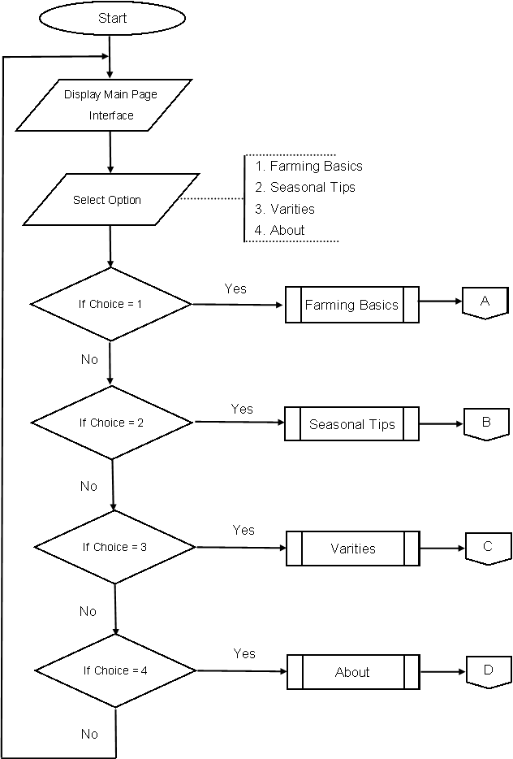

H

**Figure 3.** CocoTips Main Page

Figure 4 illustrates the CocoTips Farming Basics page, where users can select from options like Planting Guides, Watering and Fertilizing, and Pest Control. The Planting Guides provide simple, step-by-step instructions on how to properly plant coconut trees, covering spacing and soil preparation. The Watering and Fertilizing section gives practical advice on how to maintain proper hydration and apply fertilizers for optimal growth. Lastly, the Pest Control offers basic tips for managing common pests and diseases to keep the coconut trees healthy.

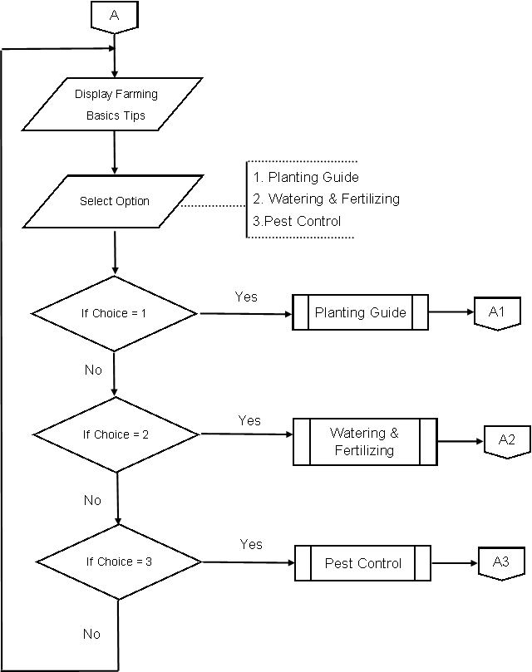

**Figure 4.** CocoTips Farming Basic page

Figure 5 shows the CocoTips Planting Guide Tip, featuring a step-by-step guide for planting coconut trees. This section details each stage of the planting process, from preparing the soil and selecting the right planting site to spacing the trees and initial care. The guide is designed to ensure users follow best practices for optimal growth and development of their coconut trees.

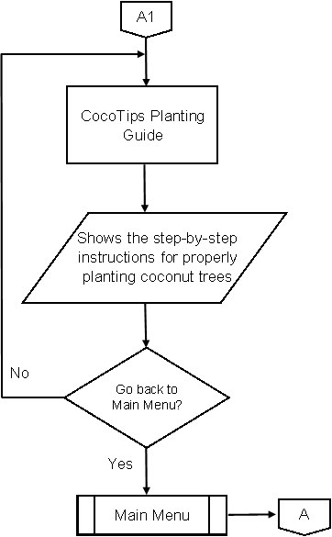

**Figure 5.** CocoTips Planting Guide Tip

Figure 6 shows the CocoTips Watering & Fertilizing Tips, which provides guidelines on maintaining proper hydration and applying fertilizers. This section outlines recommended watering schedules, the amount of water needed, and the types of fertilizers to use, ensuring users can effectively support healthy tree growth and maximize coconut yields.

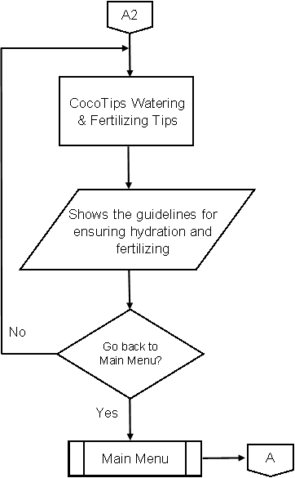

**Figure 6.** CocoTips Watering & Fertilizing Tips

Figure 7 shows the CocoTips Pest Control Tips, which offers practical advice on managing pests and diseases affecting coconut trees. This section includes guidance on identifying common pests, selecting appropriate treatments, and implementing monitoring practices to prevent and control infestations, ensuring the health and productivity of the coconut crop.

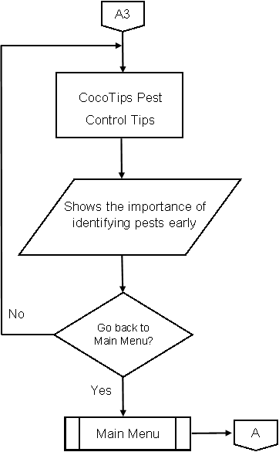

‘

**Figure 7.** CocoTips Pest Control Tips

Figure 8 displays the CocoTips Seasonal Tips page, where users can access month-by-month advice on the key farming activities for each season. This section provides tailored tips for planting, fertilizing, watering, and harvesting based on the time of year, helping farmers optimize their efforts according to seasonal weather conditions and the coconut growth cycle. The page ensures farmers are aware of the best times for crucial tasks, ultimately improving crop yield and tree health.

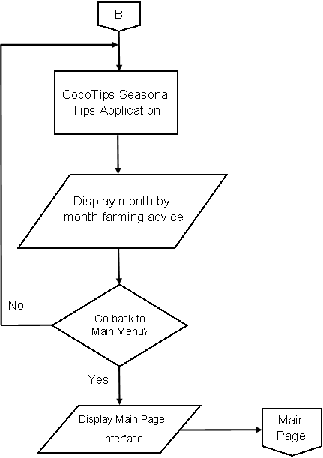

**Figure 8.** CocoTips Seasonal Tips

Figure 9 illustrates the Varieties page in CocoTips, where users can view an overview of different types of coconut trees. Each variety is briefly described, highlighting key characteristics such as growth rate, yield, and pest resistance. Users can explore more information by navigating through the varieties using the "Next" option or return to the main page by selecting the "Back" button. This layout helps farmers quickly compare and choose the best coconut variety for their needs.

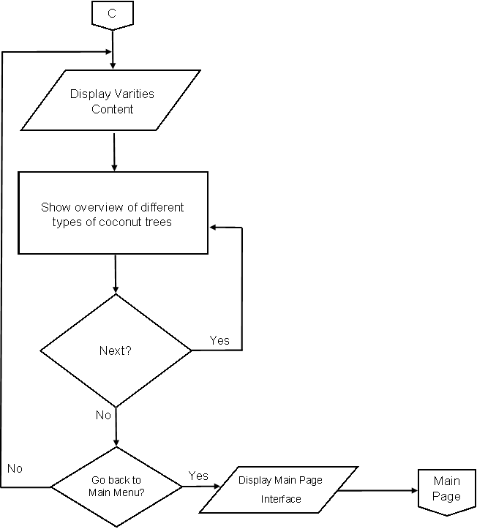

**Figure 9.** Varities Page

Figure 10 showcases the CocoTips About Page, where users can learn more about the purpose and mission of the app. This page provides a brief introduction to the app's goal of supporting coconut farmers by offering practical tips, guidance, and tools to improve farming practices. It also explains the key features of the app and how it helps farmers optimize their coconut production. Additionally, users may find contact information or links for further support, enhancing their overall experience with CocoTips.

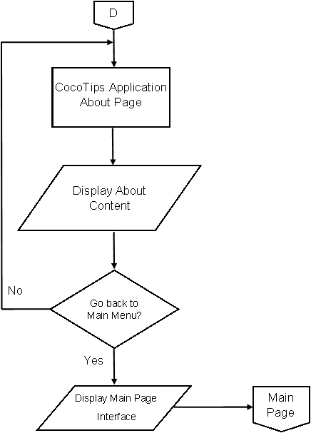

**Figure 10.** About Page

**Hardware Specification**

Table 2 illustrates the actual hardware used by developers to make CocoTips, this was made with the minimum hardware requirements. These should provide enough performance of the system that will allow the CocoTips App to run without any problem.

**Table 2.**

**Hardware Requirements**

|  |  |  |
| --- | --- | --- |
| **HARDWARE** | **MINIMUM REQUIREMENT** | **ACTUAL HARDWARE USED** |
| Laptop | 475 GB hard disk  8.00 GB RAM or better  Any type of brand and windows | 490 GB hard disk  4 GB RAM  ASUS  Windows 10 Home Single Language |
| Android phone | 4 GB RAM  32GB ROM  Any Android version | 16GB RAM  512 GB ROM  Redmi Note 13 Pro |

**Software Requirement**

In this table 3, it presents the minimum software requirements and the actual software that will be used in developing an CocoTips the alphabet learning app.

**Table 3.**

Software Requirements

|  |  |  |
| --- | --- | --- |
| **SOFTWARE** | **MINIMUM REQUIREMENT** | **ACTUAL SOFTWARE USED** |
| Android Studio | Compatible with Windows  XP/Higher versions | Android Studio Iguana | 2023.2.1  Windows |
| Unity Hub | Unity Hub Version 3.4.2 | Unity Hub Version 3.4.2 |

**BIBLIOGRAPHY**

Aguilar, Edna & Montesur, Jaime & Lacsina, Juliene. (2023). Capacitating Strategies to Promote Climate Resilient Coconut-based Farming Systems (CR-CBFS) in Vulnerable Coconut Communities of the Philippines. IOP Conference Series: Earth and Environmental Science. 1235. 012002. 10.1088/1755-1315/1235/1/012002.

Arumugam, T., & Hatta, M. A. M. (2022). Improving Coconut Using Modern Breeding Technologies: Challenges and Opportunities. Plants (Basel, Switzerland), 11(24), 3414. https://doi.org/10.3390/plants11243414

Baihaqi, Akhmad & Romano, R & Hamid, Henna & Indra, I & Kasimin, S & Ulya, Z & Bakar, B & Aziz, A & Idawanni, I & Wahyuni, I. (2023). Coconut farming development strategy in Bireuen Regency using hierarchy process analysis. IOP Conference Series: Earth and Environmental Science. 1183. 012026. 10.1088/1755-1315/1183/1/012026.

Bennett, G., J. Owens, and R. Corrigan. 2005. Truman’s scientific guide to pest management operations, 6th ed. West Lafayette, IN: Purdue University.

Beveridge, F. C., Kalaipandian, S., Yang, C., & Adkins, S. W. (2022). Fruit Biology of Coconut (Cocos nucifera L.). Plants (Basel, Switzerland), 11(23), 3293. https://doi.org/10.3390/plants11233293

Caoili, Barbara & Lee, Catherine. (2023). A Conceptual Framework for a Modern Science of Integrated Pest Management for Pests and Diseases of Coconut. IOP Conference Series: Earth and Environmental Science. 1179. 012007. 10.1088/1755-1315/1179/1/012007.

Crisostomo, S. D., Cruz, C. D. D., Quilloy, R. B., & Reaño, C.,E. (2023). Narrowing the yield gap of coconut (cocos nucifera L.) through integrated nutrient management in the philippines: An on-farm experiment approach. IOP Conference Series.Earth and Environmental Science, 1235(1), 012008. doi:https://doi.org/10.1088/1755-1315/1235/1/012008

DebMandal, M., & Mandal, S. (2011). Coconut (Cocos nucifera L.: Arecaceae): in health promotion and disease prevention. Asian Pacific journal of tropical medicine, 4(3), 241–247. https://doi.org/10.1016/S1995-7645(11)60078-3

Lima, E. B., Sousa, C. N., Meneses, L. N., Ximenes, N. C., Santos Júnior, M. A., Vasconcelos, G. S., Lima, N. B., Patrocínio, M. C., Macedo, D., & Vasconcelos, S. M. (2015). Cocos nucifera (L.) (Arecaceae): A phytochemical and pharmacological review. *Brazilian journal of medical and biological research = Revista brasileira de pesquisas medicas e biologicas*, *48*(11), 953–964. https://doi.org/10.1590/1414-431X20154773

Malshe, Kiran & Wankhede, Santosh & Ghavale, Sunil. (2024). Assessment of coconut (Cocos nucifera) + bitter gourd (Momordica charantia) intercropping system. International Journal of Research in Agronomy. 7. 621-622. 10.33545/2618060X.2024.v7.i7h.1100.

Oliveira, Maria & Rodrigues, Tatiana & Antonio, Carlos & Sobrinho, Henrique & Pontes, Alline & Pinheiro, Patrícia & Vieira, Fernandes & Oliveira, Thialle & Conceição, Ingrid & Guerra, Dantas. (2023). Sustainability in Gastronomy: Production of fermented beverage prepared with coconut green pulp (Cocos nucifera Linn.). Gaia Scientia. 17. 1-14. 10.22478/ufpb.1981-1268.2023v17n1.62795.

Pandiselvam, R., Kaavya, R., Martinez Monteagudo, S. I., Divya, V., Jain, S., Khanashyam, A. C., Kothakota, A., Prasath, V. A., Ramesh, S. V., Sruthi, N. U., Kumar, M., Manikantan, M. R., Kumar, C. A., Khaneghah, A. M., & Cozzolino, D. (2022). Contemporary Developments and Emerging Trends in the Application of Spectroscopy Techniques: A Particular Reference to Coconut (Cocos nucifera L.). Molecules (Basel, Switzerland), 27(10), 3250. https://doi.org/10.3390/molecules27103250

Roopan S. M. (2016). An Overview of Phytoconstituents, Biotechnological Applications, and Nutritive Aspects of Coconut (Cocos nucifera). Applied biochemistry and biotechnology, 179(8), 1309–1324. <https://doi.org/10.1007/s12010-016-2067->y

Sasidharan, Parvathy & Borate, Hemant & Malshe, Kiran. (2024). Development of an index to measure the managerial competency of coconut growers in coconut-based farming system. 23-28. 10.33545/26180723.2024.v7.i7c.788.

Satheesan, Avani. (2024). Problems and Issues of Tropical Coconut Cultivation. INTERANTIONAL JOURNAL OF SCIENTIFIC RESEARCH IN ENGINEERING AND MANAGEMENT. 08. 1-10. 10.55041/IJSREM28502.

S.V., Ramesh & Praveen, Shelly. (2024). Coconut Biomolecules-Future Perspectives. 10.1007/978-981-97-3976-9_13.

Thamban, C & Subramanian, P & Jayasekhar, S & Jaganathan, D. & K., Muralidharan. (2016). Group approach for enhancing profitability of small holders through technology integration -Reflections from coconut farming. Journal of Plantation Crops. 44. 158-165. 10.19071/jpc.2016.v44.i3.3165.

Ts, Abhishek & Dwivedi, Sunil. (2021). Review on integrated pest management of coconut crop. 6. 115-120.

Winotai, Amporn. (2014). Integrated Pest Management of Important Insect Pests of Coconut1. CORD. 30. 19. 10.37833/cord.v30i1.82.

Yap, E. (2014). Aging Small Scale Coconut Farmers in Central Philippines -- Their Perspectives on Farming, Succession and Future Impact on the Local Ecology. IAMURE International Journal of Ecology and Conservation, 11(1).

Yousefi, K., Abdullah, S. N. A., Hatta, M. A. M., & Ling, K. L. (2023). Genomics and Transcriptomics Reveal Genetic Contribution to Population Diversity and Specific Traits in Coconut. Plants (Basel, Switzerland), 12(9), 1913. https://doi.org/10.3390/plants12091913

Marasigan, S. B. & Serrano, J. V. (2014). Indigenous Farming Families of Ifugao: Partners in Safeguarding the Sustainable Use of Natural Resources. IAMURE International Journal of Ecology and Conservation, 10(1).