# Signature Analysis – User guide

In order to execute this application, Framework .Net 5.0 is required.

Steps

1. Execute the Signature Analysis solution from Visual Studio or executing the file “SignatureAnalysis.exe” located in the publish folder.
2. After the application is running, the first input request will be displayed (Path of the directory to be analyzed).
3. Enter the Path of the folder that the system should analyze.

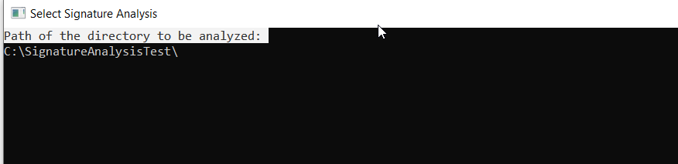

1. After a valid directory has entered in the first input request, the second input request will be displayed (Path for the output file).
2. Enter the Path where you want the system to save the new CSV file with the result of the analysis.

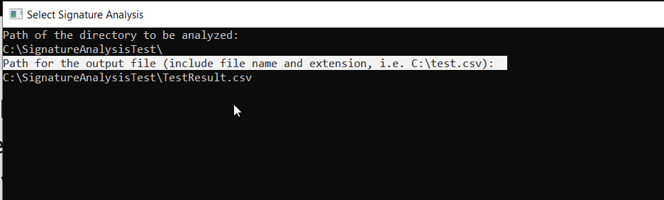

* 1. In case you enter an existing file name, the system will ask you if you want to replace the existing file or not.
  2. If the user does not want to replace the existing file, must enter a different path.

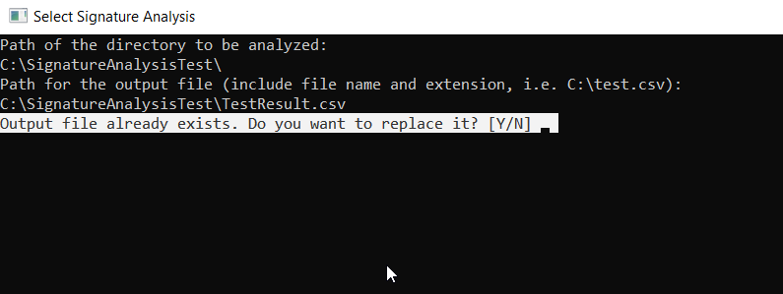

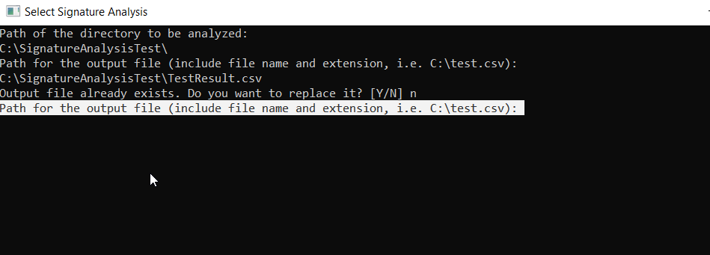

1. In the next step the system will ask if the user wants to analyze the subdirectories or not.
   1. User should type Y or N keys.

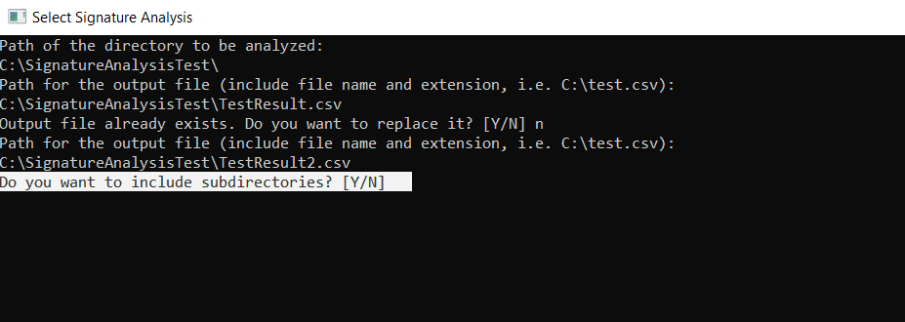

1. As a final step, the system will display the errors that have occurred, in case of any.
2. 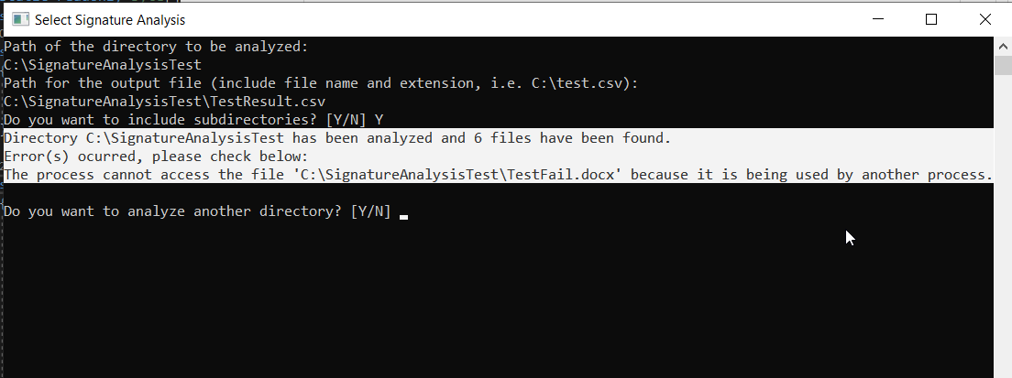System will ask the user if wants to analyze any other folder or finish the process.