The two kangaroos jump through the following sequence of locations:

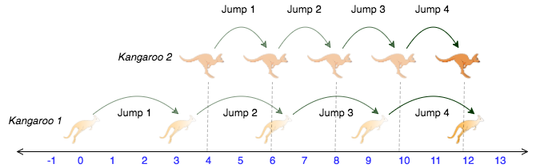

**Note:** The two kangaroos must land at the same location after making the same number of jumps.

Solution:

import java.io.*;

import java.math.*;

import java.security.*;

import java.text.*;

import java.util.*;

import java.util.concurrent.*;

import java.util.regex.*;

public class Solution

{

    static String kangaroo(int x1, int v1, int x2, int v2)

    {

        if((v1-v2)<=0)

        {

            return("NO");

        }

        else if((x2-x1)%(v1-v2)==0)

        {

            return("YES");

        }

        else

            return("NO");

    }

    public static void main(String[] args) throws IOException

    {

        BufferedWriter bufferedWriter = new BufferedWriter(new FileWriter(System.getenv("OUTPUT_PATH")));

Scanner scanner = new Scanner(System.in);

        String[] x1V1X2V2 = scanner.nextLine().split(" ");

        int x1 = Integer.parseInt(x1V1X2V2[0]);

        int v1 = Integer.parseInt(x1V1X2V2[1]);

        int x2 = Integer.parseInt(x1V1X2V2[2]);

        int v2 = Integer.parseInt(x1V1X2V2[3]);

        String result = kangaroo(x1, v1, x2, v2);

        bufferedWriter.write(result);

        bufferedWriter.newLine();

        bufferedWriter.close();

        scanner.close();

    }

}