Semester 2 Media Bazaar Project

S2-S-CB-05, Group 4

Nitu Ana, Onea Bianca, Cetinic Franulovic Ante, Barbaro Vid

Software Engineering  
Project Plan

February 22, 2021

Contents

1. Client 2

2. Team 2

3. Current situation 2

4. Problem Description 3

5. Project Goal 3

6. Deliverables 3

7. Description of the users in the Project 4

# Client

The client our team is getting feedback, requirements and requests for the project from is Ms. Qin Zhao, the representative for the company Media Bazaar. Ms. Qin Zhao is the only member of Media Bazaar that is in charge of finding a software solution for managing employees and products of the company. Media Bazaar is a small startup hardware store in Eindhoven that currently has around 50 employees and is looking to scale up to a 100 employees soon.

Contact Ms. Qin Zhao at: [q.zhao@fontys.nl](mailto:q.zhao@fontys.nl)

# Team

The members of our team are: Nitu Ana, Onea Bianca, Cetinic Franulovic Ante and Barbaro Vid. Our team representative is Nitu Ana, she is the person that talks to the client mainly and represents all the features and ideas the team came up with.

Contact Nitu Ana at: 457646@student.fontys.nl

# Current situation

Our team is creating this software from scratch, meaning we don’t have any existing or outdated system to upgrade or base our project from. The client doesn’t have any preferences from some existing software solutions on the market, and wants a new solution that isn’t on the market yet.

The client has hired 4 other teams that are tasked with the same project so these teams are our direct competitors.

# PROBLEM DESCRIPTION

Currently the main priority and the biggest problem our client has is managing employees effectively and keeping track of their shifts and working hours, alongside that the clients priority is to be able to promote the employees as well as change their salaries.

The second issue is managing and keeping track of the products meaning that the employees need to be able to request new product shipments from the warehouse when there are low supplies on certain products in the store. There should as well be a search feature for products so browsing by category in the application is going to be more effective.

# project goal

The goal of the project is to make a simple and effective application that everyone inside a company should be able to use. We are not targeting a certain age group for the users because inside Media Bazaar there are employees of all ages. The main goal we will try to achieve is to make our application easy to use but at the same time cover all the features the client wanted and more.

Our application has to manage employees easily and make it simple for managers to keep track of their employees and their details like salaries and work hours.

# DELIVERABLES

For the first 6 weeks we are going to be delivering a solution for managing employees and products of the hardware store Media Bazaar, and make that solution scalable for future improvements and additions.

# Description of the users in the Project

Media Bazaar requires a software project for managing employees and products and they contacted us, Ctrl Software Solutions, to build it.

After having the talk with our client, we were able to came up with the main structure of the software project for managing the Media Bazaar hardware store.

The first step was to identify and clarify the main users of the application and the accessibility. We have 3 ranks: the director(s), managers and workers.

* CEO / CTO / Admin is the user that has access to every feature and can view and modify both employees’ database and products database.
* The managers are divided in two: Employee Manager and Inventory Manager. The Employee Manager has to fulfill every task concerning the sales workers and the warehouse workers. He has access to the employees’ database that contains essential information about the employees (id, name, phone, address, email, hourly wage, hours worked etc.). On the other hand, the Inventory Manager is responsible with the stocks, products, warehouse employees. He has direct contact with the distributors and is in charge of making orders, research on new products and decide on whether the company should keep selling them or not.
* Both sales workers and warehouse have less accessibility on the application. They can view their profile, send requests for holidays or sick days, see their productivity statistics. The only difference between the two types of employees is that the warehouse can make requests or remarks to the inventory managers for certain products.

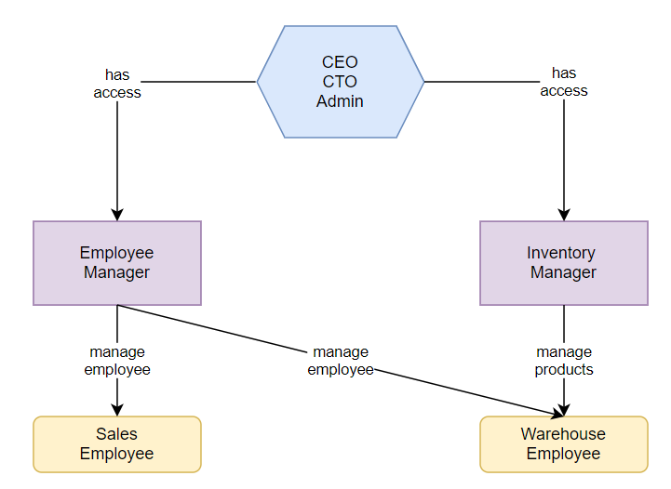

# Description of the users in the Project