
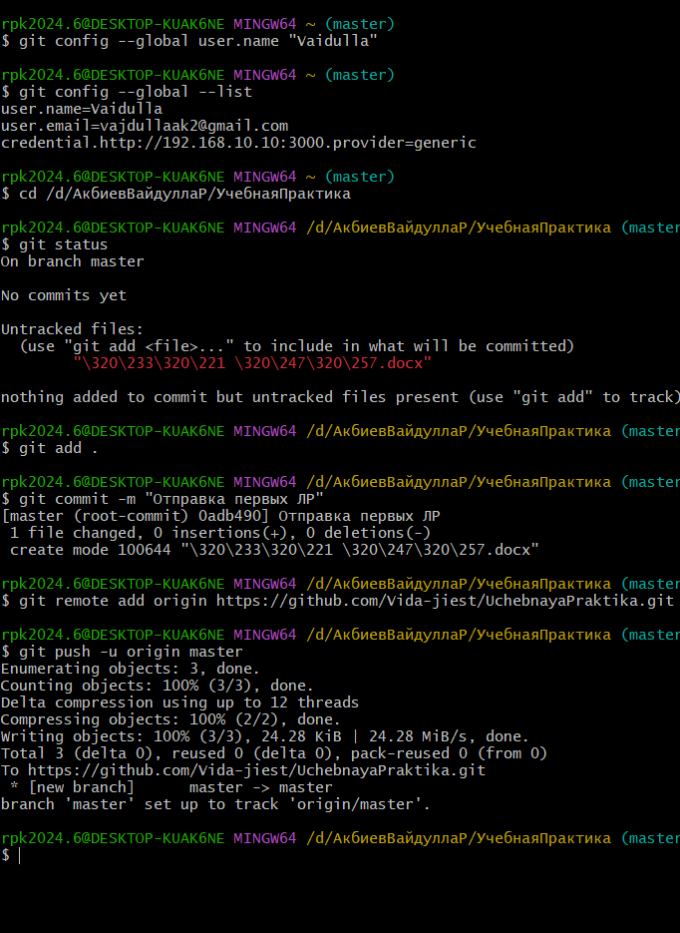
https://steamcommunity.com/market/listings/730/AWP%20%7C%20Capillary%20%28Minimal%20Wear%29

https://steamcommunity.com/market/listings/730/AWP%20%7C%20Capillary%20%28Minimal%20Wear%29

