This is a test document.

* A rough plan of the things we need to do over the project.
* Different possible usecases. 6 uses cases, 3 fully dressed.
* Who will create the GitHub project
* Upload the group contract (Christoffer!!!)
* Make the phase plan
* Have some idea about the domain model
* Set up milestones for finishing the project: at what time should we finish which part and so on
* Decide whether we should start the coding (or at least build the main classes and database tables) while working on the design?
* Who is doing what?

**Meeting 15/10/2014**

1. GUI Prototype ( starts Thursday 23/10/2014)
2. Use cases: find out as many as possible -> 6 use cases, 3 fully dressed

* login system (not a use case, but required for OS). CRUD users (admin staff)
* add cottage (luxury/standard) (CRUD)
* **- ADD Cottage Fullydressed - Martin**
* rent out a cottage to customer
* add customer, remove, edit (CRUD)
* setup season duration
* Set renovation
* **reserve cottage (*) - we provide the ability to reserve without payment for 48hrs (added feature) - Fullydressed - Ai**
* register payment (*)
* **display cottages (*): see if a cottage is available or not, if yes, which customer is renting it - Fullydressed - Ørn**
* print out receipt
* email receipt
* calculate cost
* log (security purpose)
* Google map overlay
* **Christoffer: Martin will discuss with Chis if he wants to take over a fully dressed use case instead (Ai’s use case), and Ai can do the 3 other brief use cases**

1. Review other’s work: Martin -> Ai -> Ørn -> Christoffer -> Martin
2. Setting up GitHub

* **Ørn has set it up**

1. Uploading the Group contract.

* Martin will take contact to Christoffer, and make a deal with him about that.

1. Inception:
   1. To develop an initial risk assessment, schedule, and estimate for your system
   2. To develop an initial tailoring of the Unified Process to meet your exact needs

* **Risk assessment: Ørn**
* **Schedule: Ørn**
* Estimate the scope of the system: *The system is limited to staff only. It’s an internal system that has to purpose of helping the employees managing the reservations and cottage renovations. - Martin will write a small chapter for the project.*

1. **Documentation: Word document with the index of what the subjects’ requirements are (Ai)**
2. Domain model:

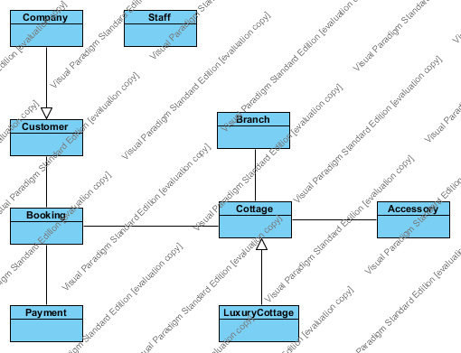

1. Milestone:
   1. Finish and hand-in on 6th Dec 2014
   2. 3rd Dec: start reviewing entire project
   3. Talk to Christoffer about northern lights (optional)
   4. Spend 1 week after finishing design to design the database and finalize it.
   5. Next time we talk each should have their own version of the database design (23/10/2014)