Farming Made Easy using Machine Learning
In this paper author is using various machine learning algorithms such as Random Forest, Decision Tree and KNN to predict crop prices. All this algorithms get train on Crop Prices dataset which contains crop details weather details such as Rainfall and below screen showing dataset details with crop name, market name with prices and Rainfall
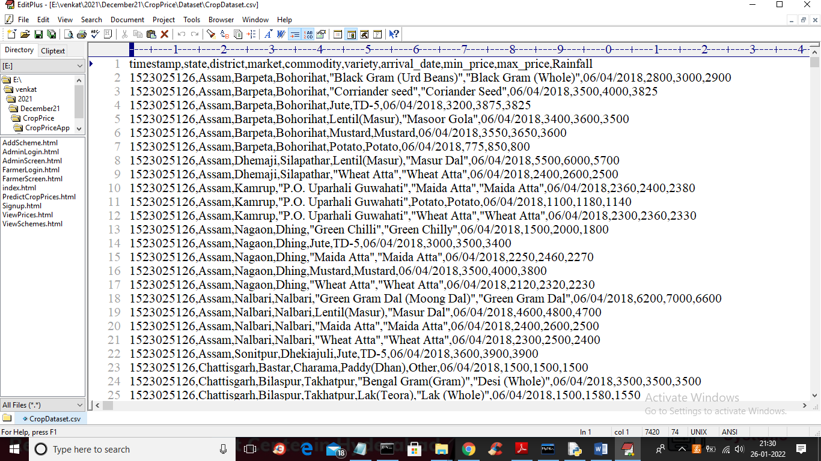
In above dataset screen first row represents dataset column names and remaining rows represents dataset values. In above dataset we can see different prices for same crop in different market name and so in application we can select any crop name and then application will predict prices based on selected crop and market name.
To implement this project we have designed following modules
- New Farmer Signup: using this module farmers can signup with application
- Farmer Login: farmer can login to application by using username and password given at signup time and then farmer can select crop name to get its predicted prices in different market. Farmer can view all schemes details launched from the government
- Admin Login: admin can login to application by using ‘admin’ as username and password and then can add new schemes details
First create database in MYSQL by copying content from ‘DB.txt’ file and paste in MYSQL console
SCREEN SHOTS
To run project double click on ‘run.bat’ file to start DJANGO server and then open browser and enter URL as ‘http://127.0.0.1:8000/index.html’ to get below home page
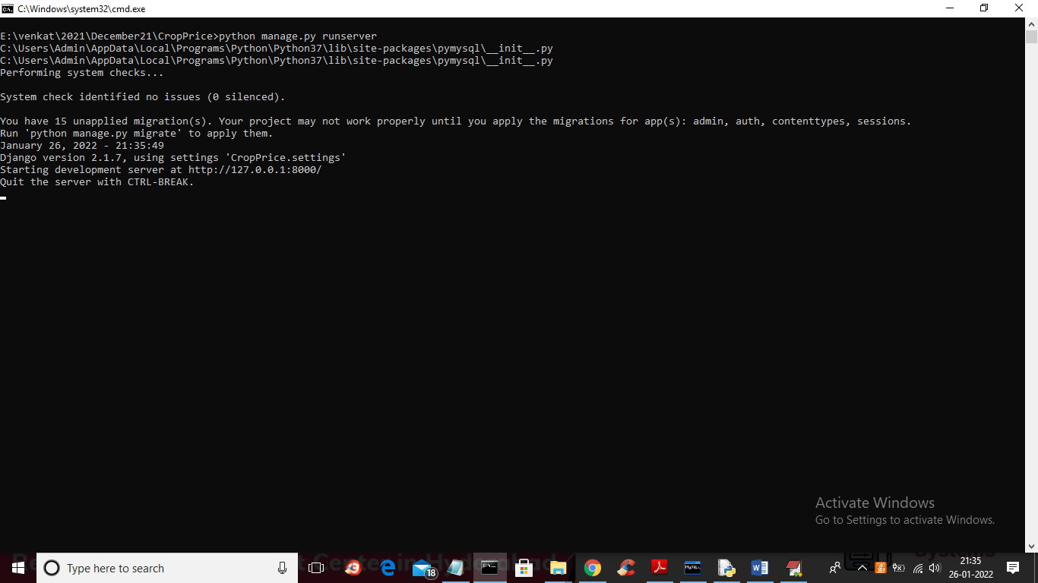
In above screen server started and now open browser and enter URL
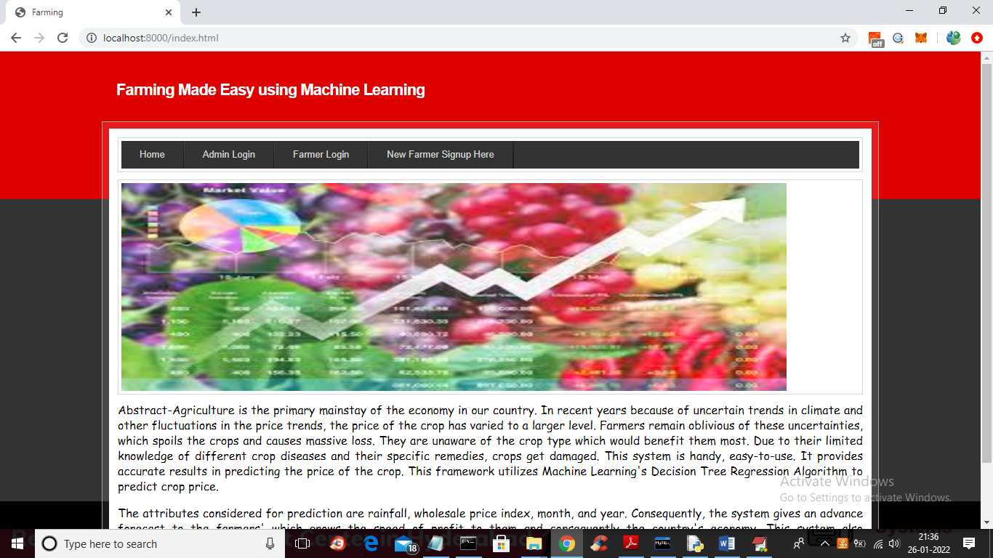
In above screen click on ‘Admin Login’ link to get below login screen
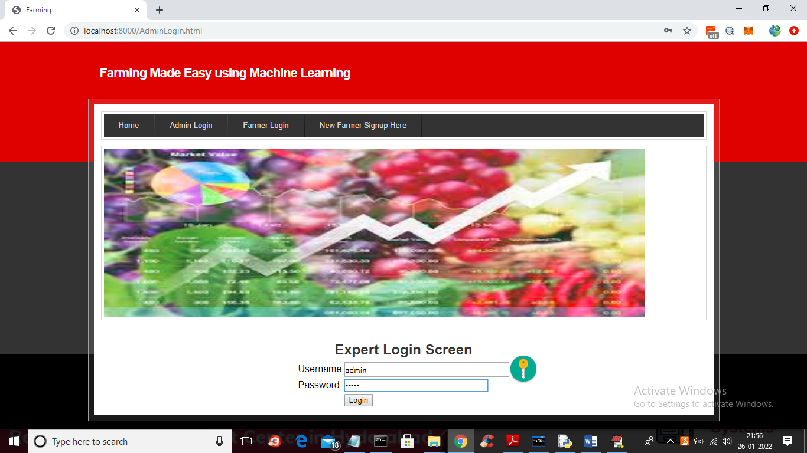
In above screen admin is login and after login will get below screen
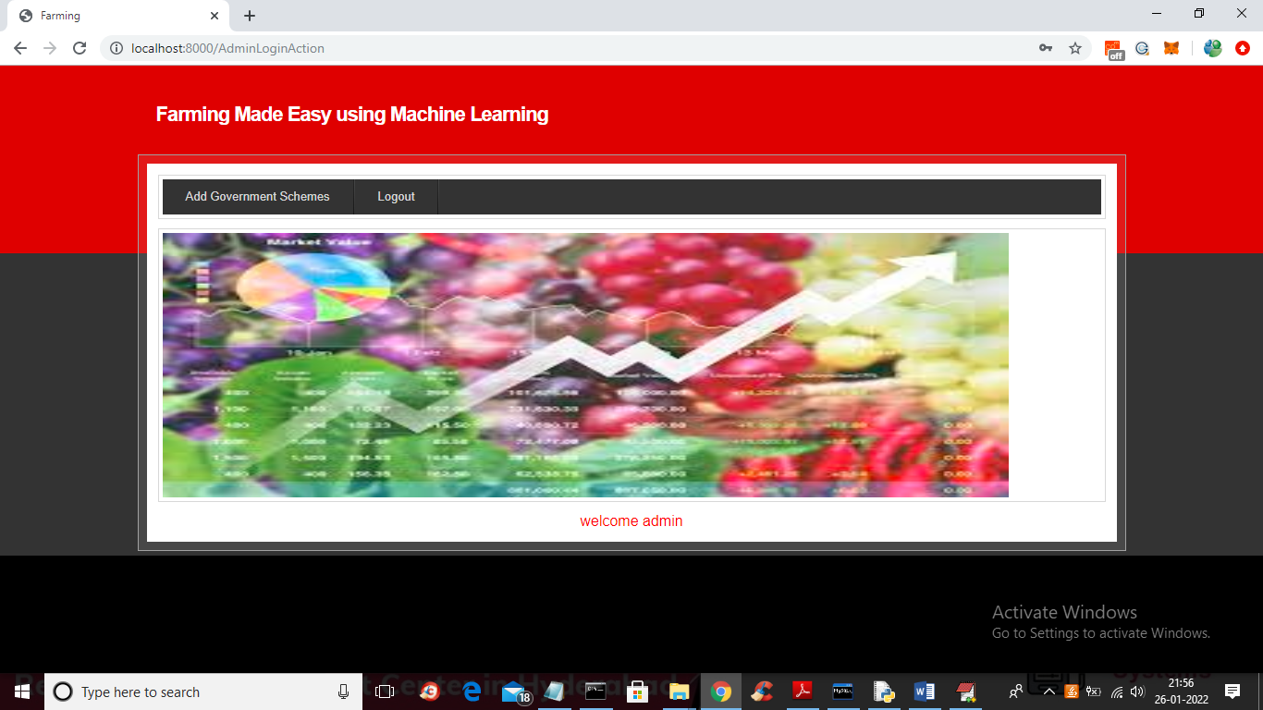
In above screen click on ‘Add Government Schemes’ link to add new schemes
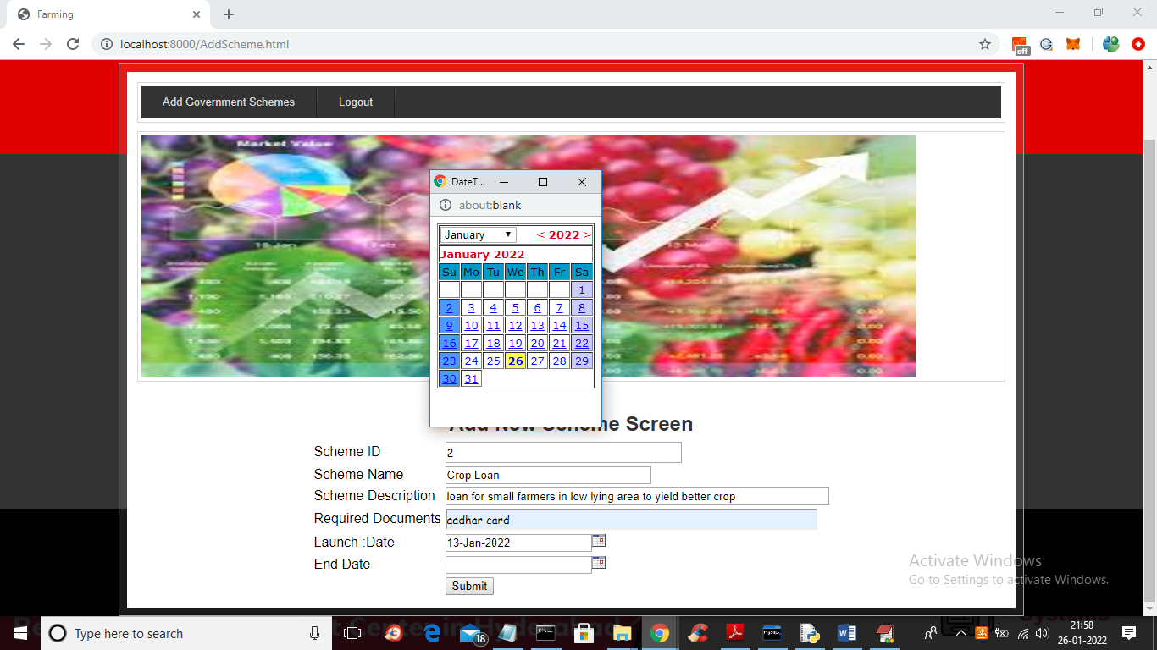
In above screen admin will ad schemes details with start and end date and then click on ‘Submit’ button to save schemes details
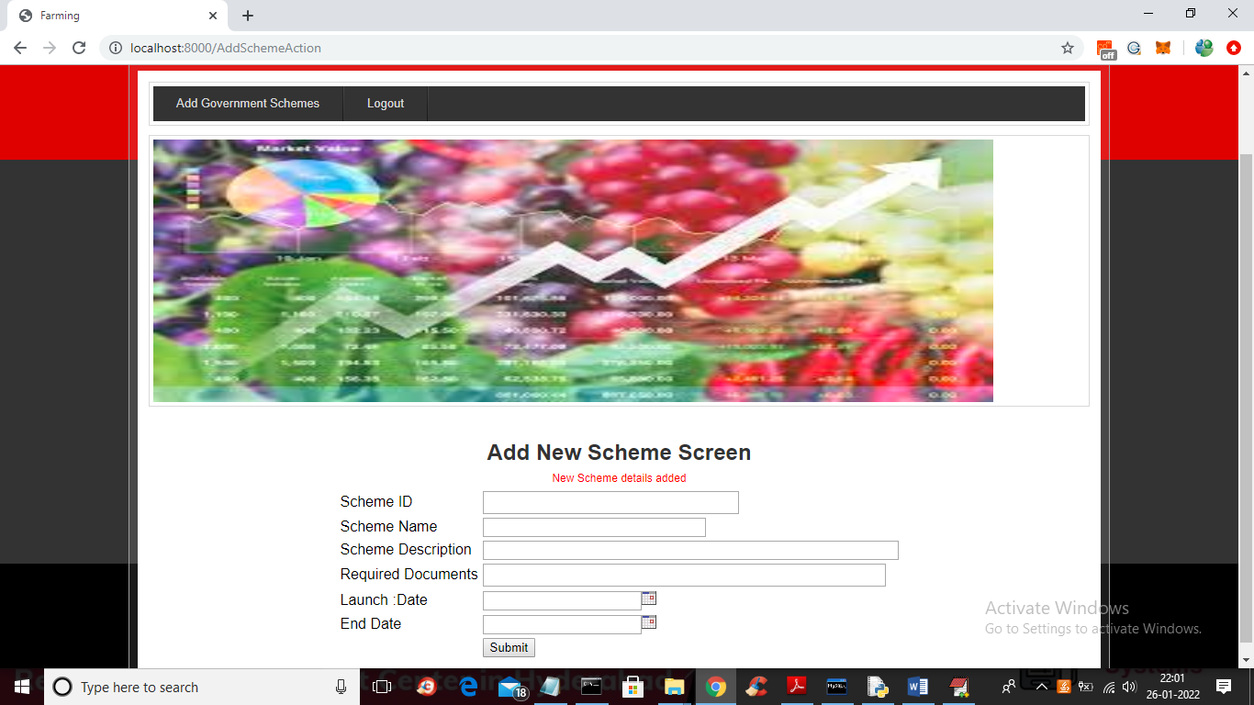
In above screen in red colour text we can see scheme details added and now logout and signup new farmer
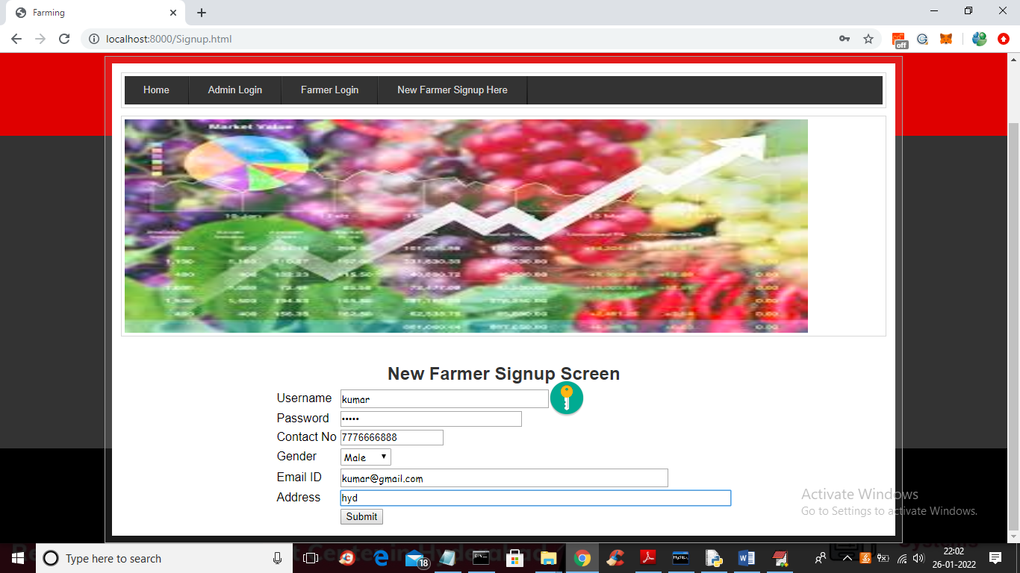
In above screen farmer is signup and click on ‘Submit’ button to complete signup process
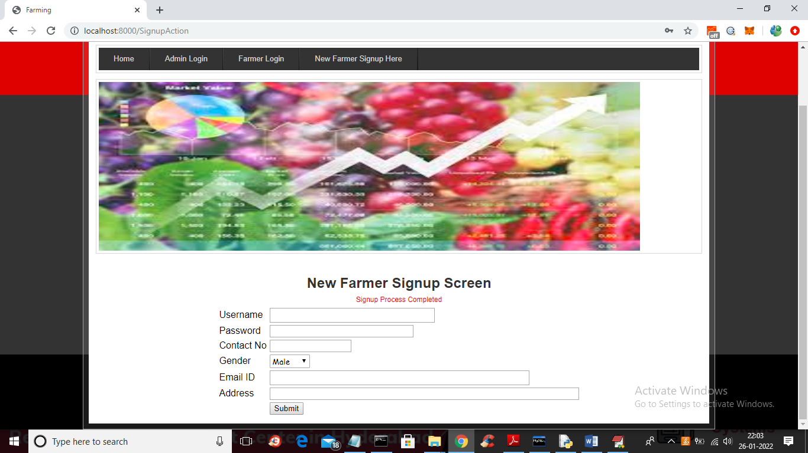
In above screen signup is completed and now click on ‘Farmer Login’ link to get below screen
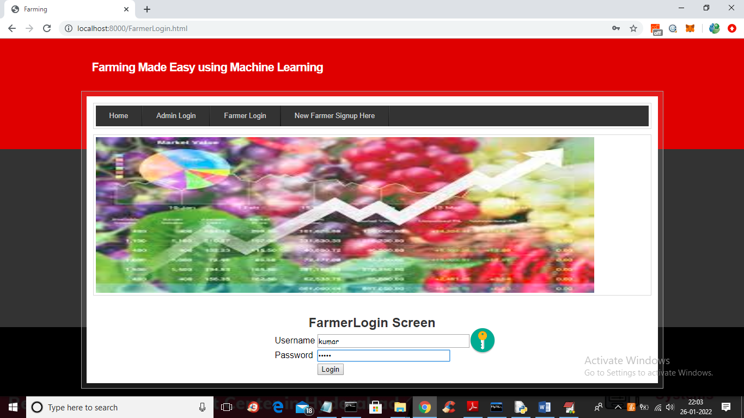
In above screen farmer is login and click on ‘Login’ button to get below screen
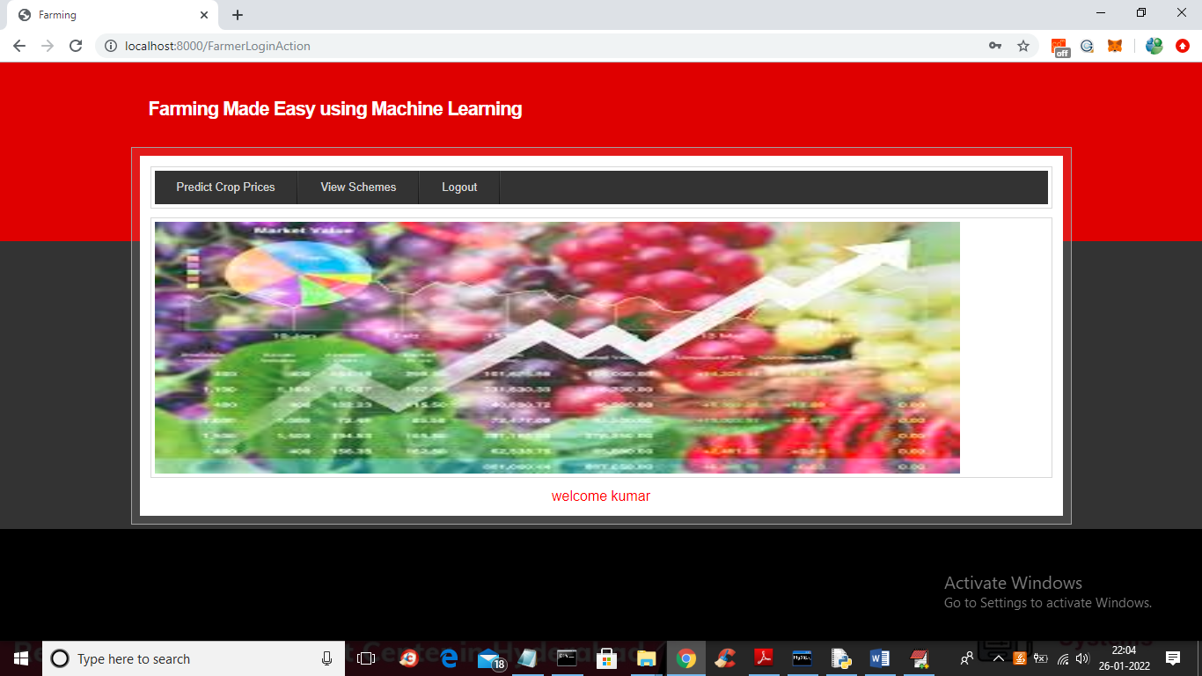
In above screen farmer can click on ‘View Schemes’ link to get all schemes details
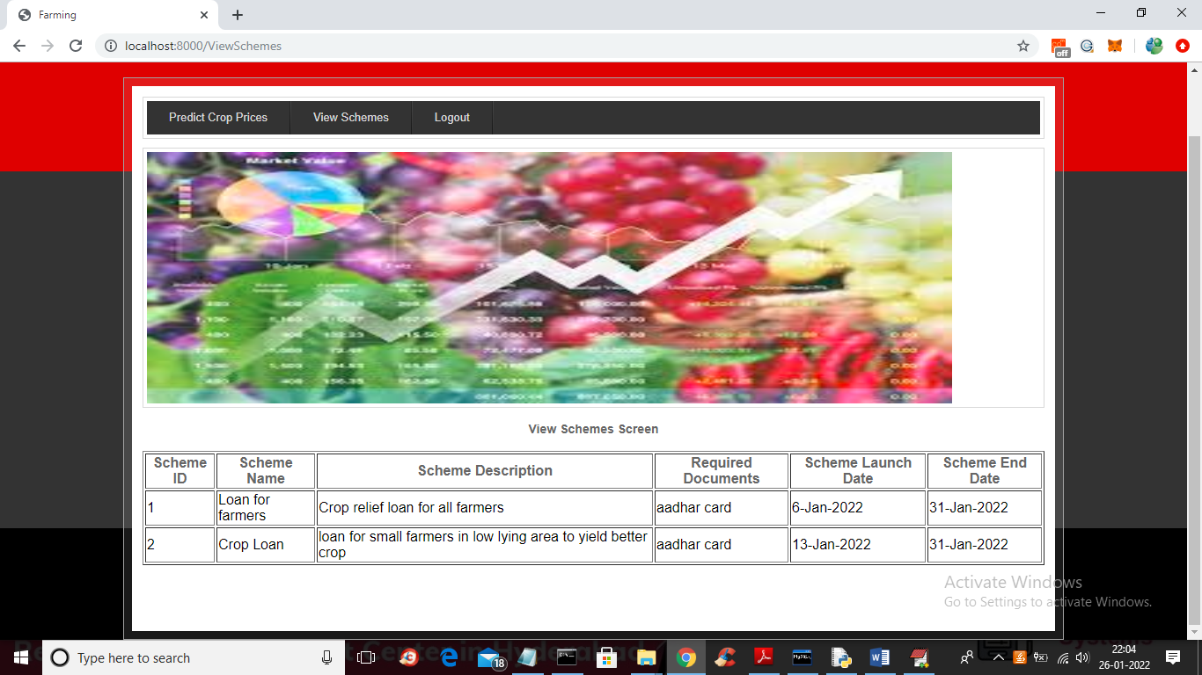
In above screen all schemes details can be viewed by farmer and now click on ‘Predict Crop Prices’ link to get below screen
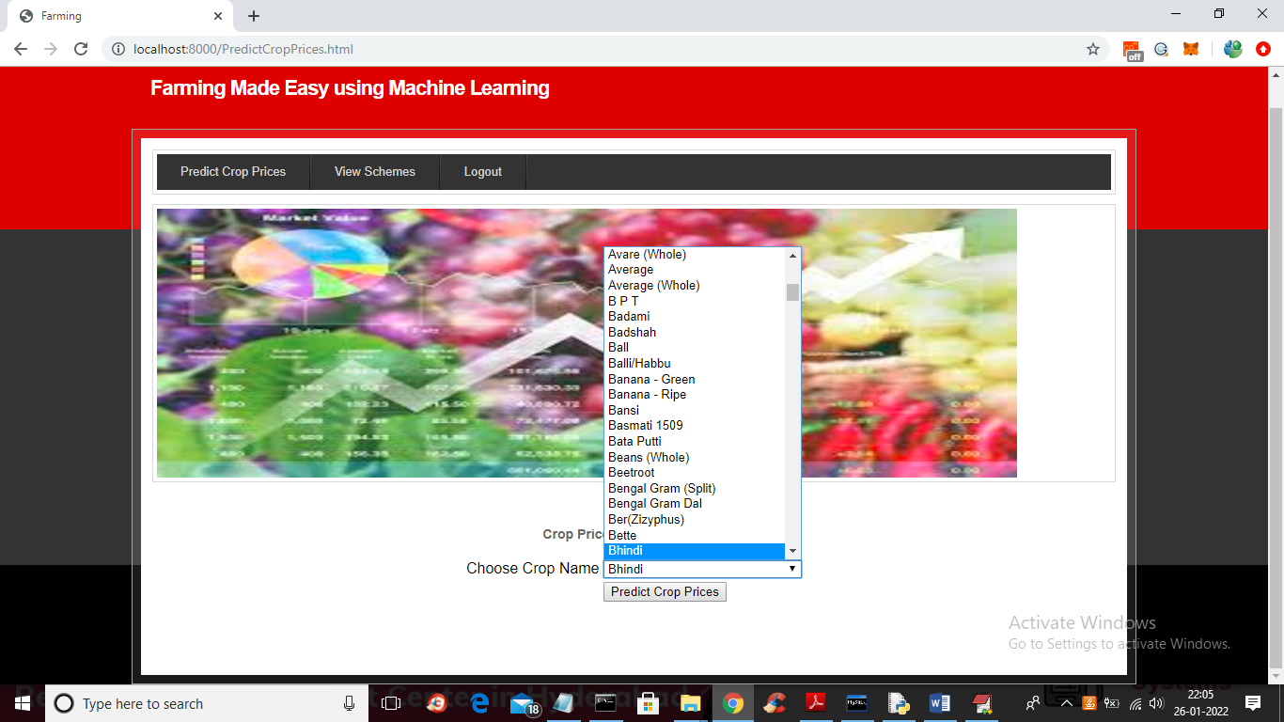
In above screen farmer can select desired crop and then click on ‘Predict Crop Prices’ link to get below prediction
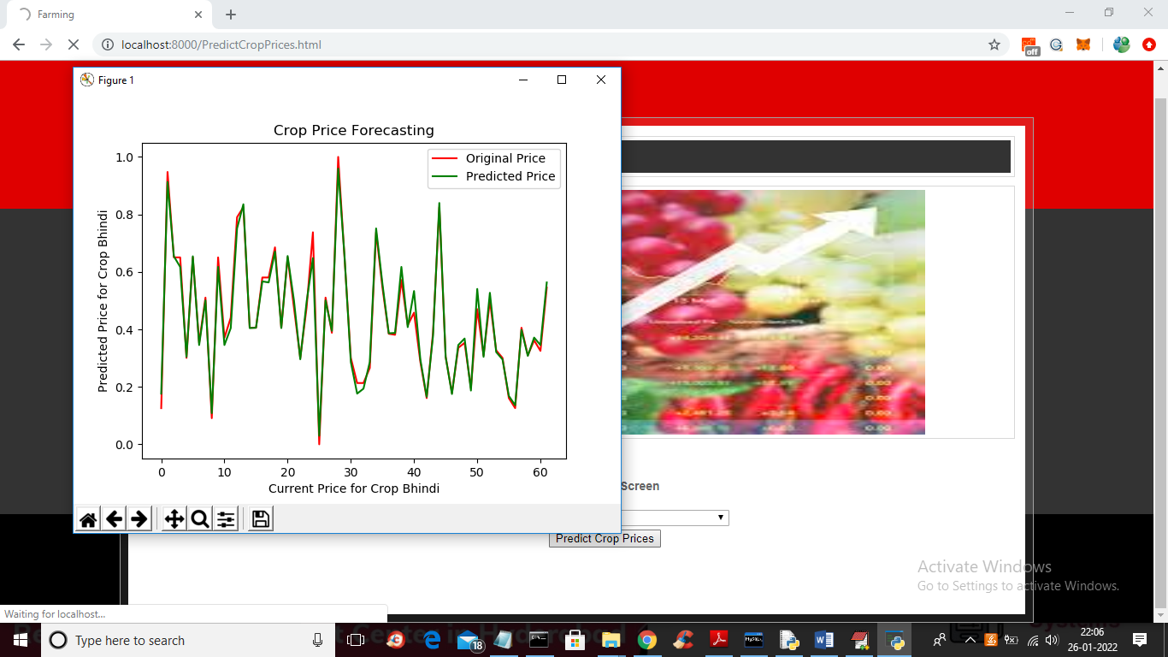
In above graph red line represents Original prices and green line represents predicted prices and by seeing above graph farmer can understand what is current price and what will be future price and now close above graph to view predicted values
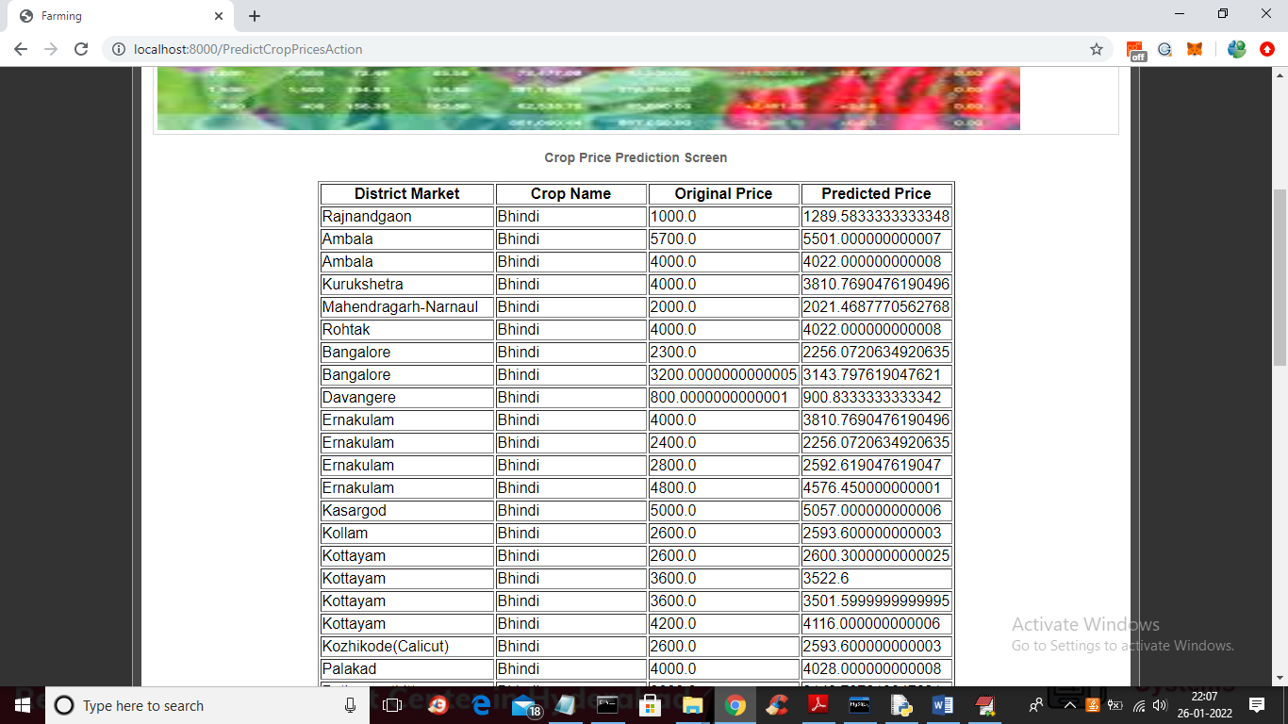
In above screen first column represents ‘district market name’ and second column represents ‘Crop Name’ and third column represents ‘Original Crop Price’ and fourth column represents “predicted prices’ using Machine learning algorithms and now scroll down above screen to view machine learning algorithms predicted accuracy
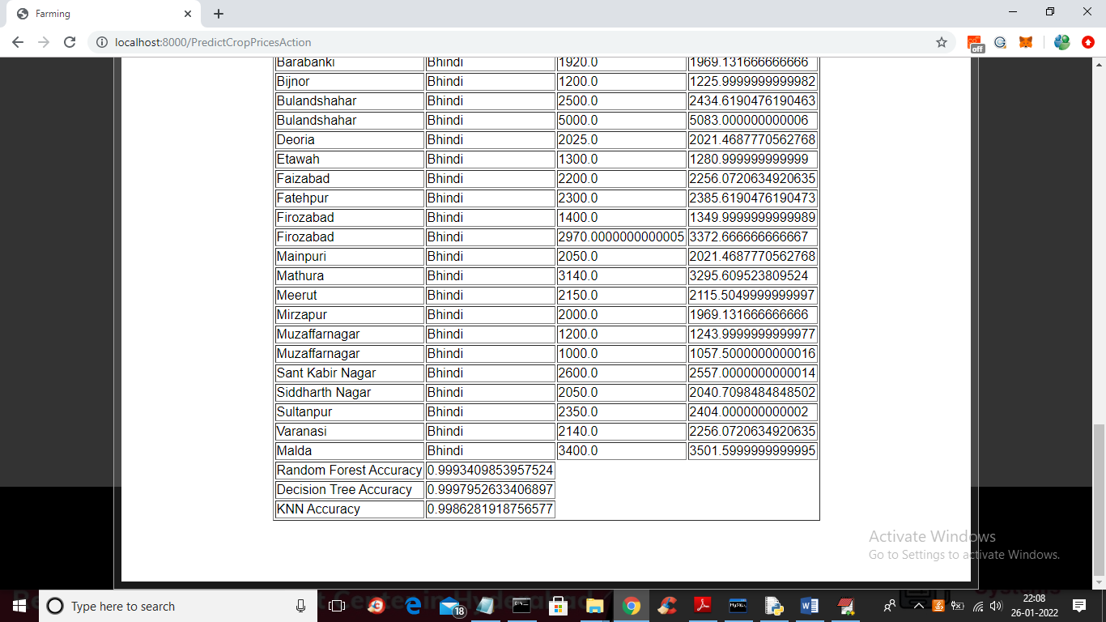
In above screen in last 3 lines we can see Random forest, KNN and decision tree prediction accuracy.
Similarly you can select any crop and get prediction prices
Note: some crop contains only 3 or 4 records so prediction may not be correct as to train we need minimum 50 to 100 records. Here bhindi and coriander crop contains more records

