Thapar Institute of Engineering and Technology, Patiala
Department of Electronics and Communication Engineering
UEC310 – Information and Communication Theory
Tutorial - 7
Q1 | Let $\{X(t),t∈[0,∞)\}$ be defined as $X(t)=A+Bt, for all t∈[0,∞),$ where A and B are independent normal N(1,1) random variables. Find  - All possible sample functions for this random process.  - Define the random variable Y=X(1). Find the PDF of Y.  - Let also $Z=X(2)$. Find $E[YZ]$.
Q2 | Consider the random process $\{X_{n},n=0,1,2,⋯\},$ in which $Xi's$ are i.i.d. standard normal random variables.  - Write down $f_{X_{n}}(x) for n=0,1,2,⋯.$  - Write down$f_{X_{m}X_{n}}(x_{1},x_{2}) for m≠n$.

Solution of tutorial-7
A1 | 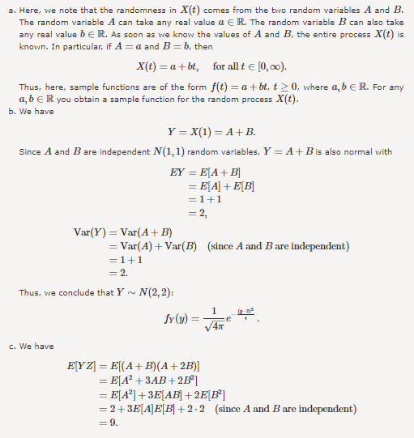
A2 | 