Thapar Institute of Engineering and Technology, Patiala
Department of Electronics and Communication Engineering
UEC310 – Information and Communication Theory
Tutorial - 3
Q1 | Suppose we have the following information:  - There is a 60 percent chance that it will rain today.  - There is a 50 percent chance that it will rain tomorrow.  - There is a 30 percent chance that it does not rain either day.  Find the following probabilities:  - The probability that it will rain today or tomorrow.  - The probability that it will rain today and tomorrow.  - The probability that it will rain today but not tomorrow.  - The probability that it either will rain today or tomorrow, but not both.
Q2 | Find the range for each of the following random variables.  - I toss a coin 100 times. Let X be the number of heads I observe.  - I toss a coin until the first heads appears. Let Y be the total number of coin tosses.  - The random variable T is defined as the time (in hours) from now until the next earthquake occurs in a certain city.
Q3 | Let X be a discrete random variable with the following PMF  $$p_{X}\left(x\right)=\left\{\begin{aligned}\begin{matrix}0.1 for x=0.2 \\ 0.2 for x=0.4\end{matrix} \\ \begin{matrix}0.2 for x=0.5 \\ 0.3 for x=0.8\end{matrix} \\ \begin{matrix}0.2 for x=1 \\ 0 otherwise\end{matrix}\end{aligned}\right.$$  - Find the range of the random variable X.  - Find $P(X≤0.5)$  - Find $P(0.25<X<0.75)$.  - Find $P(X=0.2|X<0.6)$.

Solution of tutorial-3

A1 | 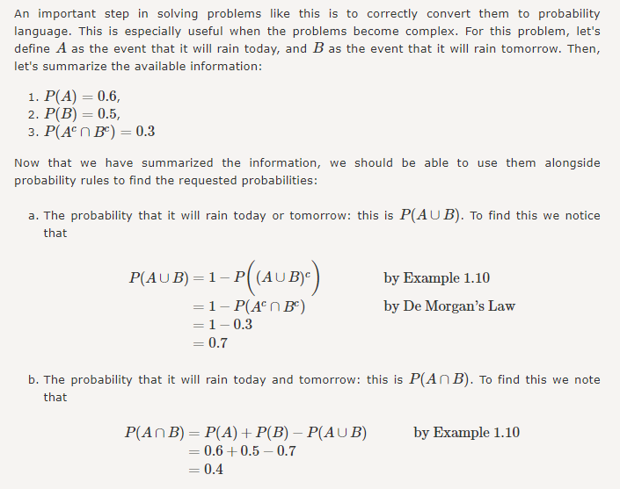  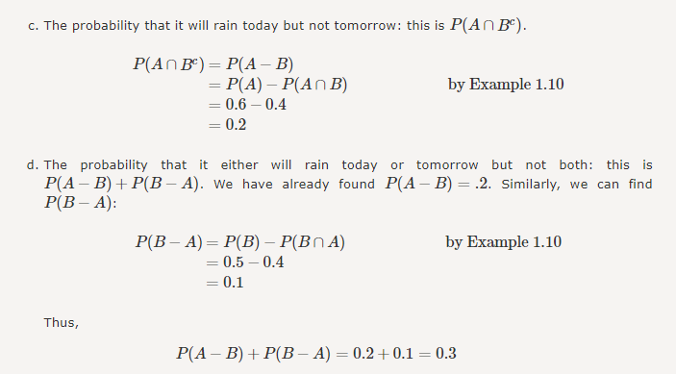
A2 | 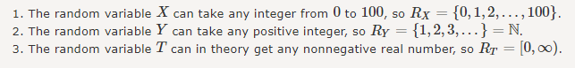
A3 | 