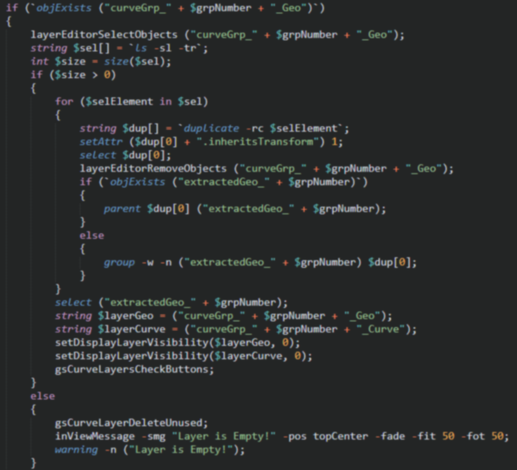

|  |
| --- |
| GS CurveTools v1.015  USER MANUAL  (tested in Autodesk Maya 2017-2020) |
| BY GEORGE SLADKOVSKY (VideoNomad)  [Online Store](https://sladkovsky3d.artstation.com/store)  [Discord Server](https://discord.gg/f4DH6HQ)  [Twitch Channel](https://www.twitch.tv/videonomad)  [YouTube Channel](https://www.youtube.com/channel/UCmIFpG98OqbUecaf5H-ixKQ)  [ArtStation](https://www.artstation.com/sladkovsky3d)  [Contact Email](mailto:george.sladkovsky@gmail.com) |
| december 23, 2019  All rights reserved |

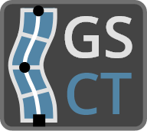

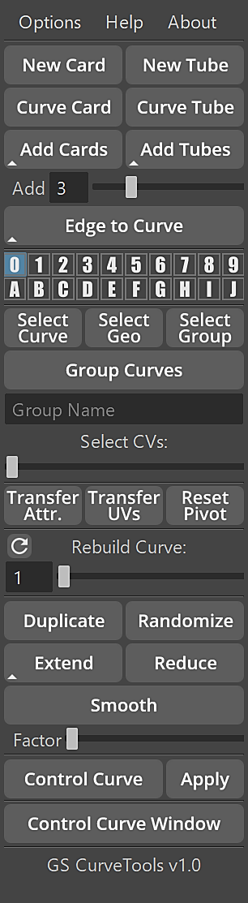

# Table of Contents

|  |  |
| --- | --- |
| Click on the list or select from the menu directly ->  Table of Contents 2  Introduction 3  Installation 4  New Curve Card/Tube 5  Curve Card/Tube Attributes 7  Applying Materials (Shaders) 9  Curve Card/Curve Tube 10  Add Cards/Add Tubes 11  Edge to Curve 12  Curve Layers 13  Selection and Grouping 15  Transfer of Attributes/UVs & Reset Pivot 16  Rebuild Curve Slider 18  Duplicate 19  Randomize 20  Extend/Reduce/Smooth 21  Control Curve 22  Curve Control Window 23  Options 24  Advanced Techniques 25 |  |

# Introduction

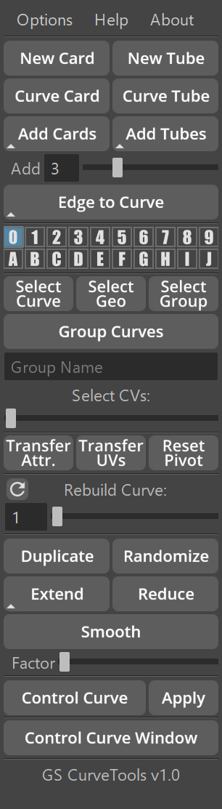**GS CurveTools** is a powerful tool to used create and manipulate geometry cards and tubes (**Curve Cards** and **Curve Tubes**). **GS CurveTools** can be used in numerous workflows, from **hair card** creation, to creation of complex procedural braided cables and much more.

The main power of this **GS CurveTools** is its ability to quickly create complex network of nodes, tailored for fast manipulation of geometry in a smooth and natural way.

One of the main focuses of **GS CurveTools** is Hair Cards workflow. Almost every game out there uses some form of hair cards to create complex and beautiful hair styles for its main characters. To be able to quickly create new hair cards, convert curves to hair cards and quickly change its parameters is very important part of **GS CurveTools** workflow.

Main Features of **GS CurveTools:**

* Fast **creation** of procedural geometry cards and tubes
* **Conversion** of already existing curves to curve cards/tubes
* Ability to quickly **populate empty spaces** between curves with new curve cards/tubes
* Intuitive and **fast controls** for created curves
* Powerful **layer** **system** for create curves/tubes
* **Fast selection** and **grouping** of curves
* **Transfer of attributes** and **UVs** between curve cards
* Interactive **rebuild** of existing curves for additional complexity or vice versa, to simplify control.
* **Duplicate** entire network of curves with one button
* **Randomize** create curves to add realism
* **Smooth/Extend/Reduce** created curves
* Controlmultiple curves with **Control Curve** deformer
* **Custom window** for all curve controls

# Installation

1. ~~Pay for WinRAR~~
2. **Unpack** and copy gs_curvetools folder to Documents/Maya/{Maya_Version}/scripts/ 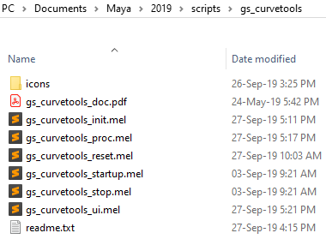
3. Run **Maya**
4. In **MEL script field** copy and paste this command:

*source "gs_curvetools/gs_curvetools_init.mel";*

1. Click Enter

**GS** tab appeared on Shelf.

**CT UI** button will open/close GS CurveTools UI.

**CT Reset** will reset GS CurveTools to its default settings.

**CT Del** will delete GS CurveTools UI and stop any background scripts.

You can use **middle mouse drag** to drag **CT UI** button to any tab.

All the **hotkeys** are now available in **Hotkey Editor > Custom Scripts > GS > GS_CurveTools**

# New Curve Card/Tube

**New Card** command will create a new **Curve Card** procedural object that consists of control curve, generated geometry and construction elements.

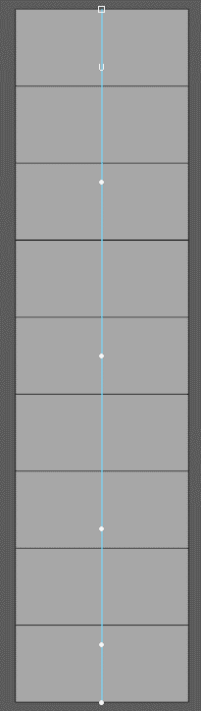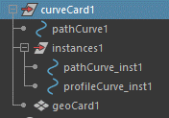

The basic structure of the **Curve Card**:

* Control Curve
* Generated Geometry
* Additional curves (hidden, not important for user)
* Curve Group

After creation, curve card can be **controlled using pathCurve# object**. **Generated geometry is not selectable** in the viewport by default (you can change this behavior in the **Layers**), only Control Curve (pathCurve) can be selected.

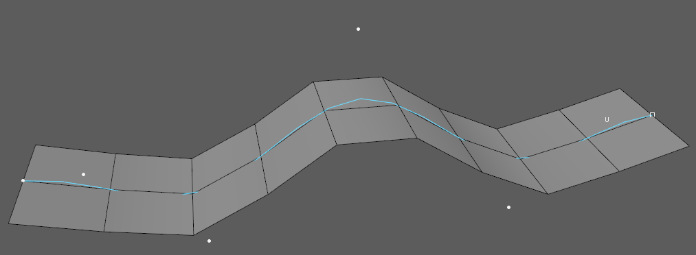

You can transform pathCurve as you transform any other curve or geometry, with only exception for scale. Only Uniform scale is supported. To increase the length of the curve, simply drag Control Vertices to make the curve longer (or use **Extend**) and then adjust **Width** attribute in the Channel Box (more on that later).

You can **change pivot point** of your control curves anytime **without any issues**.

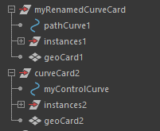

You can **only rename the entire curve group**. **Do not rename any other components.**

**New Tube** command is very similar to New Card with only exception that it creates controllable tube, instead of a card.

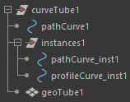The structure of a **Curve Tube** is similar to Curve Card:

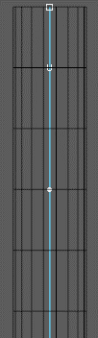

* Control Curve
* Generated Geometry
* Additional curves (hidden, not important for user)
* Curve Group

Same as with Curve Card, you can control Curve Tubes using control curves (pathCurve#) and generated geometry is not selectable in viewport by default. You can only select pathCurve# objects.

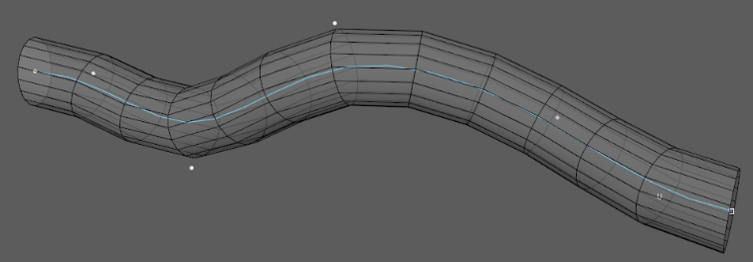

You can transform pathCurve as you transform any other curve or geometry, with only exception for scale. Only Uniform scale is supported. To increase the length of the curve, simply drag Control Vertices to make the curve longer (or use **Extend**) and then adjust **Width X** and **Width Z** attribute in the Channel Box (more on that later).

You can **change pivot point** of your control curves anytime **without any issues**.

You can **only rename the entire curve group**. **Do not rename any other components.**



# Curve Card/Tube Attributes

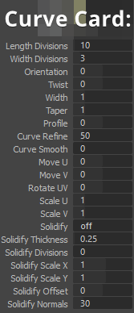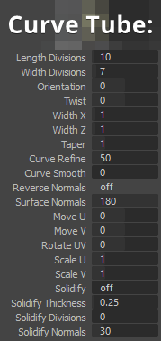Every **Curve Card** or **Tube** have **control attributes** attached to it, that allow for advanced controls and transformations.

Some of the options are different between Curve Cards and Tubes

You can change the attribute of multiple curves by selecting them, clicking on attribute name (for example **Twist**) and then middle mouse dragging in the viewport.

You can also manually enter numbers or use any other attribute editing technique Maya has to offer.

Attributes:

* **Geometry Controls**:
  + **Length Divisions** – controls the length divisions of the geometry generated by control curves.
  + **Width Divisions** – controls the width divisions of the geometry.
  + **Orientation** – rotates the geometry around its control curve
  + **Twist** – twists generated geometry around its control curve
  + **Width, Width X and Width Z** – controls the width of curve card and tube. Note how tube has two options for width, so you can create flat tubes and other shapes
  + **Taper** – tapers geometry from the first CV of the curve to the last. Taper is linear.
  + **Curve Refine** – post-subdivides control curve to allow for more accurate geometry generation. Original pathCurve stays unchanged.
  + **Curve Smooth** – post-smooth of the control curve allowing for smoother geometry generation. Original pathCurve stays unchanged.
* **UV Controls** – procedurally control the UVs of the generated geometry.
  + **Move U/Move V** – controls the UV of a curve/tube generated geometry and allows for quick UV edit right in the viewport.
  + **Rotate UV** – rotates UV of a curve/tube
  + **Scale U/Scale V** – scales UVs of a curve/tube
* **Solidify (Extrude)** – procedurally extrudes curve/tube geometry to add thickness
  + **Solidify Thickness** – controls the thickness of the extruded geometry
  + **Solidify Divisions** – controls the amount of divisions of the extruded geometry
  + **Solidify Scale X/Y** – scales the extruded geometry
  + **Solidify Offset** – offsets the extruded geometry
  + **Solidify Normals** – controls the smoothness of normals of the extruded geometry
* **Normals (Curve Tube exclusive)**
  + **Reverse normals** – reverses normals of the generated geometry
  + **Surface normals** – controls the smoothness of normals of the generated geometry

# Applying Materials (Shaders)

When working with Curve Cards/Tubes it is sometimes necessary to apply materials to your geometry (hair cards texture, cable texture, etc.)

The easiest way to apply texture:

* Select an entire curve group in the outliner (or press UP when control curve is selected)
* RMB in the viewport
* Assign New Material (or existing material)

The material is now applied.

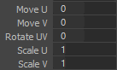You can easily control the default procedural UVs of curve cards/tubes by using UV attributes in the Channel Box. These parameters are fully procedural and changing other attributes (for example, length divisions) will not affect default UVs.

# Curve Card/Curve Tube

**Curve Card** and **Curve Tube** commands will convert any selected nurbs curves (multi selection compatible) to a fully functional **Curve Card/Tube** with all the procedural options and attributes.

All the attributes are exactly the same between **default curve cards/tubes** and the ones created from **Curve Card** and **Curve Tubes**

Note that **Length Divisions** and **Curve Refine** of the new Curve Cards and Tubes is **calculated from the number of control vertices** currently present on a selected curves. More control vertices means higher refine and more divisions (to a specific point).

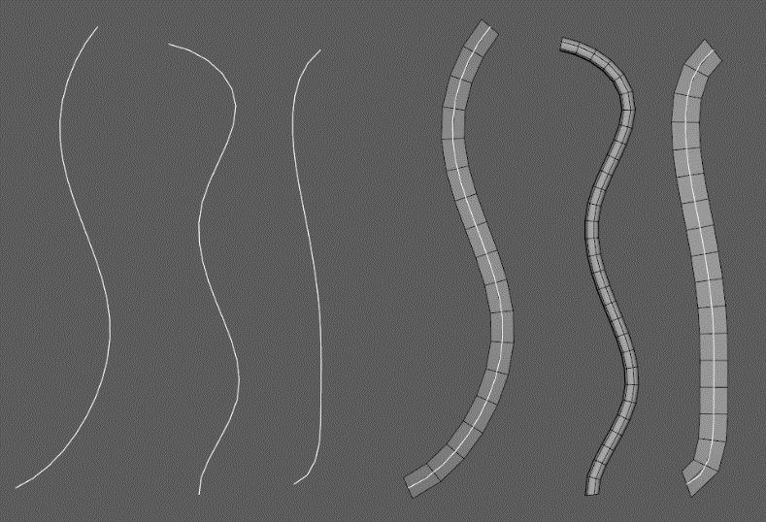

# Add Cards/Add Tubes

**Add Cards and Add Tubes** command, in conjunction with “Add” slider will add new cards or tubes in between the selected curves.

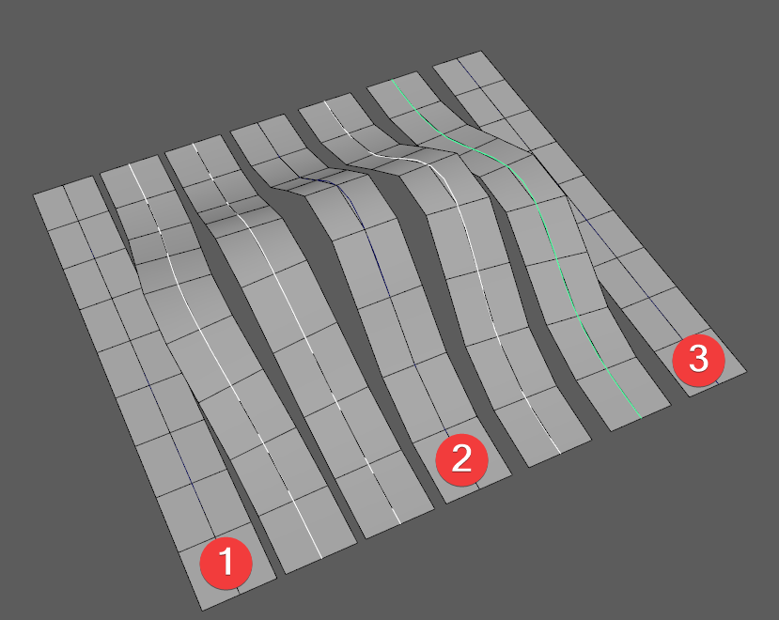**“Add” Slider** will control **how many cards/tubes will be created** in between each pair of curves selected.

For example, you selected 3 curves and set the “add” slider to 2. Now, when you click Add Cards/Tubes it will create 4 new Cards/Tubes between original curves.

Note that **selection order is very important** here.

You want to **select curves in the order** **1,2,3** or **3,2,1**.

Do not select curves like 3,1,2 or 2,3,1 etc. Irregular selection will result in unexpected results.

**Added curves are fully functional Curve Cards/Tubes** and can be treated as such.

Note how in the example, middle curve is bent and now all the created curves are following this bend from the 1 to 2 and from 2 to 3 **smoothly blending** in between.

**Attributes** **are** also **transferred** between **1,2,3** and by default are **smoothly blended**. If you want to **disable blending**, hold **Shift** modifier when clicking on **Add Curve/Tubes** button.

# Edge to Curve

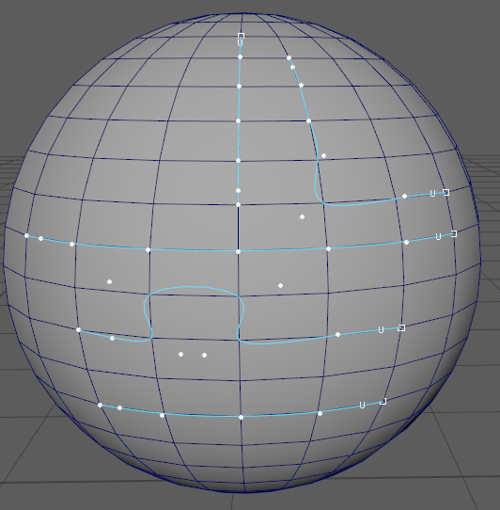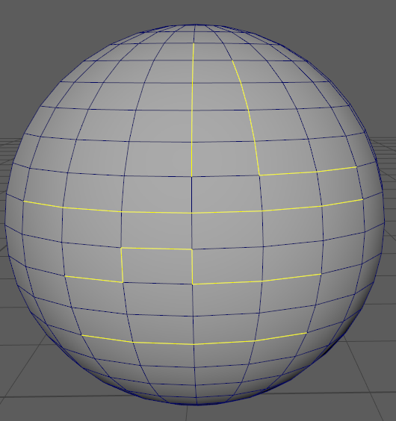**Edge to Curve**  is a procedural command that converts any selected edge groups (unconnected edges) to curve.

Created curves are now **bound to the underlying geometry** (until you delete construction history) and **will deform with this geometry.**

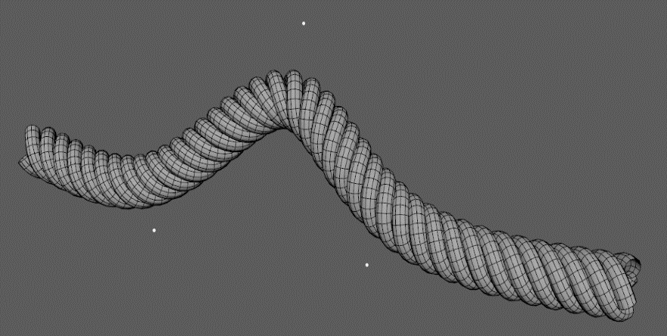**Edge to Curve** and **Curve Cards/Tubes** allow for numerous procedural constructs such as procedural braided cables, helix shapes, tubes that follow underlying geomtry and much more (more in **advanced tecniques** section).

By default, **Edge to Curve create smooth curv**e (3rd degree). If you want to create **rough curves** that follow geometry exactly, you can use **Shift + Edge to Curve** command to do that.

# Curve Layers

**Curve Layers** is a collection of 20 exclusive layers that can hold any number of curve cards and curve tubes in them.

By default, **all curve cards and tubes are created in the layer 0**, but you can **choose** in which layer to create news curves **by selecting (highlighting) that layer in the menu.**

**One curve card can only be in one layer at the same time**, there can’t be two layers with the exact same cruve in them.

Curve Layers are used to **organize, select, change visibility/editability of curves and extract geometry** for further editing or export.

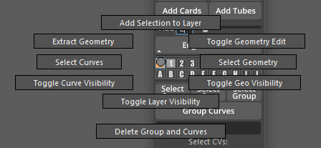Every Curve Layer has **Marking Menu** assigned to it. To access it, **hold RMB** on any Layer button.

**Layer Commands**:

* **Ctrl + Click** on a layer will select all control curves in selected layer (does not work on currently highlighted layer)
* **Shift + Click** on multiple layers will additively select all control curves in the selected layers
* **Add Selection to Layer** will add any selected Curve Cards/Tubes to this layer (removeing them from other layers)
* **Extract Geometry** will hide the original curves and make a duplicate of the geometry generated by the curves. These duplicates can now be edited or exported.
* **Select Curves** will select all control curves in current layer
* **Select Geometry** will select all the generated geometry in the current layer
* **Toggle Curve/Geo Visibility** will toggle viewport visibility of control curve or generated geometry
* **Toggle Layer Visibility** will hide the layer from viewport completely
* **Toggle Geometry Edit** enables the selectability of generated geometry in the viewport. This geometry can now be edited.
* **Delete Group and Curves** will delete all the control curves and generated geometry in that layer.

**Layer buttons** in GS Toolbox have specific **color coordination**:

|  |  |
| --- | --- |
| **Empty Layer**. No Curve Cards or Curve Tubes are assigned to this layer |  |
| **Layer with assigned curves**. There are at least one curve card or curve tube assigned to this layer |  |
| **Hidden Layer**. The layer (or its part) was hidden from the outliner |  |
| **Geometry Edit Layer**. This layer has **Geometry Edit** enabled. Generated geometry can be selected and edited |  |

**Layers work on per scene basis**. Any layer created in a scene will be available next time the scene is oppened.

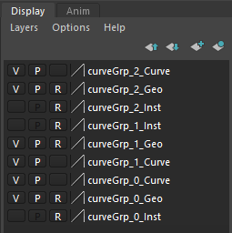Layers use Maya native display layer system. You can find them in **Channel Box -> Layers**

It is important **not to change anything in these layers from this window**. Any changes here will result in limited functionality of layer system or unexpected behaviour.

You can **only rename the entire curve group**. **Do not rename any other components.**



# Selection and Grouping

In order to simplify Curve Cards and Curve Tubes workflow, there are some additional selection and grouping options available.

* **Select Curve** will convert selection from any part of the curve group to pathCurve.
* **Select Geo** will convert selection from any part of the curve group to geoCard/Tube.
* **Select Group** will convert selection from any part of the curve group to Curve Group.
* 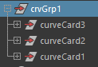**Group Curves** will group any selected curves (and their groups) to a new group named **crvGrp#** (default) or any other group name entered in “Group Name” field.

**Select CVs** slider will interactively select parts of the curve corresponding to the position of the slider. Slider works from left to right and selects **root**, **first CV**, **second CV** etc. untill the last CV on the curve (far right position). This function supports multi-selection.

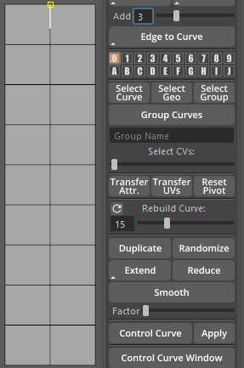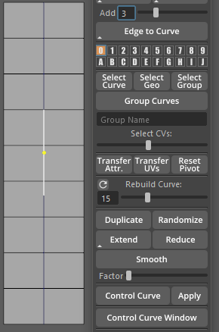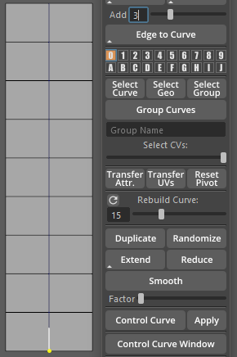

# Transfer of Attributes/UVs & Reset Pivot

You can easily **transfer attributes** (orientation, twist, width etc.) from one curve to any number of other curves.

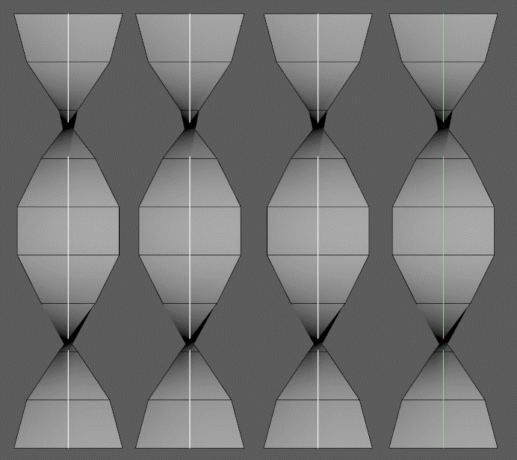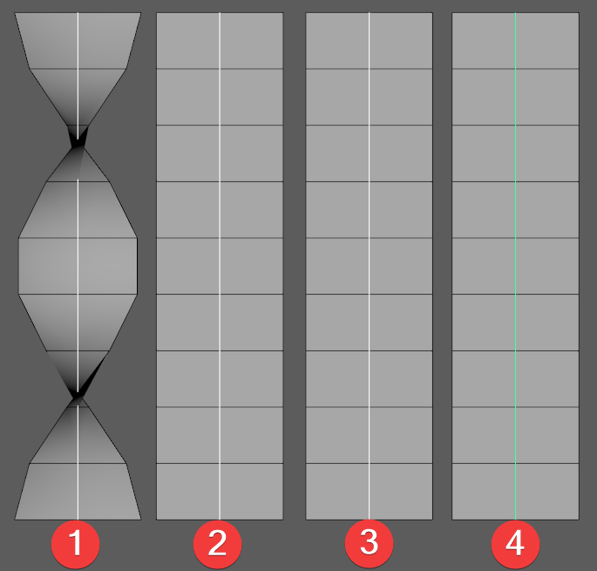First, select your **Source Curve** (1) (from which you want to transfer attributes) and then select any number of **Target Curves** (2,3,4….) and press **Transfer Attr.** Button



**Transfer UVs**

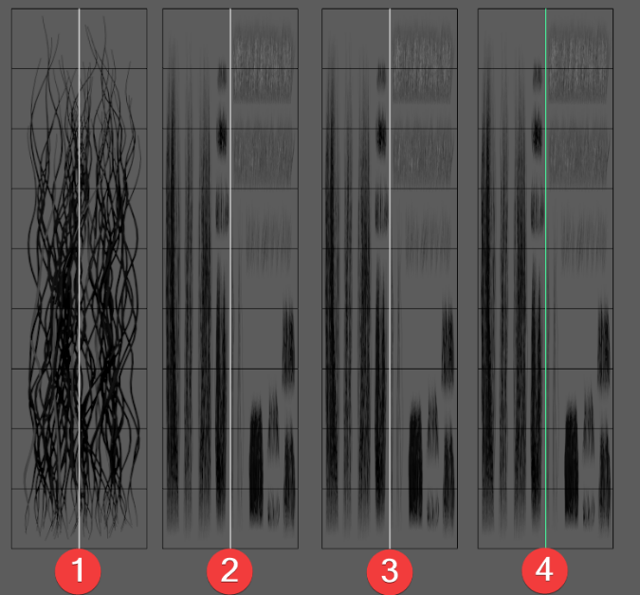Works similar to **Transfer Attr.** but transfers UV related attributes instead.

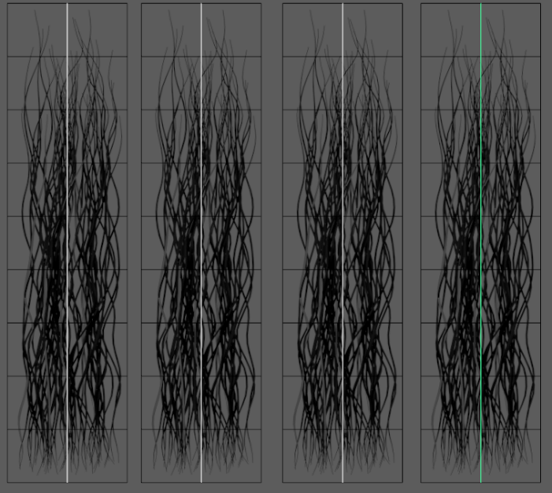

**Reset Pivot**

You can freely change pivot point of your control curves to achieve various effects during transformation of control curves. However, at some point it is beneficial to return the pivot point to its default position – root of the control curve. This function is multi-selection compatible.

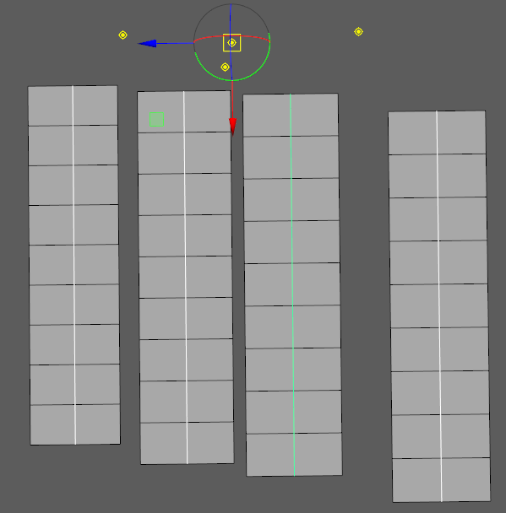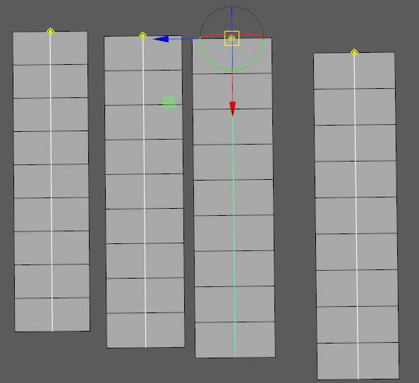



# Rebuild Curve Slider

Rebuild curve slider is an interactive slider that will change number of spans of selected curves with preview.

General workflow:

* **Select** curves
* **Start dragging the slider**. You are now in **preview mode**.
* **Release the slider to apply changes.**

By default Rebuild Curve slider has **range from 1 to 50**, but you can easily expand this range by entering any number from **51 to 999** in the input field. The slider will change its range to the selected value.

To **reset the slider** to its default range, click reset icon

# Duplicate

This simple function will duplicate an entire curve group (not layer) from any selection in that group.

Example:

* Create **Curve Card**
* Select its **Control Curve**
* Click **Duplicate**. Note how the entire Curve Card group was duplicated.

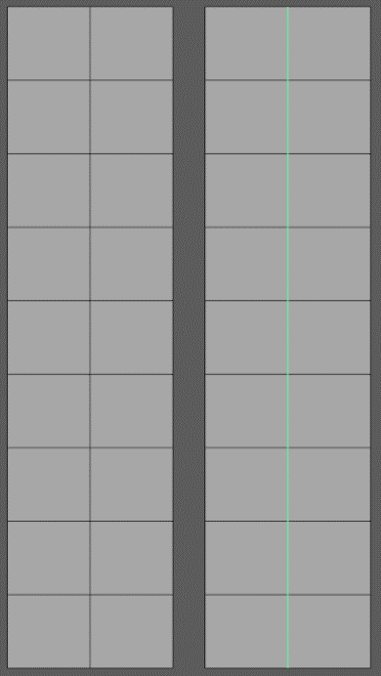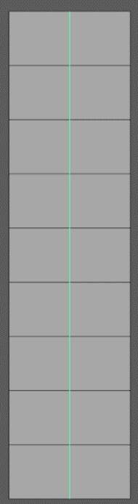This function is multi-selection compatible.

**Note** that Duplicate will not move your control curves. In this example the curve was moved for demonstration purposes.

# Randomize

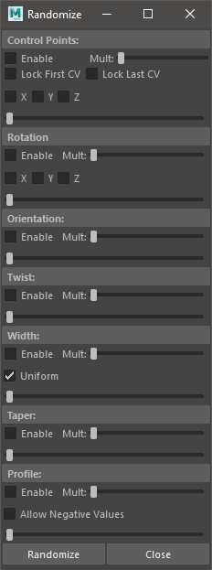**Randomize Window** is a powerful tool to add some natural randomness to your curves. It is extremly useful it you using curve cards to create hair cards or other similar organic workflows.

* **Enable** – will enable or disable randomization section.
* **XYZ** – will control the axis of randomization
* **Lock First/Last CV** to prevent first or last CV to be translated during randomization process
* **Mult** slider increases the amplidute of randomization
* **Main slider** (unlabled) controls the base amplitude of randomization and allows to preview randomization before applying it.
* 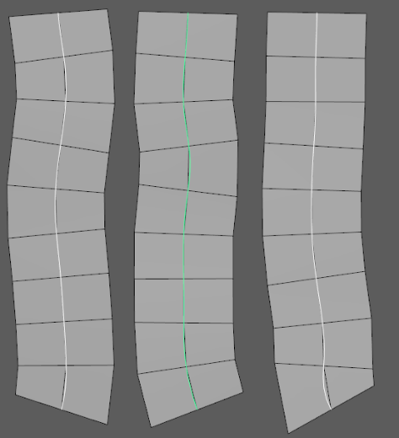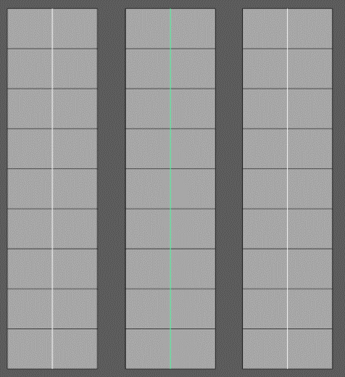**Randomize** button will apply all enabled randomizations.

# Extend/Reduce/Smooth

**Extend** will lengthen any selected curve (or curves) by an amount controlled by “**Factor**” slider. By default **Extend** tries to lenghet selected curve **lineraly**. However, sometimes it is benefitial to use alternative mode.

**Shift + Extend** will try to smoothly **interpolate-lenghten** selected curves.

It is a good idea to **extend curves by a small incriment**. Using high Factor values can result in an undesirable behaviour.

**Reduce** will shorten any selected curve (or curves) by an amount controlled by “**Factor**” slider.

**Smooth** will smooth any selected curve (or curves) by the amount controlled by “Factor” slider.

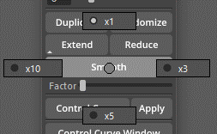**Smooth** command has x3, x5, x10 multipliers that can be found in its marking menu.

# Control Curve

Control curve is a deformer that can be used to easily control entire groups of curves.



General Workflow:

* **Select any number of curves** you want to control
* Click **Control Curve**. Note how in the middle of the selected curves, one thick line appeared. This is the control curve deformer.
* Try **moving this deformer curve**. Note how it also moves all of the previously selected curves.
* 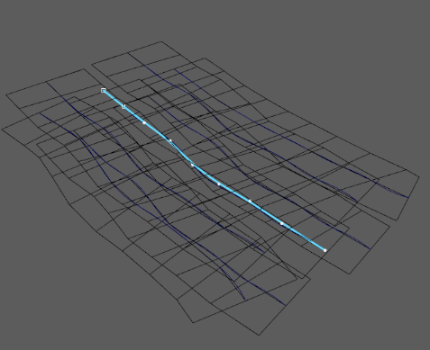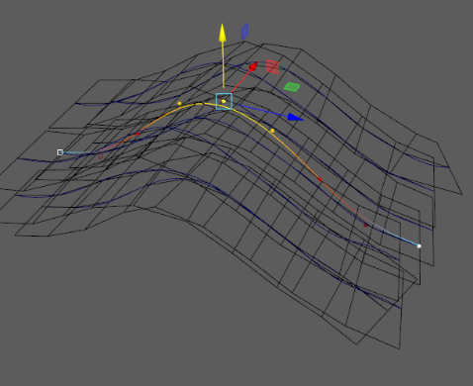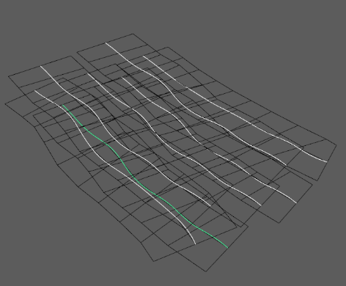Select Control Curve again and click **Apply**. Now, deformations were applied to the original curves.

# Curve Control Window

As an alternative to **Channel Box**, you can use **Curve Control Window**. This window is **Dockable**.

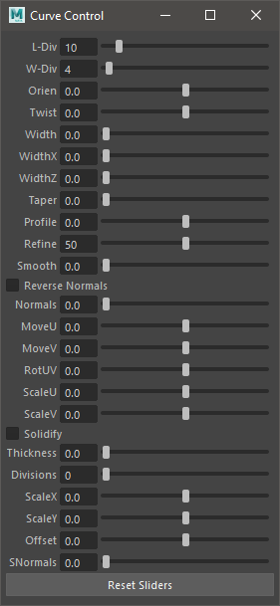This **curve control window** allows for the same functionality as Channel Box attributes.

It supports multi selection and the sliders will interactively update whenever you select a new curve.

You can easily extend the range of sliders by manually typing values to input fields.

To reset sliders back to default range, click **Reset Sliders**

# Options

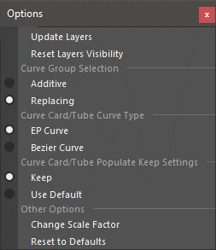Options drop-down menu.

* **Update Layers** will force-update layers (use in case of an error in layer system)
* **Reset Layer Visibility** will reset all the layers to their default visibility and selectability options
* **Curve Group Selection** will determine if Curve Selection in Marking Menu is additive or replacing.
* **Curve Card/Tube Curve Type** – will determine what type of curve will be used when creating new Curve Cards/Tubes. Bezier Curves are currently an experimental feature. EP Curves are fully supported.
* **Curve Card/Tube Populate Keep Settings** determine weather to keep/blend settings during addition of new curves or just use the default values.
* **Change Scale Factor** will change the scale factor of any newly created curve. Scale factor determines the size of a curve in the scene. Default is 1.
* **Reset to Defaults** will reset the menu to its initial state.

# Advanced Techniques

There are a number of ways to use provided procedural curves and features. Here are some of them:

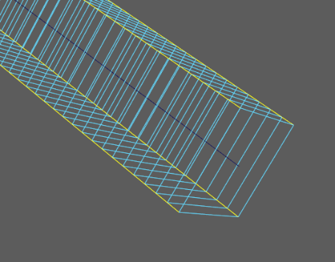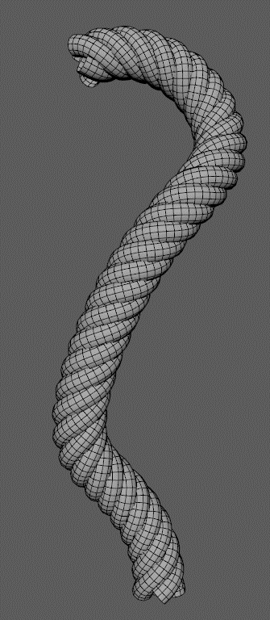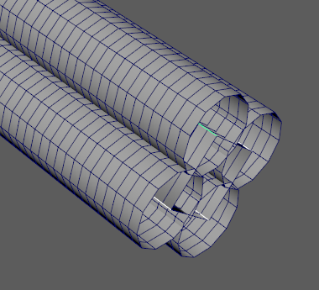**Procedural Braided Cable/Rope:**

* Create Curve Tube in the Layer 0
* Change Length Divisions to at least 100
* Change Width Divisions to 5
* Change Curve Refine to at least 100
* Enable Geo Editing for layer 0 (marking menu)
* Select four long edges and expand selection to edge the entire loop
* Click Edge to Curve
* Select Layer 1
* Click Curve Tube
* Change Length Divisions and Curve Refiner of new curves to 200
* 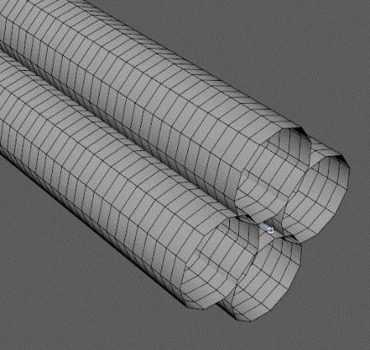Adjust curve Width X and Z to match the image.
* Change Width Divisions to at least 12
* Hide Curves from layer 1 and Hide Geometry from layer 0
* Now select curve from layer 0 and set a high twist value (2000-3000)
* Now you have a procedural braided cable that can be easily controlled by the curve from layer 0 and adjusted at any point.

**Note: Do not change length and width divisions of layer 0 after you applied Edge to Curve.**

More techniques will be added at a later date. Subscribe to my [YouTube Channel](https://www.youtube.com/channel/UCmIFpG98OqbUecaf5H-ixKQ)

for more.