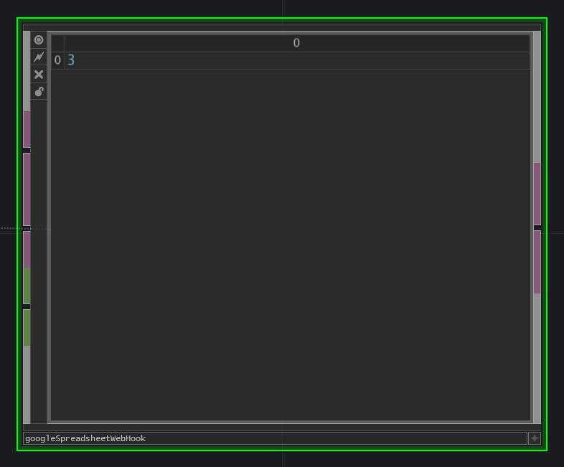

The google spreadsheet web hook can be used to get information out of a cell in google spreadsheet.
The block expects 3 inputs, the unique google spreadsheet ID, the cell entry (ID number) and a refresh trigger.

To be able to use the the google spreadsheet, it has to be made public. This can be done by "publicising on the internet". The unique ID can be extracted from the url. The cell entry is more difficult.

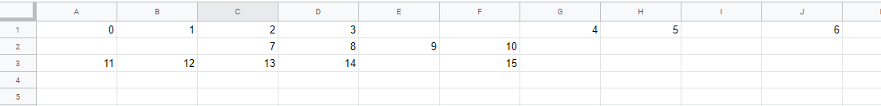

To get the entry number of the cell, you have to count the amount of used cells up to the cell you want to use.
EG the first row contains 7 cells with data, the second row contains 4 and the third row contains 5.
You need the information in the 3th cell on the second row, then it's cell entry number is 7 + 3 - 1 = 9.
The -1 is because we start counting from 0, not from 1. An example is shown in the screenshots.

The last input that is required, is the refresh trigger. When the value of the refresh trigger is pulsed to 1, the web hook will pull the new data out of the google spreadsheet.
In our example below, we used a timer which will create a pulse every 10 seconds. This could for example be replaced by a basic momentary button. This example uses 2 webhooks to pull to score of a foorball match out of google spreadsheet, and display on a picture.

