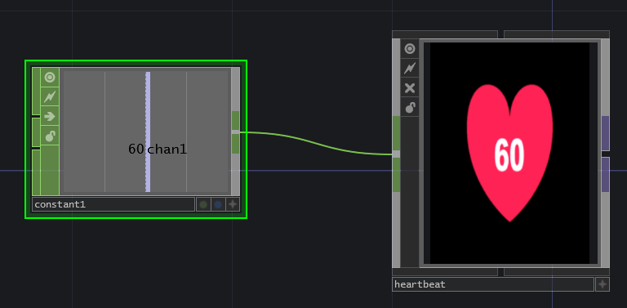
The heartbeat block is a basic block that needs a value input that corresponds with a heartbeat. The heart will beat at the given beats per minute and will display the heartbeat in the centre. Also a heartbeat sound is played at the correct BPM.

