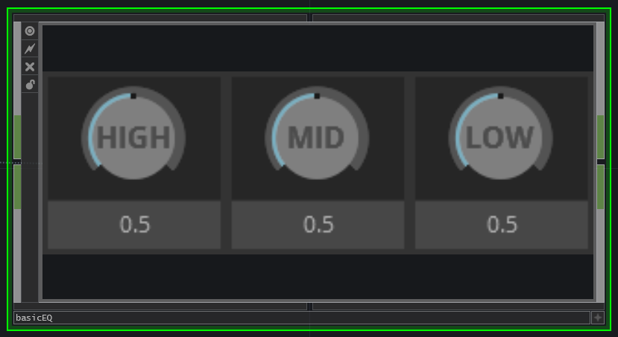
the basic EQ block is a simple high – mid – low equaliser. It needs an audio input and gives an audio output. A good example where this block is used, is in the single channel audio block.



