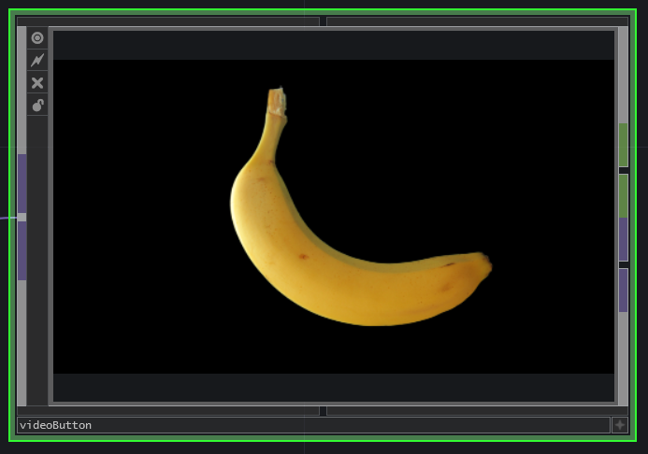

The video button is a simple radio button to select a video output. It takes a video input signal and outputs a boolean and a video signal. When the button is selected, a red border is displayed, the boolean is “1” and the output video signal is equal to the input signal. When the button is not selected, the red border is not displayed, the output boolean is “0” and a black video is outputed.
When no video is connected to the input, the button displays a red cross.
This can be used to create a video selector for live video streaming. In the example, rgb post processing is added.

